**SUMMARY of BBS**

2021-03-26

原始資料：**調查日3/1~6/30間、包含非森林、包含50m以下**

猴群數量

|  |  |  |  |  |  |  |  |  |  |  |  |  |  |  |  |  |  |  |
| --- | --- | --- | --- | --- | --- | --- | --- | --- | --- | --- | --- | --- | --- | --- | --- | --- | --- | --- |
|  | **筆數** | | | | | | **樣區數** | | | | | | **樣點數** | | | | | |
| **County** | **2015** | **2016** | **2017** | **2018** | **2019** | **2020** | **2015** | **2016** | **2017** | **2018** | **2019** | **2020** | **2015** | **2016** | **2017** | **2018** | **2019** | **2020** |
| 宜蘭縣 | 4 | 1 | 0 | 2 | 1 | 5 | 2 | 1 | 0 | 2 | 1 | 4 | 3 | 1 | 0 | 2 | 1 | 5 |
| 臺北市 | 0 | 0 | 0 | 0 | 0 | 1 | 0 | 0 | 0 | 0 | 0 | 1 | 0 | 0 | 0 | 0 | 0 | 1 |
| 新北市 | 1 | 0 | 0 | 2 | 0 | 0 | 1 | 0 | 0 | 2 | 0 | 0 | 1 | 0 | 0 | 2 | 0 | 0 |
| 桃園市 | 0 | 0 | 0 | 0 | 1 | 0 | 0 | 0 | 0 | 0 | 1 | 0 | 0 | 0 | 0 | 0 | 1 | 0 |
| 苗栗縣 | 1 | 0 | 0 | 2 | 1 | 1 | 1 | 0 | 0 | 1 | 1 | 1 | 1 | 0 | 0 | 2 | 1 | 1 |
| 臺中市 | 6 | 2 | 0 | 2 | 3 | 3 | 4 | 2 | 0 | 2 | 2 | 2 | 6 | 2 | 0 | 2 | 2 | 3 |
| 南投縣 | 2 | 5 | 3 | 7 | 10 | 6 | 2 | 5 | 2 | 7 | 6 | 5 | 2 | 5 | 2 | 7 | 10 | 6 |
| 雲林縣 | 8 | 5 | 7 | 9 | 7 | 10 | 3 | 1 | 4 | 2 | 2 | 3 | 7 | 5 | 7 | 7 | 5 | 9 |
| 嘉義縣 | 0 | 1 | 0 | 2 | 2 | 3 | 0 | 1 | 0 | 1 | 2 | 3 | 0 | 1 | 0 | 2 | 2 | 3 |
| 臺南市 | 0 | 0 | 2 | 3 | 1 | 3 | 0 | 0 | 1 | 1 | 1 | 2 | 0 | 0 | 2 | 2 | 1 | 3 |
| 高雄市 | 2 | 3 | 4 | 5 | 2 | 2 | 2 | 3 | 1 | 2 | 1 | 2 | 2 | 3 | 4 | 5 | 2 | 2 |
| 屏東縣 | 3 | 3 | 6 | 2 | 1 | 2 | 2 | 2 | 3 | 2 | 1 | 2 | 3 | 2 | 5 | 2 | 1 | 2 |
| 花蓮縣 | 14 | 16 | 10 | 11 | 12 | 10 | 8 | 9 | 4 | 6 | 8 | 6 | 13 | 15 | 9 | 10 | 11 | 10 |
| 臺東縣 | 2 | 1 | 1 | 13 | 15 | 2 | 2 | 1 | 1 | 6 | 9 | 2 | 2 | 1 | 1 | 12 | 12 | 2 |
| 合計 | 43 | 37 | 33 | 60 | 56 | 48 | 27 | 25 | 16 | 34 | 35 | 33 | 40 | 35 | 30 | 55 | 49 | 47 |

孤猴數量

|  |  |  |  |  |  |  |  |  |  |  |  |  |  |  |  |  |  |  |
| --- | --- | --- | --- | --- | --- | --- | --- | --- | --- | --- | --- | --- | --- | --- | --- | --- | --- | --- |
|  | **筆數** | | | | | | **樣區數** | | | | | | **樣點數** | | | | | |
| **County** | **2015** | **2016** | **2017** | **2018** | **2019** | **2020** | **2015** | **2016** | **2017** | **2018** | **2019** | **2020** | **2015** | **2016** | **2017** | **2018** | **2019** | **2020** |
| 宜蘭縣 | 0 | 3 | 0 | 0 | 1 | 1 | 0 | 2 | 0 | 0 | 1 | 1 | 0 | 3 | 0 | 0 | 1 | 1 |
| 新北市 | 0 | 0 | 0 | 0 | 1 | 0 | 0 | 0 | 0 | 0 | 1 | 0 | 0 | 0 | 0 | 0 | 1 | 0 |
| 苗栗縣 | 1 | 0 | 0 | 0 | 0 | 0 | 1 | 0 | 0 | 0 | 0 | 0 | 1 | 0 | 0 | 0 | 0 | 0 |
| 臺中市 | 2 | 1 | 1 | 4 | 0 | 6 | 2 | 1 | 1 | 4 | 0 | 2 | 2 | 1 | 1 | 4 | 0 | 4 |
| 南投縣 | 1 | 1 | 1 | 3 | 4 | 1 | 1 | 1 | 1 | 3 | 3 | 1 | 1 | 1 | 1 | 3 | 3 | 1 |
| 雲林縣 | 4 | 0 | 5 | 1 | 1 | 1 | 2 | 0 | 2 | 1 | 1 | 1 | 4 | 0 | 5 | 1 | 1 | 1 |
| 嘉義縣 | 1 | 0 | 0 | 2 | 0 | 3 | 1 | 0 | 0 | 1 | 0 | 3 | 1 | 0 | 0 | 2 | 0 | 3 |
| 臺南市 | 0 | 0 | 0 | 0 | 2 | 1 | 0 | 0 | 0 | 0 | 1 | 1 | 0 | 0 | 0 | 0 | 1 | 1 |
| 高雄市 | 6 | 4 | 1 | 0 | 3 | 4 | 2 | 3 | 1 | 0 | 3 | 1 | 6 | 4 | 1 | 0 | 3 | 4 |
| 屏東縣 | 0 | 2 | 2 | 1 | 1 | 3 | 0 | 1 | 1 | 1 | 1 | 2 | 0 | 2 | 2 | 1 | 1 | 3 |
| 花蓮縣 | 7 | 3 | 1 | 10 | 4 | 2 | 3 | 3 | 1 | 6 | 3 | 1 | 5 | 3 | 1 | 10 | 4 | 2 |
| 臺東縣 | 0 | 0 | 0 | 4 | 1 | 5 | 0 | 0 | 0 | 4 | 1 | 3 | 0 | 0 | 0 | 4 | 1 | 5 |
| 合計 | 22 | 14 | 11 | 25 | 18 | 27 | 12 | 11 | 7 | 20 | 15 | 16 | 20 | 14 | 11 | 25 | 16 | 25 |

分析用：**調查日3/1~6/30間、“不”包含非森林、“不”包含50m以下**

猴群數量

|  |  |  |  |  |  |  |  |  |  |  |  |  |  |  |  |  |  |  |
| --- | --- | --- | --- | --- | --- | --- | --- | --- | --- | --- | --- | --- | --- | --- | --- | --- | --- | --- |
|  | **筆數** | | | | | | **樣區數** | | | | | | **樣點數** | | | | | |
| **County** | **2015** | **2016** | **2017** | **2018** | **2019** | **2020** | **2015** | **2016** | **2017** | **2018** | **2019** | **2020** | **2015** | **2016** | **2017** | **2018** | **2019** | **2020** |
| 宜蘭縣 | 4 | 0 | 0 | 2 | 0 | 5 | 2 | 0 | 0 | 2 | 0 | 4 | 3 | 0 | 0 | 2 | 0 | 5 |
| 臺北市 | 0 | 0 | 0 | 0 | 0 | 1 | 0 | 0 | 0 | 0 | 0 | 1 | 0 | 0 | 0 | 0 | 0 | 1 |
| 新北市 | 1 | 0 | 0 | 2 | 0 | 0 | 1 | 0 | 0 | 2 | 0 | 0 | 1 | 0 | 0 | 2 | 0 | 0 |
| 桃園市 | 0 | 0 | 0 | 0 | 1 | 0 | 0 | 0 | 0 | 0 | 1 | 0 | 0 | 0 | 0 | 0 | 1 | 0 |
| 苗栗縣 | 1 | 0 | 0 | 2 | 1 | 1 | 1 | 0 | 0 | 1 | 1 | 1 | 1 | 0 | 0 | 2 | 1 | 1 |
| 臺中市 | 6 | 2 | 0 | 2 | 3 | 3 | 4 | 2 | 0 | 2 | 2 | 2 | 6 | 2 | 0 | 2 | 2 | 3 |
| 南投縣 | 2 | 5 | 3 | 7 | 10 | 6 | 2 | 5 | 2 | 7 | 6 | 5 | 2 | 5 | 2 | 7 | 10 | 6 |
| 雲林縣 | 8 | 5 | 7 | 9 | 7 | 10 | 3 | 1 | 4 | 2 | 2 | 3 | 7 | 5 | 7 | 7 | 5 | 9 |
| 嘉義縣 | 0 | 1 | 0 | 2 | 2 | 3 | 0 | 1 | 0 | 1 | 2 | 3 | 0 | 1 | 0 | 2 | 2 | 3 |
| 臺南市 | 0 | 0 | 2 | 3 | 1 | 3 | 0 | 0 | 1 | 1 | 1 | 2 | 0 | 0 | 2 | 2 | 1 | 3 |
| 高雄市 | 2 | 3 | 4 | 5 | 2 | 2 | 2 | 3 | 1 | 2 | 1 | 2 | 2 | 3 | 4 | 5 | 2 | 2 |
| 屏東縣 | 3 | 3 | 5 | 2 | 1 | 2 | 2 | 2 | 2 | 2 | 1 | 2 | 3 | 2 | 4 | 2 | 1 | 2 |
| 花蓮縣 | 14 | 16 | 10 | 11 | 12 | 10 | 8 | 9 | 4 | 6 | 8 | 6 | 13 | 15 | 9 | 10 | 11 | 10 |
| 臺東縣 | 2 | 1 | 1 | 13 | 15 | 2 | 2 | 1 | 1 | 6 | 9 | 2 | 2 | 1 | 1 | 12 | 12 | 2 |
| 合計 | 43 | 36 | 32 | 60 | 55 | 48 | 27 | 24 | 15 | 34 | 34 | 33 | 40 | 34 | 29 | 55 | 48 | 47 |

孤猴數量

|  |  |  |  |  |  |  |  |  |  |  |  |  |  |  |  |  |  |  |
| --- | --- | --- | --- | --- | --- | --- | --- | --- | --- | --- | --- | --- | --- | --- | --- | --- | --- | --- |
|  | **筆數** | | | | | | **樣區數** | | | | | | **樣點數** | | | | | |
| **County** | **2015** | **2016** | **2017** | **2018** | **2019** | **2020** | **2015** | **2016** | **2017** | **2018** | **2019** | **2020** | **2015** | **2016** | **2017** | **2018** | **2019** | **2020** |
| 宜蘭縣 | 0 | 3 | 0 | 0 | 1 | 1 | 0 | 2 | 0 | 0 | 1 | 1 | 0 | 3 | 0 | 0 | 1 | 1 |
| 新北市 | 0 | 0 | 0 | 0 | 1 | 0 | 0 | 0 | 0 | 0 | 1 | 0 | 0 | 0 | 0 | 0 | 1 | 0 |
| 苗栗縣 | 1 | 0 | 0 | 0 | 0 | 0 | 1 | 0 | 0 | 0 | 0 | 0 | 1 | 0 | 0 | 0 | 0 | 0 |
| 臺中市 | 2 | 1 | 1 | 4 | 0 | 6 | 2 | 1 | 1 | 4 | 0 | 2 | 2 | 1 | 1 | 4 | 0 | 4 |
| 南投縣 | 1 | 1 | 1 | 3 | 4 | 1 | 1 | 1 | 1 | 3 | 3 | 1 | 1 | 1 | 1 | 3 | 3 | 1 |
| 雲林縣 | 4 | 0 | 5 | 1 | 1 | 1 | 2 | 0 | 2 | 1 | 1 | 1 | 4 | 0 | 5 | 1 | 1 | 1 |
| 嘉義縣 | 1 | 0 | 0 | 2 | 0 | 3 | 1 | 0 | 0 | 1 | 0 | 3 | 1 | 0 | 0 | 2 | 0 | 3 |
| 臺南市 | 0 | 0 | 0 | 0 | 2 | 1 | 0 | 0 | 0 | 0 | 1 | 1 | 0 | 0 | 0 | 0 | 1 | 1 |
| 高雄市 | 6 | 4 | 1 | 0 | 3 | 4 | 2 | 3 | 1 | 0 | 3 | 1 | 6 | 4 | 1 | 0 | 3 | 4 |
| 屏東縣 | 0 | 2 | 2 | 1 | 1 | 3 | 0 | 1 | 1 | 1 | 1 | 2 | 0 | 2 | 2 | 1 | 1 | 3 |
| 花蓮縣 | 7 | 3 | 1 | 10 | 4 | 2 | 3 | 3 | 1 | 6 | 3 | 1 | 5 | 3 | 1 | 10 | 4 | 2 |
| 臺東縣 | 0 | 0 | 0 | 4 | 1 | 5 | 0 | 0 | 0 | 4 | 1 | 3 | 0 | 0 | 0 | 4 | 1 | 5 |
| 合計 | 22 | 14 | 11 | 25 | 18 | 27 | 12 | 11 | 7 | 20 | 15 | 16 | 20 | 14 | 11 | 25 | 16 | 25 |

2015~2020年海拔50m以上各分區的猴群數及樣點數、相對密度

|  |  |  |  |  |  |  |  |  |  |  |  |  |  |  |  |  |  |
| --- | --- | --- | --- | --- | --- | --- | --- | --- | --- | --- | --- | --- | --- | --- | --- | --- | --- |
|  |  |  | **個別旅次** | | | | | | | | | | | |  | **12個旅次** | |
| **Region2** | **variable** |  | **2015_1** | **2015_2** | **2016_1** | **2016_2** | **2017_1** | **2017_2** | **2018_1** | **2018_2** | **2019_1** | **2019_2** | **2020_1** | **2020_2** |  | **Mean** | **SE** |
| North | 樣點數 |  | 601 | 541 | 549 | 456 | 439 | 429 | 547 | 456 | 426 | 376 | 407 | 391 |  | 468.167 | 21.024 |
|  | 猴群數 |  | 4 | 2 | 0 | 0 | 0 | 0 | 2 | 4 | 0 | 2 | 4 | 3 |  | 1.75 | 0.494 |
|  | 相對密度 |  | 0.007 | 0.004 | 0 | 0 | 0 | 0 | 0.004 | 0.009 | 0 | 0.005 | 0.01 | 0.008 |  | 0.004 | 0.001 |
| Center | 樣點數 |  | 422 | 415 | 454 | 443 | 456 | 424 | 498 | 483 | 484 | 472 | 424 | 406 |  | 448.417 | 8.877 |
|  | 猴群數 |  | 4 | 4 | 4 | 3 | 1 | 2 | 5 | 4 | 5 | 8 | 8 | 1 |  | 4.083 | 0.657 |
|  | 相對密度 |  | 0.009 | 0.01 | 0.009 | 0.007 | 0.002 | 0.005 | 0.01 | 0.008 | 0.01 | 0.017 | 0.019 | 0.002 |  | 0.009 | 0.001 |
| Southwest | 樣點數 |  | 181 | 175 | 153 | 153 | 155 | 155 | 154 | 153 | 155 | 155 | 142 | 142 |  | 156.083 | 3.272 |
|  | 猴群數 |  | 4 | 4 | 1 | 5 | 3 | 6 | 6 | 8 | 5 | 5 | 5 | 11 |  | 5.25 | 0.719 |
|  | 相對密度 |  | 0.022 | 0.023 | 0.007 | 0.033 | 0.019 | 0.039 | 0.039 | 0.052 | 0.032 | 0.032 | 0.035 | 0.077 |  | 0.034 | 0.005 |
| South | 樣點數 |  | 112 | 112 | 123 | 123 | 101 | 101 | 121 | 114 | 132 | 125 | 121 | 118 |  | 116.917 | 2.704 |
|  | 猴群數 |  | 2 | 3 | 2 | 4 | 4 | 5 | 3 | 4 | 3 | 0 | 3 | 1 |  | 2.833 | 0.405 |
|  | 相對密度 |  | 0.018 | 0.027 | 0.016 | 0.033 | 0.04 | 0.05 | 0.025 | 0.035 | 0.023 | 0 | 0.025 | 0.008 |  | 0.025 | 0.004 |
| Hualien | 樣點數 |  | 162 | 162 | 149 | 127 | 156 | 148 | 140 | 139 | 151 | 151 | 128 | 106 |  | 143.25 | 4.731 |
|  | 猴群數 |  | 5 | 9 | 6 | 10 | 6 | 4 | 7 | 4 | 9 | 3 | 7 | 3 |  | 6.083 | 0.69 |
|  | 相對密度 |  | 0.031 | 0.056 | 0.04 | 0.079 | 0.038 | 0.027 | 0.05 | 0.029 | 0.06 | 0.02 | 0.055 | 0.028 |  | 0.043 | 0.005 |
| Taitung | 樣點數 |  | 59 | 59 | 59 | 59 | 55 | 45 | 75 | 75 | 75 | 74 | 75 | 75 |  | 65.417 | 3.044 |
|  | 猴群數 |  | 2 | 0 | 1 | 0 | 1 | 0 | 4 | 9 | 9 | 6 | 1 | 1 |  | 2.833 | 0.976 |
|  | 相對密度 |  | 0.034 | 0 | 0.017 | 0 | 0.018 | 0 | 0.053 | 0.12 | 0.12 | 0.081 | 0.013 | 0.013 |  | 0.039 | 0.013 |
| TW | 樣點數 |  | 1537 | 1464 | 1487 | 1361 | 1362 | 1302 | 1535 | 1420 | 1423 | 1353 | 1297 | 1238 |  | 1398.25 | 27.686 |
|  | 猴群數 |  | 21 | 22 | 14 | 22 | 15 | 17 | 27 | 33 | 31 | 24 | 28 | 20 |  | 22.833 | 1.744 |
|  | 相對密度 |  | 0.014 | 0.015 | 0.009 | 0.016 | 0.011 | 0.013 | 0.018 | 0.023 | 0.022 | 0.018 | 0.022 | 0.016 |  | 0.016 | 0.001 |

2015~2020年各森林類型的樣點數、猴群數及相對密度

|  |  |  |  |  |  |  |
| --- | --- | --- | --- | --- | --- | --- |
|  | **樣點數** | | **猴群數** | | **相對密度** | |
| **類型** | **Mean** | **Se** | **Mean** | **Se** | **Mean** | **Se** |
| Forest(EL>=50m) | 1398.3 | 27.686 | 22.833 | 1.744 | 0.0164 | 0.0012 |
| 闊葉林 | 946.3 | 19.069 | 15.083 | 1.459 | 0.0159 | 0.0015 |
| 針葉林 | 138.9 | 3.430 | 1.500 | 0.337 | 0.0111 | 0.0026 |
| 竹林 | 155.1 | 3.441 | 3.250 | 0.740 | 0.0215 | 0.0050 |
| 混淆林 | 157.9 | 3.585 | 3.000 | 0.522 | 0.0190 | 0.0033 |
| 非森林(EL>=50m) | 1159.3 | 13.551 | 0.583 | 0.229 | 0.0005 | 0.0002 |
| 森林(EL<50) | 172.7 | 5.211 | 0.250 | 0.131 | 0.0014 | 0.0007 |
| Total | 2730.3 | 36.095 | 23.667 | 1.823 | 0.0087 | 0.0007 |

2015~2020年海拔50m以上的森林內資料各變數與相對密度的箱型圖 (都是12個點畫出來的)

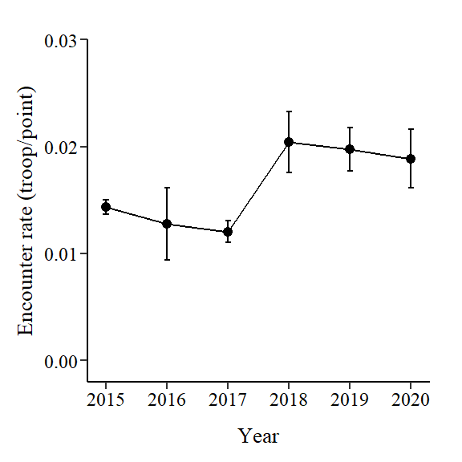 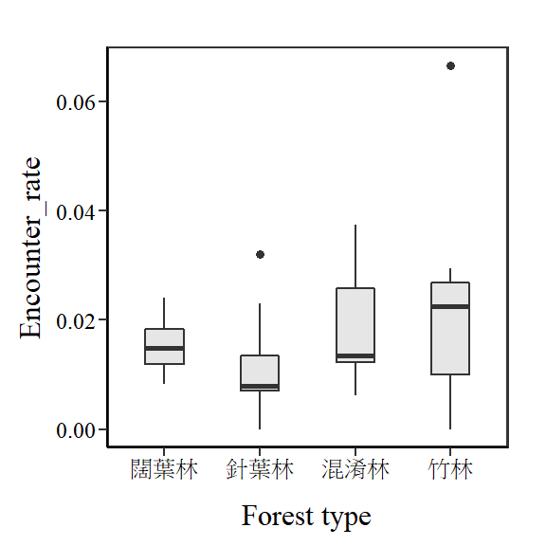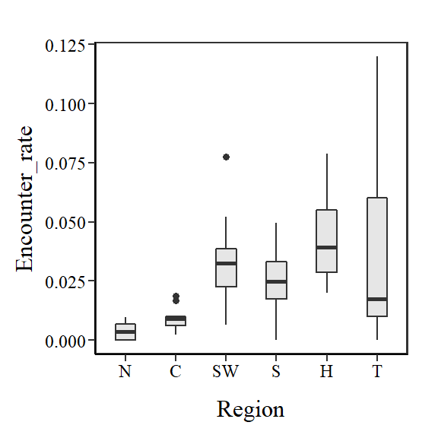 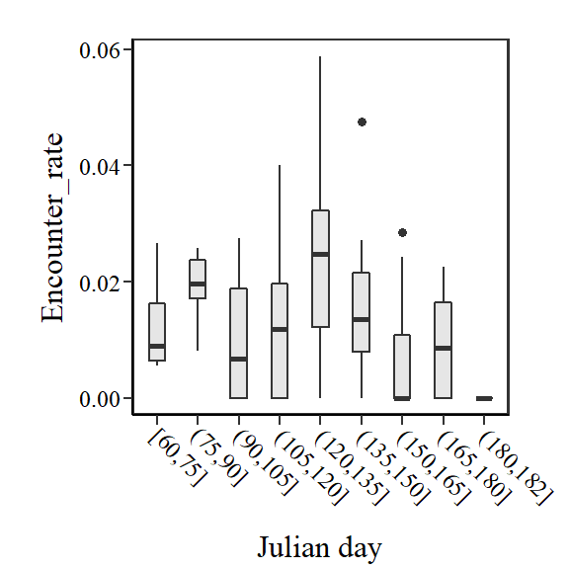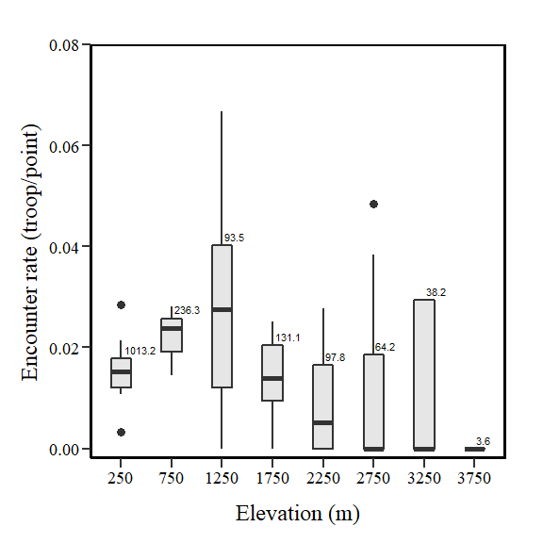

**GLMM**

Full model:

m1 <- glmer(猴群數 ~ 森林類型 + 年 + 海拔 + 調查日 + 分區 + (1|Site_N), family = binomial, data = df)

1. 年為連續變數：2015~2020 年。

2. 森林類型為類別變數：分別為闊葉林、針葉林、混淆林、竹林等4 種。

3. 海拔為連續變數，範圍海拔50m以上。

4. 調查日為連續變數：調查日為當年度的第n天。僅分析3~6月內的調查資料。

5. 分區等為類別變數：分別為北部、中彰投、雲嘉南、高屏、花蓮、臺東等六區；

1. North(北部)為基隆市、臺北市、新北市、桃園市、新竹縣、苗栗縣、宜蘭縣；
2. Center(中彰投)為臺中市、彰化縣、南投縣；
3. Southwest(雲嘉南)為雲林縣、嘉義縣、嘉義市、臺南市；
4. South(高屏)為高雄市、屏東縣；
5. Hualien (花蓮縣)；
6. Taitung (臺東縣)。

6. 樣區為隨機變數。

7. 分析總筆數：16779筆；猴群274群。

Model selection table

|  |  |  |  |  |  |  |  |  |  |  |
| --- | --- | --- | --- | --- | --- | --- | --- | --- | --- | --- |
| (Intercept) | 海拔 | 調查日 | 分區 | 森林類型 | 年 | df | logLik | AICc | delta | weight |
| -6.278 | 0.357 |  | + |  | 0.0835 | 9 | -1176.42 | 2370.9 | 0 | 0.402 |
| -6.276 | 0.3363 | 0.04862 | + |  | 0.08328 | 10 | -1176.21 | 2372.4 | 1.57 | 0.183 |

>importance(d1)

|  |  |  |  |  |  |
| --- | --- | --- | --- | --- | --- |
|  | 分區 | 海拔 | 年 | 調查日 | 森林類型 |
| Sum of weights | 1 | 0.82 | 0.79 | 0.33 | 0.1 |
| N containing models | 16 | 16 | 16 | 16 | 16 |

**\*\*\*因為森林類型在AIC中的結果顯示不重要，所以接下來的GLMM都不納入分析**

Analysis of Deviance Table (Type II Wald chisquare tests)

|  |  |  |  |  |
| --- | --- | --- | --- | --- |
|  | Chisq | Df | P-value(>Chisq) |  |
| 海拔 | 4.4251 | 1 | 0.035 | * |
| 年 | 4.6359 | 1 | 0.031 | * |
| 調查日 | 0.4313 | 1 | 0.511 |  |
| 分區 | 45.1631 | 5 | 0.000 | *** |

AIC = 2372.4

> summary(glht(m1, linfct = mcp(Region = "Tukey")))

Multiple Comparisons of Means: Tukey Contrasts

|  |  |  |  |  |  |
| --- | --- | --- | --- | --- | --- |
|  | Estimate | Std. Error | z value | Pr(>|z|) |  |
| **Hualien vs. Center** | **1.855** | **0.466** | **3.982** | **<0.001** | **\*\*\*** |
| North vs. Center | -0.661 | 0.448 | -1.475 | 0.675 |  |
| South vs. Center | 0.958 | 0.535 | 1.791 | 0.465 |  |
| Southwest vs. Center | 0.968 | 0.502 | 1.927 | 0.379 |  |
| **Taitung vs. Center** | **2.572** | **0.629** | **4.087** | **<0.001** | **\*\*\*** |
| **North vs. Hualien** | **-2.516** | **0.472** | **-5.335** | **<0.001** | **\*\*\*** |
| South vs. Hualien | -0.898 | 0.553 | -1.622 | 0.578 |  |
| Southwest vs. Hualien | -0.887 | 0.531 | -1.671 | 0.545 |  |
| Taitung vs. Hualien | 0.717 | 0.631 | 1.136 | 0.863 |  |
| **South vs. North** | **1.619** | **0.543** | **2.983** | **0.033** | **\*** |
| **Southwest vs. North** | **1.629** | **0.520** | **3.134** | **0.021** | **\*** |
| **Taitung vs. North** | **3.233** | **0.636** | **5.087** | **<0.001** | **\*\*\*** |
| Southwest vs. South | 0.010 | 0.596 | 0.017 | 1.000 |  |
| Taitung vs. South | 1.614 | 0.695 | 2.322 | 0.181 |  |
| Taitung vs. Southwest | 1.604 | 0.677 | 2.368 | 0.164 |  |

**Rtrim**

Region:分為北部、中彰投、雲嘉南、高屏、花蓮、台東，與GLMM同。

最小的scale：樣點

m1 <- trim(number ~ SP + Year + Region2, weights = "weight",df, model = 2,

changepoints = "all", overdisp = F, serialcor = F, autodelete = T, stepwise = F)

Goodness of fit:

Chi-square = 764.04, df=815, p=0.8985

Likelihood Ratio = 607.66, df=815, p=1.0000

AIC (up to a constant) = -1022.34

> wald(m1)

Wald test for significance of covariates

|  |  |  |  |
| --- | --- | --- | --- |
| Covariate | W | df | p |
| Region2 | 48.35509 | 20 | 0.000379 |

Wald test for significance of changes in slope

|  |  |  |  |
| --- | --- | --- | --- |
| Changepoint | Wald_test | df | p |
| 2015 | 9.019498 | 6 | 0.172485 |
| 2017 | 12.95242 | 6 | 0.043798 |
| 2018 | 12.34347 | 6 | 0.054731 |
| 2019 | 10.93189 | 6 | 0.090504 |

> overall(m1,"imputed")

|  |  |  |  |  |  |  |  |
| --- | --- | --- | --- | --- | --- | --- | --- |
| from | upto | add | se_add | mul | se_mul | p | meaning |
| 2015 | 2020 | 0.3623 | 0.3426 | 1.4366 | 0.4922 | 0.3500 | Uncertain |

