Macaca Data Summary 2021

2022-06-30

資料統整

### **原始資料**

#### **調查日3/1~6/30間、包含非森林、包含50m以下**

猴群數量

| variable | Year | 宜蘭縣 | 臺北市 | 新北市 | 桃園市 | 苗栗縣 | 臺中市 | 南投縣 | 雲林縣 | 嘉義縣 | 臺南市 | 高雄市 | 屏東縣 | 花蓮縣 | 臺東縣 | Total |
| --- | --- | --- | --- | --- | --- | --- | --- | --- | --- | --- | --- | --- | --- | --- | --- | --- |
| 筆數 | 2015 | 4 |  | 1 |  | 1 | 6 | 2 | 8 | 1 |  | 2 | 3 | 15 | 2 | 45 |
| 2016 | 1 |  |  |  |  | 2 | 5 | 5 | 1 |  | 3 | 3 | 16 | 1 | 37 |
| 2017 |  |  |  |  |  | 2 | 3 | 7 |  | 2 | 5 | 6 | 10 | 1 | 36 |
| 2018 | 2 |  | 2 |  | 2 | 3 | 7 | 9 | 2 | 3 | 5 | 2 | 12 | 13 | 62 |
| 2019 | 1 |  |  | 1 | 1 | 3 | 10 | 7 | 2 | 1 | 2 | 1 | 12 | 16 | 57 |
| 2020 | 5 | 1 |  |  | 1 | 3 | 6 | 10 | 3 | 3 | 2 | 2 | 12 | 2 | 50 |
| 2021 |  | 1 | 3 |  | 2 | 6 | 3 | 9 | 7 | 1 | 5 | 1 | 11 | 11 | 60 |
| 樣區數 | 2015 | 2 |  | 1 |  | 1 | 4 | 2 | 3 | 1 |  | 2 | 2 | 9 | 2 | 29 |
| 2016 | 1 |  |  |  |  | 2 | 5 | 1 | 1 |  | 3 | 2 | 9 | 1 | 25 |
| 2017 |  |  |  |  |  | 1 | 2 | 4 |  | 1 | 2 | 3 | 4 | 1 | 18 |
| 2018 | 2 |  | 2 |  | 1 | 3 | 7 | 2 | 1 | 1 | 2 | 2 | 7 | 6 | 36 |
| 2019 | 1 |  |  | 1 | 1 | 2 | 6 | 2 | 2 | 1 | 1 | 1 | 8 | 9 | 35 |
| 2020 | 4 | 1 |  |  | 1 | 2 | 5 | 3 | 3 | 2 | 2 | 2 | 8 | 2 | 35 |
| 2021 |  | 1 | 3 |  | 2 | 4 | 3 | 2 | 2 | 1 | 2 | 1 | 6 | 6 | 33 |
| 樣點數 | 2015 | 3 |  | 1 |  | 1 | 6 | 2 | 7 | 1 |  | 2 | 3 | 14 | 2 | 42 |
| 2016 | 1 |  |  |  |  | 2 | 5 | 5 | 1 |  | 3 | 2 | 15 | 1 | 35 |
| 2017 |  |  |  |  |  | 2 | 2 | 7 |  | 2 | 5 | 5 | 9 | 1 | 33 |
| 2018 | 2 |  | 2 |  | 2 | 3 | 7 | 7 | 2 | 2 | 5 | 2 | 11 | 12 | 57 |
| 2019 | 1 |  |  | 1 | 1 | 2 | 10 | 5 | 2 | 1 | 2 | 1 | 11 | 13 | 50 |
| 2020 | 5 | 1 |  |  | 1 | 3 | 6 | 9 | 3 | 3 | 2 | 2 | 12 | 2 | 49 |
| 2021 |  | 1 | 3 |  | 2 | 5 | 3 | 7 | 6 | 1 | 5 | 1 | 10 | 10 | 54 |

孤猴數量

| variable | Year | 宜蘭縣 | 新北市 | 苗栗縣 | 臺中市 | 南投縣 | 雲林縣 | 嘉義縣 | 臺南市 | 高雄市 | 屏東縣 | 花蓮縣 | 臺東縣 | Total |
| --- | --- | --- | --- | --- | --- | --- | --- | --- | --- | --- | --- | --- | --- | --- |
| 筆數 | 2015 |  |  | 1 | 2 | 1 | 4 | 3 |  | 6 |  | 8 |  | 25 |
| 2016 | 3 |  |  | 1 | 1 |  |  |  | 4 | 3 | 4 | 1 | 17 |
| 2017 |  |  |  | 1 | 1 | 5 |  |  | 3 | 2 | 2 |  | 14 |
| 2018 |  |  |  | 4 | 4 | 1 | 2 |  | 1 | 1 | 11 | 4 | 28 |
| 2019 | 1 | 1 |  |  | 4 | 1 |  | 2 | 4 | 1 | 4 | 1 | 19 |
| 2020 | 1 |  |  | 6 | 1 | 1 | 3 | 1 | 4 | 3 | 4 | 5 | 29 |
| 2021 | 2 | 1 | 2 |  | 7 | 3 | 1 | 2 | 4 | 8 | 7 | 2 | 39 |
| 樣區數 | 2015 |  |  | 1 | 2 | 1 | 2 | 2 |  | 2 |  | 4 |  | 14 |
| 2016 | 2 |  |  | 1 | 1 |  |  |  | 3 | 2 | 4 | 1 | 14 |
| 2017 |  |  |  | 1 | 1 | 2 |  |  | 2 | 1 | 2 |  | 9 |
| 2018 |  |  |  | 4 | 4 | 1 | 1 |  | 1 | 1 | 7 | 4 | 23 |
| 2019 | 1 | 1 |  |  | 3 | 1 |  | 1 | 4 | 1 | 3 | 1 | 16 |
| 2020 | 1 |  |  | 2 | 1 | 1 | 3 | 1 | 1 | 2 | 2 | 3 | 17 |
| 2021 | 2 | 1 | 2 |  | 6 | 2 | 1 | 1 | 3 | 3 | 5 | 2 | 28 |
| 樣點數 | 2015 |  |  | 1 | 2 | 1 | 4 | 3 |  | 6 |  | 6 |  | 23 |
| 2016 | 3 |  |  | 1 | 1 |  |  |  | 4 | 3 | 4 | 1 | 17 |
| 2017 |  |  |  | 1 | 1 | 5 |  |  | 3 | 2 | 2 |  | 14 |
| 2018 |  |  |  | 4 | 4 | 1 | 2 |  | 1 | 1 | 11 | 4 | 28 |
| 2019 | 1 | 1 |  |  | 3 | 1 |  | 1 | 4 | 1 | 4 | 1 | 17 |
| 2020 | 1 |  |  | 4 | 1 | 1 | 3 | 1 | 4 | 3 | 4 | 5 | 27 |
| 2021 | 2 | 1 | 2 |  | 7 | 3 | 1 | 2 | 4 | 8 | 7 | 2 | 39 |

### **分析用**

#### **調查日3/1~6/30間、“不”包含非森林、“不”包含50m以下**

猴群數量

| variable | Year | 宜蘭縣 | 臺北市 | 新北市 | 桃園市 | 苗栗縣 | 臺中市 | 南投縣 | 雲林縣 | 嘉義縣 | 臺南市 | 高雄市 | 屏東縣 | 花蓮縣 | 臺東縣 | Total |
| --- | --- | --- | --- | --- | --- | --- | --- | --- | --- | --- | --- | --- | --- | --- | --- | --- |
| 筆數 | 2015 | 4 |  | 1 |  | 1 | 6 | 2 | 8 |  |  | 2 | 3 | 14 | 2 | 43 |
| 2016 |  |  |  |  |  | 2 | 5 | 5 | 1 |  | 3 | 3 | 16 | 1 | 36 |
| 2017 |  |  |  |  |  |  | 3 | 7 |  | 2 | 4 | 5 | 10 | 1 | 32 |
| 2018 | 2 |  | 2 |  | 2 | 2 | 7 | 9 | 2 | 3 | 5 | 2 | 11 | 13 | 60 |
| 2019 |  |  |  | 1 | 1 | 3 | 10 | 7 | 2 | 1 | 2 | 1 | 12 | 15 | 55 |
| 2020 | 5 | 1 |  |  | 1 | 3 | 6 | 10 | 3 | 3 | 2 | 2 | 10 | 2 | 48 |
| 2021 |  | 1 | 3 |  | 2 | 5 | 2 | 9 | 7 | 1 | 3 | 1 | 11 | 11 | 56 |
| 樣區數 | 2015 | 2 |  | 1 |  | 1 | 4 | 2 | 3 |  |  | 2 | 2 | 8 | 2 | 27 |
| 2016 |  |  |  |  |  | 2 | 5 | 1 | 1 |  | 3 | 2 | 9 | 1 | 24 |
| 2017 |  |  |  |  |  |  | 2 | 4 |  | 1 | 1 | 2 | 4 | 1 | 15 |
| 2018 | 2 |  | 2 |  | 1 | 2 | 7 | 2 | 1 | 1 | 2 | 2 | 6 | 6 | 34 |
| 2019 |  |  |  | 1 | 1 | 2 | 6 | 2 | 2 | 1 | 1 | 1 | 8 | 9 | 34 |
| 2020 | 4 | 1 |  |  | 1 | 2 | 5 | 3 | 3 | 2 | 2 | 2 | 6 | 2 | 33 |
| 2021 |  | 1 | 3 |  | 2 | 4 | 2 | 2 | 2 | 1 | 2 | 1 | 6 | 6 | 32 |
| 樣點數 | 2015 | 3 |  | 1 |  | 1 | 6 | 2 | 7 |  |  | 2 | 3 | 13 | 2 | 40 |
| 2016 |  |  |  |  |  | 2 | 5 | 5 | 1 |  | 3 | 2 | 15 | 1 | 34 |
| 2017 |  |  |  |  |  |  | 2 | 7 |  | 2 | 4 | 4 | 9 | 1 | 29 |
| 2018 | 2 |  | 2 |  | 2 | 2 | 7 | 7 | 2 | 2 | 5 | 2 | 10 | 12 | 55 |
| 2019 |  |  |  | 1 | 1 | 2 | 10 | 5 | 2 | 1 | 2 | 1 | 11 | 12 | 48 |
| 2020 | 5 | 1 |  |  | 1 | 3 | 6 | 9 | 3 | 3 | 2 | 2 | 10 | 2 | 47 |
| 2021 |  | 1 | 3 |  | 2 | 4 | 2 | 7 | 6 | 1 | 3 | 1 | 10 | 10 | 50 |

孤猴數量

| variable | Year | 宜蘭縣 | 新北市 | 苗栗縣 | 臺中市 | 南投縣 | 雲林縣 | 嘉義縣 | 臺南市 | 高雄市 | 屏東縣 | 花蓮縣 | 臺東縣 | Total |
| --- | --- | --- | --- | --- | --- | --- | --- | --- | --- | --- | --- | --- | --- | --- |
| 筆數 | 2015 |  |  | 1 | 2 | 1 | 4 | 1 |  | 6 |  | 7 |  | 22 |
| 2016 | 3 |  |  | 1 | 1 |  |  |  | 4 | 2 | 3 |  | 14 |
| 2017 |  |  |  | 1 | 1 | 5 |  |  | 1 | 2 | 1 |  | 11 |
| 2018 |  |  |  | 4 | 3 | 1 | 2 |  |  | 1 | 10 | 4 | 25 |
| 2019 | 1 | 1 |  |  | 4 | 1 |  | 2 | 3 | 1 | 4 | 1 | 18 |
| 2020 | 1 |  |  | 6 | 1 | 1 | 3 | 1 | 4 | 3 | 2 | 5 | 27 |
| 2021 | 2 | 1 | 2 |  | 7 | 3 | 1 | 2 | 3 | 7 | 7 | 2 | 37 |
| 樣區數 | 2015 |  |  | 1 | 2 | 1 | 2 | 1 |  | 2 |  | 3 |  | 12 |
| 2016 | 2 |  |  | 1 | 1 |  |  |  | 3 | 1 | 3 |  | 11 |
| 2017 |  |  |  | 1 | 1 | 2 |  |  | 1 | 1 | 1 |  | 7 |
| 2018 |  |  |  | 4 | 3 | 1 | 1 |  |  | 1 | 6 | 4 | 20 |
| 2019 | 1 | 1 |  |  | 3 | 1 |  | 1 | 3 | 1 | 3 | 1 | 15 |
| 2020 | 1 |  |  | 2 | 1 | 1 | 3 | 1 | 1 | 2 | 1 | 3 | 16 |
| 2021 | 2 | 1 | 2 |  | 6 | 2 | 1 | 1 | 2 | 2 | 5 | 2 | 26 |
| 樣點數 | 2015 |  |  | 1 | 2 | 1 | 4 | 1 |  | 6 |  | 5 |  | 20 |
| 2016 | 3 |  |  | 1 | 1 |  |  |  | 4 | 2 | 3 |  | 14 |
| 2017 |  |  |  | 1 | 1 | 5 |  |  | 1 | 2 | 1 |  | 11 |
| 2018 |  |  |  | 4 | 3 | 1 | 2 |  |  | 1 | 10 | 4 | 25 |
| 2019 | 1 | 1 |  |  | 3 | 1 |  | 1 | 3 | 1 | 4 | 1 | 16 |
| 2020 | 1 |  |  | 4 | 1 | 1 | 3 | 1 | 4 | 3 | 2 | 5 | 25 |
| 2021 | 2 | 1 | 2 |  | 7 | 3 | 1 | 2 | 3 | 7 | 7 | 2 | 37 |

TypeName、猴群數、樣區數

| TypeName.1 | 樣點數 | | 猴群數 | | 相對密度 | |
| --- | --- | --- | --- | --- | --- | --- |
| Mean | Se | Mean | Se | Mean | Se |
| Forest | 1407.8 | 31.9 | 23.6 | 1.6 | 0.0168 | 0.0012 |
| 闊葉林 | 957.1 | 21.2 | 15.4 | 1.3 | 0.0160 | 0.0013 |
| 針葉林 | 135.9 | 5.1 | 1.6 | 0.3 | 0.0121 | 0.0024 |
| 混淆林 | 158.6 | 4.3 | 3.4 | 0.5 | 0.0215 | 0.0037 |
| 竹林 | 156.2 | 3.8 | 3.3 | 0.6 | 0.0216 | 0.0043 |
| less50 | 175.9 | 5.3 | 0.2 | 0.1 | 0.0012 | 0.0006 |
| 非森林 | 1173.4 | 21.5 | 0.7 | 0.3 | 0.0006 | 0.0002 |

年的相對密度

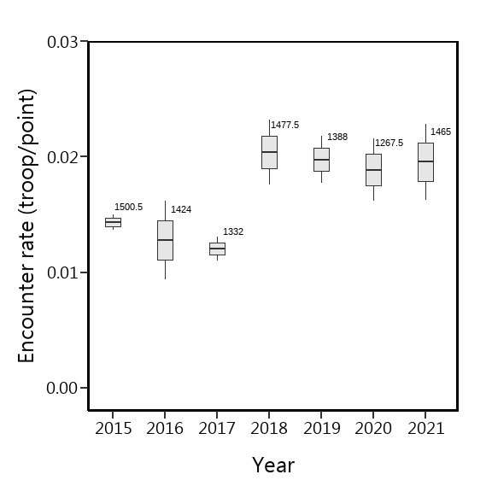

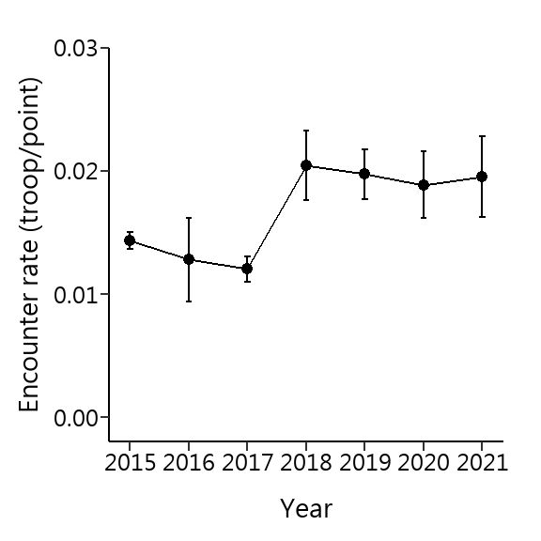

海拔的相對密度

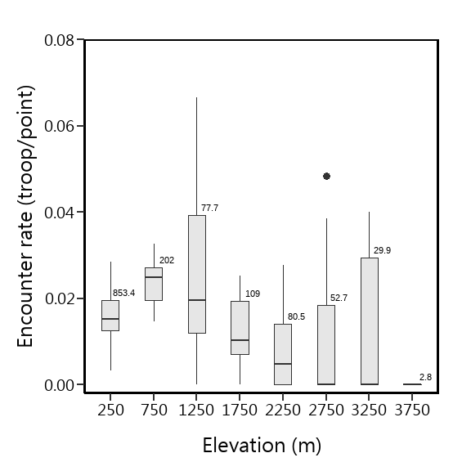

Region的相對密度

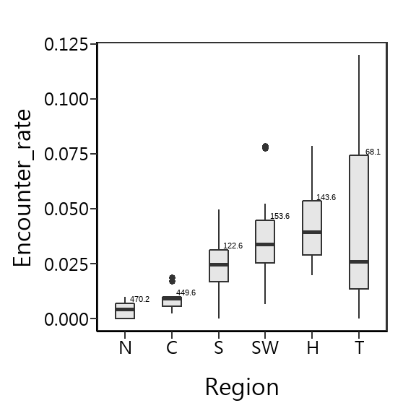

Julian Day的相對密度

Julian Day = 60，係指第60~74天，Julian Day = 75，係指第75~89天，以此類推，僅Julian Day = 180，係指第180~182天

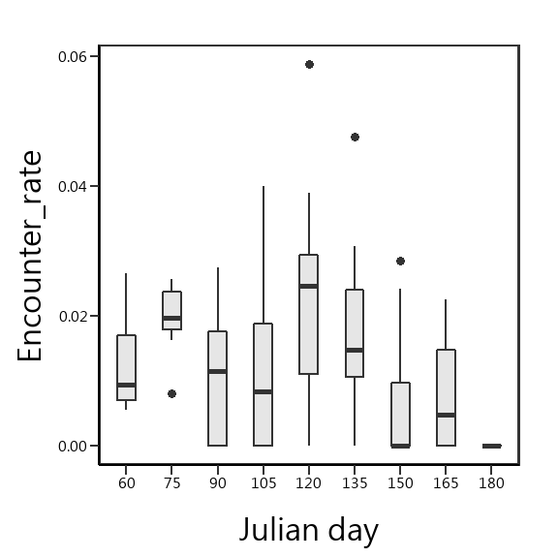

森林類型的相對密度

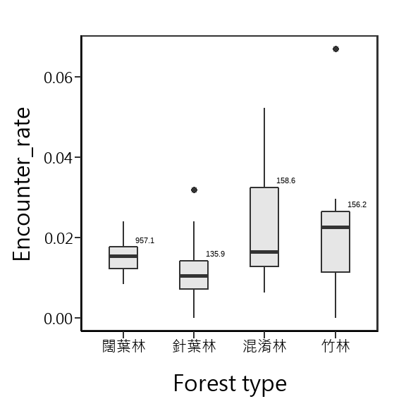

GLMM

Estimate

海拔50m以上的森林總面積=21028.14 (km2)  
方法：bootstrap  
重複抽樣：10,000次  
單位面積的半徑: 100m2

| 項目 | 值 |
| --- | --- |
| 相對密度(群/樣點) | 0.0167 |
| 相對密度(群/樣點)(95% CI) | 0.0150 ~ 0.0186 |
| 絕對密度(群/ km2) | 0.5330 |
| 絕對密度(95% CI) | 0.4781 ~ 0.5911 |
| 群 | 11208群 |
| 猴群數(95% CI): | 10053 ~ 12430群 |

Trim

wald

## Covariate W df p  
## 1 Region2 50.78856 25 0.001701691

| Covariate | W | df | p |
| --- | --- | --- | --- |
| Region2 | 50.78856 | 25 | 0.001701691 |

Index  
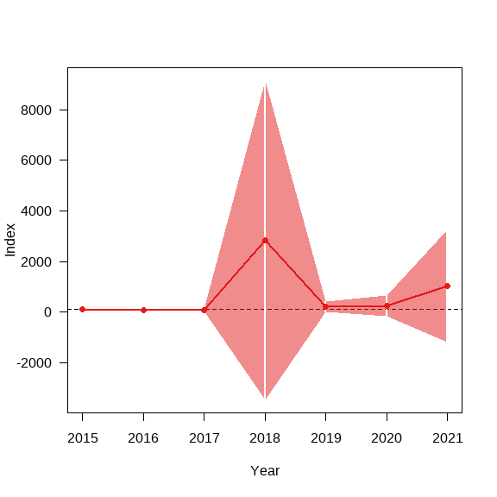

Overall

## from upto add se_add mul se_mul p meaning  
## 2015 2021 0.3656818 0.305743 1.441496 0.4407275 0.2853002 Uncertain

| from | upto | add | se_add | mul | se_mul | p | meaning |
| --- | --- | --- | --- | --- | --- | --- | --- |
| 2015 | 2021 | 0.3656818 | 0.305743 | 1.441496 | 0.4407275 | 0.2853002 | Uncertain |

overall

heatmap

index

