BBS Macaca Data Summary 2023

2024-10-28

**資料統整**

### **原始資料**

#### **調查日3/1~6/30間、包含非森林、包含50m以下**

猴群數量

| variable | Year | 宜蘭縣 | 臺北市 | 新北市 | 桃園市 | 苗栗縣 | 臺中市 | 南投縣 | 雲林縣 | 嘉義縣 | 臺南市 | 高雄市 | 屏東縣 | 花蓮縣 | 臺東縣 | Total |
| --- | --- | --- | --- | --- | --- | --- | --- | --- | --- | --- | --- | --- | --- | --- | --- | --- |
| 筆數 | 2015 | 6 |  | 1 |  | 1 | 6 | 6 | 8 | 1 |  | 2 | 3 | 13 | 2 | 49 |
| 2016 | 2 |  |  |  |  | 3 | 6 | 7 | 2 |  | 2 | 3 | 17 | 1 | 43 |
| 2017 |  |  |  |  |  | 2 | 5 | 7 | 1 |  | 4 | 6 | 5 | 2 | 32 |
| 2018 | 2 |  | 1 |  | 2 | 3 | 7 | 8 | 2 | 3 | 5 | 2 | 9 | 13 | 57 |
| 2019 | 1 |  |  | 1 | 2 | 3 | 11 | 7 | 1 | 1 | 2 | 1 | 13 | 16 | 59 |
| 2020 | 6 | 1 |  |  | 1 | 5 | 7 | 10 | 3 | 3 | 2 | 2 | 15 | 13 | 68 |
| 2021 |  | 1 | 3 |  | 2 | 6 | 8 | 10 | 7 | 1 | 5 | 5 | 11 | 11 | 70 |
| 2022 | 1 | 2 | 5 |  | 4 | 4 | 11 | 13 | 3 | 3 | 4 | 5 | 21 | 21 | 97 |
| 2023 | 3 | 4 | 4 |  | 7 | 6 | 10 | 11 | 7 |  | 13 | 3 | 13 | 8 | 89 |
| 樣區數 | 2015 | 4 |  | 1 |  | 1 | 4 | 5 | 3 | 1 |  | 2 | 2 | 8 | 2 | 33 |
| 2016 | 2 |  |  |  |  | 3 | 6 | 2 | 2 |  | 2 | 2 | 9 | 1 | 29 |
| 2017 |  |  |  |  |  | 1 | 3 | 4 | 1 |  | 1 | 3 | 3 | 2 | 18 |
| 2018 | 2 |  | 1 |  | 1 | 3 | 6 | 2 | 1 | 1 | 2 | 2 | 6 | 6 | 33 |
| 2019 | 1 |  |  | 1 | 2 | 2 | 7 | 2 | 1 | 1 | 1 | 1 | 9 | 9 | 37 |
| 2020 | 4 | 1 |  |  | 1 | 3 | 5 | 3 | 3 | 2 | 2 | 2 | 9 | 5 | 40 |
| 2021 |  | 1 | 3 |  | 2 | 4 | 6 | 2 | 2 | 1 | 2 | 3 | 6 | 6 | 38 |
| 2022 | 1 | 1 | 4 |  | 3 | 3 | 8 | 3 | 1 | 1 | 2 | 3 | 11 | 10 | 51 |
| 2023 | 3 | 1 | 4 |  | 4 | 5 | 9 | 3 | 2 |  | 3 | 3 | 7 | 5 | 49 |
| 樣點數 | 2015 | 5 |  | 1 |  | 1 | 6 | 6 | 7 | 1 |  | 2 | 3 | 12 | 2 | 46 |
| 2016 | 2 |  |  |  |  | 3 | 6 | 7 | 2 |  | 2 | 2 | 16 | 1 | 41 |
| 2017 |  |  |  |  |  | 2 | 4 | 7 | 1 |  | 4 | 5 | 5 | 2 | 30 |
| 2018 | 2 |  | 1 |  | 2 | 3 | 7 | 6 | 2 | 2 | 5 | 2 | 9 | 12 | 53 |
| 2019 | 1 |  |  | 1 | 2 | 2 | 11 | 5 | 1 | 1 | 2 | 1 | 12 | 13 | 52 |
| 2020 | 6 | 1 |  |  | 1 | 5 | 7 | 9 | 3 | 3 | 2 | 2 | 14 | 11 | 64 |
| 2021 |  | 1 | 3 |  | 2 | 5 | 8 | 8 | 6 | 1 | 5 | 5 | 10 | 10 | 64 |
| 2022 | 1 | 2 | 5 |  | 4 | 4 | 11 | 11 | 3 | 2 | 4 | 5 | 20 | 19 | 91 |
| 2023 | 3 | 4 | 4 |  | 7 | 6 | 10 | 9 | 7 |  | 9 | 3 | 13 | 8 | 83 |

孤猴數量

| variable | Year | 宜蘭縣 | 臺北市 | 新北市 | 新竹縣 | 苗栗縣 | 臺中市 | 南投縣 | 雲林縣 | 嘉義縣 | 臺南市 | 高雄市 | 屏東縣 | 花蓮縣 | 臺東縣 | Total |
| --- | --- | --- | --- | --- | --- | --- | --- | --- | --- | --- | --- | --- | --- | --- | --- | --- |
| 筆數 | 2015 |  |  |  |  | 1 | 2 | 1 | 4 | 1 |  | 6 |  | 10 |  | 25 |
| 2016 | 1 |  |  |  |  |  | 1 |  |  |  | 5 | 3 | 4 | 1 | 15 |
| 2017 |  |  |  |  |  | 2 | 2 | 5 |  |  | 1 | 2 | 3 |  | 15 |
| 2018 |  |  |  |  |  | 4 | 3 | 2 | 2 |  |  | 1 | 13 | 4 | 29 |
| 2019 | 1 |  | 1 |  |  |  | 4 | 1 | 1 | 2 | 4 | 1 | 4 | 1 | 20 |
| 2020 | 1 |  |  | 1 |  | 6 | 5 | 1 | 4 | 1 | 7 | 3 | 3 | 3 | 35 |
| 2021 | 2 |  | 1 |  | 2 |  | 8 | 2 | 1 | 2 | 4 | 4 | 7 | 2 | 35 |
| 2022 | 2 |  | 3 |  |  |  | 10 | 2 |  | 3 | 4 | 3 | 7 | 6 | 40 |
| 2023 | 4 | 2 | 2 |  | 4 | 2 | 2 | 3 | 4 |  | 5 | 1 | 10 | 5 | 44 |
| 樣區數 | 2015 |  |  |  |  | 1 | 2 | 1 | 2 | 1 |  | 2 |  | 6 |  | 15 |
| 2016 | 1 |  |  |  |  |  | 1 |  |  |  | 3 | 2 | 4 | 1 | 12 |
| 2017 |  |  |  |  |  | 2 | 2 | 2 |  |  | 1 | 1 | 3 |  | 11 |
| 2018 |  |  |  |  |  | 4 | 3 | 2 | 1 |  |  | 1 | 8 | 4 | 23 |
| 2019 | 1 |  | 1 |  |  |  | 3 | 1 | 1 | 1 | 4 | 1 | 3 | 1 | 17 |
| 2020 | 1 |  |  | 1 |  | 2 | 5 | 1 | 3 | 1 | 4 | 2 | 2 | 2 | 24 |
| 2021 | 2 |  | 1 |  | 2 |  | 7 | 2 | 1 | 1 | 3 | 3 | 5 | 2 | 29 |
| 2022 | 2 |  | 2 |  |  |  | 9 | 2 |  | 1 | 2 | 3 | 4 | 3 | 28 |
| 2023 | 3 | 2 | 2 |  | 4 | 2 | 2 | 3 | 2 |  | 4 | 1 | 7 | 3 | 35 |
| 樣點數 | 2015 |  |  |  |  | 1 | 2 | 1 | 4 | 1 |  | 6 |  | 8 |  | 23 |
| 2016 | 1 |  |  |  |  |  | 1 |  |  |  | 4 | 3 | 4 | 1 | 14 |
| 2017 |  |  |  |  |  | 2 | 2 | 5 |  |  | 1 | 2 | 3 |  | 15 |
| 2018 |  |  |  |  |  | 4 | 3 | 2 | 2 |  |  | 1 | 13 | 4 | 29 |
| 2019 | 1 |  | 1 |  |  |  | 3 | 1 | 1 | 1 | 4 | 1 | 4 | 1 | 18 |
| 2020 | 1 |  |  | 1 |  | 4 | 5 | 1 | 4 | 1 | 7 | 3 | 3 | 3 | 33 |
| 2021 | 2 |  | 1 |  | 2 |  | 8 | 2 | 1 | 2 | 4 | 4 | 7 | 2 | 35 |
| 2022 | 2 |  | 3 |  |  |  | 10 | 2 |  | 3 | 3 | 3 | 7 | 5 | 38 |
| 2023 | 4 | 2 | 2 |  | 4 | 2 | 2 | 3 | 4 |  | 5 | 1 | 10 | 5 | 44 |

### **分析用**

#### **調查日3/1~6/30間、“不”包含非森林、“不”包含50m以下**

猴群數量

| variable | Year | 宜蘭縣 | 臺北市 | 新北市 | 桃園市 | 苗栗縣 | 臺中市 | 南投縣 | 雲林縣 | 嘉義縣 | 臺南市 | 高雄市 | 屏東縣 | 花蓮縣 | 臺東縣 | Total |
| --- | --- | --- | --- | --- | --- | --- | --- | --- | --- | --- | --- | --- | --- | --- | --- | --- |
| 筆數 | 2015 | 5 |  | 1 |  | 1 | 6 | 6 | 8 |  |  | 2 | 3 | 12 | 2 | 46 |
| 2016 | 1 |  |  |  |  | 3 | 6 | 7 | 2 |  | 2 | 3 | 17 | 1 | 42 |
| 2017 |  |  |  |  |  |  | 5 | 7 | 1 |  | 4 | 5 | 5 | 2 | 29 |
| 2018 | 2 |  | 1 |  | 2 | 2 | 7 | 8 | 2 | 3 | 5 | 2 | 8 | 13 | 55 |
| 2019 |  |  |  | 1 | 2 | 3 | 11 | 7 | 1 | 1 | 2 | 1 | 12 | 15 | 56 |
| 2020 | 6 | 1 |  |  | 1 | 5 | 7 | 10 | 3 | 3 | 2 | 2 | 13 | 13 | 66 |
| 2021 |  | 1 | 3 |  | 2 | 5 | 7 | 10 | 7 | 1 | 3 | 5 | 11 | 11 | 66 |
| 2022 |  | 2 | 5 |  | 4 | 4 | 9 | 13 | 3 | 3 | 4 | 2 | 20 | 21 | 90 |
| 2023 | 3 | 4 | 4 |  | 7 | 5 | 10 | 11 | 7 |  | 12 | 2 | 13 | 8 | 86 |
| 樣區數 | 2015 | 3 |  | 1 |  | 1 | 4 | 5 | 3 |  |  | 2 | 2 | 7 | 2 | 30 |
| 2016 | 1 |  |  |  |  | 3 | 6 | 2 | 2 |  | 2 | 2 | 9 | 1 | 28 |
| 2017 |  |  |  |  |  |  | 3 | 4 | 1 |  | 1 | 2 | 3 | 2 | 16 |
| 2018 | 2 |  | 1 |  | 1 | 2 | 6 | 2 | 1 | 1 | 2 | 2 | 5 | 6 | 31 |
| 2019 |  |  |  | 1 | 2 | 2 | 7 | 2 | 1 | 1 | 1 | 1 | 8 | 9 | 35 |
| 2020 | 4 | 1 |  |  | 1 | 3 | 5 | 3 | 3 | 2 | 2 | 2 | 7 | 5 | 38 |
| 2021 |  | 1 | 3 |  | 2 | 4 | 5 | 2 | 2 | 1 | 2 | 3 | 6 | 6 | 37 |
| 2022 |  | 1 | 4 |  | 3 | 3 | 7 | 3 | 1 | 1 | 2 | 2 | 10 | 10 | 47 |
| 2023 | 3 | 1 | 4 |  | 4 | 5 | 9 | 3 | 2 |  | 3 | 2 | 7 | 5 | 48 |
| 樣點數 | 2015 | 4 |  | 1 |  | 1 | 6 | 6 | 7 |  |  | 2 | 3 | 11 | 2 | 43 |
| 2016 | 1 |  |  |  |  | 3 | 6 | 7 | 2 |  | 2 | 2 | 16 | 1 | 40 |
| 2017 |  |  |  |  |  |  | 4 | 7 | 1 |  | 4 | 4 | 5 | 2 | 27 |
| 2018 | 2 |  | 1 |  | 2 | 2 | 7 | 6 | 2 | 2 | 5 | 2 | 8 | 12 | 51 |
| 2019 |  |  |  | 1 | 2 | 2 | 11 | 5 | 1 | 1 | 2 | 1 | 11 | 12 | 49 |
| 2020 | 6 | 1 |  |  | 1 | 5 | 7 | 9 | 3 | 3 | 2 | 2 | 12 | 11 | 62 |
| 2021 |  | 1 | 3 |  | 2 | 4 | 7 | 8 | 6 | 1 | 3 | 5 | 10 | 10 | 60 |
| 2022 |  | 2 | 5 |  | 4 | 4 | 9 | 11 | 3 | 2 | 4 | 2 | 19 | 19 | 84 |
| 2023 | 3 | 4 | 4 |  | 7 | 5 | 10 | 9 | 7 |  | 8 | 2 | 13 | 8 | 80 |

孤猴數量

| variable | Year | 宜蘭縣 | 臺北市 | 新北市 | 新竹縣 | 苗栗縣 | 臺中市 | 南投縣 | 雲林縣 | 嘉義縣 | 臺南市 | 高雄市 | 屏東縣 | 花蓮縣 | 臺東縣 | Total |
| --- | --- | --- | --- | --- | --- | --- | --- | --- | --- | --- | --- | --- | --- | --- | --- | --- |
| 筆數 | 2015 |  |  |  |  | 1 | 2 | 1 | 4 | 1 |  | 6 |  | 9 |  | 24 |
| 2016 | 1 |  |  |  |  |  | 1 |  |  |  | 5 | 2 | 3 |  | 12 |
| 2017 |  |  |  |  |  | 2 | 2 | 5 |  |  | 1 | 2 | 2 |  | 14 |
| 2018 |  |  |  |  |  | 4 | 2 | 2 | 2 |  |  | 1 | 12 | 4 | 27 |
| 2019 | 1 |  | 1 |  |  |  | 4 | 1 | 1 | 2 | 3 | 1 | 4 | 1 | 19 |
| 2020 | 1 |  |  | 1 |  | 6 | 5 | 1 | 4 | 1 | 6 | 3 | 1 | 3 | 32 |
| 2021 | 2 |  | 1 |  | 2 |  | 8 | 2 | 1 | 2 | 3 | 3 | 7 | 2 | 33 |
| 2022 | 1 |  | 2 |  |  |  | 9 | 2 |  | 3 | 4 | 3 | 6 | 6 | 36 |
| 2023 | 4 | 2 | 2 |  | 4 | 1 | 2 | 3 | 4 |  | 5 | 1 | 9 | 5 | 42 |
| 樣區數 | 2015 |  |  |  |  | 1 | 2 | 1 | 2 | 1 |  | 2 |  | 5 |  | 14 |
| 2016 | 1 |  |  |  |  |  | 1 |  |  |  | 3 | 1 | 3 |  | 9 |
| 2017 |  |  |  |  |  | 2 | 2 | 2 |  |  | 1 | 1 | 2 |  | 10 |
| 2018 |  |  |  |  |  | 4 | 2 | 2 | 1 |  |  | 1 | 7 | 4 | 21 |
| 2019 | 1 |  | 1 |  |  |  | 3 | 1 | 1 | 1 | 3 | 1 | 3 | 1 | 16 |
| 2020 | 1 |  |  | 1 |  | 2 | 5 | 1 | 3 | 1 | 3 | 2 | 1 | 2 | 22 |
| 2021 | 2 |  | 1 |  | 2 |  | 7 | 2 | 1 | 1 | 2 | 2 | 5 | 2 | 27 |
| 2022 | 1 |  | 2 |  |  |  | 8 | 2 |  | 1 | 2 | 3 | 3 | 3 | 25 |
| 2023 | 3 | 2 | 2 |  | 4 | 1 | 2 | 3 | 2 |  | 4 | 1 | 6 | 3 | 33 |
| 樣點數 | 2015 |  |  |  |  | 1 | 2 | 1 | 4 | 1 |  | 6 |  | 7 |  | 22 |
| 2016 | 1 |  |  |  |  |  | 1 |  |  |  | 4 | 2 | 3 |  | 11 |
| 2017 |  |  |  |  |  | 2 | 2 | 5 |  |  | 1 | 2 | 2 |  | 14 |
| 2018 |  |  |  |  |  | 4 | 2 | 2 | 2 |  |  | 1 | 12 | 4 | 27 |
| 2019 | 1 |  | 1 |  |  |  | 3 | 1 | 1 | 1 | 3 | 1 | 4 | 1 | 17 |
| 2020 | 1 |  |  | 1 |  | 4 | 5 | 1 | 4 | 1 | 6 | 3 | 1 | 3 | 30 |
| 2021 | 2 |  | 1 |  | 2 |  | 8 | 2 | 1 | 2 | 3 | 3 | 7 | 2 | 33 |
| 2022 | 1 |  | 2 |  |  |  | 9 | 2 |  | 3 | 3 | 3 | 6 | 5 | 34 |
| 2023 | 4 | 2 | 2 |  | 4 | 1 | 2 | 3 | 4 |  | 5 | 1 | 9 | 5 | 42 |

2015 ~ 2023 年間，每年位在海拔50 m以上森林的調查樣點數、臺灣獼猴( *Macaca cyclopis* )的猴群數及相對密度

| TypeName.1 | 樣點數 | | 猴群數 | | 相對密度 | |
| --- | --- | --- | --- | --- | --- | --- |
| Mean | Se | Mean | Se | Mean | Se |
| 2015 | 1502.5 | 36.5 | 23.0 | 1.0 | 0.0153 | 0.0003 |
| 2016 | 1421.0 | 63.0 | 21.0 | 4.0 | 0.0149 | 0.0035 |
| 2017 | 1326.0 | 30.0 | 14.5 | 2.5 | 0.0110 | 0.0021 |
| 2018 | 1473.5 | 57.5 | 27.5 | 4.5 | 0.0188 | 0.0038 |
| 2019 | 1387.0 | 35.0 | 28.0 | 4.0 | 0.0201 | 0.0024 |
| 2020 | 1582.0 | 37.0 | 33.0 | 2.0 | 0.0208 | 0.0008 |
| 2021 | 1489.5 | 195.5 | 33.0 | 1.0 | 0.0225 | 0.0023 |
| 2022 | 1757.5 | 59.5 | 45.0 | 1.0 | 0.0257 | 0.0014 |
| 2023 | 1853.0 | 84.0 | 43.0 | 12.0 | 0.0230 | 0.0054 |

2015 ~ 2023 年位在海拔50 m以上森林的調查樣點數、臺灣獼猴( *Macaca cyclopis* )的猴群數及相對密度

| TypeName.1 | 樣點數 | | 猴群數 | | 相對密度 | |
| --- | --- | --- | --- | --- | --- | --- |
| Mean | Se | Mean | Se | Mean | Se |
| North | 522.8 | 24.1 | 3.3 | 0.8 | 0.0057 | 0.0011 |
| Center | 494.8 | 13.9 | 5.6 | 0.5 | 0.0112 | 0.0008 |
| South | 141.0 | 7.4 | 3.4 | 0.4 | 0.0245 | 0.0030 |
| Southwest | 143.3 | 2.8 | 6.6 | 0.7 | 0.0466 | 0.0052 |
| Hualien | 152.9 | 2.9 | 6.2 | 0.6 | 0.0403 | 0.0043 |
| Taitung | 77.7 | 5.0 | 4.8 | 0.9 | 0.0579 | 0.0098 |
| TW | 1532.4 | 44.2 | 29.8 | 2.6 | 0.0191 | 0.0013 |

2015 ~ 2023年各森林類型內的調查樣點數、臺灣獼猴( *Macaca cyclopis* )的猴群數及相對密度

| TypeName.1 | 樣點數 | | 猴群數 | | 相對密度 | |
| --- | --- | --- | --- | --- | --- | --- |
| Mean | Se | Mean | Se | Mean | Se |
| Forest (EL>50m) | 1532.4 | 44.2 | 29.8 | 2.6 | 0.0191 | 0.0013 |
| 闊葉林 | 1052.6 | 33.1 | 20.3 | 2.1 | 0.0188 | 0.0015 |
| 針葉林 | 146.4 | 6.2 | 2.3 | 0.3 | 0.0157 | 0.0018 |
| 混淆林 | 164.7 | 3.6 | 3.8 | 0.5 | 0.0234 | 0.0034 |
| 竹林 | 168.7 | 4.0 | 3.3 | 0.5 | 0.0203 | 0.0034 |
| Forest (EL<50m) | 197.0 | 8.3 | 0.5 | 0.2 | 0.0025 | 0.0008 |
| 非森林 | 1157.1 | 97.1 | 0.7 | 0.2 | 0.0005 | 0.0002 |
| Total | 2714.7 | 223.6 | 27.9 | 3.2 | 0.0091 | 0.0009 |

年的相對密度

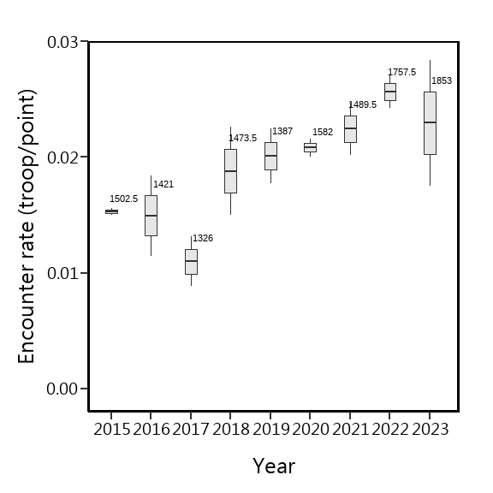

Region的相對密度

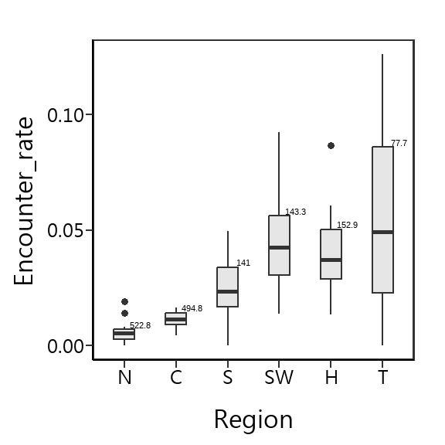

森林類型的相對密度

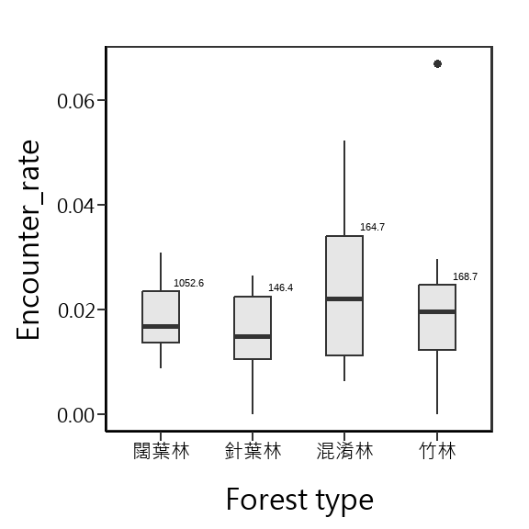

海拔的相對密度

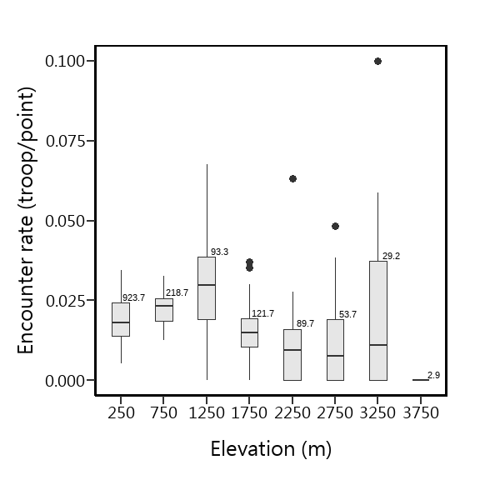

Julian Day的相對密度

Julian Day = 60，係指第60~74天，Julian Day = 75，係指第75~89天，以此類推，僅Julian Day = 180，係指第180~182天

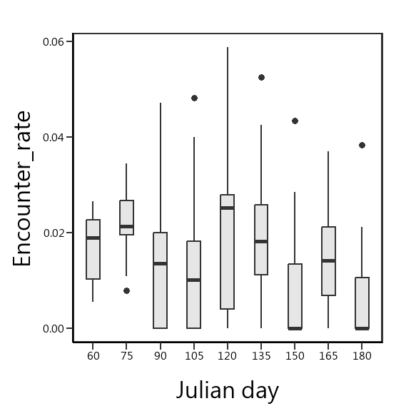

**GLMM**

**Trim**

Goodness of fit:

## Goodness of fit:  
## Chi-square = 2225.33, df=2251, p=0.6458  
## Likelihood Ratio = 1475.19, df=2251, p=1.0000  
## AIC (up to a constant) = -3026.81

Wald test for significance of covariates

| Covariate | Wald_test | df | p |
| --- | --- | --- | --- |
| Region2 | 60.0173 | 35 | 0.0053 |

Wald test for significance of changes in slope

| Changepoint | Wald_test | df | p |
| --- | --- | --- | --- |
| 2015 | 9.631 | 6 | 0.141 |
| 2017 | 9.888 | 6 | 0.129 |
| 2018 | 8.344 | 6 | 0.214 |
| 2019 | 4.243 | 6 | 0.644 |
| 2020 | 2.818 | 6 | 0.831 |
| 2021 | 5.897 | 6 | 0.435 |
| 2022 | 9.664 | 6 | 0.140 |

Index

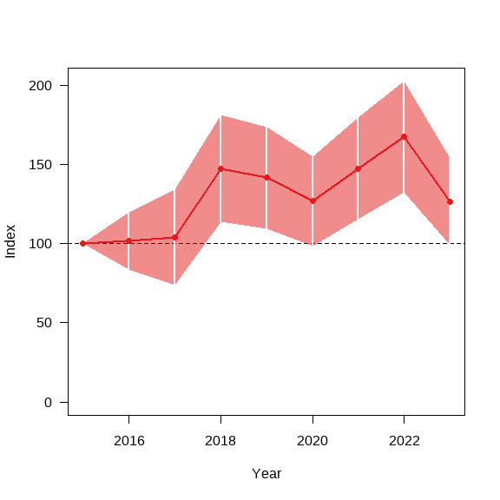

Overall

## from upto add se_add mul se_mul p meaning  
## 2015 2023 0.04966655 0.0235984 1.050921 0.02480005 0.0733649 Uncertain

| from | upto | add | se_add | mul | se_mul | p | meaning |
| --- | --- | --- | --- | --- | --- | --- | --- |
| 2015 | 2023 | 0.050 | 0.024 | 1.051 | 0.025 | 0.073 | Uncertain |

**Estimate**

海拔50m以上的森林總面積=21028.14 (km2)  
方法：bootstrap  
重複抽樣：10,000次  
單位面積的半徑: 100m2

資料範圍：2015-2023

| 項目 | 值 |
| --- | --- |
| 相對密度(群/樣點) | 0.0194 |
| 相對密度(群/樣點)(95% CI) | 0.0178~0.0211 |
| 絕對密度(群/ km^2) | 0.6182 |
| $\text{北部地區}\geq 20$ | 0.6182 |
| 絕對密度(95% CI) | 0.5666~0.6705 |
| 群 | 13000 |
| 猴群數(95% CI) | 11914~14098 |

資料範圍:2020-2023

| 項目 | 值 |
| --- | --- |
| 相對密度(群/樣點) | 0.0231 |
| 相對密度(群/樣點)(95% CI) | 0.0206~0.0257 |
| 絕對密度(群/ km^2) | 0.7339 |
| 絕對密度(95% CI) | 0.6550~0.8170 |
| 群 | 15432 |
| 猴群數(95% CI) | 11914~17179 |