20250901-猴群數估算

2025-09-01

# **林業署**

相對密度(群/樣點)圖

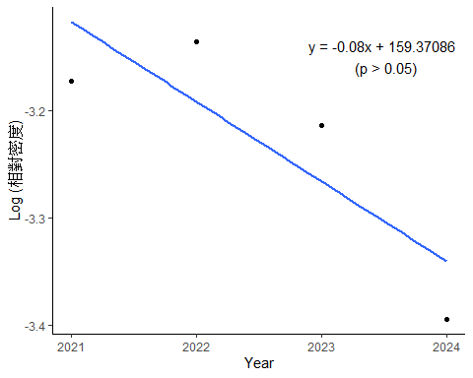

估計**林班地**猴群數

國有林班地內海拔50m以上的森林總面積=13812.00 (km2)  
方法：bootstrap  
重複抽樣：10,000次  
單位面積的半徑: 100m

troop_M_F %>%   
 arrange(M_troops) %>%   
 select(-log_troops) %>%   
   
 flextable::flextable()

| Year | q_1 | mm | q_3 | M_troops | q1_troops | q3_troops | COUNT |
| --- | --- | --- | --- | --- | --- | --- | --- |
| 2,024 | 0.02845709 | 0.03358255 | 0.03890618 | 14,764.55 | 12,511.15 | 17,105.09 | 369,113.9 |
| 2,023 | 0.03417063 | 0.03979027 | 0.04571170 | 17,493.78 | 15,023.10 | 20,097.13 | 437,344.4 |
| 2,021 | 0.03604869 | 0.04192608 | 0.04798689 | 18,432.78 | 15,848.79 | 21,097.42 | 460,819.6 |
| 2,022 | 0.03746859 | 0.04341711 | 0.04934887 | 19,088.32 | 16,473.05 | 21,696.21 | 477,207.9 |

## Warning in grid.Call(C_stringMetric, as.graphicsAnnot(x$label)): font family  
## not found in Windows font database  
## Warning in grid.Call(C_stringMetric, as.graphicsAnnot(x$label)): font family  
## not found in Windows font database

## Warning in grid.Call.graphics(C_text, as.graphicsAnnot(x$label), x$x, x$y, :  
## font family not found in Windows font database  
## Warning in grid.Call.graphics(C_text, as.graphicsAnnot(x$label), x$x, x$y, :  
## font family not found in Windows font database  
## Warning in grid.Call.graphics(C_text, as.graphicsAnnot(x$label), x$x, x$y, :  
## font family not found in Windows font database

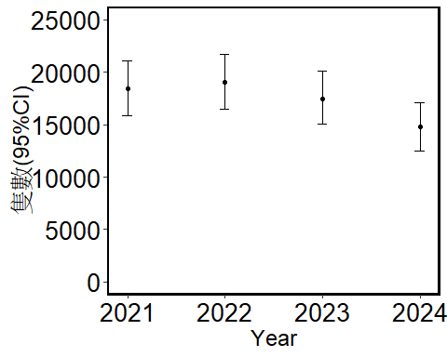

估計**分署**猴群數 50m以上的森林，2021-2024的資料bootstraps

forest_office<- read_xlsx(  
 here::here("./林務局年報2024/分署轄內50m以上的森林面積.xlsx")) %>%   
 select(-perimeter) %>%   
 mutate(area = area/1000000) #換成km2

troop_Office_F %>%   
 arrange(M_troops) %>%   
 select(-log_troops) %>%   
   
 flextable::flextable()

| Office | area | q_1 | mm | q_3 | M_troops | q1_troops | q3_troops | COUNT |
| --- | --- | --- | --- | --- | --- | --- | --- | --- |
| 新竹 | 1,452.644 | 0.006968641 | 0.01088045 | 0.01509872 | 503.1022 | 322.2237 | 698.1513 | 12,577.55 |
| 臺中 | 1,220.207 | 0.015839041 | 0.02143789 | 0.02739726 | 832.6560 | 615.1947 | 1,064.1205 | 20,816.40 |
| 宜蘭 | 1,656.195 | 0.020253165 | 0.02733691 | 0.03493671 | 1,441.1563 | 1,067.7130 | 1,841.8049 | 36,028.91 |
| 南投 | 1,715.066 | 0.023255814 | 0.03039277 | 0.03791709 | 1,659.2093 | 1,269.5869 | 2,069.9786 | 41,480.23 |
| 嘉義 | 1,092.409 | 0.040283311 | 0.04863293 | 0.05754759 | 1,691.0874 | 1,400.7504 | 2,001.0720 | 42,277.19 |
| 屏東 | 1,659.384 | 0.047992165 | 0.05792248 | 0.06807052 | 3,059.4558 | 2,534.9383 | 3,595.4737 | 76,486.40 |
| 花蓮 | 2,931.118 | 0.033736153 | 0.04231888 | 0.05135952 | 3,948.3673 | 3,147.5955 | 4,791.8618 | 98,709.18 |
| 臺東 | 2,084.826 | 0.069380972 | 0.07969900 | 0.09056917 | 5,288.9912 | 4,604.2653 | 6,010.3583 | 132,224.78 |

## Warning in grid.Call(C_textBounds, as.graphicsAnnot(x$label), x$x, x$y, : font  
## family not found in Windows font database  
## Warning in grid.Call(C_textBounds, as.graphicsAnnot(x$label), x$x, x$y, : font  
## family not found in Windows font database

## Warning in grid.Call.graphics(C_text, as.graphicsAnnot(x$label), x$x, x$y, :  
## font family not found in Windows font database  
## Warning in grid.Call.graphics(C_text, as.graphicsAnnot(x$label), x$x, x$y, :  
## font family not found in Windows font database  
## Warning in grid.Call.graphics(C_text, as.graphicsAnnot(x$label), x$x, x$y, :  
## font family not found in Windows font database

