Macaca Data Summary

2023-01-31

資料統整

### **原始資料**

#### **調查日3/1~6/30間、包含非森林、包含50m以下**

猴群數量

| variable | Year | 宜蘭縣 | 臺北市 | 新北市 | 桃園市 | 苗栗縣 | 臺中市 | 南投縣 | 雲林縣 | 嘉義縣 | 臺南市 | 高雄市 | 屏東縣 | 花蓮縣 | 臺東縣 | Total |
| --- | --- | --- | --- | --- | --- | --- | --- | --- | --- | --- | --- | --- | --- | --- | --- | --- |
| 筆數 | 2015 | 3 |  |  |  | 1 | 3 | 2 | 5 | 2 |  | 2 | 3 | 12 | 2 | 35 |
| 2016 | 2 |  |  |  |  | 3 | 4 | 5 | 2 |  | 2 | 3 | 17 | 1 | 39 |
| 2017 |  |  |  |  |  | 2 | 2 | 5 | 2 |  | 4 | 6 | 5 | 2 | 28 |
| 2018 | 1 |  |  |  | 2 | 2 | 4 | 6 | 2 |  | 5 | 2 | 9 | 13 | 46 |
| 2019 | 1 |  |  | 1 | 2 | 2 | 4 | 6 | 2 |  | 2 | 1 | 8 | 11 | 40 |
| 2020 | 4 | 1 |  |  | 1 | 2 | 4 | 8 | 2 | 1 | 2 | 2 | 12 | 10 | 49 |
| 2021 |  | 1 | 2 |  | 2 | 4 | 2 | 8 | 6 |  | 3 | 4 | 11 | 8 | 51 |
| 樣區數 | 2015 | 2 |  |  |  | 1 | 3 | 2 | 2 | 2 |  | 2 | 2 | 7 | 2 | 25 |
| 2016 | 2 |  |  |  |  | 3 | 4 | 1 | 1 |  | 2 | 2 | 8 | 1 | 24 |
| 2017 |  |  |  |  |  | 1 | 1 | 2 | 2 |  | 1 | 3 | 3 | 2 | 15 |
| 2018 | 1 |  |  |  | 1 | 2 | 3 | 1 | 1 |  | 2 | 2 | 6 | 6 | 25 |
| 2019 | 1 |  |  | 1 | 2 | 1 | 3 | 1 | 2 |  | 1 | 1 | 6 | 7 | 26 |
| 2020 | 2 | 1 |  |  | 1 | 1 | 3 | 2 | 2 | 1 | 2 | 2 | 7 | 3 | 27 |
| 2021 |  | 1 | 2 |  | 2 | 3 | 2 | 1 | 1 |  | 1 | 2 | 6 | 5 | 26 |
| 樣點數 | 2015 | 2 |  |  |  | 1 | 3 | 2 | 4 | 2 |  | 2 | 3 | 11 | 2 | 32 |
| 2016 | 2 |  |  |  |  | 3 | 4 | 5 | 1 |  | 2 | 2 | 15 | 1 | 35 |
| 2017 |  |  |  |  |  | 2 | 1 | 5 | 2 |  | 4 | 5 | 5 | 2 | 26 |
| 2018 | 1 |  |  |  | 2 | 2 | 4 | 4 | 2 |  | 5 | 2 | 9 | 12 | 43 |
| 2019 | 1 |  |  | 1 | 2 | 1 | 4 | 4 | 2 |  | 2 | 1 | 8 | 9 | 35 |
| 2020 | 4 | 1 |  |  | 1 | 2 | 4 | 7 | 2 | 1 | 2 | 2 | 11 | 8 | 45 |
| 2021 |  | 1 | 2 |  | 2 | 4 | 2 | 6 | 5 |  | 3 | 4 | 10 | 7 | 46 |

孤猴數量

| variable | Year | 宜蘭縣 | 新北市 | 新竹縣 | 苗栗縣 | 臺中市 | 南投縣 | 雲林縣 | 嘉義縣 | 高雄市 | 屏東縣 | 花蓮縣 | 臺東縣 | Total |
| --- | --- | --- | --- | --- | --- | --- | --- | --- | --- | --- | --- | --- | --- | --- |
| 筆數 | 2015 |  |  |  | 1 | 2 | 1 | 4 | 1 | 4 |  | 9 |  | 22 |
| 2016 | 1 |  |  |  |  | 1 |  |  | 4 | 3 | 5 | 1 | 15 |
| 2017 |  |  |  |  | 2 | 1 |  |  |  | 2 | 3 |  | 8 |
| 2018 |  |  |  |  | 3 | 3 | 2 | 2 |  | 1 | 12 | 2 | 25 |
| 2019 | 1 | 1 |  |  |  | 3 | 1 | 1 | 3 | 1 | 4 | 1 | 16 |
| 2020 |  |  | 1 |  | 1 | 4 | 1 | 3 | 6 | 3 | 1 | 1 | 21 |
| 2021 | 1 |  |  | 2 |  | 5 | 2 | 1 | 4 | 4 | 5 | 1 | 25 |
| 樣區數 | 2015 |  |  |  | 1 | 2 | 1 | 2 | 1 | 1 |  | 5 |  | 13 |
| 2016 | 1 |  |  |  |  | 1 |  |  | 2 | 2 | 3 | 1 | 10 |
| 2017 |  |  |  |  | 2 | 1 |  |  |  | 1 | 3 |  | 7 |
| 2018 |  |  |  |  | 3 | 3 | 2 | 1 |  | 1 | 7 | 2 | 19 |
| 2019 | 1 | 1 |  |  |  | 2 | 1 | 1 | 3 | 1 | 3 | 1 | 14 |
| 2020 |  |  | 1 |  | 1 | 4 | 1 | 2 | 3 | 2 | 1 | 1 | 16 |
| 2021 | 1 |  |  | 2 |  | 4 | 2 | 1 | 3 | 3 | 4 | 1 | 21 |
| 樣點數 | 2015 |  |  |  | 1 | 2 | 1 | 4 | 1 | 4 |  | 7 |  | 20 |
| 2016 | 1 |  |  |  |  | 1 |  |  | 3 | 3 | 3 | 1 | 12 |
| 2017 |  |  |  |  | 2 | 1 |  |  |  | 2 | 3 |  | 8 |
| 2018 |  |  |  |  | 3 | 3 | 2 | 2 |  | 1 | 11 | 2 | 24 |
| 2019 | 1 | 1 |  |  |  | 2 | 1 | 1 | 3 | 1 | 4 | 1 | 15 |
| 2020 |  |  | 1 |  | 1 | 4 | 1 | 3 | 6 | 3 | 1 | 1 | 21 |
| 2021 | 1 |  |  | 2 |  | 5 | 2 | 1 | 4 | 4 | 5 | 1 | 25 |

### **分析用**

#### **調查日3/1~6/30間、“不”包含非森林、“不”包含50m以下**

猴群數量

| variable | Year | 宜蘭縣 | 臺北市 | 新北市 | 桃園市 | 苗栗縣 | 臺中市 | 南投縣 | 雲林縣 | 嘉義縣 | 臺南市 | 高雄市 | 屏東縣 | 花蓮縣 | 臺東縣 | Total |
| --- | --- | --- | --- | --- | --- | --- | --- | --- | --- | --- | --- | --- | --- | --- | --- | --- |
| 筆數 | 2015 | 2 |  |  |  | 1 | 3 | 2 | 5 | 1 |  | 2 | 3 | 12 | 2 | 33 |
| 2016 | 1 |  |  |  |  | 3 | 4 | 5 | 2 |  | 2 | 3 | 17 | 1 | 38 |
| 2017 |  |  |  |  |  |  | 2 | 5 | 2 |  | 4 | 5 | 5 | 2 | 25 |
| 2018 | 1 |  |  |  | 2 | 1 | 4 | 6 | 2 |  | 5 | 2 | 7 | 13 | 43 |
| 2019 |  |  |  | 1 | 2 | 2 | 4 | 6 | 2 |  | 2 | 1 | 8 | 10 | 38 |
| 2020 | 4 | 1 |  |  | 1 | 2 | 4 | 8 | 2 | 1 | 2 | 2 | 11 | 10 | 48 |
| 2021 |  | 1 | 2 |  | 2 | 3 | 2 | 8 | 6 |  | 1 | 4 | 11 | 8 | 48 |
| 樣區數 | 2015 | 1 |  |  |  | 1 | 3 | 2 | 2 | 1 |  | 2 | 2 | 7 | 2 | 23 |
| 2016 | 1 |  |  |  |  | 3 | 4 | 1 | 1 |  | 2 | 2 | 8 | 1 | 23 |
| 2017 |  |  |  |  |  |  | 1 | 2 | 2 |  | 1 | 2 | 3 | 2 | 13 |
| 2018 | 1 |  |  |  | 1 | 1 | 3 | 1 | 1 |  | 2 | 2 | 4 | 6 | 22 |
| 2019 |  |  |  | 1 | 2 | 1 | 3 | 1 | 2 |  | 1 | 1 | 6 | 7 | 25 |
| 2020 | 2 | 1 |  |  | 1 | 1 | 3 | 2 | 2 | 1 | 2 | 2 | 6 | 3 | 26 |
| 2021 |  | 1 | 2 |  | 2 | 3 | 2 | 1 | 1 |  | 1 | 2 | 6 | 5 | 26 |
| 樣點數 | 2015 | 1 |  |  |  | 1 | 3 | 2 | 4 | 1 |  | 2 | 3 | 11 | 2 | 30 |
| 2016 | 1 |  |  |  |  | 3 | 4 | 5 | 1 |  | 2 | 2 | 15 | 1 | 34 |
| 2017 |  |  |  |  |  |  | 1 | 5 | 2 |  | 4 | 4 | 5 | 2 | 23 |
| 2018 | 1 |  |  |  | 2 | 1 | 4 | 4 | 2 |  | 5 | 2 | 7 | 12 | 40 |
| 2019 |  |  |  | 1 | 2 | 1 | 4 | 4 | 2 |  | 2 | 1 | 8 | 8 | 33 |
| 2020 | 4 | 1 |  |  | 1 | 2 | 4 | 7 | 2 | 1 | 2 | 2 | 10 | 8 | 44 |
| 2021 |  | 1 | 2 |  | 2 | 3 | 2 | 6 | 5 |  | 1 | 4 | 10 | 7 | 43 |

孤猴數量

| variable | Year | 宜蘭縣 | 新北市 | 新竹縣 | 苗栗縣 | 臺中市 | 南投縣 | 雲林縣 | 嘉義縣 | 高雄市 | 屏東縣 | 花蓮縣 | 臺東縣 | Total |
| --- | --- | --- | --- | --- | --- | --- | --- | --- | --- | --- | --- | --- | --- | --- |
| 筆數 | 2015 |  |  |  | 1 | 2 | 1 | 4 | 1 | 4 |  | 9 |  | 22 |
| 2016 | 1 |  |  |  |  | 1 |  |  | 4 | 2 | 3 |  | 11 |
| 2017 |  |  |  |  | 2 | 1 |  |  |  | 2 | 2 |  | 7 |
| 2018 |  |  |  |  | 3 | 2 | 2 | 2 |  | 1 | 10 | 2 | 22 |
| 2019 | 1 | 1 |  |  |  | 3 | 1 | 1 | 2 | 1 | 4 | 1 | 15 |
| 2020 |  |  | 1 |  | 1 | 4 | 1 | 3 | 6 | 3 | 1 | 1 | 21 |
| 2021 | 1 |  |  | 2 |  | 5 | 2 | 1 | 3 | 3 | 5 | 1 | 23 |
| 樣區數 | 2015 |  |  |  | 1 | 2 | 1 | 2 | 1 | 1 |  | 5 |  | 13 |
| 2016 | 1 |  |  |  |  | 1 |  |  | 2 | 1 | 2 |  | 7 |
| 2017 |  |  |  |  | 2 | 1 |  |  |  | 1 | 2 |  | 6 |
| 2018 |  |  |  |  | 3 | 2 | 2 | 1 |  | 1 | 6 | 2 | 17 |
| 2019 | 1 | 1 |  |  |  | 2 | 1 | 1 | 2 | 1 | 3 | 1 | 13 |
| 2020 |  |  | 1 |  | 1 | 4 | 1 | 2 | 3 | 2 | 1 | 1 | 16 |
| 2021 | 1 |  |  | 2 |  | 4 | 2 | 1 | 2 | 2 | 4 | 1 | 19 |
| 樣點數 | 2015 |  |  |  | 1 | 2 | 1 | 4 | 1 | 4 |  | 7 |  | 20 |
| 2016 | 1 |  |  |  |  | 1 |  |  | 3 | 2 | 2 |  | 9 |
| 2017 |  |  |  |  | 2 | 1 |  |  |  | 2 | 2 |  | 7 |
| 2018 |  |  |  |  | 3 | 2 | 2 | 2 |  | 1 | 10 | 2 | 22 |
| 2019 | 1 | 1 |  |  |  | 2 | 1 | 1 | 2 | 1 | 4 | 1 | 14 |
| 2020 |  |  | 1 |  | 1 | 4 | 1 | 3 | 6 | 3 | 1 | 1 | 21 |
| 2021 | 1 |  |  | 2 |  | 5 | 2 | 1 | 3 | 3 | 5 | 1 | 23 |

TypeName、猴群數、樣區數

| TypeName.1 | 樣點數 | | 猴群數 | | 相對密度 | |
| --- | --- | --- | --- | --- | --- | --- |
| Mean | Se | Mean | Se | Mean | Se |
| Forest (EL>50m) | 944.5 | 20.3 | 19.6 | 1.4 | 0.0208 | 0.0015 |
| 闊葉林 | 627.6 | 11.2 | 13.1 | 1.0 | 0.0208 | 0.0015 |
| 針葉林 | 95.1 | 5.1 | 1.7 | 0.3 | 0.0182 | 0.0034 |
| 混淆林 | 116.6 | 3.5 | 2.1 | 0.4 | 0.0188 | 0.0043 |
| 竹林 | 104.0 | 2.2 | 2.6 | 0.4 | 0.0252 | 0.0041 |
| Forest (EL<50m) | 91.6 | 2.0 | 0.3 | 0.1 | 0.0031 | 0.0014 |
| 非森林 | 730.6 | 11.8 | 0.4 | 0.2 | 0.0006 | 0.0003 |
| Total | 1766.7 | 30.6 | 20.3 | 1.4 | 0.0115 | 0.0008 |

年的相對密度

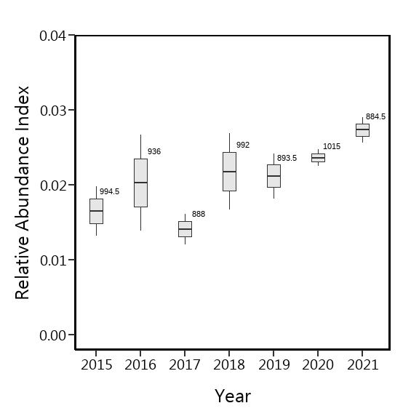

海拔的相對密度

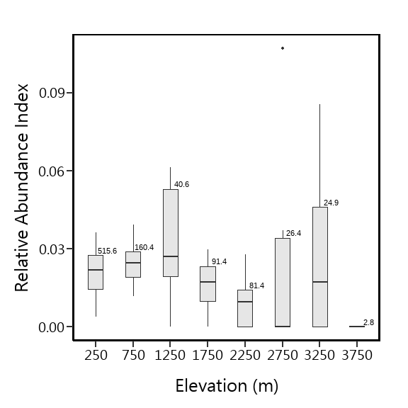

Latitde的相對密度

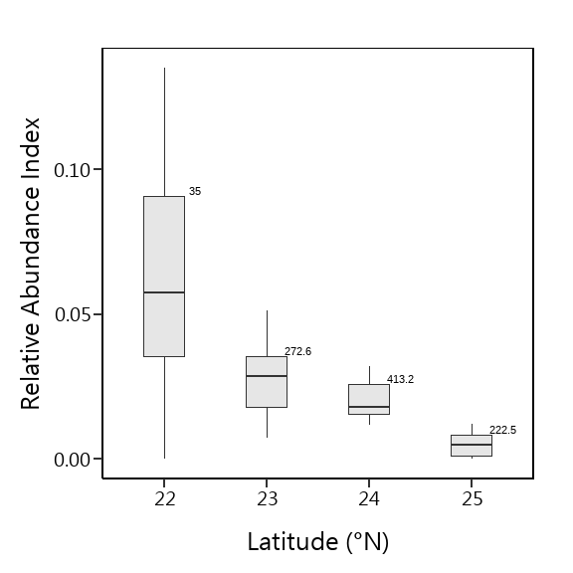

Julian Day的相對密度

Julian Day = 60，係指第60~74天，Julian Day = 75，係指第75~89天，以此類推，僅Julian Day = 180，係指第180~182天

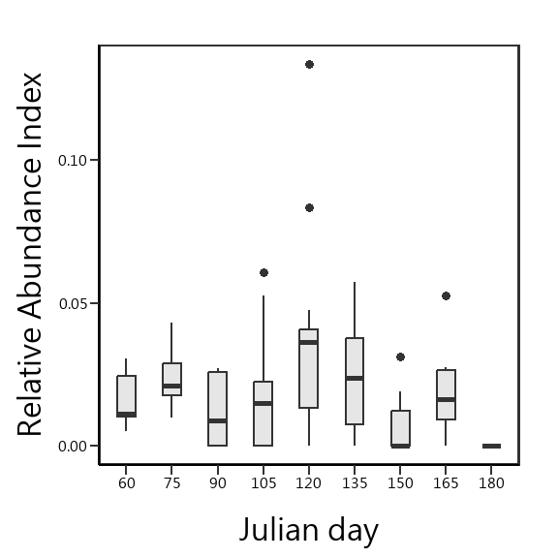

森林類型的相對密度

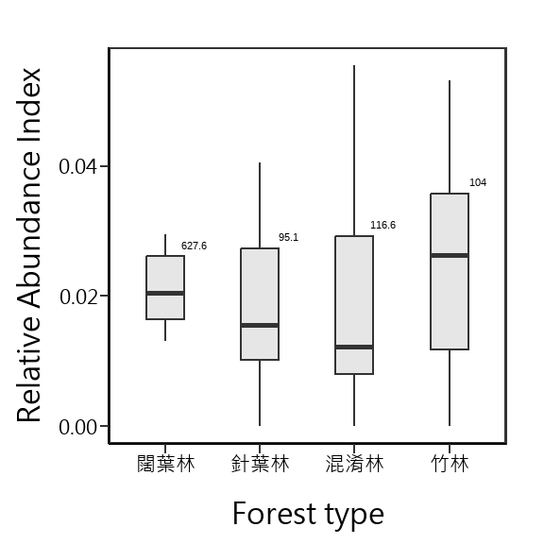

GLMM

#———————————————————————

#==============================================

model <- glmer(Macaca_sur ~ Altitude.1 + julian.D.1 +Latitude+ (1|Site_N) , df,   
 family = binomial(link = "logit") )  
car::vif(model)

## Altitude.1 julian.D.1 Latitude   
## 1.071631 1.032519 1.038502

library(ggcorrplot)

## Warning: 套件 'ggcorrplot' 是用 R 版本 4.2.2 來建造的

corr <-   
 df %>%   
 dplyr::select(Altitude,julian.D,Latitude) %>%   
 cor(.) %>%   
 round(1)  
  
ggcorrplot(corr,  
 hc.order = TRUE,  
 type = "lower",  
 lab = TRUE)

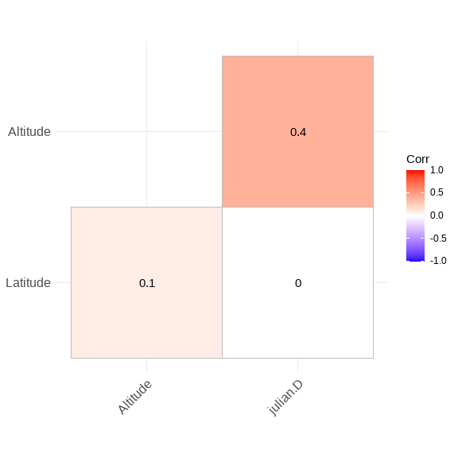

#——————————————-

m1 <- glmer(Macaca_sur ~ TypeName.1 + Altitude.1 + julian.D.1 + Latitude + (1|Site_N),   
 family = binomial(link = "logit"), data = df,  
 control = glmerControl(optimizer = "bobyqa"))

Anova(m1)

## Analysis of Deviance Table (Type II Wald chisquare tests)  
##   
## Response: Macaca_sur  
## Chisq Df Pr(>Chisq)   
## TypeName.1 7.2142 3 0.06538 .   
## Altitude.1 2.9721 1 0.08471 .   
## julian.D.1 0.7094 1 0.39963   
## Latitude 17.1671 1 3.423e-05 ***  
## ---  
## Signif. codes: 0 '***' 0.001 '**' 0.01 '*' 0.05 '.' 0.1 ' ' 1

df %>%   
 filter(Macaca_sur ==1) %>%   
 dim

## [1] 273 27

sw(d1)

## Latitude TypeName.1 Altitude.1 julian.D.1  
## Sum of weights: 1.00 0.72 0.68 0.37   
## N containing models: 8 8 8 8

#anova table

Anova(m2)

## Analysis of Deviance Table (Type II Wald chisquare tests)  
##   
## Response: Macaca_sur  
## Chisq Df Pr(>Chisq)   
## Altitude.1 3.1960 1 0.07382 .   
## julian.D.1 0.7006 1 0.40258   
## Latitude 16.6988 1 4.381e-05 ***  
## ---  
## Signif. codes: 0 '***' 0.001 '**' 0.01 '*' 0.05 '.' 0.1 ' ' 1

summary(glht(m2, linfct = c("Latitude = 0",  
 "Altitude.1 = 0",  
 "julian.D.1 = 0")))

##   
## Simultaneous Tests for General Linear Hypotheses  
##   
## Fit: glmer(formula = Macaca_sur ~ Altitude.1 + julian.D.1 + Latitude +   
## (1 | Site_N), data = df, family = binomial(link = "logit"),   
## control = glmerControl(optimizer = "bobyqa"))  
##   
## Linear Hypotheses:  
## Estimate Std. Error z value Pr(>|z|)   
## Latitude == 0 -1.03315 0.25283 -4.086 0.000131 ***  
## Altitude.1 == 0 0.32060 0.17933 1.788 0.202875   
## julian.D.1 == 0 0.06257 0.07476 0.837 0.782218   
## ---  
## Signif. codes: 0 '***' 0.001 '**' 0.01 '*' 0.05 '.' 0.1 ' ' 1  
## (Adjusted p values reported -- single-step method)