# **Text Search In Image**

## **Introduction**

Sometimes, It is difficult to search for a piece of information in an image with multiple text with different size,font,gradient,orientation. Unlike pdfs, we can not auto-search for these content in the image. This Project aims to convert the image into a pdf with copyable text at the same loaction in the image.

Example:

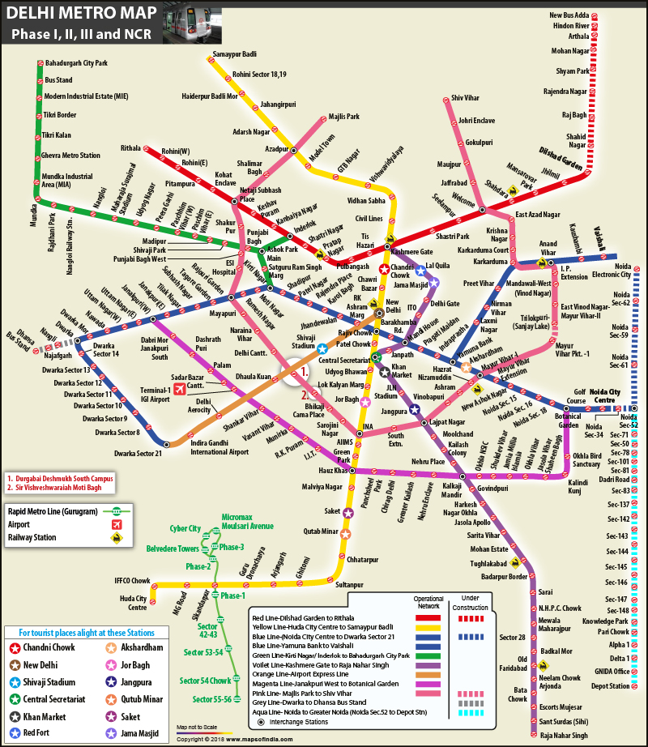

image

This is a Delhi Metro Map. People do strugle to get the desired location in the map.

## **How is it helpful?**

1. **Easy Search:** Searching through image with full of content
2. **Storage:** Documents can be stored in form of images (less space and easy to upload)
3. **Evaluation:** Handwritten text can be converted into pdf for auto-evaluation
4. **Alter Text:** Text font can be changed as per convience of user. Changing color of text helps color blind people to see the text.
5. **Disoriented Text:** Identifying Disoriented or Distorted text.

## **Milestone**

| Milstone | Detail |
| --- | --- |
| Milestone 0 | Increase Image Quality |
| Milestone 1 | Text Extraction |
| Milestone 2 | Create Contour Boxes around Identified Text |
| Milestone 3 | Preprocess extracted Contour boxes |
| Milestone 4 | OCR on Extracted image |
| Milestone 5 | Create Similar Image With no Text |
| Milestone 6 | Convert the Image from Milestone 5 into PDF |
| Milestone 7 | Write extracted text on the pdf with correct orientation |

## **Implementation**

1. **Milestone 0**
   1. **Python PIL** Library allow to increase the dpi of the image
2. **Milestone 1**
   1. **SWT (Stroke Width Transformation)** : http://www.math.tau.ac.il/~turkel/imagepapers/text_detection.pdf
3. **Milestone 2**
4. **Milestone 3**
5. **Milestone 4**
   1. **Tesseract OCR**
6. **Milestone 5**
   1. **Python PIL** Library
7. **Milestone 6**
   1. Mask the extracted text image in the original image
8. **Milestone 7**

## **Deadline**

| Date | Event |
| --- | --- |
| 4 August | Preparing Dataset |
| 5 August | Milestone 0 |
| 15 August | Milestone 1 |
| 20 August | Milestone 2 |
| 31 August | Milestone 3 |
| 10 September | Do the left-over work |
| 12 September | Milestone 4 |
| 18 September | Milestone 5 |
| 21 September | Milestone 6 |
| 25 September | Milestone 7 |
| 30 September | Do the left-over Work |
| 5 October | Testing |
| 10 October | Documentation |

## **Resources Required**

1. Subscription to medium and IEEE xplore to read more informational Blogs

## **Future Scope**

1. Identification different language images
2. Mobile API to use the tool with ease

## **Our Team**

1. Harsh Goyal
2. Tejal Kulkarni