Qt使用ros

<https://github.com/wetwilliam/tracked_robot_3/wiki>

# Qt安裝

## <https://ros-qtc-plugin.readthedocs.io/en/latest/_source/How-to-Install-Users.html>

## 下載.run

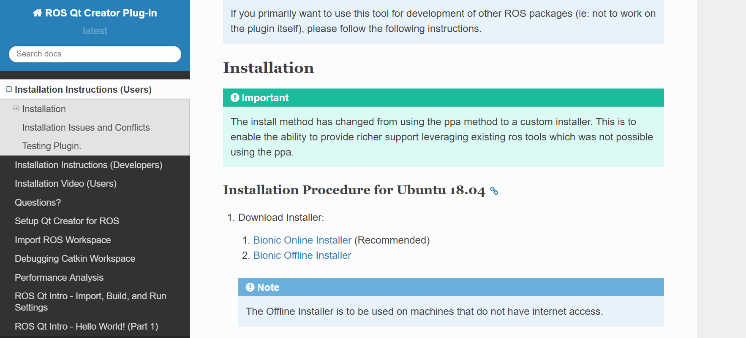

## 開啟權限

sudo chmod 777 <檔名> //r=4 w=2 x=1

## 執行run

./<檔名.run>

## 執行 qt

qtcreator-ros

## 檢查版本

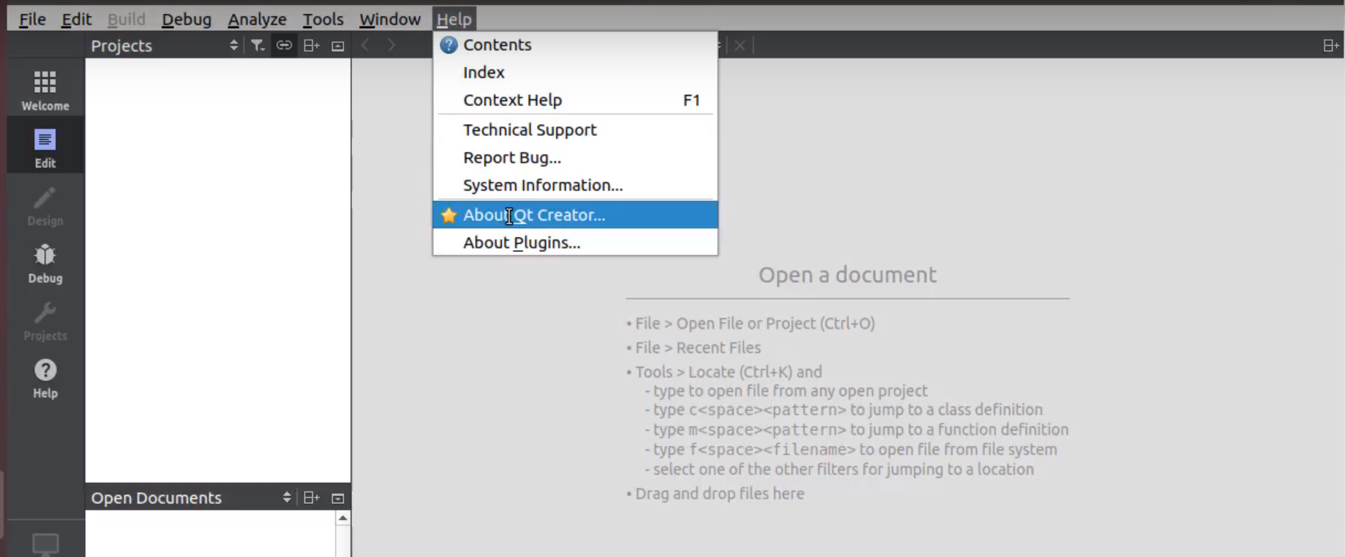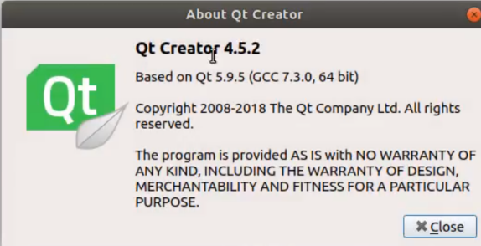

# 更改參數

## 開啟參數介面

Tools->options

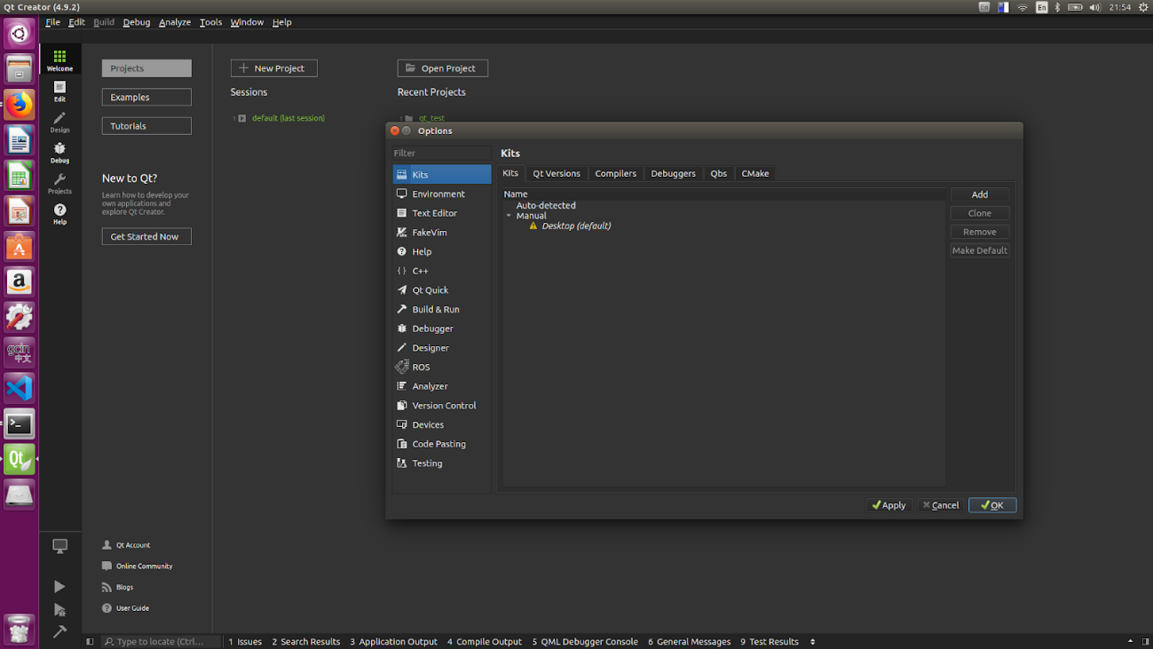

## 更改參數

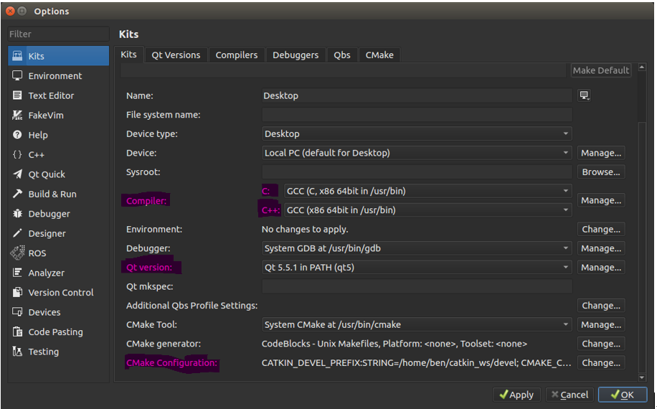

|  |  |
| --- | --- |
| Compiler  1.c:GCC(/usr/bin)  2.c++:GCC(/usr/bin) | Qt Version :  Qt5 |

## 更改 CMake configuration

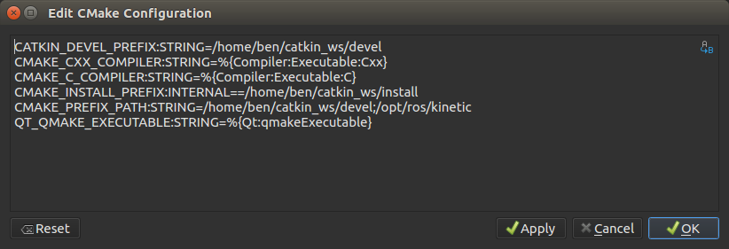

CATKIN_DEVEL_PREFIX:STRING=/home/nvidia/catkin_ws/devel

CMAKE_CXX_COMPILER:STRING=%{Compiler:Executable:Cxx}

CMAKE_C_COMPILER:STRING=%{Compiler:Executable:C}

CMAKE_INSTALL_PREFIX:INTERNAL==/home/nvidia/catkin_ws/install

CMAKE_PREFIX_PATH:STRING=/home/nvidia/catkin_ws/devel;/opt/ros/kinetic

QT_QMAKE_EXECUTABLE:STRING=%{Qt:qmakeExecutable}

# 建立Qt ROS Package 與 範例程式

## 建立Package

catkin_create_pkg <<package 名稱>> std_msgs rospy roscpp

## 開啟package

File-> open file or project

開啟 Package 內的CMakeLists.txt

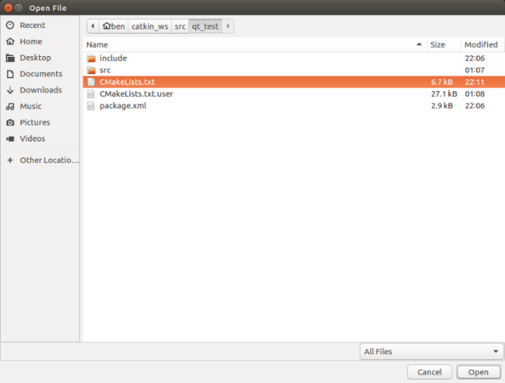

## 更改configure project

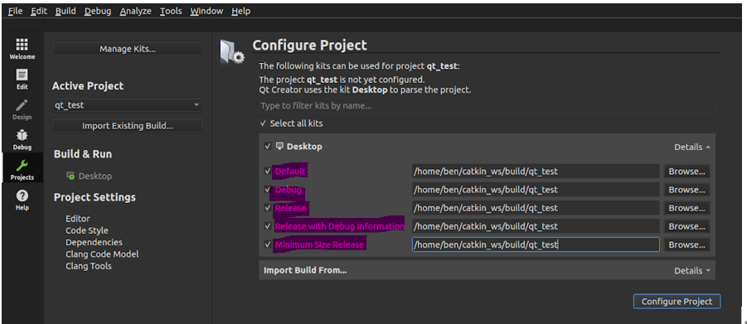

/home/ben/catkin_ws/build/<<package 名稱>>

## 建立範例程式

File-> New file or project

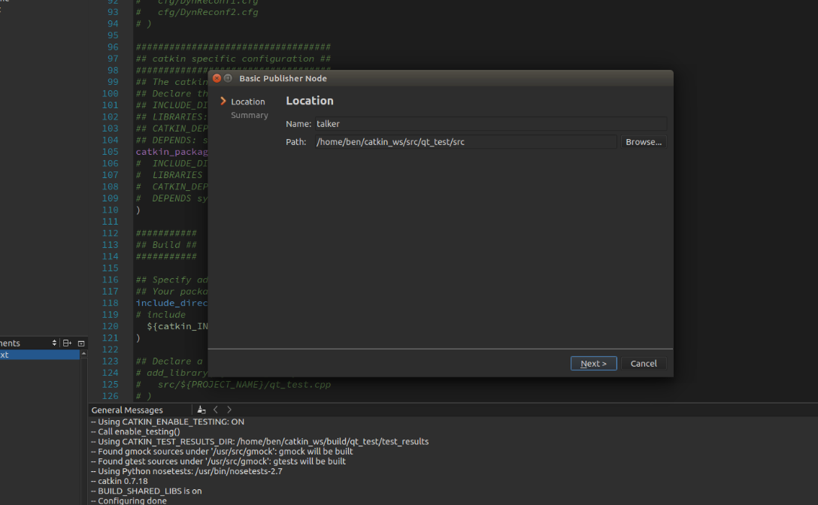 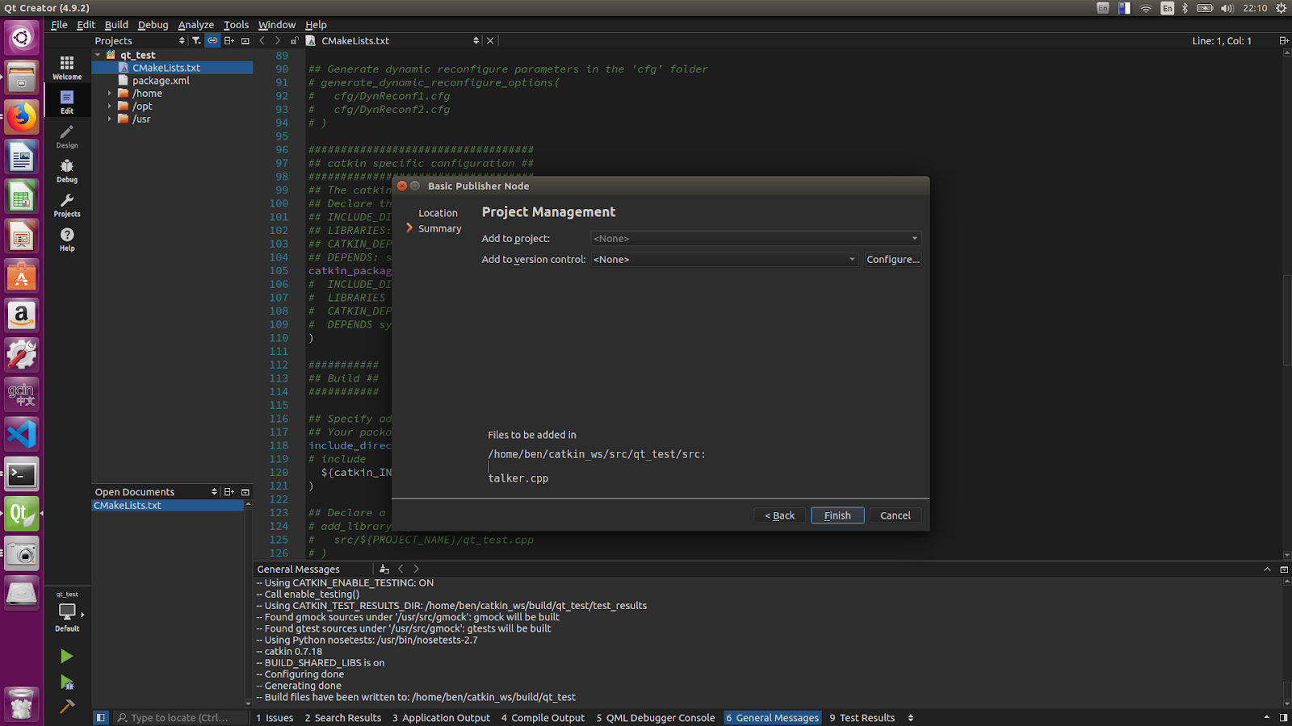

Name: CPP 檔名

## 更改CMakeLists.txt

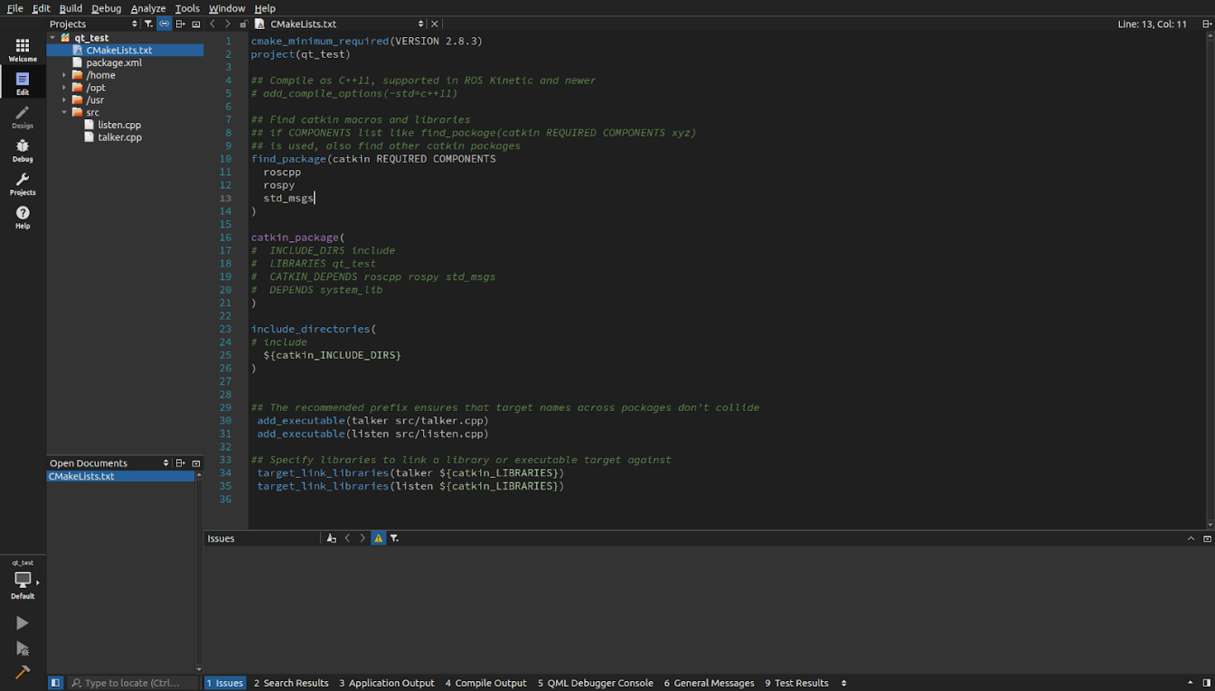

cmake_minimum_required(VERSION 2.8.3)

project(qt_test)

find_package(catkin REQUIRED COMPONENTS

roscpp rospy std_msgs )

catkin_package( )

include_directories( ${catkin_INCLUDE_DIRS})

add_executable(talker src/talker.cpp)

add_executable(listen src/listen.cpp)

target_link_libraries(talker ${catkin_LIBRARIES})

target_link_libraries(listen ${catkin_LIBRARIES})

# 建立QT UI Package

## 安裝插件

sudo apt-get install ros-kinetic-qt-create

sudo apt-get install ros-kinetic-qt-build

## 建立UI Package

catkin_create_qt_pkg <<package 名稱>>

## 開啟package

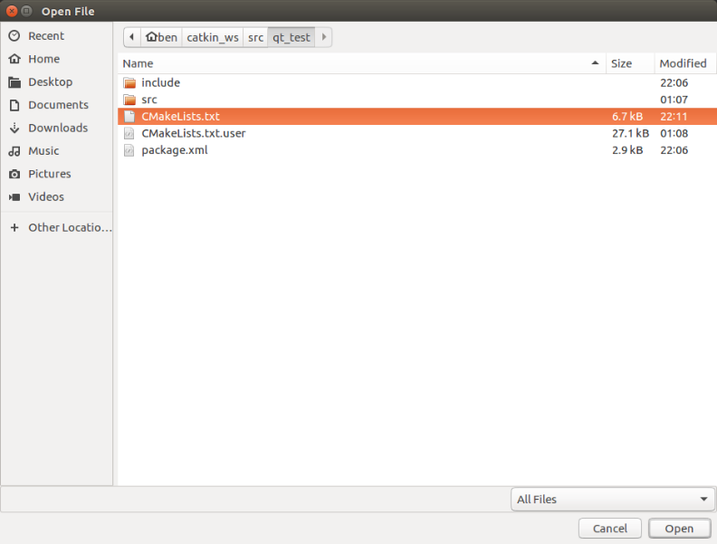

## 更改configure project



/home/ben/catkin_ws/build/<<package 名稱>>

## 更改CMakeLists.txt

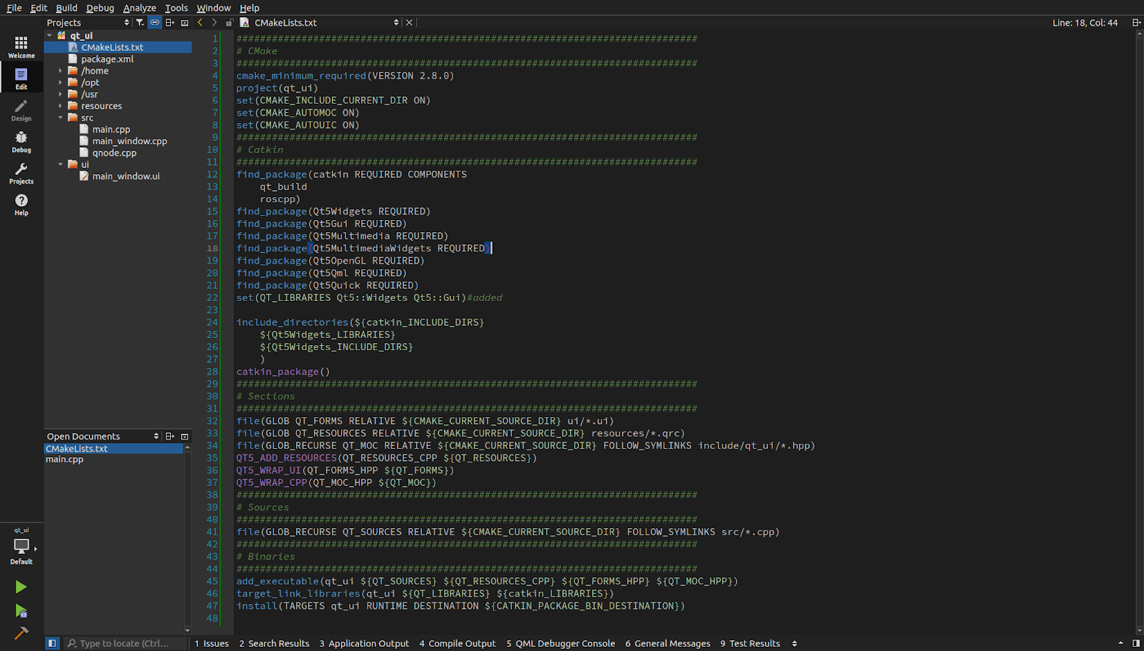

cmake_minimum_required(VERSION 2.8.0)

project(qt_ui)

set(CMAKE_INCLUDE_CURRENT_DIR ON)

set(CMAKE_AUTOMOC ON)

set(CMAKE_AUTOUIC ON)

##############################################################################

# Catkin

##############################################################################

find_package(catkin REQUIRED COMPONENTS

qt_build

roscpp)

find_package(Qt5Widgets REQUIRED)

find_package(Qt5Gui REQUIRED)

find_package(Qt5Multimedia REQUIRED)

find_package(Qt5MultimediaWidgets REQUIRED)

find_package(Qt5OpenGL REQUIRED)

find_package(Qt5Qml REQUIRED)

find_package(Qt5Quick REQUIRED)

set(QT_LIBRARIES Qt5::Widgets Qt5::Gui)#added

include_directories(${catkin_INCLUDE_DIRS}

${Qt5Widgets_LIBRARIES}

${Qt5Widgets_INCLUDE_DIRS}

)

catkin_package()

##############################################################################

# Sections

##############################################################################

file(GLOB QT_FORMS RELATIVE ${CMAKE_CURRENT_SOURCE_DIR} ui/*.ui)

file(GLOB QT_RESOURCES RELATIVE ${CMAKE_CURRENT_SOURCE_DIR} resources/*.qrc)

file(GLOB_RECURSE QT_MOC RELATIVE ${CMAKE_CURRENT_SOURCE_DIR} FOLLOW_SYMLINKS include/qt_ui/*.hpp)

QT5_ADD_RESOURCES(QT_RESOURCES_CPP ${QT_RESOURCES})

QT5_WRAP_UI(QT_FORMS_HPP ${QT_FORMS})

QT5_WRAP_CPP(QT_MOC_HPP ${QT_MOC})

##############################################################################

# Sources

##############################################################################

file(GLOB_RECURSE QT_SOURCES RELATIVE ${CMAKE_CURRENT_SOURCE_DIR} FOLLOW_SYMLINKS src/*.cpp)

##############################################################################

# Binaries

##############################################################################

add_executable(qt_ui ${QT_SOURCES} ${QT_RESOURCES_CPP} ${QT_FORMS_HPP} ${QT_MOC_HPP})

target_link_libraries(qt_ui ${QT_LIBRARIES} ${catkin_LIBRARIES})

install(TARGETS qt_ui RUNTIME DESTINATION ${CATKIN_PACKAGE_BIN_DESTINATION})

# QT UI 基本教學

<https://www.bbsmax.com/A/RnJW7r6wJq/>