**Automated OH Test Manual**

**WARNING:**

**Please ground (⏚) yourself before coming near any electronics, as they are very sensitive.**

**Contents:**

**Section 1: Physical Inspection + Installation**

**Section 2: GBT Fusing**

**Section 3: Automated Test Procedure**

**Section 4: Configure for Shipping to CERN.[1]**

**List of Appendices:**

**A.0: Connecting to Lab PCs**

**A.1: Helpful Linux Commands**

**Conventions:**

Commands run from your Laptop will be highlighted in green

Commands run on the Lab PC will be in yellow

Commands run on the CTP7 will be in red

**OH Board Reference Diagrams**

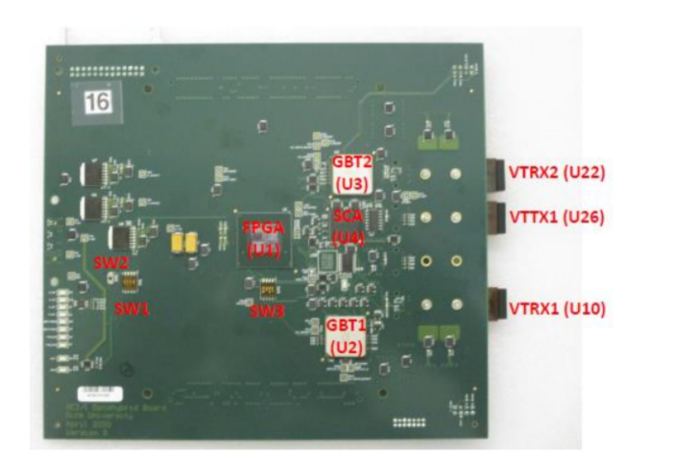

Top view OH board

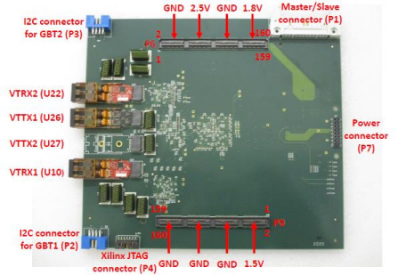

Bottom view OH board

Note that in this manual and on the printed circuit board the GBTX ASICs are numbered as GBT1 (U2) and GBT2 (U3) while in software they are numbered as GBT0 and GBT1 respectively.

**1 Physical Inspection + Installation**

This section follows sections 1-6 in the Rice OH Test Manual.

**1.0 Electrostatic safety**

a) Ensure that you are electrically discharged with a grounding strap

b) OH boards should be removed from their packaging at the static mat

**1.1 Visual Inspection**

a) Make sure all parts are installed on both sides of the OH PCB with the exception of: U25, R67, R89, R50.

b) Make sure the active parts are correctly oriented (check for pin 1)

c) Make sure polar capacitors are installed properly

d) Make sure temperature sensors R151-R154 are mounted face up

**1.2 Check OH board for shorts and GEB powers**

a) Measure the resistance between GND point and six power points (2.5V, 1.8V, 1.5V, 1.0V_AVCC, 1.2V, 1.0V_VCCINT). Typically, it varies from 50 Ohms to 180 Ohms.

b) Make sure the GEB provides 2.5V, 1.8V and 1.5V powers to P7 connector

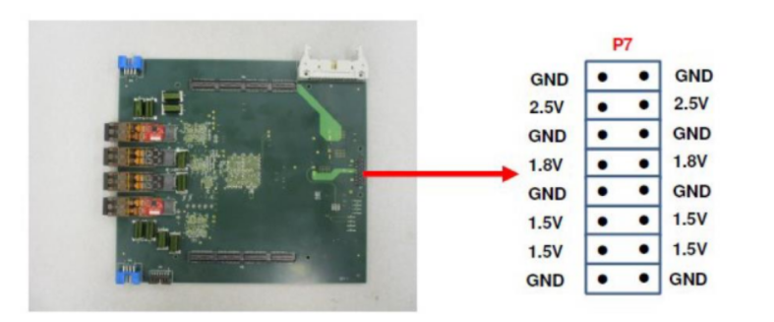

Power pin map for P7

**1.3 Set jumpers for initial testing phase**

a) The EPROM (U25) is not needed, so make sure the jumper between TP18 and TP21 is installed (to close the JTAG loop)

b) Select SW1-1/2/3=”110” for Slave SelectMAP configuration mode (FPGA is loaded from GBT1) and SW1-4=”0” (Master/Slave=0)

c) Set SW3-1/2/3/4 to:

Select Enable GBT =1 (SW3-1)

Select TESTA= 1 (Enable JTAG access to FPGA from SCA ASIC, SW3-2)

Select CCLK to the FPGA from GBT path (SW3-3)

Select CONFIGSEL=1 to allow fusing of both GBT ASICs from the dongle (SW3-4).

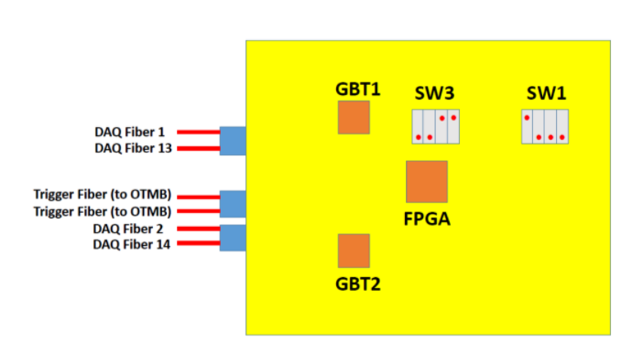

Control switches, top view

**1.4 Install VTTX and VTRX optical parts if needed**

a) Install two VTRX optical transceivers U10 and U22 (small red PCB)

b) Install one VTTX optical transmitter U26 (black PCB)

c) Attach all three optical parts with screws (6 total)

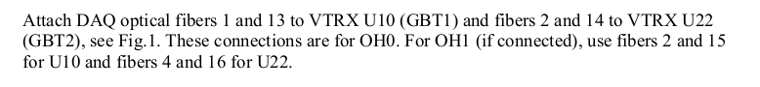**1.5 Attach Optical Fibers**

**1.6 Install OH board under test on the GEB board**

a) Carefully install OH board on the GEB board; make sure it’s fully plugged into 3 connectors.

b) **Make sure that the P7 power connector on the right is fully plugged in and use the holes to press it down.**

c) Make sure the I2C Dongle is connected to the OH but not the backend computer.

d) Power up the GEB board.

e) Measure 6 powers on the OH board with a multimeter in 6 points (2.5V, 1.8V, 1.5V, 1.0V_AVCC, 1.2V, 1.0V_VCCINT) and **make sure the voltage tolerance is within 5% of the nominal values.**

f) Make sure corresponding green LEDs D3, D4, D10, D11 are “on”.

DC Voltage Test Points

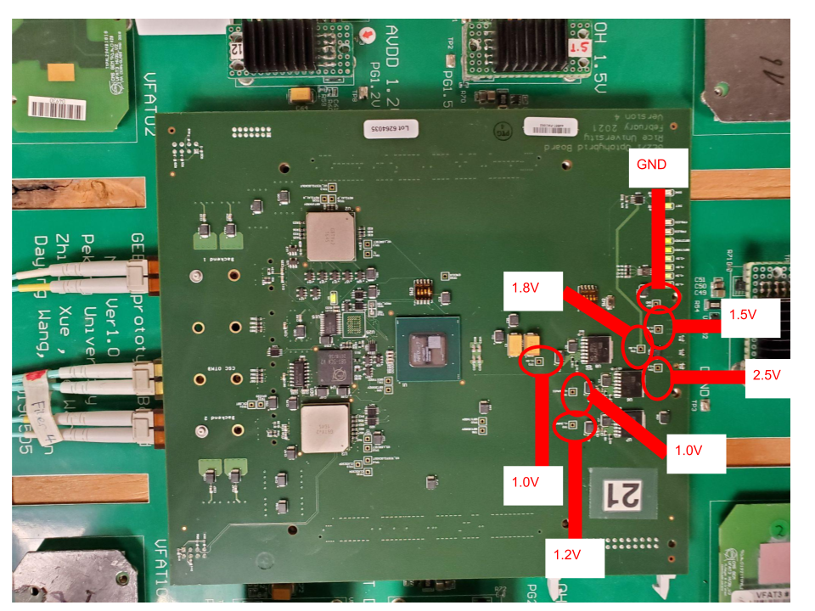

**2 GBTX Fusing**

Any OH boards received at TAMU which are not already fused shall be fused on-site.

**2.0 Ensure that you are electrically discharged with a grounding strap.**

Make sure the board is fully plugged in and the P7 power connector by the LEDs is completely connected before powering on. Make sure the I2C dongle is connected to the board but not the computer before powering on.

**2.1 Configure the OH switch settings I2C Communications**



*Note: This switch configuration enables the GBTX fusing software to read/write the GBT registers. It will need to be changed later for normal operation, after fusing is complete.

**2.2 Connecting the I2C dongle to OH, must be done *CAREFULLY\***

Follow the specific order for this - the dongle should be unplugged from the PC USB before plugging into the OH, while OH is Off. After the OH is On, connect the dongle to the USB on the computer with the fusing software. Ensure that you are electrically discharged with a grounding strap for this step.

**2.3 Starting the I2C Fusing GUI software**

Start the software if needed with this command (must be run with sudo)

sudo java -jar fusegui.jar

If it says “file not found” then go to the OH_Testing the Fusing directory and retry.

Ignore the two errors that appear at startup and click “no” when it asks if you would like to update.

**IMPORTANT - When power cycling the OH, you MUST disconnect the I2C dongle USB from the computer first. Otherwise OH will not power-up properly as there will be power from the cable.**

**2.4 Load the GBT Config Files and verify before fusing.**

a) Connect the I2C dongle (follow directions in 2.2.1 above) to **GBT0** (blue connector P2) which is the one at the top edge of the OH. Then power-up the OH and connect the dongle to the PC USB.

b) Click the “scan” button in the Top-Right corner of the Fuse GUI, ensure the software connects to the GBT, and does not produce any errors/warnings

c) Click the top left button called “Import” and then change the “files of type” field to say “All Files”

d) Import configuration file:

**GBTX_GE21_OHv2_GBT_0_minimal_2020-01-17.txt**

e) Click “Write GBTX”

f) Click “Read GBTX”

g) Under the “Fuse my GBTX!” tab in the GUI, click “update view”

h) Observe that the registers readback match the registers specified in the config file. (all entries in the registers table should be green)

i) Check **GBT0** is ready. On the CTP7 execute the following.

> reg (Wait for this to finish starting up)

> readKW OH_LINKS.OH0.GBT

It is critical to verify the correct value is read from this register:

**GEM_AMC.OH_LINKS.OH0.GBT0_READY = 0x01**

If this condition is not met then DO NOT continue, but repeat steps b through h above.

j) Back in the software click “select not zero values” -- this will select all registers with non-zero values to be fused

k) Check both boxes in the “Fuse GBTX” box

l) Click the FUSE button (This should only take ~1sec to finish) then uncheck both Fuse GBTX boxes. It is critical to uncheck these boxes when fusing is completed.

m) Ensure that you are electrically discharged with a grounding strap and disconnect the I2C USB cable. Then Power Cycle the GEB, reconnect the USB, and repeat steps b) → h) [**Excluding step d and e)**] you should see all registers matching except (#365) after the power cycle. This proves the GBTX has been properly fused, so power down the GEB then unplug the I2C cable from the OH and the PC USB.

n) Connect the I2C dongle (follow directions in 2.2.1 above) to **GBT1** (blue connector

P3) which is the at the bottom edge of the OH. Then power-up the OH and

connect the dongle to the PC USB.

o) Click the “scan” button in the Top-Right corner of the Fuse GUI, ensure the software connects to the GBT, and does not produce any errors/warnings

p) Repeat steps b) → m), but now with configuration file

**GBTX_GE21_OHv2_GBT_1_minimal_2020-01-31.txt**

Note that in step i) we check **GBT1** this time; it is critical to verify the correct

value is read from this register:

**GEM_AMC.OH_LINKS.OH0.GBT1_READY = 0x01**

If this condition is not met then DO NOT continue, but repeat steps b through h.

**2.5 Configure OH switches for automated testing phase**

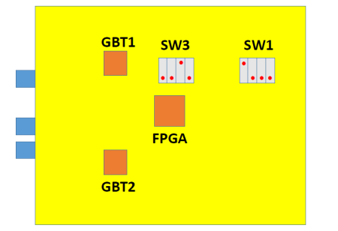

Switch configuration for normal test operations.

**In order for the remaining tests to work it is critical to change the SW3 setting as indicated above.**

**3 Automated Test Procedure**

This should run as a single unit and output 4 xml files of data into the database directory for the board you are testing.

**3.1 Using the Automated Test Stand**

* 1. **Starting the Test Stand**
     1. Navigate to the directory full_test using cd. Enter the command

python temp_full.py

* + 1. It will ask you a few questions about the board number, the run number, when it was fused, and confirming the right fuse files were used.

**3.2 Handling Failure encounters**

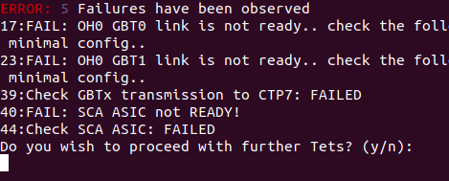

1. When a Failure condition is detected (i.e. any time an acceptance criteria for a given test is not met) the output sent to the “command line” log file is flagged to indicate a failure occurrence. [Note: all of the independent sub-scripts output is also written to the console output file. (i.e. Not just the Failure data is saved ALL data is recorded)].
2. The software will continue automatically with the next test.

**3.3 Post-failure retest**

If a test fails, power-down the GEB and reseat the OH board (ensure that you are electrically discharged with a grounding strap), making sure all VFATs and FEASTs are installed, then power-up the GEB and run the automated test again from step 3.1) above, choosing the next run number.

**3.4 Post-test board handling**

a) Ensure that you are electrically discharged with a grounding strap first, then power-down the GEB and remove the OH board.

b) Place the OH board in a static bag while working at the static mat.

c) Boards that pass all tests are placed in the Good Boards box; boards that fail a test and the retest are placed in the Return to Rice box.

**Summary of the Automated Testing Procedure**

**(in terms of original Rice test manual sections)**

1. Visual Inspection of OH (DUT)
2. Check for Short Circuits / Power on OH (DUT)
3. Set control switches for initial testing phase
4. Install VTTX and VTRX on OH (DUT)
5. Install OH (DUT) to GEB test-stand
6. Connect Optical Fibers
7. Load GBT config files, via I2C dongle
8. Check communication with CTP7
9. Fuse GBT ASICs

12. Load FPGA from GBT1 [1,000 successful load cycles]

11. Test VTTX optical link with CTP7 [1012 bit w/out errors on each link]

13. Read ADCs from SCA ASIC [All voltages/current/Temp in acceptance range]

14. Integrated Test: Set “best phase” delay for Internal Links then run tests [1012 bit w/out errors on each e-link] (PRBS)

15. Interactions with VFAT3 ASICs

16. Program VFAT “Best Phases”

17. Run S-bit Tests

**4) Prepare for Shipping to CERN**

Preparing the OH board for shipping requires that the On-Board DIP switches are configured as seen in the following Figure.

(note: the OH is likely already in this configuration, but should be double checked to ensure uniformity)



Switch configuration for normal GEM operations.

**A.0 Logging In**

All automated testing procedures and scripts are intended to be run on the CTP7 system in the lab. This system can only be accessed through the cms-elli Lab PC.

**cms-elli (TAMU exclusive):**

ssh gemtest@cms-elli.physics.tamu.edu

User : gemtest

**CTP7:**

ssh texas@eagle36

User : texas

** No password should be needed to access CTP7 from cms-elli, ssh keys have been traded **

**A.1 Linux Basics**

** Directory = Linux equivalent to Windows Folder **

**Viewing Contents of Directory**

|  |  |
| --- | --- |
| ls | List contents of current Directory |
| ls -l | ^same^ + extra details + one line / entry |
| ls -lrt | ^same^ + entries reversed in time |
| ls *.c | Lists all files with name of form = “any string”.c |

**Navigating Between Directories**

|  |  |
| --- | --- |
| pwd | Returns absolute path to current directory  pwd == “Print working directory” |
| cd </Path/> | Change Directory to specified by </Path/> |
| cd .. | Move Back one Directory |
| cd - | Go to Previous Directory |

**Moving Files / Directories**

|  |  |
| --- | --- |
| cp ”file” ”new_file” | Make copy of “file” called “new_file”  Equiv to Copy/Paste |
| cp -r dir/ new_dir/ | Make a copy of an entire directory  ** -r stands for recursive ** |
| mv “file” “new_file” | Move “file” to “new_file”  Equiv to Cut/Paste |
|  |  |
| rm “File” | Delete “File” |
| rm -rf dir/ | Deletes Directory “dir/” and all its contents |

**Viewing / Editing Contents of Files**

|  |  |
| --- | --- |
| cat “file” | Print contents of “file” |
| tail -n # “file” | Print Last # lines of “file” |
| cat “file” | less | Prints contents of “file” to terminal, with scroll Up/ Down ability using (J : ↓) and (K : ↑) keys |
| xxd “file” | View Contents of File in Hexadecimal format |
| vi “file” | Vim Text Editor; Creates “file” if doesn’t exist  Hotkey (i) insert Text Mode  Hotkey (Esc) exit any Mode → Default  To save and exit do:  (Esc)>wq>(Enter)  To exit without saving:  (Esc)>q!>(Enter)  ** This is an easy method to create new Files ** |
|

**Executing Files + Permissions**

|  |  |
| --- | --- |
| ./executable | Execute program / script |
| ./<Path>/executable | Execute program / script in another Directory |
| chmod +x “File” | Makes “File” Executable permissions |
| python “file”.py | Execute python script |

1. Last Updated On : October 20, 2021