**Automated OH Test Manual**

**WARNING:**

**Please ground (⏚) yourself before coming near any electronics, as they are very sensitive.**

**Contents:**

**Section 1: Physical Inspection + Installation**

**Section 2: GBT Fusing**

**Section 3: Automated Test Procedure**

**Section 4: Configure for Shipping to CERN.[1]**

**List of Appendices:**

**A.0: Connecting to Lab PCs**

**A.1: Helpful Linux Commands**

**Conventions:**

Commands run from your Laptop will be highlighted in green

Commands run on the Lab PC will be in yellow

Commands run on the CTP7 will be in red

**OH Board Reference Diagrams**

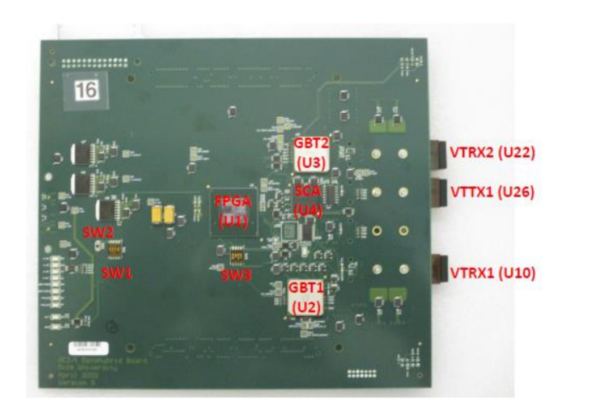

Top view OH board

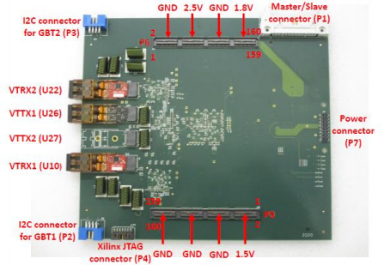

Bottom view OH board

Note that in this manual and on the printed circuit board the GBT ASICs are numbered as GBT1 (U2) and GBT2 (U3) while in software they are numbered as GBT0 and GBT1 respectively.

**1 Physical Inspection + Installation**

This Section is an exact recreation of Sections (1-6) from the Rice OH Test Manual.

**1.1 Visual Inspection**

1.1.a Make sure all parts are installed on both sides of the PCB with the exception of: U25, R67, R89, R50.

1.1.b Make sure the active parts are correctly oriented (check for pin 1)

1.1.c Make sure polar capacitors are installed properly

1.1.d Make sure temperature sensors R151-R154 are mounted face up

**1.2 Check OH board for shorts and GEB powers**

1.2.a Measure the resistance between GND point and six power points (2.5V, 1.8V, 1.5V, 1.0V_AVCC, 1.2V, 1.0V_VCCINT). Typically, it varies from 60 Ohms to 150 Ohms.

1.2.b Make sure the GEB provides 2.5V, 1.8V and 1.5V powers to P7 connector

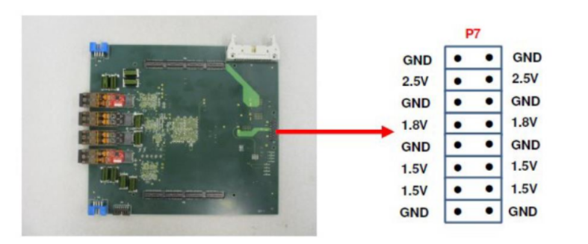

Power pin map for P7

**1.3. Set jumpers for initial debugging**

1.3.a The EPROM (U25) is not needed, so make sure the jumper between TP18 and TP21 is installed (to close the JTAG loop)

1.3.b. Select SW1-1/2/3=”110” for Slave SelectMAP configuration mode (FPGA is loaded from GBT1) and SW1-4=”0” (Master/Slave=0)

1.3.c Set SW3-1/2/3/4 to:

Select Enable GBT =1 (SW3-1)

Select TESTA= 1 (Enable JTAG access to FPGA from SCA ASIC, SW3-2)

Select CCLK to the FPGA from GBT path (SW3-3)

Select CONFIGSEL=1 to allow fusing of both GBT ASICs from the dongle (SW3-4).

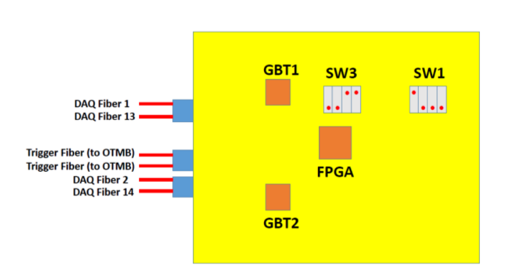

Debugging switches, top view

**1.4. Install VTTX and VTRX optical parts**

1.4.a. Install two VTRX optical transceivers U10 and U22 (red boards)

1.4.b Install one VTTX1 optical transmitter U26 (blue board)

1.4.c Attach all three optical parts with screws (6 total)

**1.5. Attach Optical Fibers**

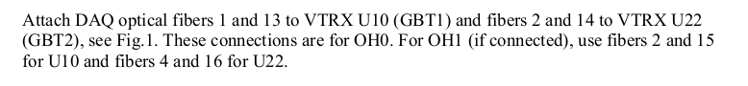

**1.6. Install OH board under test on the GEB board**

1.5.a Carefully install OH board on the GEB board; make sure it’s fully plugged into 3 connectors.

1.5.b **Make sure that the 7-pin power connector on the right is fully plugged in and use the holes to press it down.**

1.5.c Make sure the I^2C Dongle is connected to the OH but not the backend computer.

1.5.d Power up the GEB board.

1.5.e Measure 6 powers on the OH board with a multimeter in 6 points (2.5V, 1.8V, 1.5V, 1.0V_AVCC, 1.2V, 1.0V_VCCINT) and **make sure the voltage tolerance is within 5% of the nominal values. Make sure you maintain contact with the static mat at all times.**

1.5.f Make sure corresponding green LEDs D3, D4, D10, D11 are “on”.

**2 GBT Fusing**

**Any OH boards received at TAMU, which have not yet been fused, shall be fused on-site.**

**2.0 Make sure the board is fully plugged in and the 7-pin power connector by the LEDs is completely connected before powering on. Make sure the I^2C Dongle is connected to the board but not the computer before powering on.**

**2.1 Check the OH is properly installed by measuring the following voltages. Make sure your skin stays in contact with the static mat at all times.**

DC Voltage Test Points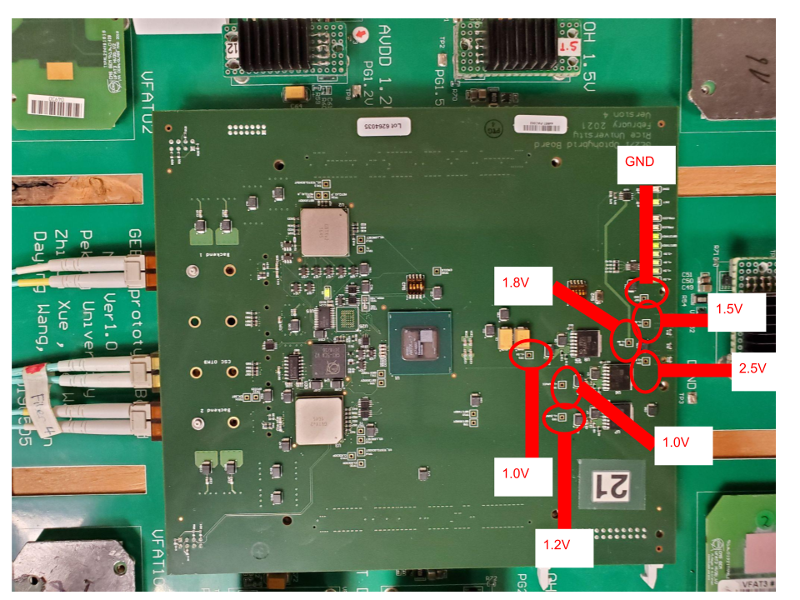

**2.2 Configure the OH switch settings I2C Communications**



*Note: This switch configuration enables the GBTX fusing software to read/write the GBT registers. And will need to be switched back for normal operation, after fusing is complete

**2.2.1 Connect the I^2C Dongle.**

There is a very specific order to this - the dongle should already be plugged into the OH. Now, connect it to the backend computer running the fusing software.

**2.3 Start the Fusing GUI software (note this needs to be run with sudo)**

sudo java -jar fusegui.jar

If it says the file cannot be found, go to the OH_Testing then the Fusing directory using cd.

Ignore the two errors that appear on startup, and click “no” when it asks if you would like to update.

**IMPORTANT - When power cycling the OH, you MUST disconnect the I^2C dongle from the computer. If you do not, it will not properly power cycle as there will be a ground current from the cable.**

**2.4 Load the GBT Config Files and verify before fusing.**

a.) Connect I2C dongle cable from PC to **GBT0** (blue connector P2). This is the one at the top of the board.

b.) Click the “scan” button in the Top-Right corner of the Fuse GUI, ensure the sw connects to the GBT, and does not produce any errors/warnings

c.) Click the top left button called “Import” and then change the “files of type” field to say “All Files”

d.) Import configuration file:

**GBTX_GE21_OHv2_GBT_0_minimal_2020-01-17.txt**

e.) Click “Write GBTX”

f.) Click “Read GBTX”

g.) Under the “Fuse my GBTX!” tab in the GUI, click “update view”

h.) Observe that the registers readback match the registers specified in the config file. (all entries in the registers table should be green)

i.) Check **GBT0** is ready. On the CTP7 execute the following.

> reg (Wait for this to finish starting up)

> readKW OH_LINKS.OH0.GBT

It is critical to verify the correct value is read from this register:

**GEM_AMC.OH_LINKS.OH0.GBT0_READY = 0x01**

If this condition is not met then DO NOT continue, but repeat steps b through h above.

j.) Back in the software click “select not zero values” -- this will select all registers with non-zero values to be fused

k.) Check both boxes in the “Fuse GBTX” box

l.) Click the FUSE button (This should only take ~1sec to finish)

m.) Disconnect the I2C cable, and Power Cycle the GEB, then repeat steps a.) → h.) [**Excluding step d. and e.)**] you should see the all registers matching except (#365) after the power cycle... This means the GBT9/X has been properly fused

n.) Connect the I2C cable into **GBT1**  (blue connector P3). This is the one closest to you.

o.) Click the “scan” button in the Top-Right corner of the Fuse GUI, ensure the sw connects to the GBT, and does not produce any errors/warnings

p.) Repeat steps b.) → l.), except with configuration file

**GBTX_GE21_OHv2_GBT_1_minimal_2020-01-31.txt**

Again, it is critical to verify the correct value is read from this register:

**GEM_AMC.OH_LINKS.OH0.GBT1_READY = 0x01**

If this condition is not met then DO NOT continue, but repeat steps b through h.

**2.5 Configure OH switches for Automation Tests.**

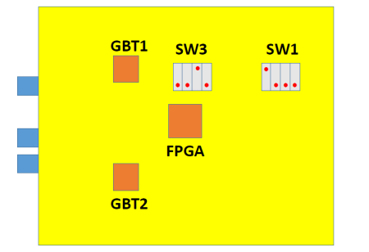

Switch Configuration for Normal Operation

**In order for the remaining tests to work it is critical to change the SW3 setting**

**3 Automated Test Procedure**

This should run as a single unit and output 4 xml files of data into the database directory for the board you are testing.

**3.1) Using the Automated Test Stand**

* 1. **Starting the Test Stand**
     1. Navigate to the directory full_test using cd. Enter the command

python temp_full.py

* + 1. It will ask you a few questions about the board number, the run number, when it was fused, and confirming the right fuse files were used.

**3.2) Handling Failure encounters**

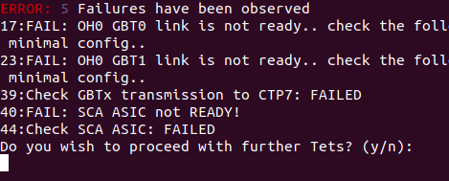

1. When a Failure condition is detected (i.e. any time an acceptance criteria for a given test is not met) the output sent to the “command line” log file is flagged to indicate a failure occurrence. [Note: all of the independent sub-scripts output is also written to the console output file. (i.e. Not just the Failure data is saved ALL data is recorded)].
2. The user is queried to Repeat the failed test, Continue with the testing process or Exit the testing program
   1. **(r,R) Repeating the Failed Test**, selecting this option will result in re-initializing the OH then re-running the test procedure associated with the failure.
   2. **(y,Y) Continuing the Testing Process**, selecting this option will override(ignore) the failure condition, and proceed further tests.
   3. **(n,N) Exiting the testing Program**, selecting this option will result in an incomplete set of log files. This should be reserved for short term debugging of the System.

**3.3) How to resume - post failure**

In order to resume after a failure encountered, and the main test script exited, you must restart the main test script from the beginning. It is necessary that a new ID handle is used, to indicate an iterated test on a given board. This will ensure the test procedure runs smoothly, without interference from or overwriting of previous results.

**Summary of Full Testing Procedure**

**(in terms of Rice test manual sections)**

1. Visual Inspection of OH (DUT)
2. Check for Short Circuits / Power on OH (DUT)
3. Set Jumper for initial Debugging
4. Install VTTX and VTRX on OH (DUT)
5. Install OH (DUT) to GEB test-stand
6. Connect Optical Fibers
7. Load GBT config files, via I2C dongle
8. Check Communication with CTP7
9. Fuse GBT ASICs

12. Load FPGA from GBT1 [1,000 successful load cycles]

11. Test VTTX optical link with CTP7 [Non-incrementing Error Counters]

13. Read ADCs from SCA ASIC [All voltages/current/Temp in acceptance range]

14. Integrated Test: Internal Links [1012 bit w/out errors, on each e-link] (PRBS)

15. Interactions with VFAT3 ASICs

16. Program VFAT “Best Phases” (Potentially requires human interaction)

17. Run S-bit Tests

**4) Prepare for Shipping to CERN**

Assuming the testing procedure passed without issue, preparing the OH board for shipping is simple, and requires only that the On-Board DIP switches are configured as seen in the following Figure. (note: the OH is likely already in this configuration, but should be double checked to ensure uniformity)



Switch Configuration for Normal Operation

**A.0 Logging In**

All automated testing procedures and scripts are intended to be run on the CTP7 system in the lab. This system can only be accessed through the cms-elli Lab PC.

**cms-elli (TAMU exclusive):**

ssh gemtest@cms-elli.physics.tamu.edu

User : gemtest

**CTP7:**

ssh texas@eagle36

User : texas

** No password should be needed to access CTP7 from cms-elli, ssh keys have been traded **

**A.1 Linux Basics**

** Directory = Linux equivalent to Windows Folder **

**Viewing Contents of Directory**

| ls | List contents of current Directory |
| --- | --- |
| ls -l | ^same^ + extra details + one line / entry |
| ls -lrt | ^same^ + entries reversed in time |
| ls *.c | Lists all files with name of form = “any string”.c |

**Navigating Between Directories**

| pwd | Returns absolute path to current directory  pwd == “Print working directory” |
| --- | --- |
| cd </Path/> | Change Directory to specified by </Path/> |
| cd .. | Move Back one Directory |
| cd - | Go to Previous Directory |

**Moving Files / Directories**

| cp ”file” ”new_file” | Make copy of “file” called “new_file”  Equiv to Copy/Paste |
| --- | --- |
| cp -r dir/ new_dir/ | Make a copy of an entire directory  ** -r stands for recursive ** |
| mv “file” “new_file” | Move “file” to “new_file”  Equiv to Cut/Paste |
|  |  |
| rm “File” | Delete “File” |
| rm -rf dir/ | Deletes Directory “dir/” and all its contents |

**Viewing / Editing Contents of Files**

| cat “file” | Print contents of “file” |
| --- | --- |
| tail -n # “file” | Print Last # lines of “file” |
| cat “file” | less | Prints contents of “file” to terminal, with scroll Up/ Down ability using (J : ↓) and (K : ↑) keys |
| xxd “file” | View Contents of File in Hexadecimal format |
| vi “file” | Vim Text Editor; Creates “file” if doesn’t exist  Hotkey (i) insert Text Mode  Hotkey (Esc) exit any Mode → Default  To save and exit do:  (Esc)>wq>(Enter)  To exit without saving:  (Esc)>q!>(Enter)  ** This is an easy method to create new Files ** |
|

**Executing Files + Permissions**

| ./executable | Execute program / script |
| --- | --- |
| ./<Path>/executable | Execute program / script in another Directory |
| chmod +x “File” | Makes “File” Executable permissions |
| python “file”.py | Execute python script |

1. Last Updated On : June 24, 2021