Defence Cyber Certification (DCC)
Level 0 Scoping Attestation — Sanitised Example & Template
Organisation Name | [Example Organisation Ltd]
Company Registration Number | [00000000]
Registered Address | [Registered Office Address Line 1, City, Postcode]
DCC Certification Level | Level 0
DCC Application Reference | [DCC-XXXX]
Certification Scope | Whole Organisation
Document Version & Date | Version 1.0 — [DD Month YYYY]
Assessor / Assessment Body | [Assessor Name], [Accredited Assessment Body]

Context & Scoping Guidance Alignment
This document establishes the official scoping attestation and architectural boundary for Defence Cyber Certification (DCC) Level 0. The scoping parameters fully adhere to the DCC Scoping Guide requirements, providing explicit demarcation between in-scope systems, coterminous Cyber Essentials (CE) and Cyber Essentials Plus (CE+) assets, and formally excluded estates. All customer identifiers, company specifics, and sensitive operational identifiers have been removed or generalised for template use.

Attestation Statement
“I, [Name], [Chief Information Security Officer / Authorised Technical Director], am authorised to make this statement on behalf of [Example Organisation Ltd] and hereby attest that the statements and details provided in this Defence Cyber Certification Level 0 scoping document dated [DD Month YYYY] are accurate, complete, and that no material facts have been omitted or misrepresented.
I confirm that all essential services, networks, identities, and functions required for my organisation to operate normal business activities, and deliver contracted output, are within my DCC scope as detailed below.”

(a) Sites and Their Operational Functions
Site / Location | Operational Function & Boundary Details
Primary Operational HQ  [Serviced Commercial Building] | Central operations, administration, and executive staff. Serviced commercial facility; landlord/building-provided network is isolated per tenant/user on dedicated corporate VLANs.
Registered Corporate Office  [Statutory Address] | Official correspondence, statutory registration, and secure physical archive storage. Houses zero IT systems, servers, or operational staff.
Remote / Hybrid Teleworkers  [Dispersed Regional Workforce] | Remote business operations conducted exclusively via corporate-managed endpoints authenticated through Zero Trust Network Access (ZTNA) with certificate validation.
Assets in Transit: All portable assets carried between sites are corporate-issued mobile workstations, fully managed via Mobile Device Management (MDM), enforced with full-disk encryption (FDE), and subject to compliance posture checks.

(b) IT Networks and Systems
Network / Platform | Implementation & Purpose
Local Facility Network | Serviced commercial Wi-Fi/LAN segregated per user against enterprise identity accounts on dedicated tenant VLANs.
Zero Trust Remote Access (ZTNA) | Certificate-based, broker-authenticated access to internal resources, replacing legacy perimeter VPNs.
Cloud Productivity Suite (M365 / Workspace) | Corporate email, collaborative document storage, and shared libraries with regional sovereign data residency guarantees.
Identity Provider (IdP) & Cloud MDM | Centralised identity directory enforcing phishing-resistant MFA, context-aware conditional access, device posture verification, and remote wipe capabilities.
Endpoint Boundary Protection | Host-based Application Firewalls and centrally managed Endpoint Detection & Response (EDR) enforced across all endpoints. No organisation-owned edge routers are deployed.

(c) Operational Technology (OT) Networks and Systems
[Example Organisation Ltd] operates as a professional software and enterprise data services provider. The organisation does not operate, deploy, or maintain any Operational Technology (OT), Industrial Control Systems (ICS), or Supervisory Control and Data Acquisition (SCADA) platforms within its business operations.

(d) Devices and Assets
Device Classification | Quantity | Operating System & Management State
Portable User Laptops | [XX] | Supported Enterprise OS; 100% MDM-managed; Full-disk encryption (FDE) strictly enforced.
Shared / Lab Workstations | [X] | Supported Enterprise OS; MDM-managed; FDE enforced.
Corporate Mobile Devices / Tablets | [X] | Supported Mobile OS; MDM-managed profile.
Network Edge Hardware | None | Serviced office architecture; boundary control enforced at the host endpoint layer.

(e) Data and Document Storage
• Cloud Enterprise Repositories: Hosted in enterprise SaaS suites with regional data residency guarantees covering corporate mail, collaboration files, and business-critical sites.
• Automated Cloud Backup: Dedicated cloud-to-cloud automated backup with retention policies covering primary sites, shared drives, and user accounts with a 1-year recovery window.
• Enterprise Cloud Infrastructure: Governed backend cloud subscriptions (Azure / AWS / GCP) used for enterprise workloads under strict RBAC.
• Local Device Storage: Encrypted locally on MDM-managed user endpoints with enforced remote wipe.
• Physical Storage: Secure, access-controlled document storage at the registered office.

(f) Scoping Architecture & Boundary Diagrams
The sections below provide both visual architecture diagrams and tabular alignment matrices demonstrating scope boundaries, coterminous Cyber Essentials alignment, and formal out-of-scope exclusions.

(f)(i) Diagram 1: DCC & Cyber Essentials Scope Boundary
Visual representation of in-scope technology, locations, workforce, and formal exclusions:
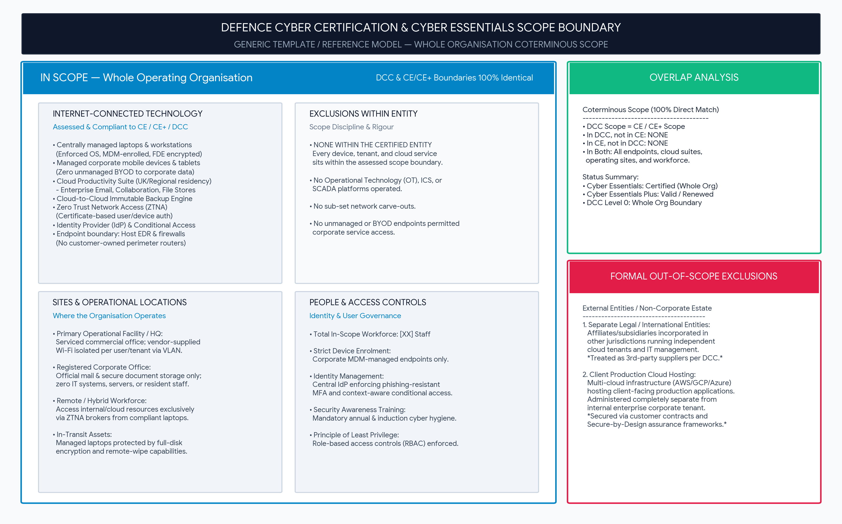

Scope Definition & Boundary Alignment Matrix
In Scope (DCC & CE / CE+ Coterminous) | Out of Scope (Formally Excluded)
• Whole Certified Organisation: All [XX] managed workstations and mobile devices.  • Cloud productivity, identity tenant (IdP), and ZTNA remote broker.  • Centrally managed host boundary firewalls & EDR agents.  • Primary operational office, registered office, and all remote workforce. | 1. Affiliated International Entities:  Separate legal entities incorporated in other jurisdictions operating independent cloud tenants, device pools, and IT providers. Treated as third-party suppliers per DCC scoping rules.  2. Client Product Hosting Estate:  Multi-cloud client-facing production infrastructure, administered separately from the corporate tenant and assured via customer contracts and Secure-by-Design accreditations.
Cyber Essentials Scope Overlap:  100% Coterminous. Nothing sits inside one boundary and outside the other. | Exclusion Rationale:  Neither external entity sits inside the certified corporate boundary.

(f)(ii) Diagram 2: Systems, Networks, Assets & Relationships
Logical four-layer connection model from physical sites to enterprise cloud data:
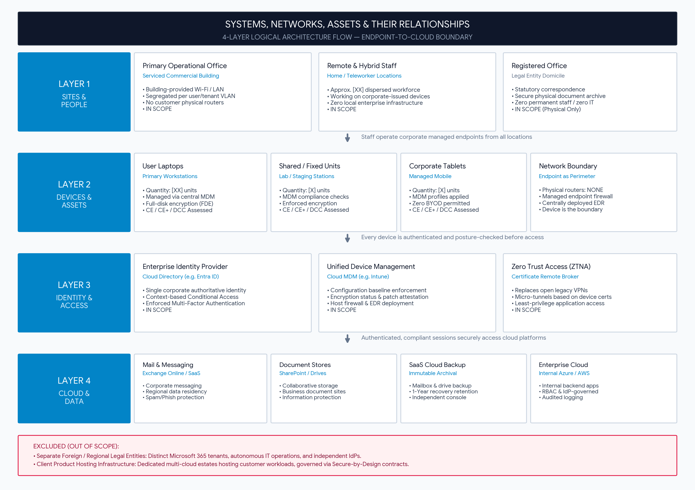

(f)(iii) Boundary Coterminous Matrix
Relationship | Scope Content
In DCC scope, not in CE/CE+ scope | None
In CE/CE+ scope, not in DCC scope | None
In both scopes | All devices, cloud services, identity directories, operating sites, and personnel.
In neither scope | Autonomous international subsidiaries; client-facing product cloud hosting environments.

Certification Currency & Maintenance
Framework | Scope Boundary | Status / Reference
Cyber Essentials | Whole Organisation | Certificate: [Cert-Ref-XXXX]  Valid / Annual Renewal
Cyber Essentials Plus | Whole Organisation | Certificate: [Cert-Ref-YYYY]  Valid / Annual Assessment
Defence Cyber Certification | Whole Organisation | Reference: [DCC-XXXX]  Level 0 Attestation

Declaration & Authorisation
For the purposes of this attestation, a material fact is defined as any information that could influence the acceptance, validity, or assessment of the certification. I understand that if any statements or details are later found to be misleading, inaccurate, or incomplete, this may result in the invalidation and revocation of the certification.
I also confirm that [Example Organisation Ltd] commits to maintaining continuous Cyber Essentials certification for the duration of any function related to this activity and any DCC certification period.
Authorised Signature: | __________________________________________________
Full Name: | [Authorised Signatory Name]
Title / Position: | [Chief Information Security Officer / Technical Director]
Date: | [DD Month YYYY]

