# Nessus Agent Installation for Windows

Contents

1. Download the agent. 3

2. Run installer on client device and click next. 3

3. Accept the license agreement and click next. 4

4. Accept the install location and click next. 4

5. Accept typical setup type and click next. 5

6. Fill in the configuration settings shown below. 5

7. Finally click Finish. 6

## Download the agent [here](https://www.tenable.com/downloads/nessus-agents?loginAttempted=true).



## Run installer on client device and click next.

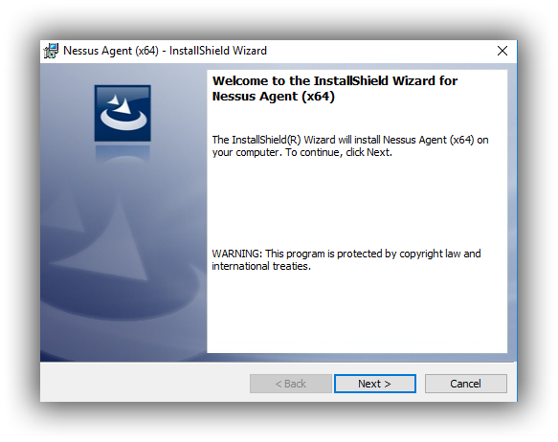

## Accept the license agreement and click next.

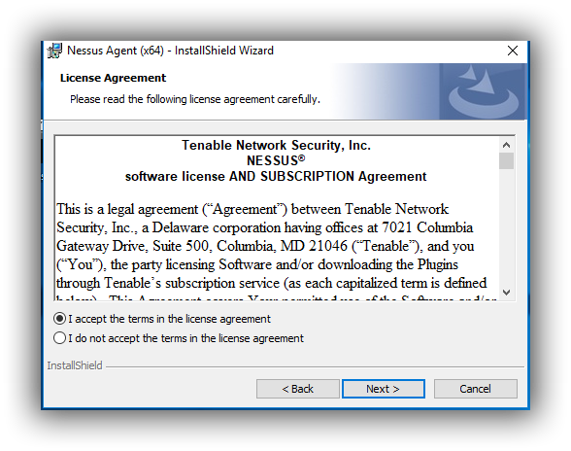

## Accept the install location and click next.

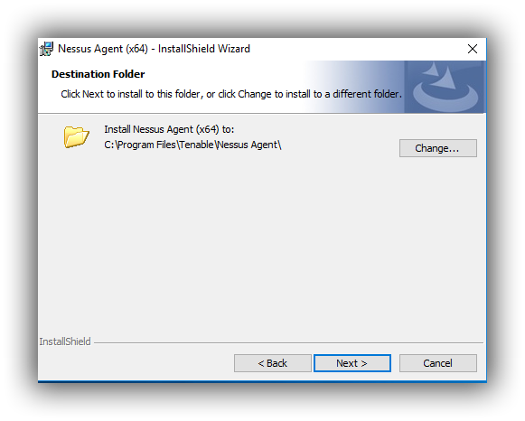

## Accept typical setup type and click next.

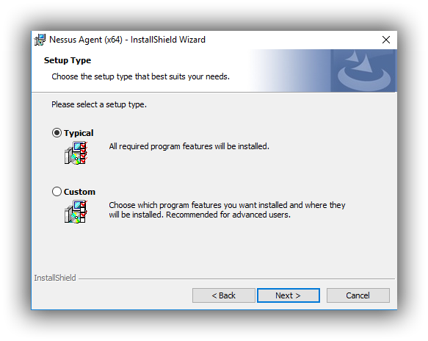

## Fill in the configuration settings shown below.

Lateral

|  |  |
| --- | --- |
| Key | 50cffa4700d979a7e6a61993e63542e4aea81c9823ea721099de6736cb866111 |
| Server | cloud.tenable.com:443 |
| Group | Lateral |

**Please note the group is case sensitive.**

## Finally click Finish.

