

**PLAGIARISM DECLARATION FORM (T-DF)**

|  |
| --- |
| **Instructions**  **Please complete and attach this Plagiarism Declaration Form to each Assignment that you submit into the Online Assignment Submission (OAS) system for marking.** |
| I declare that the attached work is entirely my own (or when submitted to meet the requirements of an approved group assignment is the work of the group), except where materials cited, quoted or paraphrased are acknowledged in the text. I also declare that this work / assignment has not been submitted for assessment in any other course or university without due acknowledgement.  I understand that plagiarism, collusion, and copying are grave and serious offences.  I understand that disciplinary action (which may include deduction of marks in the Assignment) will be taken against me if I am found to be an offender of Assignment plagiarism.  **Full name and IC No: Low Chin Kee, 940329-08-6285 Date: 17th March 2023** |

|  |  |
| --- | --- |
| **Assignment Declaration Form** | |
| Semester/Year | **January 2023** |
| Student’s Name | **Low Chin Kee** |
| Student’s ID No: | **051180047** |
| Course Code | **TSE309/10** |
| Course Title | **SE Project** |
| Class Code | **5P-SEP1-Y** |
| Assignment No: | **3** |
| No. of pages of this Assignment *(including this page)* | 87 |
| Project Supervisor | **Mr Ho Hsiao Hsiung** |
| Course Lead | **Dr Tan Choo Jun** |

***T-DF*** *Assignment Declaration Form (1/2020 version #003)*

**Guru ICT – A Web Initiative Intended for Encouraging Secondary School Student ICT Support and Knowledge**

**Low Chin Kee**

**051180047**

Project report submitted as part fulfillment for the degree of Bachelor of Software Engineering (Honours)



**SCHOOL OF SCIENCE AND TECHNOLOGY**

**January 2023**

# **COPYRIGHT DECLARATION**

Wawasan Open University

Session: **January 2023**

I, **Low Chin Kee** declare that this report shall be the property of Wawasan Open University and I allow copies of it to be made for academic purposes.



________________________________________________________

(Signature)

Date: 18th March 2023

# **ORIGINAL DECLARATION**

I declare that this report titled “*Guru ICT – A Web Initiative Intended for Encouraging Secondary School Student ICT Support and Knowledge*” is my own work except where cited in the references. The report has not been accepted, and is not being submitted in candidature, for any degree or other award elsewhere.



__________________________________________________________

(Signature)

Low Chin Kee

(Name in full as your NRIC)

Date: 18th March 2023

**COPYRIGHT DECLARATION** 3

**Abstact** 5

**1. Introduction** 6

1.1. Objective of the project 7

1.2. Scope of the project 8

1.3. Problem Statement 8

**2. Literature Review** 9

2.1. Overview of the situation where students lacking computer knowledge 9

2.2. Why students should learn computer knowledge since young 10

2.3. Why should students have the basic knowledge of computer 10

2.4. Insufficient up-to-date computer in schools 11

2.5. How computer knowledge website improves the common computer knowledge of students 12

2.6. Malaysia Government donates electronic devices to help students in their academic but.. 13

2.7. Thesis Statement 15

3. **Overview of methodology** 19

3.1. Requirements gathering/analysis 19

3.2. Design Phase 19

3.3. Implementation Phase 20

3.4. Testing Phase 20

3.5. Deployment and maintenance 20

4. **Project Plan and methodology** 21

4.1. Requirements Gathering Phase 22

4.2. Design and Implementation Phase 26

4.3. Testing Phase 43

4.4. Maintenance Phase 45

**5. Conclusion** 46

5.1. Future improvements 46

5.2. Lessons learnt 47

5.3. Appendices 47

5.4. References 84

**ABSTRACT**

In this digital rapidly advancing era, technology is one of the best initiatives to improve the quality of life, technology involved in most parts of our life. However, for technology to work it’s best in improving our lifestyle, everyone should at least have the basic computer knowledge. This report describes the overall situation of students lacking computer knowledge in this digital era. The objective of this project is to develop a website to provide fundamental computer knowledge to students as well as others who are interested in learning in order to increase and stir up their interest in learning technology. This report consists of several sources from different articles and journals to indicate the current situation in which most students are lacking computer knowledge due to different reasons and alternatives on how to enhance the situation. The website developed in this project can be accessed by different electronic devices such as home computer, laptop, smartphones and whatever device that have an internet connection. The website will be tested for a few days because published to make sure it is working properly on different platforms.

**1. Introduction**

In this modern era, information technology is advancing at a rapid rate. Almost every field in this 21st century requires information technology, it is crucial that everyone should learn and have the fundamental knowledge of the technology. Information technology involves the study and combination of hardware and software that is used to do the necessary tasks that people need on an everyday basis. Most professionals who are working in the IT field with an organization technically know what they want in order to achieve their needs, they will set up or implement the technology that is available to perform their required tasks. Since we are living in the world of technology, information technology became a part of our lives, most companies now have their own IT departments to manage their computers, networks, security and other technical areas related to technology of their businesses. Not only for the business sector, but with the help of information technology, online transactions are made easier and safer. One can pay their bills online in a few clicks with their smartphone.

Information technology allows teachers in school to be up to date with new technology and help their students to be updated with the latest information technology such as the usage of tablets, smart phones, computers etc. in their study. Information technology helps students to learn new things in an efficient way with the use of laptops, especially those in college or university. With the rapid advancement of information technology educationon has evolved its outlook and developed a modern way of teaching and learning. Teachers in school can use modern gadgets to teach their students, a computer or other device with an internet connection allows students to learn and understand the topics easily. Information technology allows the sharing of knowledge throughout the world, not only students are beneficial, but teachers are also taking advantage and staying up to date with modern technology. For accurate sharing or exchanging of knowledge and information, efficient teaching and learning, information technology is crucial. Besides, learning information technology can prevent students from leaking out their personal information such as their accounts in social media or private photos they stored in their own device. It is like a double-edged sword, it is convenient to store everything in social media such as Instagram and Facebook, but on the other hand, it is easy to be accessed by everyone for different purposes. It is important for them to learn at least the basics of computer knowledge, how to set up the setting in social media and use the internet in a secure way.

However, not everyone dives into learning information technology skills quite easily, it is best to start from a younger age. The goal of developing this project is to stir up secondary students’ interest in computer studies by developing a website to provide them fundamental information about computer software and hardware. Website is also providing some simple troubleshooting and solutions for frequent computer issues. For example, interactions between the school and students can be provided to promote their learning about information technology, they can start looking into the computer in the school labs or their own computer. With the help of information technology, students will be able to exchange information and discuss in online about their study, it is encouraged to have good computer knowledge especially in their age, this is the perfect time for them to pick up knowledge about computer, not only does it benefit in their study, they can gain most for their future lifestyle also. For example, with the knowledge of information technology, their career path is made easier, they will have better opportunity to get a job especially most jobs require computer skills in this modern era, even a food restaurant will need to use information technology for their billing system, stocks inventory record and so on. In this project, a website will be developed to stir up student’s interest in learning computer knowledge and basic troubleshooting skills to deal with common computer issues.

**1.1 Objective of the project**

The objective of this project is to develop a simple informative website to provide fundamental knowledges of the computer in both software and hardware to secondary students for them to learn and perform simple computer functions such as copying files, duplicating folder, deleting files permanently and etc. The website developed in this project must be able to be accessed through different platforms such as desktop computer, laptop as well as different browsers, the website will provide information about computer software and hardware to allow students to have a better understanding of how the computer works and they will be able to fix common computer issues when they happen.

**1.2. Scopes of the project**

* Adding a forum into the website to provide communications among the users
* Adding a quiz section on the website for users to test their computer knowledge
* Website developed in this project must be accessible by at least 5 different web browser and they are Google Chrome, Mozilla Firefox, Apple Safari, Microsoft Edge and Opera in both computer and smartphone
* Adding a FAQs section on the website to allow students to look for quick solutions to common computer problems easily.

**1.3. Problem Statement**

In this era, computers are important for students in their studying but there is not enough support for them from outside, their quality of learning will be slower especially for those who is not familiar with the use of computers. For example, the result of comparison between students who look for information through the school library and students who look for information through the internet with the use of computer is obvious, internet users will be more efficient. However, not every student is able to use the computer in school, the computer lab in school provides insufficient time for students to learn about computers. Consider that a school with few hundred students sharing a school lab, they only get access to it like few hours in a month, it is even worse when a computer problem occurred, it takes quite a long time for school to fix it because computer course is not the main worry in secondary school. It will be good if students can fix the common computer issue to make the lab available again. Besides, students can learn computer knowledge through online like TechGuy, through Youtube and etc, but it would be hard for them because these websites assume that users have the basic of computer knowledge, it is hard for students with minimal computer knowledge to start learning from these websites.

**2. Literature Review**

**2.1 Overview of the situation where students lacking computer knowledge**

The current situation is that most students do not have sufficient computer knowledge, some even do not know what a processor and motherboards are, not to mention some complex actions like formatting the computer or upgrading windows. There are a few reasons why they are lacking computer knowledge, the first reason is because there are insufficient materials and no proper platform in school for students to learn about computers properly, most students only get access to computer like once per week and the session only last about 45 minutes, in my experience in school, I only get like 2 sessions of computer lesson every month, because the computer class is replaced by another subject. It is possible that my school thought computer classes were not important and they are willing to drop it out for other subjects like physics, biology and chemistry. If most of the schools have the similar thinking, students especially the younger generation will start to lose interest in learning computer. Not only that, but I can also remember vividly that during the computer classes when I was in primary school, the teacher only taught us to open an emulator called “Mame32” and there were plenty of games there, we played for like half an hour while the teacher is just sitting there doing her own things. It was even funnier during my secondary school, computer classes are just a waste of time, we can do whatever we want in the computer lab with the computers or do our homework from other subjects as long as we are not making loud noises, most of my friends including me were just chit-chatting for the whole class and the teacher were just playing with the phone. This is my personal experiences and I hope it is not the same in other schools, imagine if this scenario happens in schools, more and more students will start losing their interest in learning computer knowledges and eventually most of the students will be lacking computer knowledge.

**2.2 Why students should learn computer knowledge since young**

It is not a good thing that students lacking computer knowledge especially during this digital era, having sufficient computer knowledge is good for their working or college life in the future because the computer technology brings countless benefits towards us in today’s world, even most of the normal restaurant is using computer technology like EWallet paying system, cashier billing system, stocks and inventory tracking and so on. A report has shown that the starting salaries for fresh graduate students have fallen because they lack digital skills in an increasingly competitive market and a tough economy. A salary report done by JobStreet in 2020 ([***https://www.jobstreet.com.my/en/cms/employer/laws-of-attaction/inspirations/the-job-report-may-2020-edition/***](https://www.jobstreet.com.my/en/cms/employer/laws-of-attaction/inspirations/the-job-report-may-2020-edition/)***)*** Indicates that fresh graduates’ salaries have been “quite consistent” year after year, that means the number of fresh graduate students with digital skills had remained the same for years, showing no improvement. The situation as I stated earlier could be one of the main reasons why there were no improvement throughout the years because young students are lacking interest or being discouraged by schools to learn about basic computer knowledge, schools want to focus on other objects such as accounting, physics, mathematics and so on. This could probably be the reason why a quarter of university graduates remain unemployed six months after graduating despite employers complaining about difficulties sourcing talent. *(Eduspiral, 2019)*. Talents such as data analytics, artificial intelligence, applications programming and e-commerce are important in today’s rapidly advancing technology world, almost every company need these talents to work in their business and they are looking for new people with such talents. Needless to say if a person is capable of a few of the talents mentioned above, he or she will have the ability to look for jobs with above-average wages.

**2.3 Why should students have the basic knowledge of computer**

Using a computer or laptop plays a crucial role for students towards their study. With the knowledge of computers, they can access online libraries or forums where students can exchange information. Victoria Williamson stated that students can look for many ways to solve a certain problem given to them with the infinite amount of useful and relevant information over the internet. (Victoria Williamson. 2018). However, the premise is that they have to use it in an appropriate way, some students could be addicted to computer games and ignore their schoolwork.

Besides, if they have the basic computer knowledge about hardware components, they will be able to identify and fix the problems such as blank screen, windows unable to boot, computer performance is slow and etc. Sending their computer to the repair shop outside could have high cost even for a small problem or they could be tricked by the shop for turning a small issue into something huge, they would not know if they do not have the basic computer knowledge.

Other than that, students who use computers will have better performance in their studies compared to those who do not have the use computers. This is because the learning process gets much simpler and efficient with the use of computers, the students get access to new methods of communication such as forums or online meetings. This helps them to have easy communication with their tutors or other students. They can get the information they want within a few minutes rather than taking a long time looking for the desired information with books. Today, the availability of a computer in education makes it a whole lot easier and faster to access everything you need to research, you can get all the answers you want for your school projects in a few clicks. (Vinat Prajapati. 2021). In short, research work has become far easier at present due to technology, students do not have to go through physical copies of books in the library for the information they want.

**2.4 Insufficient up-to-date computer in schools**

Other than that, there is not enough up-to-date computer in school classes to let their students to learn about the latest technology, for example, it seems useless for students to learn about how to use a computer that have an operating system of Windows XP in 2022 and Windows XP was released almost 20 years ago considering that most operating system that is being used by the world now is at least Windows 7 although Windows 7 looks out-of-date but still better than the Windows XP. Therefore, some of the big companies are now donating to schools to help them improve their computer technology. For example,Lotuss Stores (Malaysia) Sdn Bhd (Lotus’s Malaysia), together with VSTECS Bhd has recently donated 50 laptops to Sekolah Kebangsaan (SK) Seksyen 17 and refurbished its computer laboratory because the overall condition of the school’s computer laboratory was in a very poor condition, more than 40 computers are not functioning and need an update and maintenance on their main servers.*(Timothy Tuan, 2022)*. Since 2016, Lotus’s Malaysia has been working with the PINTAR Foundation, which is a school adoption programmed by GLCs and private sector companies in Malaysia to deliver aids to youths in underserved communities, to provide various listings to improve the lives of the students.

Some may argue that it is just the big company that wants to promote their reputation and donate only a few laptops for a school for displaying purpose to show how kind they were. In my perspective, this could be their true purpose but in reality, they did donate some laptops to a school, it is a win-win situation in my opinion, the company got what they want, and the schools had new laptops. In the bigger picture, if other big companies see their competitors do this, they could follow the trend and donate some computer devices to schools that have outdated computer systems. This practice will increase the number of students learning about computer knowledge and the company can improve their reputation to attract more customers.

**2.5 How computer knowledge website improves the common computer knowledge of students**

Websites can improve the computer knowledge of students in various ways. For example, students will be able to access a wealth of information, websites usually provide them a huge range of information and resources that can help them to have a deeper understanding of computer knowledge. Other than that, students will be able to learn at their own pace, which can be really beneficial especially for those who always needed extra time to learn something. Gemma Josep, a writer of online learning, education and technology as well as the content manager for Classgap stated that “We are now entering a new era — the revolution of online education.” (Gemma Josep, 30 Dec 2022). Not only is it flexible, but it is also accessible, and students will be able to learn from websites from anywhere in the world. A decent website usually has a wide range of information so that the students can learn whatever they feel like learning. The main advantage of learning online is that it allows students to access to information anywhere, anytime and any pace, as mentioned earlier, they could be sitting in their home and access the information if they have internet connection and device for internet like laptops, smartphones and desktop computers. The website that is being developed for this project will have all the basic computer information such as the input and output units, display settings for windows, hardware to build up a computer and so on. Besides, there will be some advanced section on the website for students already have the basic computer knowledge like firewall configuration, database organizing, system file configuration and etc. This website is developed towards the needs of computer knowledge in today’s students and also to improve the current situation where most students are lacking the basic computer knowledge.

**2.6 Malaysia Government donates electronic devices to help students in their academic but it is a new challenge for students without computer knowledge**

The reason why I decided to embark on this project is to give students or other people a chance to learn computer knowledges in a convenient way, all they have to do is just enter my website, it consists of many basic computer information like the introduction to input and output devices, usage of certain computer parts, troubleshooting and so on. Besides, the website really saves a lot of previous time for the students in many ways as time plays a very crucial role for the students. For example, if their parents want their child to learn computer knowledges, they would have sent their child to a physical computer class outside, the time their students take to be prepared to classes, the time the parents drive their child to the location, all these times could be saved if the child can access the website and learn computer knowledge with their electronic devices such as laptop, computer and mobile. The parents will not face the need to drive through congested traffic for extra tuition for the child and making time to send their child back and forth from the tuition classes, their child can easily learn and get the desired information from the website of my project. However, there exists a situation where students do not have electronic devices at home because their household income is not good enough to spend money on luxury things such as tablets and smartphone, the good thing is the Malaysia government has finally began distributing the tablets to underprivileged B40 students, the tablets are Samsung galaxy Tab A8 LTE which is more than enough to support the student to do simple web surfing and learning purpose. *(Yasmin Abdul Latif, 2022)*.To be eligible for the part of giveaway, students have to prove that their family has a household income of less than RM4,850. A past studies show that, a survey done by the Ministry of Education (MOE) shows that ownership of computers and tablets among the students in Malaysia is only 6% and 9% respectively and smartphone ownership is much better at 46% (Gan Siowck Lee, 2020). Imagine what is going to happen with the rest who does not have any devices for their study, especially during the past 2 years, all the schools are closed, and students have to study and learn through internet, some without devices will not be able to keep up with their study. Therefore, government of Malaysia is trying to give tablets to B40 students to assist them in their study. “Do they need to return the devices back to government?”, “Are there any requirements such as payments in the future?”, some questions like these were brought by most of the parents and they cannot be ignored as unanswered questions could lead to a commotion in the public, the good thing is the Prime Minister Datuk Seri Ismail Sabri Yaakob had stated that, students who receive tablets under the Perantisiswa Keluarga Malaysia initiative will not need to return the devices once they graduate. (The Sun Daily, 2022). They can keep on using the given devices or pass it to the next student who is in need of the device. Not only Lotus’s Malaysia, there are quite a lot of company in Malaysia also doing the same thing, for example, Siemens Malaysia work hand in hand with Medical Awareness Camp Outreach (MACO) to help students in the B40 community by donating 163 used laptops to underprivileged students in 2021. MACO is a non-profit organization started by a group of specialist doctors and non-medical volunteers to help collecting used laptops and refurbish them into working condition to donate to the students without a device to study in home, students lose access to the education they deserve if they do not have the devices needed for e-learning. Although a donation of 163 used laptops seemed insignificant compared to the number of students lacking devices now, but it is still better than none, I believe the donations will eventually be bigger in the future as the government of Malaysia is concerned about the current situation of insufficient and outdated computers and technology in most schools.

The situation became more vivid from the first Malaysia Movement Control Order (MCO) on 18th March 2020, most business, industry, government and educational institutions. Students will be conducting their study at home with computer devices, all classes are done through online meeting software such as Zoom, Microsoft Teams, Skype and so on. However, there were many issues when students have to study in home, teachers cannot control their behavior and some even went absent for the whole class due to insufficient computer knowledge, they had no idea how to set up the software for online classes even with guide given by the tutors, some students do not have devices for them to attend online classes. Therefore, several issues were discussed at the time, such as limited applications and the lack of technological infrastructures and internet access, it is just not easy to study via the internet, it involves a lot of things such as internet access, devices, education materials, peer guidance in meeting students’ needs, responsibility from parents and their child and etc. (Sufian, Nordin, Tauji, & Nasir, 2020).

This project is started with an initial purpose of letting students to learn computer knowledges from a simple website to stir up their interest in learning computer knowledge, more and more students including other people will be interested in learning computer knowledge from a simple website. The website in my project can act as a platform for people and students to share their opinions and ideas on various topics, they can also interact with each other and discuss the topics in depth. Students no longer have to worry about a poor environment to learn computer knowledge like outdated computer systems in schools or teachers not doing their job teaching computer knowledge properly. The desired outcome of this project will be an increase in the number of students or people learning computer knowledge through the simple informative website without a hassle.

**2.7 Thesis statement**

Will the current situation of students lacking computer knowledge be enriched by a simple informative website and how does it help in their current and future study?

The website that is going to be developed in this project consists of basic computer knowledge which is a good platform for students who is not getting enough time to learn computer knowledge and not getting a chance to learn computer knowledge in schools due to several issues as mentioned in the literature review. Therefore, I believe the current situation of students lacking computer knowledge will be better if students are able to learn through websites.

As mentioned earlier, the main cause of the current situation where students are lacking computer knowledge is mostly because of the lack of opportunity to learn such as lack of time, place and no idea where to start learning. For example, students have to focus on other subjects in school and the school is willing to drop computer classes for subjects like physics, chemistry, accounting and etc. The first reason why simple informative website is a good alternative to improve the situation of students lacking computer knowledge is because students can access the content on the website wherever and whenever they want, students can be sitting at their comfortable position in home or even laying on the bed to access the website for computer knowledge. Additionally, students can learn whatever they are interested in, for example, if a student had no idea what kind of keyboards are available and would like to learn about it, there is a specific page for information of keyboards in the website of this project. This is totally different from physical classes at school or outside, because classes at school or outside usually filled with many students, the materials and knowledge provided by the lecturer will be at standard pace, which means the students are learning the same thing at the same time. In this case, there will be scenario where some slow students are not able to catch up with the teaching, only 2 options are available at this point, either the teacher slow down the overall pace of the teaching or ignore the slow students and continue with the current pace, no matter what the decision is, some students will be affected for sure. This could be the issue why some students are lack of computer knowledge, if the tutor taught them computer knowledge such as turning on a computer, open Microsoft applications and done some copying and pasting on file system in a particular class, some students may not be able to learn all these in a class within an hour, “Why don’t they raise their hands and ask for help in the class?”, there are several reasons to this question, students may be introverts and afraid to ask for help, the tutor just start to ignore them as long as the teaching materials are completed within the session or just like my own experience, the tutor was not doing the job, students can do whatever they want in class. A website is a good solution for situations like that, students can learn at their own pace in a comfortable environment like their home, they can learn whatever they want from an informative website. E-learning has been viewed as the ability to focus on the requirements of individual learners. For instance, focusing on the needs of individual learners can deliver knowledge in digital age effectively as compared to educational institutions’ needs or instructors (Huang and Chiu, 2015). An information website is a good way to fulfill the needs of a platform for students to learn computer knowledge freely.

However, some may argue that students would prefer classroom learning over the internet. In a paper of student perspective of classroom and distance learning during COVID-19 pandemic, 301 students were surveyed at the end of the semester, less than half of the students preferred distance leaning over classroom learning. (BMC Medical Education, 2020). After I have gone through the paper, the students stated that distance learning gave a more efficient learning method, it provides more time to study and revision but most of them still prefer classroom learning over learning through internet, this is because, as stated in the paper, challenges such as unstable internet connection, extra financial burden for electronic devices are the reasons why classroom learning is more preferred. Imagine if a country has decent coverage of internet and most families own a computer or smart phones, I believe more than half of the students will prefer distance learning over classroom learning. Some parents even think that their child should not be wasting time on their tablets or electronic devices, these things could be a burden towards their child’s study. On the whole, the situation of students lacking computer knowledge will be improved if they can learn effectively from a website in their free time, their studies at school will not be affected as they can control when and where they want to learn computer knowledge from the informative website. Of course, parental control plays a crucial role in this part to make sure their child is really learning something from the internet, some could be addicted to movies, internet games or other unhealthy activities. By letting students access the internet at a younger age, some parents cited that technology as the main reason why parenting is getting harder today than in the past because their children are addicted to the screens for long hours every day.

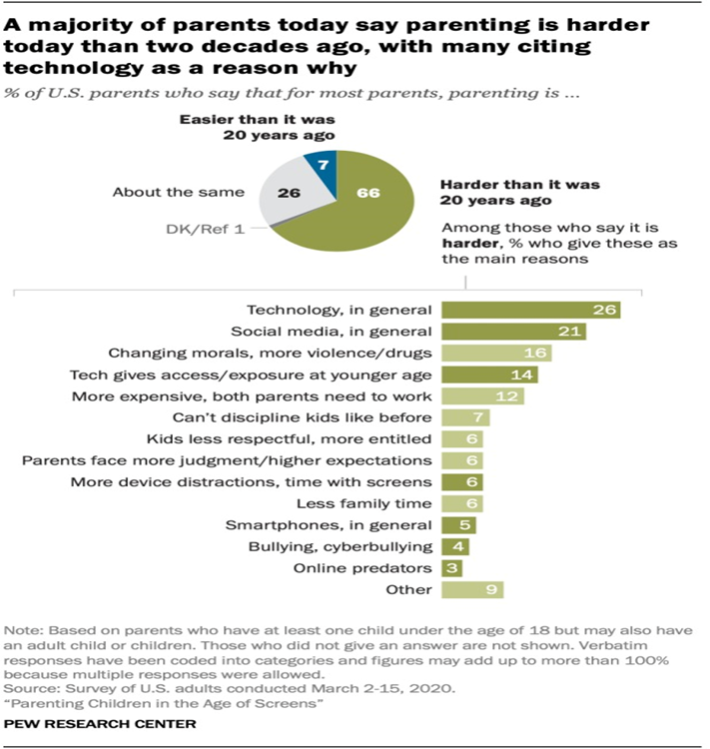

Image source:[*https://www.pewresearch.org/internet/2020/07/28/parenting-children-in-the-age-of-screens/pi_2020-07-28_kids-and-screens_00-03/*](https://www.pewresearch.org/internet/2020/07/28/parenting-children-in-the-age-of-screens/pi_2020-07-28_kids-and-screens_00-03/)

The survey above is done in the United States in March 2020 by Pew Research Center, more than half of the parents think that technology had made the parenting in today harder than before. They expect students especially aged 11 or younger should not be gaining access to the internet such as educational websites. In my opinion, it is best to get started on using technology before the age of 11, this is where the children learn at their best. “Although the brain continues to develop and change into adulthood, the first 8 years can build a foundation for future learning, health and life success. In short, children are able to learn faster than an adult, it is best if they can start using technology in the early ages especially in this rapidly advancing technology world, condition is that as I mentioned earlier, parental control of their time using the technology must be control at an appropriate standard. The informative website in this project is a good example to encourage students as well as their parents to notice the benefits of using technology to learn something that students were not able to learn from the school effectively like computer knowledges.

**3. Overview of methodology**

The methodology that is going to be used throughout this project is Waterfall methodology, it is a linear approach for project management where the requirements of stakeholder and customer are collected at the start of the project, requirements will be analyzed and evaluated after that. It is named as Waterfall methodology because each phase of the project happens in a sequence, previous phase must be completed before next phase begins, each phase is following down like a waterfall. This approach is widely used to manage construction, IT and software development.

**3.1 Requirements gathering/analysis**

Requirement gathering/analysis is the first phase of the waterfall model. More detailed requirements for the software system to be developed must be gathered in this phase. It is crucial for a company to understand the needs of users before developing the software system. After the requirements are given, they will be analyzed to make sure that these requirements can be included in the developing software without any problems with the system functionality. For example, if a company wants to have the same pricing and products or inventory on the website, the pricing of the website must be accurate and updated at regular intervals. After the requirements phase is done, the next stage will be system designing.

**3.2 Design**

During this phase, software developers have to design a technical solution to the problems that are brought by the product requirements in previous stages like scenarios, layouts and data models. So, the other members of the team can review the documentation for each requirement for validation. For example, documents like users should be able to view their shopping history, users should be able to get assistance through live support that could be included in the system.

This stage can be described by splitting them into logical design and physical design subphases. The logical design phase shows the representation of how data flows, inputs and outputs of a system is performed. This representation can be conducted through modelling and using an over-abstract model of the system. For example, entity-relationship diagram can be used for the representation. It is not needed to specify how the tasks should be allocated because the representation of the logical nature of the system about the status of the tasks is shown. The physical design phase is about how the system’s internal and external entities and the flows of data to be displayed, this can be done by a graphical representation. After the design phase is done, next phase will be implementation.

**3.3 Implementation**

Implementation phase is usually the shortest and easiest stage in the waterfall model. Since the construction of the software was done in the previous stages, developers can start working on the computer code. Coding is where the specifications of the physical design turn into working computer code.

**3.4 Testing**

In this phase, testing is carried out with coding to make sure that the system is fulfilling the stated requirements before using the system. Testing can be done by doing inspections, unit testing or walkthroughs. The team member who is in charge of testing will try to test the whole system and identify if there are any defects in the system, if a defect is detected, developers will be informed and try to fix the defects and test again by the testing team to see if any new defects are introduced. After the testing is done, the software system will be installed and deployed.

**3.5 Deployment and maintenance**

The last phase of Waterfall methodology is maintenance, maintenance will be done after the deployment of the software system. Most newly introduced systems always are in need of ongoing maintenance to make sure that the software is running at optimum levels of performance. For example, users can try to discover bugs, errors and inadequate features then report them to the developer, the developer will try to fix them as soon as possible until the users are satisfied.

**4.0 Project Plan and methodology**

For the development of my project, I have decided to use Waterfall methodology, the first thing I do is to note down all the requirements for the website to be developed, it is important for me to understand the needs of users before developing the website. For example, some of the requirements for me to develop in this project are every page on the website must have a similar design, the position of the menu for navigation to other page must be consistent. This phase is easy considering that my project is small and simple, I moved to the next phase as soon as I finished marking down all the requirements for my project. All the requirements are collected with some of my friends and decided only by me as I am the developer for this project, I have to brainstorm with myself to come up with the final decision. As a developer of this project, I have gathered user requirements and functional requirements. User requirements are the expectations of users outside of a system, they need the system to do the way they want. Users have the right to illustrate what the software system has to do to achieve the users’ objectives. For example, one of the user requirements is “Users must be able to raise concerns regarding any issues to the admin”. Functional requirements bring a complexity with manually requested requirements and it is hard for me to manage in this project, it plays an important role in development of software. For example, “There should be redirecting of users to the other page when they clicked on one of the bars in title menu such as Home, About us and etc.”, these requirements must be fine-tuned. Non-functional requirements on the other hand, is pretty straightforward and easy to understand. For instance, some of the non-functional I have gathered in this phase are “The website must have high capacity to handle large number of users at the same time” and “The website’s up time is almost 24/7 to the users”. These non-functional requirements do not really define the system, but they are essential to the operations of the system.

**4.1 Requirements gathering**

Before the development of my project, the website in this project will be developed via WordPress hosting of DreamHost, as an undergraduate software engineering student, I write my own functions in HTML, JavaScript and CSS and add to the WordPress hosting, my own coding will be discussed in the design phase. The way I develop this project is on my own and of course with the help of my project supervisor, Mr.Ho Hsieh Hsiung, we have frequent meeting to keep my project process updated.

Before I start discussing my methodology, I would like to show the specifications of the devices I am using for the development of this project. The development of this project will be done on my own desktop computer, the specifications of both software and hardware of my computer are shown below. There will be 2 devices to test the website of my WordPress hosting with DreamHost to look for the difference between a computer and a smartphone. To make sure the website is displaying properly some different devices, the specifications such as the display, resolution, web browser and software will be included in the specification list. There are also some specifications for software that will be used for the development of this project.

**Hardware**

**Desktop Computer**

|  |  |
| --- | --- |
| Component | Specification |
| Processor | Intel(R) Core(TM) i3-10105F [CPU@3.70GHz](mailto:CPU@3.70GHz) (8CPUs), ~3.7GHZ |
| Operating System | Windows 10 Pro 64-bit (10.0, Build 19044) |
| Memory (RAM) | HyperX fury black 3200MHz DDR4 16GB (15.9 usable) |
| Storage | PNY CS900 240GB SSD and Seagate external HDD 1TB |
| Graphics/Video | Zotac GTX 1060 6GB |
| Monitor | AOC C27G1 1080p 144Hz |
| Mouse | SteelSeries Rival 600 |
| Sound | Speakers (HyperX Cloud Revolver S) |
| Headphones | HyperX Cloud Revolver S |

Samsung Galaxy S22+

|  |  |
| --- | --- |
| Component | Specification |
| Operating System | Android 13 |
| Chipset | Qualcomm SM8450 Snapdragon 8 Gen 1 (4nm) |
| Display | Dynamic AMOLED 2X, 120Hz, 1080x2340 pixels, 19:5:9 ratio |
| Processor | Octa-core (1x3.00 GHz Cortex-X2 & 3x2.50 GHz Cortex-A710 & 4x1.80 GHz Cortex-A510) |
| Graphic/Video | Adreno 730 |
| Storage | 256GB UFC3.1 |
| Sound | Stereo speakers |
| Network | GSM/CDMA/HSPA/EVDO/LTE/5G |

**Software**

Used in my desktop computer

|  |  |
| --- | --- |
| Software name | Specification |
| Pencil | To design the basic layout of the website |
| Microsoft Word | To write a report based on what I had found for the project & to write down some important notes for the development of the project for my own use |
| Microsoft Project | To plan the timeline for the tasks in this project |
| Google Chrome | The main browser for using WordPress hosting with Dreamhost |
| Microsoft Edge | Secondary browser in case Google Chrome is not working properly |
| Opera Browser | A browser to test if the website of this project is displaying properly |
| Mozilla Firefox | A browser to test if the website of this project is displaying properly |
| Visual Studio Code | To do coding to add to my WordPress hosting |
| NetBeans IDE | To do coding to add to my WordPress hosting |
| Selenium | Open-source automated testing framework to test my web applications |

Used in my Samsung galaxy S22+

|  |  |
| --- | --- |
| Software name | Specification |
| Samsung Internet Browser | The main browser on this device to test the website |
| Google Chrome | A browser to test if the website of this project is displaying properly |
| Opera Browser | A browser to test if the website of this project is displaying properly |
| Microsoft Edge | A browser to test if the website of this project is displaying properly |
| Adblock Browser | A browser to test if the website of this project is displaying properly |

For the development of my project, I have decided to use Waterfall methodology, the first thing I do is to note down all the requirements for the website to be developed, it is important for me to understand the needs of users before developing the website. For example, some of the requirements for me to develop in this project are every page on the website must have a similar design, the position of the menu for navigation to other page must be consistent. This phase is easy considering that my project is small and simple, I moved to the next phase as soon as I finished marking down all the requirements for my project. All the requirements are collected with some of my friends and decided only by me as I am the developer for this project, I have to brainstorm with myself to come up with the final decision. As a developer of this project, I have gathered user requirements and functional requirements, user requirements are the expectations of users outside of a system, they need the system to do the way they want. Users have the right to illustrate what the software system has to do to achieve the users’ objectives. For example, one of the user requirements is “Users must be able to raise concerns regarding any issues to the admin”. Functional requirements bring a complexity with manually requested requirements and it is hard for me to manage in this project, it plays an important role in development of software. For example, “There should be redirecting of users to the other page when they clicked on one of the bars in title menu such as Home, About us and etc.”, these requirements must be fine-tuned. Non-functional requirements on the other hand, are pretty straightforward and easy to understand. For instance, some of the non-functional I have gathered in this phase are “The website must have high capacity to handle large number of users at the same time” and “The website’s up time is almost 24/7 to the users”. These non-functional requirements do not really define the system,but they are essential to the operations of the system. The list below shows the functional and non-functional requirements for the website in this project.

Functional requirements:

1. The website shall allow users to access forum
2. The website shall allow users to use search function
3. The website shall allow users to answer random quiz
4. The website shall allow users to scroll back to top immediately after clicking on a “back to top” button
5. The website shall allow users to send an email to the website owner

Non-functional requirements:

1. The website should be available 99.9% of the time
2. The website should be compatible with all major web browsers
3. The website should be secure and protect user data from unauthorized access
4. Switching and loading each page of the website should be within 3 seconds

At this point, the scope, expectations and requirements for this project is done, the second phase which is analysis and design phase, documents and sign off are not needed as I am developing this project on my own without any other stakeholder.

**4.2 Design and implementation phase**

The website that is being developed in this project will be done using WordPress, and the hosting services for the website will be provided by DreamHost. DreamHost is known for its commitment to open-source software and its support for web developers. They have been a long-time supporter of the WordPress community and have developed their own custom control panel for WordPress sites management. The reason I choose DreamHost is because it offers unlimited disk space and bandwidth, WordPress available and 100% uptime guarantee, most importantly is because of the cost, it is not expensive and suitable for an undergraduate student like me, it costs around 45$(USD) per year.

In this phase, I have created a functional requirement template that describes what the website should do and how it should perform and also an interface design. The list below shows the functional specification of my project.

|  |  |
| --- | --- |
| WHO ARE YOU? | I am currently an undergraduate software engineering student at Wawasan Open University (WOU). |
| WHY DO YOU NEED A WEBSITE? | This website is developed to improve the situation where most students are lacking basic computer knowledge in this digital era. |
| WHO IS YOUR KEY AUDIENCE | The main target of this website is the students who want to learn basic computer knowledge though non-students are welcome too. |
| HOW SHOULD YOUR SITE BE ORGANIZED | The website consists of various features such as Quiz, Forum, FAQ, Email. All of them can be seen and easily access through the menu bar on the website. |
| HOW DOES IT WORK? | Students and others will be able to access this website via a URL. This website provides various basic computer knowledge. |
| WHO ARE YOUR COMPETITORS | This is a non-profit website, and it does not have any competitors at this time, there could be competitors in the future where more features are added to improve the website. |
| WHAT ELSE? | The website is developed based on my fundamental knowledge as an undergraduate software engineering student, I expect it to be further improved in the future by myself or better developers. |
| WHAT IS YOUR BUDGET AND DEADLINE | The deadline of this project is about 44 weeks from the initiation of the project and the budget for this project is around 50$(USD). |

After that, I created a simple UI design with a software called “Pencil”, the image below shows the basic UI layout design without any customizations such as effects and colors that I have created with Pencil.

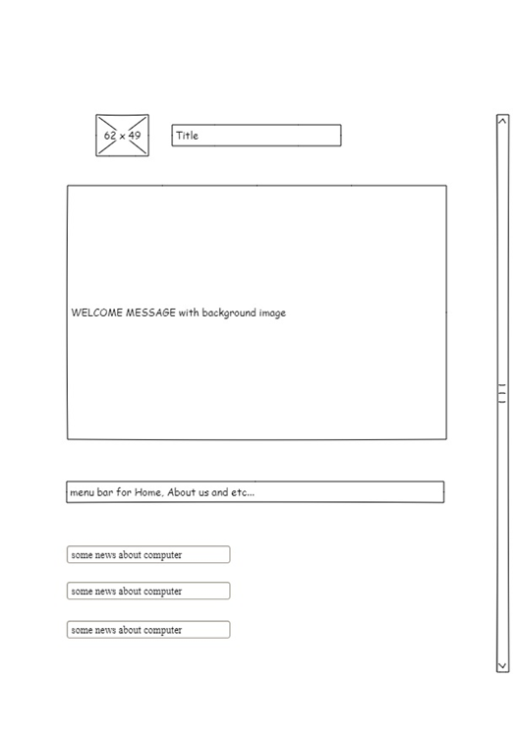

Then I proceed to set up my WordPress in DreamHost. The images below show the interfaces of DreamHost and the page for designing my website with DreamHost.

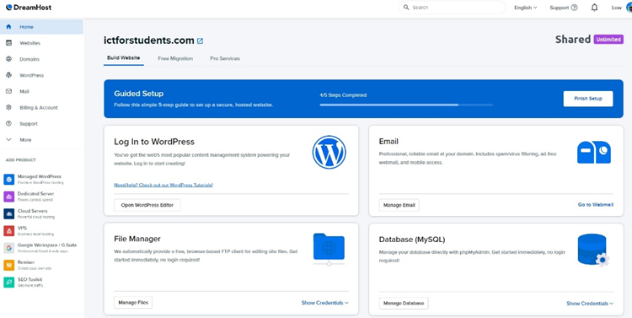

The URL for the website in this project is <https://www.ictforstudents.com>

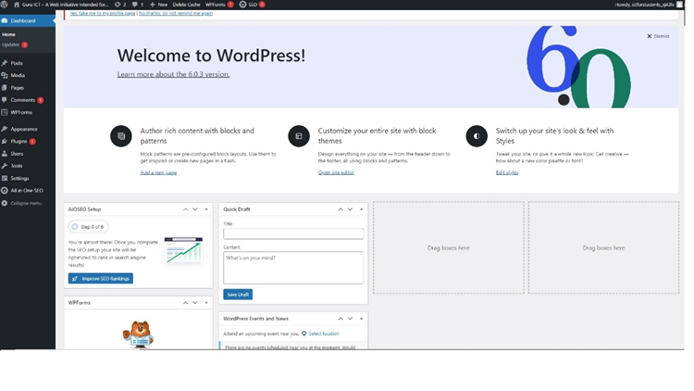

This is the first page after I logged in to my DreamHost account, there are many features I can use in this page. On the left-hand side, I can check my billing and account, mail, domains, websites and many more. This is a quite simple interface for new users as almost everything is straight-forward, it even has a guided setup for new users to get into WordPress hosting of DreamHost easily.

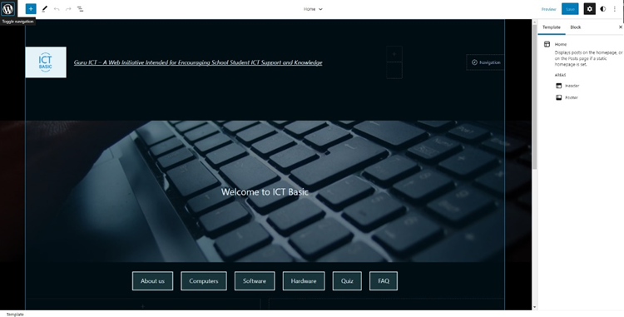

The image above represents the basic layout and design of my website, there are plenty of features I had planned to add into the website slowly as I am not familiar with the use of WordPress hosting, I have to spend some time on learning to use it. The way I designed the basic layout of the website is based on a sample draft I created with Pencil software as mentioned earlier. After I have the simple layout design for my website, I try to start adding features such as forum, quiz, FAQ and etc. The first feature I try to implement into the website is “back to top” button as it is the simplest function for me to add. However, I have trouble trying to add the code into my WordPress, the custom HTML box in WordPress originally is not working properly for my code. So, I have no choice but to install plugin to my WordPress, there is plugin, Custom CSS & JS, allow me to add my custom JavaScript and CSS code to my website but the features are limited because I am using a free version of it. Still, it works for my “back to top” button, below shows a part of my code for the button, please refer to appendix 4 for the full code.

#myBtn {

display: none;

position: fixed;

bottom: 20px;

right: 30px;

z-index: 99;

font-size: 18px;

border: none;

outline: none;

background-color: aqua;

color: red;

cursor: pointer;

padding: 15px;

border-radius: 4px;

}

This “back to top” button is highlighted and stays in the exact position which is on the right-bottom side of the website, so users can notice it immediately when they scroll down.

*button onclick="topFunction()" id="myBtn" title="Go to top">Top</button>*

This code allows users to go back to the top of the webpage immediately when they click on it.

The button will appear only when the user scrolls down.

*if (document.body.scrollTop > 20 || document.documentElement.scrollTop > 20) {*

*mybutton.style.display = "block";*

*} else {*

*mybutton.style.display = "none";*

*}*

The code above gives a function when user does not scroll down, the button will not appear. If the user scrolls down by 20px of their screen, the button will appear. After the “back to top” button function is done, I proceed to code a quiz function for my website. Before coding the quiz function, I inserted hyperlink to the menu bar, so when users click on any boxes in the menu bar, they will be directed to other pages of the website.

I have written few versions of code for the quiz functions, please refer to appendix 1, 2, and 3, the website is currently using the 3rd version as it is working better and have more functions than the 1st and 2nd version although there are many similarities in them.

When users clicked into the quiz page of my website (https://www.ictforstudents.com/quiz), users will be able to see the quiz questions directly when they scroll down the page. The image below shows the interface of the quiz page as well as the quiz questions.

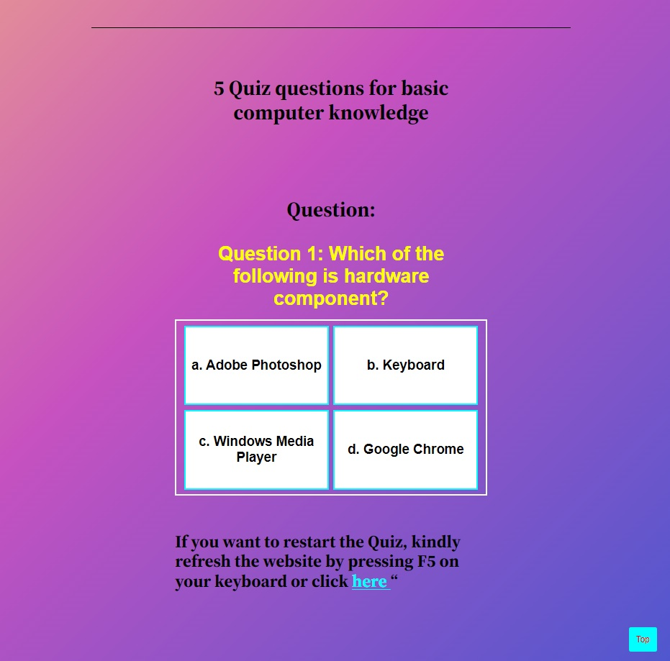

Since this website is mainly targeting students or people with limited knowledge in computers, I have added some questions with an image to it. This can be done by insert *“<img src=’ examplewebsite’>”*.

For example,

question: "<br><img src='https://i.postimg.cc/PJVkdzQ3/cpu-g6f7e9d924-1280.jpg'><br>What is the purpose of this computer component?",

answers: {

a: "To protect the PSU",

b: "Display image and video",

c: "Do nothing",

d: "Process instruction and carry out computation"

},

correctAnswer: "d"

},

The image below shows an example of a question with image.

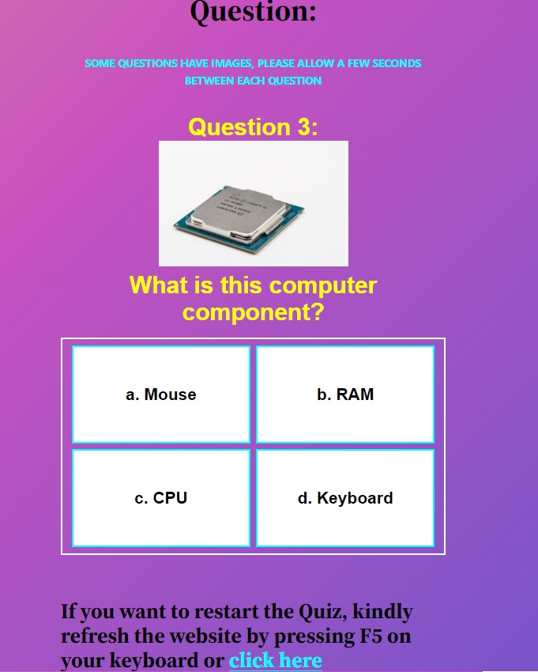

If a user wants to restart or try the quiz again, they can click on the highlighted word “here”, it refreshes the page. For this function there are many of ways to do it via JavaScript, I just simply write this line “*<a href="#" onclick="location.reload();" style="color:aqua";>click here</a>*” on the customer HTML box in WordPress. It refreshes the page when users click on it.

The score and a prompt message will be displayed when the user finishes the quiz. The image below shows a few examples of the result message according to the correct or incorrect answers by the users.

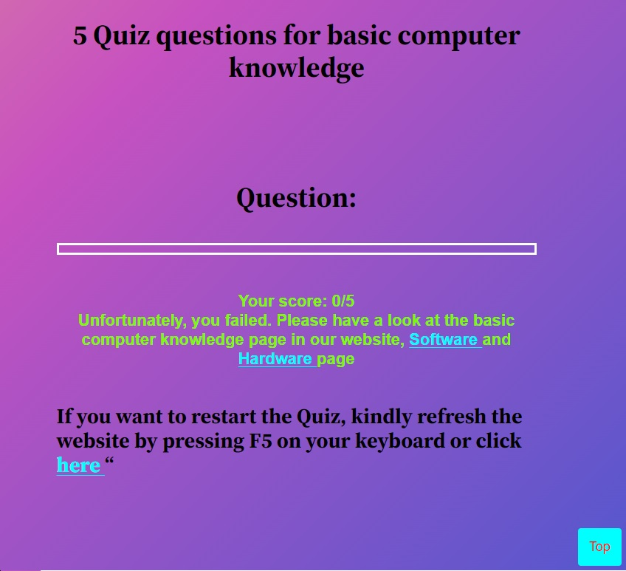

If their score is too low, the website will display a message to advise the user to learn basic computer knowledge related to the quiz question through the software and hardware page, they can even click on the highlighted “Software” and “Hardware” word to access the website immediately. The images below show a few more examples of the messages based on the score.

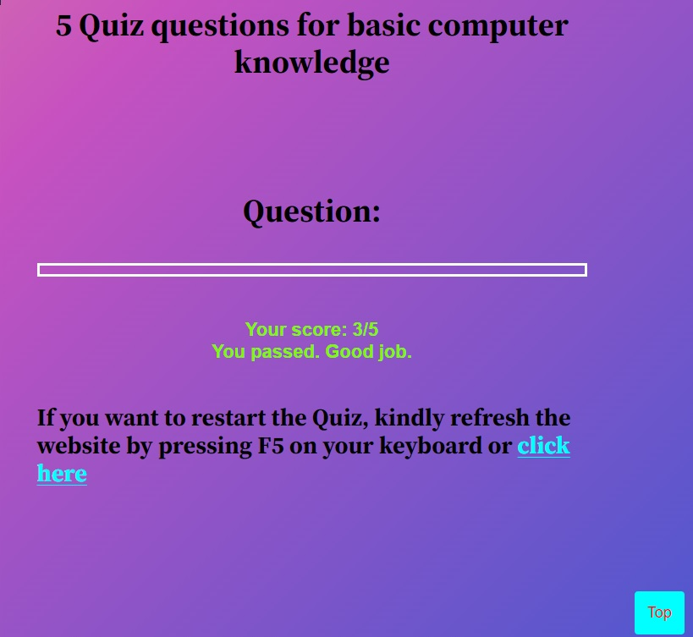

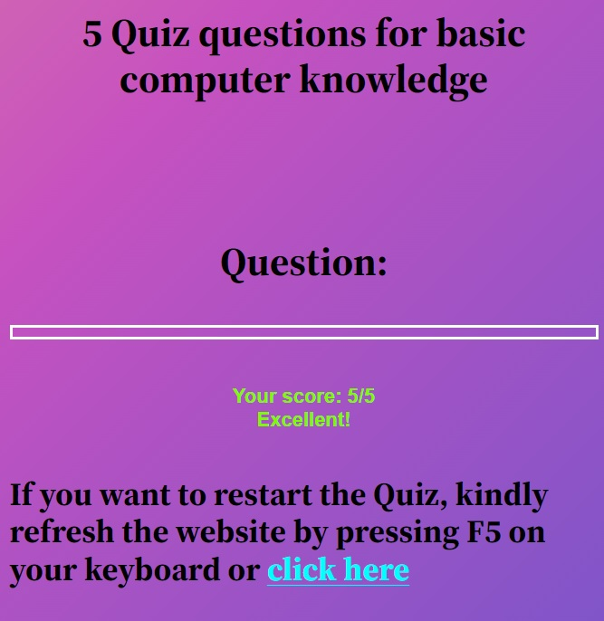

I can add as many questions as I want into the coding, but the website is only choosing 5 random questions from the questions.

const randomQuestions = questions

.sort(() => 0.5 - Math.random())

.slice(0, 5);

This function will randomly select 5 questions every time the quiz or the website is refreshed. If I want to add or edit the questions, I go to this part of my coding to do editing.

const questions = [

{

question: "Example question 1",

answers: {

a: "choice 1",

b: " choice 2",

c: " choice 3",

d: " choice 4,

},

correctAnswer: "a/b/c/d"

},

{

question: "Example question 2",

answers: {

a: " choice 1",

b: "choice 2",

c: " choice 3",

d: " choice 4"

},

correctAnswer: "c"

},

After the quiz feature is completed, I proceed to add a forum feature into the website. This is complicated task for me to code the whole forum on my own, considering the deadline for this project, I installed wpForo plugin to my WordPress, it is a beginner friendly plugin, it comes with multiple modern forum layouts. The image below shows the menu of wpForo. The link to the quiz website is *“https://www.ictforstudents.com/quiz/”*

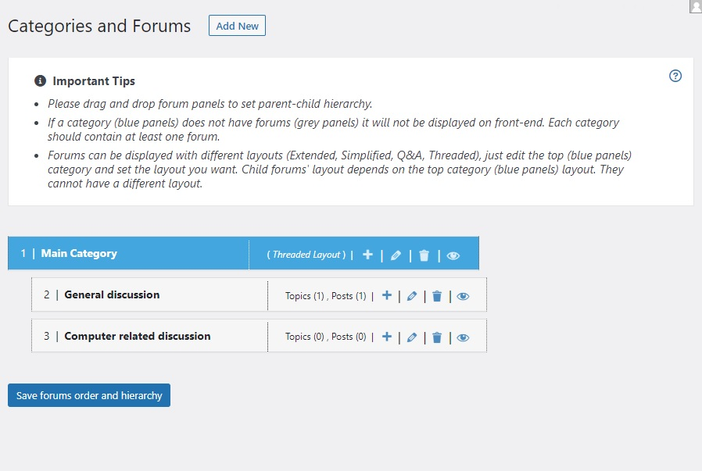

If I want to add or delete a certain forum topic, I can do it with a few clicks on this wpForo page. I can even ban users or add certain rights such as delete topic or review a topic before published to a specific person. The image below shows the interface of the forum.

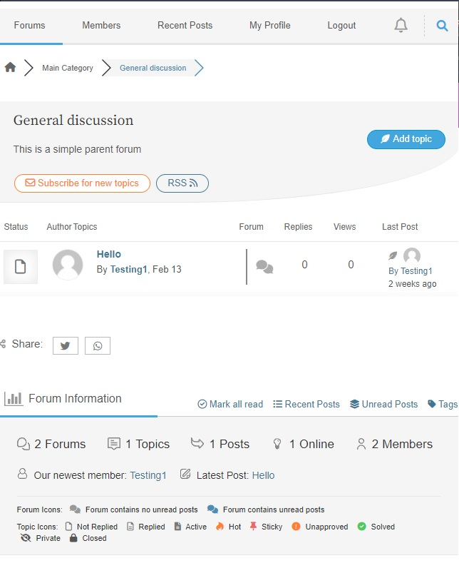

After that, I proceed to create my FAQ page, the code for FAQ page is quite simple, I just write the code in HTML and paste it to the custom HTML box in WordPress and there are some highlighted words such as “Software”, “Email”, “Hardware” and etc., it will re-direct the users to certain page when they clicked on it. The image below shows part of the FAQ page of my website, the URL for my FAQ page is [*https://www.ictforstudents.com/faq/*](https://www.ictforstudents.com/faq/)

Please refer to appendix 6 for the HTML code for FAQ.

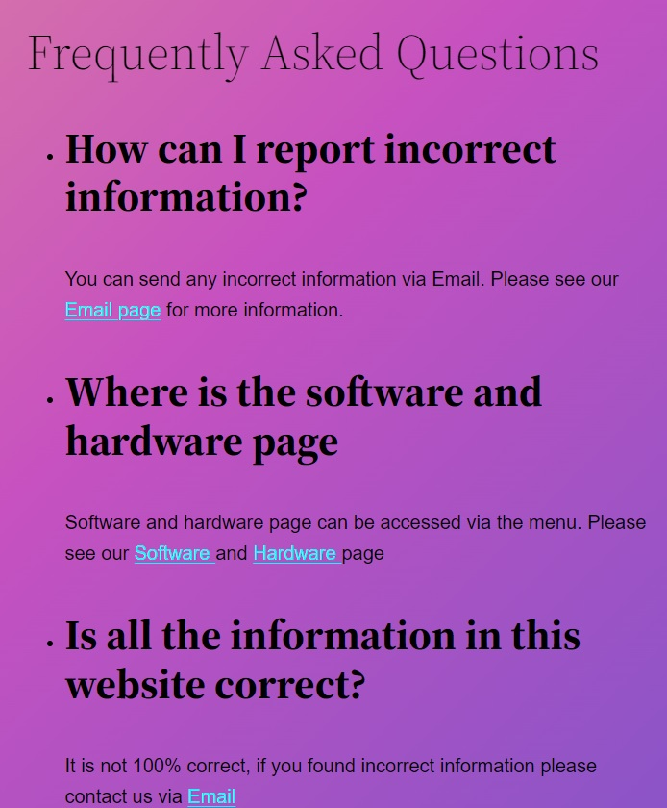

After these pages are finished, I proceed to create “about us” and a few basic computer pages as well as adding the search function with the help of WordPress. All of them can be easily managed under WordPress in DreamHost. The image below shows the interface of WordPress to manage my pages.

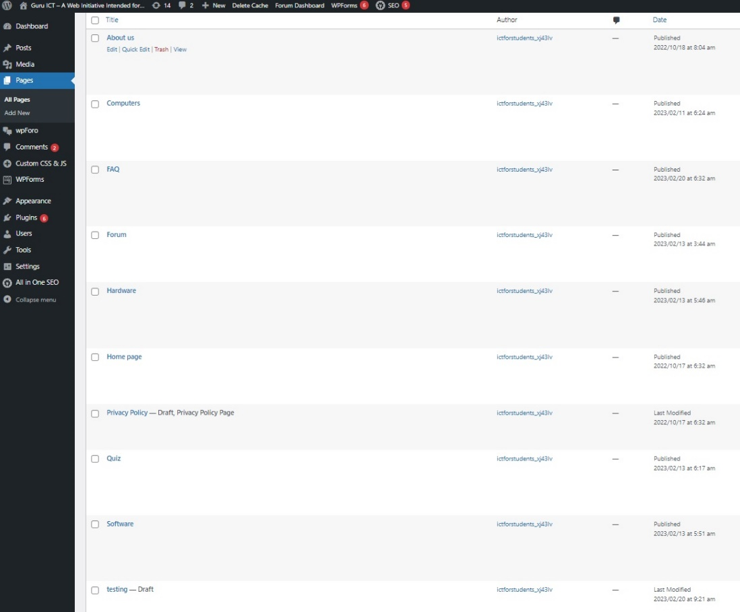

After all set and done, I move on to the testing phase. The image below shows the final version of my interface of the website before testing. The “back to top” button and search functions as well as the hyperlinks on the menu bar is working as expected.

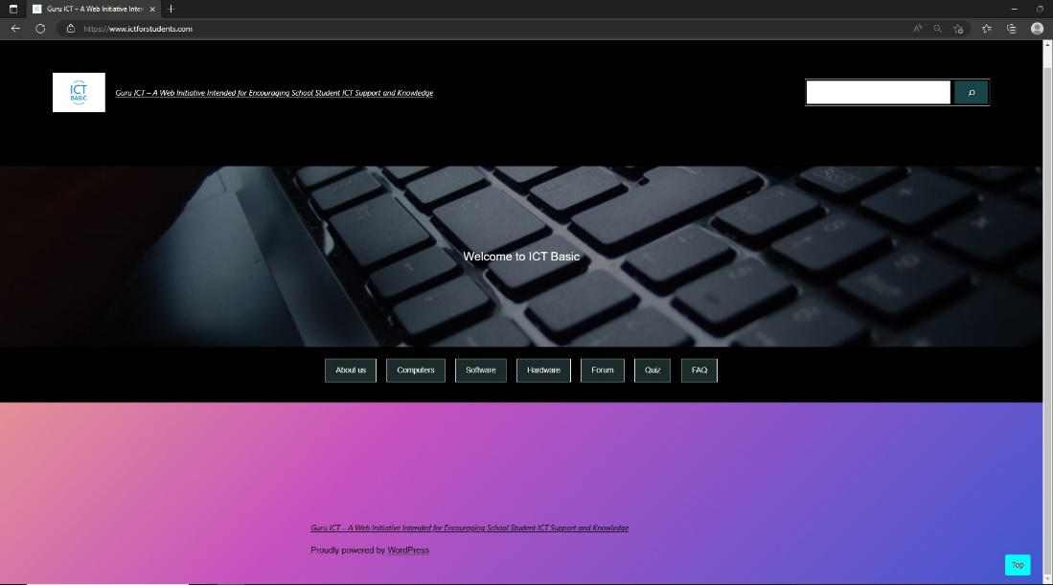

**4.3 Testing**

There are many tools to test a website such as Pingdom, SemRush, LoadRunner and so on. But their pricing is out of my budget for this project, so I must look for free alternatives to do simple tests on my website. Before testing my website with tools, I tested it on my desktop computer, my smart phone and a few laptops and mobile devices with my friends. I am satisfied with the result although it is not decent, the average load time and response time for my website is around 2.8 seconds. I have tested it on different browsers for a week at different times and they are working the way I expected without any error.

For the visuals and layout of the design, I have contacted a friend who currently owns a few e-commerce websites for his business. His feedback for my website is listed as below:

1. Layout: The layout of the website appears to be quite simple and straightforward. The top menu bar provides easy navigation to different sections of the website. The use of a single column design helps to keep the focus on the content, making it easier to read.
2. Color scheme: The website uses a blue and white color scheme, which creates a clean and professional look. The colors are also consistent throughout the website, which helps to create a cohesive design.
3. Typography: The font used for the website's content is easy to read and consistent, which is important for ensuring a good user experience. However, the font size could be slightly increased to make it easier to read, particularly for users with visual impairments.
4. Images: The website makes use of relevant images to help illustrate the content. However, the images could be optimized for faster loading speeds to improve the overall user experience.

After that, I have found some free tools for do simple testing on my website performance and load time such as Google PageSpeed, GTmetrix, SpeedLab and Pingdom Speed Test, the results are shown as below:

Result 1 (SpeedLab)

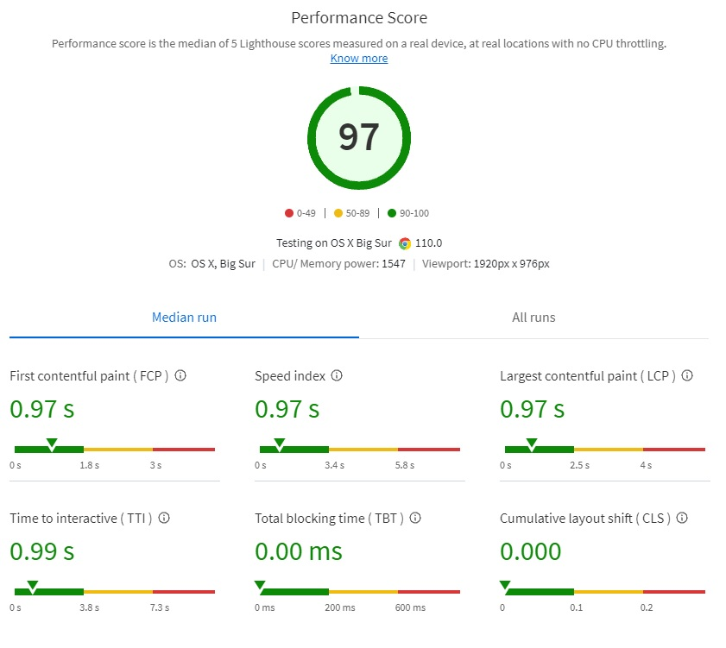

Result 2 (Pingdom Speed test)

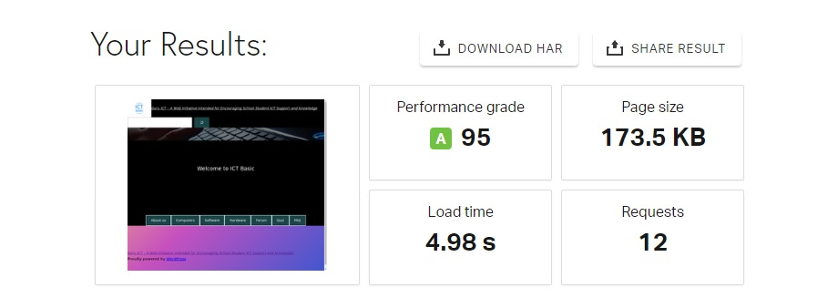

Result 3 (Google PageSpeed)

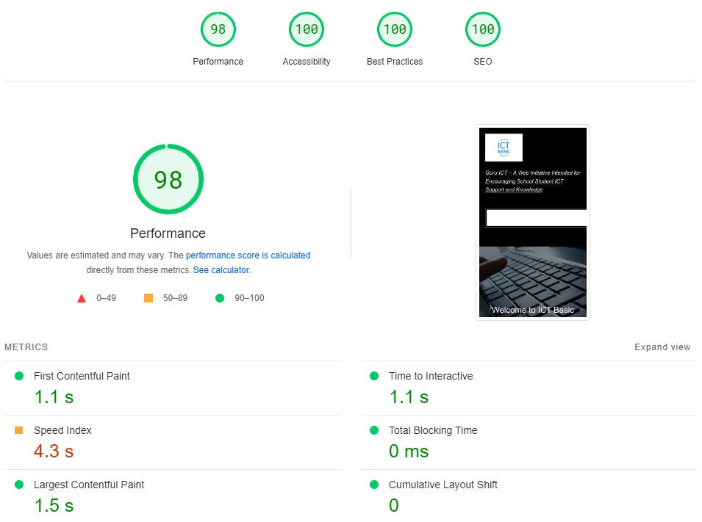

Result 4 (GTmetrix)

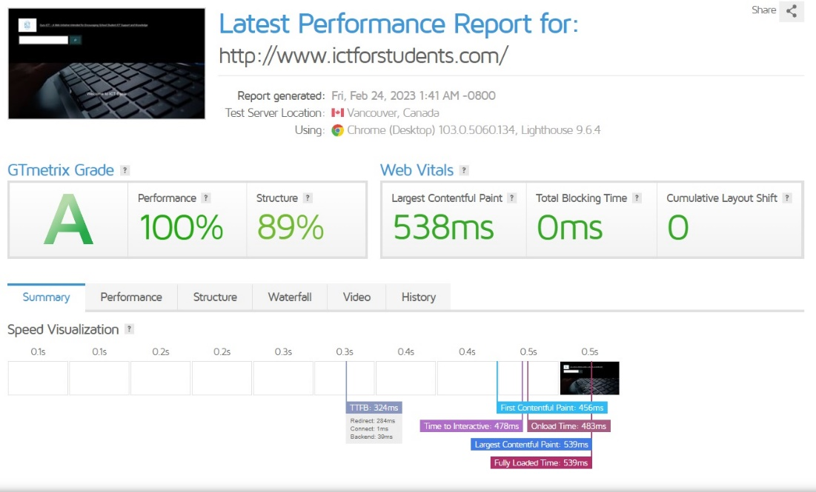

At this point, all of the functional and non-functional requirements are achieved, and I decided to publish the website.

**4.4 Maintenance Phase**

With the help of DreamHost, the concern for website hosted with DreamHost is not really critical, DreamHost has a team of security engineers, internally known as Nightmare Labs to provide security services such as malware remover, “Let’s Encrypt”, free domain privacy and many more. It does not mean that I as an owner of the website do not need to do anything after publishing, I have to check my email regularly to see if users discover any incorrect information or bugs on my website. Also, I have to check the performance of my website frequently to make sure it is performing optimally. Any changes that I have made after publishing will be documented for future usage.

Other than that, I have to keep all of the plugins in my WordPress up to date because these plugins are updated frequently for better usage although I can enable auto-update for all the plugins. But it is better if I read every update note to see what new features, functions or changes, they have added into the updated plugins, and I manually update them as I read though the patch note.

**5. Conclusion**

In conclusion, the website development project was a great success. I was able to create a functional, user-friendly website that meets the needs and expectations in this project. The website is fully functional, intuitive navigation, minimal design and all the necessary features to provide a good user experience. I utilized the latest technologies and best practices to make sure the website is responsive and optimized.

**5.1 Future improvements**

The website developed through this project is not perfect, there are many ways to improve it in the future. I have listed down a few sections which could be further improving in the future.

The first thing is the design, I had only focused on the function and coding phase in this project and the website design layout is not good in my opinion, but it is easy to navigate and clean design. Besides, I will try to add in more detailed content and latest information about computer knowledge, I can also further explain each computer software and hardware in a more detailed way through embedding a video or images to illustrate it.

The search bar, social media integration or even a chatbot can be implemented into the website. For example, forms can be added to the website, but they must be easy to fill out and only including the important fields, auto filling and predictive text features can be implemented to make form filling even more effective in the future.

Other than the aspects mentioned earlier, there are many other things to be improved or implemented in the future as we are living in an era of rapidly advancing digital technology, no one knows what new features or functions could be introduced in the future.

**5.2 Lessons learnt**

There are many lessons I have learnt from this project, the first thing I learnt is the importance of planning. Any project without a plan would have failed easily, having a proper plan before starting the development of my website in this project has saved me a lot of time and effort in the long run. Clearly defining the project’s goals and objectives and required functionality before starting can help avoid immediate changes or uncertain decisions later. I also have to put user experience in my website development as a website’s success really depends on the user experience, the website must be easy to navigate, visually appealing and have valuable contents.

Besides, I also learnt about security and the way to develop a website with the help of WordPress. Therefore, security was not my main concern throughout the project, I just worry about the functionalities on my website, testing my website regularly during the development process can help me identity and fix issues before launching, any bugs or user experience issues will be fixed.

**5.3 Appendix**

**Appendix 1)**

<style>

.quiz-container {

width: 80%;

margin: 0 auto;

text-align: center;

font: 22px Arial;

font-weight: bold;

}

.question {

font-size: 30px;

margin-bottom: 20px;

}

.answers {

display: flex;

justify-content: space-evenly;

margin-bottom: 25px;

border: 3px;

border-color: white;

padding: 5px;

border-style: solid;

font-size: 20px;

font: Arial;

}

.answer {

width: 30%;

font-size: 16px;

cursor: pointer;

}

.result {

font-size: 22px;

margin-top: 50px;

}

.correct {

color: green;

}

.incorrect {

color: red;

}

</style>

<div class="quiz-container">

<h1>Quiz for basic computer knowledge</h1>

<p id="question"></p>

<div class="answers" id="answers"></div>

<button id="submit">Submit</button>

<p class="result" id="result"></p>

</div>

<script>

const questions = [

{

question: "xxxxxxx",

answers: {

a: "xxxxxx,

b: "xxxxxx",

c: "xxxxxx",

},

correctAnswer: "c"

},

];

let currentQuestion = 0;

let score = 0;

const randomQuestions = questions

.sort(() => 0.5 - Math.random())

.slice(0, 5);

function displayQuestion() {

let q = randomQuestions[currentQuestion];

document.querySelector("#question").innerHTML = q.question;

document.querySelector("#answers").innerHTML = "";

for (letter in q.answers) {

document.querySelector("#answers").innerHTML += `

<div class="answer" onclick="checkAnswer('${letter}')">

${letter}. ${q.answers[letter]}

</div>

`;

}

}

function checkAnswer(answer) {

if (answer === randomQuestions[currentQuestion].correctAnswer) {

score++;

}

currentQuestion++;

if (currentQuestion === randomQuestions.length) {

document.querySelector("#question").innerHTML = "";

document.querySelector("#answers").innerHTML = "";

document.querySelector("#submit").style.display = "none";

document.querySelector("#result").innerHTML =" Your score: " + score + "/" + randomQuestions.length;

if (score === randomQuestions.length) {

document.querySelector("#result").innerHTML += "<br>Perfect score! You're a genius.";

} else if (score / randomQuestions.length >= 0.75) {

document.querySelector("#result").innerHTML += "<br>Congratulations! You did great.";

} else if (score / randomQuestions.length >= 0.5) {

document.querySelector("#result").innerHTML += "<br>You passed. Good job.";

} else {

document.querySelector("#result").innerHTML += "<br>Unfortunately, you failed. Better luck next time.";

}

} else {

displayQuestion();

}

}

displayQuestion();

</script>

**Appendix 2)**

<style>

.quiz-container {

width: 80%;

margin: 0 auto;

text-align: center;

font: 22px Arial;

font-weight: bold;

}

.question {

font-size: 30px;

margin-bottom: 20px;

}

.answers {

display: flex;

justify-content: space-evenly;

margin-bottom: 25px;

border: 3px;

border-color: white;

padding: 5px;

border-style: solid;

font-size: 20px;

font: Arial;

}

.answers div {

border: 3px solid white;

padding: 5px;

}

.answers div:nth-child(1) {

border-color: aqua;

background-color: white;

}

.answers div:nth-child(2) {

border-color: aqua;

background-color: white;

}

.answers div:nth-child(3) {

border-color: aqua;

background-color: white;

}

.answers div:nth-child(4) {

border-color: aqua;

background-color: white;

}

.answer {

width: 30%;

font-size: 16px;

cursor: pointer;

}

.result {

font-size: 22px;

margin-top: 50px;

}

.correct {

color: green;

}

.incorrect {

color: red;

}

</style>

<div class="quiz-container">

<h2><strong>Quiz for basic computer knowledge</strong></h2>

<p id="question"></p>

<div class="answers" id="answers"></div>

<button id="submit">Submit</button>

<p class="result" id="result"></p>

</div>

<script>

const questions = [

{

question: "What does RAM stand for?",

answers: {

a: "Random Average Memory",

b: "Random Anti Memory",

c: "Random Access Memory",

d: "Random Arranged Memory"

},

correctAnswer: "c"

},

{

question: "Which of the following is not an input device?",

answers: {

a: "Microphone",

b: "Mouse",

c: "Monitor",

d: "GPU"

},

correctAnswer: "c"

},

{

question: "What is the brain of any computer system?",

answers: {

a: "Google Chrome",

b: "Windows XP",

c: "CPU",

d: "Motherboard"

},

correctAnswer: "c"

},

{

question: "Which of the following is hardware component?",

answers: {

a: "Adobe Photoshop",

b: "Keyboard",

c: "Windows Media Player",

d: "Google Chrome"

},

correctAnswer: "b"

},

{

question: "Which of the following is hardware component?",

answers: {

a: "GPU",

b: "Microsoft Edge",

c: "Apache Open Office",

d: "Paint 3D"

},

correctAnswer: "a"

},

{

question: "Which of the following is software component?",

answers: {

a: "Solid State Drive",

b: "Speakers",

c: "Windows Media Player",

d: "Motherboard"

},

correctAnswer: "c"

},

{

question: "Which of the following is software component?",

answers: {

a: "Adobe Photoshop",

b: "RAM",

c: "Motherboard",

d: "CPU"

},

correctAnswer: "a"

},

{

question: "What does SSD stand for?",

answers: {

a: "Solid State Device",

b: "Serial State Drive",

c: "Solid State Drive",

d: "Serial State Device"

},

correctAnswer: "c"

},

{

question: "Which of the following is a storage device?",

answers: {

a: "CPU",

b: "Motherboard",

c: "Files explorer",

d: "Solid State Drive"

},

correctAnswer: "d"

},

];

let currentQuestion = 0;

let score = 0;

const randomQuestions = questions

.sort(() => 0.5 - Math.random())

.slice(0, 5);

function displayQuestion() {

let q = randomQuestions[currentQuestion];

document.querySelector("#question").innerHTML = q.question;

document.querySelector("#answers").innerHTML = "";

for (letter in q.answers) {

document.querySelector("#answers").innerHTML += `

<div class="answer" onclick="checkAnswer('${letter}')">

${letter}. ${q.answers[letter]}

</div>

`;

}

}

function checkAnswer(answer) {

if (answer === randomQuestions[currentQuestion].correctAnswer) {

score++;

}

currentQuestion++;

if (currentQuestion === randomQuestions.length) {

document.querySelector("#question").innerHTML = "";

document.querySelector("#answers").innerHTML = "";

document.querySelector("#submit").style.display = "none";

document.querySelector("#result").innerHTML =" Your score: " + score + "/" + randomQuestions.length;

if (score === randomQuestions.length) {

document.querySelector("#result").innerHTML += "<br>Perfect score! You're a genius.";

} else if (score / randomQuestions.length >= 0.75) {

document.querySelector("#result").innerHTML += "<br>Congratulations! You did great.";

} else if (score / randomQuestions.length >= 0.5) {

document.querySelector("#result").innerHTML += "<br>You passed. Good job.";

} else {

document.querySelector("#result").innerHTML += "<br>Unfortunately, you failed. Better luck next time.";

}

} else {

displayQuestion();

}

}

displayQuestion();

</script>

**Appendix 3)**

<style>

.quiz-container {

width: 80%;

margin: 0 auto;

text-align: center;

font: 22px Arial;

font-weight: bold;

}

#question {

font-size: 40px;

margin-bottom: 20px;

color: yellow;

}

.answers {

display: flex;

flex-wrap: wrap;

justify-content: center;

margin-bottom: 25px;

border: 3px solid white;

padding: 5px;

font-size: 24px;

font-family: Arial;

}

.answers div {

width: 45%;

height: 150px;

margin: 5px;

display: flex;

justify-content: center;

align-items: center;

border: 3px solid white;

padding: 5px;

background-color: white;

font-size: 28px;

}

.answers div:nth-child(1),

.answers div:nth-child(2),

.answers div:nth-child(3),

.answers div:nth-child(4) {

border-color: aqua;

}

.answer {

width: 30%;

font-size: 16px;

cursor: pointer;

}

.result {

font-size: 22px;

margin-top: 50px;

color: LawnGreen;

}

.correct {

color: green;

}

.incorrect {

color: red;

}

</style>

<div class="quiz-container">

<h2><strong>5 Quiz questions for basic computer knowledge<br><br><br><br> Question:</strong></h2>

<h6 style="color:aqua;"><strong> Some questions have images, please allow a few seconds between each question</strong></h6>

<p id="question"></p>

<div class="answers" id="answers"></div>

<p class="result" id="result"></p>

</div>

<script>

const questions = [

{

question: "What does RAM stand for?",

answers: {

a: "Random Average Memory",

b: "Random Anti Memory",

c: "Random Access Memory",

d: "Random Arranged Memory"

},

correctAnswer: "c"

},

{

question: "Which of the following is not an input device?",

answers: {

a: "Microphone",

b: "Mouse",

c: "Monitor",

d: "Keyboard"

},

correctAnswer: "c"

},

{

question: "What is the brain of any computer system?",

answers: {

a: "Google Chrome",

b: "Windows XP",

c: "CPU",

d: "Motherboard"

},

correctAnswer: "c"

},

{

question: "Which of the following is hardware component?",

answers: {

a: "Adobe Photoshop",

b: "Keyboard",

c: "Windows Media Player",

d: "Google Chrome"

},

correctAnswer: "b"

},

{

question: "Which of the following is hardware component?",

answers: {

a: "GPU",

b: "Microsoft Edge",

c: "Apache Open Office",

d: "Paint 3D"

},

correctAnswer: "a"

},

{

question: "Which of the following is software component?",

answers: {

a: "Solid State Drive",

b: "Speakers",

c: "Windows Media Player",

d: "Motherboard"

},

correctAnswer: "c"

},

{

question: "Which of the following is software component?",

answers: {

a: "Adobe Photoshop",

b: "RAM",

c: "Motherboard",

d: "CPU"

},

correctAnswer: "a"

},

{

question: "What does SSD stand for?",

answers: {

a: "Solid State Device",

b: "Serial State Drive",

c: "Solid State Drive",

d: "Serial State Device"

},

correctAnswer: "c"

},

{

question: "Which of the following is a storage device?",

answers: {

a: "CPU",

b: "Motherboard",

c: "Files explorer",

d: "Solid State Drive"

},

correctAnswer: "d"

},

{

question: "<br><img src='https://i.postimg.cc/9fYKWYWd/usb-g162aaad42-1280.jpg'><br> What is this computer component?",

answers: {

a: "CPU",

b: "Motherboard",

c: "Files explorer",

d: "Pendrive"

},

correctAnswer: "d"

},

{

question: "<br><img src='https://i.postimg.cc/5yc5CJ1m/mouse-g04eb749d1-1280.jpg'><br>What is this computer component?",

answers: {

a: "CPU",

b: "Motherboard",

c: "Files explorer",

d: "Mouse"

},

correctAnswer: "d"

},

{

question: "<br><img src='https://i.postimg.cc/zvCRMvwG/lcd-g4880715dc-640.png'><br>What is this computer component?",

answers: {

a: "Monitor",

b: "Motherboard",

c: "Files explorer",

d: "Mouse"

},

correctAnswer: "a"

},

{

question: "<br><img src='https://i.postimg.cc/8kHYMcG4/pc-gc08222cce-1280.jpg'><br>What is this computer component?",

answers: {

a: "Monitor",

b: "RAM",

c: "GPU",

d: "Keyboard"

},

correctAnswer: "c"

},

{

question: "<br><img src='https://i.postimg.cc/PJVkdzQ3/cpu-g6f7e9d924-1280.jpg'><br>What is this computer component?",

answers: {

a: "Mouse",

b: "RAM",

c: "CPU",

d: "Keyboard"

},

correctAnswer: "c"

},

{

question: "<br><img src='https://i.postimg.cc/9fZdvMqz/storage-g3a05554f0-1280.jpg'><br>What is this computer component?",

answers: {

a: "Keyboard",

b: "Hard disc drive",

c: "Motherboard",

d: "Fatherboard"

},

correctAnswer: "b"

},

{

question: "<br><img src='https://i.postimg.cc/K8sv7rqy/computer-g21afeb1e9-1280.jpg'><br>What is the purpose of this computer component?",

answers: {

a: "Display image",

b: "Provide voltage and current to computer",

c: "To output sound",

d: "To store files"

},

correctAnswer: "b"

},

{

question: "<br><img src='https://i.postimg.cc/zvCRMvwG/lcd-g4880715dc-640.png'><br>What is the purpose of this computer component?",

answers: {

a: "Display image",

b: "Store files",

c: "Do nothing",

d: "Enter text into the computer"

},

correctAnswer: "a"

},

{

question: "<br><img src='https://i.postimg.cc/PJVkdzQ3/cpu-g6f7e9d924-1280.jpg'><br>What is the purpose of this computer component?",

answers: {

a: "To protect the PSU",

b: "Display image and video",

c: "Do nothing",

d: "Process instruction and carry out computation"

},

correctAnswer: "d"

},

{

question: "<br><img src='https://i.postimg.cc/jdKsp6My/portable-computer-gb44ece14b-1280.png'><br>What is this?",

answers: {

a: "Hard disc drive",

b: "PlayStation 5",

c: "IPhone 15",

d: "Laptop"

},

correctAnswer: "d"

},

{

question: "<br><img src='https://i.postimg.cc/jdKsp6My/portable-computer-gb44ece14b-1280.png'><br>What type of computer is this?",

answers: {

a: "Laptop",

b: "Desktop computer",

c: "Tablets",

d: "Smart phone"

},

correctAnswer: "a"

},

];

let currentQuestion = 0;

let score = 0;

const randomQuestions = questions

.sort(() => 0.5 - Math.random())

.slice(0, 5);

function displayQuestion() {

let q = randomQuestions[currentQuestion];

let num = currentQuestion + 1;

document.querySelector("#question").innerHTML = `Question ${num}: ${q.question}`;

document.querySelector("#answers").innerHTML = "";

for (letter in q.answers) {

document.querySelector("#answers").innerHTML += `

<div class="answer" onclick="checkAnswer('${letter}')">

${letter}. ${q.answers[letter]}

</div>

`;

}

}

function checkAnswer(answer) {

if (answer === randomQuestions[currentQuestion].correctAnswer) {

score++;

}

currentQuestion++;

if (currentQuestion === randomQuestions.length) {

document.querySelector("#question").innerHTML = "";

document.querySelector("#answers").innerHTML = "";

document.querySelector("#result").innerHTML =" Your score: " + score + "/" + randomQuestions.length;

if (score === randomQuestions.length) {

document.querySelector("#result").innerHTML += "<br>Excellent!";

} else if (score / randomQuestions.length >= 0.75) {

document.querySelector("#result").innerHTML += "<br>Congratulations! You did great.";

} else if (score / randomQuestions.length >= 0.5) {

document.querySelector("#result").innerHTML += "<br>You passed. Good job.";

} else {

document.querySelector("#result").innerHTML += "<br>Unfortunately, you failed. Please have a look at the basic computer knowledge page in our website, <a href='https://www.ictforstudents.com/software' style='color: aqua;'> Software </a> and <a href='https://www.example.com/basic-computer-knowledge' style='color: aqua;'> Hardware </a> page";

}

} else {

displayQuestion();

}

}

displayQuestion();

</script>

**Appendix 4)**

<style>

.quiz-container {

width: 80%;

margin: 0 auto;

text-align: center;

font: 22px Arial;

font-weight: bold;

}

.question {

font-size: 30px;

margin-bottom: 20px;

}

.answers {

display: flex;

justify-content: space-evenly;

margin-bottom: 25px;

border: 3px;

border-color: white;

padding: 5px;

border-style: solid;

font-size: 20px;

font: Arial;

}

.answers div {

border: 3px solid white;

padding: 5px;

}

.answers div:nth-child(1) {

border-color: aqua;

background-color: white;

}

.answers div:nth-child(2) {

border-color: aqua;

background-color: white;

}

.answers div:nth-child(3) {

border-color: aqua;

background-color: white;

}

.answers div:nth-child(4) {

border-color: aqua;

background-color: white;

}

.answer {

width: 30%;

font-size: 16px;

cursor: pointer;

}

.result {

font-size: 22px;

margin-top: 50px;

}

.correct {

color: green;

}

.incorrect {

color: red;

}

</style>

<div class="quiz-container">

<h2><strong>Quiz for basic computer knowledge</strong></h2>

<p id="question"></p>

<div class="answers" id="answers"></div>

<button id="submit">Submit</button>

<p class="result" id="result"></p>

</div>

<script>

const questions = [

{

question: "What does RAM stand for?",

answers: {

a: "Random Average Memory",

b: "Random Anti Memory",

c: "Random Access Memory",

d: "Random Arranged Memory"

},

correctAnswer: "c"

},

{

question: "Which of the following is not an input device?",

answers: {

a: "Microphone",

b: "Mouse",

c: "Monitor",

d: "GPU"

},

correctAnswer: "c"

},

{

question: "What is the brain of any computer system?",

answers: {

a: "Google Chrome",

b: "Windows XP",

c: "CPU",

d: "Motherboard"

},

correctAnswer: "c"

},

{

question: "Which of the following is hardware component?",

answers: {

a: "Adobe Photoshop",

b: "Keyboard",

c: "Windows Media Player",

d: "Google Chrome"

},

correctAnswer: "b"

},

{

question: "Which of the following is hardware component?",

answers: {

a: "GPU",

b: "Microsoft Edge",

c: "Apache Open Office",

d: "Paint 3D"

},

correctAnswer: "a"

},

{

question: "Which of the following is software component?",

answers: {

a: "Solid State Drive",

b: "Speakers",

c: "Windows Media Player",

d: "Motherboard"

},

correctAnswer: "c"

},

{

question: "Which of the following is software component?",

answers: {

a: "Adobe Photoshop",

b: "RAM",

c: "Motherboard",

d: "CPU"

},

correctAnswer: "a"

},

{

question: "What does SSD stand for?",

answers: {

a: "Solid State Device",

b: "Serial State Drive",

c: "Solid State Drive",

d: "Serial State Device"

},

correctAnswer: "c"

},

{

question: "Which of the following is a storage device?",

answers: {

a: "CPU",

b: "Motherboard",

c: "Files explorer",

d: "Solid State Drive"

},

correctAnswer: "d"

},

];

let currentQuestion = 0;

let score = 0;

const randomQuestions = questions

.sort(() => 0.5 - Math.random())

.slice(0, 5);

function displayQuestion() {

let q = randomQuestions[currentQuestion];

document.querySelector("#question").innerHTML = q.question;

document.querySelector("#answers").innerHTML = "";

for (letter in q.answers) {

document.querySelector("#answers").innerHTML += `

<div class="answer" onclick="checkAnswer('${letter}')">

${letter}. ${q.answers[letter]}

</div>

`;

}

}

function checkAnswer(answer) {

if (answer === randomQuestions[currentQuestion].correctAnswer) {

score++;

}

currentQuestion++;

if (currentQuestion === randomQuestions.length) {

document.querySelector("#question").innerHTML = "";

document.querySelector("#answers").innerHTML = "";

document.querySelector("#submit").style.display = "none";

document.querySelector("#result").innerHTML =" Your score: " + score + "/" + randomQuestions.length;

if (score === randomQuestions.length) {

document.querySelector("#result").innerHTML += "<br>Perfect score! You're a genius.";

} else if (score / randomQuestions.length >= 0.75) {

document.querySelector("#result").innerHTML += "<br>Congratulations! You did great.";

} else if (score / randomQuestions.length >= 0.5) {

document.querySelector("#result").innerHTML += "<br>You passed. Good job.";

} else {

document.querySelector("#result").innerHTML += "<br>Unfortunately, you failed. Better luck next time.";

}

} else {

displayQuestion();

}

}

displayQuestion();

</script>

**Appendix 5)**

<html>

<head>

<meta name="viewport" content="width=device-width, initial-scale=1">

<style>

body {

font-family: Arial, Helvetica, sans-serif;

font-size: 20px;

}

#myBtn {

display: none;

position: fixed;

bottom: 20px;

right: 30px;

z-index: 99;

font-size: 18px;

border: none;

outline: none;

background-color: aqua;

color: red;

cursor: pointer;

padding: 15px;

border-radius: 4px;

}

#myBtn:hover {

background-color: #555;

}

</style>

</head>

<body>

<button onclick="topFunction()" id="myBtn" title="Go to top">Top</button>

<script>

let mybutton = document.getElementById("myBtn");

window.onscroll = function() {scrollFunction()};

function scrollFunction() {

if (document.body.scrollTop > 20 || document.documentElement.scrollTop > 20) {

mybutton.style.display = "block";

} else {

mybutton.style.display = "none";

}

}

function topFunction() {

document.body.scrollTop = 0;

document.documentElement.scrollTop = 0;

}

</script>

<h4><strong>If you want to restart the Quiz, kindly refresh the website by pressing F5 on your keyboard or <a href="#" onclick="location.reload();" style="color:aqua" ;="">click here</a></strong></h4>

</body>

</html>

**Appendix 6)**

<div class="faq-section">

<h2>Frequently Asked Questions</h2>

<ul class="faq-list">

<li>

<h3><strong>How can I report incorrect information?</strong></h3>

<p>You can send any incorrect information via Email. Please see our <a href="/about-us" style="color: aqua;">Email page</a> for more information.</p>

</li>

<li>

<h3><strong>Where is the software and hardware page</strong></h3>

<p>Software and hardware page can be accessed via the menu. Please see our <a href="/software" style="color: aqua;"> Software </a> and <a href="/hardware" style="color: aqua;"> Hardware </a> page</p>

</li>

<li>

<h3><strong>Is all the information in this website correct?</strong></h3>

<p> It is not 100% correct, if you found incorrect information please contact us via <a href="mailto:mocatree7@ictforstudents.com" style="color: aqua;">Email</a></p>

</li>

<li>

<h3><strong> Is there such a community or forum in this website?</strong></h3>

<p> Yes, there is a forum where you can post and discuss anything, please visit our <a href="/forum" style="color: aqua;"> Forum </a> page </p>

</li>

</ul>

</div>

**5.4 References**

[1] Gemma Josep (2022, December 30). 5 Reasons Why Online Learning is the Future of Education in 2023. Educations. Last accessed 1st March 2023: [*https://www.educations.com/articles-and-advice/5-reasons-online-learning-is-future-of-education-17146*](https://www.educations.com/articles-and-advice/5-reasons-online-learning-is-future-of-education-17146)

[2] EduSpiral ( n.d.). Digital talents are employers’ top priority According to Jobstreet Job Outlook 2019 Survey. EduSpiral. Last accessed 18th February 2023: [*https://eduspiral.com/2019/03/20/jobstreet-com-job-outlook-2019-for-malaysia/*](https://eduspiral.com/2019/03/20/jobstreet-com-job-outlook-2019-for-malaysia/)

[3] Victoria Williamson (2018, October 26). Advantages of Having Computer in Education. OlpCanada. Last accessed 26th February 2023: *http://olpccanada.com/advantages-of-having-computer-in-education/*

[4] Timothy Tuan (2022, October 6). Lotus’s Malaysia, VSTECS Bhd refurbish primary school’s computer lab. NewStraitsTimes.Last accessed 4th March 2023: <https://www.nst.com.my/news/nation/2022/10/837797/lotuss-malaysia-vstecs-bhd-refurbish-primary-schools-computer-lab>

[5] Yasmin Abdul Latif (2022, April 26). Free tablet giveaway now down to 400,000, says Annuar. FreeMalaysiaToday. Last accessed 5th February 2023: <https://www.freemalaysiatoday.com/category/nation/2022/04/26/free-tablet-giveaway-now-down-to-400000-says-minister/>

[6] Gan Siowck Lee (2020, May 18). Remodelling schools. TheSunDaily. Last accessed 4th March 2023: <https://www.thesundaily.my/opinion/remodelling-schools-JK2419821>

[7] Anonymous (2022, September 3). Students will not need to return Perantisiswa tablets, says PM(Updated). TheSunDaily. Last accessed 4th March 2023: <https://www.thesundaily.my/local/students-will-not-need-to-return-perantisiswa-tablets-says-pm-updated-CC9774613>

[8] Huang, Y.M. and Chiu, P.S. (2015) ‘The effectiveness of a meaningful learning‐based evaluation model for context‐aware mobile learning’, British Journal of Educational Technology, Vol. 46, No. 2, pp.437–447.