MLB Analyst Platform
Replit Execution Runbook
Every step. Every command. Every expected output.
Replit app SuperficialTealErrors | github.com/wevilly/2026MLB
Written 2026-08-24, after PR #1 and PR #2 were merged
8 phases | 45 steps | 6 mandatory stop points

How to use this document
This is a script, not a suggestion. Every step tells you exactly what to run, exactly what you should see, and exactly what to do if you see something different. Work them in order, starting at Step 1.

The five rules
Rule | What it means in practice
1. Follow the order. | Steps are numbered because later ones depend on earlier ones. Do not jump ahead because a step looks unnecessary. Do not batch several steps together to save time.
2. Stop where it says stop. | A STOP means: post what you found and wait for a human reply. It does not mean pause and then continue if it looked fine. You are not the one deciding whether it looked fine.
3. Report the actual output. | Paste what the terminal printed. Do not summarise it, do not describe it, do not say it worked. Exit codes and row counts are the whole point.
4. When something does not match, stop. | Every step has an IF YOU SEE ANYTHING ELSE section. If none of those cases match what happened, that is also a stop. An unexpected result is information, not an obstacle to work around.
5. Never invent a workaround. | If a command fails, do not try a different command that might get past it. The forbidden commands in this document are forbidden because they cause silent damage that is expensive to undo.

Commands you must never run in this project
drizzle-kit push on its own, outside the package script
pnpm ... push-force or drizzle-kit push --force, ever, for any reason
git push --force or --force-with-lease, on main
Any SQL that sets model_versions.status to 'ACTIVE' directly
Any SQL that writes into missing_stale_evidence
Each of these is explained where it becomes relevant. If you find yourself wanting to run one, that is the moment to stop and ask.

The map
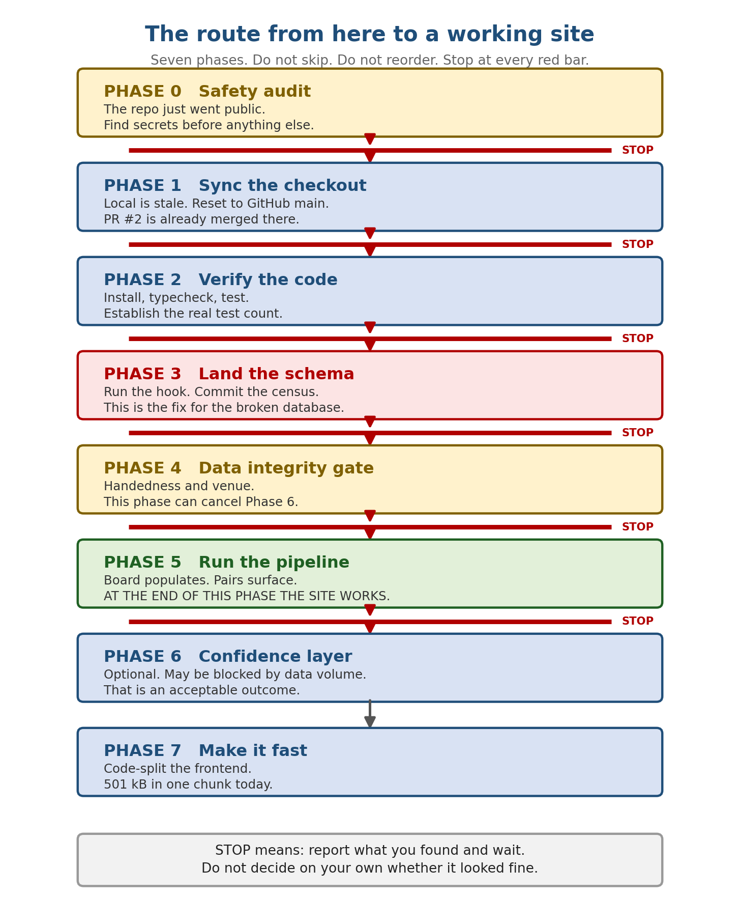

What you are actually fixing
The site already runs. Three workflows are up and the frontend renders. The problem is underneath it: the database is missing two objects, so parts of the application throw as soon as they are touched, and no prediction model has ever been switched on.
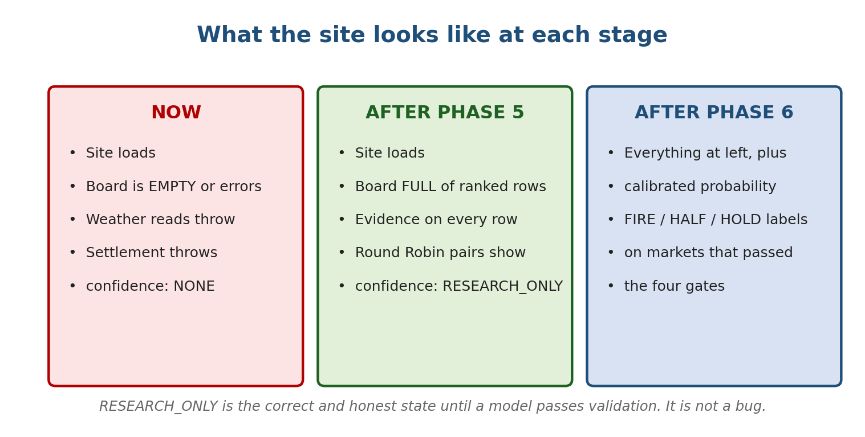
Read the middle column carefully. RESEARCH_ONLY is not an error. It is the application correctly refusing to show a probability it has not earned the right to show. Phase 5 is the finish line for a working site. Phase 6 is a bonus that may not be available yet.

The trap in Phase 3, explained before you get there
Phase 3 is where the database gets fixed. There is one thing about it that has already fooled two people, so read this diagram now rather than when you hit it.
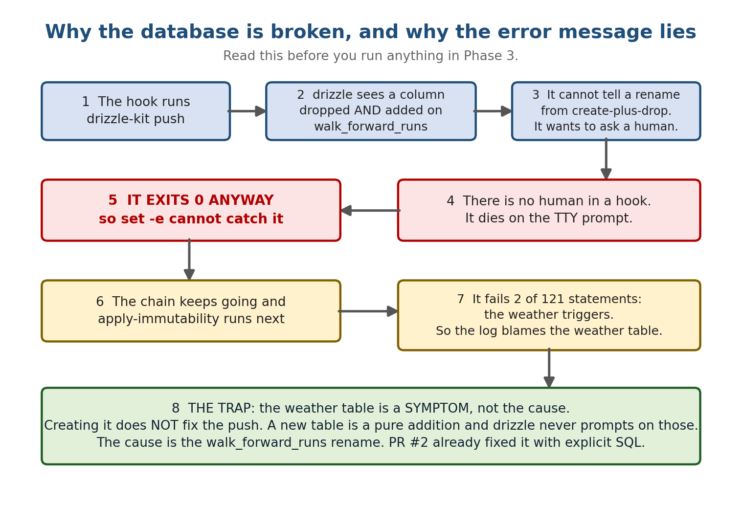
The single most important sentence in this document
drizzle-kit push exits with code 0 when it dies on the interactive prompt.
That means set -e cannot catch it, the script keeps running, and the error you finally see is about the WRONG THING.
If you ever see a message about game_weather_observations not existing, that is a downstream symptom. Do not go create that table. The fix is already merged. Just run the hook.

PHASE 0. Safety audit
The repository just became public. It was private for its whole life before this. Anything ever committed to it is now readable by anyone on the internet, including things that were deleted later, because git keeps history.
This phase runs before everything else because if a credential is exposed, it needs rotating today and nothing else matters until it is.
STEP 1
Scan the entire git history for secrets
Why: Deleting a secret from the current files does not remove it from history. A key committed in June is still public today.
RUN THIS
# search every commit that ever existed, not just the working tree
git log --all -p | grep -n -i -E \
'DATABASE_URL=|postgres://|postgresql://|OPENAI_API_KEY|sk-[A-Za-z0-9]{20}|' \
-e 'AI_ANALYST_OPERATOR_APPROVAL_KEY|GOOGLE_APPLICATION_CREDENTIALS|BEGIN PRIVATE KEY'

# and check whether a .env file was ever tracked
git log --all --diff-filter=A --name-only --format='%H %ad' | grep -i -E '\.env|credential|secret|\.pem|\.key'
YOU SHOULD SEE
No output from either command.
IF YOU SEE ANYTHING ELSE
- If ANY match appears, STOP immediately and report the matching line, the file, and the commit hash.
- Do not delete the file. Do not rewrite history. Do not attempt to fix it yourself.
- A secret in public git history is considered leaked the moment it was pushed. The fix is to rotate the credential at its source, and that is a decision for a human.
REPORT BACK
- The exact output of both commands, even if empty. Say 'no matches' explicitly rather than staying silent.

STEP 2
Inventory the working directories
Why: attached_assets, screenshots and reports hold about 90 tracked files that are not build inputs. They are now world-readable. A prior audit already recommended removing them from version control.
RUN THIS
git ls-files attached_assets/ screenshots/ reports/ | wc -l
git ls-files attached_assets/ screenshots/ reports/ | head -60
du -sh attached_assets screenshots reports 2>/dev/null
REPORT BACK
- The file count and the first 60 names.
- Whether any filename suggests personal data, account details, financial records, or screenshots of a logged-in third-party site.
Do NOT do this
Do not delete anything in these directories. They are the operator's material. Report and wait.

STEP 3
Check the agent memory directory
Why: It is committed and therefore public. It should contain engineering notes and nothing else.
RUN THIS
ls -la .agents/memory/
cat .agents/memory/MEMORY.md
REPORT BACK
- Whether anything in there is not an engineering note.

STOP HERE. Report, then wait for a reply.
Report Steps 1, 2 and 3 together.
If Step 1 found anything at all, do not proceed to Phase 1 under any circumstances.

PHASE 1. Sync the checkout
The Replit workspace is out of date. PR #2 is already merged on GitHub, but this checkout still has the old files, including the old broken version of the post-merge hook. Until this phase is done, running anything else tests the wrong code.
Two things about this repository that will confuse you
1. The GitHub remote is NOT named origin. It is named subrepl-2wsmbzw5. Commands using 'origin' will fail with 'does not appear to be a git repository'. That is expected, not a problem to solve.
2. Local main and GitHub main both have a commit whose message is 'Add post-merge database hook and update memory documentation', but with different hashes: local 68c5b262, GitHub 20035d9d. They are the same work carried across under a new hash. This matters for Step 6.
STEP 4
Fetch from GitHub and see where you are
Why: You need the current remote state before deciding anything.
RUN THIS
git fetch subrepl-2wsmbzw5
git status
git log --oneline -5
git log --oneline subrepl-2wsmbzw5/main -5
YOU SHOULD SEE
The fetch succeeds with no authentication error.
GitHub main is ahead and contains the PR #2 merge commit e9f3027.
IF YOU SEE ANYTHING ELSE
- If the fetch fails with an authentication error, STOP. The GitHub connection has dropped again and a human must reconnect it in the Replit UI.
REPORT BACK
- All four outputs in full.

STEP 5
Prove the local commit is a duplicate, not unique work
Why: You are about to discard local commits. Before you do, prove there is nothing on the local side that is not already on GitHub. This is the one step in the document where getting it wrong loses work.
RUN THIS
# what does local have that GitHub main does not?
git log --oneline subrepl-2wsmbzw5/main..HEAD

# and the file-level difference
git diff HEAD subrepl-2wsmbzw5/main --stat
YOU SHOULD SEE
The first command lists ONLY 68c5b262, and nothing else.
The second shows differences only in PR #2's files: .replit, scripts/post-merge.sh,
lib/db/scripts/pre-push-migrations.mjs, plus the other files PR #2 touched.
IF YOU SEE ANYTHING ELSE
- If the first command lists ANY commit other than 68c5b262, STOP and report. There is local work that has never been pushed and it must not be discarded.
- If the diff shows a file changed on the local side that PR #2 did not touch, STOP and report that filename.
REPORT BACK
- Both outputs in full, and a plain yes or no: is 68c5b262 the only local-only commit?

STEP 6
Reset the checkout to GitHub main
Why: Merging would try to apply the same memory-file lines twice and conflict on them, because that work is already on GitHub under a different hash. A reset is correct here and only here.
RUN THIS
git reset --hard subrepl-2wsmbzw5/main
git status
git log --oneline -5
YOU SHOULD SEE
HEAD now points at the same commit as subrepl-2wsmbzw5/main.
Working tree clean.
The PR #2 merge commit e9f3027 is visible in the log.
REPORT BACK
- git status and git log --oneline -5.
Do NOT do this
This is the ONLY step in this entire document where git reset --hard is permitted. Do not reach for it again later. If a future step goes wrong, stop and report instead.

STEP 7
Confirm you actually have PR #2's files now
Why: This is how you verify the reset worked at the level that matters. The old hook contained a line that the new one does not.
RUN THIS
cat scripts/post-merge.sh
grep -n 'walk_forward_runs' lib/db/scripts/pre-push-migrations.mjs | head -20
grep -n 'runButton' .replit || echo 'runButton line is gone, which is correct'
YOU SHOULD SEE
scripts/post-merge.sh is LONGER than four lines and does NOT contain: pnpm --filter db push
It should contain a handedness census step and explicit handling for the drizzle prompt.
pre-push-migrations.mjs contains walk_forward_runs DDL.
IF YOU SEE ANYTHING ELSE
- If scripts/post-merge.sh still reads 'pnpm --filter db push' on line 4, the reset did not take. STOP and report.
REPORT BACK
- The full contents of scripts/post-merge.sh.

STOP HERE. Report, then wait for a reply.
Report Steps 4 through 7. Do not install or run anything yet.

PHASE 2. Verify the code
Before touching the database, confirm the code you just pulled is sound. All three of these passed on the pre-merge code, so a failure here means the merge broke something.
STEP 8
Install dependencies
Why: PR #2 moved 54 frontend packages from devDependencies to dependencies and regenerated the lockfile in the same commit. The install must match the lockfile exactly.
RUN THIS
pnpm install --frozen-lockfile
YOU SHOULD SEE
Completes with no error. It may say 'Already up to date' or install the moved packages.
IF YOU SEE ANYTHING ELSE
- If it fails with ERR_PNPM_OUTDATED_LOCKFILE, STOP and report. Do not run plain 'pnpm install' to regenerate it. A regenerated lockfile would break every future merge and would undo a deliberate fix.
REPORT BACK
- Exit code and the last 15 lines.

STEP 9
Typecheck
RUN THIS
pnpm run typecheck
YOU SHOULD SEE
Exit code 0. Four projects: api-server, mlb-analyst, mockup-sandbox, scripts. No errors.
IF YOU SEE ANYTHING ELSE
- Any type error is a stop. Report the full error text with the file and line.
REPORT BACK
- Exit code, and any errors verbatim.

STEP 10
Run the unit tests and establish the real number
Why: The test count has been reported as 161, then 183, then 193, then 197 at different points. Nobody has run it on the merged code. Whatever number you get is the true one.
RUN THIS
pnpm run test:unit
YOU SHOULD SEE
Exit code 0, 0 failures.
A count somewhere between 190 and 200 is expected.
IF YOU SEE ANYTHING ELSE
- Any failing test is a stop. Report the test name and the assertion message.
- A count far below 190 may mean not all test files are wired into the script. Report the number either way.
REPORT BACK
- The exact TAP summary block: tests, suites, pass, fail.

STEP 11
Build
RUN THIS
pnpm run build
YOU SHOULD SEE
Exit code 0.
Two known warnings, both harmless and both handled in Phase 7:
- a sourcemap warning on src/components/ui/tooltip.tsx
- a chunk-size warning, roughly 501 kB for the main mlb-analyst bundle
IF YOU SEE ANYTHING ELSE
- Any error, as opposed to a warning, is a stop.
REPORT BACK
- Exit code, and the mlb-analyst bundle size line, both raw and gzipped. Write these down, Phase 7 compares against them.

STOP HERE. Report, then wait for a reply.
Report Steps 8 through 11, with the exact test count and the exact bundle size.

PHASE 3. Land the schema
This is the phase that fixes the broken database. Re-read the trap diagram earlier in this document before starting.
What is broken right now
Two database objects do not exist: the game_weather_observations table, and the settled_without_snapshot column on historical_outcomes.
Because of that: weather reads throw, settlement inserts throw, and two append-only triggers could not be attached.
The cause is NOT those two objects. The cause is a rename on walk_forward_runs that made drizzle stop and ask a question it could not ask. PR #2 fixed that with explicit SQL. You are about to run that fix.
STEP 12
Take a database backup
Why: Two of the changes about to be applied are not reversible by themselves.
RUN THIS
# use whatever backup mechanism this environment provides;
# if pg_dump is available and DATABASE_URL is set:
pg_dump "$DATABASE_URL" > /tmp/pre-schema-backup-$(date +%Y%m%d-%H%M).sql
ls -lh /tmp/pre-schema-backup-*.sql
YOU SHOULD SEE
A backup file with a non-trivial size.
IF YOU SEE ANYTHING ELSE
- If no backup mechanism is available, STOP and report that. Do not proceed without one.
REPORT BACK
- The backup path and size, or an explicit statement that you could not take one.

STEP 13
Run the post-merge hook
Why: This is the whole fix. It runs three things in order: the pre-push migrations, the schema push, then the immutability policy.
RUN THIS
bash scripts/post-merge.sh
echo "EXIT CODE: $?"
YOU SHOULD SEE
EXIT CODE: 0
apply-immutability: 121 OK, 0 failed
A handedness census block printed BEFORE the push chain, with a line telling you to commit a file.
IF YOU SEE ANYTHING ELSE
- 119 OK, 2 failed -> the migration did not run. STOP and report. Do not create the weather table by hand.
- A TTY prompt error -> a NEW schema ambiguity has appeared that the migration does not cover. STOP and report the exact table and column names it printed. Do not use --force.
- Any non-zero exit -> STOP and report the full output.
REPORT BACK
- The complete output of the hook, top to bottom, plus the exit code.
Do NOT do this
If it fails, do not run drizzle-kit push yourself. Do not add --force. Do not create missing tables manually. Every one of those hides the real problem instead of fixing it.

STEP 14
Commit the census file immediately
Why: This is a one-shot measurement. The migration converts stored empty-string handedness values to NULL. Every run after this one records zero by construction, so only the FIRST capture contains information. If you lose it, it cannot be recovered.
RUN THIS
cat reports/handedness-census.jsonl
git add reports/handedness-census.jsonl
git commit -m 'Record first handedness census before M6 normalisation'
git push subrepl-2wsmbzw5 main
YOU SHOULD SEE
The census record shows isFirstCapture true and splitStillIntact true.
It shows non-zero counts in throwsEmpty or batsEmpty if the bug had done damage.
IF YOU SEE ANYTHING ELSE
- If isFirstCapture is false or splitStillIntact is false, the census ran late. STOP and report, because the empty-versus-null split is already gone.
REPORT BACK
- The full census record, and confirmation that it is committed and pushed.

STEP 15
Verify the two objects now exist
RUN THIS
SELECT to_regclass('game_weather_observations') AS weather_table;

SELECT count(*) AS has_column
FROM information_schema.columns
WHERE table_name = 'historical_outcomes'
AND column_name = 'settled_without_snapshot';

SELECT tgname FROM pg_trigger
WHERE tgrelid = 'game_weather_observations'::regclass
AND NOT tgisinternal;
YOU SHOULD SEE
weather_table is not null
has_column is 1
Two triggers: game_weather_append_only and game_weather_truncate_guard
IF YOU SEE ANYTHING ELSE
- Any of the three not matching is a stop. Report all three results.
REPORT BACK
- All three query results.

STEP 16
Verify the rename preserved the old values correctly
Why: The old calibration_error column held mean absolute error, produced by a gate that was measuring the wrong thing. It had to be preserved under an honest name, not silently promoted into the new gate column.
RUN THIS
SELECT column_name FROM information_schema.columns
WHERE table_name = 'walk_forward_runs'
AND column_name IN ('calibration_error',
'mean_absolute_prediction_error',
'expected_calibration_error')
ORDER BY column_name;

SELECT count(*) AS rows_with_old_value
FROM walk_forward_runs
WHERE mean_absolute_prediction_error IS NOT NULL;

SELECT count(*) AS rows_with_new_gate_value
FROM walk_forward_runs
WHERE expected_calibration_error IS NOT NULL;
YOU SHOULD SEE
calibration_error is GONE.
mean_absolute_prediction_error and expected_calibration_error both exist.
Old values survived in mean_absolute_prediction_error.
expected_calibration_error is 0 rows, because no run has been scored under the new gate yet.
IF YOU SEE ANYTHING ELSE
- If expected_calibration_error already has values, STOP. The old discredited numbers were carried into the new gate column and every future promotion decision would read them.
REPORT BACK
- All three results.

STEP 17
Prove the hook is idempotent
Why: This hook runs automatically on every future merge. If a second run changes anything, every merge will fight it.
RUN THIS
bash scripts/post-merge.sh
echo "EXIT CODE: $?"
YOU SHOULD SEE
EXIT CODE: 0
121 OK, 0 failed again
The census now shows isFirstCapture false and zeros. That is correct and expected.
IF YOU SEE ANYTHING ELSE
- Any schema change on the second run is a stop.
REPORT BACK
- Exit code and the apply-immutability line.

STOP HERE. Report, then wait for a reply.
Report Steps 12 through 17.
This is the most important stop in the document. The database is either correct now or it is not, and everything after this assumes it is.

PHASE 4. Data integrity gate
Two things can make the whole analysis layer silently run on nothing. Both are cheap to check and both are worth knowing before spending time on Phases 5 and 6.
STEP 18
Back up, then run the handedness backfill
Why: A bug was overwriting each player's batting and throwing hand with an empty string. Everywhere the code splits a statistic by handedness, an empty value silently falls back to the unsplit season number, and nothing reports it.
RUN THIS
# find the backfill script registered in package.json, then run it
grep -n 'backfill\|hydrate\|handed' package.json
# then run whichever script that reveals
YOU SHOULD SEE
It reports how many players it re-hydrated and how many it left alone.
IF YOU SEE ANYTHING ELSE
- If it overwrites a known value with a feed disagreement, that is a bug. STOP and report.
REPORT BACK
- Rehydrated count, skipped count, and any errors.

STEP 19
Ask the application how bad the handedness problem is
RUN THIS
curl -s localhost:8080/api/analyst/data-health | head -60
# or hit GET /api/analyst/data-health however this environment reaches the API
YOU SHOULD SEE
A handedness population section, new in PR #2, giving counts of null or empty throws in today's lineups.
REPORT BACK
- The handedness counters verbatim.
- The percentage of today's lineup players with unknown handedness.

STEP 20
The venue gate. This is the one that can cancel Phase 6.
Why: The daily pipeline builds today's game list from FantasyPros, not from MLB. Those rows can carry a null venue and a null start time. Park factors and weather both look up the venue. The snapshot freeze and the model validation window both look up the start time.
RUN THIS
SELECT count(*) AS games,
count(*) FILTER (WHERE venue_id IS NULL) AS no_venue,
count(*) FILTER (WHERE start_time_utc IS NULL) AS no_start
FROM games WHERE game_date = CURRENT_DATE;

SELECT game_date,
count(*) AS games,
count(*) FILTER (WHERE venue_id IS NULL) AS no_venue,
count(*) FILTER (WHERE start_time_utc IS NULL) AS no_start
FROM games
WHERE game_date >= CURRENT_DATE - 14
GROUP BY 1 ORDER BY 1;
YOU SHOULD SEE
Ideally no_venue and no_start are both 0.
IF YOU SEE ANYTHING ELSE
- If no_venue or no_start is more than a small handful, STOP and report loudly.
- This is audit item S18 and it should be re-rated from HIGH to BLOCKER.
- It means park and weather are contributing nothing to the rankings, and any model trained in Phase 6 would be trained on a signal layer that is not running. That model would have to be thrown away.
REPORT BACK
- Both query results in full.

STOP HERE. Report, then wait for a reply.
Report Steps 18, 19 and 20.
If the venue gate shows material nulls, Phase 6 is cancelled until S18 is fixed. Phase 5 can still proceed, because a populated board with honest gaps is still a working site.

PHASE 5. Run the pipeline and get the site serving
This is the finish line for a working site
When this phase is done: the board is full of ranked rows with evidence, Round Robin pairs are surfacing, nothing throws, and the interface loads clean.
The confidence column will still say RESEARCH_ONLY. That is correct. Do not treat it as a failure and do not try to fix it here.
STEP 21
Restart the workflows so they pick up the new code
Why: The API server was built before the reset. It is running old code.
RUN THIS
# restart the API Server and web workflows through the Replit workflow controls
# then confirm the server is alive:
curl -s -o /dev/null -w '%{http_code}\n' localhost:8080/api/healthz
YOU SHOULD SEE
200
IF YOU SEE ANYTHING ELSE
- Anything other than 200 is a stop. Report the server startup log.
REPORT BACK
- The health status code and the last 30 lines of the API server log.

STEP 22
Launch a full orchestration run for today
RUN THIS
curl -s -X POST localhost:8080/api/analyst/orchestration/run \
-H 'Content-Type: application/json' \
-d '{"date":"TODAY_AS_YYYY-MM-DD"}'

# then poll the run until it finishes
curl -s localhost:8080/api/analyst/orchestration/runs | head -100
YOU SHOULD SEE
Every step reaches SUCCESS or WARNING, none FAILED:
fantasypros_ingest, fantasypros_baseline, research_refresh, bullpen_refresh,
tb_engine, xbh_engine, walk_engine, hr_engine, hrrbi_engine,
market_board, health_check, feature_snapshot_freeze
IF YOU SEE ANYTHING ELSE
- Any FAILED step is a stop. Report the step name and its detail field.
- IMPORTANT: a step that says SUCCESS but processed ZERO rows on a day with real games is ALSO a failure. Check the counts in each step's detail, not just its status.
REPORT BACK
- Every step, its status, and its detail field. All twelve. Do not summarise.

STEP 23
Read the board
RUN THIS
SELECT market, research_state, count(*)
FROM daily_market_board
WHERE slate_date = CURRENT_DATE
GROUP BY 1,2 ORDER BY 1,2;

SELECT confidence_basis, count(*)
FROM daily_market_board
WHERE slate_date = CURRENT_DATE
GROUP BY 1;
YOU SHOULD SEE
Four markets populated: TB, XBH, WALK, HR, each with a spread of research states.
confidence_basis entirely RESEARCH_ONLY. This is correct at this stage.
IF YOU SEE ANYTHING ELSE
- An empty board after a successful pipeline run is a stop.
- A confidence_basis other than RESEARCH_ONLY at this stage is also a stop, because no model has been promoted.
REPORT BACK
- Both results in full.

STEP 24
Check that no blocked row survived on the board
Why: A late-scratched player must disappear from the board on the next refresh. There is an invariant for exactly this and it should have been asserted during the refresh.
RUN THIS
SELECT count(*) AS blocked_rows_still_on_board
FROM daily_market_board b
JOIN market_research_candidates c
ON c.slate_date = b.slate_date AND c.market = b.market
AND c.player_id = b.player_id AND c.game_pk = b.game_pk
WHERE b.slate_date = CURRENT_DATE
AND c.research_state = 'BLOCKED';
YOU SHOULD SEE
0
IF YOU SEE ANYTHING ELSE
- Anything above 0 is a stop. The board reconciliation is not working.
REPORT BACK
- The count.

STEP 25
Check Round Robin pairs, and record the number
Why: A gate that was killing whole games was removed. This number is evidence that was formally requested and has never been captured.
RUN THIS
curl -s 'localhost:8080/api/analyst/round-robin/comparison?date=TODAY_AS_YYYY-MM-DD' | head -200
YOU SHOULD SEE
Most games return a selected construction.
IF YOU SEE ANYTHING ELSE
- If a game returns NO_LEGAL_CONSTRUCTION for a BULLPEN reason, that is a stop. The removed gate has survived somewhere and needs finding.
- Other reasons, such as no market candidates or an unknown starter, are legitimate.
REPORT BACK
- How many games returned a pair.
- How many returned NO_LEGAL_CONSTRUCTION, and the reason for each one.

STEP 26
Open the site and look at it
RUN THIS
# open the web preview and click through every page
YOU SHOULD SEE
The readiness strip renders on every page.
The board page shows rows.
A 'Research-only' count is displayed as a first-class number.
The Round Robin page shows pairs.
No page returns a 500.
IF YOU SEE ANYTHING ELSE
- Report every console error and every failed network request with its path and status code.
REPORT BACK
- Confirmation for each of the five expectations above, individually.
- Any console error or failed request, verbatim.
- How long the first page load took.

STOP HERE. Report, then wait for a reply.
Report Steps 21 through 26.
If everything passed, the site is working. Say so plainly and wait, rather than continuing into Phase 6 on your own.

PHASE 6. The confidence layer
This phase is optional and may not be available
It needs at least ten distinct past slates per market with frozen snapshots and settled outcomes.
If that data does not exist yet, validation returns INCOMPLETE and there is nothing to be done except wait for more slates to settle.
That is a data-volume answer, not a failure, and no threshold may be adjusted to get around it.
STEP 27
Pre-flight. One minute, before spending an hour.
RUN THIS
SELECT pfs.market, count(DISTINCT pfs.slate_date) AS usable_slates
FROM pregame_feature_snapshots pfs
JOIN historical_outcomes ho
ON ho.player_id = pfs.player_id
AND ho.game_pk = pfs.game_pk
AND ho.market = pfs.market
AND ho.slate_date = pfs.slate_date
WHERE ho.settlement_state = 'SETTLED'
AND ho.source_id = 'MLB_OFFICIAL'
GROUP BY 1 ORDER BY 1;
YOU SHOULD SEE
Ten or more usable slates in a market means that market can be trained.
IF YOU SEE ANYTHING ELSE
- Fewer than ten in a market: skip that market entirely. Do not train it. Report the number and move on.
- If ALL FOUR markets are below ten, Phase 6 is over. Report and stop. This is a normal outcome.
REPORT BACK
- The counts for all four markets.

STEP 28
Capture the before-numbers
Why: These are the evidence that the confidence layer went from off to on. They are gone the moment you refresh the board.
RUN THIS
SELECT confidence_basis, count(*) FROM daily_market_board GROUP BY 1;
SELECT status, count(*) FROM model_versions GROUP BY 1;
YOU SHOULD SEE
One row of RESEARCH_ONLY. Roughly 7 CANDIDATE and 1 FAILED.
REPORT BACK
- Both results. Write them down; they get compared at the end.

STEP 29
Retrain, for qualifying markets only
Why: Every existing model was fitted by code that summed single-variable slopes instead of fitting a real model. Those artifacts are deliberately rejected by the loader now. They are dead weight.
RUN THIS
curl -s -X POST 'localhost:8080/api/analyst/models/train?market=TB'
curl -s -X POST 'localhost:8080/api/analyst/models/train?market=XBH'
curl -s -X POST 'localhost:8080/api/analyst/models/train?market=WALK'
curl -s -X POST 'localhost:8080/api/analyst/models/train?market=HR'
YOU SHOULD SEE
Each returns a new version id with status CANDIDATE.
The training row count will be LOWER than before. That is two separate fixes working, not a regression.
REPORT BACK
- Version id and training sample count per market.

STEP 30
Validate, and expect failures
RUN THIS
curl -s -X POST localhost:8080/api/analyst/models/validate \
-H 'Content-Type: application/json' \
-d '{"modelVersionId":"THE_ID_FROM_STEP_29"}'
YOU SHOULD SEE
PASS, FAIL, or INCOMPLETE, with per-fold numbers.
REPORT BACK
- Per market: fold count, expected calibration error, prediction standard deviation, benchmark margin, and the final status.
Do NOT do this
Do not adjust any threshold to make a model pass. Not the calibration threshold, not the sharpness guard, not the benchmark margin, not the fold minimum.
A model that only passes with a loosened gate is a model that will be wrong with confidence. The gates exist because the previous ones were measuring the wrong thing entirely.

The four gates a model must clear, all at once:
Gate | Threshold | What it stops
Expected calibration error | at or below 0.05 | The previous gate rewarded overconfident models and rejected honest ones. This one measures whether stated probabilities match observed rates.
Prediction standard deviation | above 0.03 | A model that passes by predicting the same base rate for every single row.
Benchmark margin | derived from held-out row count | The previous margin was 0.001, which is indistinguishable from noise.
Fold count | at least 5 | Two folds, which is not a walk-forward validation at all.

STEP 31
Promote, one market at a time
Why: This is the only route to ACTIVE. It is deliberately manual.
RUN THIS
curl -s -X POST localhost:8080/api/analyst/models/THE_VERSION_ID/promote
YOU SHOULD SEE
Success only if every gate was met. It refuses with a named reason otherwise.
It retires the previously active model for that market in the same transaction.
IF YOU SEE ANYTHING ELSE
- A refusal is a correct outcome, not an obstacle. Report the reason and stop for that market.
REPORT BACK
- The response for each market you attempted.
Do NOT do this
Never write status = 'ACTIVE' with SQL. There is a test asserting that exactly one file in the codebase does this, and a database trigger that rejects it from anywhere else. Working around either is a serious problem.

STEP 32
Refresh the board and record the change
RUN THIS
curl -s -X POST localhost:8080/api/analyst/market-board/refresh

SELECT confidence_basis, count(*)
FROM daily_market_board
WHERE slate_date = CURRENT_DATE
GROUP BY 1;
YOU SHOULD SEE
Something other than a single RESEARCH_ONLY row, for any market that was promoted.
REPORT BACK
- The before-numbers from Step 28 and the after-numbers side by side.

If you got here with a promoted model
The confidence layer has just run in production for the first time in the life of this application. Say so in the report.

PHASE 7. Make the site load fast
Correctness first, speed second. Do not start this until Phase 5 is signed off.
STEP 33
Measure before you change anything
RUN THIS
pnpm run build 2>&1 | grep -A3 'dist/public/assets'
YOU SHOULD SEE
Roughly 501 kB raw, 150 kB gzipped, in ONE chunk.
REPORT BACK
- The exact sizes. These are the baseline.

STEP 34
Split the page components out of App.tsx
Why: App.tsx is over 100 kB in a single file holding every page. Everything a visitor could ever need is downloaded before the first screen appears.
RUN THIS
wc -l artifacts/mlb-analyst/src/App.tsx
# then: move each page into its own file under src/pages/,
# leaving App.tsx as routing only
YOU SHOULD SEE
App.tsx reduced to routing and layout. Each page a separate module.
REPORT BACK
- The new line count of App.tsx and the list of files created.
Do NOT do this
Change no behaviour in this commit. It is a pure move. If you find a bug while moving code, note it and fix it in a separate commit.

STEP 35
Lazy-load the routes
RUN THIS
# in App.tsx, convert each page import to:
const RoundRobinPage = lazy(() => import('./pages/round-robin-page'));
# and wrap the router in <Suspense fallback={...}>
YOU SHOULD SEE
The build now emits several chunks instead of one.
REPORT BACK
- The new chunk list with sizes.

STEP 36
Split the heavy vendor libraries
Why: recharts, framer-motion and the Radix set are large and rarely all needed on first paint.
RUN THIS
# in vite.config.ts, add build.rollupOptions.output.manualChunks
# grouping the large vendor packages separately
YOU SHOULD SEE
Initial chunk comfortably below 200 kB minified.
IF YOU SEE ANYTHING ELSE
- If splitting a library breaks the page, revert that one grouping rather than the whole change.
REPORT BACK
- Before and after sizes, raw and gzipped, and the first-load time.

STEP 37
Remove the dead artifact from the build
Why: mockup-sandbox is a component-preview scaffold with no production service. It compiles a 187 kB bundle on every build that nothing ever serves.
RUN THIS
pnpm run build 2>&1 | grep -i mockup
YOU SHOULD SEE
No mockup-sandbox build output. PR #2 already excluded it. Confirm that took effect.
REPORT BACK
- Whether it still builds.

STEP 38
Fix the sourcemap warning
Why: Fifteen files carry a 'use client' directive, which is a Next.js instruction with no meaning in this project. It is harmless except that a runtime error in those files reports the wrong location.
RUN THIS
grep -rln "^'use client'" artifacts/mlb-analyst/src/components/ui/
# remove that first line from each file it lists
YOU SHOULD SEE
The build no longer warns about tooltip.tsx.
REPORT BACK
- The file list and confirmation the warning is gone.
Do NOT do this
Do this as its own commit. Do not bundle a fifteen-file cleanup into anything else.

Appendix A. Every command, in order
For copy-paste. The full step text above has the expected output and the failure handling; this list does not. Do not run from this list alone.
Step | Command
1 | git log --all -p | grep -i -E 'DATABASE_URL=|postgres://|OPENAI_API_KEY|...'
2 | git ls-files attached_assets/ screenshots/ reports/ | wc -l
3 | cat .agents/memory/MEMORY.md
4 | git fetch subrepl-2wsmbzw5 && git status && git log --oneline -5
5 | git log --oneline subrepl-2wsmbzw5/main..HEAD
6 | git reset --hard subrepl-2wsmbzw5/main
7 | cat scripts/post-merge.sh
8 | pnpm install --frozen-lockfile
9 | pnpm run typecheck
10 | pnpm run test:unit
11 | pnpm run build
12 | pg_dump "$DATABASE_URL" > /tmp/pre-schema-backup-*.sql
13 | bash scripts/post-merge.sh
14 | git add reports/handedness-census.jsonl && git commit && git push
15 | SELECT to_regclass('game_weather_observations');
16 | SELECT column_name FROM information_schema.columns WHERE table_name='walk_forward_runs' ...
17 | bash scripts/post-merge.sh (second run, must be a no-op)
18 | run the handedness backfill script
19 | GET /api/analyst/data-health
20 | SELECT count(*) FILTER (WHERE venue_id IS NULL) FROM games WHERE game_date = CURRENT_DATE;
21 | restart workflows, then GET /api/healthz
22 | POST /api/analyst/orchestration/run
23 | SELECT market, research_state, count(*) FROM daily_market_board ...
24 | blocked-rows-on-board check
25 | GET /api/analyst/round-robin/comparison
26 | open the site, click every page
27 | usable-slates pre-flight query
28 | capture before-numbers
29 | POST /api/analyst/models/train?market=...
30 | POST /api/analyst/models/validate
31 | POST /api/analyst/models/:id/promote
32 | POST /api/analyst/market-board/refresh
33-38 | Phase 7 frontend work

Appendix B. What to do when something goes wrong
Find the symptom, do what the row says. If your symptom is not listed, that is a stop.
If you see this | It means | Do this
fatal: 'origin' does not appear to be a git repository | The remote is named subrepl-2wsmbzw5, not origin. | Use the correct remote name. Not a problem.
Authentication failed for github.com | The Replit GitHub connection has dropped. | STOP. A human must reconnect it in the Replit UI. You cannot fix this.
Interactive prompts require a TTY terminal | drizzle found a schema change it cannot resolve alone. | STOP. Report the exact table and column it named. Never use --force.
apply-immutability: 119 OK, 2 failed | The schema push silently did nothing. The two failures are a symptom. | STOP. Do not create the weather table by hand.
ERR_PNPM_OUTDATED_LOCKFILE | The lockfile and the manifest disagree. | STOP. Do not regenerate the lockfile.
A pipeline step says SUCCESS but processed 0 rows | A silent failure. This is a known failure mode. | Treat as FAILED. Report expected vs actual counts.
confidence_basis is RESEARCH_ONLY after Phase 5 | Correct and expected. | Nothing. This is not a bug.
Validation returns INCOMPLETE | Not enough settled slates yet. | Report the count and stop for that market. Do not lower any threshold.
A game returns NO_LEGAL_CONSTRUCTION for a bullpen reason | A removed gate survived somewhere. | STOP and report the game and the reason string.
A test fails that passed before | The merge broke something. | STOP. Report the test name and assertion. Do not edit the test to make it pass.
Anything not on this list | Unknown. | STOP and report. Do not improvise.

Appendix C. Things in this codebase that are deliberate
Each of these looks like a bug and is not. Changing any of them undoes work that was done on purpose.
Looks wrong | Is actually
RESEARCH_ONLY on every board row | The application refusing to show a probability it has not earned. It is honest, not broken.
A tie between two sides returns no pick at all | The surfaced-ties contract. Adding a tiebreak to compareConstruction would silently delete it.
Bullpen data missing but the pair still shows | RANK, DON'T GATE. A missing third-order input is a disclosure on the row, not a veto that deletes it.
A model that trains fine but will not promote | The four gates working. The previous gates were measuring the wrong thing and would have promoted a bad model.
The training row count dropped after the fix | Two fixes: rows frozen after first pitch are excluded, and rows settled without a snapshot are excluded.
No odds, prices or EV anywhere in the code | A hard rule. The operator prices at the book. Two separate guards enforce it. Never add any.
missing_stale_evidence looks like a notes field | It is a blocking gate. Anything written there makes a candidate unselectable. Never put a disclosure in it.
The API server refuses to start without PORT | Deliberate. There is no default, so a misconfigured deploy fails loudly instead of listening on the wrong port.

Still owed after all of this
Not your decision to make, but you should know they exist so you do not guess at them:
- Whether intentional walks count toward the walk market, and whether hit by pitch counts. The code currently assumes one answer and labels it as an assumption. Every settled slate makes changing it more expensive.
- Whether the AI tool-call and chat routes should require an approved operator session.
- Whether the roughly 90 tracked files in attached_assets, screenshots and reports should leave version control, now that the repository is public.

Prepared from: the 27-task remediation plan of 2026-08-24, PR #1 and PR #2, docs/audit-extension-2026-08-24.md, replit.md, and direct runtime, database and git inspection of the repl on 2026-08-24.

