MLB ANALYST PLATFORM
Website Visual Specification + Final Replit Project Setup
Data-driven. AI-powered. Bettor-aware. Process-obsessed.
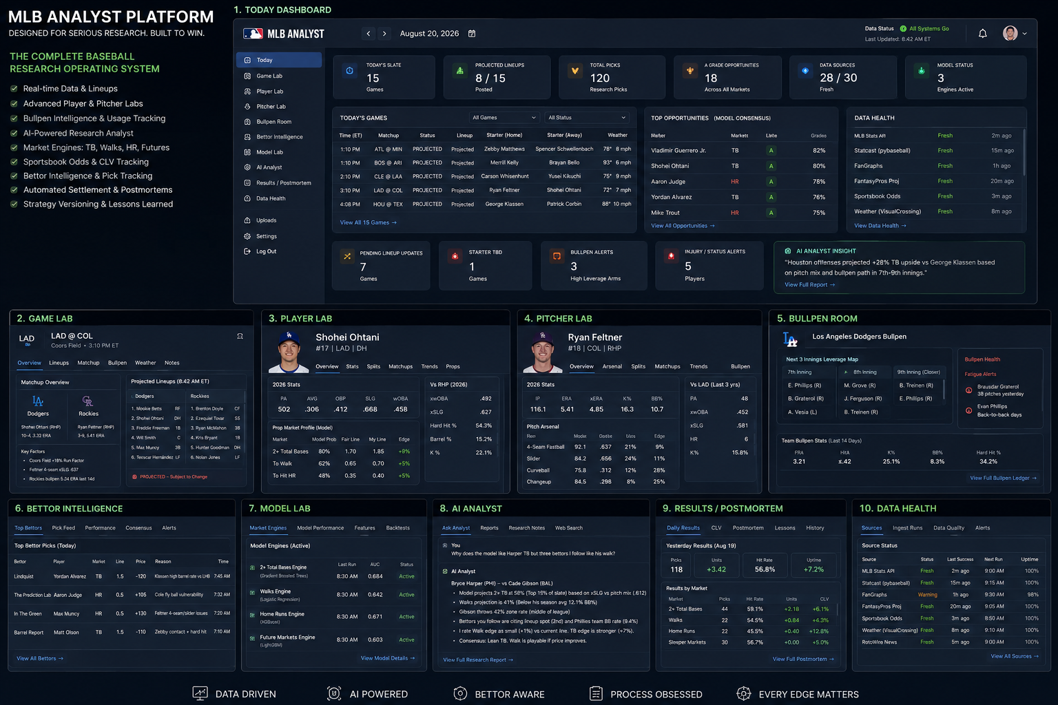
Purpose: give Replit a visual target, exact page behavior, source ownership, AI boundaries, data contracts and phased build plan.

1. Product Direction
The platform should feel like a baseball operations room crossed with a trading terminal - not a promotional sportsbook page.
Principle | What it means
Data first | Every source is timestamped, freshness is visible, and missing data is allowed to stay missing.
Independent markets | Total bases, batter walks and home runs are separate research/model problems.
AI augmented | The AI searches, compares, explains and challenges. It does not overwrite deterministic data or historical truth.
Bettor aware | Other bettors become structured evidence with price, timestamp, mechanism, deduplication and historical performance.
Process obsessed | Pregame snapshots are immutable; postmortems grade process as well as outcome.
Evidence labels: VERIFIED SOURCED INFERENCE NOT FOUND
Game/card statuses: FIRE HALF HOLD PASS PARKED

Navigation
Today | Game Lab | Player Lab | Pitcher Lab | Bullpen Room | Projection Center | Bettor Intelligence | Model Lab | AI Analyst | Results/Postmortem | Data Health | Settings

2. Core Analysis Pages
Today, Game Lab, Player Lab and Pitcher Lab form the core research flow.
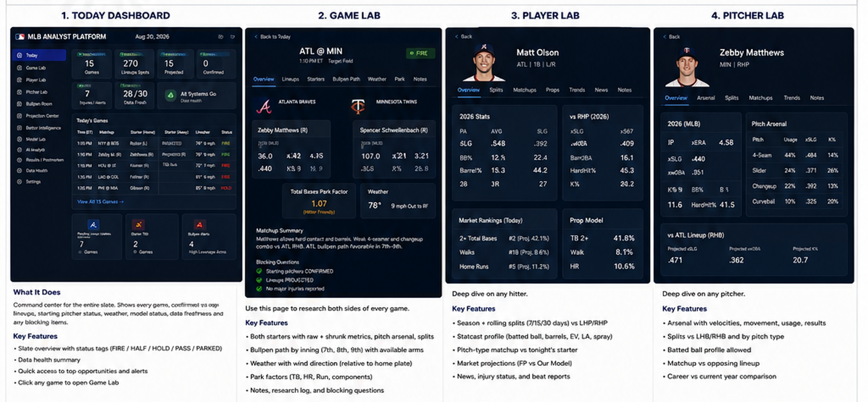

3. Intelligence & Model Pages
Bullpen Room, Projection Center, Bettor Intelligence and Model Lab add persistent state, external views and model governance.
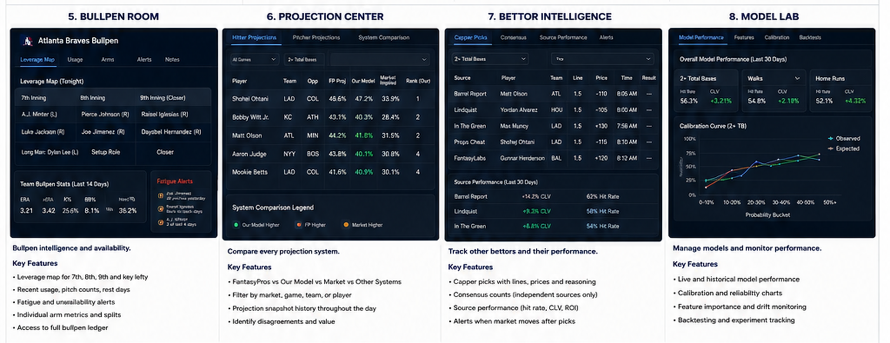

4. AI & Operations Pages
AI Analyst, Results/Postmortem, Data Health and Settings make the system researchable, auditable and operable.
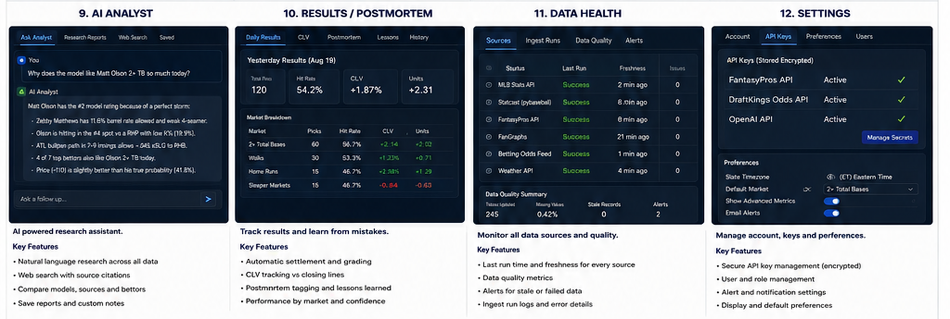

5. Today Dashboard
Command center for the current slate.
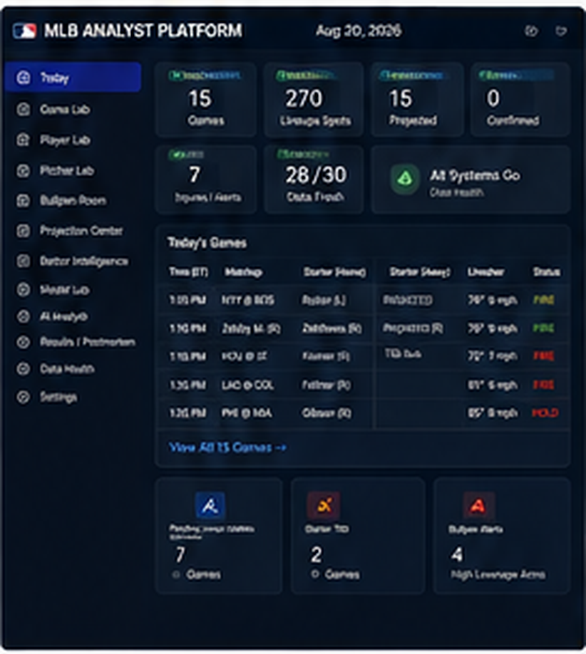 | What this page must show  - Slate table with every game in first-pitch order.  - Official/probable starter state: CONFIRMED / PROBABLE / TBD / OPENER / BULK.  - Projected/posted lineup state with source conflicts.  - Park, roof, temperature, wind direction relative to home plate and bullpen freshness.  - Top market research reads plus pending lineup/starter/bullpen/injury alerts.  User actions  - Filter by market, team, game status, lineup state, blocking item or sportsbook.  - Click game -> Game Lab; click player -> Player Lab.  - Manual refresh for a selected game/source.  - Challenge any read with Ask Analyst.  Build rule: Phase 1 builds this with real game/source state. No fake model probabilities.

6. Game Lab
Complete research room for one matchup.
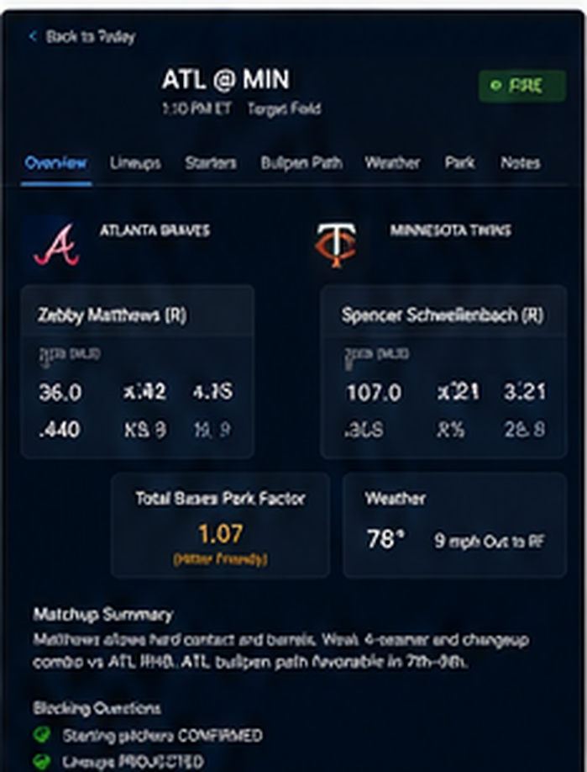 | What this page must show  - Tabs: Overview, Lineups, Starters, Bullpen Path, Weather, Park, Odds, Bettors, Research Log.  - Both starters side-by-side with handedness, arsenal, raw/adjusted metrics, sample confidence and expected workload.  - Both full lineups remain researchable even when one side is the preferred attack.  - Separate TB / Walk / HR hitter reads.  - Research log stores supporting evidence, rejected evidence, disagreements and changes of mind.  User actions  - Open pitcher/player detail.  - Recompute affected game after lineup/starter update.  - Open AI counter-case from current game context.  - Inspect exact frozen evidence/price snapshot before firing.  Build rule: The Game Lab is the working analyst page; side selection is context, not a roster filter.

7. Player Lab
Who is this hitter, how is he changing, and which market fits tonight?
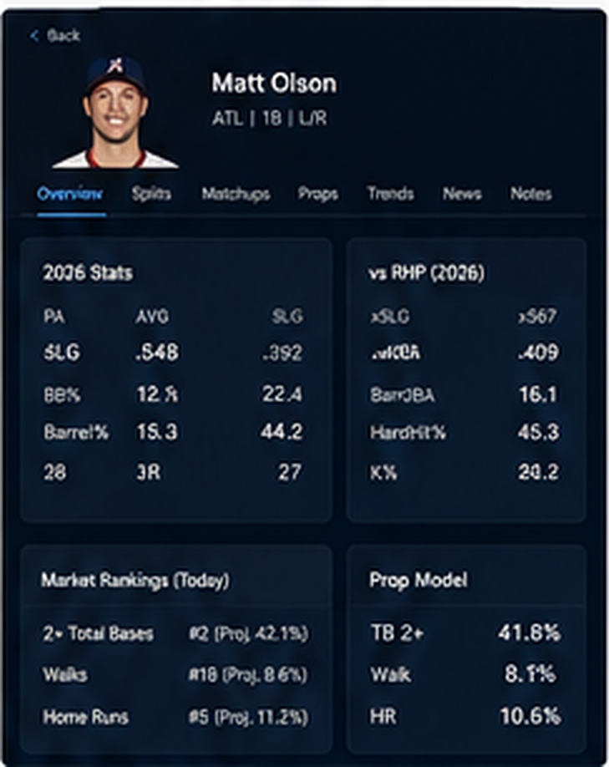 | What this page must show  - Tabs: Overview, Stats, Splits, Matchups, Trends, Projections, Props, News, History.  - Season/career and rolling 7/14/30/60 day views.  - LHP/RHP splits, xSLG, barrel/PA, doubles, contact/K, line drives, 90th EV, air pull.  - Walk discipline: uBB/BB, chase, zone swing, pitches/PA, first-pitch behavior.  - Pitch-type/velocity/movement matchup and lineup-position history.  - FantasyPros/current external projections beside internal market outputs.  User actions  - Open today vs history.  - Compare projections through the day.  - Ask AI why the player fits one market but not another.  - Review prior predictions with result and process grade.  Build rule: Do not make one universal hitter rating the main decision value.

8. Pitcher Lab
Understand pitcher shape, arsenal and market-specific vulnerability.
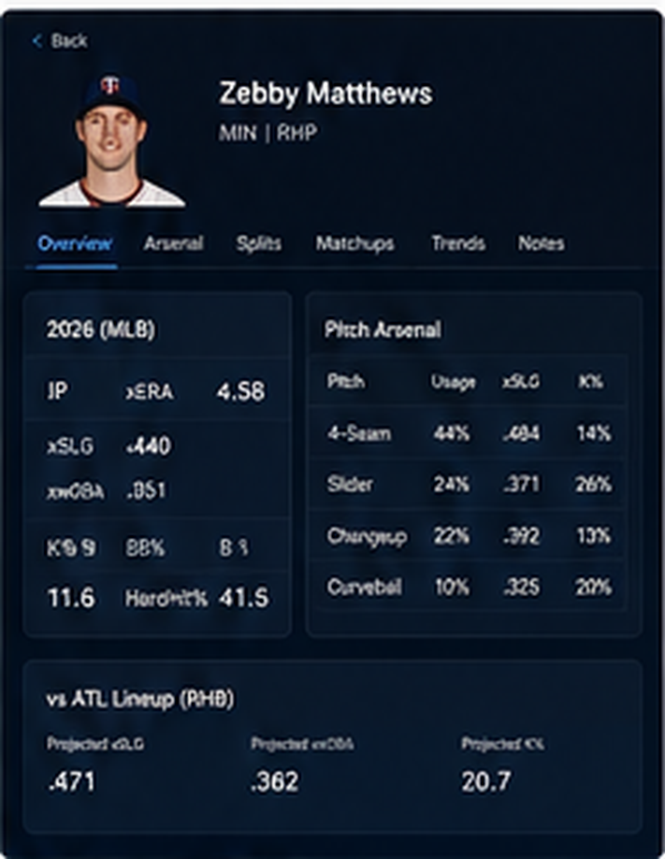 | What this page must show  - Tabs: Overview, Arsenal, Splits, Matchups, Trends, TTO, Bullpen Transition, History.  - Current vs career context, xSLG/xwOBA by batter side, K/BB, GB/FB/LD.  - Zone%, first-pitch strike%, chase generated and count/command behavior.  - Pitch usage/results, velocity, movement, release and location maps.  - Last starts, expected innings and times-through-order.  - Market Vulnerability cards for TB, Walk and HR separately.  User actions  - Switch batter side.  - Compare current vs career or rolling windows.  - See target lineup and pitch-type exposure.  - Send a specific vulnerability claim to AI for challenge.  Build rule: A high ERA alone is never the vulnerability explanation.

9. Bullpen Room
Persistent availability and leverage memory.
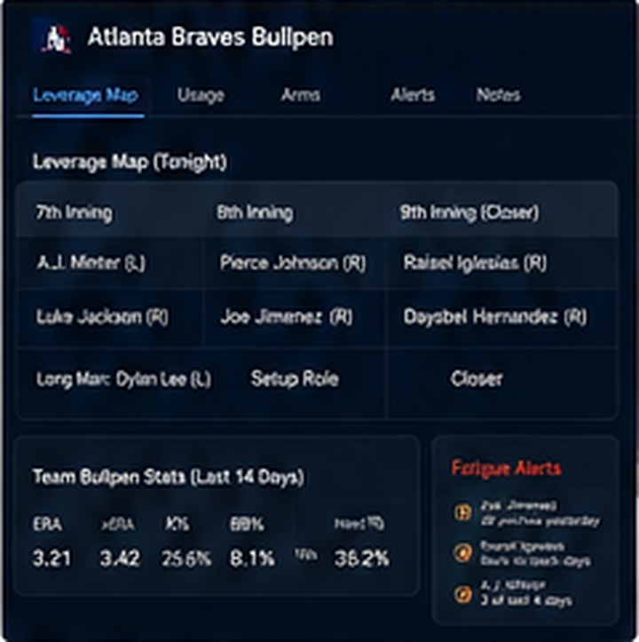 | What this page must show  - Projected 7th/8th/9th arms, closer/setup/lefty/long man.  - Last three days usage, pitch counts, rest and back-to-back flags.  - Computed availability plus manager/beat overrides.  - Projected lineup-slot path and handedness.  - Reliever Book, Usage Log, Role Change Log and Availability history.  User actions  - Open any team/reliever.  - Record or review overrides.  - Export current ledger-compatible workbook.  - Mark stale data visibly.  Build rule: If usage has not been refreshed, the page must say STALE prominently; do not quietly use old bullpen state.

10. Projection Center
Compare forward-looking systems without averaging disagreements away.
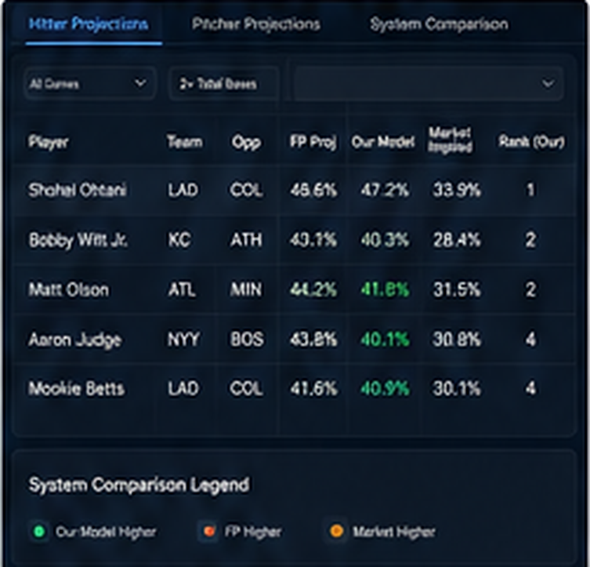 | What this page must show  - Tabs: Hitter Projections, Pitcher Projections, Market Comparison, Projection Movement, Conflicts.  - FantasyPros is the first external projection system.  - Show morning vs latest FantasyPros snapshots.  - Compare Our Baseline, Our Research-Adjusted and Market implied probability when available.  - Highlight material conflicts and projection movement through the day.  User actions  - Filter by game/team/market/system.  - Open player projection history.  - Manual FantasyPros refresh subject to configured quota.  - Flag a projection conflict for AI research.  Build rule: Every FantasyPros pull is immutable. Later snapshots never overwrite the morning view.

11. Bettor Intelligence
Turn outside betting content into structured, testable evidence.
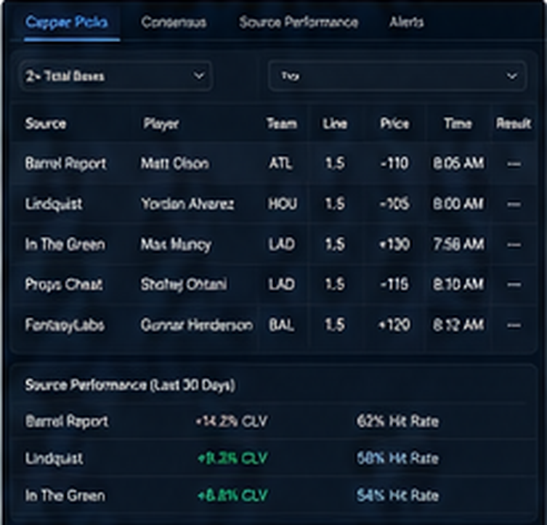 | What this page must show  - Tabs: Today, Pick Feed, Consensus, Source Performance, Mechanisms, Alerts.  - Store exact pick, line/price, source, publication time, rationale and mechanism.  - Group copied/syndicated picks into one independence group.  - Track source results by market/mechanism, price quality and CLV where available.  - Consensus counts independent sources only.  User actions  - Open source profile.  - Compare a bettor claim against internal player/pitcher data.  - Ask AI what the bettor may see that the model does not.  - Reject weak/copied evidence with reason.  Build rule: Other bettors are evidence, not votes. Popularity cannot automatically change a pick.

12. Model Lab
Manage market models and prove whether research/model changes add signal.
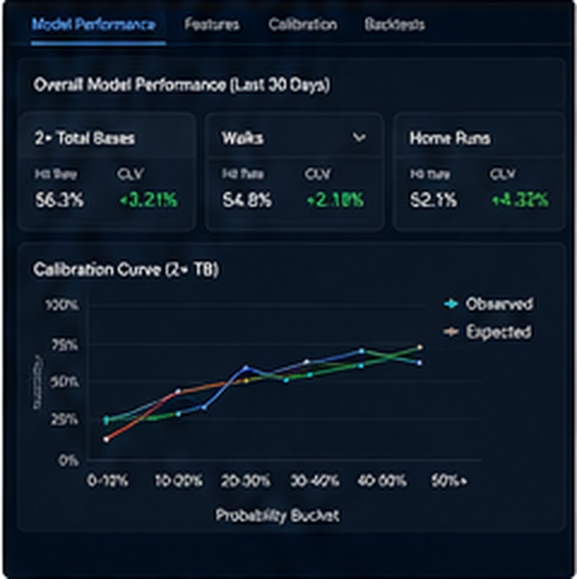 | What this page must show  - Tabs: Market Engines, Model Performance, Features, Calibration, Backtests, Experiments, Versions.  - Separate TB, Walk and HR engines.  - Model version, training cutoff, feature version and active state.  - Calibration curve, Brier/log loss, rank discrimination, feature drift.  - Baseline vs research-adjusted comparison and registered experiments.  User actions  - Compare model versions.  - Inspect probability buckets and drift.  - Create a versioned proposal, not an in-place historical edit.  - Promote models only through deterministic evaluation.  Build rule: No output should be called a probability unless the model metadata supports calibration/validation.

13. AI Analyst
Research workstation with internal data, web search and uploaded-file context.
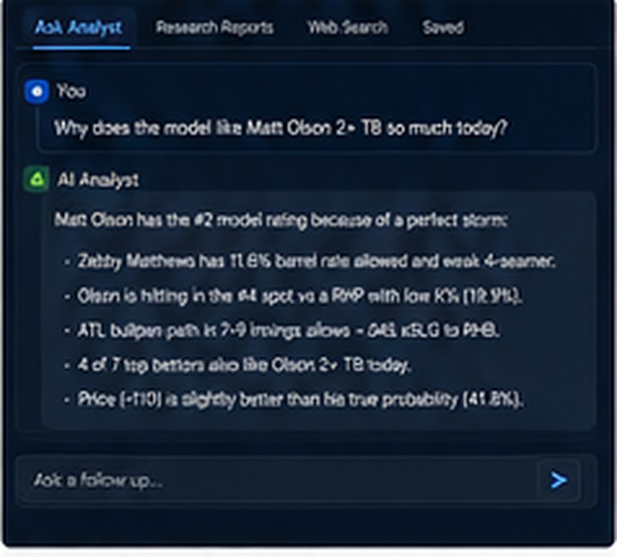 | What this page must show  - Main research conversation/report in the center.  - Evidence rail shows internal tools, web sources, uploaded files and evidence labels.  - Explicit rejected sources, unresolved conflicts and NOT FOUND items.  - Examples: challenge a game, explain market assignment, compare bettors, find weak sourcing.  User actions  - Ask from any current game/player/pitcher/bettor context.  - Save draft research report/evidence.  - Create data-quality note.  - Propose strategy change for later review.  Build rule: AI never gets direct tools to overwrite predictions, settle outcomes, change historical odds or activate models.

14. Results / Postmortem
Settle, grade and learn without outcome chasing.
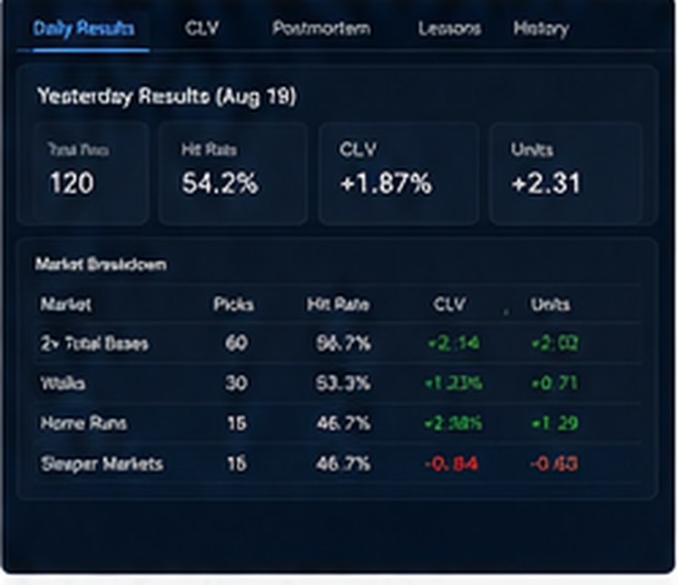 | What this page must show  - Tabs: Daily Results, CLV, Postmortem, Lessons, History, Experiments.  - Hit rate by market/status/model version and source overlap.  - ROI/units only where exact prices exist; CLV where closing snapshots exist.  - Miss class: Data / Opportunity / Probability / Normal Variance.  - Show wins with bad process and losses with good process.  User actions  - Open any frozen pick and its pregame state.  - Compare baseline vs research-adjusted.  - Review bettor/source movement after settlement.  - Create versioned lesson/proposal only after classification.  Build rule: The point is reproducibility: yesterday must be reconstructable from frozen snapshots.

15. Data Health
Make data trustworthiness visible before the user trusts a pick.
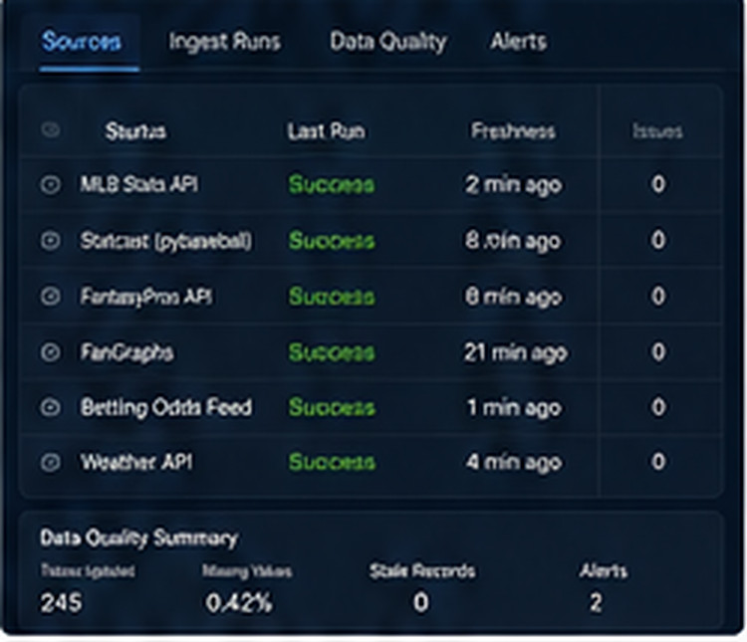 | What this page must show  - Per source: last attempt, last success, freshness, row count, errors and fallback.  - Quota/rate-limit metadata when returned by provider.  - Unresolved player-ID mappings, lineup/starter conflicts, stale bullpens and missing prices.  - Scheduled-job run history and data-quality issue queue.  - Source access/license notes.  User actions  - Retry ingest.  - Acknowledge/resolve mapping or conflict.  - Open failed run/log.  - Disable a broken adapter without deleting history.  Build rule: A blocking source problem should be obvious here and flow into game/card status.

16. Settings / API Keys
Configure the platform without exposing credentials.
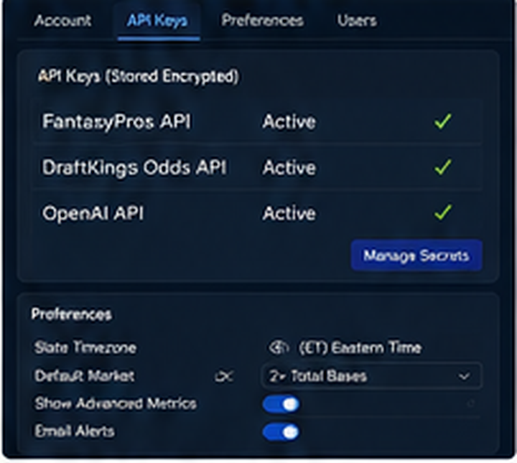 | What this page must show  - Tabs: Account, API Connections, Preferences, Users, Source Watchlist.  - Connection status for FantasyPros, OpenAI, odds/weather and optional sources.  - Timezone, default market/view, sportsbook preference and alert settings.  - FantasyPros refresh cadence is configurable because API plan/quota can differ.  User actions  - Show only secret name and configured/not-configured state.  - Never return the secret value to the browser.  - Manage source enablement and safe preferences.  Build rule: Actual keys live only in Replit Secrets. The frontend must never receive FANTASYPROS_API_KEY or OPENAI_API_KEY.

17. Final Replit Project Setup
The build is intentionally phased. Replit should not be allowed to build a pretty front end full of fake betting outputs before the source/identity/audit layer works.
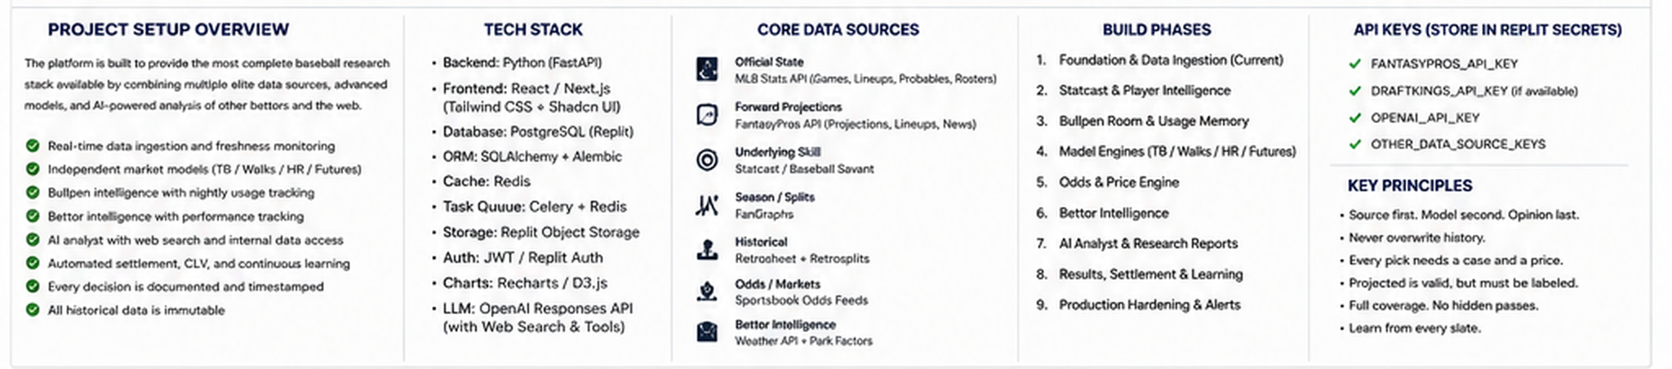
Component | Decision
Backend | Python / FastAPI; separate source adapters, domain services, model services and AI orchestration.
Frontend | React-based analyst UI following the mockups; desktop-first with tablet/mobile monitoring flows.
Database | Replit Database/Postgres via DATABASE_URL; SQLAlchemy + Alembic migrations.
FantasyPros | Phase 1 daily projections, lineup snapshots, news and external-player IDs through backend only.
OpenAI | Responses API on backend for AI Analyst; web search, file search and custom read-only DB functions.
Scheduled jobs | Replit Scheduled Deployments for ingestion, grading and maintenance jobs.
Secrets | Replit Secrets for FANTASYPROS_API_KEY, OPENAI_API_KEY and optional provider credentials.
Persistence | Do not store important state in deployment filesystem. Use database/object storage.

Source ownership
- MLB official data owns official schedule/game/starter/posted-lineup state.
- FantasyPros owns its own forward projections and acts as a lineup/news cross-check, not the official game-state authority.
- Statcast/Baseball Savant owns pitch-level and batted-ball-quality research inputs.
- The accumulated bullpen database owns current availability state once refreshed; stale state stays STALE.
- Exact sportsbook snapshots own price/value claims.
- Bettor content is a structured claim with source/timestamp/mechanism, never automatic truth.

Replit Secrets
Secret | Required? | Purpose
FANTASYPROS_API_KEY | Yes for FP ingestion | Daily projections, lineup feed and news.
OPENAI_API_KEY | Yes for live AI | AI Analyst through Responses API.
THE_ODDS_API_KEY | Optional initially | Sportsbook/market price ingestion.
VISUAL_CROSSING_API_KEY | Optional | Alternate weather provider if configured.

Build sequence
- Phase 1 - Foundation + MLB official state + FantasyPros + Today/Projection Center/Data Health/Settings.
- Phase 2 - Statcast warehouse and Player/Pitcher Labs.
- Phase 3 - Bullpen Room and persistent availability memory.
- Phase 4 - Independent TB / Walk / HR engines.
- Phase 5 - Odds, exact price snapshots, CLV and SGP pricing.
- Phase 6 - Bettor Intelligence and source performance.
- Phase 7 - AI Analyst with web/file/internal tools.
- Phase 8 - Automated settlement, calibration and experiments.
- Phase 9 - Production hardening, auth, backups, observability, cost and mobile.

18. Phase 1 Acceptance Gate
Replit must stop after Phase 1 and produce a PASS / FAIL / PARTIAL acceptance report. These are non-negotiable before model work begins.
- Migrations apply to a clean database.
- Today's MLB schedule/game IDs/teams and starter states ingest without duplicate canonical records.
- FantasyPros hitter and pitcher daily projections ingest as immutable snapshots.
- FantasyPros lineup feed preserves projected/non-projected state and retrieval time.
- FantasyPros news is source-attributed and does not silently mutate official roster state.
- External player-ID mapping exists; unresolved matches appear in Data Health.
- Today Dashboard renders real slate/source state with no fake model probabilities.
- Projection Center shows current and prior same-day FantasyPros snapshots.
- Data Health reports last attempt, last success, freshness and errors for MLB and FantasyPros.
- Settings shows connection status but no secret values.
- Ingestion is idempotent and snapshot changes are immutable.
- Frontend bundle/API responses contain no FANTASYPROS_API_KEY or OPENAI_API_KEY.
Why this matters: the existing MLB process already depends on official starter confirmation, lineup-state honesty, bullpen freshness, market-specific reasoning and reproducible frozen cards. The website should automate those disciplines, not erase them.

19. Reference Sources Used for This Specification
Existing project methodology: 00_PROJECT_INSTRUCTIONS.md, 01_ONBOARDING_LEAGUE_BASELINE.md, 02_SOURCE_DIRECTORY.md, 03_RESEARCH_QUESTIONS.md, 04_BULLPEN_PROTOCOL.md, 05_WORKBOOK_SPEC.md, 06_DAILY_PROMPTS.md and current August strategy/postmortems.
FantasyPros Public API v2: https://api.fantasypros.com/public/v2/docs/
Replit Secrets: https://docs.replit.com/core-concepts/project-editor/app-setup/secrets
Replit Publishing / Deployment types: https://docs.replit.com/learn/projects-and-artifacts/replit-deployments
Replit Database: https://replit.com/products/database
OpenAI developer quickstart / Responses API tools: https://platform.openai.com/docs/quickstart/make-your-first-api-request
Implementation note: review provider plan limits, licenses and publication/commercial terms before enabling production distribution. The platform therefore stores source-governance metadata instead of assuming all research feeds have identical rights.

