MLB ANALYST PLATFORM
Full Build, Winning Research System, Audit and Five Round Robin Specification
Version 5.0 - Draft for review before Replit Plan Mode
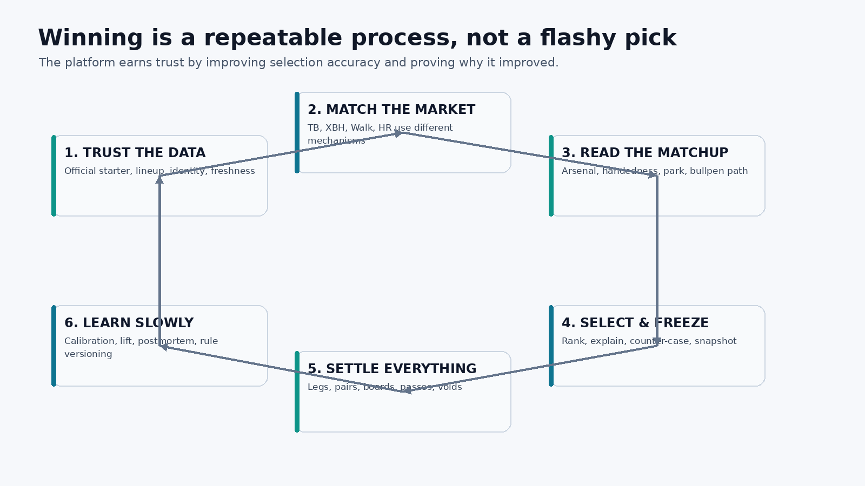
Figure 1. The product wins by making the research loop measurable and repeatable, not by dressing one pick in more adjectives.
Purpose of this document
This is the consolidated build specification. It merges the current project rules, the August 22 live-app audit, the useful parts of the Claude round-robin proposal, the existing Replit architecture, the three reference-site screenshots, the five-board Round Robin decision, BvP methodology, source and GitHub requirements, validation standards, and the full build order. This document is intentionally detailed so we can edit the product on paper before implementation.

0. Document Control and Decision Hierarchy
Field | Current ruling
Document | MLB Analyst Platform - Full Build, Winning Research System, Audit and Five Round Robin Specification
Version | 5.0
Date | 2026-08-22
Status | Draft for review. Do not send to Replit until approved.
Primary objective | Predict and rank which player-market outcomes are most likely to hit using baseball research, validated models, lineup opportunity, bullpen state and historical learning.
Pricing rule | Sportsbook price, odds, implied probability, EV and CLV are not core selection inputs. They may exist later as optional context only if explicitly re-approved.
Core markets | 2+ Total Bases, 1+ Extra Base Hit, 1+ Batter Walk, Home Run.
Companion market | 2+ H+R+RBI is added as an RR3 companion module, not silently treated as a fifth core engine.
Round Robin boards | RR1 TB+TB, RR2 TB+Walk, RR3 XBH+H+R+RBI, RR4 XBH+Walk, RR5 All/General.
Standard Round Robin shape | Target 10 games, one selected pair per game, 20 player legs on a full board. If fewer than 10 legitimate pairs exist, show THIN rather than force a pair.
Authority order | This v5 document > current project rules > accepted platform architecture > older slates/methods > Claude proposal where not superseded.

Critical supersession
The Claude round-robin document contains strong structural ideas, but its price-first thesis conflicts with the current project decision. Keep its geometry, immutability, point-in-time, ledger, BvP shrinkage, arsenal, anti-hindsight and shadow-tracking concepts. Remove price/EV/CLV as requirements for selecting or ranking players.

0.1 Source set used to build this specification
- Current project rules: MLB_Analyst_Replit_Handoff_v3/02_CURRENT_PROJECT_RULES.md
- Daily research methodology: 00_PROJECT_INSTRUCTIONS.md, 02_SOURCE_DIRECTORY.md, 03_RESEARCH_QUESTIONS.md, 04_BULLPEN_PROTOCOL.md, 05_WORKBOOK_SPEC.md.
- Existing platform roadmap: MLB_Analyst_Master_Plan_v4 and prior Replit handoff packages.
- Current live-app audit: MLB_Analyst_Platform_Bug_Audit_and_Round_Robin_Spec_2026-08-22.docx and the August 22 Replit read-only audit.
- Claude proposal: MLB_RoundRobin_Platform_Spec.docx, 77 pages.
- Reference UI: Three user-provided screenshots showing a projections leaderboard, a dense prop table and game-card lineup presentation.
- Current public-code research: GitHub repositories and licenses checked on 2026-08-22, summarized in Part 15.

0.2 Contents
- Part 1 - Why anyone would use this site, and what “winning” means
- Part 2 - What Claude got right, what changes, what is rejected
- Part 3 - Current app audit: every known problem and required fix
- Part 4 - Product information architecture and page-by-page design
- Part 5 - Reference-site visual teardown: what to borrow and what not to borrow
- Part 6 - Data truth, source ownership, identity and provenance
- Part 7 - Player, Pitcher, Park and Bullpen research foundation
- Part 8 - BvP master class: what it is, why it misleads, and the correct use
- Part 9 - Independent market research engines
- Part 10 - H+R+RBI companion module
- Part 11 - Five Round Robin boards and pair-construction rules
- Part 12 - Round Robin math without price dependence
- Part 13 - Historical settlement, postmortems and anti-hindsight
- Part 14 - Model validation, calibration and activation rules
- Part 15 - GitHub and open-source integration plan
- Part 16 - Bettor Intelligence and AI Analyst
- Part 17 - Daily operations, workbook/export compatibility and recovery
- Part 18 - Full Replit multi-task build plan
- Part 19 - Acceptance tests and definition of done
- Appendices - data schemas, status glossary, BvP examples, Round Robin formulas, user inputs to provide

Part 1. Why Someone Would Use This Site, and What “Winning” Means
The site only deserves to exist if it produces a better decision than a user could get from opening three projection pages, reading a few capper posts and picking the most famous hitter. “Better” must be measurable. The platform should reduce preventable data mistakes, rank the right type of hitter for the right market, detect lineup and bullpen changes, explain why a player is ranked where he is, and keep a permanent record of when the research was right or wrong.
Winning in this project is not defined by finding a favorable sportsbook price. The current project rule is outcome-first: identify the player and market most likely to hit, then grade the selection process. Price, EV and CLV are deliberately outside the core selection loop unless the project owner later adds them back. This changes the site’s job. The site must become unusually good at ranking outcomes, not unusually good at decorating market prices.

Figure 2. The winning flywheel. The biggest early gains come from eliminating bad data and market mismatch before adding model complexity.

1.1 The trust contract for every pick
- Correct identity: The player is the right human, team and game. No name-only join can put one Max Muncy’s statistics on another Max Muncy.
- Correct opportunity: The lineup state and batting slot are visible. Projected is not presented as official. A player who moves from second to eighth is not treated as the same opportunity.
- Correct opponent: The opposing starter is official/probable/TBD/opening role with the correct handedness and expected duration. No hitter can ever be matched against his own pitcher.
- Market-specific mechanism: A walk candidate is selected for patience versus command. An XBH candidate is selected for extra-base contact. A TB candidate can win through two singles. An HR candidate is held to a much narrower power standard.
- Bullpen-aware: Full-game hitter props include the likely relief path, which arms are actually available and what handedness/command/contact shape the hitter is likely to see after the starter.
- Explainable: The pick card names the primary mechanism, secondary mechanism, strongest counter-case, missing evidence, sources and freshness.
- Frozen and graded: The exact pregame state is frozen. Results cannot rewrite what the system believed before first pitch.
- Slow learning: One bad night cannot rewrite thresholds. Model and rule changes require enough historical and forward evidence.

1.2 How to measure whether our picks are getting better
Metric | What it answers | When it becomes active
Top-N hit rate | Do the highest-ranked outcomes actually hit more often than lower-ranked eligible outcomes? | Immediately for research ranks.
Selection lift | Top-N hit rate minus the eligible-universe hit rate. | Immediately once settlement exists.
Rank discrimination | Does #1-10 outperform #11-30 and #31+? | Research engine and model validation.
Calibration | If a model says 35%, do similar 35% picks hit about 35%? | Only after probability models are validated.
Brier score | Overall squared error of probabilities. | Model phase.
Log loss | Punishes confident misses more heavily. | Model phase.
Pair joint lift | Does observed same-team pair success exceed what independent marginals would imply? | Round Robin validation.
Process execution | How often were starter, lineup, identity, freshness and bullpen checks complete before lock? | Daily.
Data failure rate | How many misses or voids were caused by bad/late data rather than baseball variance? | Daily postmortem.
Counter-case accuracy | How often did the named risk actually explain the miss? | Postmortem and model feature review.

1.3 Why this is more useful than a normal projection site
A normal projection site is good at showing a number. This platform must be good at showing the evidence chain behind a decision and then proving whether that chain worked. The advantage is not another “38%” next to a player’s name. The advantage is that the platform can tell the user which source supplied the number, whether the hitter is confirmed in the lineup, what pitch mix he will actually see, whether the bullpen is fresh, how the park affects doubles versus home runs, whether the BvP sample is meaningful, and whether similar selections have historically ranked correctly.
Winning principle
Do not optimize for the most impressive-looking screen. Optimize for the smallest number of preventable wrong reads and the highest separation between the top-ranked outcomes and the rest of the slate.

Part 2. Claude Proposal Review: Adopt, Modify, Reject
The 77-page Claude specification is valuable because it thinks in systems rather than isolated picks. It treats the ledger, point-in-time data, blocking checks, geometry, historical reconstruction and correction loops as first-class product features. Those ideas belong in the build. Several of its conclusions, however, were written under an earlier price-centered philosophy and conflict with the current project direction.

2.1 Adopt directly
- Immutable pregame snapshots and append-only settlement/correction history.
- Point-in-time feature storage so historical analysis cannot read future information.
- Canonical player identity by stable IDs and explicit conflict handling.
- Blocking starter/lineup/identity checks upstream of ranking.
- Round Robin pair geometry for TB+Walk, XBH+H+R+RBI and XBH+Walk.
- Shadow tracking for new boards and rejected legs before promoting rules.
- BvP shrinkage, recency decay, effective sample display and pitch-level drilldown.
- Arsenal matchup as the better answer to “does this hitter handle what this pitcher throws?”
- One pair per game per Round Robin board to control pair dependence across games.
- Anti-hindsight enforcement in data queries rather than relying on analyst discipline.
- Detailed explanation drawers that show contribution families, source and counter-evidence.
- Historical reconstruction and pre-registered experiments before changing rules.

2.2 Modify
Claude proposal | Current ruling | Why
Price capture is the highest-value platform feature. | Price is optional context, not a core selection dependency. | Current project explicitly removed price, EV and CLV because they distorted player selection.
Four RR boards plus separate HR and Parlay tabs. | Five RR boards only: TB+TB, TB+Walk, XBH+H+R+RBI, XBH+Walk, All/General. | This is the latest user decision.
10+ PA bad BvP can hard-fade a hitter. | No automatic BvP fade until historical validation supports it. | Current doctrine says BvP is close to worthless below 50 PA and loses to current/arsenal evidence.
TB described at points as an extra-base market. | TB is a two-path market. Two singles count. | Current project correction explicitly recognizes contact hitters as live TB candidates.
H+R+RBI as a full market alongside the others. | H+R+RBI is initially a companion module for RR3. | Keeps the core four-market architecture intact while supporting RR3.
Break-even and pair quote screens are central. | Round Robin survival/exposure math is central; payout math is not required. | The site should help choose the right players and pairs even with no price.

2.3 Reject unless explicitly re-approved
- Imported sportsbook EV or third-party star ratings as a selection/ranking authority.
- Any “due”, drought, last-unders or streak-based promotion/fade rule.
- One composite hitter score reused across TB, XBH, Walk and HR.
- Hard decimal gates that pretend .428 and .432 represent different baseball classes.
- Historical rewrites of predictions or settlements.
- Price or market availability being required to calculate research quality.
- Any BvP display that shows a big rate without the sample size and date distribution.

Part 3. August 22 Live-App Audit: Every Known Problem
The current app has a strong data foundation, but the August 22 audit found nineteen user-facing and operational defects. The most important theme is truthfulness: a system can be technically online while being partially useful, and the UI must never compress those states into one optimistic READY badge. The following issues are the baseline bug list for the stabilization task.
ID | Severity | Area | Problem
B-01 | BLOCKER | Data Health / Today | READY can contradict blocked or partial evidence.
B-02 | BLOCKER | Navigation | Future pages can look production-ready.
H-01 | HIGH | Player/Pitcher Lab | Mobile clipping and unusable two-column layout.
H-02 | HIGH | Dates | UTC defaults can select the wrong MLB slate.
H-03 | HIGH | Audit/Orchestration | Test and fixture runs mixed with production.
H-04 | HIGH | API | Bad inputs return 500 instead of 400.
H-05 | HIGH | Weather | Weather/roof source not configured.
H-06 | HIGH | Sources | Fresh source status can hide zero usable coverage.
M-01 | MEDIUM | Data Health | Freshness used as a proxy for usefulness.
M-02 | MEDIUM | Bullpen Room | Roster coverage overstated as actionable availability.
M-03 | MEDIUM | Bullpen API | Payload too large and history-heavy.
M-04 | MEDIUM | Research Board | Active date unclear in empty states.
M-05 | MEDIUM | Labs | NOT FOUND cards visually compete with real evidence.
M-06 | MEDIUM | Game Lab | Park factor scale not explained.
M-07 | MEDIUM | Feature Store | Reachable route has no intentional audience placement.
M-08 | MEDIUM | Global UI | Status vocabulary inconsistent.
L-01 | LOW | AI Analyst | Autocomplete accessibility warning.
L-02 | LOW | Today/Game Lab | Repeated NOT FOUND reduces scanability.
L-03 | LOW | All pages | Empty, partial and unavailable states look too similar.

B-01 - READY contradicts the actual evidence
Audit classification
Severity: BLOCKER | Area: Data Health / Today / global status

What the user sees
The platform can display READY or Systems nominal while the same date shows partial FantasyPros coverage, blocked FanGraphs, unresolved identities, quarantined rows, team conflicts, stale windows, and dozens of review issues.

Why it matters
The headline status tells the operator the system is complete enough to trust even when the underlying source state is materially incomplete. Transport success is being confused with research readiness.

Required fix
Use one shared readiness contract across the API and UI: READY, PARTIAL, BLOCKED, STALE, NOT RUN. The current-date headline must be derived from required-source coverage, identity coverage, stale windows, and blocking review issues. Rename a pure connectivity badge to Application connected.

Acceptance test
For a slate with a blocked required source or unresolved required identity coverage, every page shows PARTIAL or BLOCKED. No static Systems nominal badge may contradict Data Health.
Illustrative wireframe reconstructed from the current Replit audit; not a literal production screenshot.
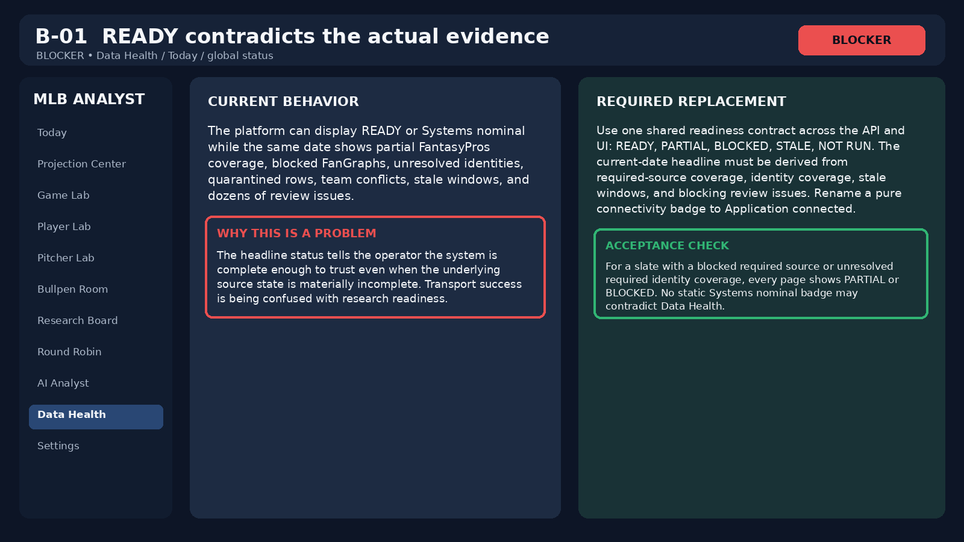
Audit visual for B-01. The graphic is explanatory, not a screenshot of a separate source.

B-02 - Future pages look production-ready
Audit classification
Severity: BLOCKER | Area: Primary navigation / unfinished future surfaces

What the user sees
Bettor Intelligence, Model Lab, Results and other future-phase destinations can appear beside working operational pages even when they are stubs or not yet trustworthy.

Why it matters
Users cannot tell which pages are production workflows versus planned capabilities. This makes unfinished features look broken and can cause people to rely on incomplete outputs.

Required fix
Keep future capabilities in a clearly labeled Planned / Preview section until their data contract and acceptance tests ship. Do not delete Bettor Intelligence permanently; it is a planned project phase. Model Lab and Results should not look operational before they are complete.

Acceptance test
Every visible primary-nav page either works end to end or carries an unmistakable PREVIEW label and cannot be mistaken for a trusted production workflow.
Illustrative wireframe reconstructed from the current Replit audit; not a literal production screenshot.
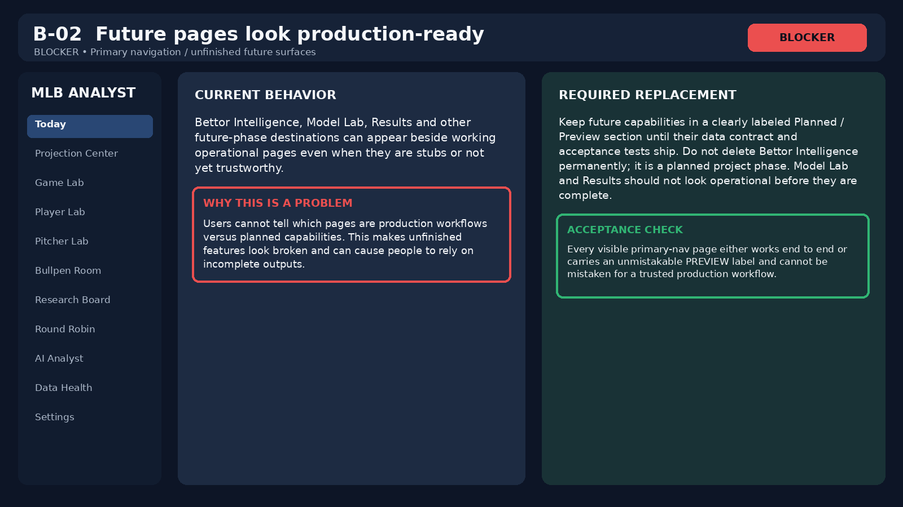
Audit visual for B-02. The graphic is explanatory, not a screenshot of a separate source.

H-01 - Player Lab clips on mobile
Audit classification
Severity: HIGH | Area: Player Lab / Pitcher Lab mobile layout

What the user sees
At phone width, the desktop two-column layout remains active. The fixed search/profile rail consumes width and the selected player content is clipped or pushed beyond the viewport.

Why it matters
The page is functionally unusable on mobile, not merely unattractive. Important player metrics cannot be read or operated reliably.

Required fix
At mobile widths, stack search/results above the selected profile, collapse metric grids, keep all content within viewport, and add a clear back-to-results control. Apply the same responsive pattern to Pitcher Lab.

Acceptance test
At 390-430px wide, search, selected player, every metric group and all controls are usable without page-level horizontal clipping.
Illustrative wireframe reconstructed from the current Replit audit; not a literal production screenshot.
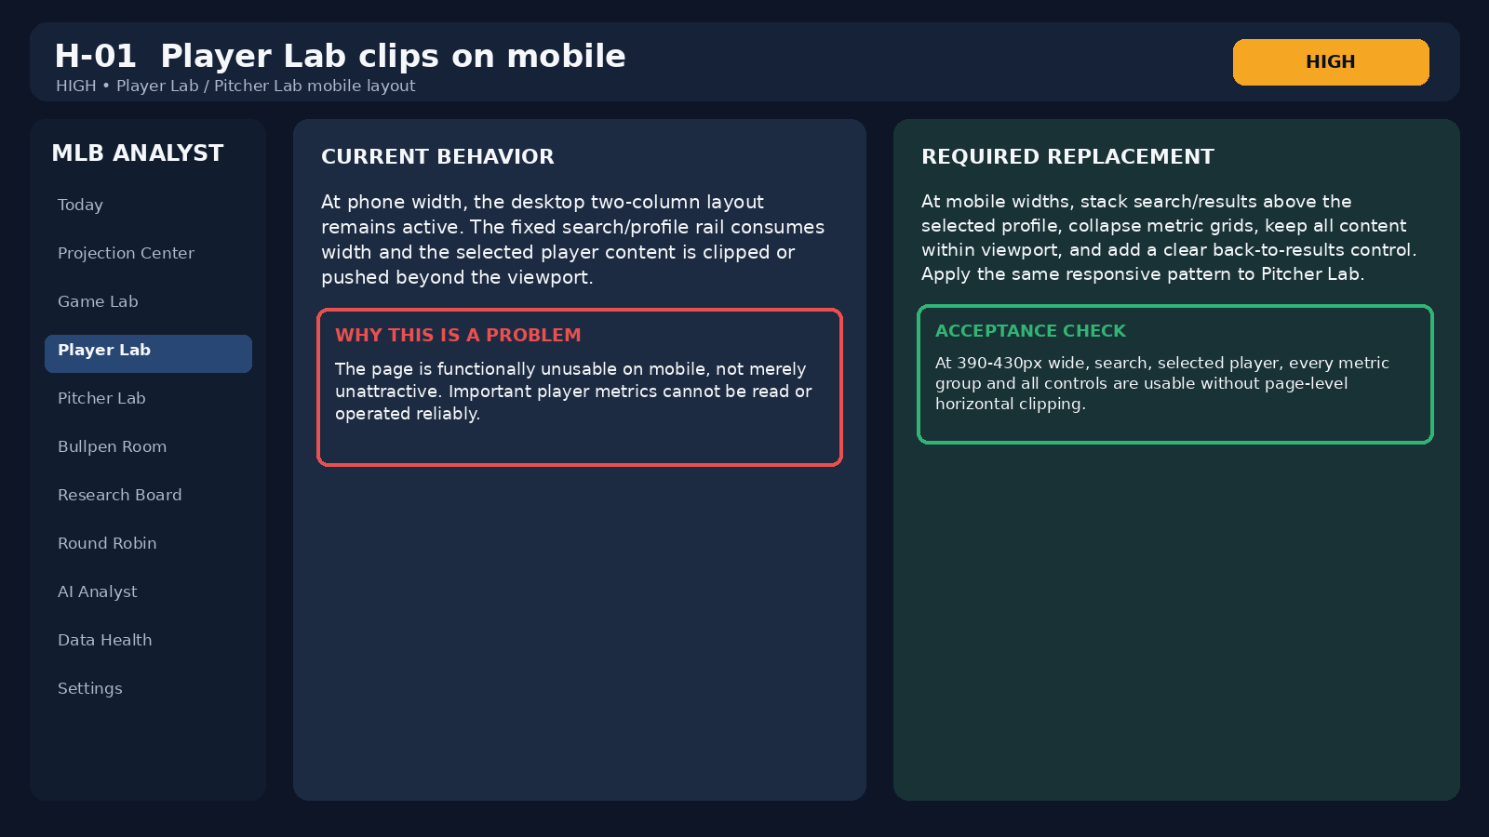
Audit visual for H-01. The graphic is explanatory, not a screenshot of a separate source.

H-02 - UTC defaults can select the wrong MLB slate
Audit classification
Severity: HIGH | Area: Bullpen Room / Feature Store / Research Board dates

What the user sees
Several pages derive the default date from UTC. Some date fields can also appear blank while the page silently queries a date.

Why it matters
MLB slate operations are organized in Eastern Time. Around midnight ET, a UTC date can point at the wrong baseball day. A hidden effective date makes the error difficult to notice.

Required fix
Use one America/New_York date helper everywhere. Always render the effective date in the control and near the results, for example Viewing August 22, 2026 ET.

Acceptance test
All pages, APIs, exports and empty states resolve the same ET date. A test spanning midnight UTC cannot move the user to a different MLB slate.
Illustrative wireframe reconstructed from the current Replit audit; not a literal production screenshot.
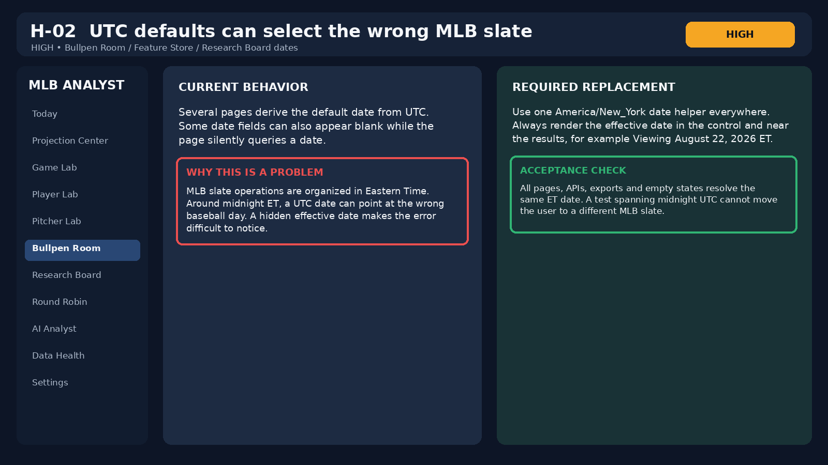
Audit visual for H-02. The graphic is explanatory, not a screenshot of a separate source.

H-03 - Test and fixture runs are mixed with production history
Audit classification
Severity: HIGH | Area: Audit Trail / Orchestration

What the user sees
TEST acceptance events, cancelled fixtures and operational records can appear together. Some runs display COMPLETE while their visible step or freeze state is incomplete.

Why it matters
The operator cannot quickly tell what actually ran against production data or whether a supposedly complete run reached every required step.

Required fix
Default to production records. Add environment/type badges and a separate test filter. Use precise states such as COMPLETE, INCOMPLETE, CANCELLED, NO-OP and TEST COMPLETE. Freeze outcome must be a first-class result.

Acceptance test
A production-only default view contains no test fixtures. COMPLETE requires a completed step ledger and a resolved freeze outcome.
Illustrative wireframe reconstructed from the current Replit audit; not a literal production screenshot.
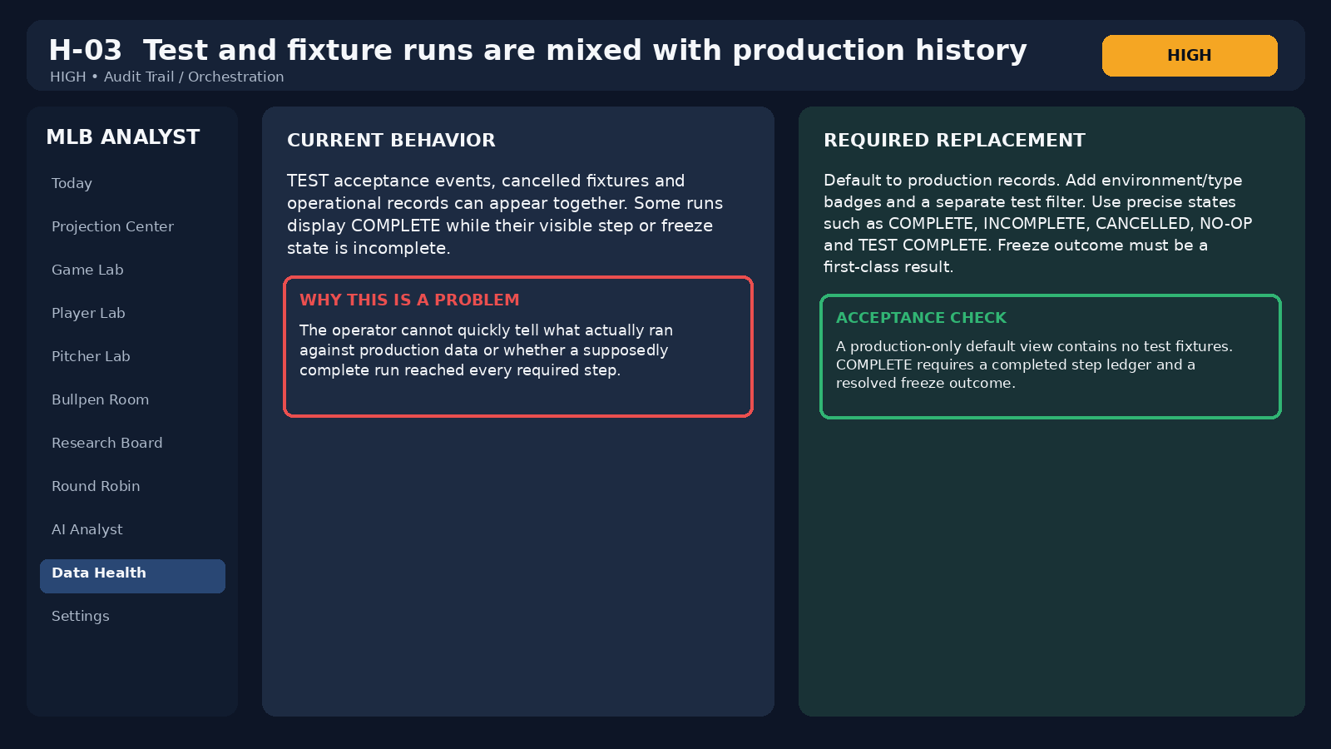
Audit visual for H-03. The graphic is explanatory, not a screenshot of a separate source.

H-04 - Bad inputs return HTTP 500
Audit classification
Severity: HIGH | Area: API validation

What the user sees
Invalid dates and non-numeric IDs can fall into the generic server error path and return HTTP 500 Internal server error.

Why it matters
A client validation error is being reported as an infrastructure failure. It pollutes logs, complicates recovery and can allow invalid values to reach the database.

Required fix
Validate at the request boundary. Return HTTP 400 with stable error codes such as INVALID_DATE or INVALID_PLAYER_ID. The client should preserve the last valid result and show an inline validation message.

Acceptance test
Every malformed supported query returns 400, never 500. No invalid calendar date reaches PostgreSQL.
Illustrative wireframe reconstructed from the current Replit audit; not a literal production screenshot.
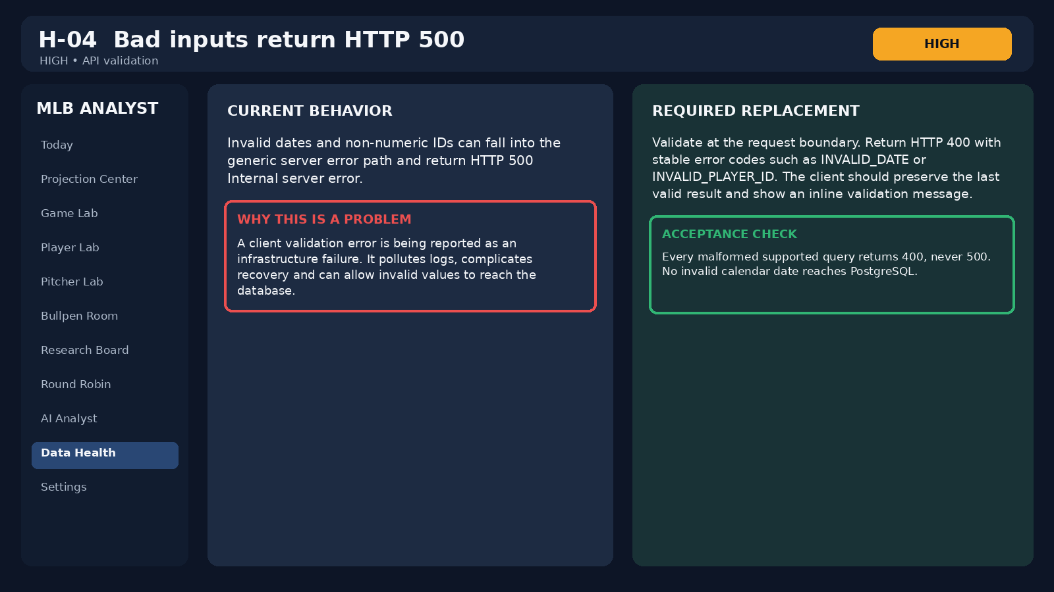
Audit visual for H-04. The graphic is explanatory, not a screenshot of a separate source.

H-05 - Weather is not configured for a weather-sensitive MLB research app
Audit classification
Severity: HIGH | Area: Weather / roof / game context

What the user sees
Weather remains NOT CONFIGURED, and Today/Game Lab can show repeated missing wind, temperature or roof context.

Why it matters
Wind direction, temperature and roof state can materially affect HR and XBH research. Repeated missing fields also make the app look noisier than necessary.

Required fix
Add a reliable weather source and explicit roof-state handling. Until configured, summarize the gap once per game or slate instead of repeating large NOT FOUND cards. Never infer wind direction.

Acceptance test
Outdoor games show sourced temperature, wind speed and direction relative to home plate with timestamps, or one compact unavailable-state banner.
Illustrative wireframe reconstructed from the current Replit audit; not a literal production screenshot.
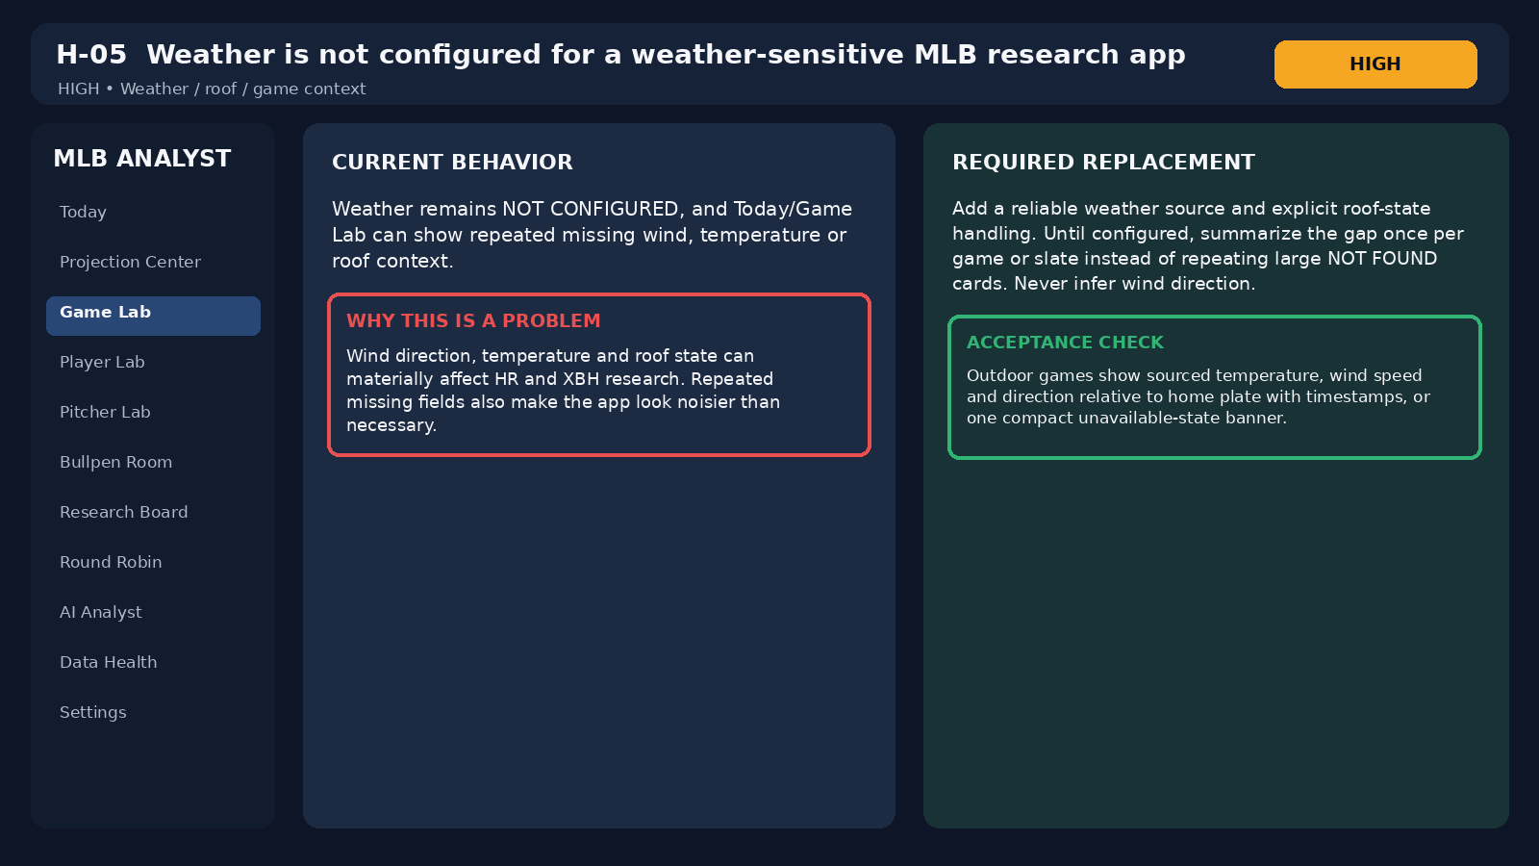
Audit visual for H-05. The graphic is explanatory, not a screenshot of a separate source.

H-06 - Source status can contradict usable research coverage
Audit classification
Severity: HIGH | Area: Research source reliability

What the user sees
FanGraphs can be BLOCKED while Statcast split data is labeled FRESH even when it contributes zero usable rows for the active slate.

Why it matters
A successful transport or stale source label does not tell the analyst whether the actual research fields needed for the workflow are available.

Required fix
Separate transport status, usable row count, coverage scope and workflow requirement. If a source fetch succeeds with zero usable rows, label it FRESH - NO USABLE ROWS. Show fallback source ownership explicitly.

Acceptance test
Every source card shows fetch status plus usable-record coverage. A zero-row source cannot contribute to a READY research gate.
Illustrative wireframe reconstructed from the current Replit audit; not a literal production screenshot.
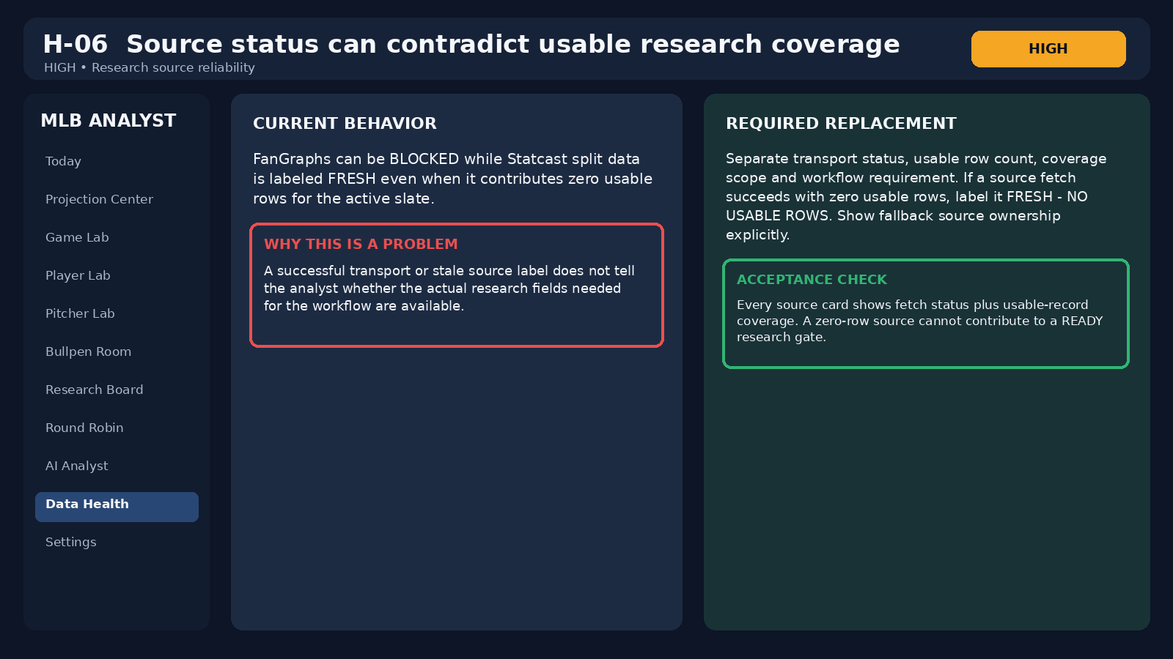
Audit visual for H-06. The graphic is explanatory, not a screenshot of a separate source.

M-01 - Freshness is being used as a proxy for usefulness
Audit classification
Severity: MEDIUM | Area: Data Health source cards

What the user sees
A source card may look healthy because it was fetched recently even if its usable record count is zero or its coverage does not include the active workflow.

Why it matters
Fresh data that contains no applicable evidence is operationally different from healthy research coverage.

Required fix
Display transport, last fetch, usable rows, rejected rows, coverage scope, freshness and required/optional status independently.

Acceptance test
A source with zero usable rows displays a warning state even if the HTTP request succeeded minutes ago.
Illustrative wireframe reconstructed from the current Replit audit; not a literal production screenshot.
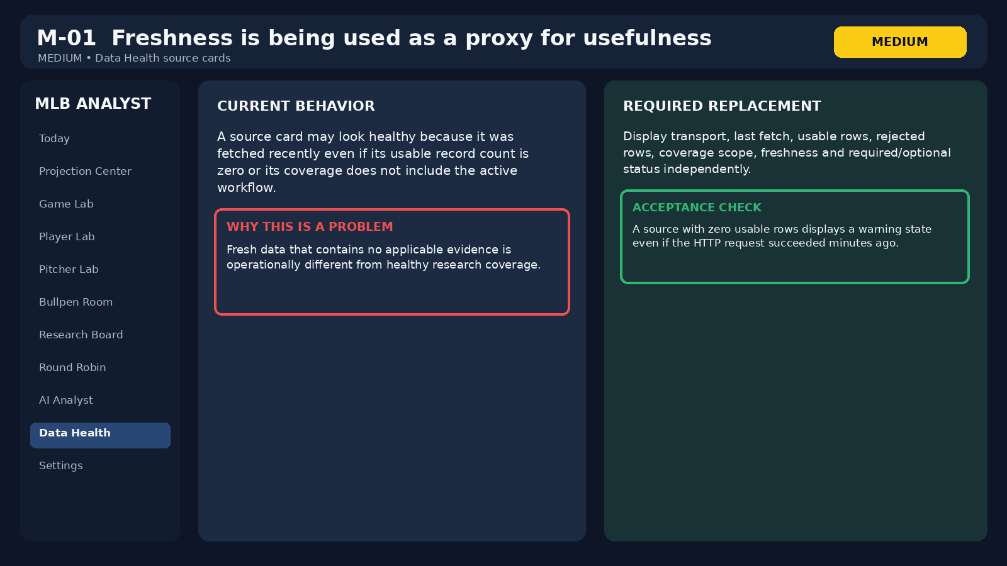
Audit visual for M-01. The graphic is explanatory, not a screenshot of a separate source.

M-02 - Bullpen summary overstates actionable availability
Audit classification
Severity: MEDIUM | Area: Bullpen Room summary

What the user sees
The page can show all 30 teams represented while zero arms have known current availability and hundreds remain unknown.

Why it matters
Roster representation is not the same thing as an actionable bullpen read. The summary language makes the page sound more complete than it is.

Required fix
Separate teams represented, arms with appearance data, arms with current availability, arms awaiting data and teams with usable leverage maps.

Acceptance test
If 0 arms have current availability, the headline says exactly that even if all 30 teams have roster records.
Illustrative wireframe reconstructed from the current Replit audit; not a literal production screenshot.
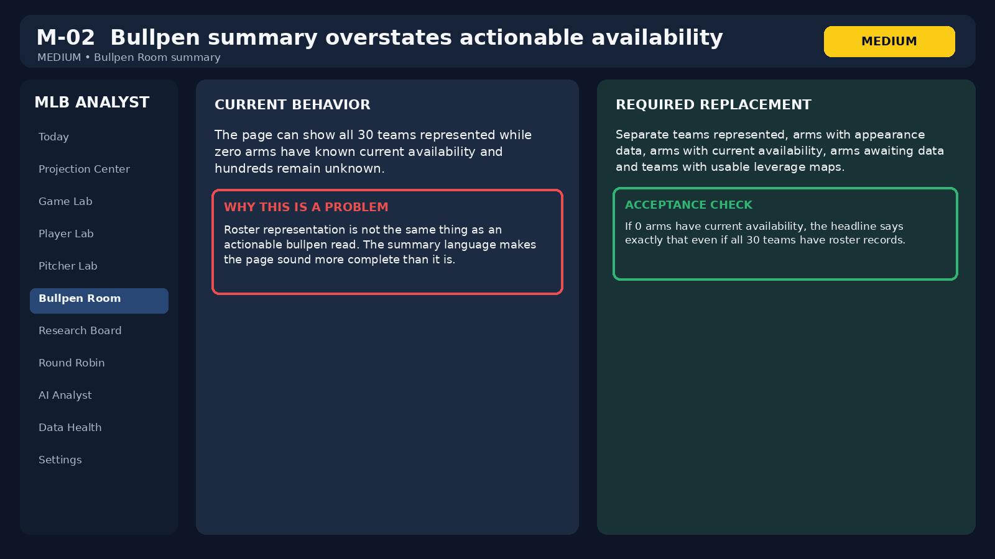
Audit visual for M-02. The graphic is explanatory, not a screenshot of a separate source.

M-03 - Bullpen board payload is too large and history-heavy
Audit classification
Severity: MEDIUM | Area: Bullpen API / role history

What the user sees
The board response can embed long role histories for many relievers, including repeated transitions, instead of returning only current actionable state.

Why it matters
Large payloads slow the page, waste memory and make history look duplicated. It also makes every refresh more expensive.

Required fix
Return current bullpen state in the board response. Lazy-load bounded role history only when a reliever is opened. Deduplicate equivalent events and keep refreshes idempotent.

Acceptance test
Initial Bullpen Room load contains current state only. Opening one arm fetches that arm's bounded history on demand.
Illustrative wireframe reconstructed from the current Replit audit; not a literal production screenshot.
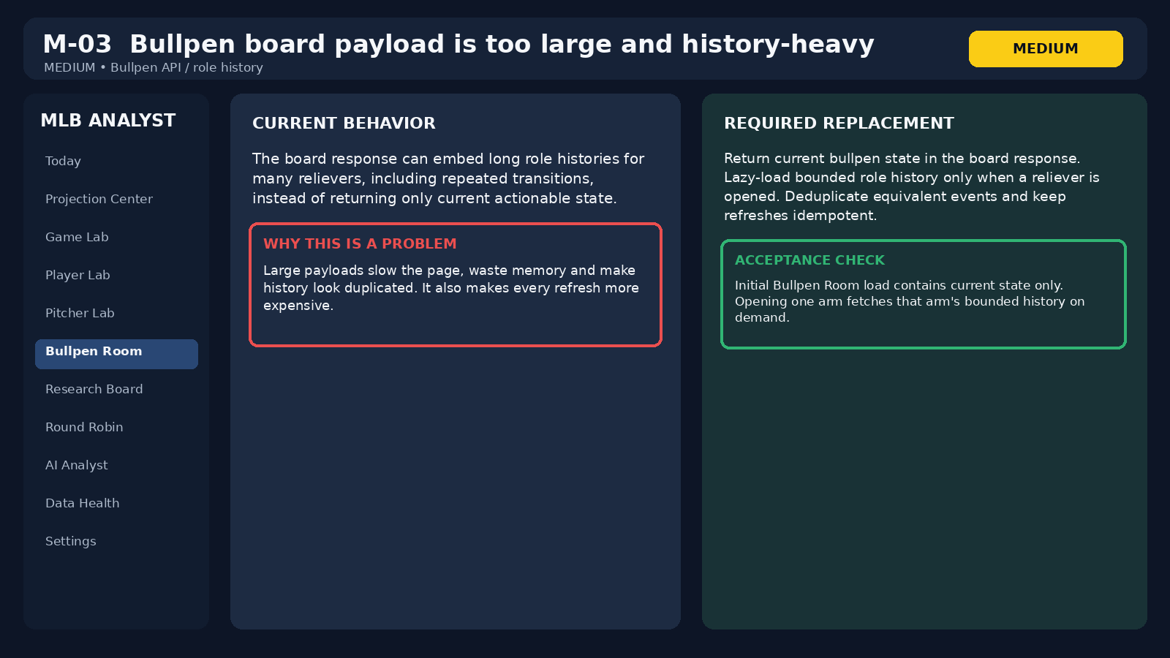
Audit visual for M-03. The graphic is explanatory, not a screenshot of a separate source.

M-04 - The active date is unclear in empty states
Audit classification
Severity: MEDIUM | Area: Research Board / Market Board

What the user sees
The page can query the current slate while its date control appears blank, and an empty result does not clearly distinguish no captured research from no rows matching filters.

Why it matters
Those states imply different operator actions. One requires ingestion; the other requires changing filters.

Required fix
Always show the active ET date. Use distinct empty states for no research captured, no filter matches, source blocked, not configured and stale data.

Acceptance test
The user can tell the effective date and why the board is empty without opening Data Health.
Illustrative wireframe reconstructed from the current Replit audit; not a literal production screenshot.
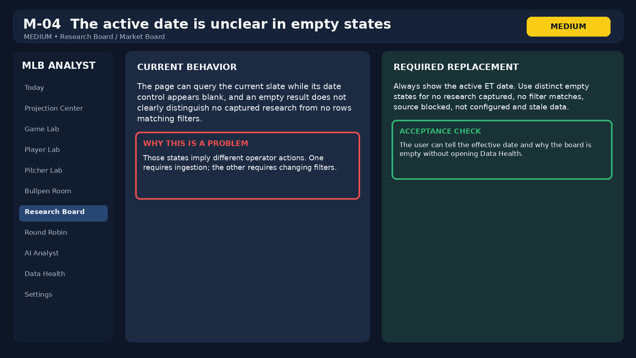
Audit visual for M-04. The graphic is explanatory, not a screenshot of a separate source.

M-05 - NOT FOUND cards visually compete with real evidence
Audit classification
Severity: MEDIUM | Area: Player Lab / Pitcher Lab metric panels

What the user sees
Available metrics and missing metrics receive similar visual weight, causing pages with partial coverage to become dense walls of NOT FOUND cards.

Why it matters
The analyst has to spend effort separating evidence from absence. The page is honest but inefficient to scan.

Required fix
Group metrics into Available, Insufficient sample, Not available and Source blocked/stale. Collapse unavailable groups by default. Show source, denominator, date window and definition for valid metrics.

Acceptance test
A partially covered player profile emphasizes usable evidence first while preserving one-click access to missing-field detail.
Illustrative wireframe reconstructed from the current Replit audit; not a literal production screenshot.
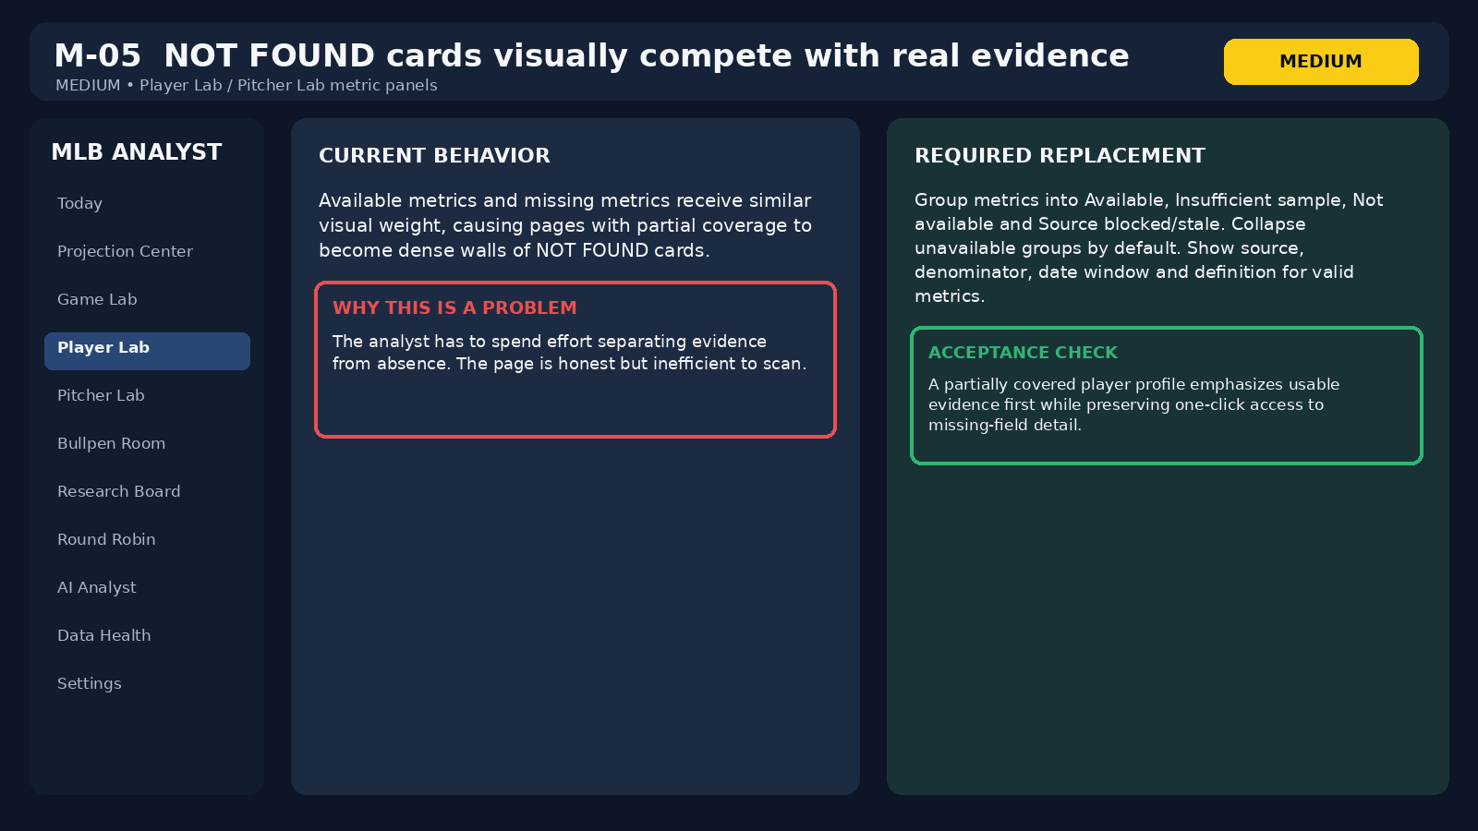
Audit visual for M-05. The graphic is explanatory, not a screenshot of a separate source.

M-06 - Park factor values have no neutral-scale explanation
Audit classification
Severity: MEDIUM | Area: Game Lab park factors

What the user sees
Game Lab can show values such as 95 or 118 with only a factor label and no explanation of what 100 means.

Why it matters
The analyst may not know whether higher is favorable, whether the number is percent-based or what event/season the factor describes.

Required fix
Label 100 = neutral. Where valid, translate 118 to 18% above neutral. Show event component, season/year range, handedness, venue and source.

Acceptance test
Every park factor is interpretable without external documentation.
Illustrative wireframe reconstructed from the current Replit audit; not a literal production screenshot.
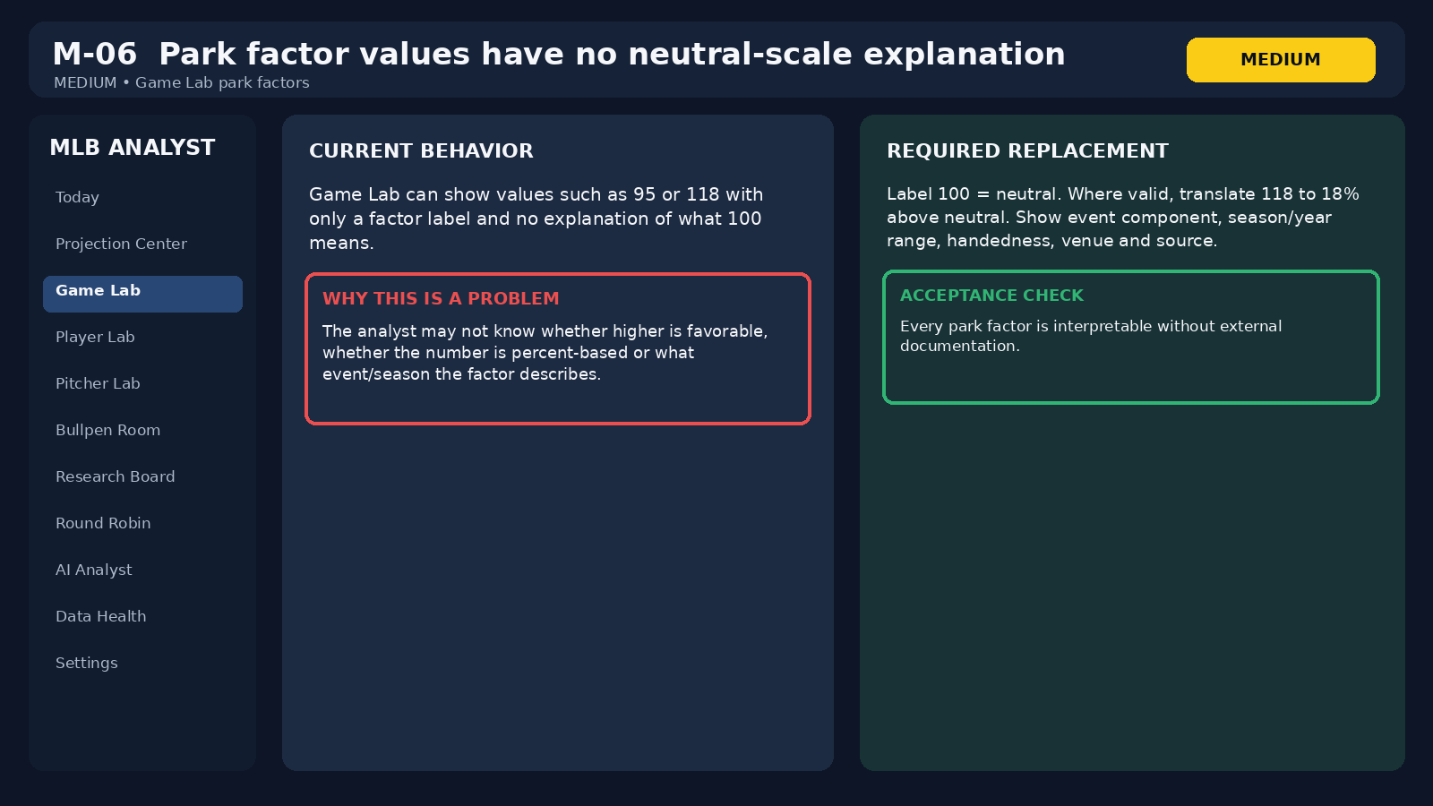
Audit visual for M-06. The graphic is explanatory, not a screenshot of a separate source.

M-07 - Feature Store is reachable but has no intentional audience placement
Audit classification
Severity: MEDIUM | Area: Feature Store navigation

What the user sees
Feature Store exists as a route but is not clearly framed as an operator page or an internal engineering/research surface.

Why it matters
Hidden-but-reachable pages create inconsistent expectations and clutter the product information architecture.

Required fix
Either place it under an explicit Engineering / Research Data section or treat it as internal and keep it out of normal operator navigation.

Acceptance test
Every reachable production route has a clear audience, nav location and purpose.
Illustrative wireframe reconstructed from the current Replit audit; not a literal production screenshot.
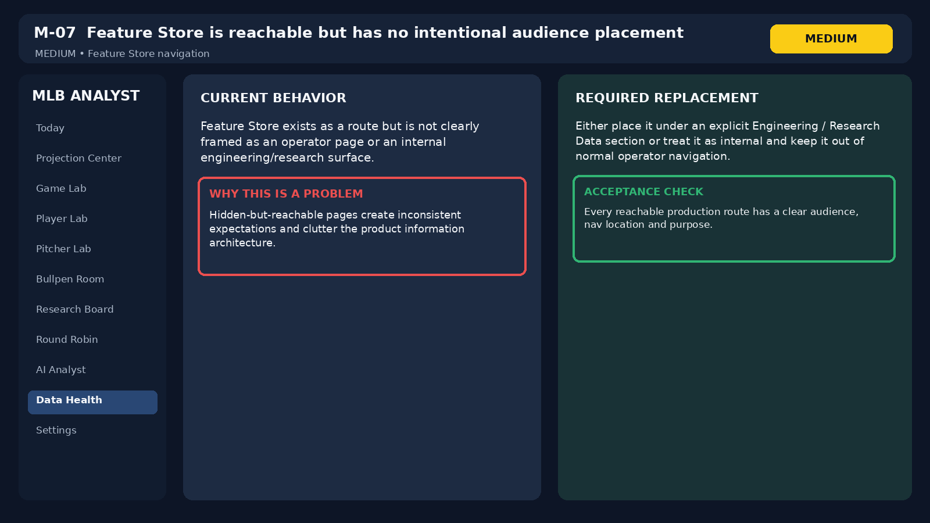
Audit visual for M-07. The graphic is explanatory, not a screenshot of a separate source.

M-08 - Status terms are inconsistent across pages
Audit classification
Severity: MEDIUM | Area: Global status vocabulary

What the user sees
Fresh, Online, Ready, Complete, Healthy and Nominal can appear as if they mean the same thing even though they describe different states.

Why it matters
Operators cannot infer whether a badge means transport success, source freshness, workflow completeness or application uptime.

Required fix
Create a status glossary and shared enums. Suggested data/workflow vocabulary: FRESH, PARTIAL, BLOCKED, STALE, EMPTY, NOT CONFIGURED, READY, INCOMPLETE, CANCELLED.

Acceptance test
The same semantic state uses the same word and color everywhere. Connectivity is never labeled as research readiness.
Illustrative wireframe reconstructed from the current Replit audit; not a literal production screenshot.
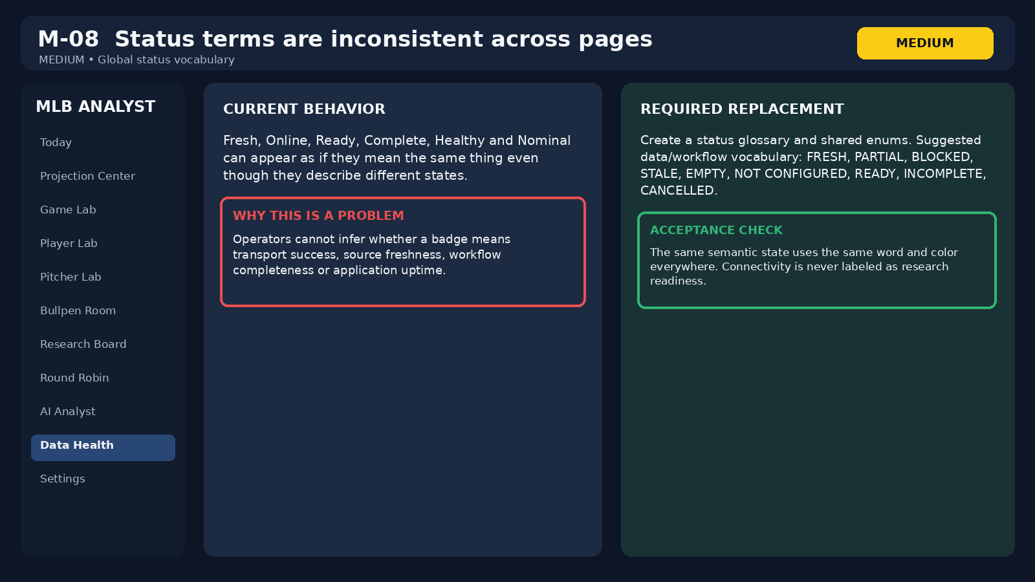
Audit visual for M-08. The graphic is explanatory, not a screenshot of a separate source.

L-01 - AI input is missing an autocomplete attribute
Audit classification
Severity: LOW | Area: AI Analyst input accessibility

What the user sees
The browser reports an accessibility warning for a text input without an appropriate autocomplete attribute.

Why it matters
It is a small quality issue and can cause inconsistent browser autofill behavior.

Required fix
Set autocomplete=off or a field-specific standard value based on the input purpose.

Acceptance test
Browser accessibility/console audit no longer reports the autocomplete warning.
Illustrative wireframe reconstructed from the current Replit audit; not a literal production screenshot.
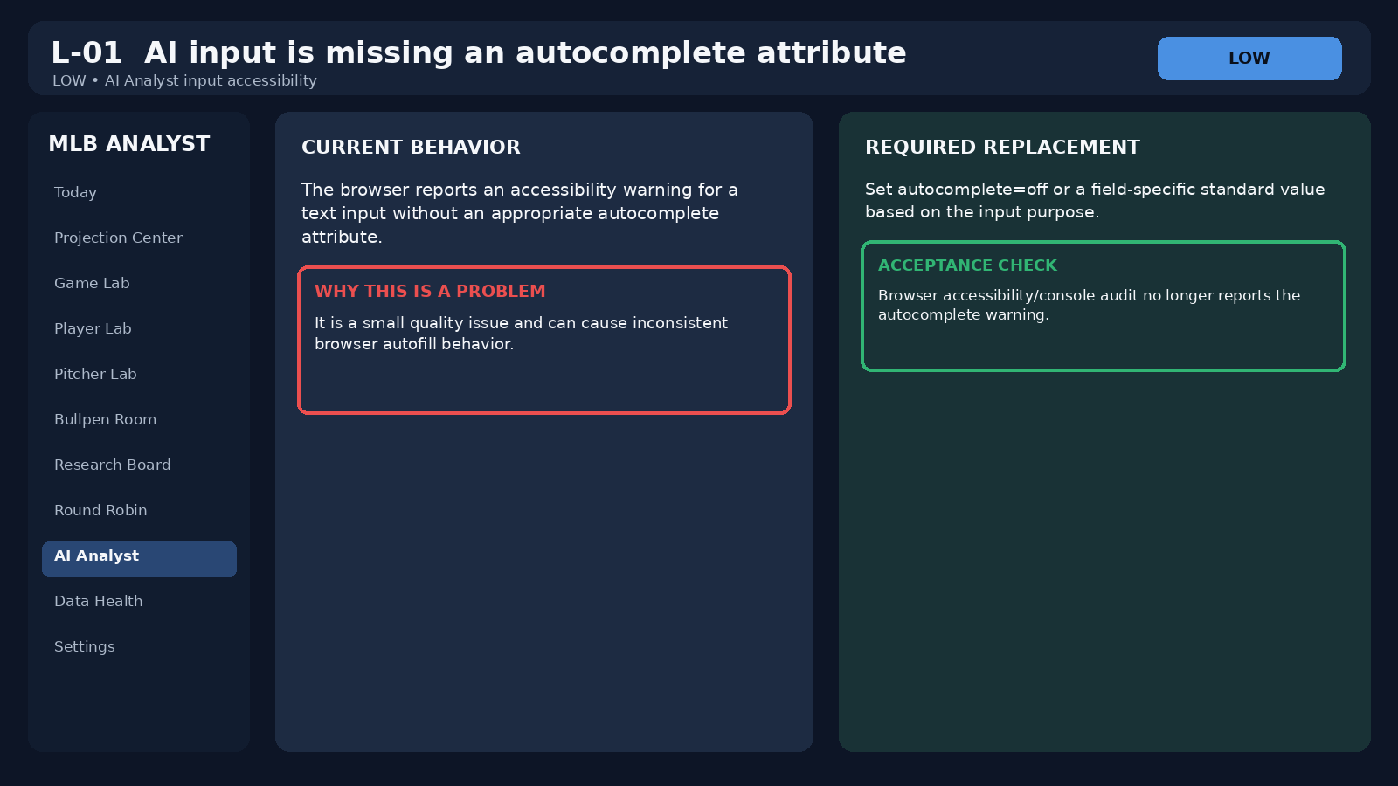
Audit visual for L-01. The graphic is explanatory, not a screenshot of a separate source.

L-02 - Repeated NOT FOUND values reduce scanability
Audit classification
Severity: LOW | Area: Today / Game Lab missing-data presentation

What the user sees
Missing weather, roof, handedness or other context can appear as many repeated NOT FOUND labels across a page.

Why it matters
The app is being truthful, but the repetition overwhelms the actual baseball information.

Required fix
Summarize repeated missing fields in a compact slate/game banner and allow expansion for field-level detail.

Acceptance test
A game with several missing environmental fields shows one concise warning plus expandable detail rather than a wall of repeated cards.
Illustrative wireframe reconstructed from the current Replit audit; not a literal production screenshot.
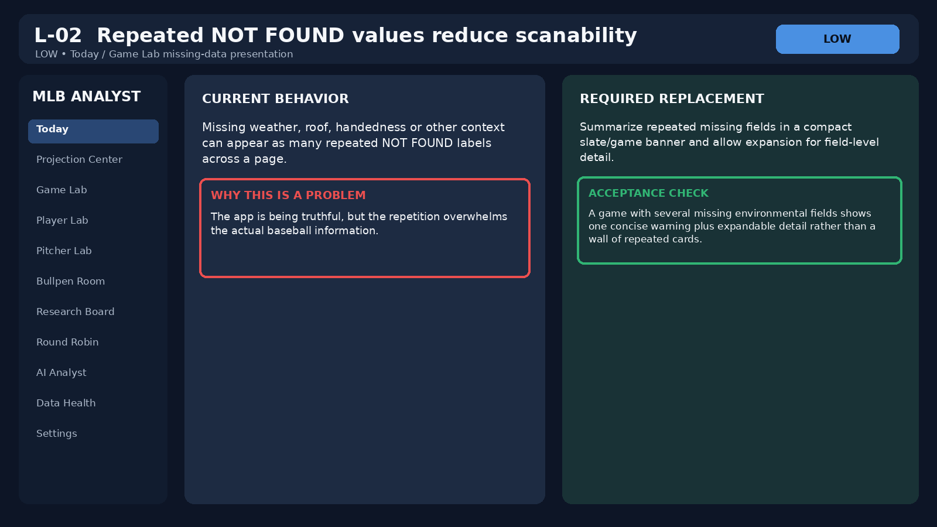
Audit visual for L-02. The graphic is explanatory, not a screenshot of a separate source.

L-03 - Empty, partial and unavailable states look too similar
Audit classification
Severity: LOW | Area: All empty / unavailable states

What the user sees
No fetch, zero usable rows, no filter matches, blocked source, not configured and stale data can all result in similar empty-looking screens.

Why it matters
Each state requires a different operator response, so visual ambiguity slows diagnosis.

Required fix
Create distinct page-level states: NOT RUN, EMPTY, FILTERED EMPTY, BLOCKED, NOT CONFIGURED, STALE and PARTIAL. Pair each with one recommended operator action.

Acceptance test
A user can identify the reason for an empty page and the next action from the page itself.
Illustrative wireframe reconstructed from the current Replit audit; not a literal production screenshot.
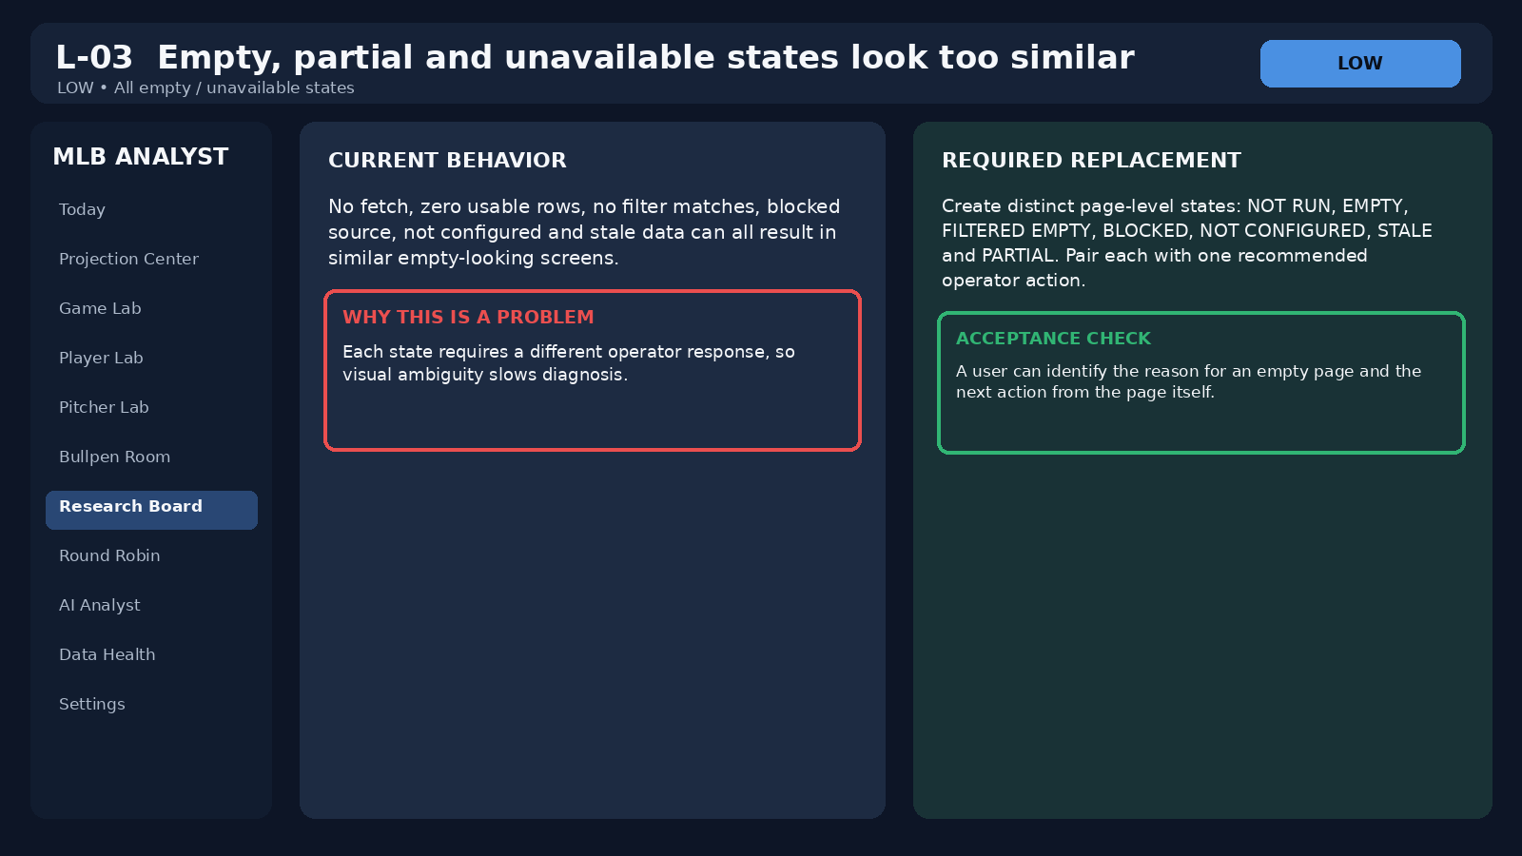
Audit visual for L-03. The graphic is explanatory, not a screenshot of a separate source.

3.1 Stabilization order before adding new product behavior
- Fix shared readiness semantics and source usability. A READY badge must mean the same thing everywhere.
- Centralize America/New_York dates and visible effective-date labels.
- Fix invalid request handling so user input cannot create false 500 errors.
- Separate test/fixture records from production operations.
- Fix Player Lab and Pitcher Lab mobile behavior.
- Configure weather/roof handling and compact missing-data presentation.
- Normalize status vocabulary and empty-state taxonomy.
- Reduce Bullpen Room payload size and stop overstating availability.
- Reframe unfinished future pages as Preview/Planned rather than operational.
- Only after the stabilization pass should the five Round Robin workspace become a trusted daily surface.

Part 4. Final Product Information Architecture
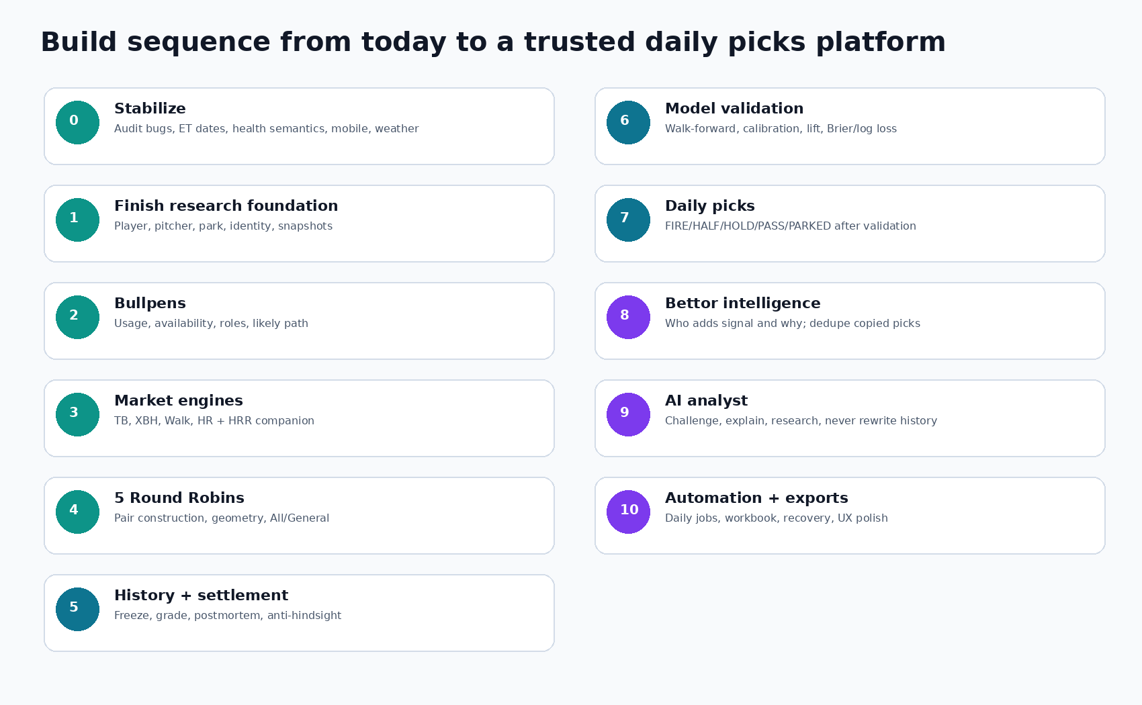
Figure 3. Product build sequence from the current app to the full daily picks system.

4.1 Navigation groups
Group | Pages | Purpose
OPERATIONS | Today, Projection Center, Data Health, Orchestration, Audit Trail | What is current, what ran, what is blocked, what changed.
RESEARCH LABS | Game Lab, Player Lab, Pitcher Lab, Bullpen Room | Deep baseball evidence. No generic “pick” page hidden in these labs.
ANALYSIS BOARDS | Research Board, Round Robins | Market-specific rankings and the five pair boards.
LEARNING | Results/Postmortem, Model Lab, Bettor Intelligence | Only visible as operational when their phases pass acceptance.
ANALYST | AI Analyst | Research, challenge, explanation and source synthesis.
ENGINEERING | Feature Store, Source Registry, Settings | Internal/debug visibility. Keep separate from operator workflow.

4.2 Today
Today is the command center. It should answer three questions within five seconds: What games are on the slate? What is blocking trustworthy research? What is the strongest current research surface to open next? Every game card must show first pitch ET, venue, official/probable starter state, lineup state, park/weather availability, bullpen freshness and a direct link into Game Lab.
- Hide started games by default, with an explicit toggle.
- Show global current-date status as READY, PARTIAL, BLOCKED, STALE or NOT RUN using the same Data Health contract.
- Show a compact “changes since last refresh” rail: lineup posted, starter changed, player scratched, bullpen arm used yesterday, weather direction changed.
- Do not repeat NOT FOUND fifteen times. Summarize missing source families once and allow expansion.
- Do not show FIRE/HALF/HOLD before validated prediction engines exist.

4.3 Projection Center
Projection Center remains a source-comparison page, not the model. It should show FantasyPros component projections, immutable snapshot times, movement between snapshots, identity status and lineup state. Once our models exist, a separate column can compare Our Model versus FantasyPros, but the site must preserve the difference between an external projection and an internally validated probability.

4.4 Game Lab
- Both starters with current season, career baseline and recent windows.
- Pitch arsenal usage, velocity, movement, xSLG/contact outcomes by batter side and expected innings.
- Both lineups side by side with projected/confirmed state, lineup slot and each hitter’s rank in TB, XBH, Walk and HR.
- Park factor components with 100 = neutral and exact year range/handedness.
- Weather direction relative to home plate, not wind speed alone.
- Projected bullpen path using only available or likely-available arms.
- Every legal pair in the five Round Robin boards for this game, with geometry and the reason rejected pairs failed.

4.5 Player Lab
Player Lab answers: who is this hitter, what does he do, which market fits his shape, and what specifically about tonight changes the baseline? It must not answer with one universal score.
Panel | Key fields
Opportunity | Lineup spot history, PA/AB, starts, platoon usage, expected opportunity later.
Core offense | AVG, OBP, SLG, ISO, wOBA, xBA, xSLG, xwOBA.
Contact | K%, contact, zone contact, chase contact, line drive, ground ball, fly ball, BABIP.
Damage | Average EV, 90th EV, max EV, hard-hit, barrels, barrel/PA, sweet spot, launch distribution, pull/center/oppo, pull-air.
XBH | 2B, 3B, HR, XBH/PA, XBH/hit, route shares, sprint speed, directional extra-base damage.
Walk | BB/uBB, chase, zone swing, first-pitch swing, pitches/PA, swing-strike/called-strike.
Splits | vs LHP/RHP with denominators and time windows.
Pitch types | Usage faced, xSLG/wOBA/whiff/hard-hit/barrels/run value by pitch family and velocity band.
Our history | Every prior board appearance and outcome, separated by market and model version.

4.6 Pitcher Lab
Panel | Key fields
Workload | Starts/relief appearances, IP/BF, pitches/start, innings/start, times through order, recent workload.
Run prevention context | ERA, xERA, FIP/xFIP/SIERA where available, current vs career. Context only, never the vulnerability score.
Contact allowed | xBA, xSLG, xwOBA, hard-hit, barrels, EV, LD/GB/FB, BABIP.
Command | K%, BB/uBB, K-BB, Zone, F-strike, chase, swinging strike, pitches/BF.
Side splits | LHB/RHB outcomes with BF denominators.
XBH vulnerability | 2B/3B/HR allowed, XBH/BF, XBH/BIP, deep line/fly-ball damage, directional damage.
Arsenal | Usage, velocity, trend, movement, spin, release, extension, whiff, chase, xSLG/xwOBA, barrels.
Location | Heart/shadow/chase/waste, middle-middle and edge frequency, heatmap data.

4.7 Bullpen Room
The bullpen is the standing memory layer and must describe individual available arms, not team ERA. The summary should explicitly distinguish 30 teams represented from 30 teams with actionable availability. A team can have a complete roster and still have zero trusted availability if appearance data is stale.

Part 5. Reference-Site Visual Teardown
The three supplied screenshots are useful because they solve different presentation problems. None should be copied wholesale. The goal is to take information architecture that improves speed while rejecting price-centric and conclusion-heavy elements that conflict with the project.
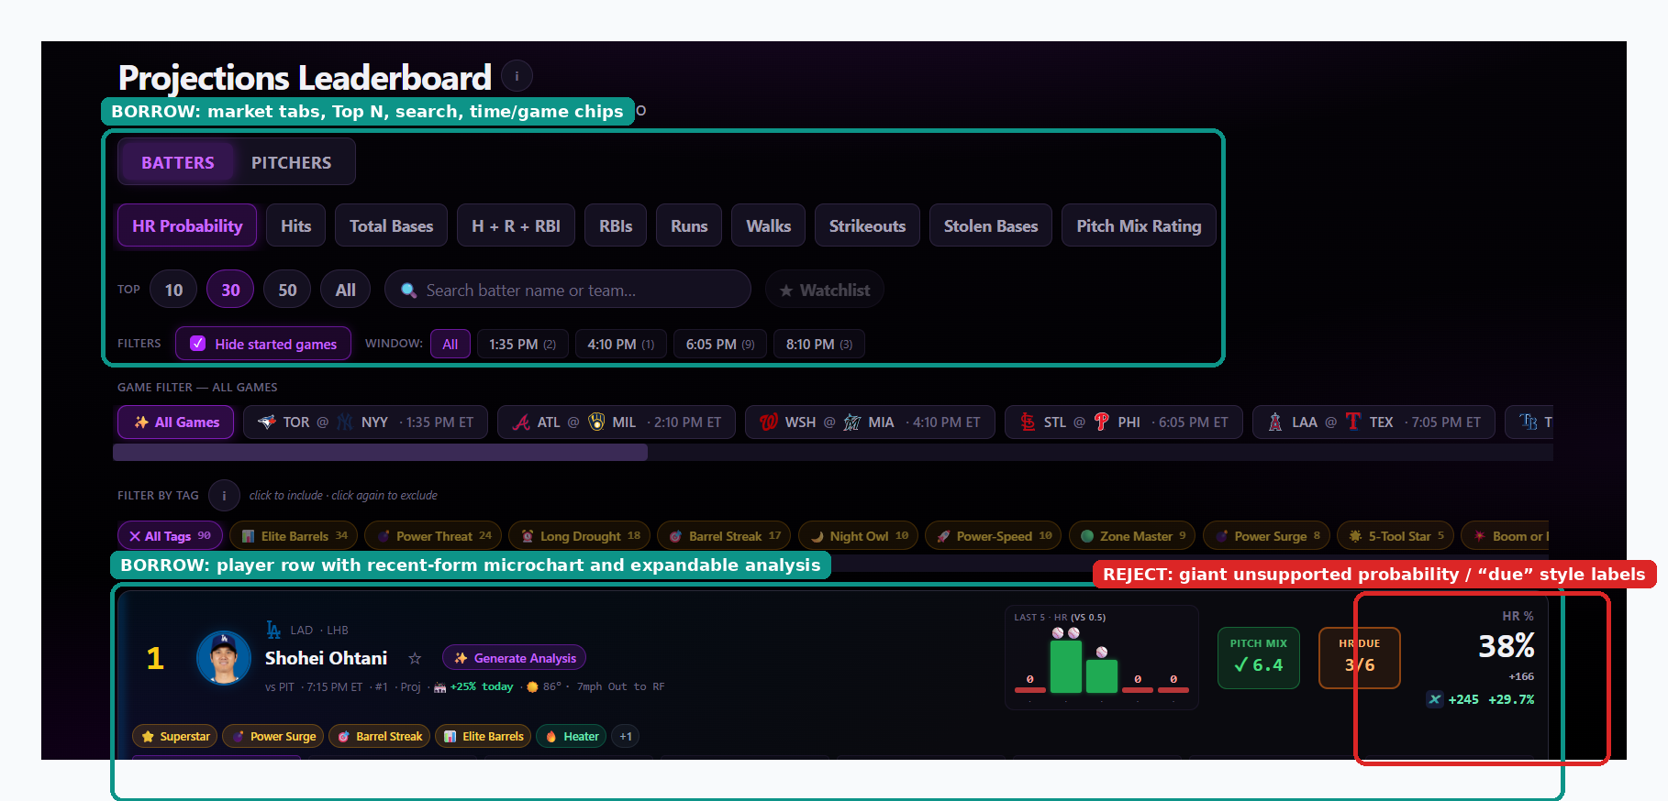
Figure 4. Projection leaderboard reference. Borrow the market-first navigation, game/time chips, Top N controls and expandable player analysis. Reject unsupported headline probabilities and “due” logic.
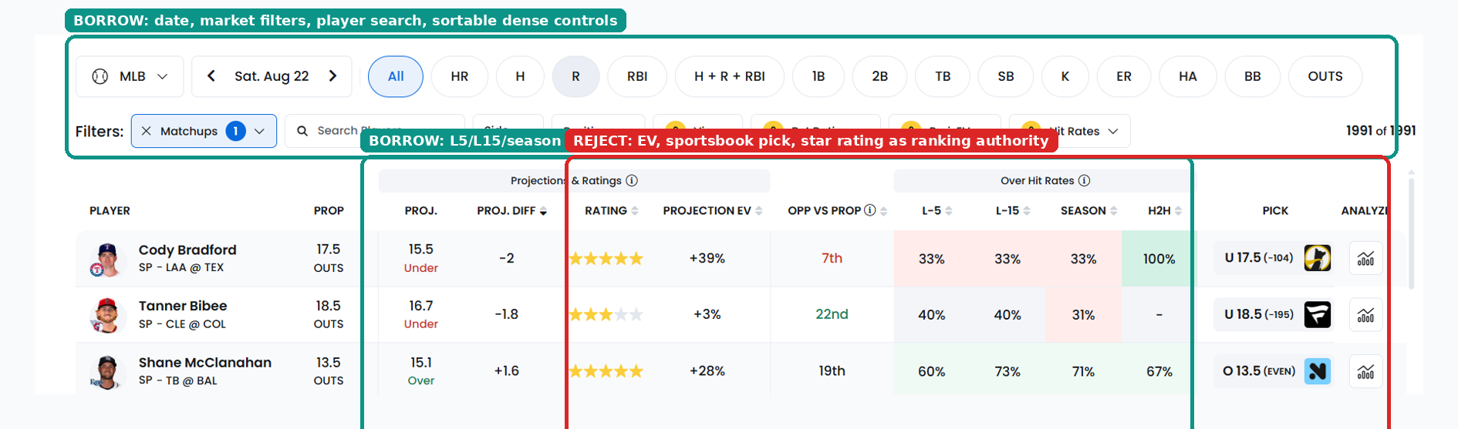
Figure 5. Dense prop table reference. Borrow filtering, search, sortable windows and compact comparison. Reject sportsbook EV, picks and star ratings as authority.
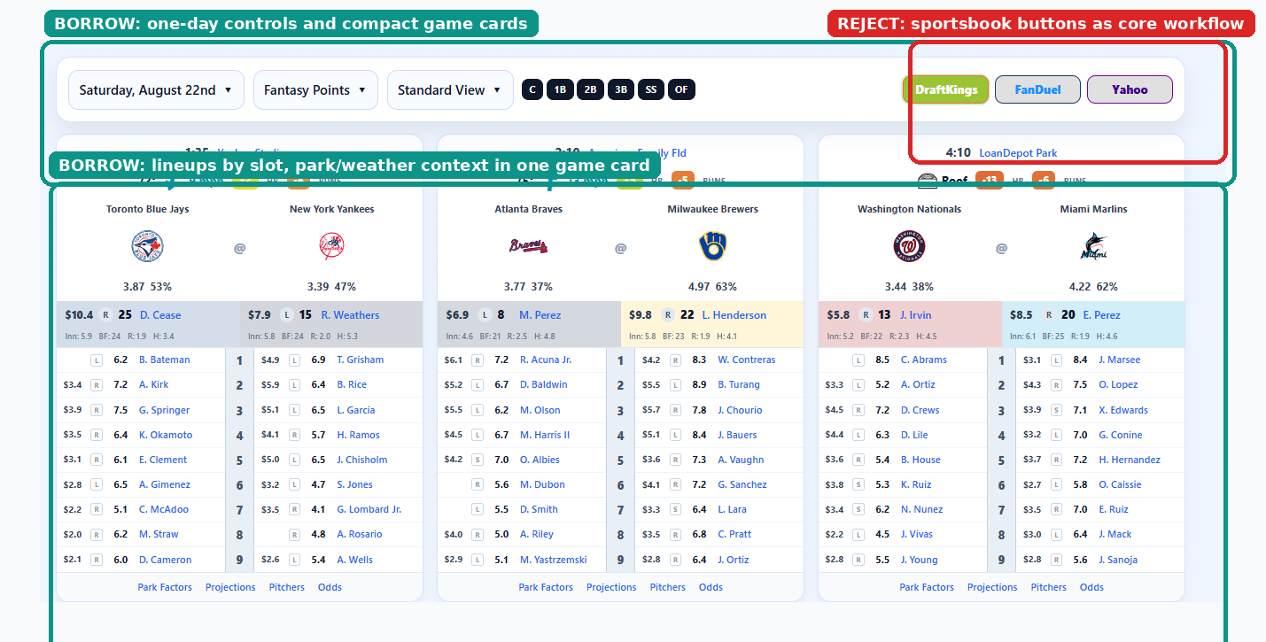
Figure 6. Game-card reference. Borrow one-day game cards, lineups by slot and contextual weather/park placement. Reject sportsbook buttons as the core workflow.

5.1 The screen we should build from these references
- Market tabs across the top: 2+ TB, XBH, Walk, HR, plus H+R+RBI only where the RR3 companion module is needed.
- Top 10 / 30 / 50 / All controls, player/team search and specific-game chips with first pitch ET.
- Hide started games by default.
- Sortable L5/L15/L30/season windows, always with denominators. Avoid red/green streak psychology.
- Dense rows for desktop, card mode for mobile.
- Each row shows source/provenance, lineup state, starter state, data age and “Why”.
- Tags must be factual descriptors such as Pull Air, Barrel Profile, Contact Route, Patience, Starter Contact-Inducing, not conclusions such as Due or Lock.

Part 6. Data Truth, Source Ownership, Identity and Provenance
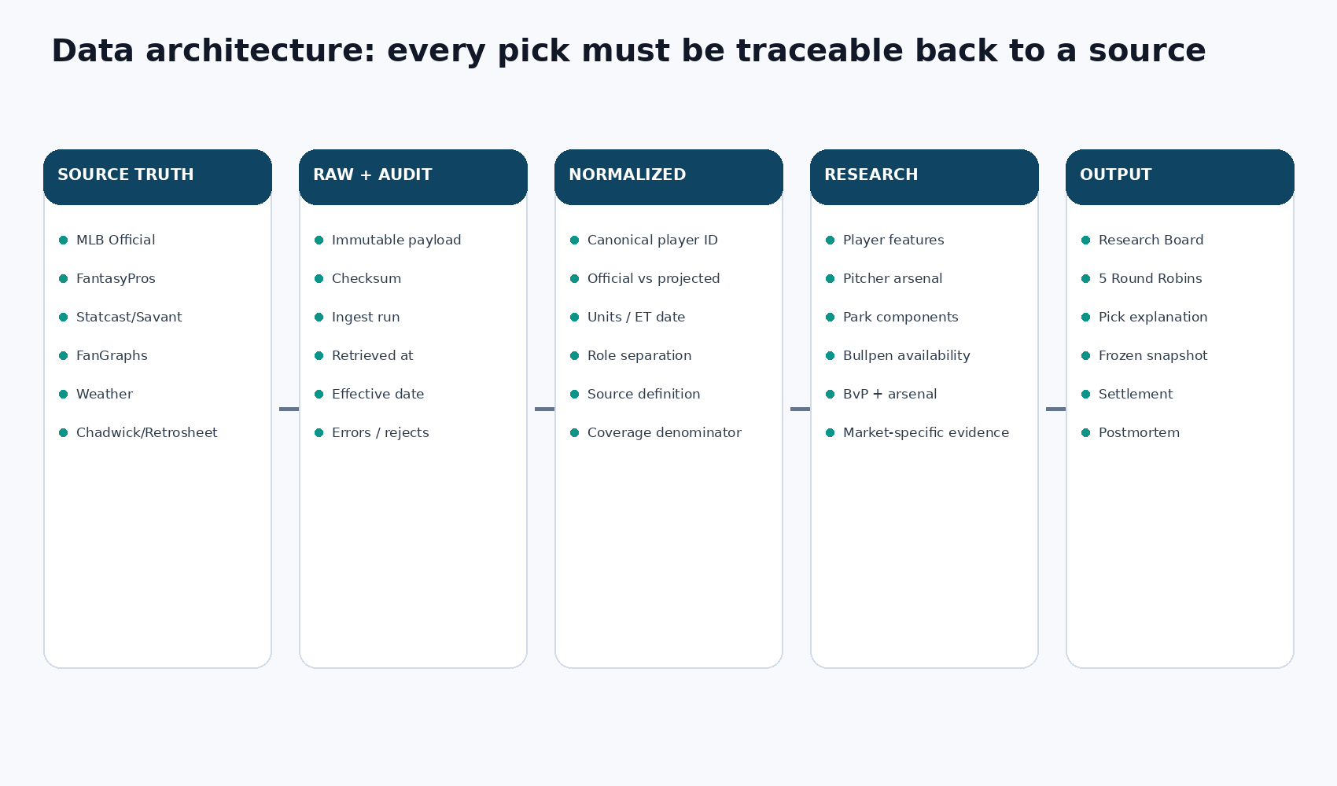
Figure 7. Source-to-output architecture. Every displayed pick must remain traceable to raw evidence and an ingest run.

6.1 Source ownership
Field family | Primary owner | Cross-check / fallback | Rule
Official game/schedule | MLB Stats API | MLB wrappers | Third-party schedule never overrides official state.
Official starter/lineup | MLB official feed | FantasyPros/projected lineup only as evidence | Projected remains PROJECTED until official.
Forward projections | FantasyPros API | Our historical models later | Store every snapshot, never overwrite.
Pitch-level skill | Baseball Savant / Statcast | pybaseball/baseballr wrappers | Raw pitch-level evidence preserved.
Season/split/discipline | FanGraphs | Statcast-derived fallback where definitions allow | Definition differences must remain explicit.
Park components | Baseball Savant Statcast Park Factors | Other sources as cross-check | Store hits, 1B, 2B, 3B, HR independently by side/year range.
Identity | MLBAM + Chadwick Register | Team/position/date corroboration | No name-only finalization.
Historical PBP | Retrosheet/Chadwick | MLB official overlapping samples | Reconcile overlapping games before trusting backfill.
Bullpen availability | Official appearances + manager/club statements | Beat report/manual override later | Manager statement outranks heuristic.
Weather | Approved weather provider | Park roof/official club info | Direction relative to home plate required for wind.

6.2 Identity contract
- Every human gets one internal canonical player_id.
- External IDs are mapped for MLBAM, FantasyPros, FanGraphs, Retrosheet and Baseball-Reference where available.
- Name normalization can propose a candidate but may not finalize a match without corroborating evidence.
- Accents, suffixes, punctuation and abbreviations are normalized for search while preserving the canonical display name.
- Low-confidence matches create Data Health review issues instead of silently attaching metrics.
- Historical or stale source rows are quarantined from current research but never deleted from raw audit history.

6.3 Provenance model
Label | Meaning | Example
VERIFIED | Checked today against a named authoritative source/current stored record. | Official lineup slot, Statcast pitch count, park factor row.
SOURCED | Traceable source logic exists but the specific value is carried forward or not independently re-checked today. | Historical baseline imported from a dated source snapshot.
INFERENCE | Reasoning rather than direct measurement. | Likely bullpen sequence, qualitative command deterioration.
DERIVED | Computed deterministically from source fields. | XBH = 2B + 3B + HR.
HEURISTIC | A deliberate rule/formula that is not validated as a probability. | TB park composite using hits/doubles/HR weights.
NOT FOUND | No reliable value exists. | Missing roof status or pitch-side split.

6.4 Point-in-time rule
Every feature used in a pregame decision must carry an as-of timestamp and remain queryable later. Historical evaluation must read only evidence that existed before the simulated first pitch. This is the core anti-hindsight guarantee. The platform should freeze a complete snapshot whenever the research board is generated and again at final lock if the state materially changed.

Part 7. Player, Pitcher, Park and Bullpen Research Foundation

7.1 Player feature snapshots
Feature rows should be long-form or otherwise versionable by player, metric, window, side and as-of date. The same value should not be overwritten when a new day arrives. At minimum support season, career where practical, and rolling 7/14/30/60-day windows with the denominator behind every rate.

7.2 Pitcher role separation
Starter and reliever samples must remain separate where a pitcher has changed roles. A swingman should not silently carry one blended profile into the starter matchup or bullpen path. Role is part of the feature key.

7.3 Park factors
Store component factors independently. Total Bases and XBH require different interpretations of the same park. The existing TB composite can remain as a labeled HEURISTIC: 0.45 times hits factor + 0.30 times doubles factor + 0.25 times HR factor, divided by 100. XBH must not inherit that formula. Its raw doubles, triples and HR components remain separate until historical testing supports a weighting.

7.4 Bullpen state
Entity | Required fields
Reliever profile | Canonical ID, team, throws, current roster state, role, role effective date, season/current metrics, arsenal.
Appearance log | Game/date/opponent, inning entered, outs, pitches, BF, hits, BB, K, runs, leverage if available. Append only.
Availability observation | D-1/D-2/D-3 pitch counts, consecutive days, multi-inning, days rest, heuristic state, manager override, final state, freshness.
Role event | Closer/setup promotions/demotions, call-up, option, IL, trade, opener/swing usage. Append only.
Leverage map | Projected 9th, 8th, 7th, leverage lefty, long man, high-walk available arm, low-walk available arm, uncertainty.

Bullpen rule
Team bullpen ERA is not the main feature. Later market engines must compute bullpen context from the arms who are actually likely to be available and likely to face the hitter.

Part 8. BvP Master Class: Batter vs Pitcher, Taught Correctly
BvP means Batter versus Pitcher history: the outcomes from plate appearances where this exact hitter faced this exact pitcher. It is seductive because it feels specific. A .400 BvP batting average looks more matchup-specific than a season line. The problem is that specificity and reliability are not the same thing. Most BvP samples are tiny, spread across multiple years and often produced by older versions of both players.
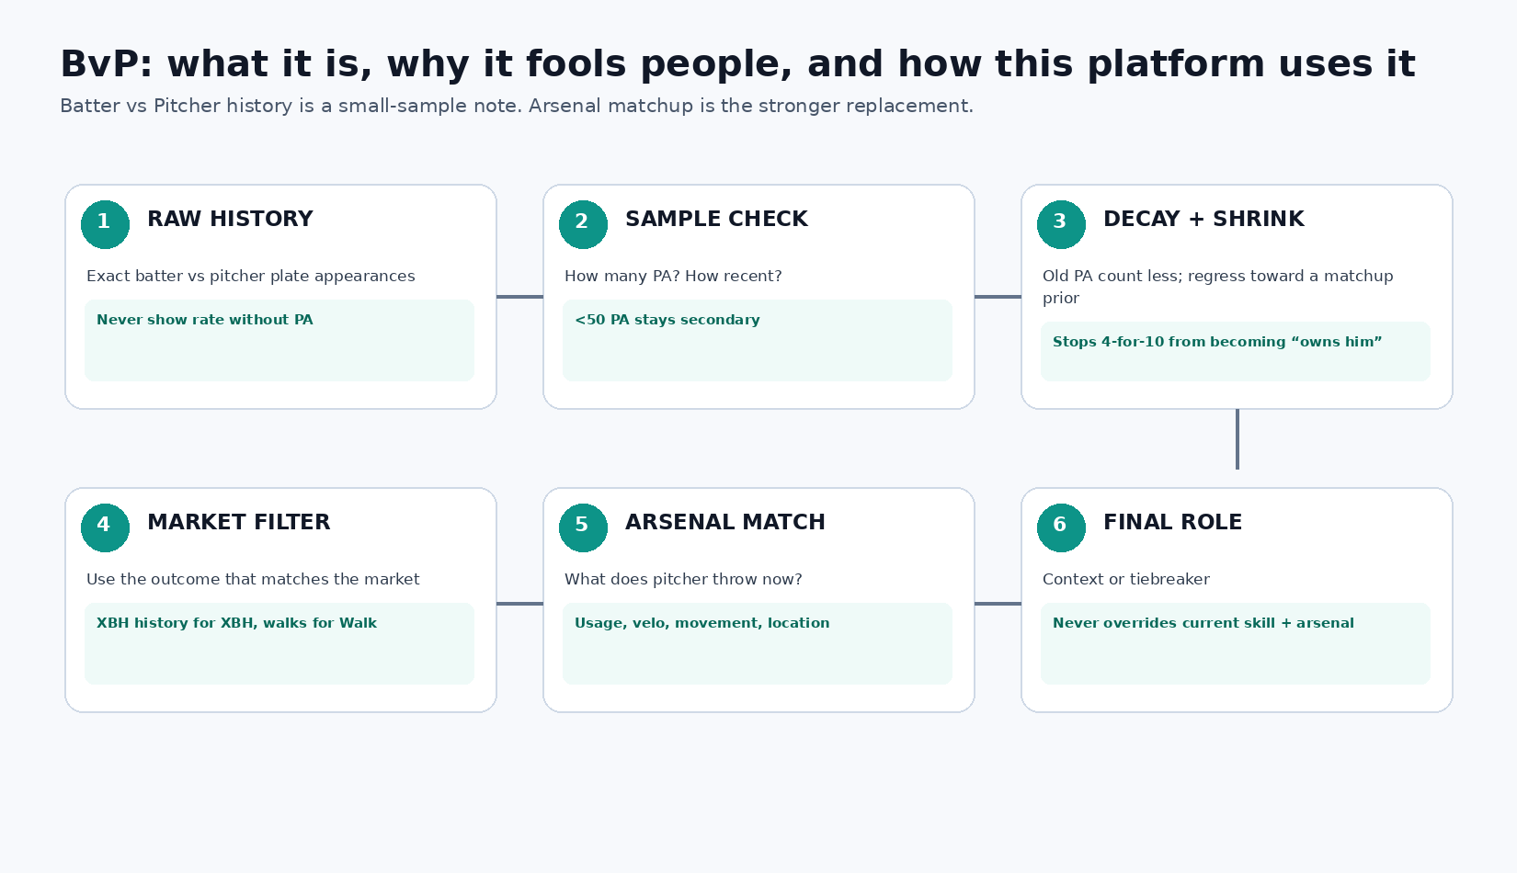
Figure 8. Correct BvP pipeline. Raw head-to-head history is processed through sample size, recency, shrinkage and market relevance before it is allowed to influence a decision.

8.1 What raw BvP answers
Raw BvP answers only this question: what happened in the recorded plate appearances between this hitter and this pitcher? It does not directly answer what should happen tonight. To make that second claim, the analyst must account for sample size, recency, handedness, pitcher evolution, velocity changes, pitch-mix changes, injury history, park, lineup opportunity and current hitter skill.

8.2 Why small samples mislead
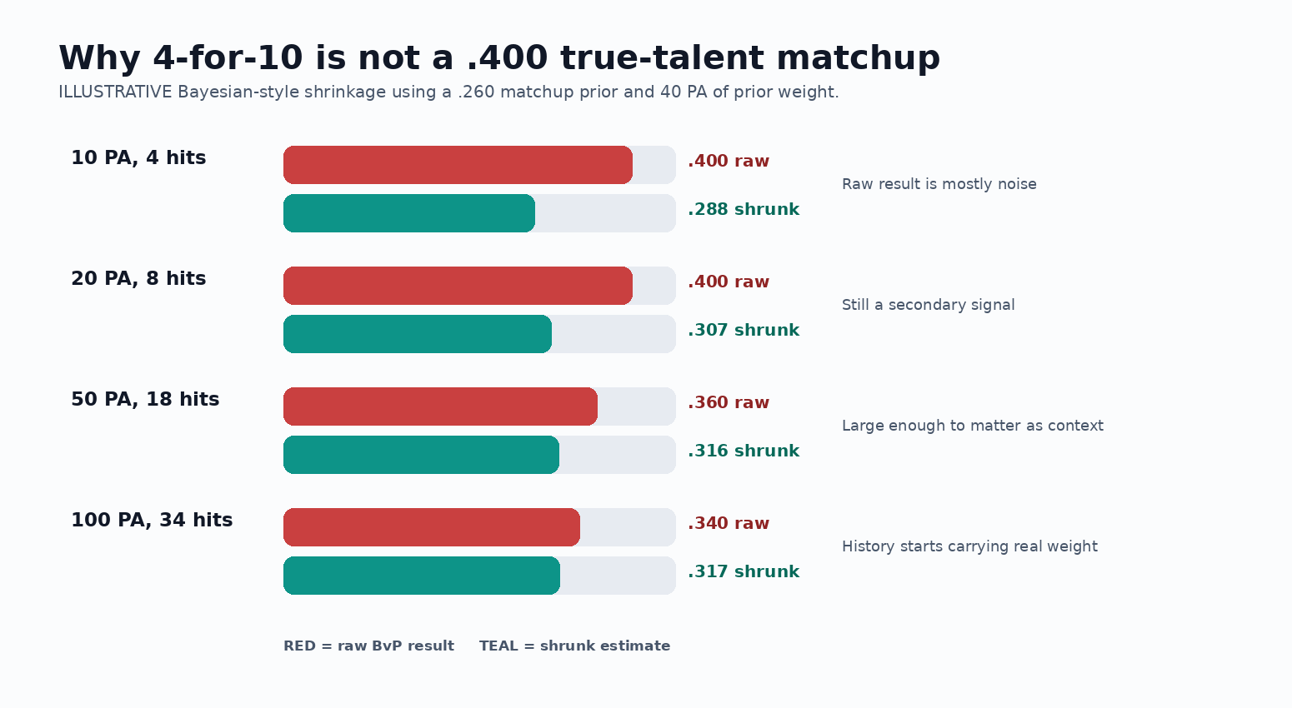
Figure 9. ILLUSTRATIVE shrinkage. A raw 4-for-10 BvP line should move the prior only slightly, not become a .400 “true matchup” claim.
An illustrative shrinkage formula is: shrunk_rate = (observed_successes + k x prior_rate) / (observed_PA + k). The prior should be matchup-aware rather than a generic league average. The parameter k represents how much prior information is required before tiny BvP samples meaningfully move the estimate. The exact k must be estimated historically, not picked because it looks good on one slate.

8.3 Practical BvP interpretation ladder
Raw PA | Current platform treatment | What the UI should do
0-9 | Anecdote only. No promotion or fade. | Grey, sample shown, no heatmap color.
10-24 | Weak context only. | Show result distribution and dates; cannot override current/arsenal evidence.
25-49 | Secondary/tiebreaker evidence at most. | Apply shrinkage and recency decay, show effective sample.
50+ | Can matter as context if still representative of current player/pitcher versions. | Still loses to strong current-season + arsenal evidence when they disagree.

Important change from the Claude proposal
Do not hard-fade a hitter simply because he is below .150 in 10+ BvP PA. That is too aggressive under the current project doctrine. Keep the idea as a historical experiment. If a pre-registered backtest later proves that a narrow bad-BvP rule improves out-of-sample ranking, then it can be promoted as a versioned rule.

8.4 BvP must be market-specific
Market | BvP field that matters | Allowed role
2+ TB | Total bases / extra-base outcomes, not just batting average. | Tiebreaker/context only. Current contact/power, pitcher contact/K and arsenal outrank it.
1+ XBH | 2B/3B/HR outcomes and quality of contact. | Low-weight context. Tiny XBH samples are even noisier.
Walk | Walks, counts, swing decisions and approach. | Context only; the primary evidence is hitter discipline vs current pitcher command.
HR | HR events and pitch location/type that produced them. | Mostly descriptive. No “due” logic and no promotion on tiny HR history.
2+ H+R+RBI | Hits/on-base context may matter, but lineup/teammate environment dominates. | Secondary context for the RR3 companion.

8.5 Arsenal matchup is the better replacement
What people really want from BvP is an answer to “does this hitter handle what this pitcher throws?” Arsenal matchup can answer that using far more observations. Build the pitcher’s current pitch mix by type, velocity, movement and location. Build the hitter’s results against those pitch families and velocity/movement bands. Then usage-weight the hitter’s performance against the pitcher’s actual current mix. This should carry much more weight than a handful of historical head-to-head plate appearances.
- Pitcher current usage share by pitch type and batter side.
- Pitcher velocity and movement trends, not only season averages.
- Hitter xSLG/wOBA/whiff/hard-hit/barrels by pitch type.
- Fastball velocity bands and breaking-ball movement families where data supports them.
- Location vulnerability: heart, shadow, chase and middle-middle frequency.
- Sample denominator per component, with insufficient-sample flags.
- Current-season and rolling-window versions so a newly added pitch can change the matchup immediately.

8.6 BvP interface
- Never render a BvP rate without raw PA and date range in the same visual group.
- Show raw and shrunk values side by side when shrinkage is active.
- Show effective sample after recency decay.
- Display terminal plate-appearance outcomes in a drilldown, not just one rate.
- Show how the pitcher’s current arsenal differs from the years that produced the BvP history.
- If current arsenal materially changed, place a warning beside the BvP result.
- Never color tiny positive BvP samples bright green. That design teaches the analyst to overweight noise.

Part 9. Independent Market Research Engines
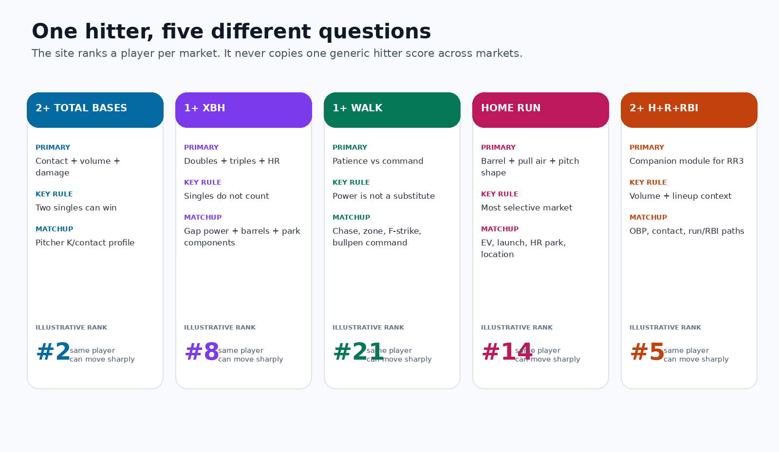
Figure 10. The same hitter can legitimately rank very differently across TB, XBH, Walk, HR and the RR3 companion module.

9.1 Shared candidate contract
Field group | Required values
Identity | Slate date, game ID, player ID, team, opponent, lineup slot/state.
Research | Market, research rank, primary mechanism, secondary mechanism, counter-evidence.
Opponent | Starter, side split, arsenal matchup, expected duration.
Bullpen | Expected relief path, availability coverage, market-specific bullpen evidence.
Environment | Park components, roof/weather state, data freshness.
Context | Recent/season/career baseline with denominators.
Quality | Provenance, source timestamps, missing/stale evidence, research state.

9.2 2+ Total Bases engine
TB is a two-route market. A hitter can clear with one power event or with multiple hits. The engine therefore needs separate contact-volume and damage contributions instead of assuming that the biggest slugger is always the best TB player.
- Lineup slot and expected plate appearances.
- Contact%, K%, BIP, xBA and hit-related proxies.
- SLG/xSLG/ISO, doubles, barrels and hard contact.
- Pitcher xSLG allowed by batter side, K/contact profile and pitch mix.
- Starter expected duration and bullpen contact path.
- TB park heuristic as context only.
- Counter-evidence: elite pitcher whiff/K, low PA, platoon removal risk, strong available relief path.

9.3 1+ Extra Base Hit engine
XBH is not HR-lite and not TB. A doubles-heavy hitter can be an elite XBH candidate without being a top HR hitter, and two singles do nothing for this market.
- 2B/PA, 3B/PA, HR/PA, XBH/PA and XBH share of hits.
- Line-drive and deep-line-drive profile.
- Hard-hit, 90th EV, barrels, sweet spot and launch distribution.
- Directional damage and gap profile.
- Sprint speed where triples matter.
- Pitcher XBH/BF and XBH/BIP by side.
- Doubles, triples and HR park factors independently.
- Route label: DOUBLE_ROUTE, TRIPLE_ROUTE, HOME_RUN_ROUTE, MULTI_PATH.

9.4 Batter Walk engine
Walks require both halves: a hitter who will take a ball and a pitcher who is likely to create bad counts or miss the zone. BB/9 alone finds only half the condition.
- Hitter BB/uBB, chase, zone swing, first-pitch swing, pitches/PA.
- Pitcher BB/uBB, Zone%, first-pitch strike, chase generated, pitches/BF.
- Side splits for both hitter and pitcher.
- Starter workload and available bullpen command profile.
- Umpire when a reliable source is configured.
- Counter-evidence: aggressive hitter, high chase, pitcher with strong zone/F-strike and low walk path.

9.5 Home Run engine
The HR engine should be the most selective board. It needs supported power, not streaks. High HR/FB without barrel and EV support is a regression warning, not an automatic signal.
- Barrels per PA, rolling barrels, 90th EV and max EV.
- Pull-air and pulled-fly-ball rates.
- Launch-angle distribution and supported HR/FB.
- Pitcher barrel, hard-hit, fly-ball, HR/BF and side splits.
- Pitch-type and location vulnerability.
- HR park factor and wind direction when configured.
- Available bullpen HR path.

9.6 Ranking, not fake gates
Research engines rank continuous evidence. A hitter at .428 SLG is not categorically different from .432. Hard thresholds are reserved for data validity and hard product constraints, such as a player not being in the lineup. Baseball features should generally contribute smoothly to a rank or model.

Part 10. 2+ H+R+RBI Companion Module for RR3
The user’s new RR3 requires a companion market that is not one of the four core engines. The platform should add a dedicated 2+ H+R+RBI research module used initially only for RR3. It must be independently researched rather than reusing the XBH anchor rank.

10.1 Settlement
Outcome = Hits + Runs + RBIs >= 2. A single plus a run scored clears. A solo home run produces one hit, one run and one RBI, so it clears comfortably. A walk by itself does not add a hit but can later contribute if the player scores a run.

10.2 Best companion profile
- Lineup spots 1-4 strongly preferred because the market is volume/context dependent.
- OBP and contact matter more than isolated power alone.
- Strong team offensive context and hitters behind/ahead create run/RBI paths.
- Expected PA matters heavily.
- Platoon and pinch-hit removal risk matter.
- In RR3, lineup geometry relative to the XBH anchor becomes part of the pair mechanism.

10.3 What not to do
- Do not assume the best XBH hitter is also the best H+R+RBI companion.
- Do not treat H+R+RBI as a power-only market.
- Do not reuse the Total Bases score.
- Do not promote this module to a fifth full market across the entire app until the user explicitly chooses to do so.

Part 11. The Five Round Robin Boards
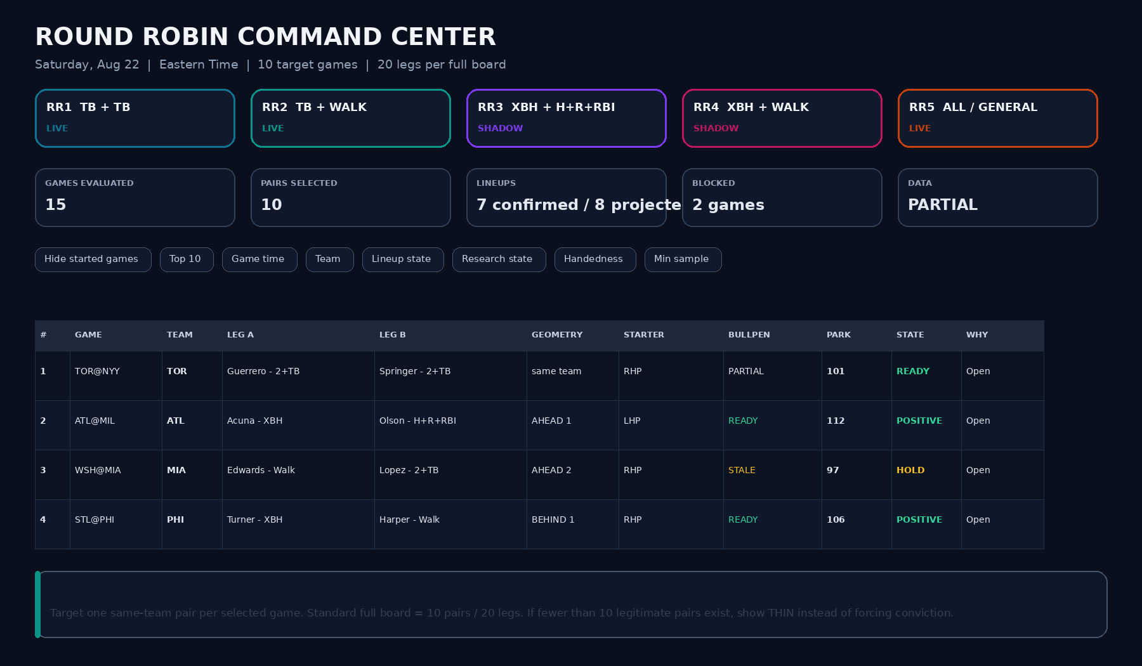
Figure 11. Proposed five-tab Round Robin command center. Standard full board = 10 selected games, one pair per game, 20 legs.
The Round Robin workspace is one page with five board tabs. Each tab is a separate construction. The research board can cover every MLB game, but a full Round Robin board targets ten games and selects at most one pair from any game. If the slate has more than ten games, the board selects the ten strongest legal pairs. If fewer than ten pairs are legitimate, it shows THIN and does not manufacture conviction.
Board | Leg A | Leg B | Same-team rule | Geometry
RR1 | 2+ Total Bases | 2+ Total Bases | Yes, different players | Not a primary driver.
RR2 | 2+ Total Bases | 1+ Walk | Yes, different players | Prefer walker ahead of TB anchor.
RR3 | 1+ XBH | 2+ H+R+RBI | Yes, different players | Both ahead and behind can create a direct companion path.
RR4 | 1+ XBH | 1+ Walk | Yes, different players | Prefer walker ahead; shared command-collapse mechanism.
RR5 | Best legal construction from RR1-RR4 | Best legal companion | Yes, different players | Uses the geometry rules of the selected construction.

11.1 RR1 - 2+ TB + 2+ TB
Select the two strongest same-team TB candidates for the game after TB-specific research. They share pitcher, park, bullpen and general game context, but one hitter’s TB success does not mechanically create TB for the other. This board should therefore be described as shared-context, not magically correlated.

11.2 RR2 - 2+ TB + Walk
Select the TB anchor with the TB engine and the walk companion with the Walk engine. Do not let the same player occupy both legs. When two walk candidates are close, prefer the one batting ahead of the TB anchor because his walk can occur before the anchor’s plate appearance and can extend the inning.

11.3 RR3 - XBH + H+R+RBI
This is the strongest structural argument from the Claude document and is worth keeping. If the H+R+RBI companion bats ahead, he can reach base and score on the XBH anchor’s damage. If he bats behind, the XBH anchor can reach scoring position and the companion can generate an RBI with a hit. The link is still not guaranteed, but it is mechanically clearer than RR1.

11.4 RR4 - XBH + Walk
This pair expresses two symptoms of pitching vulnerability: command loss can create walks, and mistakes in the zone can create extra-base damage. The legs are not mechanically linked like RR3, so the shared-cause argument must be explicit. Walker-ahead geometry is preferred when alternatives are close.

11.5 RR5 - All / General
RR5 asks a different question: what is the strongest two-leg construction in each game, regardless of which of the first four board types produced it? The app enumerates legal RR1-RR4 pairs, compares their research strength and data quality, and selects one construction per selected game. RR5 should display the chosen pair type on every row so the user can see whether a game’s best construction is TB+TB, TB+Walk, XBH+H+R+RBI or XBH+Walk.
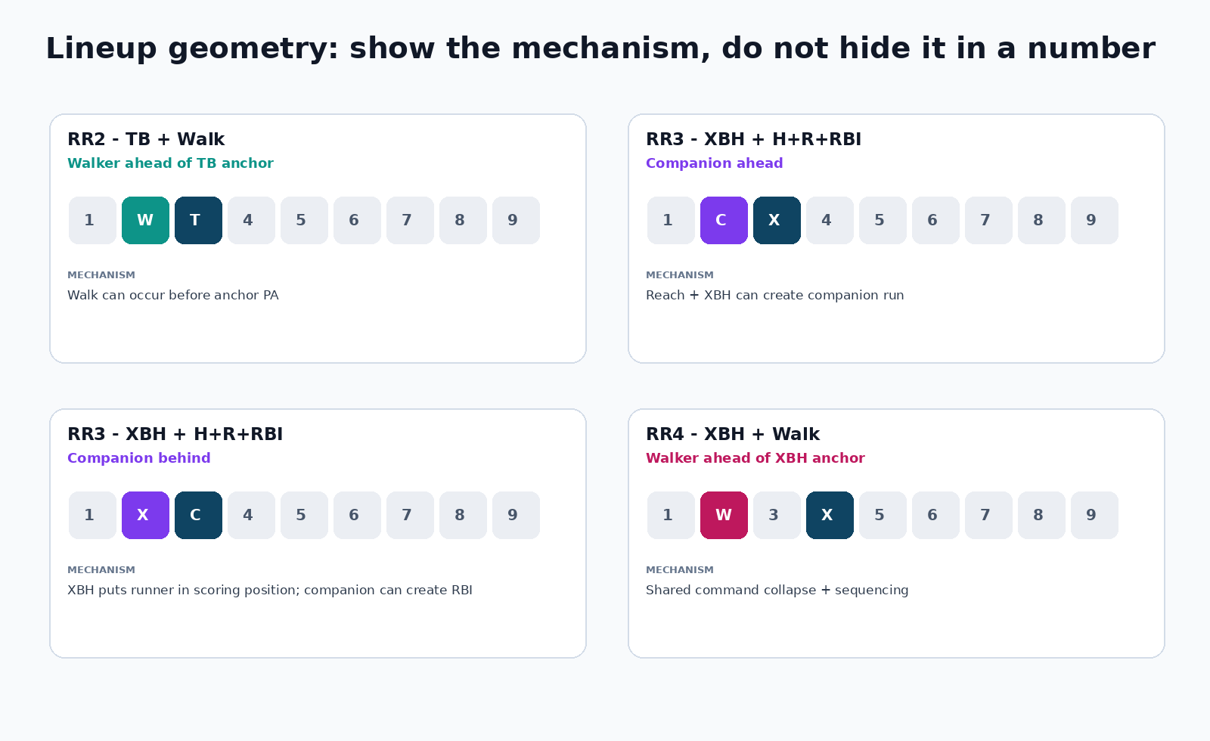
Figure 12. Geometry should be drawn in lineup slots. The user should not have to mentally decode “distance 2, behind.”

11.6 Pair selection pipeline
- Generate all research-eligible hitters for every game, not only favorites.
- Generate market-specific ranks independently for each leg market.
- Enumerate same-team, different-player legal pairings for the board.
- Attach official/probable starter state, lineup state, park, weather and bullpen coverage.
- Apply only hard eligibility rules: identity, not scratched, correct team/game, required data state, distinct players.
- Compute geometry fields when the board uses sequencing.
- Create pair-level primary mechanism and counter-case.
- Rank legal pairs within each game.
- Select at most one pair per game per board.
- If more than 10 games are available, select the 10 strongest game-level pairs for the board. If fewer, mark THIN.
- Freeze the board snapshot and keep excluded pairs with rejection reasons for later evaluation.

11.7 What every Round Robin row shows
Column | Required content
Rank | Board rank. Recomputed under current filters.
Game | Teams, first pitch ET, venue, game state.
Team | The offense both legs belong to.
Leg A | Player, market, lineup spot, research rank/state.
Leg B | Player, market, lineup spot, research rank/state.
Geometry | Ahead/behind, distance, mini lineup graphic where relevant.
Starter | Name, hand, state, expected duration.
Bullpen | Path freshness and market-specific relief note.
Park | Relevant components, 100=neutral, side/year range.
Research state | Strong/Positive/Neutral/Negative/Blocked until prediction statuses exist.
Why | Opens side-by-side leg cases, shared mechanism, counter-case and provenance.

11.8 User controls
- Date in ET and visible effective date.
- Top 5 / 10 / All.
- Hide started games.
- Specific game chips and time windows.
- Team, batter handedness, starter handedness, lineup state and research state.
- Minimum sample / provenance floor.
- Search player/team.
- Show excluded games and rejection reason.
- Desktop dense table plus mobile pair cards.

Part 12. Round Robin Structure Math Without Price Dependence
Even without sportsbook price, the site should teach the user how concentration works. For n selected pairs and combination size k, the number of tickets is C(n,k). Any one pair appears in C(n-1,k-1) tickets, so a weak pair can dominate a short board. This is a structural property and does not require odds.
Pairs n | Tickets at k=4 | Tickets containing one pair | Single-pair concentration
5 | 5 | 4 | 80.0%
6 | 15 | 10 | 66.7%
7 | 35 | 20 | 57.1%
8 | 70 | 35 | 50.0%
9 | 126 | 56 | 44.4%
10 | 210 | 84 | 40.0%

12.1 Winning-ticket survival table at n=10, k=4
Winning pairs w | Winning 4-pair tickets C(w,4)
0 | 0
1 | 0
2 | 0
3 | 0
4 | 1
5 | 5
6 | 15
7 | 35
8 | 70
9 | 126
10 | 210

This is the right price-free way to think about Round Robin performance. The platform can grade how many pairs won and therefore how many combinations survived, without claiming anything about return or value. New board types can be compared on pair hit rate, ticket survival and concentration before any price layer is considered.

12.2 Do not force ten pairs
The user’s standard board target is 10 games and 20 legs. That is a target, not permission to invent a pair. If only seven games have legitimate same-team pair constructions after current data, the board should say 7 pairs, THIN, and show why the other games were excluded. Forced coverage is exactly how confidence gets manufactured.

Part 13. Historical Settlement, Postmortems and Anti-Hindsight

13.1 Freeze before first pitch
Every research row, selected pair and board state must reference a frozen pregame snapshot. A later lineup change produces a new snapshot rather than mutating the old one. The historical question is not “what do we know now about that player?” It is “what did we know when we made the decision?”

13.2 Settlement definitions
Outcome | Settlement
2+ TB | 1B + 2x2B + 3x3B + 4xHR >= 2. Walks and HBP add zero TB.
1+ XBH | 2B + 3B + HR >= 1. Singles do not count.
1+ Walk | Grade the platform’s stored qualifying walk definition; preserve IBB separately when available.
Home Run | HR >= 1.
2+ H+R+RBI | H + R + RBI >= 2.
Round Robin pair | Both legs win. Void/push handling follows the stored settlement rule and must be explicit.

13.3 Miss classification
Class | Definition | Example
DATA FAILURE | The evidence fed to the research was wrong/stale/misidentified. | Wrong starter, stale lineup, player identity collision.
OPPORTUNITY FAILURE | The process projected enough opportunity but it did not materialize. | Late scratch, early pinch-hit removal, starter leaves earlier/later than expected.
PROBABILITY FAILURE | The research/model materially overrated the outcome given accurate data. | Top-ranked XBH player repeatedly lacks enough quality contact in similar spots.
NORMAL VARIANCE | The process and probability were reasonable but the event did not happen. | Hard line drive caught; strong walk profile gets three first-pitch strikes.
WON, BAD PROCESS | The pick hit despite weak or incorrect reasoning. | A player hits HR after being selected only because he was “due.”
LOST, CORRECT PROCESS | The pick lost but the pregame evidence and uncertainty were handled correctly. | Strong contact path with normal variance.

13.4 Grade the things we rejected
The rejected-leg shadow portfolio is one of the highest-value ideas in the Claude proposal. If a gate removes a candidate, keep and settle the row. Otherwise the platform can never discover that a gate removes more winners than losers. The same rule applies to PASS games, ungated candidates and new RR3/RR4/RR5 constructions.

Part 14. Model Validation, Calibration and Activation
The site should not ask users to trust our picks because they are ours. It should show that the ranking separates outcomes better than simpler alternatives. The modeling phase is therefore a validation program, not a one-time training job.

14.1 Targets
- Separate binary targets for TB>=2, XBH>=1, Walk>=1 and HR>=1.
- Separate H+R+RBI>=2 companion model only if RR3 needs a probability after research validation.
- Pair-level joint targets per Round Robin board for later joint-model testing.

14.2 Walk-forward validation
Train on earlier periods, test on later periods, roll forward and report each season/window separately. Do not randomly shuffle games across time. Any hyperparameter choice or feature selection must be made inside the training/inner validation window, then judged on an untouched outer period.

14.3 Activation standards
Requirement | Why
Outperforms simple baseline rank | A complex model that cannot beat SLG/BB/HR baseline ordering does not deserve production.
Stable across multiple time windows | One hot month is not a model.
Calibration acceptable by bucket | A well-ranked but overconfident model needs calibration, not more features.
Brier/log loss not degraded | Protects against confident error.
Top-N lift positive | The part users actually consume must beat the eligible pool.
No identity/lineup leakage | Backtests must not use information unavailable pregame.
Ablation understood | Know whether a feature family adds signal or merely decorates the model.
Version frozen | Every live prediction references a model version and feature schema.

14.4 Prediction status after validation
Only after the model phase passes should FIRE, HALF, HOLD, PASS and PARKED become active. They describe prediction confidence and research completeness, not price value. A FIRE pick still needs a named mechanism, counter-case, data-quality state and frozen probability/model version.

14.5 Why users should follow our picks
The strongest reason is not that the model has a clever feature. It is that the system can show a repeatable record: top-ranked candidates outperform lower-ranked candidates, stated probabilities calibrate to observed outcomes, lineup and bullpen information is current, market-specific mechanisms are distinct, and every miss remains visible. That is the trust product.

Part 15. GitHub and Open-Source Integration Plan
The user does not need to manually download public repositories. Replit should fetch or inspect public repositories itself, pin commit/version information and record license/terms before code or datasets enter the production path. The user only needs to send private repositories, private custom logic, paid data exports or credentials that cannot be discovered publicly.

15.1 Production/core candidates

Repository | License / terms | What we need | Recommendation
jldbc/pybaseball | MIT | Statcast, Savant, FanGraphs/BRef retrieval and custom date windows. | Use as retrieval/helper dependency with caching. Validate upstream field changes.
toddrob99/MLB-StatsAPI | GPL-3.0 | Schedule, rosters, probables, game feeds, box scores. | Prefer API/package use rather than copying GPL code into proprietary modules.
chadwickbureau/register | ODC-By 1.0 data | Identity crosswalk across MLBAM/FanGraphs/BRef/Retrosheet. | High-value identity source. Snapshot periodically and attribute.
chadwickbureau/retrosheet | Retrosheet terms | Historical play-by-play/event files. | Core historical source. Preserve Retrosheet attribution/terms.
chadwickbureau/retrosplits | ODbL 1.0 + Database Contents License | Historical day-by-day and split datasets. | Useful for long-run splits/backfill. Respect share-alike/database terms.
BillPetti/baseballr | License needs recorded from repository/CRAN before vendoring | Cross-check Savant/FanGraphs/MLB endpoints and methods. | Reference and cross-check because primary serving stack is Python.
sportsdataverse/baseballr-data | MIT | Published MLB model/data assets and Statcast data pipeline patterns. | Evaluate data freshness/definitions before ingest.
jmaslek/statcast-lab | MIT | Arsenal, platoon, batted-ball, park factor feature engineering and UI ideas. | High-value reference. Reproduce formulas with tests rather than blindly copy.
power-edge/pymlb_statsapi | MIT | Schema-driven MLB Stats API wrapper and parameter validation. | Good fallback/typed contract reference.
zero-sum-seattle/python-mlb-statsapi | MIT code; repo notes educational/non-commercial context | Pydantic MLB API models and error/retry patterns. | Reference typing and validation; review stated use restrictions before dependency choice.

15.2 Model and architecture references
Repository | Use | Status
randodgers/hr-forecast | Weather relative to park orientation, HR research pipeline, grading ideas | REFERENCE
AustinRyan/hr-predictor | Postgres/FastAPI/Next architecture, model registry/calibration patterns | REFERENCE
SJTreadway/mlb_py | Rolling-window HR features and calibration ideas | REFERENCE
KatyushaDashboard/katyushaMLB | Source priority, caching and ingestion patterns | REFERENCE
Volodymyr4K/market-efficiency-lab | Walk-forward evaluation discipline and null-result honesty | REFERENCE
hedgertronic/fungo | Multi-source retrieval helper ideas | EVALUATE, do not depend on fragile FanGraphs scraping
gstoke8/mlb-props | Prop model automation/settlement ideas | REFERENCE ONLY; remove price/CLV logic from core
ArnavSaraogi/mlb-odds-scraper | Historical odds capture | OUT OF CORE under current no-price rule

15.3 What Replit should do automatically
- Clone or inspect public repos in a disposable/reference workspace rather than blindly merging them into production.
- Record repository URL, commit SHA/tag, license, relevant modules, accepted idea, rejected idea and any copied code.
- Prefer dependency installation or formula reimplementation over copy/paste when licensing is complex.
- Create local regression fixtures so upstream scrapers changing tomorrow cannot silently change historical behavior.
- Vendor datasets only when terms permit and always attach source version, snapshot date and attribution.
- Never ask the user to upload public documentation or sample responses before attempting retrieval itself.

15.4 What the user may need to provide
- FantasyPros API key through Replit Secrets only, never in chat or a document.
- Any private GitHub repositories containing custom logic.
- Paid or private data exports not accessible through public endpoints.
- The current bullpen ledger during migration/reconciliation.
- Historical private cards/workbooks if we want them imported into the learning database.
- Book-specific settlement rules only if the user wants exact settlement behavior for a market; no price data is required.
Do not send secrets
No .env files, API keys, passwords, session tokens or credentials belong in the handoff document or repository. Replit Secrets owns credentials.

Part 16. Bettor Intelligence and AI Analyst

16.1 Bettor Intelligence is still part of the product
The August audit correctly said unfinished future pages should not look production-ready, but Bettor Intelligence should not be permanently removed. The current project roadmap explicitly includes it as a later phase. Until built, place it under Planned/Preview. Once active, it should measure outside researchers by the accuracy of their player/market reasoning, not by popularity or copied consensus.
Store for each external pick | Purpose
Source / bettor / timestamp | Who said it and when.
Player / game / market | What outcome they selected.
Stated reason / mechanism | What they believed would cause the outcome.
Source URL / evidence | Traceability.
Duplication lineage | Five sites copying one original post count as one opinion.
Result | Did the outcome hit.
Mechanism result | Was the reason itself supported even if the result differed.
Our pregame view | Did the outside opinion add information beyond our system.

16.2 AI Analyst
The AI should be a research workstation with read-only access to trusted internal state plus live web research. It can challenge a pick, explain why two markets rank the same hitter differently, compare our research with outside bettors, investigate an injury or beat report and summarize what changed. It cannot rewrite frozen predictions, source records, settlements, historical model versions or official MLB state.
- Every AI claim is labeled VERIFIED, SOURCED, INFERENCE or NOT FOUND.
- Every external claim names the source and retrieval time.
- AI may recommend research focus, but the deterministic ingestion and settlement paths do not depend on the LLM.
- AI must be able to say the current data is insufficient instead of filling a hole with narrative.
- When asked “why this pick?”, the AI leads with the market-specific mechanism and counter-case, not with a generic hot-streak story.

Part 17. Daily Operations, Workbook Export and Recovery

17.1 Daily sequence
Time | Job
06:00 | Settle previous day and reconcile official outcomes.
06:30 | Run postmortem classification and update historical performance.
08:00 | Load current slate, MLB official state, FantasyPros snapshots and identities.
08:30 | Refresh Statcast/FanGraphs/park features and current player/pitcher labs.
09:00 | Refresh bullpen usage/roles and availability observations.
09:15 | Build research boards for TB, XBH, Walk, HR and H+R+RBI companion.
09:30 | Build five Round Robin boards using current projected lineups.
Throughout day | Refresh projections, source health and lineup state. Preserve every snapshot.
T-90 per game | Refresh weather/roof and bullpen changes.
T-60 per game | Official lineup scrub. Diff projected vs posted and re-run affected pair geometry.
T-45 per game | Freeze current research snapshot after acknowledged lineup changes.
T-0 | Lock game from further pregame edits and hide started rows by default.
After final | Settle every leg, pair, board and shadow/rejected row.

17.2 Workbook compatibility
The website should not strand the existing Excel workflow. During transition, export the daily record in the established workbook style while adding the new XBH and Round Robin requirements. The database becomes the truth; the workbook becomes a portable daily artifact and fallback.
Sheet | Future content
Picks by Game | All games, market-specific picks/ranks, detailed why, source/data state.
RR1 | TB+TB pairs.
RR2 | TB+Walk pairs with geometry.
RR3 | XBH+H+R+RBI pairs with geometry and mechanism.
RR4 | XBH+Walk pairs with geometry.
RR5 | All/General selected construction by game.
Bullpen | Current availability/roles and stale states.
Source / Audit | What was used, rejected, missing and changed.
Results / Postmortem | Settlement and failure classification.

17.3 Recovery
- All source ingests idempotent.
- Raw payloads retained with checksums.
- Historical snapshots immutable.
- Database backups and recovery runbook before production reliance.
- If one source fails, dependent panels show BLOCKED/PARTIAL, not cached data masquerading as current.
- Excel export can be generated from frozen database state even if the UI is temporarily unavailable.

Part 18. Full Replit Multi-Task Build Plan
This is the sequence to give Replit in Plan Mode. Replit should create individual tasks, dependencies and acceptance checks from this plan before editing code. Multiple tasks can run in parallel only when they do not compete to define canonical state or model semantics.

Phase | Task group | Build | Exit gate
0 | Same-day stabilization | Fix the 19 audit issues, shared ET/date/readiness/status behavior, weather, mobile and API validation. | App can be trusted as a current research tool.
1 | Phase 2A formal closeout | Lock Player/Pitcher/Park/Statcast research acceptance evidence. | Research foundation frozen.
2 | Bullpen foundation | Usage logs, availability, roles, leverage map, reconciliation with ledger. | All 30 teams have usable or explicit STALE/UNKNOWN bullpen state.
3 | Market research engines | TB, XBH, Walk, HR plus H+R+RBI companion. | Distinct rankings and explanations, no probabilities required.
4 | Five Round Robin workspace | RR1-RR5 enumeration, same-team rules, geometry, filters, desktop/mobile UI. | Full 10-game board target with honest THIN state.
5 | Historical store + settlement | Freeze snapshots, settlement engine, postmortem taxonomy, shadow portfolios. | Every row gradeable without hindsight.
6 | Backfill and experiments | Statcast/Retrosheet historical reconstruction, BvP and RR correlation experiments. | Pre-registered questions answered out of sample.
7 | Model validation | Separate models, walk-forward tests, calibration, ablation, activation criteria. | Only validated models become active.
8 | Daily picks/confidence | FIRE/HALF/HOLD/PASS/PARKED, model-vs-research board, explanation cards. | Trusted daily pick surface.
9 | Bettor Intelligence | Outside pick/reason ingestion, dedupe, settlement and signal analysis. | External evidence can be compared without voting.
10 | AI Analyst | Read-only internal tools plus web/file research, challenge/explain workflows. | AI can research but cannot mutate truth.
11 | Automation + exports | Daily job orchestration, workbook/json export, alerts, recovery. | End-to-end daily operation.
12 | Hardening | Performance, caching, permissions, backups, mobile polish, documentation. | Production-quality private application.

18.1 Safe parallel work
- Responsive UI work against frozen API contracts.
- Source documentation and GitHub/license research.
- Regression fixture creation.
- Historical source import in isolated tables.
- Independent market feature exploration after shared feature definitions are frozen.

18.2 Do not parallelize
- Canonical identity rules.
- Settlement definitions.
- Bullpen availability truth.
- Confidence status semantics.
- Model targets/calibration rules.
- Source precedence for the same field.
- Round Robin same-team/geometry rules.

18.3 Representative task breakdown

Task | Name | Priority
T00-01 | Shared status/readiness contract | P0
T00-02 | ET date helper across all pages/APIs | P0
T00-03 | 400 validation and client recovery | P0
T00-04 | Production vs test audit separation | P0
T00-05 | Mobile Player/Pitcher Labs | P0
T00-06 | Weather/roof provider + compact missing state | P0
T00-07 | Bullpen payload slimming | P1
T00-08 | Status/empty-state glossary implementation | P1
T02-01 | Bullpen appearance ingestion | P0
T02-02 | Availability observations and heuristic config | P0
T02-03 | Role event history and leverage map | P1
T02-04 | Ledger import/export parity tests | P1
T03-01 | TB research engine | P0
T03-02 | XBH research engine | P0
T03-03 | Walk research engine | P0
T03-04 | HR research engine | P0
T03-05 | H+R+RBI companion module | P1
T03-06 | Shared explanation/provenance drawer | P1
T03-07 | BvP shrinkage and arsenal matchup module | P1
T04-01 | RR pair schema and board snapshots | P0
T04-02 | RR1 TB+TB | P0
T04-03 | RR2 TB+Walk geometry | P0
T04-04 | RR3 XBH+H+R+RBI geometry | P0
T04-05 | RR4 XBH+Walk geometry | P0
T04-06 | RR5 All/General selector | P0
T04-07 | Round Robin responsive workspace | P1
T04-08 | Round Robin export | P1
T05-01 | Official settlement engine | P0
T05-02 | Frozen pregame snapshots | P0
T05-03 | Failure taxonomy/postmortem UI | P1
T05-04 | Shadow/rejected portfolios | P1
T06-01 | Retrosheet/Chadwick backfill | P1
T06-02 | Point-in-time historical feature reconstruction | P0
T06-03 | BvP experiment | P1
T06-04 | RR3 geometry/joint-lift experiment | P1
T06-05 | Gate rejection cost experiments | P1
T07-01 | TB model | P0
T07-02 | XBH model | P0
T07-03 | Walk model | P0
T07-04 | HR model | P0
T07-05 | Calibration and model registry | P0
T07-06 | Activation/rollback gates | P0
T08-01 | Daily ranking board | P0
T08-02 | Confidence statuses and explanation cards | P0
T08-03 | Game-level summary and changes rail | P1
T09-01 | Bettor source/pick schema | P1
T09-02 | Duplicate lineage | P1
T09-03 | Bettor settlement and signal dashboard | P1
T10-01 | AI read-only tool contracts | P0
T10-02 | Challenge/explain workflows | P1
T10-03 | Web/file source rail | P1
T11-01 | Daily orchestrator | P0
T11-02 | Workbook/json export | P0
T11-03 | Alerts and failed-job recovery | P1
T12-01 | Backups and disaster recovery | P0
T12-02 | Performance/caching | P1
T12-03 | Final mobile/accessibility audit | P1

Part 19. Acceptance Tests and Definition of Done

19.1 Same-day app trust tests
- Current ET date is visible and identical across Today, labs, Research Board and Round Robins.
- Invalid date/player/game inputs return 400 with stable codes.
- No production view says READY while required current data is blocked or stale.
- Started games hide by default.
- Official lineups never get overwritten by projected lineups.
- Mobile Player/Pitcher Lab has no page-level horizontal clipping.
- Weather and park values either have current sourced values or one explicit unavailable state.
- No test fixture appears in production audit history by default.

19.2 Baseball logic tests
- Two singles count as 2 TB.
- Two singles do not count as an XBH.
- XBH = double + triple + HR only.
- Walk engine does not use power as a proxy for discipline.
- A high-K pitcher can suppress TB even when his damage-on-contact is poor.
- Park TB heuristic uses hits/doubles/HR and is labeled HEURISTIC.
- XBH park research preserves 2B/3B/HR components separately.
- BvP below 50 PA cannot automatically promote/fade a hitter.
- Arsenal matchup uses current pitch usage and sample denominators.
- Starter/reliever roles are not silently blended.

19.3 Round Robin tests
- All five tabs exist and use the correct two-leg construction.
- Every pair uses two different players from the same team and same game.
- At most one selected pair per game per board.
- Full target board = 10 pairs / 20 legs; fewer legitimate pairs produce THIN, not forced selections.
- RR2 and RR4 record walker ahead/behind and distance.
- RR3 records both ahead/behind mechanisms and distance.
- RR5 identifies which construction won the per-game comparison.
- Changing filters recomputes board ranks and counts.
- Started games hidden by default.
- Board snapshot freezes pregame state for settlement.

19.4 Model activation tests
- Walk-forward validation, not random train/test shuffle.
- No probability displayed until the active model version passes validation.
- Top-N lift is positive on held-out periods.
- Calibration and Brier/log loss meet pre-registered thresholds.
- Historical query cannot read a future-dated feature.
- Model rollback is possible without rewriting historical predictions.

19.5 Final user-level definition of done
The site is done when a user can open Today, trust the data state, open a game, understand both starting pitchers and the likely bullpen path, inspect a hitter’s market-specific profile and BvP/arsenal context, see the ranked TB/XBH/Walk/HR board, open all five Round Robin tabs, understand why every pair was chosen, freeze the slate, return the next day to see every result and postmortem, and inspect whether the system’s top ranks are actually beating its lower ranks over time. The product should be able to admit “NOT FOUND”, “BLOCKED” and “we were wrong” without losing the thread of the historical record.

Appendix A. Status Glossary
Status | Use
READY | Required current data and workflow checks are complete for the scope.
PARTIAL | Usable research exists but one or more supporting sources/fields are incomplete.
BLOCKED | A required identity/starter/lineup/source condition prevents reliable downstream research.
STALE | Data exists but is older than the accepted threshold.
NOT RUN | The job/source has not been attempted for the effective date.
NOT CONFIGURED | The source/capability is intentionally not configured.
EMPTY | Fetch succeeded but no records exist for the scope.
FILTERED EMPTY | Data exists but the selected filters match no rows.
STRONG/POSITIVE/NEUTRAL/NEGATIVE | Pre-model research states.
FIRE/HALF/HOLD/PASS/PARKED | Future prediction-confidence states after validated models.

Appendix B. Round Robin Combination Reference
n pairs | k=2 | k=3 | k=4 | k=5
5 | 10 | 10 | 5 | 1
6 | 15 | 20 | 15 | 6
7 | 21 | 35 | 35 | 21
8 | 28 | 56 | 70 | 56
9 | 36 | 84 | 126 | 126
10 | 45 | 120 | 210 | 252
11 | 55 | 165 | 330 | 462
12 | 66 | 220 | 495 | 792

Appendix C. BvP Example Calculation
ILLUSTRATIVE only. Prior matchup hit rate = .260. Prior weight k = 40 PA. Raw BvP = 4 hits in 10 PA. Shrunk estimate = (4 + 40 x .260) / (10 + 40) = .288. The raw .400 is not deleted; it is displayed as raw history with 10 PA, while the shrunk value shows how little such a small sample should move the expectation. The exact prior and k must be learned empirically by the later BvP experiment.

Appendix D. What to Send to Replit After This Document Is Approved
Send | Do not send / let Replit self-fetch
This approved v5 build document | Public GitHub repositories. Replit should clone/inspect them itself.
Current audit document and reference screenshots | MLB Stats API public docs/sample responses. Replit can capture fixtures.
Current methodology files | FantasyPros public docs. Replit can access docs and API with the configured secret.
Bullpen ledger/template for migration | API keys, .env files, passwords or tokens.
Private repos/custom scripts if any | Public Chadwick/Retrosheet/pybaseball/baseballr files.
Historical private cards/workbooks if we want full import | Odds/price repositories, unless later explicitly re-added to scope.

Appendix E. External Repository Verification Notes
Repository notes were checked against public GitHub pages on 2026-08-22. Key current facts used in the build plan: pybaseball exposes Statcast, Baseball Reference and FanGraphs retrieval under MIT; MLB-StatsAPI is GPL-3.0 and had release v1.9.0 in 2025; the Chadwick Register is licensed ODC-By 1.0 and updated periodically; retrosplits is ODbL 1.0 plus the Database Contents License; Retrosheet data carries Retrosheet’s own terms; statcast-lab and sportsdataverse/baseballr-data identify MIT licensing. Replit must still record the exact license and commit/tag it actually uses at implementation time.
- https://github.com/jldbc/pybaseball
- https://github.com/toddrob99/MLB-StatsAPI
- https://github.com/chadwickbureau/register
- https://github.com/chadwickbureau/retrosheet
- https://github.com/chadwickbureau/retrosplits
- https://github.com/BillPetti/baseballr
- https://github.com/sportsdataverse/baseballr-data
- https://github.com/jmaslek/statcast-lab
- https://github.com/power-edge/pymlb_statsapi
- https://github.com/zero-sum-seattle/python-mlb-statsapi

Appendix F. Decisions to Review Before We Send This to Replit
- Confirm the standard Round Robin target really is 10 games / 10 pairs / 20 legs even on 15-game slates, with THIN allowed when fewer than 10 legitimate pairs exist.
- Confirm one selected pair per game per board and same-team requirement for all five boards.
- Confirm H+R+RBI remains RR3 companion-only for now.
- Confirm current BvP rule: no automatic hard fade based on small head-to-head history until backtested.
- Choose the weather source and stale threshold.
- Choose the bullpen heuristic thresholds for pitch count/consecutive use, knowing manager overrides must win.
- Decide whether Model Lab, Results and Bettor Intelligence remain visible as PREVIEW before their phases ship.
- Decide whether the final production design remains dark or moves toward the lighter operator style recommended by the audit. Functionality is independent of theme.
- Confirm workbook export gains RR3, RR4 and RR5 sheets while retaining current reproducibility.

