**ARDUINO BASED WEARABLE HEARTRATE MONITOR WITH AROMATHERAPY DIFFUSER**



A Master’s Thesis Presented to the Faculty of the Graduate School St. Michael’s College Iligan City

By:

Canny N. Cañete

Joshue G. Cabalida

January 2021

**Chapter I**

**THE PROBLEM AND ITS SETTING**

* 1. **Introduction**

Heart rate is the number of heartbeat within a given time. Usually heart rate is measured in beats per minute (BPM). Heart rate can be measured by manually counting one's pulse in one minute. However, most people use heart rate monitoring devices for convenience. Keeping track of one’s heart rate gives an idea of their fitness level, heart health and emotional health. High heart rate usually means the person is either exercising or doing an activity that requires the heart to pump more blood; however, a high heart rate even when the person is resting can be a cause of stress, anxiety or an abnormality of a person’s heart rhythm. This study aims to offer a solution for high resting heart rates.

Aromatherapy is an alternative treatment method that uses essential oil vapors from various plants inhaled for health therapy. Aromatherapy works by stimulating smell receptors in the nose, which then send messages through the nervous system to the limbic system which is the part of the brain that deals with emotion. According to a research conducted by Widadi et al. (2020) there are differences in the before and after of one’s heart rate after being treated with aromatherapy which proves that it does indeed affects mood, reduces fatigue and anxiety, and stimulates relaxation.

Oil diffusers will release a fine mist of water to diffuse the oils around the room. The diffuser should be placed near the center of the room to let the oil distribute evenly around the space. The diffuser has a top casing that can be lifted off to reveal the reservoir. Rotating, popping, or even just lifting the top of the diffuser will open it and get access to the internal water tank which should be filled with right amount of water that is around room temperature. A cap directly over the water reservoir should then be unscrewed to be filled with a chosen essential oil. The diffuser can then be plugged to a nearby power source, and be turned on by a button to let it start running.

Wearable heart rate monitor are convenient ways of keeping track of one’s heart rate. Common commercial smart watches also have heart rate monitoring technology installed to them. For this reason, the researcher decided to develop a heart rate monitor that can be worn in the wrist.

The researcher aims to develop an Arduino based heart rate monitor with aromatherapy diffuser to keep a person’s resting heart rate to normal. However, the aromatherapy diffuser will not be portable and will only be limited to a person’s workplace in where stress and anxiety will most likely happen. The wearable Arduino based heartrate monitor will be designed to automatically trigger the aromatherapy diffuser when the monitor receives a set above normal value of the resting heart rate.

**Statement of the Problem**

The researchers found out that the common problem in traditional heart rate monitoring are the following:

* Manual counting of a person’s pulse takes a lot of time and is subject to inaccuracy.
* Heart rate monitors are separate to any kind of high heart rate treatment methods.
* Most employees on the work place have high resting heart rates because of stress.
  1. **Objectives of the Study**

The objective of this study is to design and develop an aromatherapy device with a wearable Arduino based heartrate monitor.

These are the following objectives:

* Design an accurate Arduino based heart rate monitor.
* Integrate a wearable heart rate monitor to an automatic aromatherapy diffuser.
* Monitor a person’s heart rate in an office work place and keep his/her resting heart rate to normal through aromatherapy.
  1. **Scope and Limitation of the Study**

This study focuses on integrating a wearable heart rate monitor to an automatic aromatherapy diffuser. However, the aromatherapy diffuser will not be portable and will only be based on an office workplace and the target users will be office workers. The wearable heart rate monitor will display the wearer’s heart rate every a set amount of time (10 seconds) and sends the data to the aromatherapy diffuser’s automated system. The aromatherapy diffuser is set to receive heart rate readings every 10 seconds. The aromatherapy diffuser will be designed to turn on only when the heart rate monitor is reading above 100 BPM (beats per minute) and is nearby, which means the wearer is in their workplace. The aromatherapy diffuser is set to release relaxing aroma to stimulate relaxation which help keeps the resting heart rate at a normal value.

* 1. **Significance of the Study**

This study will give a sufficient contribution to people who are almost always stressed or having anxiety in their office; it will help the user to not only keep track of their heart rate, but also to keep it at normal values. This will also help the user to be more productive in their workplace by having a relaxed office. This study will also help future researchers on the effects of aromatherapy to a person’s emotion, mood or stress level.

**Employee/User.** This will help the users to keep track and keep their heart rate at normal values and be more productive in their workplace.

**Researchers.** The study will help the researchers address the problem about high resting heart rates in the workplace due to stress. It will also guide them enhance their skills and capabilities in making Arduino based projects.

**Future Researchers.** This research would partly help them undertake similar studies and help them to understand more about aromatherapy and its effects to a person’s emotion, mood or stress level.

**Definition of Terms**

**Automated.** It is operated by automatic equipment.

**Aromatherapy.** Aromatherapy is a holistic healing treatment that uses natural plant extracts to promote health and well-being.

**Aroma.** The distinct smell produced by the aromatherapy diffuser.

**Diffuser.** Disperses essential oils into the air and fills the area with a relaxing natural fragrance. In this study it also refers to “aromatherapy diffuser” or “aroma diffuser”.

**Person/ User/ Employee.** The target user of the wearable heart rate monitor and aroma diffuser.

**E-Textiles.** Electronic textiles or e-textiles are fabrics that enable digital components such as a battery and a light, and electronics to be embedded in them.

**Actuators.** An actuator is a component of a machine that is responsible for moving and controlling a mechanism or system, for example by opening a valve.

**Chapter II**

**Review of Related Literatures and Studies**

This chapter presents the relevant literature and studies that the researchers considered in strengthening the importance of the present study.

**2.1 Related Literature**

Aromatherapy, also known as essential oil therapy, is an alternative healing treatment that uses natural plant extracts to promote health and well-being. Aromatherapy uses aromatic essential oils medicinally to improve the health of the body, mind, and spirit. It enhances both physical and emotional health. Cronkleton E. (2019)

Most people are working 72 hours a week and many people work even more than this. Jobs are often very stressful and stress is a known trigger for many common ailments and diseases. Mood and sleep disturbances, upset stomach, headaches and disturbed relationships with family and friends are examples of stress related problems that are quick to develop. For this aromatherapy enhance the mood and encourage a sense of general well-being therefore reduces stress. Aromatherapy incorporates essential oil to deliver a therapeutic solution. There are very few ways to release stress that is as reliable, affordable, and effective as using aromatherapy essential oils. Vivek & Sachdev (2013)

Meanwhile with the development of Artificial Intelligence, it is getting easier and easier to have smart home appliances that can help people monitor and control their emotions. For this research, the researcher had investigated the relationship of users’ emotions with ambient aromas. They aimed to find out whether the use of the smart aroma therapeutic home device would be helpful or not. The researchers created a prototype containing 4 atomisers, 4 tubes, a control panel, a tube holder, an Arduino Nano and, an electromagnetic relay. Regulated by the control panel, the Arduino Nano and the electromagnetic relay, the atomiser diffuses the essential oils contained in the tubes which are held by the tube holder into the air flowing towards the users’ noses. Pan et al. (2019).

The WHO reports that in 2012 alone around seven million people died and that means one in eight of total deaths globally is due to air pollution exposure. An adult breathes approximately six liters of air per minute which means 8640 liters each day, that's a huge amount of air that's getting into our system every single day and everybody knows the quality of air is bad. Introducing simple more essential and revolutionary arduino based air pollution detector which combined a small-sized, minimum-cost sensor to an arduino microcontroller unit that will help you know about the quality of air around you when the system detects a critical carbon monoxide level it'll notify you immediately of the severity of the air pollution around you. When talking about air quality, all have compliance, all have issues but what are going to do about it this exact same question is to build a futuristic and unique system like an arduino based air pollution detector and give you the data you will never have before about the personal exposure to air pollution. Ahasan et al. (2018).

**2.2 Related Studies**

A study of optical heart rate sensors supports straight analog or digital signal output, allowing us to either read the heartbeat pattern or count real-time heart rate using the most basic Arduino IDE building examples. It comes with a wristband and a 3 pin jumper cable. To start, just attach the sensor to the body and hook it up with an Arduino board. The optical heart rate sensor is based on PPG — Photoplethysmography Technology which may sound horrible. However, it is based on a straightforward fact —— blood absorbs green light. Each time the heartbeats, it pumps a blood pulse into the vessel. As a result, more green light is absorbed. Therefore, the intensity of reflected lights captured by the optical sensor gives the density of the blood pulse. PPG technology is widely used in consumer wearable devices such as fitness watches or smart wristbands. It is also used in professional medical devices for fast diagnosis. Acquisto et al. (2019)

A study was done to examine the effects of aromatherapy on stress and stress responses in adolescents. A two-group cross-over design was used for this study. The experimental treatment was aroma essential oil inhalation and the placebo treatment was carrier oil inhalation using a necklace. The sample included 36 female high school students. Stress levels were significantly lower when the students received the aroma treatment compared to when they received the placebo treatment. The stress responses except salivary IgA levels were significantly lower when the students received the aroma treatment. Aroma inhalation could be a very effective stress management method for high school students. Therefore, it is recommended that this program be used in clinical practice as an effective nursing intervention for high school students. Ji-Yieong S. (2009)

Another Study was conducted on the effects of aromatherapy on stress of nurses working in operating room. The study design was nonequivalent control-group pretest-posttest design. The subjects were 45 nurses working in the operating room. Experimental group (which was treated with aromatherapy) were 24 nurses in G Hospital and control group were 21 nurses in U Hospital. All of the subjects were measured of the subjective stress, stress responses and the job stress. For aromatherapy, lavender, bergamot, and ylang were mixed in the ratio of 2:2:1. The result of the study was that the stress response of experimental group is lower than that of the control group. The study suggested that such aroma inhalation method could be effective on stress of nurses working in operating room. Sung & Eun (2007)

In most studies, Heart Rate Variability (HRV) variables changed in response to stress induced by various methods. The most frequently reported factor associated with variation in HRV variables was low parasympathetic activity, which is characterized by a decrease in the high-frequency band and an increase in the low-frequency band. Neuroimaging studies suggested that HRV may be linked to cortical regions (e.g., the ventromedial prefrontal cortex) that are involved in stressful situation appraisal. In conclusion, the current neurobiological evidence suggests that HRV is impacted by stress and supports its use for the objective assessment of psychological health and stress. Hye-Geun et al. (2018)

A simple way to measure stresses is by measuring the resting heart rate. It was clear with the mentioned literature and studies that aromatherapy does promote relaxation and reduces stress which then keeps the resting heart rate at normal values. By this information, the researchers found the importance of making a wearable heart rate monitor with aromatherapy diffuser as a treatment method if ever an above normal resting heart rate was detected. Recently a study was to develop wearable technology that could be used to get some accurate and meaningful about the physiological state and individual. Sweat provides with a wealth information about the body condition. It consists of a wide spectrum of different chemicals and to get the accurate and useful information of the body and health and mental conditions by analyzing sweat. The researcher developed these array of sensors that can detect and analyze multiple different chemicals simultaneously in real time. And at the same time the researchers have developed the computation that goes along with it. Bariya et al. (2018).

There is the flexible printed electronic components, this is where have the sensors can detect the different chemicals inside and there's the second component and that's where it can process the information and can analyse data, it can also transmit the signal to a wireless, for example wireless cell phone. By looking at a concentration of some of the electrolytes like sodium and potassium, it can get information about dehydration. By looking at lactate, the researcher can get information about muscle fatigue. As the skin temperature changes the output of the sensor changes as part of this electronic board. The researcher have a processor chip effectively a computer that can simultaneously correct for this temperature changes. So once the researcher designed and fabricated, and built the sensor, the question of course was what information can be obtained and how accurate it is. So the researcher started trying to find collaborators on campus or off campus. Just one day in office, the researcher was Googling "Exercise Physiology at Berkeley," and just like that the first hit that get is "Exercise Physiology Lab at Berkeley led by Professor George Brooks."-

This technology can be used in the future as a way of getting useful information about health in real time, and it's all done using a platform. Wei Gao, Tu (2020).

Another study is that researchers have developed small wearable sensors that will monitor a person's immediate environment and vital signs. One part of the sensor, like if it's located on the wrist, can monitor hydration levels, heart rate, EKG, and if it's located a little bit above in the arm. The same platform can also be used to monitor the environment. And there we're looking at gases such as ozone, carbon monoxide and nitrogen dioxides. And so the technologies will really enable that connection, and help people make better decisions and also prevent themselves from getting exposed to toxins in the environment that can exacerbate certain conditions like asthma. Veena et al (2015).

**Chapter III**

**Research Methods**

This chapter concentrates on the methodology deployed in this study, specifically the diagrams that will be utilized to develop the system.

**3.1 Conceptual Framework**

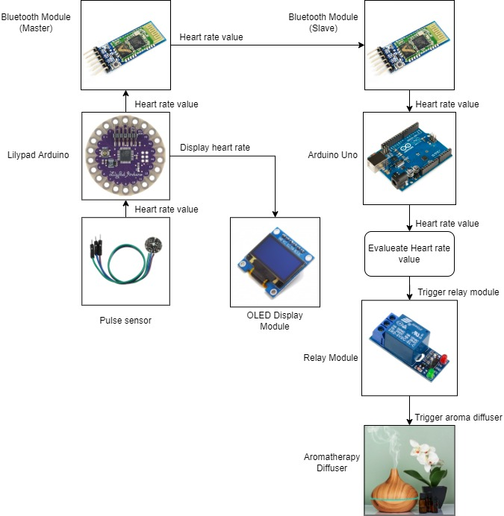

The pulse sensor installed in the Lilypad Arduino wearable, will read the pulse of the user every a set amount of time (10 seconds) and display the pulse/heart rate in the OLED display module. The pulse/heart rate values will then be sent to the Arduino Uno of the Automated Aroma Diffuser via HC-05 Bluetooth module from Master to Slave or Transmitter to Receiver. The Arduino Uno will then send the heart rate values to the Relay Module. The Arduino Uno will be programmed to calculate heart rate readings if it is above normal value (100 BPM); if the reading is above a set normal value, it will set with a value of ‘HIGH’; however, if the reading is within the set normal value, the value will have set with a ‘LOW’. And the value “HIGH” is assigned to turn on the relay module. On the other hand, the value “LOW” will turn the relay module off. Since the pulse sensor is only programmed to read pulse rates every 10 seconds, the set variable will be updated with values of either “High” or “Low” every 10 seconds. But in this case the function of the diffuser uses a push button to turn on the device so we need to update the code of the receiver side on the Arduino UNO, so by adding delay for 0.18 milliseconds to turn on/off the relay module and therefor the diffuser device will turn on.

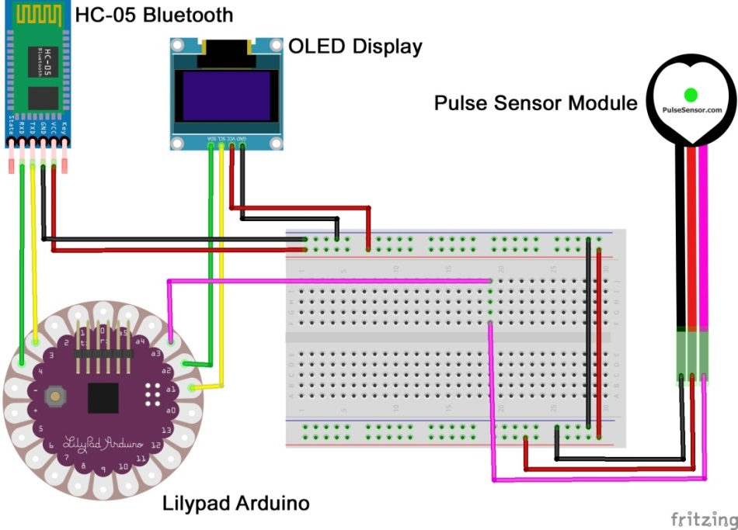**3.2** **Circuit Diagram**

Figure 3.2.1 Circuit Diagram for the Wearable Heart Rate Monitor

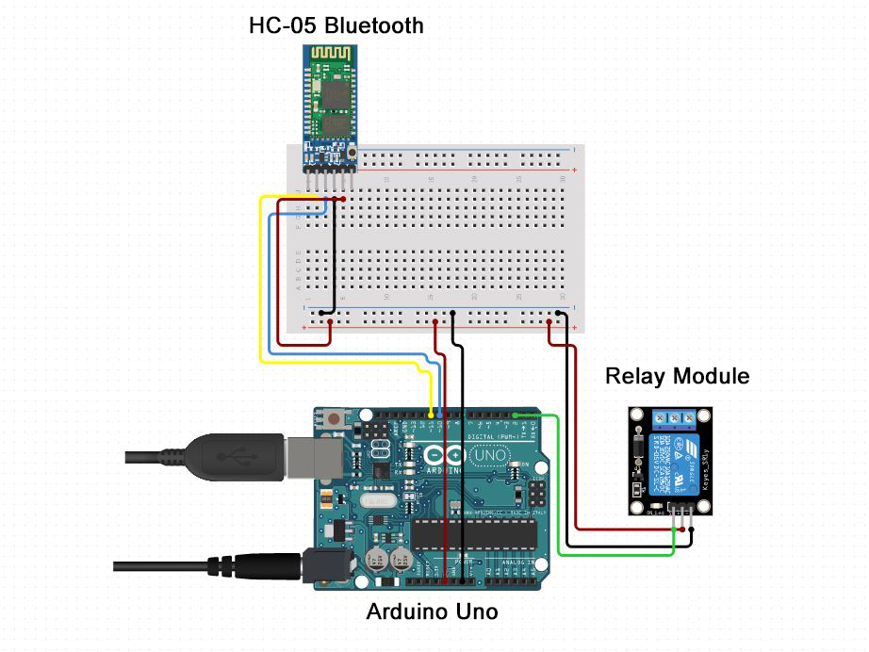

Figure 3.2.2 Circuit Diagram for the Automated Aroma Diffuser

**3.3 Components**

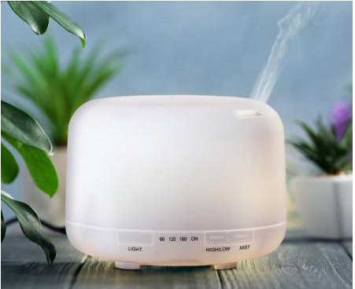

Figure 3.3.1 Aroma Diffuser

Aroma diffuser is a device that disperses essential oils into the air and fills the area with a relaxing fragrance. In this study, an aroma diffuser will be designed to be automated based on the user’s heart rate.

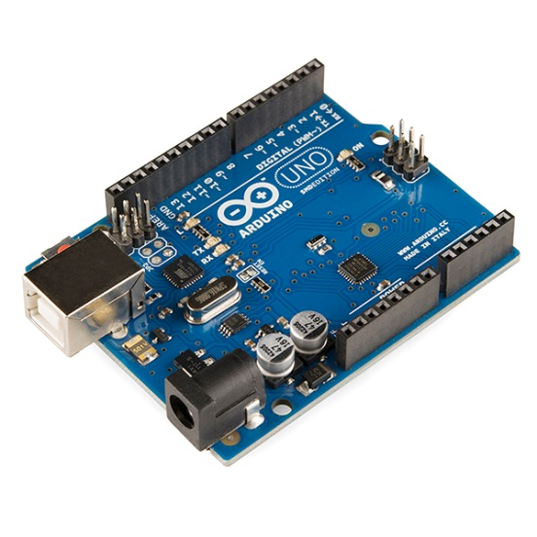

Figure 3.3.2 Arduino Uno

Arduino Uno is an open-source microcontroller most commonly used for IOT projects. Arduino boards are able to read inputs such as light on a sensor, a finger on a button, pulse rate, and turn it into an output such as activating a motor, turning on an LED and so on. In this study, an Arduino Uno will be used to automate the aroma diffuser.

* Operating voltage: 5V
* Input voltage (recommended): 7-12V
* Input voltage (limits): 6-20V
* Digital I/O pins: 14 (of which 6 provide PWM output)
* Analog input pins: 6
* DC current per I/O Pin: 40 mA
* DC current for 3.3V Pin: 50 mA
* Flash memory: 32 KB of which 0.5 KB used by bootloader
* SRAM: 2 KB
* Clock speed: 16 MHz

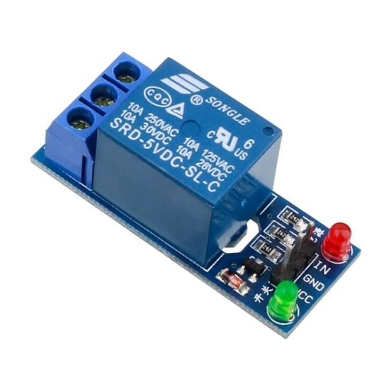

Figure 3.3.3 1 Channel Relay Module

Relay module is an electrical switch that is operated by an electromagnet. The electromagnet is activated by a separate low-power signal from a micro controller. When activated, the electromagnet pulls to either open or close an electrical circuit. In this study, the relay module will be used to either open or close the electrical circuit of the aroma diffuser thus turning it on or off.

* Channel: 1 Channel
* Relay Voltage: 5V
* Dimensions: 56.5mm x 17mm x 20mm
* Weight: 16.5g

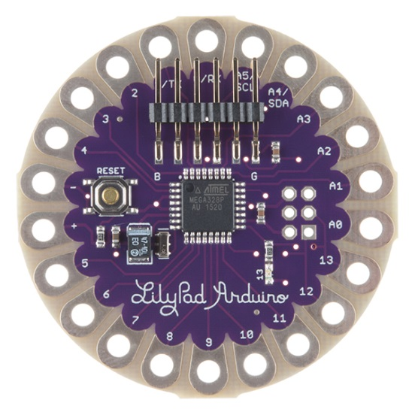

Figure 3.3.4 Lilypad Arduino

Lilypad Arduino is a small microcontroller design for wearables and e-textiles. In this study, the researchers decided to use the Lilypad Arduino as the microcontroller or motherboard for the wearable hear rate monitor because it is small and is specifically designed for such small and compact wearable projects. LilyPad Arduino is the main board consisting of an ATmega328 with the Arduino bootloader and a minimum number of external components to keep it as small (and as simple) as possible. Board will run from 2V to 5V. The latest version of the LilyPad supports automatic reset for even easier programming

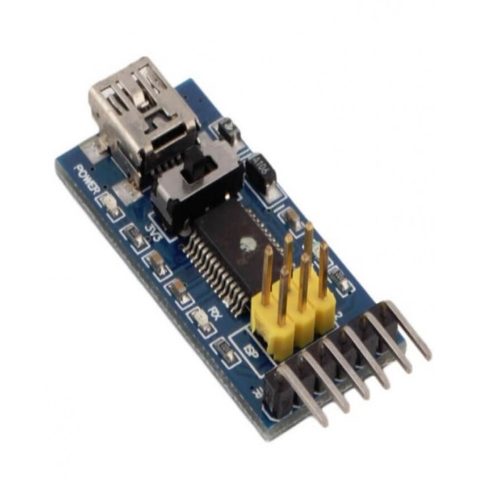

Figure 3.3.5 FTDI USB to TTL Serial Converter

FTDI USB to TTL serial converter module is used for general serial applications. It is popularly used for communication to and from microcontroller development boards such as ESP-01s and Arduino micros, which do not have USB interfaces. In this study, FTDI TTL module will be used for the Lilypad Arduino for communication and programing.

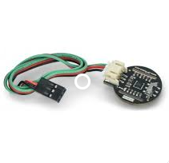

Figure 3.3.6 Gravity：Analog/Digital PPG Heart Rate Sensor

Pulse Sensor is a well-designed plug-and-play heart-rate sensor for Arduino. In this study, the pulse sensor will be mounted to the Lilypad Arduino.

* Power supply: 3-5
* Diameter: 16M
* Magnification: 33
* LED wavelength: 609 nm

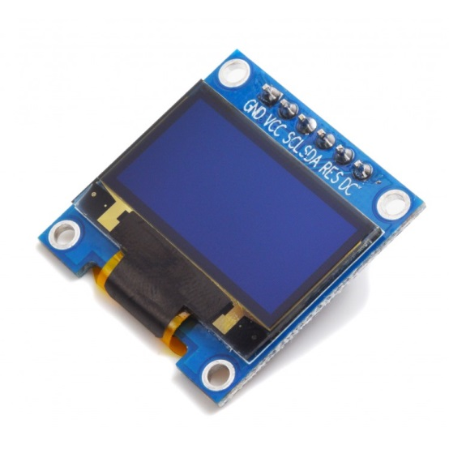

Figure 3.3.7 0.9” OLED Display

OLED(Organic Light Emitting Diode) Display Module is a relatively new technology with the potential to replace current LCD and LED televisions, monitors, and cell phone displays. This is a 0.9 inches small screen that will be used to display the heart rate of the user.

* Driver IC: SSD1306
* Size: 0.91 inch OLED
* Resolution: 128 x 32
* IIC interface
* 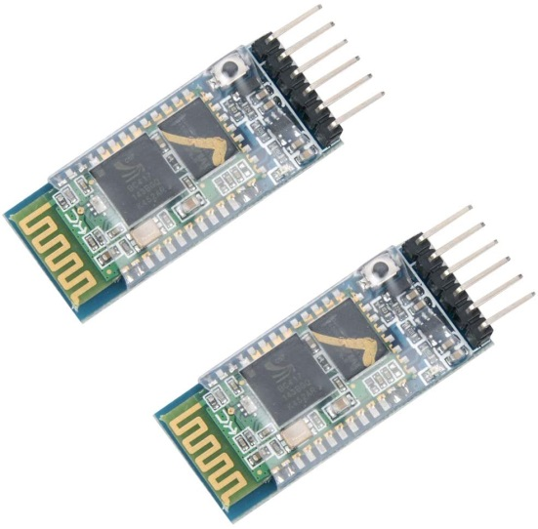Display Color: Blue

Figure 3.3.8 HC-05 Bluetooth Module

Bluetooth module is designed for transparent wireless serial connection setup. In this study, an HC-05 Bluetooth module will be used for Master & Slave (Transmitter / Receiver) communication between the Automated Aroma Diffuser’s Arduino Uno and the Wearable Heart Rate Monitor’s Lilypad Arduino.

* Power Input: 5VDC
* Communication Interface: Serial
* Communication Distance: 10 meters
* PCB Dimensions: 16.2x37.5

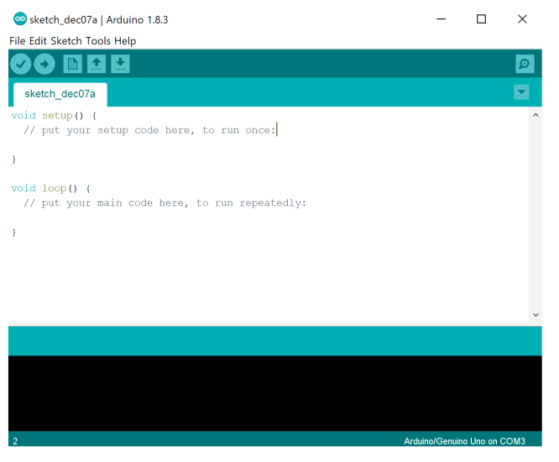**Software Requirements**

Figure 3.3.10 Arduino IDE

The Arduino IDE (Integrated Development Environment) is a cross-platform application that is written in functions from C and C++. It is used to write and upload programs to Arduino compatible boards, but also, with the help of third-party cores, other vendor development boards.

**Data Gathering Procedure**

In the testing phase of the project, the test-users will be subjected to performing intense exercise to simulate a high heart rate of a stressed person. The test-user should perform exercise while wearing the heart rate monitor to keep track of their heart rate every a set amount of time. Once the high heart rate is achieved, the test-users should sit near the aroma diffuser for the Bluetooth connection to work between the automated aroma diffuser and the heart rate monitor which the test-user is wearing. This process tests if both the heart rate monitor and the automated aroma diffuser work.

The researchers will conduct evaluation to the test-users after the testing of the prototype. In addition, the researchers will follow-up with interviews for feedback and recommendations to improve the prototype. The testing and evaluation process will be repeated by a number of 10 test-users to gather enough information of the effectiveness of the prototype.

**Chapter IV**

**Results and Discussions**

This chapter covers the testing results including the interface of the prototype. Each part of the system will be discussed thoroughly in this chapter to provide a clearer understanding on all of its functions.

**4.1 Description of the Prototype**

Wearable heart rate monitor are convenient ways of keeping track of one’s heart rate. Common commercial smart watches also have heart rate monitoring technology installed to them. For this reason, the researcher decided to develop a heart rate monitor that can be worn in the wrist.

The researcher developed an Arduino based heart rate monitor with aromatherapy diffuser to keep a person’s resting heart rate to normal. However, the aromatherapy diffuser is not portable and will only be limited to a person’s workplace in where stress and anxiety will most likely happen. The wearable Arduino based heartrate monitor is designed to automatically trigger the aromatherapy diffuser when the monitor receives a set above normal value of the resting heart rate.

**4.2 Arduino Based Heart Rate Monitor with Aroma Diffuser**

Shown in this section are the pictures of the prototype that the user will see throughout his/her use of the system.

**4.2.1 The heartrate monitor with reading of below 100bpm.** This picture shows the heartrate monitor with a reading of below 100bpm and an off aroma diffuser in the background.

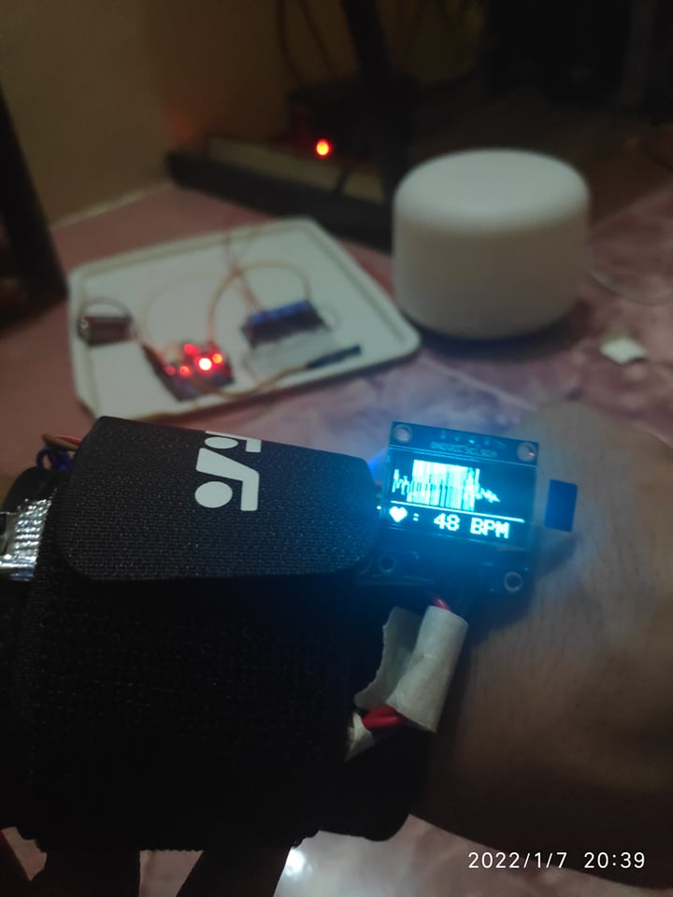

Figure 4.2.1 The heartrate monitor with reading of below 100bpm

**4.2.2 The heartrate monitor with reading of above 100bpm.** This picture shows the heartrate monitor with a reading of above 100bpm and an ON aroma diffuser in the background (indicated by the green light form the diffuser).

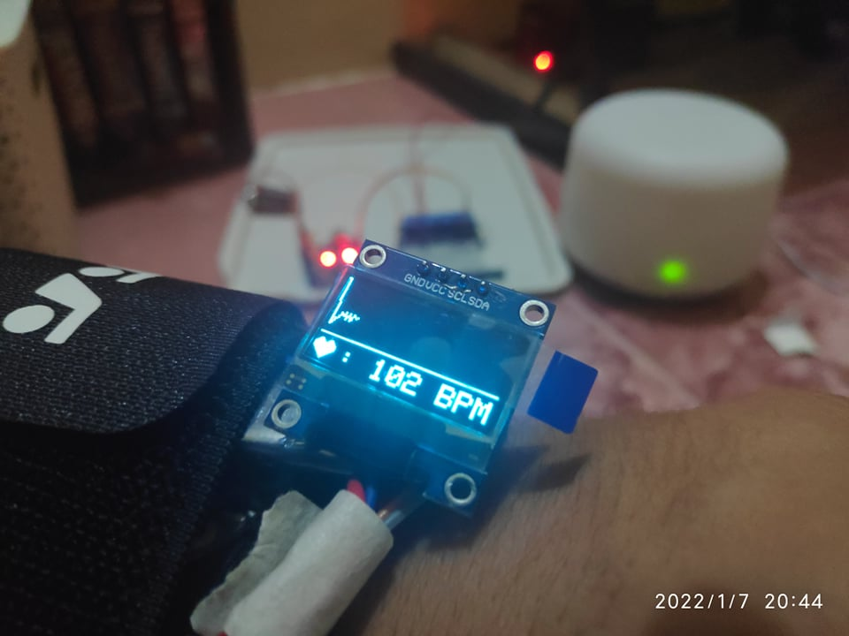

Figure 4.2.1 The heartrate monitor with reading of above 100bpm

**4.3 Product Testing**

This section shows the pictures of the prototype being tested in a working environment.

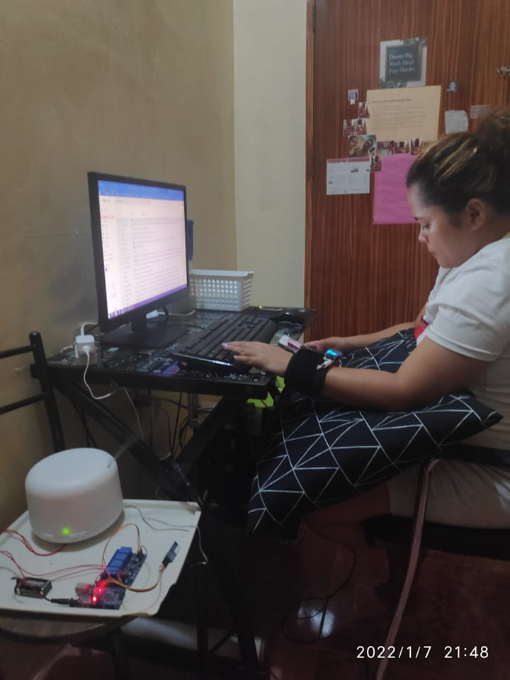

Figure 4.3.1 Actual Testing of Ms. Tangian

Ms. Tangian testing the prototype in a working environment. In this test, her heart rate was above 100bpm and which activated the Aromatherapy Diffuser.

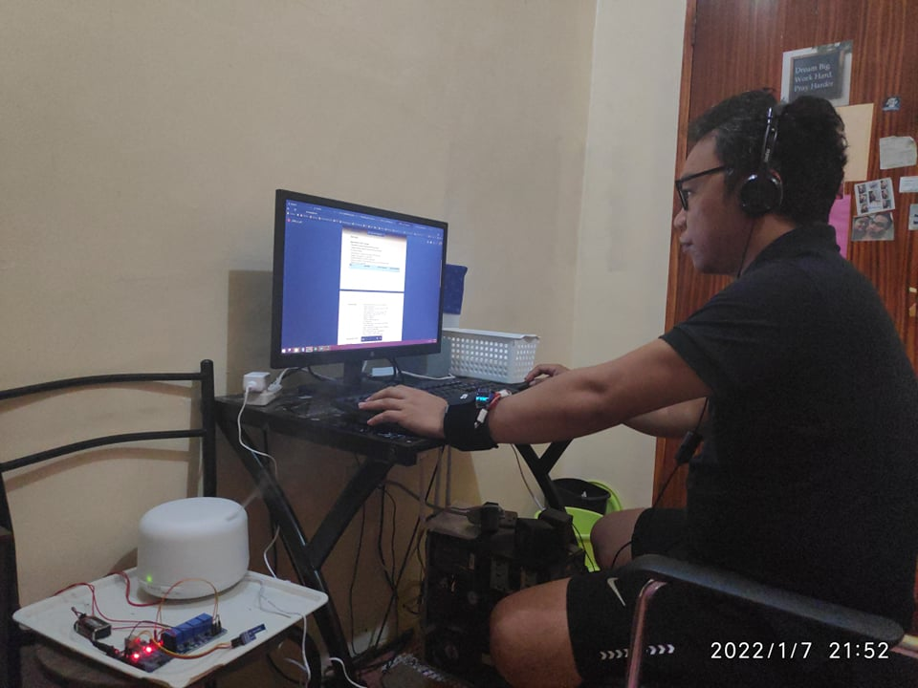

Figure 4.3.2 Actual Testing of Mr. Cabalida

Mr. Cabalida testing the prototype in a working environment. In this test, his heart rate was above 100bpm and which activated the Aromatherapy Diffuser.

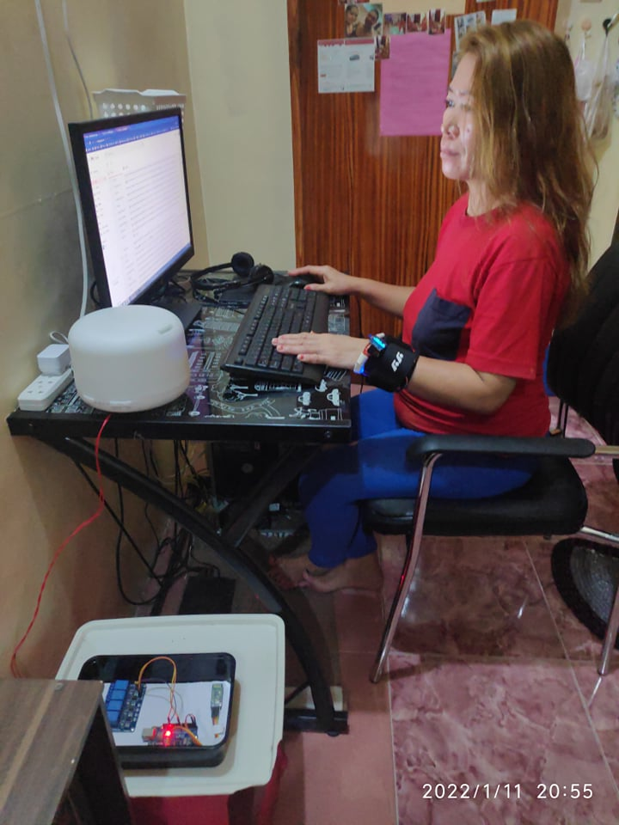

Figure 4.3.3 Actual Testing of Mrs. Rosal

Mrs. Rosal testing the prototype in a working environment. In this test, his heart rate was below 100bpm and which didn’t activate the Aromatherapy Diffuser.

**4.4 Testing and Results**

A testing was conducted to 5 college students to gather necessary information which could be used in the improvement of this product. In addition, the test-users have been follow-upped with interviews for feedback and recommendations to improve the prototype.

**Table 4.4.1 Wearing the prototype**

|  |  |  |  |  |  |
| --- | --- | --- | --- | --- | --- |
| Wearing the prototype | 1 | 2 | 3 | 4 | 5 |
| Comfort in wearing the prototype (Worst to Best) |  | 20% | 80% |  |  |
| Weight of the prototype (Light to Heavy) |  |  | 20% | 80% |  |
| Ease of putting on or off of the prototype in the wrist(Worst to Best) |  | 20% | 60% | 20% |  |
| Mobility (Worst to Best) |  |  | 20% | 80% |  |

In Table 4.4.1, 80% of the respondents find the prototype on average in terms of comfort in wearing it while 20% find it discomforting. 80% of the respondents find the prototype heavy in the wrist. 60% of the respondents find the prototype on average in terms of ease in putting it on or off. 80% of the respondents find it easy to move around while the prototype.

**Table 4.4.2 Design the prototype**

|  |  |  |  |  |  |
| --- | --- | --- | --- | --- | --- |
| Design of the prototype | 1 | 2 | 3 | 4 | 5 |
| Wiring clutter of the prototype (Worst to Best) |  |  | 100% |  |  |
| Design of the prototype (Worst to Best) |  |  | 100% |  |  |

In Table 4.4.2, 100% of the respondents find the prototype on average in terms of wiring clutter. 100% of the respondents also find the design of the prototype to be average.

**Table 4.4.3 Functionality the prototype**

|  |  |  |  |  |  |
| --- | --- | --- | --- | --- | --- |
| Design of the prototype | 1 | 2 | 3 | 4 | 5 |
| Overall Functionality of the prototype (Worst to Best) |  |  |  |  | 100% |
| Accuracy of the pulse sensor ( Worst to Best) |  | 100% |  |  |  |

In Table 4.4.3, 100%% of the respondents find the prototype to have a great overall functionality. 100% of the respondents also find pulse sensor to have a very bad BPM readings and recommends changing for a better pulse sensor that reads accurate BPMs.

**Chapter V**

**Conclusion and Recommendation**

This chapter presents the conclusion made and the recommendations being offered to further develop the efficiency of the Arduino based heart rate monitor with aromatherapy diffuser.

**5.1 Summary of the Study**

The Arduino based heart rate monitor with aromatherapy diffuser is design to monitor and keep a person’s resting heart rate to normal. The researcher designed the prototype to eliminate the following problems:

* Inaccurate and time consuming manual counting of a person's heartrate
* Separate system for heartrate monitoring and treatment methods,
* High resting heart rate due to stress

The prototype was successfully developed and to be able to continuously measure heart rate and activates the aromatherapy diffuser whenever the measured heart rate exceeds normal values. A problem the researcher encountered during development is that the pulse rate sensor module is highly inaccurate because an accurate pulse sensor module is simply not available to the researchers. The researchers got around this problem by recommending changing and upgrading the pulse sensor module to an accurate one. Another problem the researchers’ encountered was that in order to turn on a diffuser, a button on the diffuser must be pushed first. This was a problem because this means during development, the code for its system cannot simply send a value to the relay to turn the power on or off. The researchers solved this problem by writing a code that mimics the push button function of the diffuser. Overall the objectives of the study were met except for reading accurate heart rate.

**5.1 Conclusion**

The prototype was evaluated by to 5 college students to gather necessary information which could be used in the improvement of this product. As per evaluation result, majority of the respondents rated the prototype to be average in terms of general comfort in wearing it. Respondents also rated the design of the prototype to be average. However, the functionality is where the prototype is at its lowest rating because of a single and one of the most important modules which is the pulse sensor itself. The pulse sensor is simply inaccurate in reading a person’s pulse rate. All the other modules of the prototype including the system’s code are working perfectly. For this reason, the respondents highly recommend opting for a better and more accurate pulse sensor module for the prototype.

**5.2 Recommendations**

The proponents recommend the following to the future researchers for further development of the system:

* A better and more accurate pulse sensor module.
* Lighter weight and smaller profile of the prototype.
* Less clutter design of the prototype.
* Integration with a mobile application to keep track of the heart rate readings.

**References**

Pan, Xi and Jiang (2019). “Emotional Effects of Smart Aromatherapeutic Home Devices”

<https://link.springer.com/chapter/10.1007/978-3-030-19135-1_48>

Ahasan, Abdullah and Roy (2018). “Arduino-Based Real Time Air Quality and Pollution Monitoring System”

<https://papers.ssrn.com/sol3/papers.cfm?abstract_id=3531764>

Acquisto, Montinaro, Zangla and Bellavia (2019). “A preliminary investigation of the effect of contact pressure on the accuracy of heart rate monitoring by wearable PPG wrist band”

<https://ieeexplore.ieee.org/abstract/document/8792834/>

Ji-Yieong S. (2009). “The effects of aromatherapy on stress and stress responses in adolescents”

<https://pubmed.ncbi.nlm.nih.gov/19571632/>

Sung SN., Eun Y. (2007). “The Effect of Aromatherapy on Stress of Nurses Working in Operating Room”

<https://komci.org/GSResult.php?RID=0094JKAAN%2F2007.19.1.1&DT=6&ITEMNO=1&TITEM=15>

Hye-Geun K., Eun-Jin C., Dai-Seg B., Young Hwan L., Bon-Hoon K. (2018). “Stress and Heart Rate Variability: A Meta-Analysis and Review of the Literature”

<https://www.ncbi.nlm.nih.gov/pmc/articles/PMC5900369/>

Bariya, Nyein, & Javey (2018) “Wearable sweat sensors”

<https://www.nature.com/articles/s41928-018-0043-y>

Wei Gao, Tu (2020). “A laser-engraved wearable sensor for sensitive detection of uric acid and tyrosine in sweat”

<https://www.nature.com/articles/s41587-019-0321-x>

Veena Misra, Bozkurt, & Calhoun (2015). “Low-Power Wearable Systems for Continuous Monitoring of Environment and Health for Chronic Respiratory Disease”

<https://ieeexplore.ieee.org/abstract/document/7479442/>