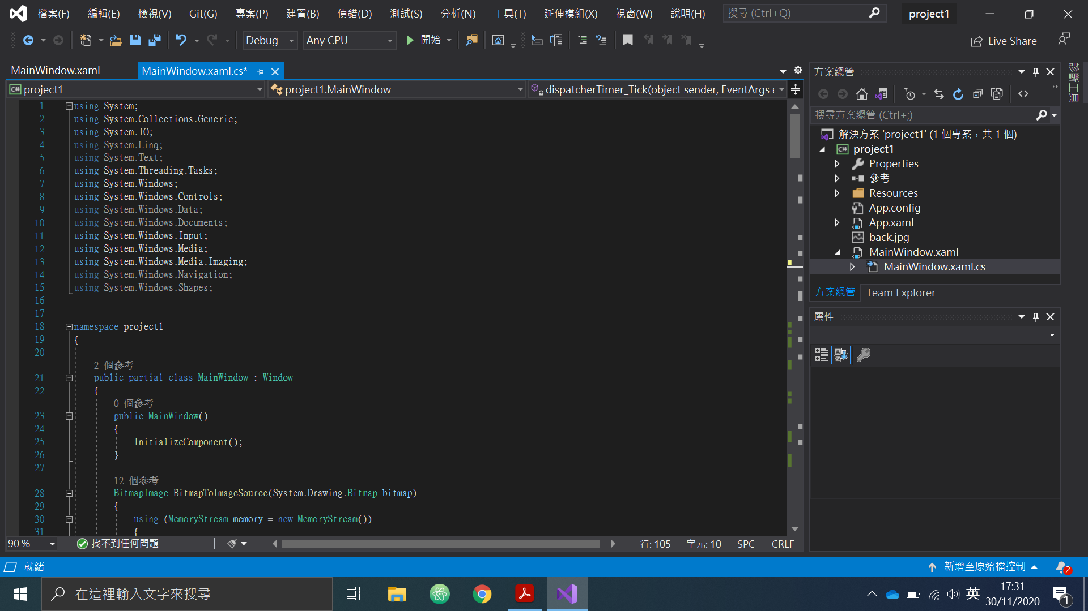

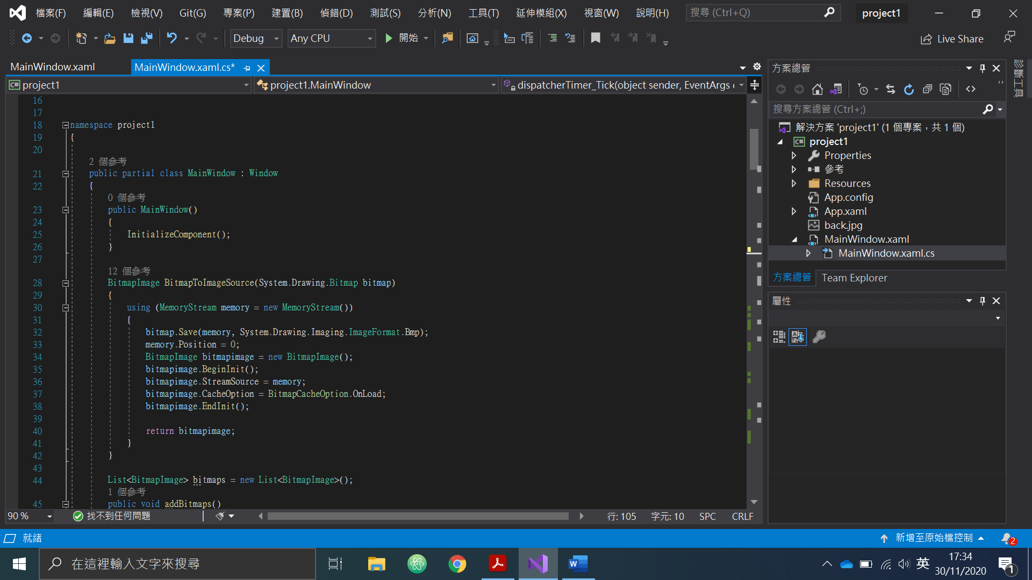

Change bitmap to image.source.

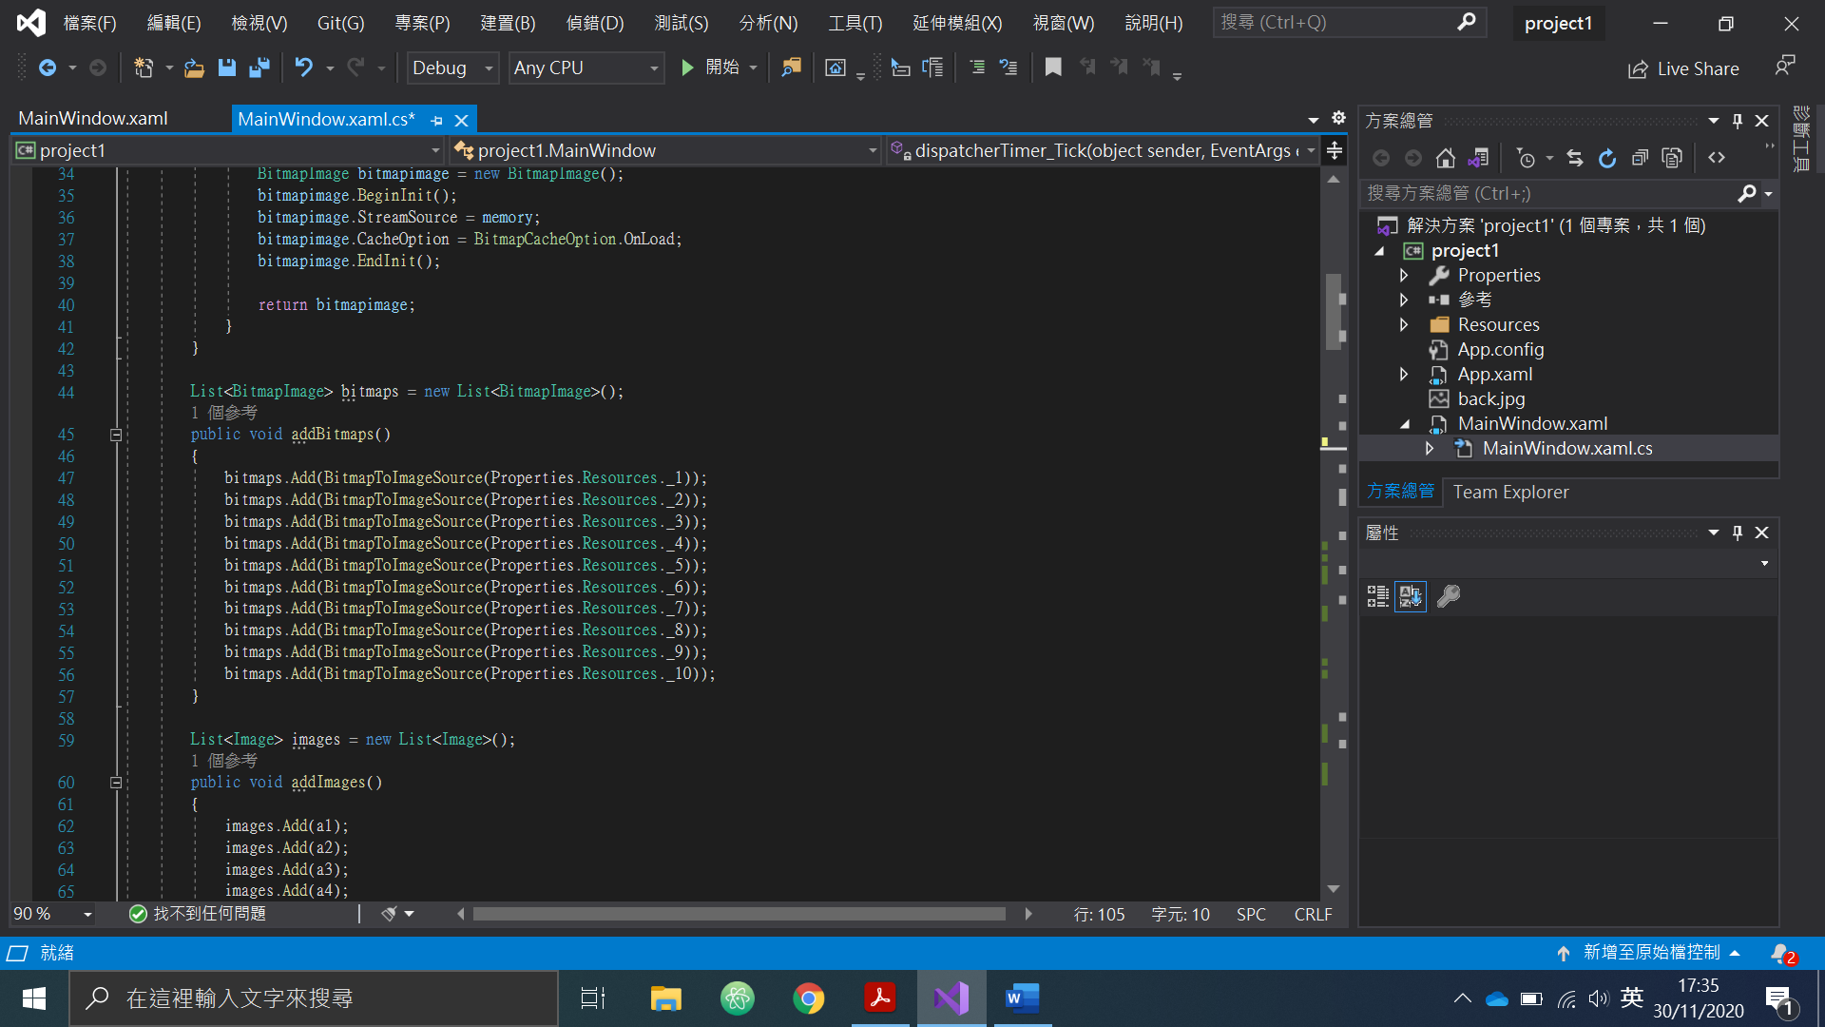

Store the bitmap in list for convient to call.

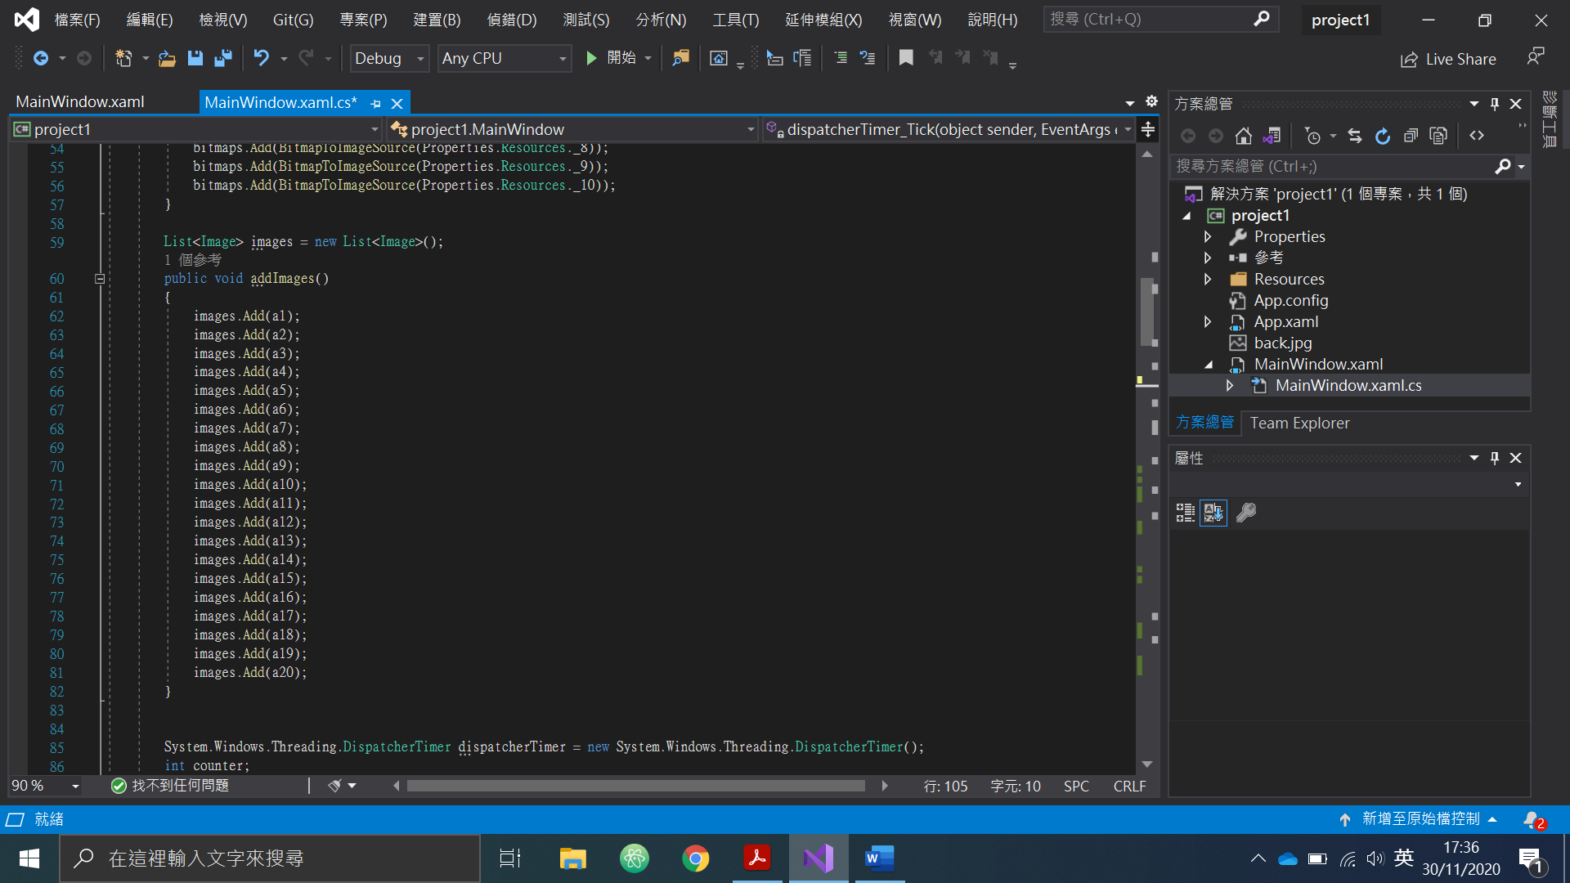

Store the 4x5 image button in list for convient to call.

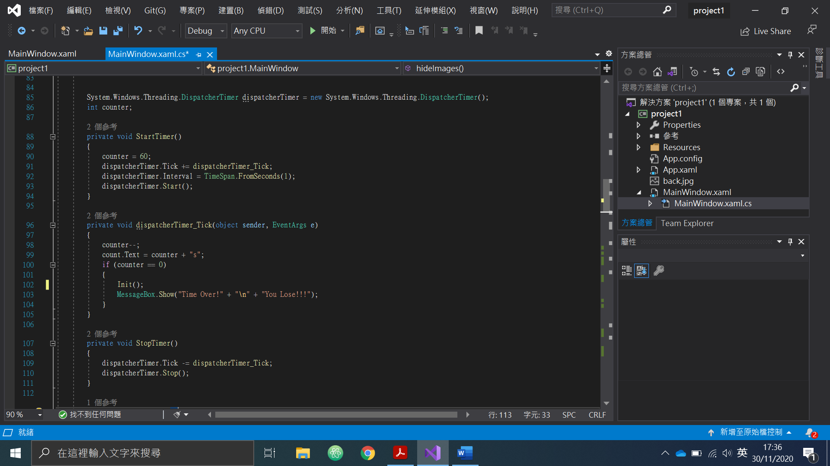

Set up the timer to count down 60 seconds and show the remaaining time to player.

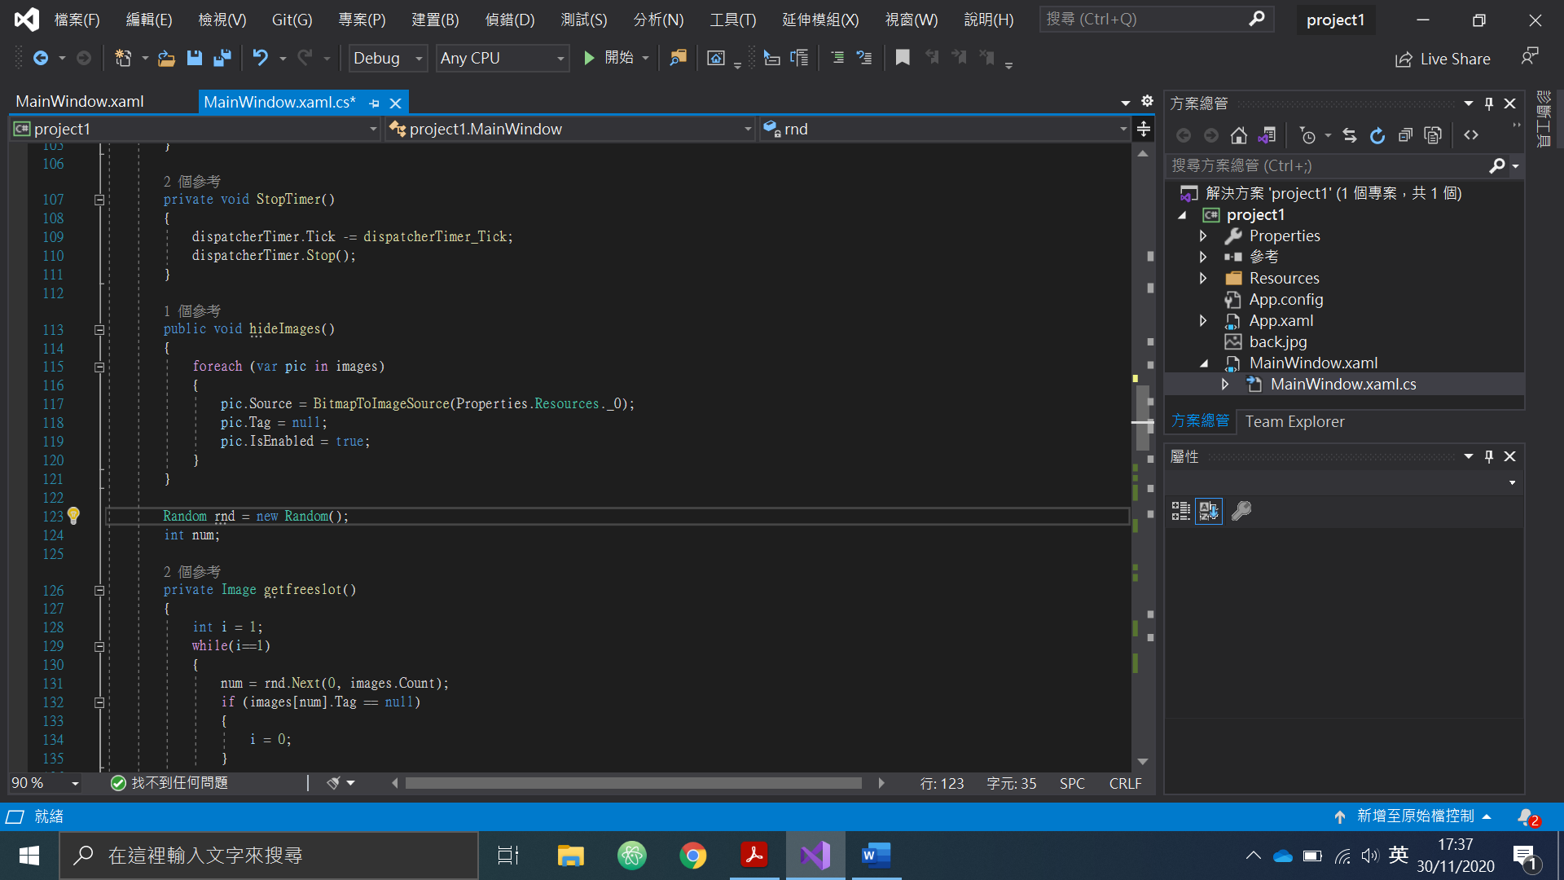

To hide the card content for player to guess.

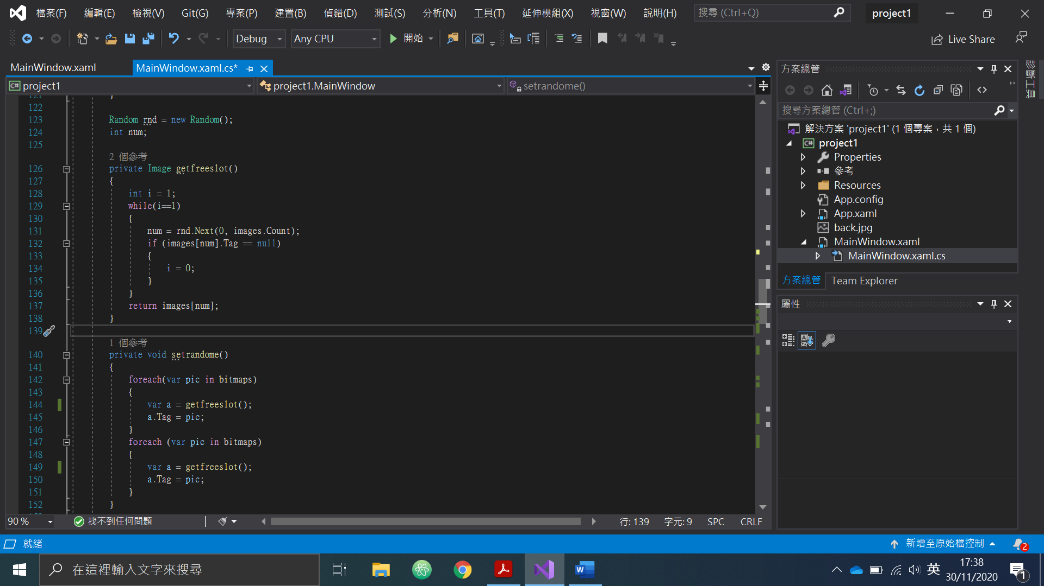

Generrate the card content and randomly put them in 4x5 cards.

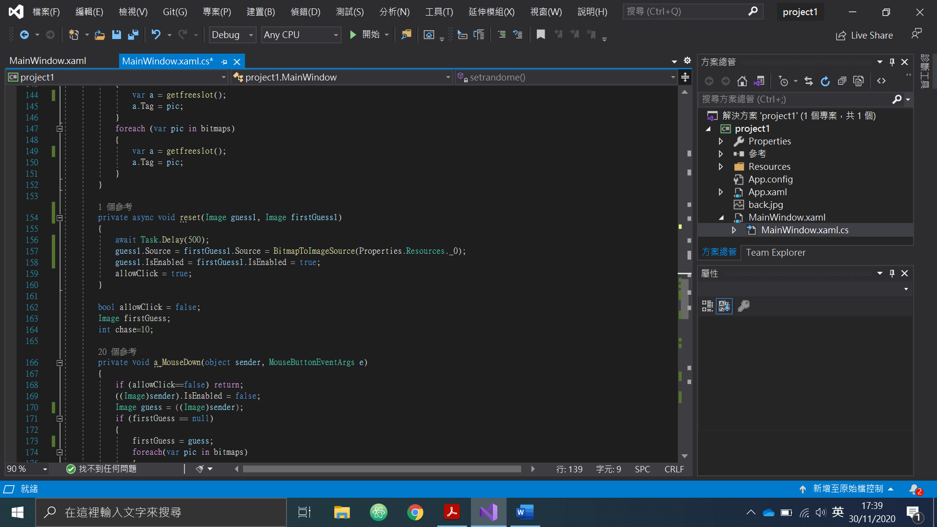

To hide the content when two card contents are not the saem, a delay is set, so that the card won’t turn over immediately, to let the player have time to memorize the card content.

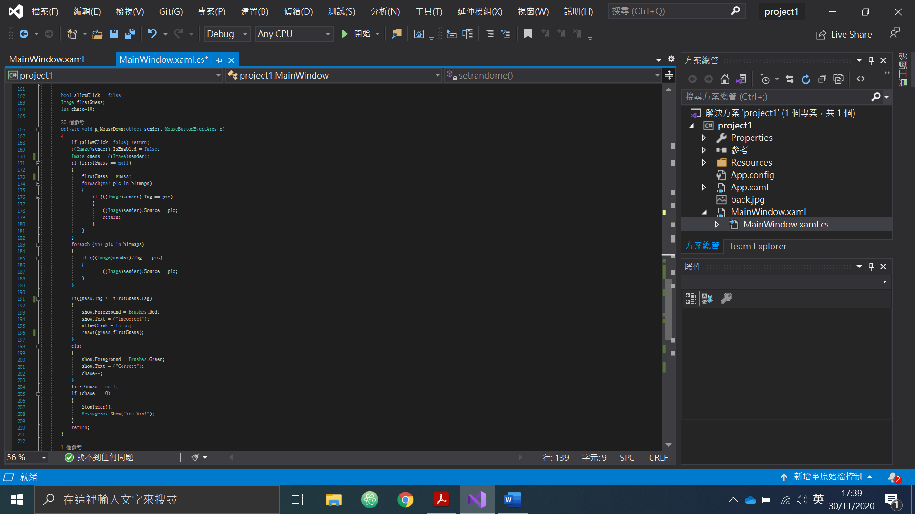

Action took when player press the card. To identify it is the first or second card the player is choosing. If first card, it will save the card content. If it is the second card, it will compare to the first card saved to see if it it identical. If no , it will turn over the two card and show incorrect. If yes, it keep 2 card open and show correct. Also, this function can check if the player is won or not and show the player if he has won.

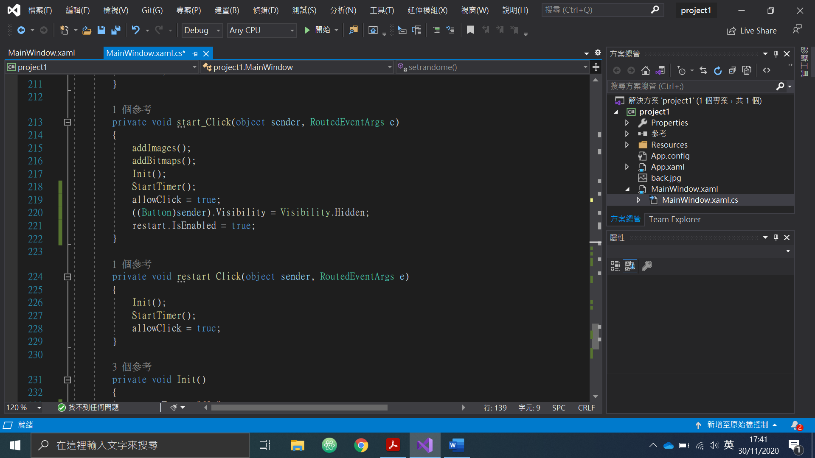

Start button to initialize the game and activate the restart button. Restart button to let player can restart the game at any time.

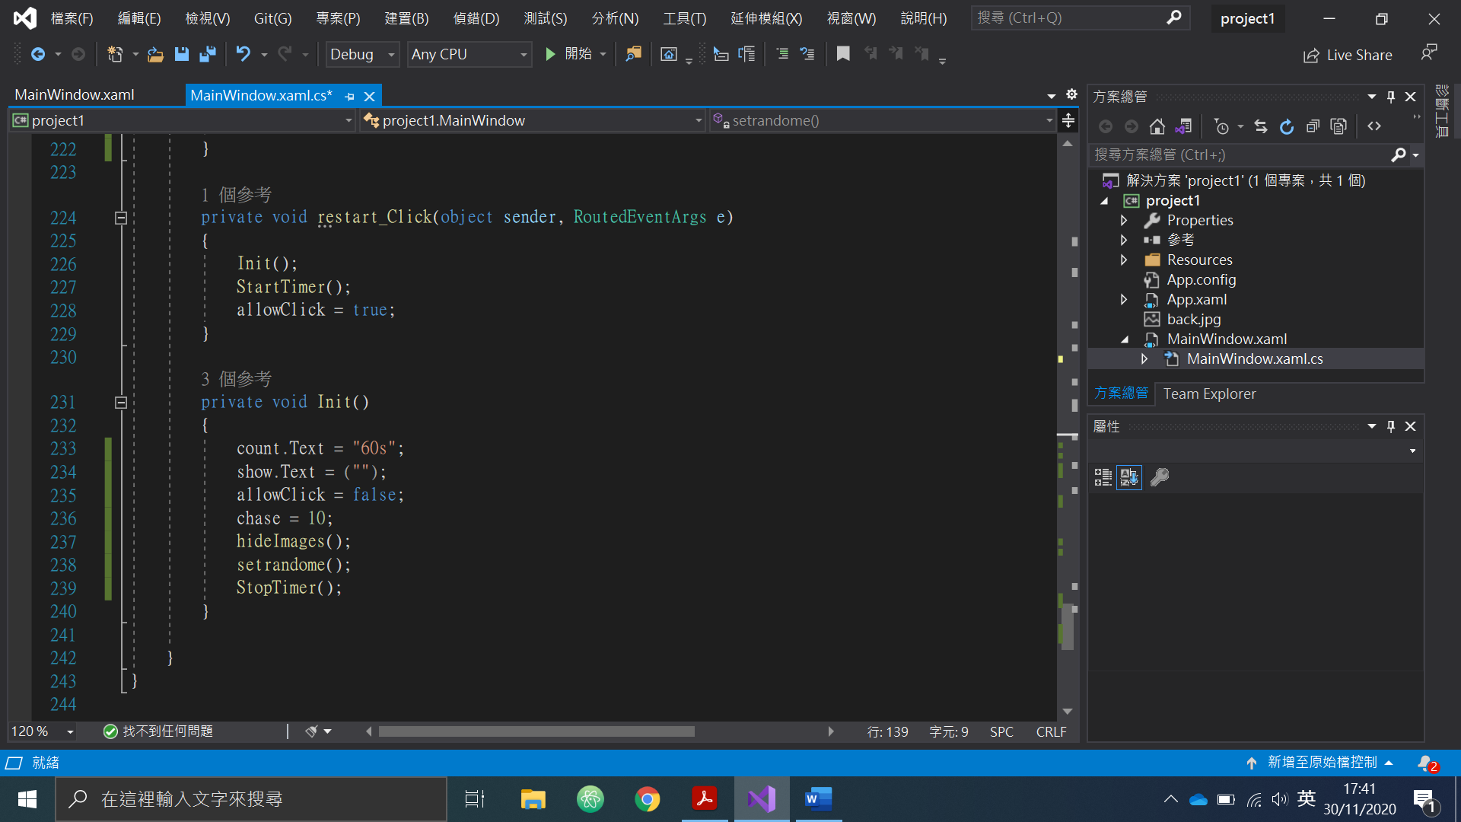

To set up the game environment.

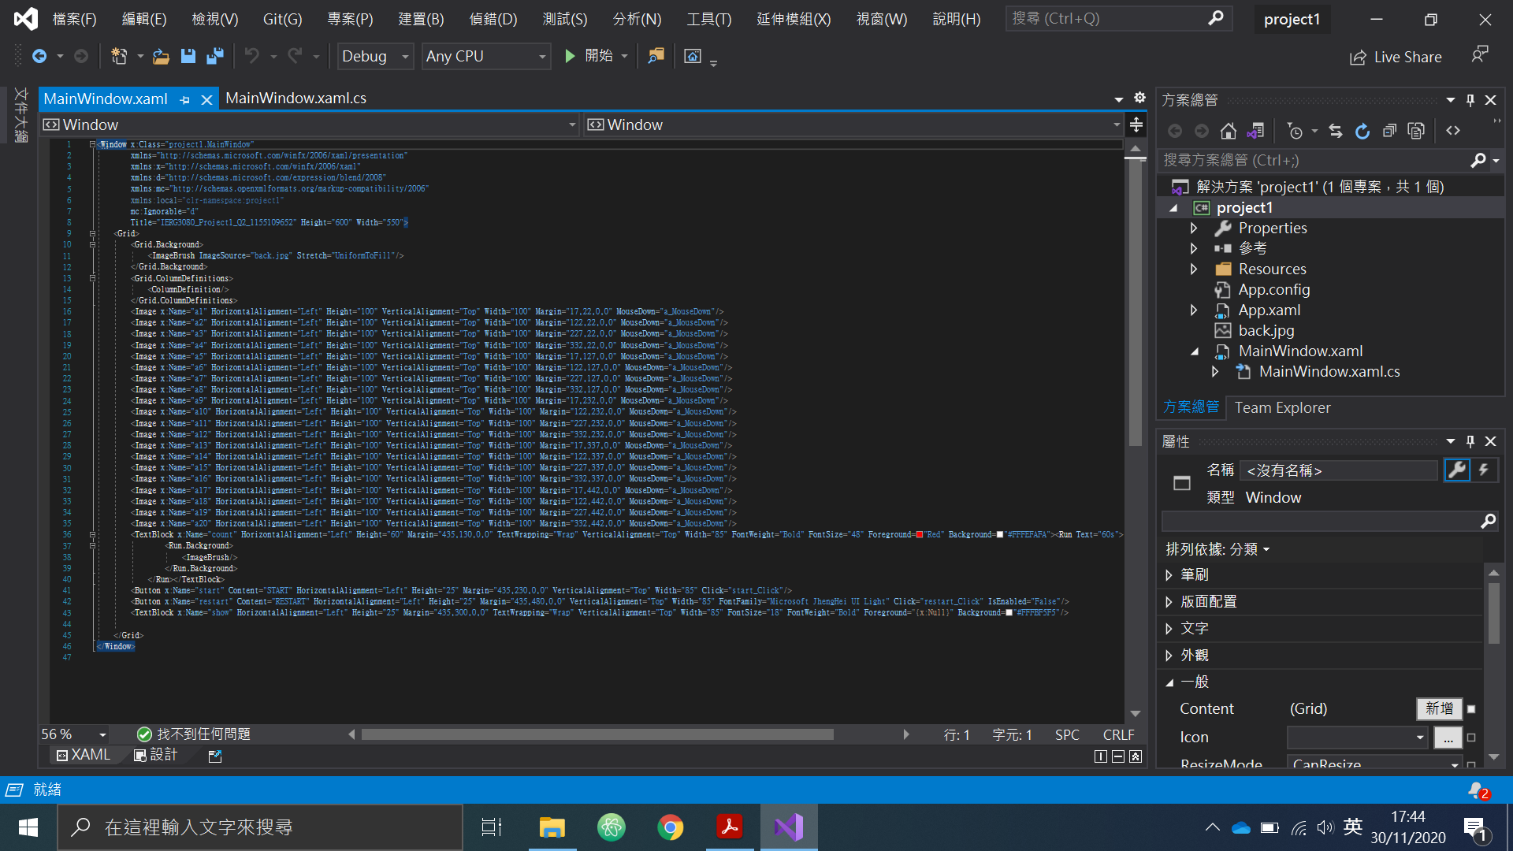

MouseDown is added to the 4x5 cards so it can work as a button.