Introduction
Due to the selection if a non-standard antenna coil for the RFID transponder for extended range, it is necessary to perform the calculations to determine the size and voltage rating of the adjustment trim capacitor C_{E} that is added to the circuit.

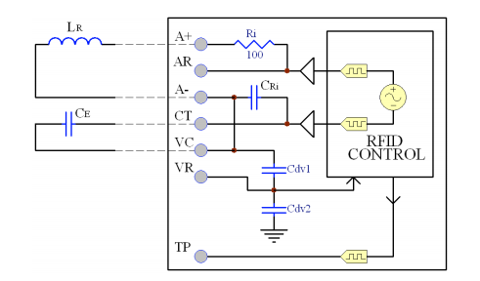

We are using the folowing componetns for the AGV RFID system:
RFID Controller: RFIDRW-E-TTL
Coil: RFIDCOIL-250A (L = 2.7 mH @ 125kHz, R= 8.7 ohms
Tag: 75567

Equations

