Installing SQL Server
In this online appendix, I’ll walk you through the process of installing SQL Server and the Adventure Works 2012 sample database. Note that I will be using SQL Server 2012 Standard Edition, which is commonly used in production environments. Installing other production editions looks almost exactly the same, but installing the Express edition has a few minor differences. If you’re installing Express, you should still be able to use this walkthrough to get started. As a reminder, you can download SQL Server Express 2012 from http://www.microsoft.com/en-us/download/details.aspx?id=29062; I suggest the SQLEXPRADV download for either 64-bit (x64) or 32-bit (x86), depending on the operating system your computer runs.
  - Setting Up Your Computer
For my lab environment, I prefer to use a virtual machine. You can use Hyper-V if your computer supports it, or a product like VMware Workstation. On a Mac, you can use something like Parallels or VMware Fusion.
I recommend using a newer operating system, like Windows 7 or Windows 8. You can also use a server operating system, such as Windows Server 2012. If you don’t own a copy of one of these, you can get a free trial from Microsoft’s Web site. You can, of course, also install SQL Server directly on a Windows 7 or Windows 8 (or later) computer that you already own.
I do suggest a 64-bit (x64) operating system, although if you only have access to a 32-bit OS, SQL Server will still work just fine.
  - Installing SQL Server
Start by double-clicking the Setup executable, whether that’s one you downloaded (if you’re installing Express) or that you found on the SQL Server installation DVD. You’ll begin at a kind of “task list” screen for production editions; just click on the “Installation” task to find Setup and get things running.
Figure A-1 shows what you should see first: the SQL Server pre-setup pre-requisite check. Hopefully, you’ll have everything installed that you need; if you’re missing something, follow the instructions and install whatever you’re asked to. Usually, that will just include a version of the .NET Framework and some other basic Microsoft software.
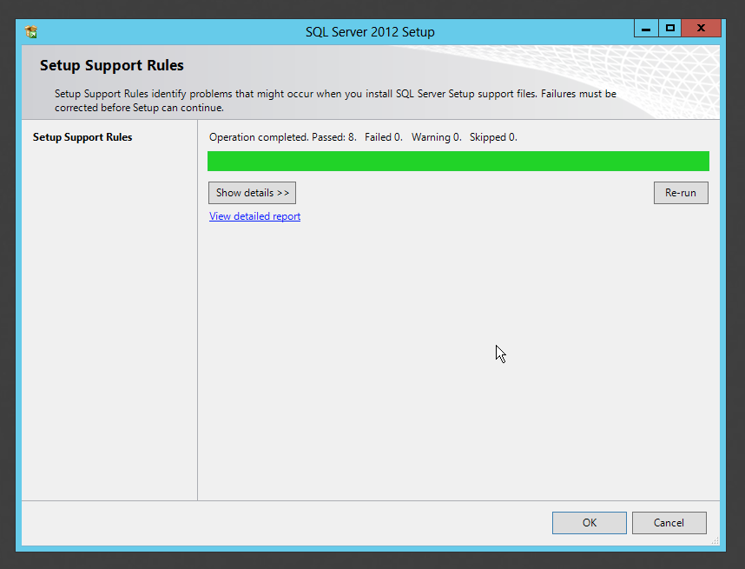
Figure A-1 SQL Server starts by checking pre-requisites
After you click OK, SQL Server will check the online Microsoft Update Web site for updates to the setup routines. You’ll usually want to let it do this, so that you can have the latest software. As shown in figure A-2, SQL Server may find an update or two for you to install.
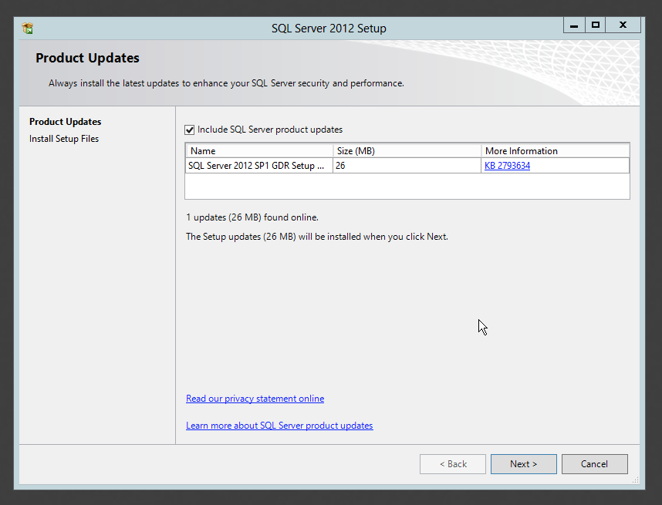
Figure A-2 SQL Server will download setup updates for you
Once that’s done, as shown in figure A-3, SQL Server will install SQL Server Setup. Yeah, that seems strange, but it’s what has to be done: Setup has to install the real Setup, so that it can setup SQL Server. How many setups would Setup set up if it could only set up setups?
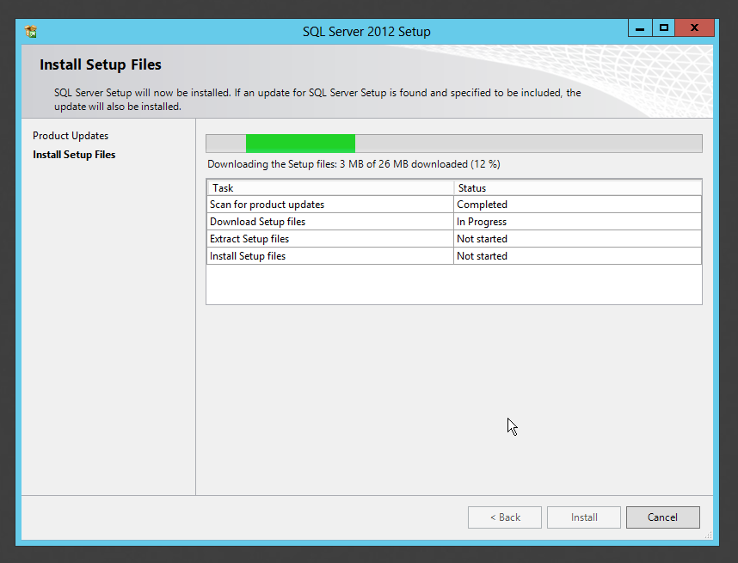
Figure A-3 Setup will then install the actual Setup files
Once Setup is installed, it will launch automatically and start by checking several pre-installation rules. You’ll notice in figure A-4 that I got a warning, probably because the Windows Firewall is installed on my computer. The warning in this case is reminding me that Setup won’t add any exceptions to the firewall, so unless I do so manually, nobody will be able to connect to my server. That’s a detail my server administrator handles, so I’ll pass on the reminder to her.

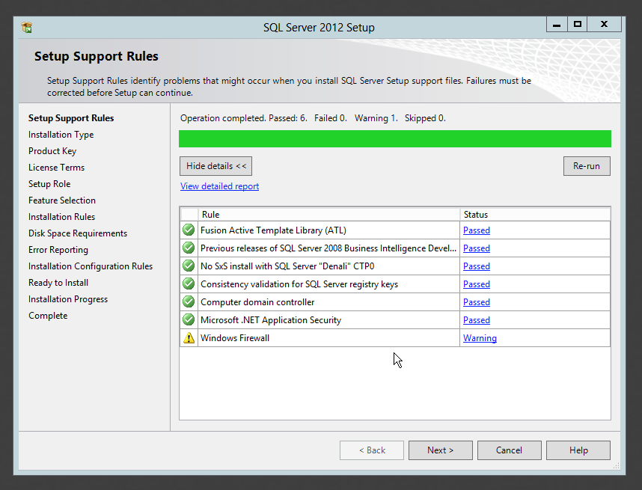
Figure A-4 Setup will check several installation rules before proceeding
Next, Setup will ask what you’d like to do. As shown in Figure A-5, you can install a default instance of SQL Server, or a named instance. I’ve chosen to install a named instance called “SQL2.” You can see in the table at the bottom of the screen that an existing instance, MSSQLSERVER, is already installed. If you’re installing SQL Server Express, it should default to installing a named instance called “SQLEXPRESS.” I recommend letting it do that.
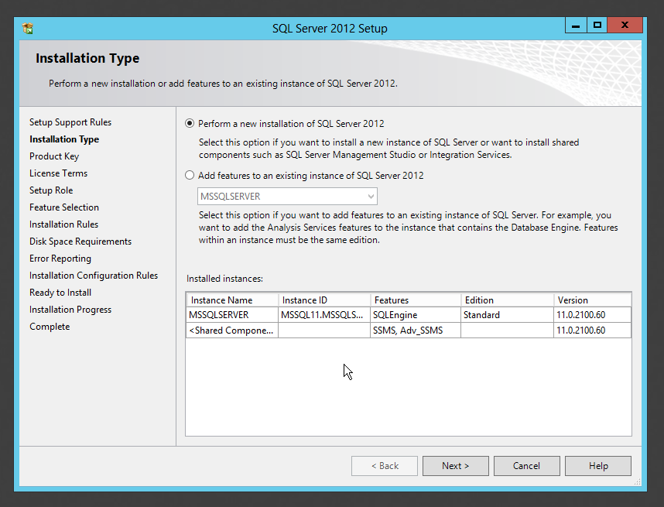
Figure A-5 Decide if you want to install a named instance, or the default
My next prompt is for a license key. As shown in figure A-6, you also have the option of installing a free edition, such as an evaluation, which might expire. SQL Server Express might not show you this screen at all. I’ll enter my product key and click Next to proceed. If you do enter a product key, it will usually determine what edition of SQL Server is installed, so make sure you double-check the key before using it.
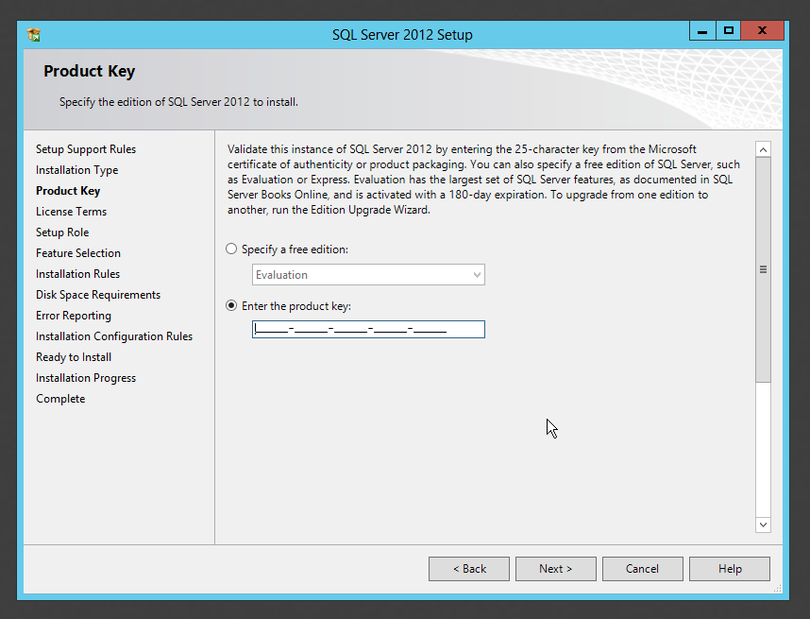
Figure A-6 Enter your product key to proceed
Figure A-7 shows the next step, which is the inevitable license agreement. Make sure you read it and understand it (or get a lawyer to help) before proceeding.
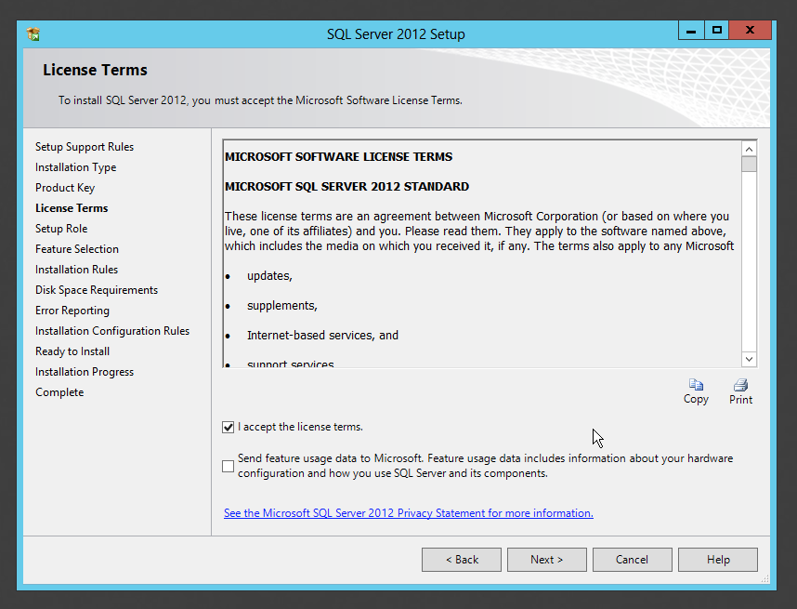
Figure A-7 Accept the license terms to proceed
The next screen, shown in figure A-8, is a kind of shortcut offering. You can elect to do a “feature install,” where you get to pick the bits of SQL Server you want, or you can just install everything – including the kitchen sink. The “full” install is pretty large, and it’s rare in a production environment that you’ll actually need everything, so I usually do a feature install.
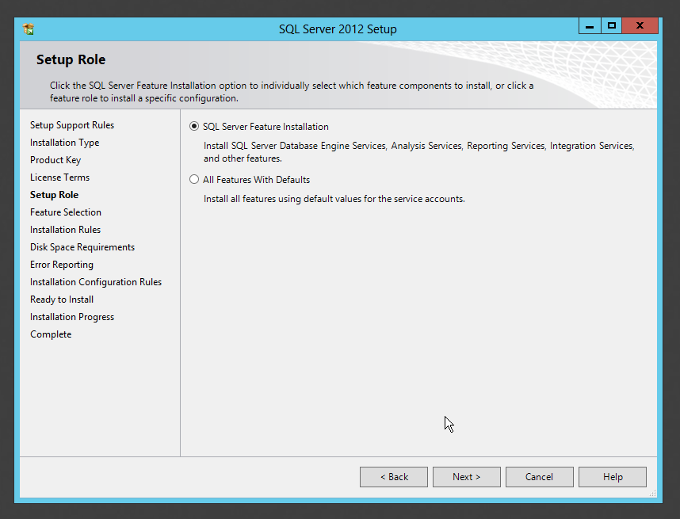
Figure A-8 I usually select the Feature Installation option
Figure A-9 shows where I get to select the features I want. I’m just going to install the core database engine, which is pretty common on a production server. I already have the management tools installed from a previous installation (the existing instance on this computer), and if you scrolled down the feature list you’d see those tools with a gray check mark, indicating they were already installed. Note that SQL Server Express has a smaller feature list.
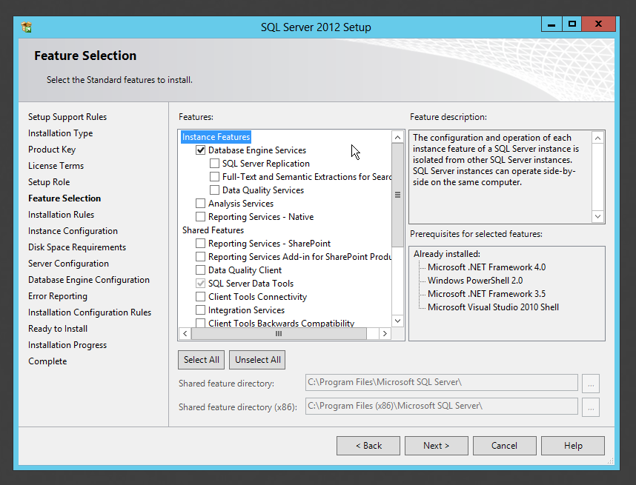
Figure A-9 Select the features you want to install
Step 10, shown in figure A-10, is where Setup checks to see if any of the files it needs to play with are in use. If they are, you’ll be required to restart your computer at the end of the installation, and this is where you’ll receive that warning.
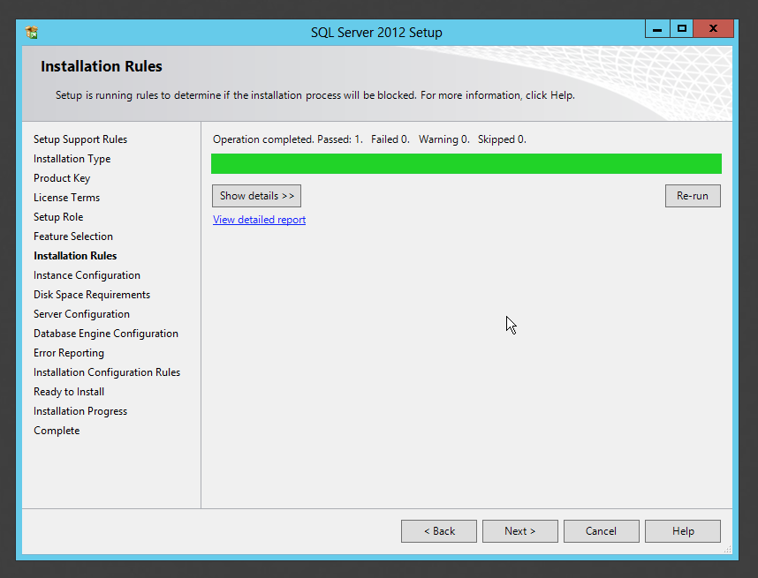
Figure A-10 Setup checks to see if any files are in use
The next step, shown in figure A-11, is very important. This is where you give your named instance a name, and where you choose the root installation folder. Setup will actually create a folder hierarchy for your instance in this location, so it’s okay to install multiple instances to this same root folder.
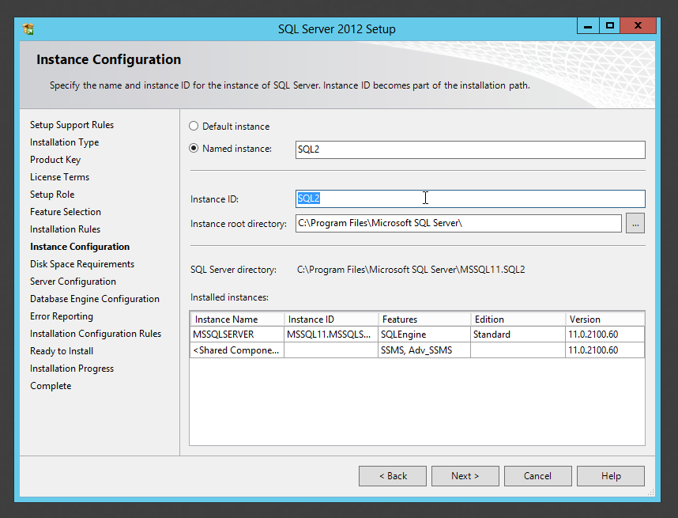
Figure A-11 Don’t forget the instance name that you provide here!
Setup will then show you how much disk space this will all take, as shown in figure A-12. Make sure you’re comfortable with the amount of free space you’ll have left.
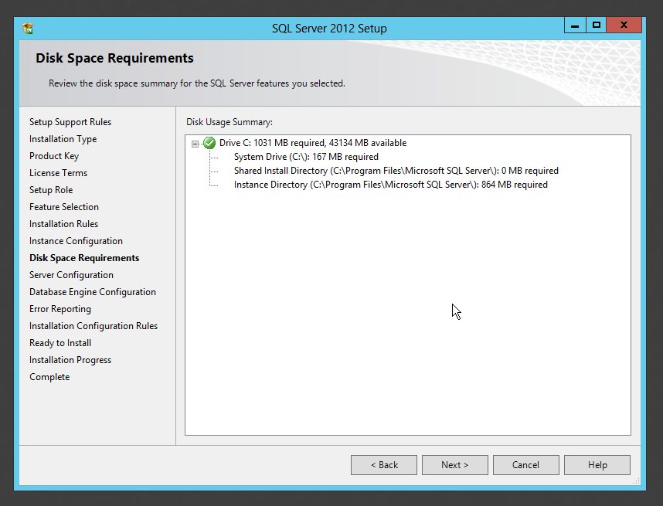
Figure A-12 Setup provides you with a disk space requirement
The next screen, shown in figure A-13, is also important. Here, you’ll specify the user accounts and startup types for the SQL Server services that are required by the features you chose. If you’re setting up a lab environment, it’s pretty safe to leave these at the default, although I do like to change SQL Server Agent to start automatically, and I often set the Browser to Manual since I don’t use it. In a production environment, it’s becoming more common to configure a user account or a Managed Service Account to run the services under; you’ll need to consult with your directory services folks to see which they prefer to use. You’ll learn more about how these user accounts are used in Learn SQL Server in a Month of Lunches.
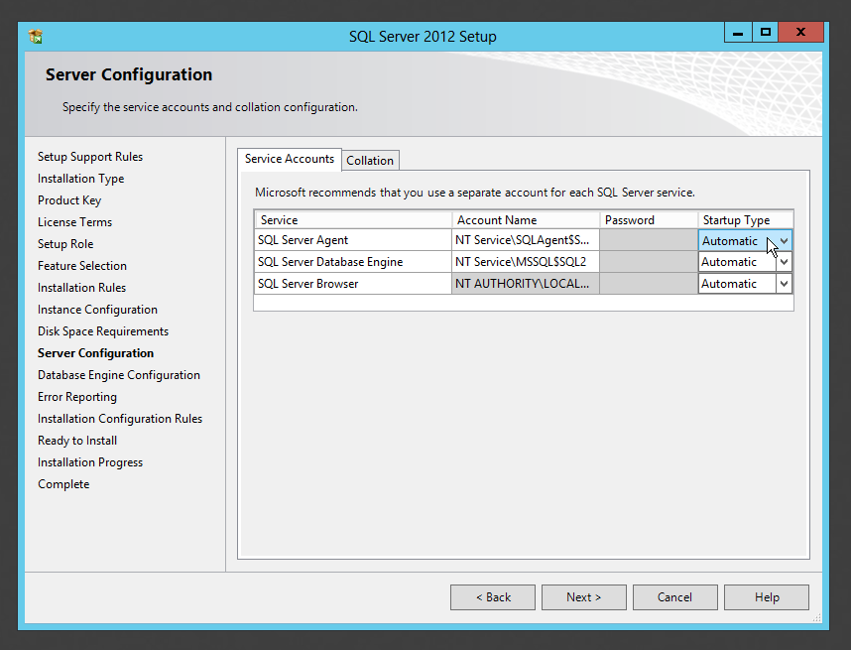
Figure A-13 Choose the service parameters for SQL Server’s services
We’re almost done, and figure A-14 has the last main configuration screen. Here, you’ll select the authentication mode SQL Server will use. In production, you’ll need to know what the applications using SQL Server expect, and many will require “Mixed Mode,” which is what I’ve selected. If you choose that, you must provide a password for the built-in, all-powerfull “sa” account.
In a lab environment, you can just leave it at “Windows authentication.” Either way, you’ll need to add a Windows user or group as an administrator of SQL Server. The Add current user button will add whoever you’re currently logged on as.
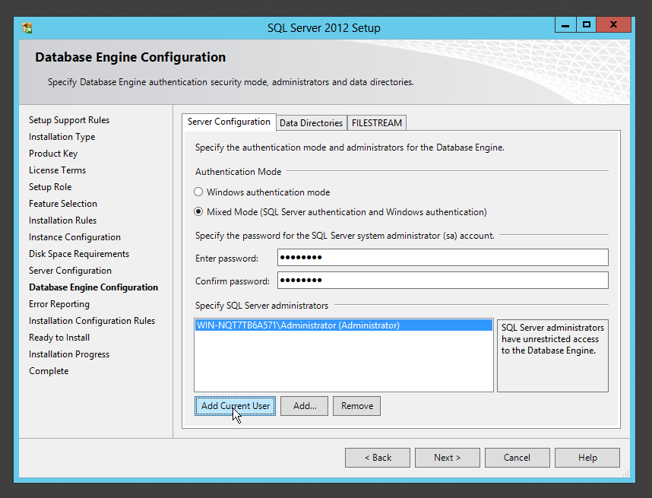
Figure A-14 Choose your authentication mode
The next screen, shown in figure A-15, asks if you want error reports to be sent to Microsoft. Your organization should have a policy about that, since many Microsoft products offer the option.
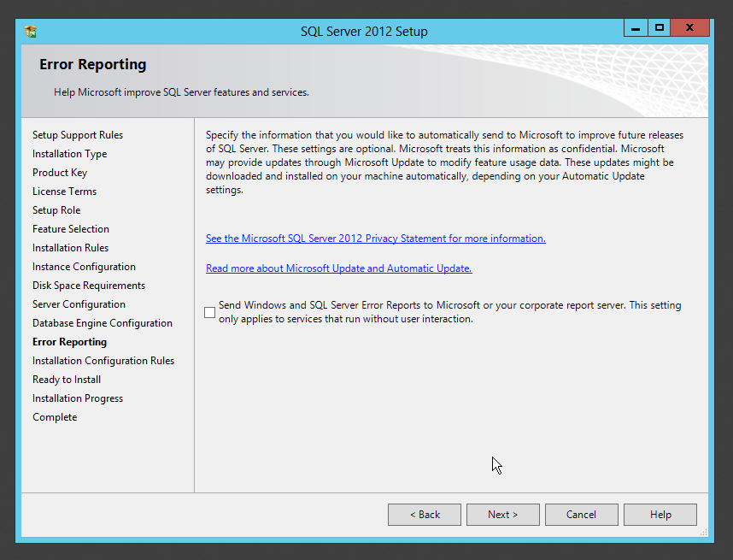
Figure A-15 Choose an error reporting option
As shown in figure A-16, SQL Server will perform one last round of checks to make sure everything looks okay to install based on the information you’ve provided. Be sure to deal with any errors, as you can’t safely proceed without resolving them.
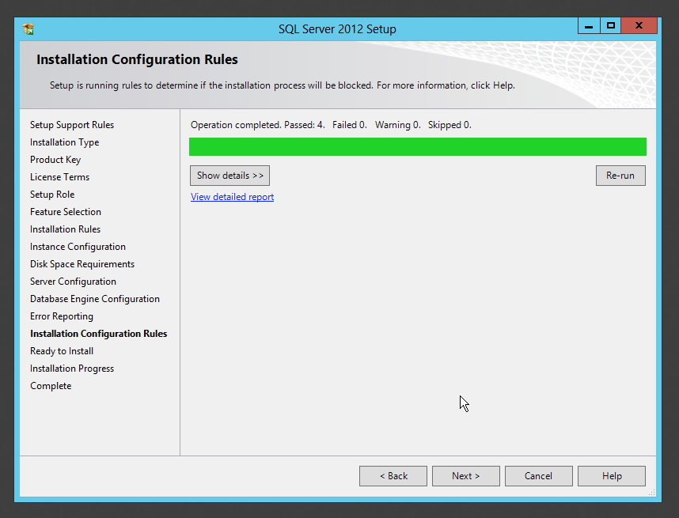
Figure A-16 The final installation check
Figure A-17 shows your last screen, where you’ll confirm what Setup is about to do.
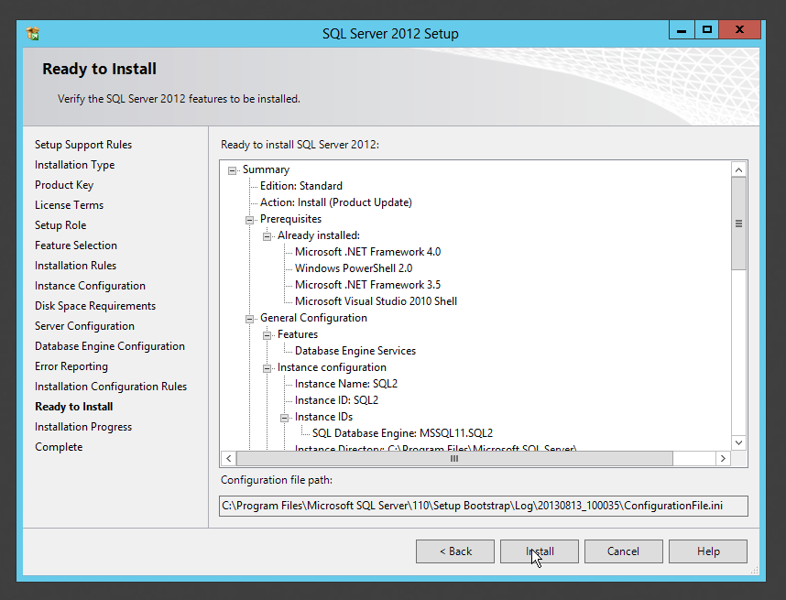
Figure A-17 Check everything carefully before clicking Install
You’re off an running! Figure A-18 shows the progress bar you’ll be watching for anything from a few minutes to what seems like an eternity, depending on what you’ve asked to be installed.
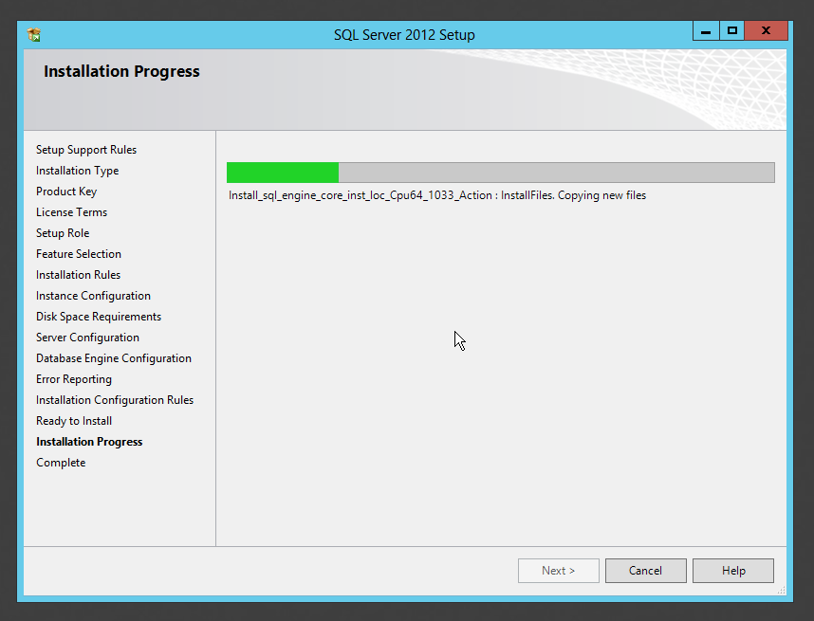
Figure A-18 Watching Setup install SQL Server
With any luck, you’ll complete without error. Figure A-19 shows that I’ll need to restart, something that happens a lot to me when I install another instance on a computer that already has one instance running on it. Take care of that restart, and SQL Server is up and running.
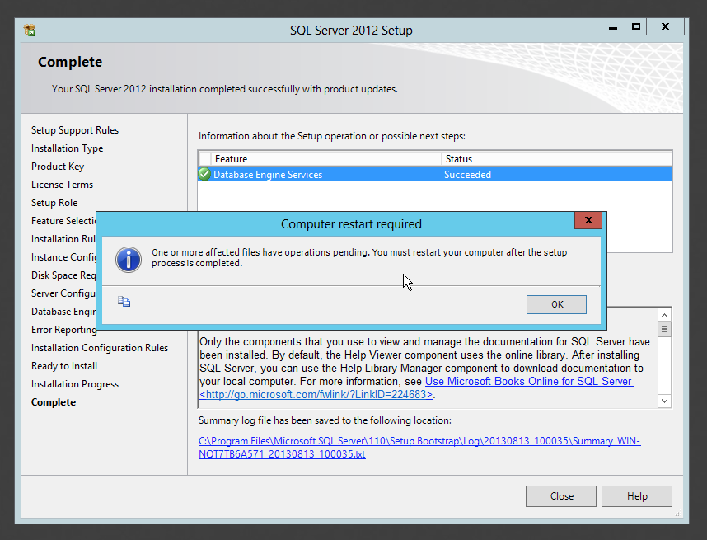
Figure A-19 Setup complete, and time to restart
Once you restart (if necessary), SQL Server should be ready to use.
  - Installing the Adventure Works 2012 Database
This isn’t a necessary step in a production environment, but in a lab environment the Adventure Works 2012 database gives you a fully populated database to play with, making labs more interesting.
Note If didn’t install SQL Server 2012, make sure you try to get a matching version of Adventure Works. For example, there’s an Adventure Works 2008 sample database also. Most should be available from the same CodePlex.com Web site where Adventure Works 2012 is located. It’s usually safe to use an older database on a newer version of SQL Server, and the worst that can happen is that it just won’t work – you shouldn’t damage anything by trying.
The trick is in getting the right download. Adventure Works is Microsoft’s all-in-one sample, so they offer a variety of different variations, such as one for data warehousing (the “DW” variant). I went to http://msftdbprodsamples.codeplex.com/releases/ and found a link for all of the Adventure Works releases, including 2008, 2008R2, and 2012. Note that the “DW” variant isn’t what you want – I went to http://msftdbprodsamples.codeplex.com/releases/view/93587 to get the right download. The “Recommended Download” on that page was “AdventureWorks2012_Database.zip,” which is what I wanted. Pay close attention to filenames; you don’t want the “LT” light-weight version, and you don’t want the “DW” data warehousing version.
There are brief instructions on the page for attaching the downloaded database to SQL Server, but I’ll walk you through it. Obviously, start by downloading it first. What you’ll end up with is a ZIP file; right-click that to extract all the files. I suggest extracting them to a permanent location, such as C:\Data.
Then open, SQL Server Management Studio – in newer versions of Windows, I like to pin this to the Task bar so I can find it easily. It should be located in SQL Server’s installation folder if you can’t find it; in Windows 8, go to the Start screen and type “SQL” to try and find it. The first thing you’ll see when you run it is the connection screen – as you can see in figure A-20, I’m connecting to my local computer (localhost) and the SQL2 instance I just installed (localhost\SQL2). I have it using Windows authentication, meaning it’s connecting using my logon credentials.
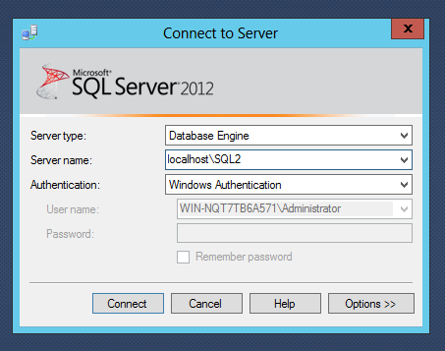
Figure A-20 Connect to your SQL Server instance

In the Object Explorer, which is usually on the left, right-click Databases and select Attach… as shown in figure A-21.
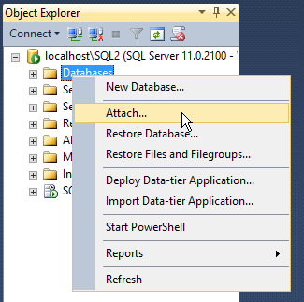
Figure A-21 Select the option to attach a database
Click the Add button to add the Adventure Works 2012 data file, which has an .MDF filename extension. If you’ve placed that file somewhere under your profile folder, such as in your Documents or Desktop folder, the folder picker may have trouble finding it. That’s why I tend to create a folder specifically for the database, under the C:\ drive, just so it’s easy to find. Figure A-22 shows what you should see after choosing the file – notice that the corresponding log file, with an .LDF filename extension, has been selected automatically.
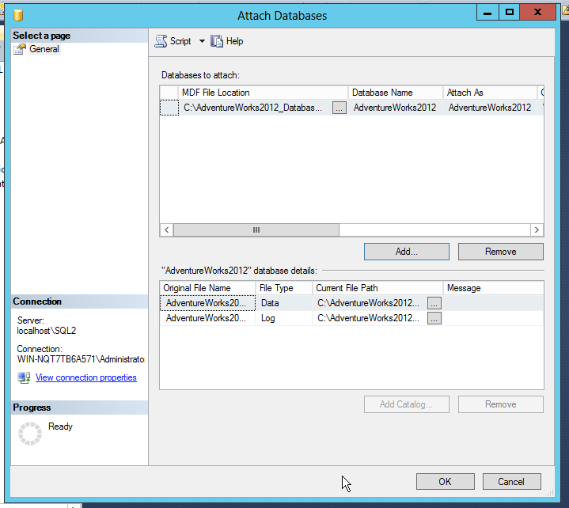
Figure A-22 Select the Adventure Works 2012 database files
Now just click OK. As shown in figure A-22, you should be able to expand the Databases node in Object Explorer and see AdventureWorks2012 connected and ready to go. You only have to do this once; it’ll be there from now on when you open SQL Server Management Studio.
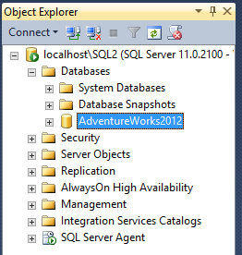
Figure A-23 The database is attached and ready to go
I should point out that everything I’ve shown you about attaching this database is suitable only in a lab environment. In a production environment, you wouldn’t store your database on the C:\ drive – and you probably wouldn’t be attaching a sample database in production, either! Learn SQL Server in a Month of Lunches discusses appropriate locations for database files, along with other concerns.
At this point, your lab should be set up and ready to go.

