WF5W Rmail Server
(EmComm)

Use with any SmartPhone, PC, Apple, or Tablet devices

How do I

send a

Message?
Step 1



Set phone to Airplane Mode
Step 2

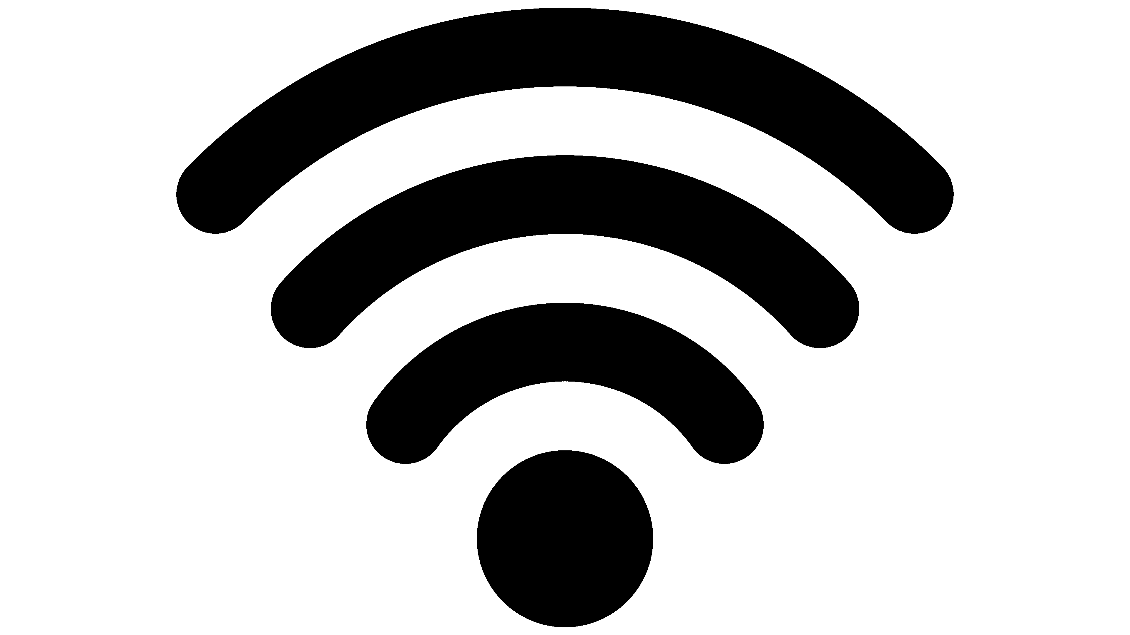

Verify Wi-Fi is on
Step 3

RMAIL-xxxxxx

Connect to RMAIL Wi-Fi
Step 4a

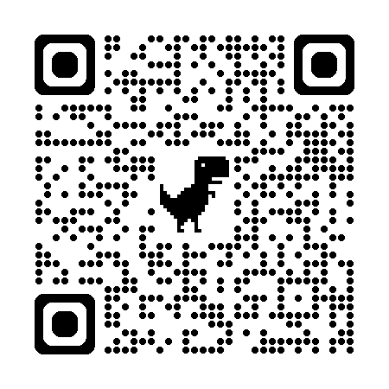
Select QR code using camera
or go to Step 4b
Step 4b



Open Web Browser and Type
10.42.0.1:4000
Step 5
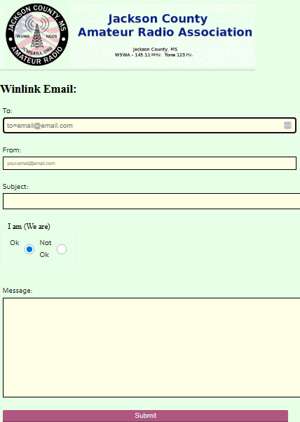
Every Rmail sent you will receive a cc: email copy.

