"PRINCIPLES OF PHYLOGENETICS: ECOLOGY AND EVOLUTION"
Integrative Biology 200 Spring 2014
University of California, Berkeley D.D. Ackerly

April 16, 2014. Community Ecology and Phylogenetics

Readings:
Cavender-Bares, J., D. D. Ackerly, D. Baum, and F. A. Bazzaz. 2004. Phylogenetic overdispersion in Floridian oak communities. Amer. Nat. 163:823-843.
Cavender-Bares, J., K. H. Kozak, P. V. A. Fine, and S. W. Kembel. 2009. The merging of community ecology and phylogenetic biology. Ecology letters 12:693-715.

The field of community ecology asks: what are the processes responsible for the identity and relative abundance of species that cooccur in local assemblages, and how do these vary through time? These processes span a wide range, from ecophysiology and stress tolerance, to the intricacies of biotic interactions including competition, predation, symbioses, etc. The concept of the niche has played a central, though controversial role in community ecology. Two related ideas have shaped the intersection of community ecology with phylogenetics: 1) identical species cannot coexist (the competitive exclusion principle), and 2) related species are ecologically similar (niche conservatism or phylogenetic signal). Therefore, as Darwin argued:

As species of the same genus have usually, though by no means invariably, some similarity in habits and constitution, and always in structure, the struggle will generally be more severe between species of the same genus, when they come into competition with each other, than between species of distinct genera.
(Darwin 1859)

The corollary of these two principles is that closely related species should co-occur less than would be expected (though the question of what is expected requires careful consideration). Initial efforts to test this hypothesis focused on species:genus ratios, predicted to be lower than expected in local assemblages (e.g., on islands, see citations in Webb et al. 2002). With the elaboration of highly resolved and time-calibrated phylogenies, these questions have been reframed in terms of phyletic distance among co-occurring species.

Starting with Diamond (1975), the focus on the competitive exclusion principle was expanded to the more general idea of community assembly, and the search for rules and regularities in community structure that might reflect underlying ecological processes. One of the important results of these studies, especially in plant ecology, was the renewed attention to convergence in community assembly, i.e., that co-occurring species may actually be phenotypically similar, reflecting similar functional requirements to survive under shared abiotic and biotic conditions. So it is an open question for any particular trait whether co-occurring species will be more similar or more different from each other than expected. These patterns may be termed phenotypic clustering (or underdispersion) and phenotypic evenness (or overdispersion).

The initial focus on niche conservatism (or high phylogenetic signal) can also be expanded to consider the full range of possibilities: traits of relevance to community assembly may exhibit a high degree of signal, or a very low level of signal (often indistinguishable from random). These different possibilities set up the following table, relating patterns of phylogenetic signal, community assembly and resulting phylogenetic community structure (see Webb et al. 2002, Cavender-Bares et al. 2004, Kraft et al. 2007):

 | Phylogenetic signal in traits
Trait-based Community assembly | High (K ≥ 1) | Low (K << 1)
Phenotypic clustering | Phylogenetic clustering | Phylogenetic evenness
Phenotypic evenness | Phylogenetic evenness | Random

We have discussed measures of phylogenetic signal previously. Analysis of phenotypic clustering and evenness can be conducted based on trait variance and other statistics applied to the distributions of traits among co-occurring species. Two metrics that have proven useful are tests for reduced trait range, as a measure of phenotypic clustering, and for reduced standard deviation of nearest neighbor distances (in trait space), for phenotypic evenness (Kraft et al. 2008; Cornwell and Ackerly 2009). Null models with randomly assembled communities are used as a basis to test for reduced values of these statistics, relative to the null.

Here I will introduce two measures of phylogenetic clustering and evenness, as applied to community ecology. A wide array of measures have now been introduced in this area, and are reviewed in Ives and Helmus (2010)

The basic data for phylogenetic community structure analysis is a phylogenetic tree for the species of a regional species pool (i.e., the collective species list across a range of habitats or a large area), together with individual species lists for smaller plots or specific habitats within the community.

1. Phylogenetic diversity (Net relatedness index, Nearest taxon index):
To determine if the species in a particular plot are more closely related than expected by chance, the mean phylogenetic distance (MPD) is calculated as the mean of the pairwise phyletic distances among all pairs of taxa in the community:

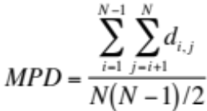

where d_{i,j} is phyletic distance between taxa i and j, and N(N-1)/2 is the number of pairwise comparisons among N taxa. This can also be generalized to incorporate species relative abundance

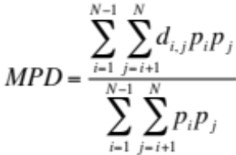

where p_{i}, p_{j} are relative abundance of species in a community (which sum to 1). The numerator alone is then known as Rao's entropy, and is closely related to the Simpson diversity index used in ecology.

The expected value for this statistic under a null model can the be calculated by randomly drawing communities of the same species richness from the regional species pool, and calculating the mean MPD across a large number of random draws. If MPD_{obs} < MPD_{null}, then the observed community is phylogenetically clustered, and conversely if MPD_{obs} > MPD_{null}. Webb et al. (2002, 2008) define the Net Relatedness Index as:

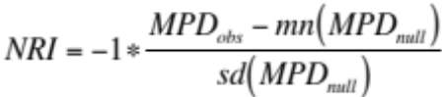

where mn and sd are the mean and standard deviation of MPD values obtained from a large number (usually 999+) of random draws. NRI is positive for clustered communities and negative for evenly spread communties, and significance can be determined by ranking the observed value in comparison with the distribution of null values. (Note that there has been some inconsistency in the literature about whether to reverse the sign of this metric, so look closely at what positive vs. negative values mean.)

A second measure of community phylogenetic structure is whether the most closely related co-occurring species in a community is more or less closely related than expected. This measure is more directly related to the calculation of species:genus ratios, as it focuses on whether closely related species tend to co-occur or not. It can be determined by first calculating the mean nearest neighbor distance:

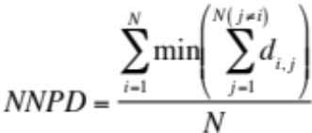

and then comparing that to the expected distribution under a null model, to obtain the Nearest Taxon Index:

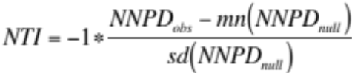

Again, positive values of NTI indicate that species co-occur with more closely related species than expected, and negative values indicate that closely related species do not co-occur.

Here I have only mentioned the simplest null model, involving a random draw of species from the overall species pool. There are a variety of more sophisticated null models, in particular ones that keep the frequency of occurrence of species constant across an entire data set (see Gotelli and Graves 1996, Kembel 2006).

2. Mantel test approaches
The second major class of methods to assess phylogenetic community structure is based on Mantel tests of correlations between distance matrices, and is analogous to the use of Mantel tests for assessing phylogenetic signal. In this case the data set would be a series of plots of communities across a landscape. For each pair of taxa in the entire landscape, you can calculate phyletic distance (d_{ij}) and a measure of co-occurrence or overlap in distribution, such as:

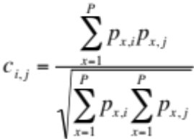

where P is the total number of plots in the data set, and p_{x,i} is presence/absence (or abundance) of species i in plot x. c_{i,j} ranges from 0, for species that never co-occur, to 1 for species that are always found together. A plot of c_{i,j} vs. p_{i,j} then provides a measure of whether closely related species tend to co-occur or to have complementary distributions (see Cavender-Bares et al. 2004).

As in discussions of phylogenetic signal, there is a many-to-one problem in the relationship between community assembly processes and community phylogenetic structure. If we use a single metric, such as NRI, it can either be positive, not different from 0, or negative. Yet, there are many different processes that may shape this statistic, depending on the scale of the study, including filtering, competition, facilitation, biotic interactions, biogeographic sorting, speciation, etc. Not surprisingly, calculating the community phylogenetics signals alone will not reveal the underlying community assembly processes. These approaches must be combined with an appreciation for the scale of the samples and pools, the makeup of the biota, evidence from trait-based studies, and experimental analysis of the factors influencing species establishment and distributions. One of the main reasons that community phylogenetics is valuable is that it is relatively easy, requiring only plot level distribution data and some phylogenetic information.

3. Community similarity and dissimilarity; phylogenetic beta-diversity
Just as the degree of relatedness of co-occurring species is calculated within communities, the phylogenetic similarity or distance between species in different communities can be assessed as a basis for community phylo-ordination or calculation of phylo-betadiversity. Ives and Helmus (2010) have introduced an interesting approach termed phylogenetic community dissimilarity (PCD) which decomposes the similarity of two communities into one component reflecting the number of species they share in common, and a second component reflecting the phylogenetic relatedness of unshared species. Graham and Fine (2008) provide a conceptual framework of applications of phylo-betadiversity to questions about spatial turnover of species and lineage diversification across communities. Fine and Kembel (2011) illustrate the application of betadiversity to questions at a regional scale at the interface of community assembly processes and regional speciation patterns.

Special Issues with lots of good articles
Ecology, vol. 87, special issue (July 2006) on phylogenies and community ecology
Ecology, vol. 93, special issue (August 2012), Integrating phylogenetics and ecology

Citations (very selective with a bias towards DA and collaborators!)
Ackerly, D. (2009) Phylogenetic Methods in Ecology. eLS DOI: 10.1002/9780470015902.a0021223
Bennett, J. a et al. (2013) Increased competition does not lead to increased phylogenetic overdispersion in a native grassland. Ecol. Lett. 16, 1168–76
Cavender-Bares, J., D. D. Ackerly, D. Baum, and F. A. Bazzaz. 2004. Phylogenetic overdispersion in Floridian oak communities. Amer. Nat. 163:823-843.
Cavender-Bares, J., et al.. 2009. The merging of community ecology and phylogenetic biology. Ecology letters 12:693-715.
Cornwell, W.K. and D.D. Ackerly. 2009. Community assembly and shifts in the distribution of functional trait values across an environmental gradient in coastal California. Ecological Monographs 79: 109-126.
Crisp, M. and Cook, L. (2012) Phylogenetic niche conservatism : what are the underlying evolutionary and ecological causes ? New Phytol.
Diamond, J.M. (1975). Assembly of species communities. In Ecology and evolution of communities (M. L. Cody and J. M. Diamond, eds.) pp. 342-373, Belknap Press, Cambridge, MA.
Fine, P.V.A. and S.W. Kembel. 2011. Phylogenetic community structure and phylogenetic turnover across space and edaphic gradients in western Amazonian tree communities. Ecography 34: 552-565
Gotelli, N., and G. Graves. 1996. Null models in ecology. Smithsonian Inst. Press, Washington DC.
Graham, C. H., and P. V. A. Fine. 2008. Phylogenetic beta diversity: linking ecological and evolutionary processes across space in time. Ecology Letters 11:1265-1277. doi: 10.1111/j.1461-0248.2008.01256.x.
Helmus, M.R. et al. (2007) Separating the determinants of phylogenetic community structure. Ecol. Lett. 10, 917–25
Ives, A. R., and M. R. Helmus. 2010. Phylogenetic metrics of community similarity. The American naturalist 176:E128-42. doi: 10.1086/656486.
Kembel, S.W. & Hubbell, S.P. (2006) The phylogenetic structure of a neotropical forest tree community. ECOLOGY, 87, S86-S99.
Kembel, S.W., et al.. 2010. Picante: R tools for integrating phylogenies and ecology. Bioinformatics 26: 1463-1464.
Kraft, N. and Ackerly, D. (2013) The Assembly of Plant Communities. Ecol. Environ. DOI: 10.1007/978-1-4614-7612-2
Kraft, N.J.B., et al.. 2008. Functional traits and niche-based tree community assembly in an Amazonian forest. Science 322: 580-582.
Kraft, N.P.R. and D.D. Ackerly. 2010. Functional trait and phylogenetic tests of community assembly across spatial scales in an Amazonian forest. Ecological Monographs 80: 401-422
Lessard, J.-P. et al. (2012) Inferring local ecological processes amid species pool influences. Trends Ecol. Evol. 27, 600–7
Mayfield, M.M. and Levine, J.M. (2010) Opposing effects of competitive exclusion on the phylogenetic structure of communities. Ecol. Lett. 13, 1085–93
Münkemüller, T. et al. 2014. Scale decisions can reverse conclusions on community assembly processes. Global Ecology and Biogeography, 23, 620–632.
Swenson, N.G., et al.. 2006. The problem and promise of scale dependency in community phylogenetics. Ecology 87: 2418-2424.
Valiente-Banuet, A. and M. Verdú. 2007. Facilitation can increase the phylogenetic diversity of plant communities. Ecology Letters 10: 1029-1036
Vamosi, S.M. et al. (2009) Emerging patterns in the comparative analysis of phylogenetic community structure. Mol. Ecol. 18, 572–92
Webb, C. O., et al.. 2002. Phylogenies and community ecology. Annu. Rev. Ecol. Syst. 33:475-505.
Webb, C.O., et al. 2008. Phylocom: software for the analysis of phylogenetic community structure and trait evolution. Bioinformatics 24: 2098-2100.

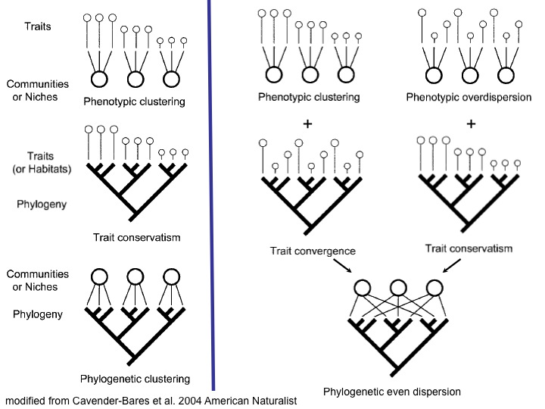

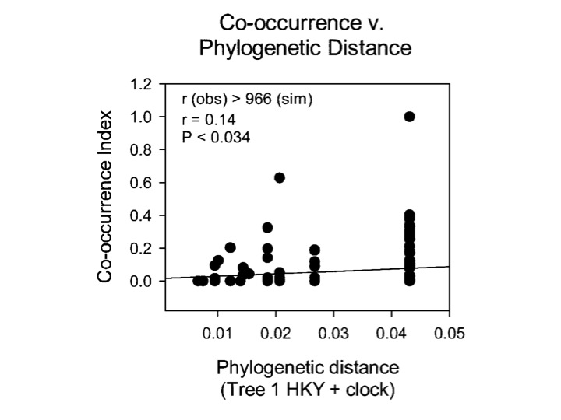
Cavender-Bares et al. 2004. Amer. Nat.

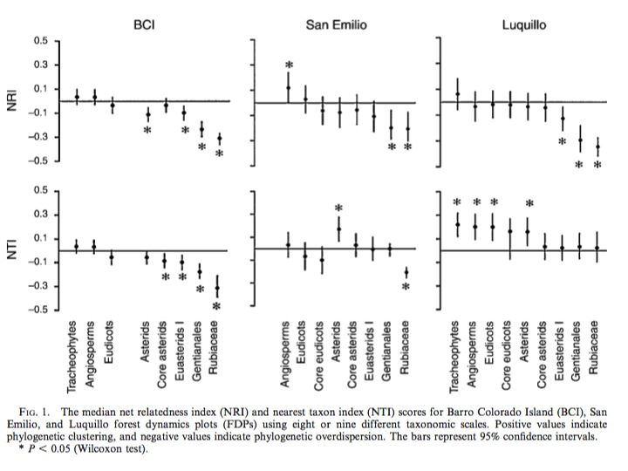
Swenson et al. 2006. Ecology
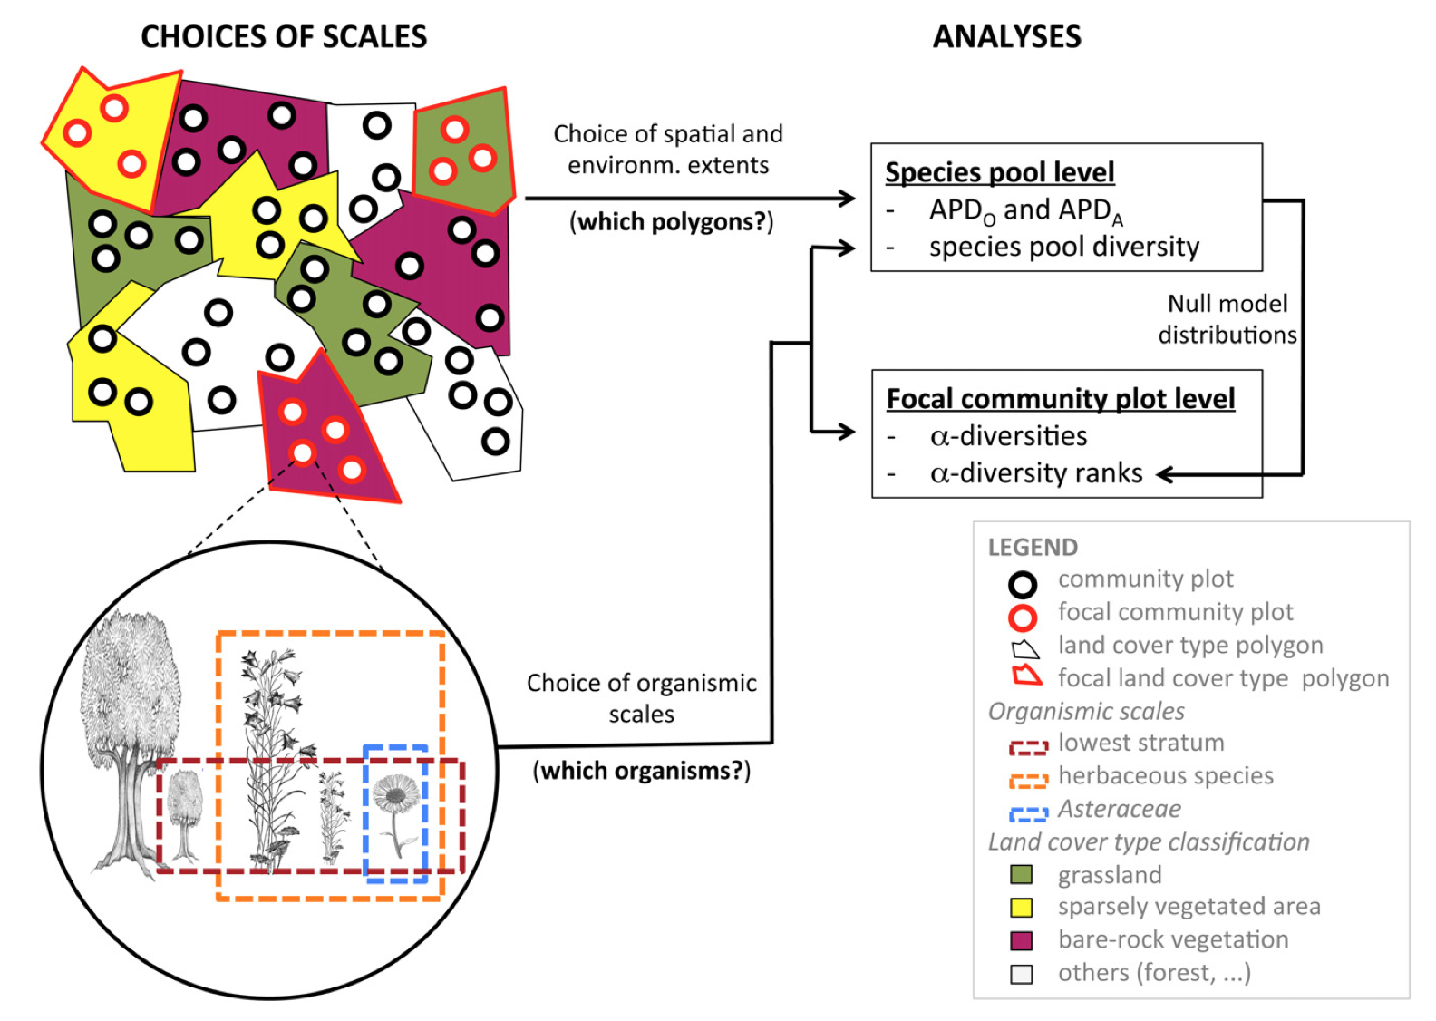
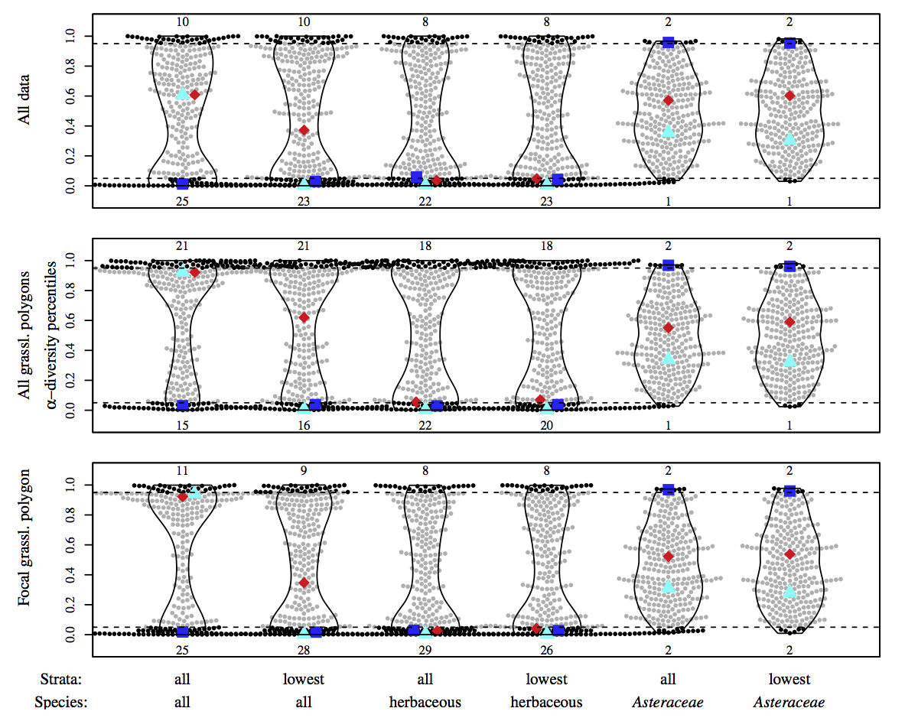
Münkemüller et al. 2014 Glob Ecol Biogeogr.

