*Integrative Biology 200A* "PRINCIPLES OF PHYLOGENETICS: SYSTEMATICS" Spring 2012

**Quiz 1**

You may use any books, notes, or references, but you must work independently of other people. To keep the amount of writing under control, please confine the answers to the space provided (but write clearly and large enough to see!); outlines and pictures are fine. Word-processed answers are OK, as long as they are the equivalent length. **The Quiz is due at 3:30 sharp**, either in room 3083 VLSB, or by email to: BMishler@berkeley.edu. Relative point value is given -- 100 points total.

**1.** (10 pts.) Fossils can be useful in breaking up long branches that result when only living taxa are considered in morphological analyses. But what do you do when the fossil groups do not have any obvious living relatives? For example, trilobites and crabs.

**2.** (10 pts.) Think about Miniature Pinscher and Doberman Pinscher dog breeds.

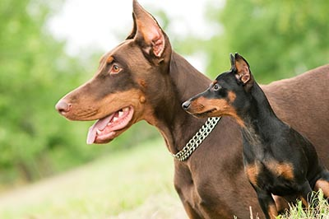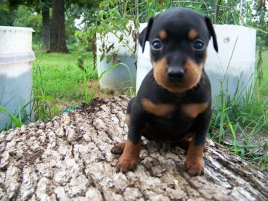

Doberman MinPin Pup of both breeds

What form of heterochrony has been selected for here? How are size, shape, and age varying in each breed?

**3.** (10 pts.)How does a data matrix created for a phenetic analysis differ from one build for a cladistic analysis, and how would these differ from one for an evolutionary systematist? What are the difference in philosophy underlying these differences?

**4.** (20 pts.) Consider this data matrix:

OTU_0 0001

OTU_1 0001

OTU_2 1000

OTU_3 1110

OTU_4 1110

OTU_5 1100

OTU_0 is the outgroup. The characters given are non-additive.

**a**. Find the most parsimonious tree for this matrix:

**b**. Without changing the resulting tree(s) that result from the given matrix add additional characters to the matrix (one each) with the following attributes:

i) An autapomorphy

ii) A character that has an ambiguous optimization

iii) An uninformative character

iv) A multistate additive character with at least 4 states

**c.** Show the tree from **a** with your new characters optimized on it:

**d.** Show the same tree with the alternative optimization for ii drawn on it:

**e**. Combine your tree with the ones below and make the strict, semi-strict and majority rules trees.

(OTU_0 (OTU_1 (OTU_3 (OTU_5 (OTU_2 OTU_4 )))))

(OTU_0 (OTU_1 (OTU_2 (OTU_5 (OTU_3 OTU_4 )))))

(OTU_0 (OTU_1 (OTU_3 (OTU_5 (OTU_2 OTU_4 )))))

(OTU_0 (OTU_1 (OTU_2 (OTU_5 (OTU_3 OTU_4 )))))

(OTU_0 (OTU_1 (OTU_3 (OTU_5 (OTU_2 OTU_4 )))))

(OTU_0 (OTU_1 (OTU_2 (OTU_5 (OTU_4 OTU_3 )))))

(OTU_0 (OTU_1 (OTU_2 OTU_5 (OTU_3 OTU_4 )))))

(OTU_0 (OTU_1 (OTU_2 (OTU_5 OTU_3 OTU_4 )))))

(OTU_0 (OTU_1 (OTU_2 (OTU_3 (OTU_5 OTU_4 )))))

**5.** (10 pts.) Two research labs are studying the same taxonomic group. One lab is analyzing many OTUs (>100) but using only two genes. The other is using 10 genes but only from 20 OTUs. At an international meeting the two labs present their results, which conflict at certain key points in the tree. The 20 OTU lab claims that because their bootstrap values are much higher that the >100 OTU lab that their results should be preferred. Assuming all else is equal, do you find the argument for preferring the 20 OTU lab’s results compelling? Explain your answer.

What might you use to determine the relative merits of the two studies in addition to, or as an alternative to bootstrap analysis?

**6.** (10 pts.) Since we can theoretically have a model for DNA character change that is extremely parameter rich, why do we chose not to do so? What methods are available for choosing? Explain how the choice is made.

**7.** (10 pts.) What is the molecular clock hypothesis? Explain why the molecular clock better serves as a null hypothesis or an alternative hypothesis. Suppose you build a phylogeny using maximum likelihood. How would you test whether your traits are subject to a global molecular clock?

**8.** (10 pts.) Recall Bayes’ theorem:

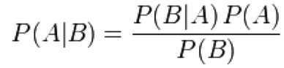

Label the prior, posterior, and likelihood. In a phylogenetic context, what are the random variables A and B for these functions? Suppose you use MrBayes (which uses Markov chain Monte Carlo (MCMC)) analyze your data matrix. What distribution does MCMC sample from when it is in stationarity? How might you tell you are in stationarity using MrBayes?

**9.** (10 pts. total -- 2 pts. ea.) Compare and contrast the following pairs of terms:

a. Establishing and testing homology in morphological characters versus the alignment of sequence data?

b. ordering of characters versus polarizing of characters.

c. gaps in aligned DNA sequences versus missing or inapplicable morphological data

d. ontology versus epistemology in philosophy

e. plant versus animal development