Assignment 2.16 (Creation of S3 Bucket and associated Screenshots using AWS CDK up to Run cdk destroy)

Updated Policies

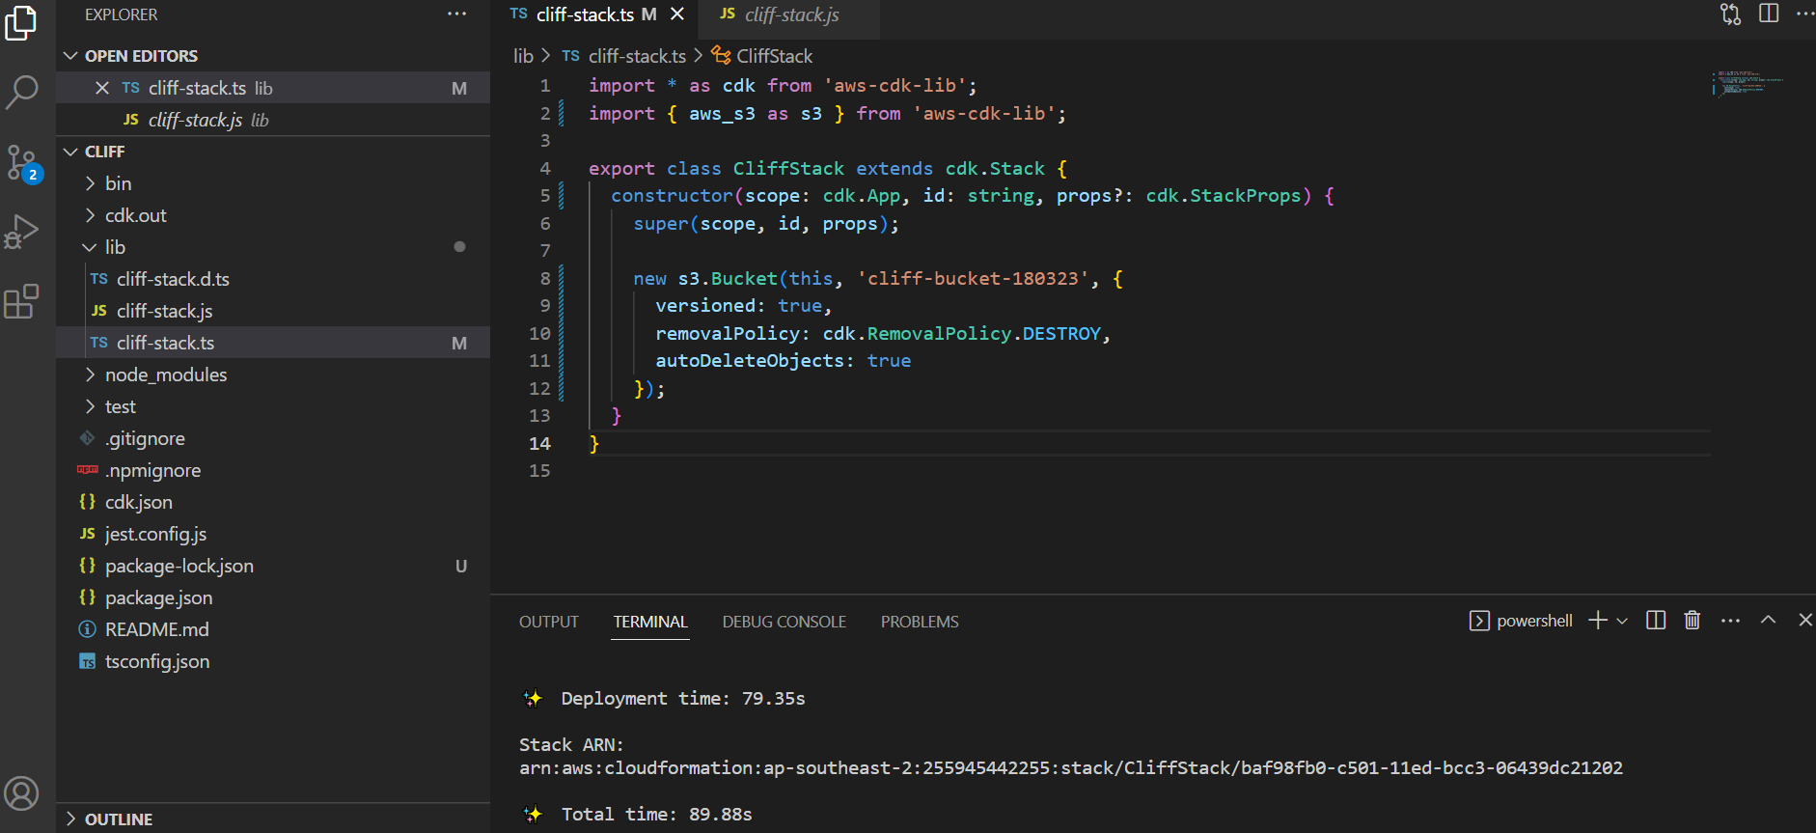

cdk diff

Stack CliffStack

IAM Statement Changes

┌───┬──────────────────────────────┬────────┬──────────────────────────────┬───────────────────────────────┬───────────┐

│ │ Resource │ Effect │ Action │ Principal │ Condition │

├───┼──────────────────────────────┼────────┼──────────────────────────────┼───────────────────────────────┼───────────┤

│ + │ ${Custom::S3AutoDeleteObject │ Allow │ sts:AssumeRole │ Service:lambda.amazonaws.com │ │

│ │ sCustomResourceProvider/Role │ │ │ │ │

│ │ .Arn} │ │ │ │ │

├───┼──────────────────────────────┼────────┼──────────────────────────────┼───────────────────────────────┼───────────┤

│ + │ ${cliff-bucket-180323.Arn} │ Allow │ s3:DeleteObject* │ AWS:${Custom::S3AutoDeleteObj │ │

│ │ ${cliff-bucket-180323.Arn}/* │ │ s3:GetBucket* │ ectsCustomResourceProvider/Ro │ │

│ │ │ │ s3:List* │ le.Arn} │ │

└───┴──────────────────────────────┴────────┴──────────────────────────────┴───────────────────────────────┴───────────┘

IAM Policy Changes

┌───┬────────────────────────────────────────────────────────┬─────────────────────────────────────────────────────────┐

│ │ Resource │ Managed Policy ARN │

├───┼────────────────────────────────────────────────────────┼─────────────────────────────────────────────────────────┤

│ + │ ${Custom::S3AutoDeleteObjectsCustomResourceProvider/Ro │ {"Fn::Sub":"arn:${AWS::Partition}:iam::aws:policy/servi │

│ │ le} │ ce-role/AWSLambdaBasicExecutionRole"} │

└───┴────────────────────────────────────────────────────────┴─────────────────────────────────────────────────────────┘

(NOTE: There may be security-related changes not in this list. See https://github.com/aws/aws-cdk/issues/1299)

Resources

[+] AWS::S3::BucketPolicy cliff-bucket-180323/Policy cliffbucket180323Policy78FEE5B4

[+] Custom::S3AutoDeleteObjects cliff-bucket-180323/AutoDeleteObjectsCustomResource cliffbucket180323AutoDeleteObjectsCustomResource3DEFBD83

[+] AWS::IAM::Role Custom::S3AutoDeleteObjectsCustomResourceProvider/Role CustomS3AutoDeleteObjectsCustomResourceProviderRole3B1BD092

[+] AWS::Lambda::Function Custom::S3AutoDeleteObjectsCustomResourceProvider/Handler CustomS3AutoDeleteObjectsCustomResourceProviderHandler9D90184F

[~] AWS::S3::Bucket cliff-bucket-180323 cliffbucket18032363BA7F1A

├─ [+] Tags

│ └─ [{"Key":"aws-cdk:auto-delete-objects","Value":"true"}]

├─ [~] DeletionPolicy

│ ├─ [-] Retain

│ └─ [+] Delete

└─ [~] UpdateReplacePolicy

├─ [-] Retain

└─ [+] Delete

cdk deploy

CliffStack: creating CloudFormation changeset...

CliffStack | 0/8 | 5:09:48 AM | UPDATE_IN_PROGRESS | AWS::CloudFormation::Stack | CliffStack User Initiated

CliffStack | 0/8 | 5:09:51 AM | CREATE_IN_PROGRESS | AWS::IAM::Role | Custom::S3AutoDeleteObjectsCustomResourceProvider/Role (CustomS3AutoDeleteObjectsCustomResourceProviderRole3B1BD092)

CliffStack | 0/8 | 5:09:51 AM | UPDATE_IN_PROGRESS | AWS::S3::Bucket | cliff-bucket-180323 (cliffbucket18032363BA7F1A)

CliffStack | 0/8 | 5:09:52 AM | UPDATE_IN_PROGRESS | AWS::CDK::Metadata | CDKMetadata/Default (CDKMetadata)

CliffStack | 0/8 | 5:09:52 AM | CREATE_IN_PROGRESS | AWS::IAM::Role | Custom::S3AutoDeleteObjectsCustomResourceProvider/Role (CustomS3AutoDeleteObjectsCustomResourceProviderRole3B1BD092) Resource creation Initiated

CliffStack | 1/8 | 5:09:53 AM | UPDATE_COMPLETE | AWS::CDK::Metadata | CDKMetadata/Default (CDKMetadata)

CliffStack | 2/8 | 5:10:12 AM | UPDATE_COMPLETE | AWS::S3::Bucket | cliff-bucket-180323 (cliffbucket18032363BA7F1A)

CliffStack | 3/8 | 5:10:34 AM | CREATE_COMPLETE | AWS::IAM::Role | Custom::S3AutoDeleteObjectsCustomResourceProvider/Role (CustomS3AutoDeleteObjectsCustomResourceProviderRole3B1BD092)

CliffStack | 3/8 | 5:10:36 AM | CREATE_IN_PROGRESS | AWS::Lambda::Function | Custom::S3AutoDeleteObjectsCustomResourceProvider/Handler (CustomS3AutoDeleteObjectsCustomResourceProviderHandler9D90184F)

CliffStack | 3/8 | 5:10:37 AM | CREATE_IN_PROGRESS | AWS::S3::BucketPolicy | cliff-bucket-180323/Policy (cliffbucket180323Policy78FEE5B4)

CliffStack | 3/8 | 5:10:38 AM | CREATE_IN_PROGRESS | AWS::S3::BucketPolicy | cliff-bucket-180323/Policy (cliffbucket180323Policy78FEE5B4) Resource creation Initiated

CliffStack | 4/8 | 5:10:38 AM | CREATE_COMPLETE | AWS::S3::BucketPolicy | cliff-bucket-180323/Policy (cliffbucket180323Policy78FEE5B4)

CliffStack | 4/8 | 5:10:38 AM | CREATE_IN_PROGRESS | AWS::Lambda::Function | Custom::S3AutoDeleteObjectsCustomResourceProvider/Handler (CustomS3AutoDeleteObjectsCustomResourceProviderHandler9D90184F) Resource creation Initiated

CliffStack | 5/8 | 5:10:44 AM | CREATE_COMPLETE | AWS::Lambda::Function | Custom::S3AutoDeleteObjectsCustomResourceProvider/Handler (CustomS3AutoDeleteObjectsCustomResourceProviderHandler9D90184F)

CliffStack | 5/8 | 5:10:45 AM | CREATE_IN_PROGRESS | Custom::S3AutoDeleteObjects | cliff-bucket-180323/AutoDeleteObjectsCustomResource/Default (cliffbucket180323AutoDeleteObjectsCustomResource3DEFBD83)

CliffStack | 5/8 | 5:10:51 AM | CREATE_IN_PROGRESS | Custom::S3AutoDeleteObjects | cliff-bucket-180323/AutoDeleteObjectsCustomResource/Default (cliffbucket180323AutoDeleteObjectsCustomResource3DEFBD83) Resource creation Initiated

CliffStack | 6/8 | 5:10:52 AM | CREATE_COMPLETE | Custom::S3AutoDeleteObjects | cliff-bucket-180323/AutoDeleteObjectsCustomResource/Default (cliffbucket180323AutoDeleteObjectsCustomResource3DEFBD83)

CliffStack | 7/8 | 5:10:53 AM | UPDATE_COMPLETE_CLEA | AWS::CloudFormation::Stack | CliffStack

CliffStack | 8/8 | 5:10:53 AM | UPDATE_COMPLETE | AWS::CloudFormation::Stack | CliffStack

✅ CliffStack

✨ Deployment time: 79.35s

Stack ARN:

arn:aws:cloudformation:ap-southeast-2:255945442255:stack/CliffStack/baf98fb0-c501-11ed-bcc3-06439dc21202

✨ Total time: 89.88s

Run

cdk destroy

PS C:\Users\wfccl\cliff> cdk destroy

Are you sure you want to delete: CliffStack (y/n)? y

CliffStack: destroying... [1/1]

CliffStack | 0 | 6:30:45 AM | DELETE_IN_PROGRESS | AWS::CloudFormation::Stack | CliffStack User Initiated

CliffStack | 0 | 6:30:47 AM | DELETE_IN_PROGRESS | AWS::CDK::Metadata | CDKMetadata/Default (CDKMetadata)

CliffStack | 0 | 6:30:47 AM | DELETE_IN_PROGRESS | Custom::S3AutoDeleteObjects | cliff-bucket-180323/AutoDeleteObjectsCustomResource/Default (cliffbucket180323AutoDeleteObjectsCustomResource3DEFBD83)

CliffStack | 1 | 6:30:48 AM | DELETE_COMPLETE | AWS::CDK::Metadata | CDKMetadata/Default (CDKMetadata)

CliffStack | 2 | 6:30:55 AM | DELETE_COMPLETE | Custom::S3AutoDeleteObjects | cliff-bucket-180323/AutoDeleteObjectsCustomResource/Default (cliffbucket180323AutoDeleteObjectsCustomResource3DEFBD83)

CliffStack | 2 | 6:30:56 AM | DELETE_IN_PROGRESS | AWS::S3::BucketPolicy | cliff-bucket-180323/Policy (cliffbucket180323Policy78FEE5B4)

CliffStack | 2 | 6:30:56 AM | DELETE_IN_PROGRESS | AWS::Lambda::Function | Custom::S3AutoDeleteObjectsCustomResourceProvider/Handler (CustomS3AutoDeleteObjectsCustomResourceProviderHandler9D90184F)

CliffStack | 3 | 6:30:58 AM | DELETE_COMPLETE | AWS::S3::BucketPolicy | cliff-bucket-180323/Policy (cliffbucket180323Policy78FEE5B4)

✅ CliffStack: destroyed