一、

1、select * from customers where soundex(cust_contact)=soundex('Y Lie');

2、where过滤行，having过滤分组；where在分组前过滤，having在分组后过滤。（所有类型的where子句都可用having子句替代）

    同时用：

    select * from products where prod_price>=10 group by vend_id having count(*) >=2;

3、union

     union all 不会去重

4、





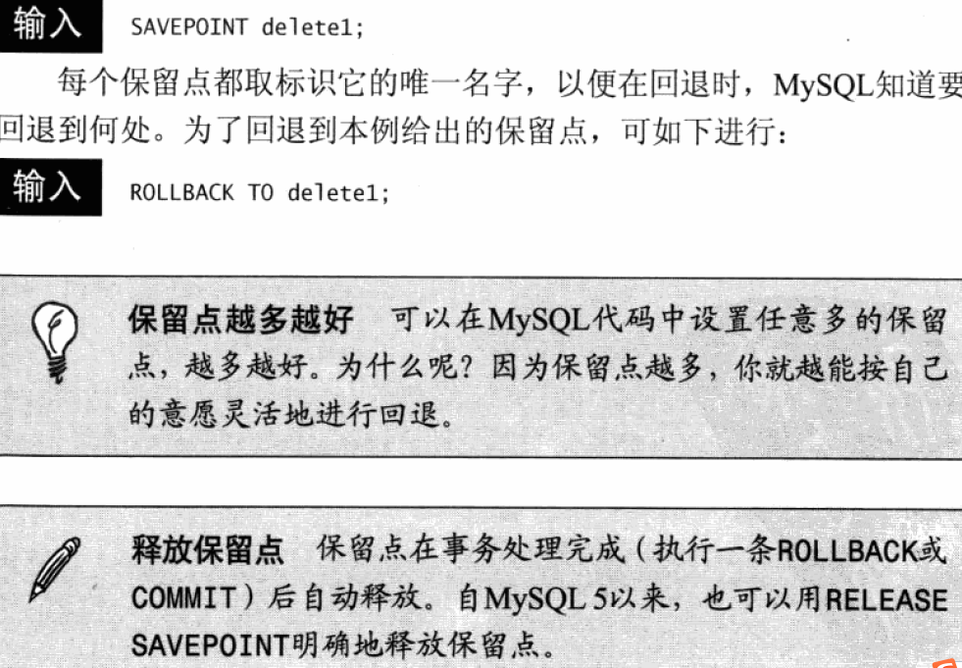

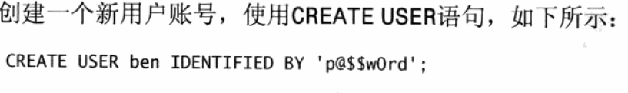

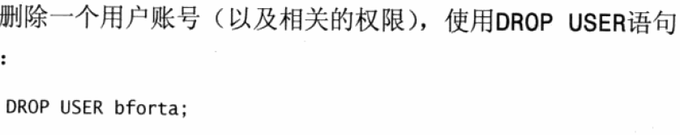

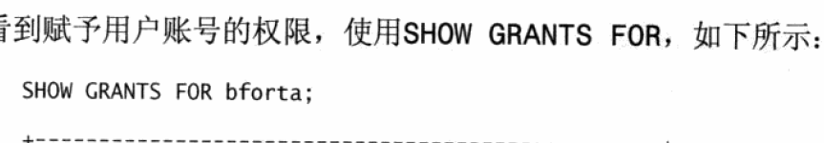

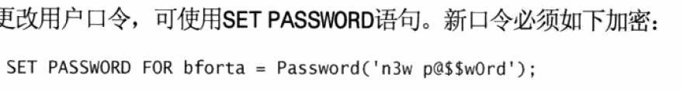

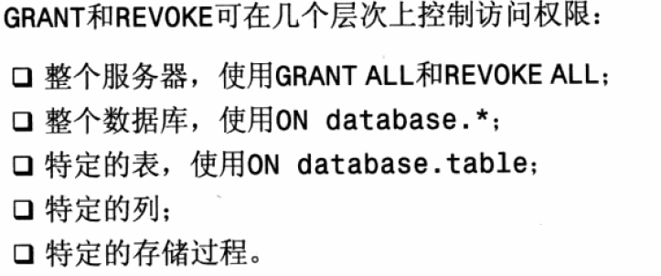

二、

1、

mysql> select b.Name,a.Name as Employee,max(a.Salary) as Salary from employee a,

department b where a.id=b.id;

select  * from product limit 0,10;

mysql> select * from employee;

+----+-------+--------+--------------+

| Id | Name  | Salary | DepartmentId |

+----+-------+--------+--------------+

|  1 | Joe   |  70000 |            1 |

|  2 | Henry |  80000 |            2 |

|  3 | Sam   |  60000 |            2 |

|  4 | Max   |  90000 |            1 |

|  5 | Janet |  69000 |            1 |

|  6 | Randy |  85000 |            1 |

+----+-------+--------+--------------+

6 rows in set (0.00 sec)

mysql> select * from department;

+----+-------+

| Id | Name  |

+----+-------+

|  1 | IT    |

|  2 | Sales |

+----+-------+

2 rows in set (0.00 sec)

mysql> select b.Name,a.Name as Employee,a.Salary as Salary from employee a,depar

tment b where a.departmentid=b.id order by a.Salary desc limit 0,3;

mysql> select b.Name,a.Name as Employee,a.Salary as Salary from employee a,depar

tment b where a.departmentid=b.id order by a.Salary desc limit 0,3;

+-------+----------+--------+

| Name  | Employee | Salary |

+-------+----------+--------+

| IT    | Max      |  90000 |

| IT    | Randy    |  85000 |

| Sales | Henry    |  80000 |

+-------+----------+--------+

3 rows in set (0.01 sec)

2、

查看表结构：

desc tablename

转换表的类型：

alter table tablename type=myisam/innodb

3、

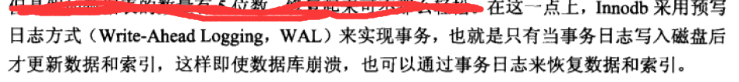

4、

5、

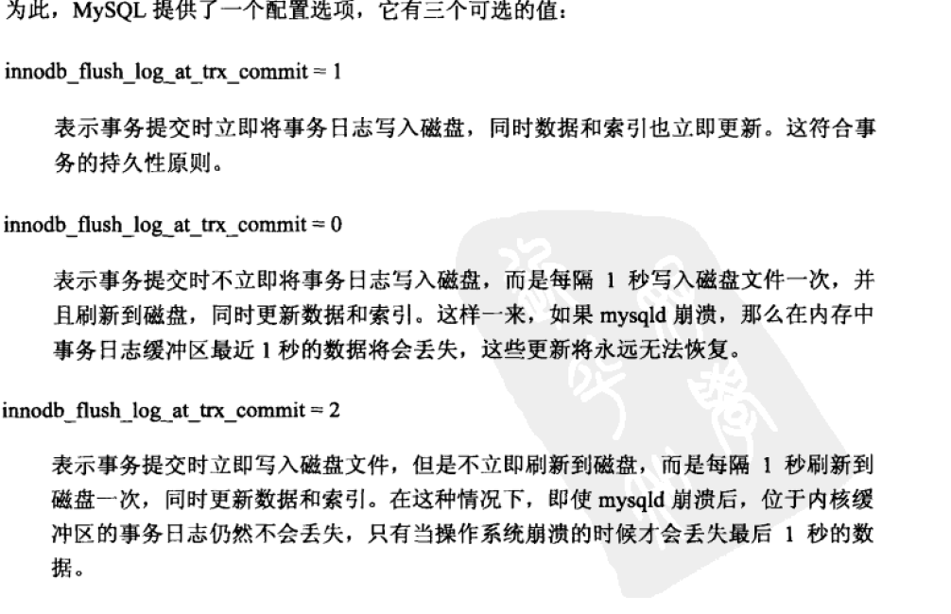



6、