AgenticRadioGen

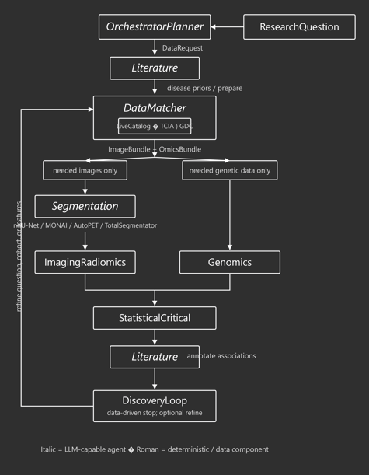
Figure 1. Conceptual framework supplied with the repository. The code-grounded architecture in Figure 2 is the authoritative interpretation of current implementation.

1. Executive Summary
AgenticRadioGen is a research-prototype application for radiogenomics. In plain language, it takes a medical research question, finds patients for whom both medical images and genomic information are available, converts the images into numerical radiomic features, converts gene mutation information into patient-level variables, and then tests whether particular imaging features possess correlation systematically with particular gene mutations.
The application is “agentic” mainly at the workflow level: different software agents handle question interpretation, data matching, imaging, genomics, statistics, and literature annotation. The scientific calculations themselves are conventional methods implemented in Python. By default the system is deterministic; an optional large language model (LLM) can help select data sources and interpret the wording of a research question.
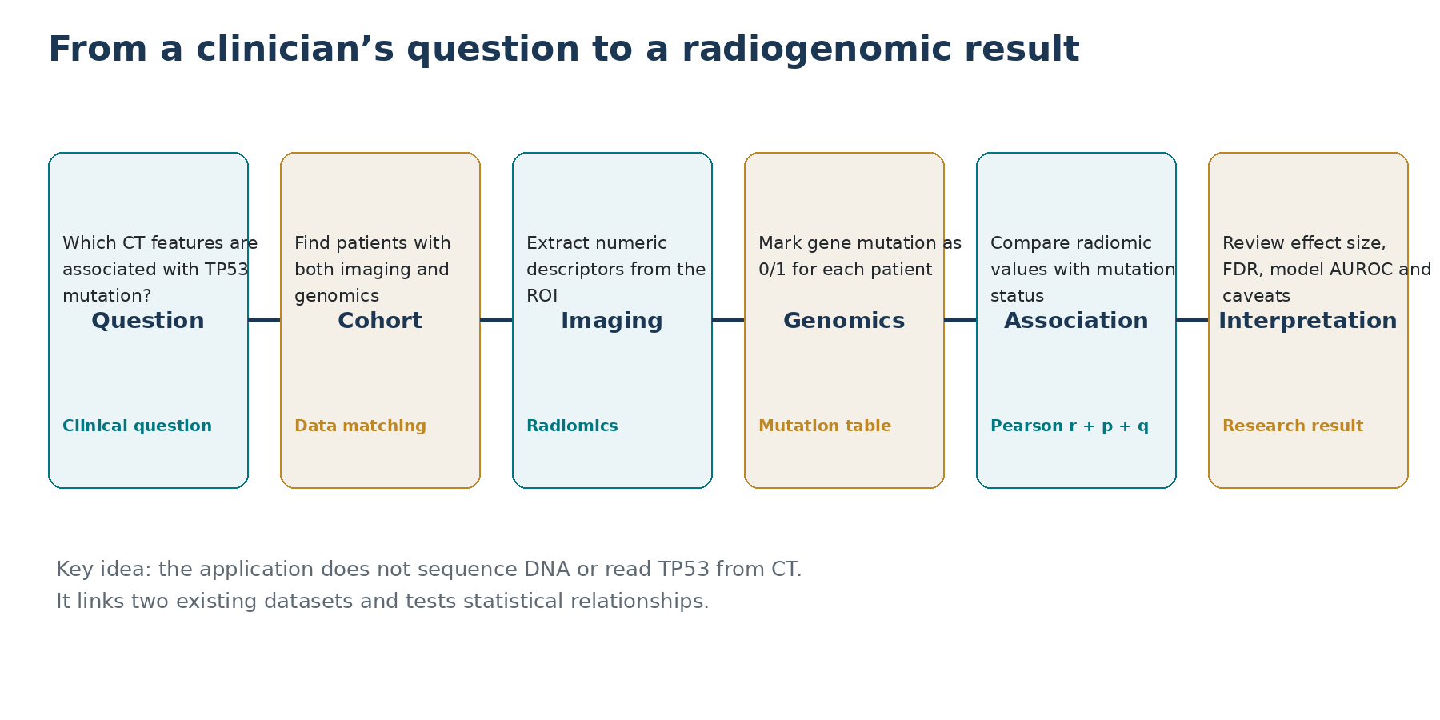
Figure 2. The end-to-end story in non-technical language.

What the application produces
Output | What it means for a non-technical user
Patient table | One row per matched patient, with radiomic measurements, mutation indicators, and selected clinical fields.
Association table | Pairs of an imaging feature and a gene-mutation variable with Pearson r, p-value, FDR-adjusted q-value, and sample size n.
Model metrics | Optional AUROC for a logistic classifier trained to separate mutation-positive from mutation-negative patients; a simple C-index is also produced when survival fields are available.
Literature labels | It uses an agent to search relavent research on PubMed.
Run metadata | The question, data request, matched sources, intermediate matching counts, and other diagnostics.

2. What the Code Actually Implements Today

Area | Implemented in current code | Important interpretation
Data pairing | Yes. TCIA imaging patients are intersected with GDC cases using normalized TCGA submitter IDs. | This is the key link between the imaging and genomic worlds.
Radiomics | Yes. PyRadiomics is called with all standard 3D feature classes enabled; fixed CT bin width = 25; no intensity normalization. | The application extracts classical handcrafted radiomics, not deep imaging embeddings.
Tumor segmentation | SegmentationAgen chooses segmentation model from patient-specific disease (e.g. TCGA-LUSC) | The agent selects available professional tumor segmentation model to be downloaded the label lesion.
Genomic mutation status | Yes. A gene is marked 1 when GDC SSM occurrences identify that gene for the patient; otherwise 0. | This is mutation presence/absence, not variant allele frequency or a full molecular profile.
Association statistics | Yes. Pearson correlation against a 0/1 mutation indicator plus Benjamini–Hochberg FDR. | This is an exploratory association test. It is not causal inference.
Predictive model | Yes. A logistic regression uses radiomics to compute an AUROC on a single 65/35 holdout. | Useful as a prototype discrimination metric; not yet a robust clinical validation protocol.
Self-correction loop | Schema and loop scaffolding exist, but the current decide() stops rather than changing the request. | The present system is best viewed as a one-pass discovery pipeline with loop infrastructure.

3. Application Structure and Main Components
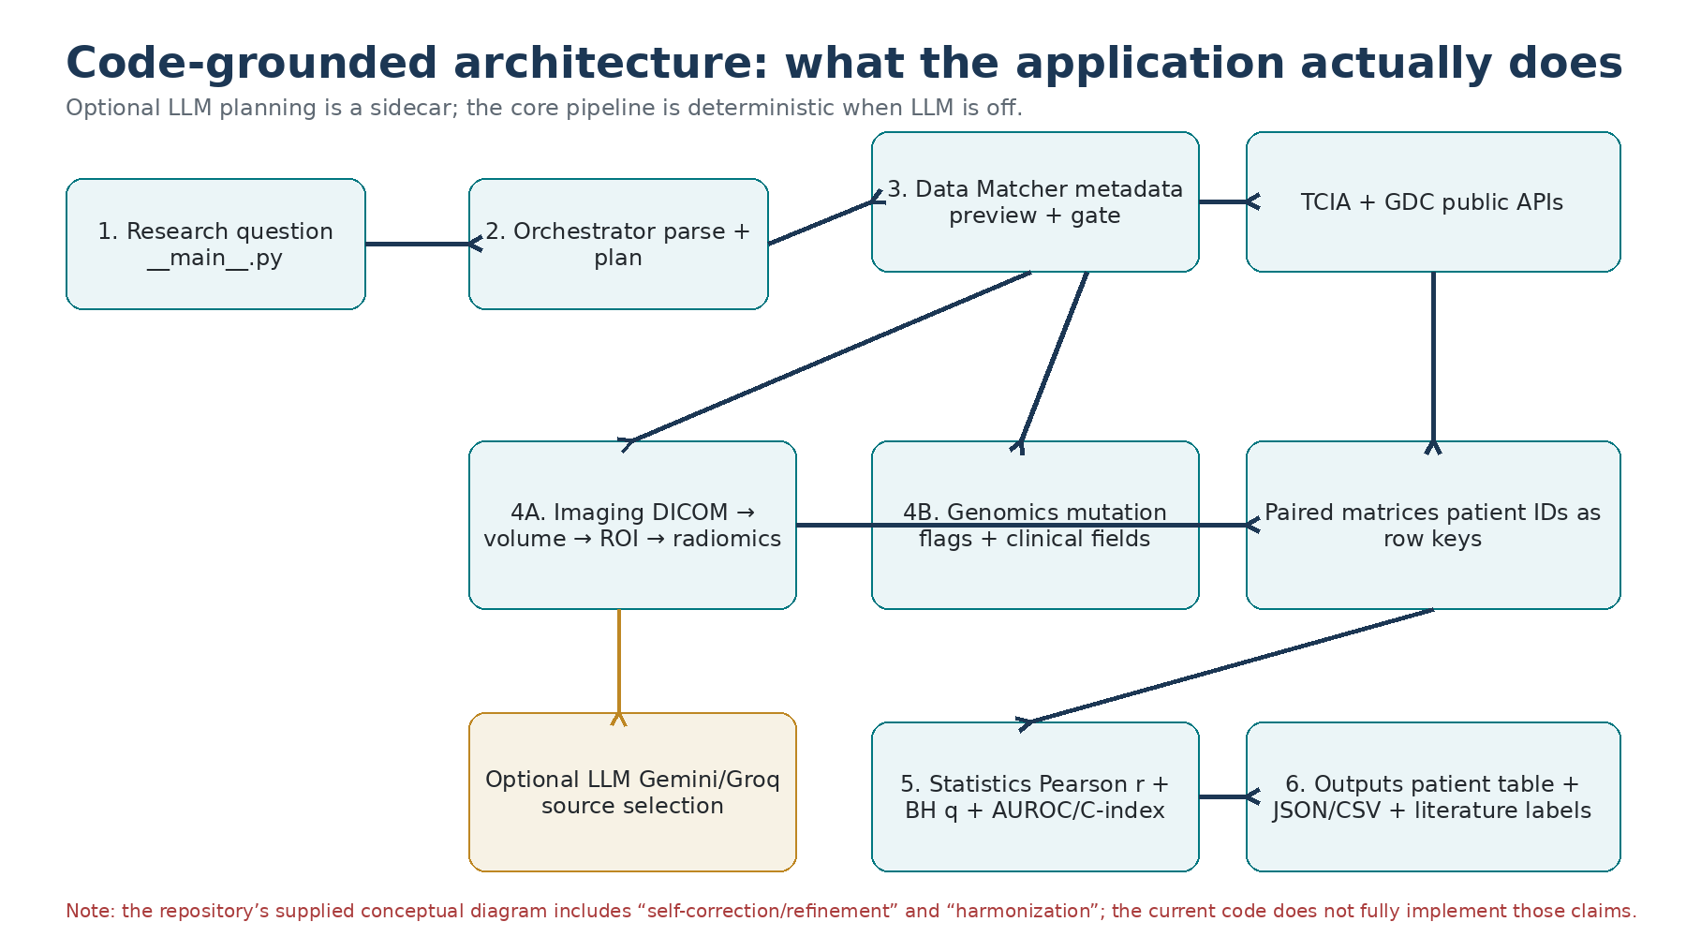
Figure 3. Code-grounded architecture derived from the source package.

Major components
Component | Repository location | Business/scientific role
Command-line entry point | agentic_radiogen/__main__.py | Starts the application, runs stages, prints summaries, and writes JSON/CSV outputs.
Orchestrator | agentic_radiogen/agents/orchestrator.py | Turns the natural-language research question into a structured data request.
Data Matcher | agentic_radiogen/agents/data_matcher.py | Previews the cohort and fetches only the selected paired patients.
Live data layer | agentic_radiogen/data/live_catalog.py | Coordinates TCIA and GDC source discovery, patient intersection, mutation discovery, and image downloading.
TCIA client | agentic_radiogen/data/tcia_client.py | Lists image collections/series, extracts patient IDs, normalizes TCGA barcodes, and downloads DICOM series.
GDC client | agentic_radiogen/data/gdc_client.py | Lists projects/cases and queries GDC somatic-mutation occurrences and selected clinical fields.
Imaging specialist | agentic_radiogen/agents/imaging.py | Converts image bundles into a patient-by-feature radiomic matrix.
DICOM loader | agentic_radiogen/imaging/dicom_io.py | Builds a 3-D numeric volume from individual DICOM slices.
Segmentation/ROI | agentic_radiogen/imaging/segment.py | Creates an ROI mask using optional TotalSegmentator or a CPU threshold fallback.
Radiomics extractor | agentic_radiogen/imaging/radiomics_extract.py | Runs PyRadiomics and caches feature values.
Genomics specialist | agentic_radiogen/agents/genomics.py | Converts mutation dictionaries into gene _mut columns and carries clinical fields.
Statistics | agentic_radiogen/agents/statistics.py | Joins imaging and genomic matrices, computes r/p/q, diagnostics, and prototype model metrics.
Literature annotator | agentic_radiogen/agents/literature.py | Matches findings to a tiny built-in paper corpus and adds interpretive labels.
Pipeline stages | agentic_radiogen/pipeline/ | Runs specialists in parallel, joins results, and manages the discovery-loop state.
Schemas | agentic_radiogen/schemas/contracts.py | Defines the structured objects passed between modules.
Optional LLM layer | agentic_radiogen/llm/ | Uses Gemini/Groq only for question/source selection; it does not perform radiomics.

4. Step-by-Step: What Happens When a User Asks a Question

4.1 User enters a research question
A typical question might be: “Which CT imaging features are associated with TP53 mutations in lung cancer?” The command-line entry point creates an OrchestratorAgent. The orchestrator identifies the disease, likely modality, desired endpoints, and gene mode, then builds a DataRequest.
agentic_radiogen/__main__.py::main() → run_stage4() → DiscoveryLoop.run()
agentic_radiogen/agents/orchestrator.py::parse() and ::plan()

4.2 The system finds a disease-appropriate imaging and genomic source
The live data path can use rule-based keyword matching or an optional LLM. The rule layer expands disease synonyms and ranks TCIA collections and GDC projects. The system prefers “pairable” sources containing TCGA-style identifiers, because a patient-level match is required before scientific analysis can proceed.
agentic_radiogen/data/disease_match.py::keyword_match_tiers(), ::rank_names(), ::diagnosis_matches()
agentic_radiogen/data/live_catalog.py::_query_by_keywords(), ::_resolve_keyword_sources()

4.3 The full imaging–genomics intersection is computed
Before the application applies the --max-patients cap, it computes the full intersection of the imaging patient IDs and GDC patient IDs. This prevents a subtle bias in which the first N imaging patients are selected before the genomic overlap is known.
agentic_radiogen/agents/data_matcher.py::preview()
agentic_radiogen/data/live_catalog.py::_build_paired_records()

4.4 Only after preview does the live run download data
A human download gate is enforced for live fetches. The fetch is question-scoped: it downloads only the paired patient IDs selected by the preview rather than an entire archive.
agentic_radiogen/agents/data_matcher.py::fetch()
agentic_radiogen/data/gate.py::FlagGate.approve()

4.5 Imaging and genomics are processed in parallel
Stage 2 launches the imaging and genomics specialists in parallel. They produce two matrices that use the same patient identifier as the row key. That shared key is the second, software-level protection against mismatching a patient’s image with another patient’s genomic data.
agentic_radiogen/pipeline/stage2.py::extract_parallel()

5. How Patient IDs Are Matched Between TCIA and GDC
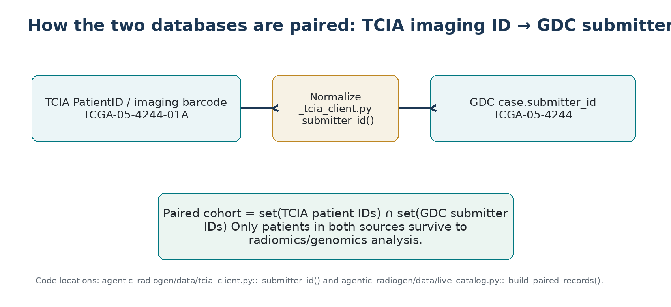
Figure 4. The actual identifier normalization used by the application.
TCIA imaging metadata can contain a longer TCGA barcode such as “TCGA-05-4244-01A”. GDC cases use the 12-character TCGA submitter ID, such as “TCGA-05-4244”. The application therefore normalizes the imaging barcode before performing the intersection.
Step | Code behavior | Why it matters
1. Read TCIA metadata | TciaClient parses PatientID from TCIA series records. | This establishes the imaging-side patient identifier.
2. Normalize TCIA identifier | _submitter_id() keeps the first three TCGA barcode components, e.g. TCGA-05-4244. | Makes TCIA and GDC identifiers comparable.
3. Read GDC cases | GdcClient retrieves case.submitter_id. | This establishes the genomics-side identifier.
4. Intersect sets | paired = set(tcia_patients) & set(gdc_cases). | Only patients represented in both databases enter the paired cohort.
5. Keep series | The selected TCIA series UID is attached to each paired record. | The image record remains traceable to a specific source series.
agentic_radiogen/data/tcia_client.py::_submitter_id()
agentic_radiogen/data/live_catalog.py::_build_paired_records()
Important practical implication
A patient can be present in TCIA but absent from GDC, or vice versa. Such a patient is deliberately excluded from the radiogenomic association analysis because both sides are required.

6. How Gene Mutations Are Found

6.1 Current live mechanism
The live genomic pathway queries GDC somatic-mutation occurrences (SSM occurrences). For each returned mutation observation, the application looks at the GDC case submitter ID and the gene symbol contained in the SSM consequence/transcript annotation. It aggregates observed gene symbols per patient.
agentic_radiogen/data/gdc_client.py::_mutation_hits()
agentic_radiogen/data/gdc_client.py::_gene_symbols()
The application can either use a specified gene panel or discover genes that are mutated in the paired cohort. When no explicit gene list is supplied, discover_genes() counts how many paired patients have an observed mutation in each gene, then ranks genes by number of affected patients.
agentic_radiogen/data/gdc_client.py::discover_genes() → ::_gene_counts()

6.2 How the gene becomes a patient-level variable
GenomicsAgent turns mutation observations into columns such as TP53_mut, EGFR_mut, KRAS_mut. The value is 1 when the gene is marked mutated for that patient and 0 otherwise. It also computes TMB_proxy as the sum of these binary mutation flags across the selected genes.
agentic_radiogen/agents/genomics.py::GenomicsAgent.extract()
Variable | Meaning in the current application
TP53_mut = 1 | At least one GDC SSM occurrence maps to TP53 for that patient.
TP53_mut = 0 | No TP53 SSM occurrence was returned/identified for that patient under the active query.
TMB_proxy | Count of selected gene-level mutation flags in the patient table; not a clinical tumor mutational burden measurement.
OS_time / OS_event | Optional overall-survival fields extracted from GDC clinical metadata.
What this does NOT mean
The current pipeline is not calculating mutation pathogenicity, allele frequency, variant clonality, copy-number alterations, methylation, transcript abundance, or a complete clinically curated mutation profile. It is a patient-level mutation-presence abstraction based on the GDC SSM query.

7. How the Imaging Side Works

7.1 DICOM is turned into a 3-D numeric volume
TCIA returns a DICOM series. load_dicom_series() reads DICOM files recursively, sorts slices by InstanceNumber (or z position), applies RescaleSlope and RescaleIntercept, converts RGB/multichannel data to grayscale when needed, resizes heterogeneous slice dimensions to a common in-plane shape, and stacks slices into a 3-D array ordered as (z, y, x).
agentic_radiogen/imaging/dicom_io.py::load_dicom_series()

7.2 An ROI mask is created
The radiomics extractor requires an ROI (region of interest). The application first checks whether TotalSegmentator is installed and usable. If so, it tries a TotalSegmentator “total” task and prefers a lung label when available. If that path is unavailable or fails, the application falls back to a CPU threshold heuristic: it removes air-like background using a -500 HU cutoff, then keeps roughly the 60th–99th percentile of intensities inside the body.
agentic_radiogen/imaging/segment.py::make_roi_mask()
agentic_radiogen/imaging/segment.py::_totalsegmentator_mask() and ::_threshold_mask()
Medical interpretation of the ROI
For a real tumor study, a tumor-specific segmentation should be validated. The current fallback mask is a soft-tissue/lesion proxy, and the TotalSegmentator route is an organ-oriented segmentation wrapper rather than a validated tumor contouring pipeline.

7.3 PyRadiomics converts the ROI into numbers
Once the image volume and ROI mask are available, PyRadiomics computes classical handcrafted features from the original image. The extractor enables all standard feature classes, uses a fixed CT bin width of 25, and explicitly disables intensity normalization. The package does not currently enable wavelet or LoG filtered feature families.
agentic_radiogen/imaging/radiomics_extract.py::_extractor()
agentic_radiogen/imaging/radiomics_extract.py::_pyradiomics_features()

8. Radiomic Features Extracted
Under the repository’s current PyRadiomics configuration, the expected standard 3-D output is 107 active original features under PyRadiomics 3.0.1’s enableAllFeatures() semantics: deprecated features are excluded. These are 18 first-order + 14 shape + 24 GLCM + 16 GLRLM + 16 GLSZM + 5 NGTDM + 14 GLDM features. The application then adds one compatibility alias, original_glcm_Entropy, because JointEntropy is present. Therefore the exported radiomic feature dictionary is expected to contain 108 named radiomic features (plus a non-radiomic metadata flag). The StandardDeviation alias is conditional and is normally not added under the documented 3.0.1 enable-all behavior because StandardDeviation is deprecated. Exact counts can change if a different PyRadiomics version or extractor configuration is used.
Feature-count summary
107 active PyRadiomics 3-D features + 1 legacy GLCM entropy alias = 108 radiomic feature names in the exported feature dictionary. The “meta_segmentation_is_gpu_or_ts” key is metadata and is not a radiomic feature.

First Order (18 active)
# | Feature | Feature | Feature
1 | Energy | TotalEnergy | Entropy
4 | Minimum | 10Percentile | 90Percentile
7 | Mean | Median | InterquartileRange
10 | Range | MeanAbsoluteDeviation | RobustMeanAbsoluteDeviation
13 | RootMeanSquared | Skewness | Kurtosis
16 | Variance | Uniformity | Maximum

Shape (3-D active; 14)
# | Feature | Feature | Feature
1 | MeshVolume | VoxelVolume | SurfaceArea
4 | SurfaceVolumeRatio | Sphericity | Maximum3DDiameter
7 | Maximum2DDiameterSlice | Maximum2DDiameterColumn | Maximum2DDiameterRow
10 | MajorAxisLength | MinorAxisLength | LeastAxisLength
13 | Elongation | Flatness

GLCM (24 active)
# | Feature | Feature | Feature
1 | Autocorrelation | JointAverage | ClusterProminence
4 | ClusterShade | ClusterTendency | Contrast
7 | Correlation | DifferenceAverage | DifferenceEntropy
10 | DifferenceVariance | JointEnergy | JointEntropy
13 | Imc1 | Imc2 | Idm
16 | MCC | Idmn | Id
19 | Idn | InverseVariance | MaximumProbability
22 | SumAverage | SumEntropy | SumSquares

GLRLM (16)
# | Feature | Feature | Feature
1 | ShortRunEmphasis | LongRunEmphasis | GrayLevelNonUniformity
4 | GrayLevelNonUniformityNormalized | RunLengthNonUniformity | RunLengthNonUniformityNormalized
7 | RunPercentage | GrayLevelVariance | RunVariance
10 | RunEntropy | LowGrayLevelRunEmphasis | HighGrayLevelRunEmphasis
13 | ShortRunLowGrayLevelEmphasis | ShortRunHighGrayLevelEmphasis | LongRunLowGrayLevelEmphasis
16 | LongRunHighGrayLevelEmphasis

GLSZM (16)
# | Feature | Feature | Feature
1 | SmallAreaEmphasis | LargeAreaEmphasis | GrayLevelNonUniformity
4 | GrayLevelNonUniformityNormalized | SizeZoneNonUniformity | SizeZoneNonUniformityNormalized
7 | ZonePercentage | GrayLevelVariance | ZoneVariance
10 | ZoneEntropy | LowGrayLevelZoneEmphasis | HighGrayLevelZoneEmphasis
13 | SmallAreaLowGrayLevelEmphasis | SmallAreaHighGrayLevelEmphasis | LargeAreaLowGrayLevelEmphasis
16 | LargeAreaHighGrayLevelEmphasis

NGTDM (5)
# | Feature | Feature | Feature
1 | Coarseness | Contrast | Busyness
4 | Complexity | Strength

GLDM (14 active)
# | Feature | Feature | Feature
1 | SmallDependenceEmphasis | LargeDependenceEmphasis | GrayLevelNonUniformity
4 | DependenceNonUniformity | DependenceNonUniformityNormalized | GrayLevelVariance
7 | DependenceVariance | DependenceEntropy | LowGrayLevelEmphasis
10 | HighGrayLevelEmphasis | SmallDependenceLowGrayLevelEmphasis | SmallDependenceHighGrayLevelEmphasis
13 | LargeDependenceLowGrayLevelEmphasis | LargeDependenceHighGrayLevelEmphasis

Compatibility alias added by the application: original_glcm_Entropy = original_glcm_JointEntropy. The code also has a conditional original_firstorder_Std alias, but PyRadiomics 3.0.1 marks StandardDeviation deprecated and does not enable it through enableAllFeatures(), so that alias is normally absent unless the extractor behavior/version is changed.

Exactly where feature extraction happens
File | Function | What it does
agentic_radiogen/imaging/radiomics_extract.py | extract_series_features() | Loads or reads a cached radiomics JSON for one image series.
agentic_radiogen/imaging/radiomics_extract.py | extract_radiomics_from_volume() | Creates ROI, calls PyRadiomics, adds aliases, and builds a volume summary.
agentic_radiogen/imaging/radiomics_extract.py | _extractor() | Constructs RadiomicsFeatureExtractor, enables all features, sets binWidth=25 and normalize=False.
agentic_radiogen/imaging/radiomics_extract.py | _pyradiomics_features() | Converts NumPy volume/mask to SimpleITK images, executes PyRadiomics, and keeps original_* outputs.
agentic_radiogen/agents/imaging.py | ImagingRadiomicsAgent.extract() | Builds the patient-by-feature RadiomicMatrix from image bundles.
Important implementation detail
The current _pyradiomics_features() explicitly sets SimpleITK image spacing to (1,1,1). That means geometry-dependent quantities are not using the original DICOM physical spacing in the present implementation. This should be reviewed before clinical or cross-scanner interpretation of shape features.

9. How Statistical Association Is Computed

9.1 Current association statistic: Pearson r
For every radiomic feature and every selected gene mutation column, the StatisticalCriticalAgent intersects the patient IDs, converts the values to numeric arrays, removes non-finite values, requires at least four usable patients, and requires variation in both variables. It then calls scipy.stats.pearsonr(x, y).
agentic_radiogen/agents/statistics.py::StatisticalCriticalAgent.analyze()
Because a mutation column is binary (0 or 1), the Pearson correlation here is mathematically equivalent to a point-biserial correlation. Thus a reported r is best read as the strength and direction of the relationship between a continuous radiomic feature and mutation presence/absence.
Displayed quantity | Plain-language meaning
r | Effect-size-like measure of linear association. Positive = higher radiomic values tend to occur more often in mutation-positive patients; negative = the opposite.
p | Unadjusted significance level for the Pearson test.
q | Benjamini–Hochberg false-discovery-rate adjusted p-value across the tested feature–gene pairs.
n | Number of patients contributing to that specific feature–gene comparison.

9.2 Multiple testing correction
Because many radiomic features are tested against many mutation variables, the raw p-values can produce false discoveries by chance. The application therefore applies its own Benjamini–Hochberg routine to convert the collection of p-values into q-values.
agentic_radiogen/agents/statistics.py::_fdr_bh()

9.3 Prototype mutation prediction: AUROC
For each mutation target, the code can also train a standard logistic regression using all available radiomic features. It standardizes the features, creates a 65/35 train/test split, stratifies when feasible, and reports the test-set AUROC.
agentic_radiogen/agents/statistics.py::_predict_mutation()
AUROC answers a different question from association: “How well can the radiomic feature set discriminate mutation-positive from mutation-negative patients?” It does not say that any individual feature is causally responsible for the mutation, and it can be optimistic or unstable in small cohorts.

9.4 Survival metric when OS is available
When overall survival fields exist, the code computes a simple pairwise concordance index using the first radiomic feature column as the risk score. This is diagnostic/prototypical and should not be confused with a multivariable survival model.
agentic_radiogen/agents/statistics.py::_concordance_index()
What is NOT yet implemented in the statistics agent
No logistic-regression odds ratios for individual features, no mutual information, no effect-size comparison such as Cohen’s d, no covariate-adjusted association model, no nested cross-validation, no bootstrap confidence intervals, no calibration analysis, and no external validation cohort.

10. Literature Annotation and the “Agentic” Loop

Literature module
LiteratureAgent does not perform a live literature search. It compares findings against a small built-in corpus containing three paper-like records: an EGFR/lung CT texture example, a HER2/breast MRI example, and a conflicting KRAS/first-order example. It then labels findings and may identify whether the current direction is supported, unverified, or contradicted by that small corpus.
agentic_radiogen/agents/literature.py::LiteratureAgent.interpret() and ::classify()

Discovery loop
The pipeline has state, iteration history, and refinement directives in its schemas, but the current DiscoveryLoop.decide() returns STOP. Therefore, the present implementation does not yet perform an autonomous “try a different cohort / change the feature strategy / re-run until convergence” cycle. The loop infrastructure is ready for that future enhancement.
agentic_radiogen/pipeline/loop.py::DiscoveryLoop.run(), ::step(), and ::decide()

11. What the Optional AI/LLM Layer Does
The optional Gemini/Groq component is not the radiomics engine and does not replace the statistical engine. Its current role is planning: interpret the natural-language question and, when enabled, help select likely TCIA collections and GDC projects. When an LLM call fails or is disabled, the system falls back to rule-based matching.
LLM component | Current role
agentic_radiogen/llm/client.py | HTTP-based client for Gemini/Groq; JSON response parsing and secret redaction.
agentic_radiogen/llm/orchestrator_plan.py | Structured LLM plan for disease/modality/endpoints/question interpretation.
agentic_radiogen/llm/matcher_plan.py | Structured LLM plan for source selection among candidate TCIA/GDC sources.
Current default
The source code currently sets Gemini 3.8 Flash as the default model and falls back to earlier Gemini models when needed. This is an implementation detail, not a scientific dependency: the core pipeline can run without an LLM.

12. File-by-File Functional Map
The following map is intended as a “who should I ask?” guide for the team. It focuses on the application source files that contain domain or orchestration logic.
File | Module | Key functions/classes | Function in the system
agentic_radiogen/__main__.py | CLI/runtime control | print_summary, build_catalog, _run_matcher, run_stage1/2/3/4, main | Starts runs; writes outputs; shows headline results.
agents/orchestrator.py | Question planning | infer_disease, parse, plan, parse_and_plan | Natural language → ResearchQuestion/DataRequest.
agents/data_matcher.py | Cohort assembly | preview, fetch, _prepare_llm_sources, _split_payloads | Paired-cohort preview, human gate, question-scoped fetch.
agents/imaging.py | Imaging specialist | extract, _series_features, _from_local_path | Image bundle → RadiomicMatrix.
agents/genomics.py | Genomic specialist | extract | Mutation dictionaries → GenomicMatrix.
agents/statistics.py | Statistical analysis | analyze, _fdr_bh, _diagnostics, _predict_mutation, _concordance_index | Feature–mutation associations, FDR, AUROC, C-index.
agents/literature.py | Literature annotation | interpret, classify, token helpers | Adds evidence labels from built-in corpus.
data/live_catalog.py | Live data orchestration | query_metadata, _resolve_keyword_sources, _build_paired_records, fetch_records | Coordinates TCIA/GDC matching and downloads.
data/tcia_client.py | TCIA access | list_collections, list_series, _parse_series_rows, download_series, _submitter_id | Image metadata and DICOM download.
data/gdc_client.py | GDC access | list_projects, list_cases_multi, mutation_flags, discover_genes, _mutation_hits, _gene_symbols, expression_means | Cases, mutations, selected clinical information.
data/catalog.py | Unified data contract/demo | CatalogRecord, is_paired_record, DemoCatalog | Common record shape and offline synthetic demo data.
data/disease_match.py | Disease/source matching | extract_disease_query, keywords_from_query, rank_names, diagnosis_matches | Rules for disease terms, synonyms, and source ranking.
data/gate.py | Human approval | FlagGate, AlwaysAllowGate, AlwaysDenyGate | Controls whether live fetch is permitted.
data/http_json.py | Network utility | get_json, post_json, get_bytes | HTTP requests, retries, timeout/error wrapping.
imaging/dicom_io.py | DICOM loading | load_dicom_series, _as_grayscale_hw, _resize_slice | DICOM files → 3-D numeric volume.
imaging/segment.py | ROI generation | segmentation_backend, make_roi_mask, _threshold_mask, _totalsegmentator_mask | Optional deep segmentation or threshold proxy.
imaging/radiomics_extract.py | Radiomics extraction | extract_series_features, extract_radiomics_from_volume, _extractor, _pyradiomics_features | PyRadiomics features + caching.
pipeline/stage2.py | Parallel specialists | extract_parallel | Runs imaging/genomics specialists concurrently.
pipeline/stage3.py | Merge + interpret | join_and_interpret | Invokes statistics + literature.
pipeline/loop.py | Agentic state | run, step, decide | Coordinates repeated workflow; currently stops after first decision.
pipeline/report_table.py | Reporting | build_patient_table, mutation_prevalence, associations_by_gene, write_associations_csv | Turns matrices/results into human-readable reports.
schemas/contracts.py | Data structures | ResearchQuestion, DataRequest, RadiomicMatrix, GenomicMatrix, Association, ModelResult, etc. | Defines the objects passed between modules.
schemas/profiles.py | Disease defaults | DiseaseProfile, get_profile, list_profiles | Default modality/endpoints and 14-gene PANCAN panel for auto mode.
llm/client.py | LLM transport | resolve_llm_config, LlmClient.complete_json | Optional Gemini/Groq API access.
llm/orchestrator_plan.py | LLM question planning | plan_with_llm | Question interpretation via LLM.
llm/matcher_plan.py | LLM source planning | plan_match_sources_with_llm | TCIA/GDC candidate selection via LLM.
util/progress.py | Runtime logging | progress_enabled, log, progress_iter | Progress messages and optional tqdm display.

13. Where to Find the Results
Artifact | Where produced | What the team should inspect
Terminal summary | __main__.py::print_summary() | Disease, source pair, paired counts, top associations, metrics, literature notes.
JSON run file | --out path.json via __main__.py | Full structured run including patient table, associations, metrics, diagnostics, intermediate matching information, and loop state.
CSV association file | pipeline/report_table.py::write_associations_csv() | One association per row; convenient for spreadsheet review/statistical follow-up.
Patient table | pipeline/report_table.py::build_patient_table() | Patient-level merged imaging + genomic view.
Radiomics cache | radiomics_features.json in each cached TCIA series directory | Reusable feature values and volume summary for a series.

14. Key Scientific and Engineering Considerations Before Clinical or Investment Use
Issue | Why it matters | Recommended next step
Tumor segmentation | A non-tumor or organ-level ROI can create radiomic patterns unrelated to the biological question. | Use validated tumor contours or validated automated tumor segmentation; quantify inter-reader/algorithm agreement.
Physical voxel spacing | The current radiomics code forces unit spacing. Shape features can therefore lose physical scale. | Carry true DICOM PixelSpacing/SliceThickness/spacing into SimpleITK image geometry before extracting shape features.
Scanner/site effects | Radiomics are sensitive to acquisition and reconstruction differences. | Record scanner/protocol/site metadata, harmonize where justified (e.g., ComBat variants), and test residual site effects.
High-dimensional feature redundancy | 108 exported radiomic names are not independent; texture features can be strongly correlated. | Perform stability filtering, redundancy reduction, and pre-specified feature selection inside the training folds.
Small/imbalanced mutation cohorts | Rare mutations can make r, p-values, and AUROC unstable. | Report confidence intervals, consider PR-AUC/MCC for rare targets, and require minimum event counts.
Confounding | Tumor size, stage, scanner, and other factors can produce apparent radiogenomic associations. | Use multivariable models or stratified analyses with pre-specified confounders.
Multiple comparisons | Hundreds/thousands of feature–gene tests create false discoveries. | Retain BH/FDR, report q-values, and use an independent validation cohort.
Model validation | A single 65/35 split is fragile for small radiogenomic cohorts. | Use nested cross-validation for model selection and a locked external test cohort.
Evidence interpretation | Statistical association is not causation, and association is not necessarily clinical utility. | Separate discovery, prediction, and causal/clinical claims in reporting.
Literature support | The built-in corpus is tiny and not equivalent to systematic literature review. | Integrate an auditable literature search or curated evidence database.

Recommended statistical extension for a TP53-style binary mutation question
For a future production version, a stronger per-feature analysis would use several complementary views rather than relying on a single correlation number: an univariate distribution test plus an interpretable effect size (e.g., Cohen’s d or rank-biserial correlation), logistic regression with odds ratio per standardized feature, mutual information as a nonlinear screen, and then a multivariable regularized classifier evaluated with nested cross-validation and external validation. The existing Pearson r/BH framework is a reasonable baseline, but it should be presented as exploratory.

15. Package Status and Reproducibility Notes
The source tree was inspected module-by-module. The repository includes 77 passing tests, 3 radiomics-related failures, and 1 skipped test in the current container environment. The failing tests trace to missing SimpleITK/PyRadiomics at runtime in that environment, so they do not by themselves establish an algorithmic defect. A network-free install attempt was not possible because the environment could not resolve external package repositories.
There is also a packaging inconsistency worth fixing: requirements.txt explicitly includes pyradiomics and SimpleITK, while the core dependencies in pyproject.toml do not. A clean installation using the requirements file therefore more accurately reflects what the imaging module needs.
Recommended release hygiene
Pin the tested PyRadiomics/SimpleITK versions, add them consistently to the project packaging metadata, add a radiomics smoke test to the default CI path, and record the exact imaging preprocessing/segmentation settings in every result.

16. One-Page Team Quick Reference
Question the team may ask | Answer / code location
Where is the main entry point? | agentic_radiogen/__main__.py::main()
Where is the research question interpreted? | agentic_radiogen/agents/orchestrator.py::parse() and ::plan()
Where are patients paired? | agentic_radiogen/data/live_catalog.py::_build_paired_records()
How is a TCGA barcode normalized? | agentic_radiogen/data/tcia_client.py::_submitter_id()
Where are gene mutations retrieved? | agentic_radiogen/data/gdc_client.py::_mutation_hits()
Where are mutations turned into 0/1 columns? | agentic_radiogen/agents/genomics.py::GenomicsAgent.extract()
Where are images loaded? | agentic_radiogen/imaging/dicom_io.py::load_dicom_series()
Where is the ROI generated? | agentic_radiogen/imaging/segment.py::make_roi_mask()
Where are radiomics features extracted? | agentic_radiogen/imaging/radiomics_extract.py::extract_radiomics_from_volume() and ::_pyradiomics_features()
How many radiomic features? | Expected 107 active standard 3-D PyRadiomics features + 1 legacy GLCM entropy alias = 108 exported radiomic names under PyRadiomics 3.0.1 semantics.
Where are associations computed? | agentic_radiogen/agents/statistics.py::StatisticalCriticalAgent.analyze()
What is the current association metric? | Pearson r against a binary mutation flag; q-values are BH/FDR adjusted.
Where is the AUROC calculated? | agentic_radiogen/agents/statistics.py::_predict_mutation()
Where is the patient report assembled? | agentic_radiogen/pipeline/report_table.py::build_patient_table()
Where is the CSV written? | agentic_radiogen/pipeline/report_table.py::write_associations_csv()
Does the LLM perform scientific calculations? | No. It currently assists question/source planning; the core radiomics/statistics remain Python/scientific libraries.
Does the current loop self-correct? | No. The current decide() stops; refinement scaffolding exists but is not yet active.

17. Selected References and Implementation Sources
Primary source for this guide: the uploaded AgenticRadioGen source package, inspected file-by-file. Code references throughout the document use repository-relative file paths and function names.
1. AgenticRadioGen README.md — repository overview, stages, outputs, install/runtime notes.
2. PyRadiomics 3.0.1 feature documentation — feature classes, active 3-D features, and feature definitions: https://pyradiomics.readthedocs.io/en/v3.0.1/features.html
3. The Cancer Imaging Archive (TCIA) — public imaging archive/programmatic access documentation: https://www.cancerimagingarchive.net/
4. NCI Genomic Data Commons (GDC) — API and data documentation: https://docs.gdc.cancer.gov/API/
5. Benjamini–Hochberg false discovery rate — statistical method implemented directly in agentic_radiogen/agents/statistics.py::_fdr_bh().
6. scipy.stats.pearsonr — current univariate association calculation used by StatisticalCriticalAgent.analyze().
7. scikit-learn — LogisticRegression, train_test_split, and roc_auc_score used by _predict_mutation().

