Weicong Feng

Professor Konstantinos Krampis

BIOL79303

08/30/2021

Assignment1

Assignment 1

Due date: Wednesday, 09/01/2021

Ans: In general, the structure of an ANN will not be changed during the training, for example, the number of layers in the network, the number of nodes in each layer. However, the weights of each node inside the ANN will be changed during the training. Backpropagation is an important phase when we train the ANN, in which the algorithm calculates the partial derivative of the cost function with respect to all of the parameters. Then, according to the result, parameters are updated for next forward propagation.

Ans: Inside each artificial neuron, it is a linear regression equation. The input layer is the first layer in an ANN. It takes the data and connects to subsequent layer. The output layer is the last layer in an ANN. It gives the output. The hidden layers are the layers between input layer and output layer. They are responsible for process data and transformation. For 5 inputted variables, there should be 5 input neurons in the input layer. Whereas there isn’t necessary correspondence between hidden layer and input layer, depending on the situation.

Ans: The activation function resides in each neuron other than input layer. Hence, in the case of above diagram, the network calls activation function 5+5+4+4 = 18 times.

Ans: Yes, the number of neurons in the hidden layers are different, 5->5->4. From the above diagram, we have 4-dimensions input data. The first hidden layer represents a 5 equations linear system, whose outputs were to be feed into the second hidden layer that represents another 5 equations linear system, whose outputs were to be feed into the third hidden layer that represents a 4 equations linear system, whose outputs were to be feed into the output layer. About the number of neurons in the output layer need, it is case by case. For example, if this is a classifier with 4 target classes, it indeed needs 4 output neurons, but it is not because of the input of 4 neurons. In contrast, if that is a regression issue that needs a value as output, only one output neuron needs.

Ans: a∙b = ¾\*4+ (-1)\*3 = 0

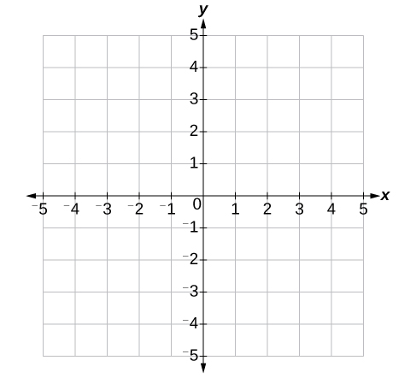

b

a

The angle between a and b is 90o.

c∙d = -2\*1 + 2\*2 = 2

d

c

The angle between c and d is less than 90o.

Ans:

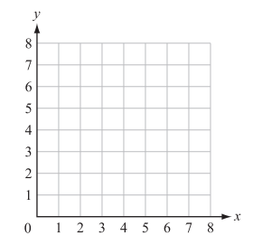

Ans: Considering 3 conditions:

1. No solution: in any case, there is nothing lies on the space.
2. Infinite solutions: it depends on the existing of the number of free variables,
3. For 2-D system, no free variable, only one solution; one free variable, the solution set is a line.
4. For 3-D system, no free variable, only one solution; one free variable, the solution set is a line; two free variables, the solution set is a plane.
5. For 4-D system, no free variable, only one solution; one free variable, the solution set is a line; two free variables, the solution set is a plane; three free variables, the solution set is a 3-d space.

Ans:

=

=

=

=

=

=

=

So, the solution of equation system:

is x = - 9/7, y = 6/7, z = 80/21

Ans:

AB = = =

AD = = =

BC = = =

If A = , E = , then:

A+E = + =

(A+E)T =

AT = , ET = then,

AT + ET = + =

So, it is verified that (A+E)T = AT + ET

Ans: For the matrix C in Question 9:

det(C) = det = 1x2-((-)x(-)) = 2 - = 0

Identity matrix is a special kind square matrix in which all elements on its main diagonal are one and other elements are zero. In the case of 2x2, it could be .

Let’s say an matrix A and an matrix B, and , then we can say A is the transpose matrix of B, and B is the transpose matrix of A. For example, the transpose matrix of C in question 9 is

If there is an matrix A and an matrix B such that AB = *In* and BA = *In*. The matrix B is called the inverse matrix of A and can be written B = A-1. In the case of matrix C in question 9, because det(C) = 0, matrix C is not inversible.