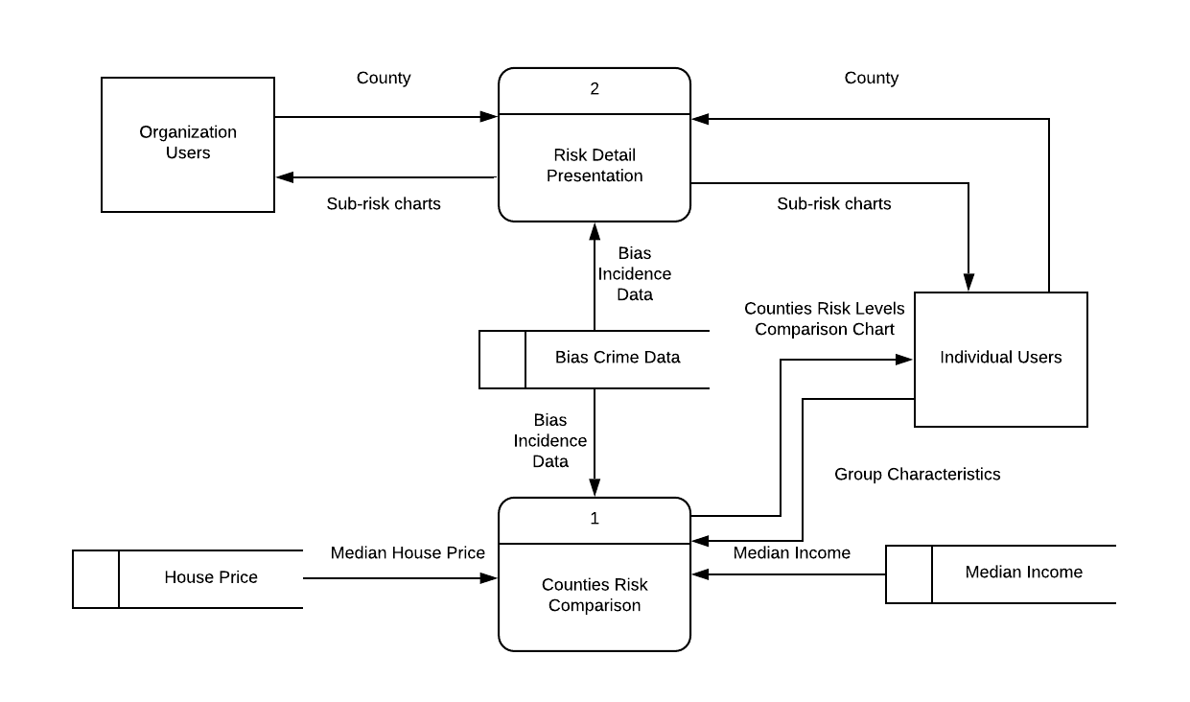

Level 0 Data Flow Diagram