Weicong Feng

Professor Feng Gu

CSC 429

04/09/2019

Assignment 3

Assignment 3

Due on Wednesday, April 10, 2019

1. Give an CREW algorithm for solving the problem of multiplying an *n*×*n* matrix *A* and vector *x* in *O*(log *n*) time. How many processors does your algorithm require? How much work does it require? Comparing your algorithm to its sequential one, what is its efficiency and speedup? (Use *O*(.) notation to describe various results).

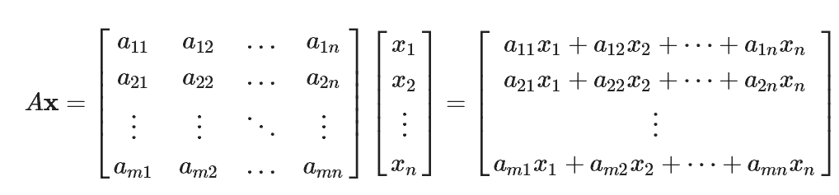

Sequential:

For dot product: T = 2n -1

For Matrix-vector product: T = (2n – 1) \* n = O(n2)

CREW:

P = O(n2)

n2 multiplications

n ( n – 1 ) additions

1. Broadcast

aij to processors ( i, j, \* )

xk to processors ( \*, \*, k)

all processors read concurrently, so T = O(1)

1. Multiplication

All processors multiply, T = O(1)

1. Parallel sum: T = O(logn)
2. Because each elements of result should be saved in separate memory cell, processor can save them concurrently, so T = O(1)

Total : T = O(logn)

W = O(n2logn)

Sp = ts/tp = ((2n - 1)n)/logn

E = Sp/p = ((2n – 1)n)/(logn\*n2) ≈ 1/ logn

= 0, no cost optimal

1. Make the algorithm in Problem 1 to work on an EREW PRAM. What is its running time?
2. Broadcast T = O(logn)
3. Multiplication T = O(1)
4. Parallel sum T = O(logn)
5. Write result T = O(1)

Total T = O(logn)

3.Input: *x*[1], *x*[2], *x*[3], …, *x*[*i*], …, *x*[*n*]

Output: *y*[*i*] 1<=*i*<=*n* where *y*[*i*] saves the maximum number among the first *i* elements of array *x*.

Please give an *O*(log *n*) time parallel EREW algorithm.

Algorithm: phase j: processor i read contents of cell i and i-2j ( if it exists ) and save the max one to cell j.

T = O(logn)

W=O(nlogn)

1. Give a constant time CRCW PRAM algorithm for problem 3.

Algorithm: p0 reads from c0, writes to d0,

p1, p2 read from c0, c1, and write to d1,

p3, p4, p5 read from c0, c1, c2, and write to d2,

p6, p7, p8, p9 read from c0, c1, c2, c3, and write to d3

T = O(1)

P = O(n2)

W = O(n2)

1. Give an *O*(1) CRCW algorithm for Logical OR.

Algorithm: processor 1 write a 0 to share memory cell 0(use for storing result). If xi = 1, processor i write a 1 to cell 0.

T = O(1)

P = O(n)

W = O(n)