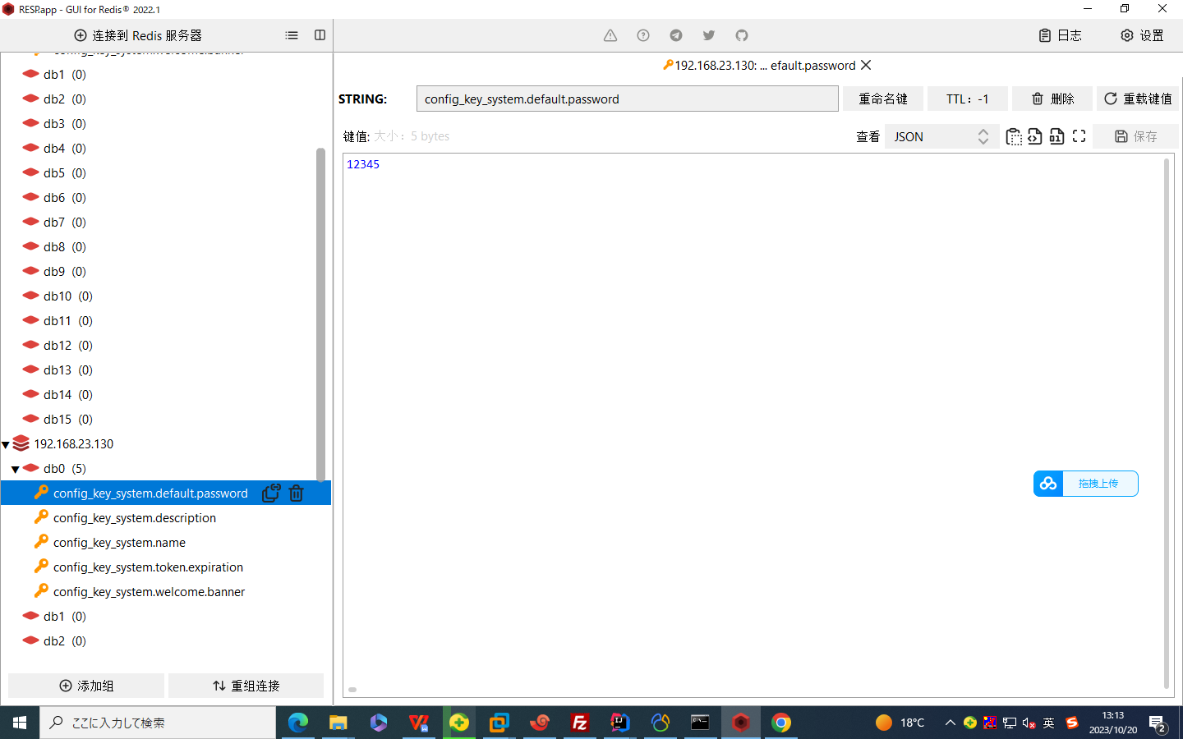

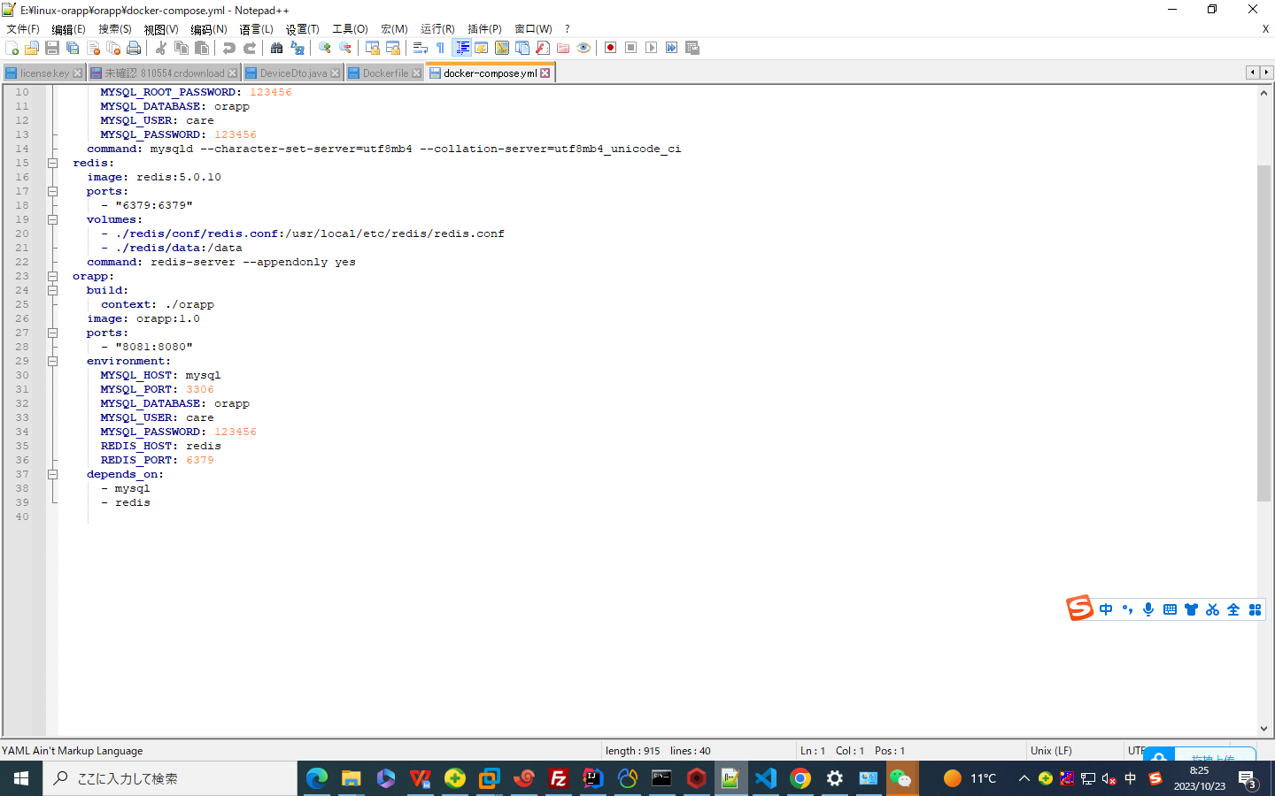

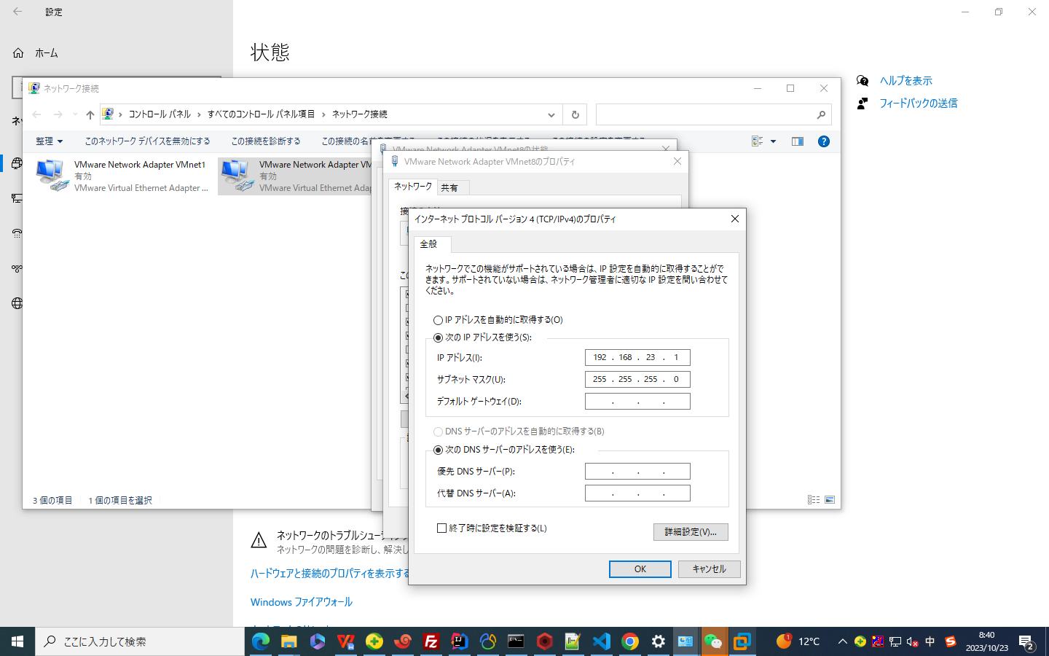

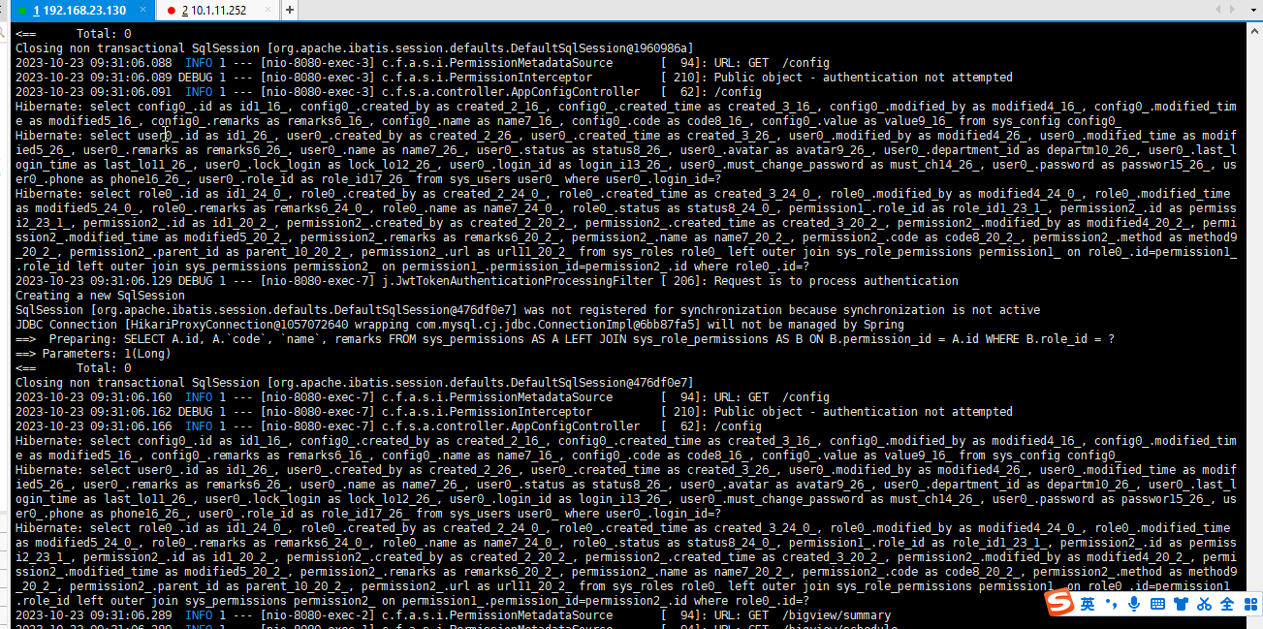
/var/tmp/mysqld.cnf.swp

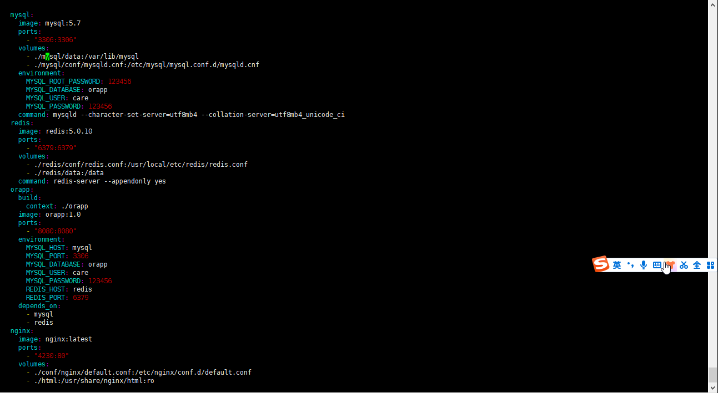
- ./mysql/data:/var/lib/mysql
- ./mysql/conf/mysqld.cnf:/etc/mysql/mysql.conf.d/mysqld.cnf

安装Vi:apt-get install vim，如果提示：Unable to locate package vim，则需要敲：apt-get update。等更新完毕以后再敲命令： apt-get install vim

sql_mode=STRICT_TRANS_TABLES,NO_ZERO_IN_DATE,NO_ZERO_DATE,ERROR_FOR_DIVISION_BY_ZERO,NO_AUTO_CREATE_USER,NO_ENGINE_SUBSTITUTION

Docker 中修改Mysql 数据库的 only_full_group_by 模式

# Copyright (c) 2014, 2016, Oracle and/or its affiliates. All rights reserved.
#
# This program is free software; you can redistribute it and/or modify
# it under the terms of the GNU General Public License as published by
# the Free Software Foundation; version 2 of the License.
#
# This program is distributed in the hope that it will be useful,
# but WITHOUT ANY WARRANTY; without even the implied warranty of
# MERCHANTABILITY or FITNESS FOR A PARTICULAR PURPOSE. See the
# GNU General Public License for more details.
#
# You should have received a copy of the GNU General Public License
# along with this program; if not, write to the Free Software
# Foundation, Inc., 51 Franklin St, Fifth Floor, Boston, MA 02110-1301 USA

#
# The MySQL Server configuration file.
#
# For explanations see
# http://dev.mysql.com/doc/mysql/en/server-system-variables.html

[mysqld]
pid-file = /var/run/mysqld/mysqld.pid
socket = /var/run/mysqld/mysqld.sock
datadir = /var/lib/mysql
#log-error = /var/log/mysql/error.log
# By default we only accept connections from localhost
#bind-address = 127.0.0.1
# Disabling symbolic-links is recommended to prevent assorted security risks
symbolic-links=0

#
sql_mode=STRICT_TRANS_TABLES,NO_ENGINE_SUBSTITUTION

