Will Hendrix

COMP 2710 – 001

Lab3

November 5th, 2017

Analysis

Use Cases (User starts the program, then interacts with it through a simple user interface…)

* **User starts the Snakes and Ladders Maze Game**: System displays a welcome banner. System prompts the user for the number of players. System prompts the user for the name of each player. First player has the first turn.
* **For each player, until the end node is reached**: System prompts user to roll the dice by pressing enter. System displays the dice roll. System prompts user to choose a direction (N, S, E, W) for how many times the roll was. The next user is then chosen.
* **When the end node is found**: System displays that the user won, and prints all the nodes visited.

Design

Classes:

* **Menu class**: this class manages the menu for the program.
  + Variables:
    - Node* nodes[]
    - Node* currentNode
    - Node* start
    - Node* finish
    - Int numberOfNodes
  + Functions:
    - Maze() – default constructor
    - userInterface() – manages the user interface
    - createMaze() – creates the maze from the file
    - takeTurn() – does one players turn
    - indexOf() – finds the index of the node in nodes
* **Node class**: this class manages the nodes.
  + Variables:
    - String name
    - Node* attachedNodes[4]
    - Node* snakeOrLadderNodes
  + Functions:
    - Node(string newName) – constructor with string
    - Node() – default constructor

Class Diagram:

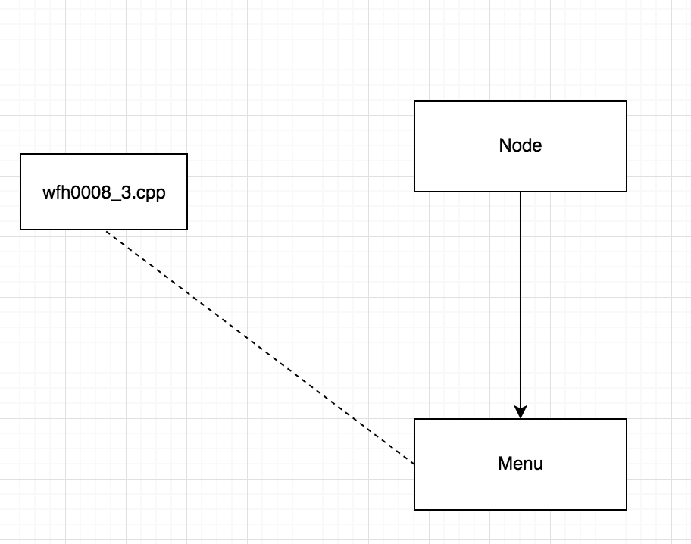

Data Flow Diagram:

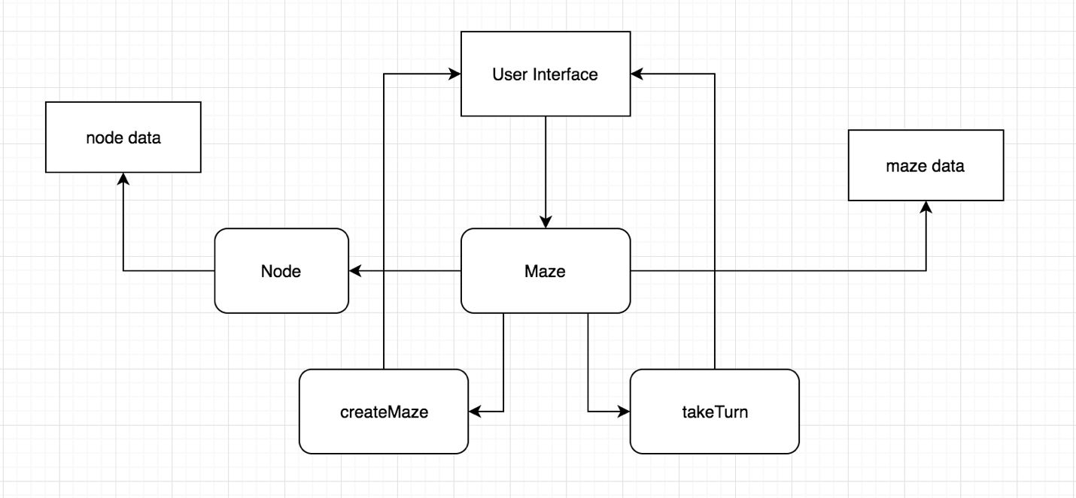

Testing

Unit testing:

* Node:
  + Node() - Create a new node with the default constructor
  + Node(string username) - Create a new node with a string as the name
* Menu
  + Maze() – create a new Maze with a default constructor.
  + userInterface() – check to make sure the user interface is displaying properly.
  + createMaze() – try creates the maze from the file and check the output
  + takeTurn() – make sure each turn is taken correctly
  + indexOf() – try the find the index of a

System testing: test with a driver!