Using the Program

The program can be run by executing src/vtkModel/wxGUI/GUI_Main.py with python. Three windows will appear:

- The Atoms window:
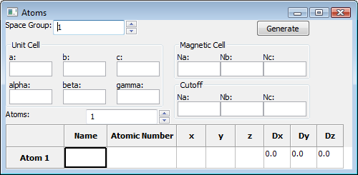

This is the window in which you will put information about the crystallographic structure of the lattice. You must enter the Space group number and dimensions of the crystallographic as well as magnetic unit cells. The cutoff cell is at least as large as the magnetic unit cell. If any magnetic interactions between atoms span a length longer than the magnetic unit cell, then the cutoff cell should be made large enough to contain the interaction. The cutoff cell will be displayed in the main window.

Unit Cell
For the crystallographic unit cell, you must enter a, b, and c as well as alpha, beta, and gamma. a, b, and c are the lengths of the three axes on the unit cell. Alpha, beta, and gamma are the angles between the three axes. At the time of this writing, this information is unimportant because the 3D model is displayed with cubic unit cells.

Magnetic Cell / Cutoff
For the magnetic and cutoff cells; Na, Nb, and Nc are the size of the cell in units of crystallographic unit cells. For example, if Na = 2, Nb = 2, and Nc =2; the cell will be a 2 by 2 by 2 block of crystallographic unit cells.

Atoms
The number of unique atoms (atoms that are not translated into each other using the symmetry operations of the space group) to be defined can be set using the spinner labeled “Atoms:” This will set the size of the atom table at the bottom of the window.
Each atom is given a name, atomic number, coordinates, and single ion anisotropy values. The name is completely up to the preference of the user. The atomic number is meant to eventually be used to select a color and size for the display of the atom, but is currently not used. The color is currently random, and all the sizes are the same. ‘x’, ‘y’, and ‘z’ are the coordinates of the atom in the crystallographic unit cell in units of the axes of the cell. These should really read ‘a’, ‘b’, and ‘c’, but since everything is being displayed orthogonally, they are equivalent. These values must be less than one; otherwise they would be outside of the unit cell. Last, are the single ion anisotropy terms, ‘Dx’, ‘Dy’, and ‘Dz’. These describe a tendency for a spin to lie along a certain axis and default to 0.

- The “Bonds” window:
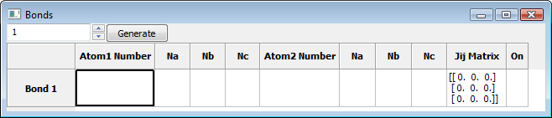

This window is used to add interactions between the spins of atoms. Atom Number is the unique identifying number of the atom, which can be seen next to each atom in the 3D model displayed in the main window. Na, Nb, and Nc are the coordinates of the crystallographic unit cell in directions a, b, and c, which are currently the same as x, y, z in the main window display. The box on the very right can be clicked to turn the bond on or off. An easier way of adding interactions involves selecting atoms in the 3D display of the main window, which will be covered below.

The Jij Matrix is the matrix describing the energy of the interaction between the two atoms, where the energy associated with an atom’s spin is given by the Heisenberg Hamiltonian:

E = – S_{i}J_{ij}S_{j} – D_{x}S_{ix}² – D_{y}S_{iy}² – D_{z}S_{iz}²

Summed over all S_{j}, where S_{i} is the spin of the atom and S_{j} is the spin of the atom interacting with S_{i}. D_{x}, D_{y}, and D_{z} are the single ion anisotropy terms.

- The Main window:

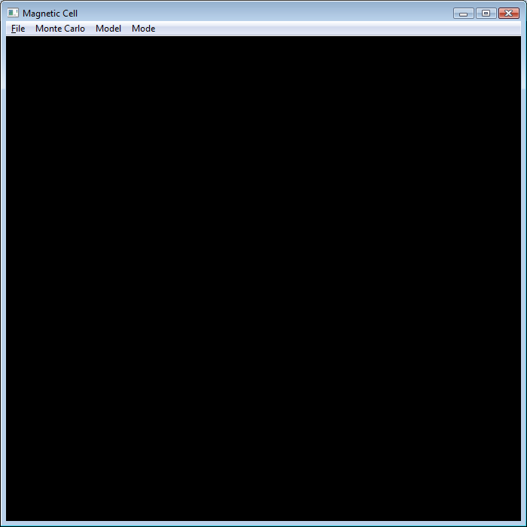

This is where 3D models of the crystal lattice will be displayed.

The File Menu

- Open: You can open two kinds of files. The first is Crystallographic Information Files (.cif). The second is an xml format saved session created by going to
File->Save.
- Save: This saves all the information about the current cutoff cell that is being displayed in xml format. If information was added to the Atom or Bond windows, but the generate button was not pressed, it will not be saved. At the time of this writing, single ion anisotropy has not been added to the save files.
- Save Image: This will save the image in the main window as it is currently displayed (like a screenshot minus the menu bar and border). Currently the only image format is .tiff. *This doesn’t always work when part of the window is covered by another window, or if it is off the screen.
- Quit: As you would expect, this quits the program.

The Monte Carlo Menu

This menu is used to run the Monte Carlo simulation (simulated annealing) to find the ground state spin configuration of the lattice. The interactions are first exported to a file so that the simulation can be run as a separate program. The spins are then written to a file which can be read back in from the main program. The simulation can also be run in as part of the main program, but the interaction and spin files must still be created.

- Export for Monte Carlo: This exports the interactions to a text file. This is the first thing that must be done to before running the simulation.
- Launch Simulation: This opens the simulation window as part of this main program. Alternatively, it can be run separately by running src\MonteCarlo\CSim.py.
- Load Spins from File: This will read in the spins from the text file output of the simulation. Each atom displayed in the main window will be given a spin if it is contained (by position) within the spin file.

The Model Menu

- Delete: This will delete the selected bond and all symmetry equivalent bonds, if a bond is selected. Alternatively, one can click a bond and press the Del key.

The Mode Menu

This switches between different picking behaviors.

- Normal Selection: Information about the selected atom or bond is printed in the console window when the user clicks on an atom or bond.
- Bond Creation: This mode is selected to create “bonds” by clicking on atoms in the main window display. First, this mode is selected, then an atom is clicked, and then another atom is clicked. An entry is then appended to the list in the bond window connecting the two atoms that were just clicked. This behavior persists until Normal Selection mode is selected again. Information about the selected atom or bond is still displayed in the console window.

The Code
The code was written mostly in Python. VTK was used to create the 3D visual and wxPython was used to create the GUI. The Monte Carlo simulation was written in C for speed.

The model consists of a magnetic cell class which stores a list of all the crystallographic cells (Cell class) as well as all the bonds. The Cell class, in turn, stores all the atoms in that cell. Every time the program is run, an instance of the Session class is created which stores the current magnetic cell and acts as the intermediary between the model and view (GUI). The GUI stores the Session object, but Session communicates with the GUI by sending messages which the appropriate parts of the GUI intercept.

Creating the 3D view is handled by the class vtkDrawer which creates vtkLODActors to represent the atoms, bonds, and cells. wxVTKRenderWindowInteractor is used to render the vtk images in a wx window.

Things to Change

- Single ion anisotropy values are not currently saved in the xml session files.
- Crystallographic unit cells are always displayed as cubes and therefore a, b, c, alpha, gamma, and beta are all not used.
- The Magnetic Cell and Cutoff cell are used interchangeably. This is because the program was originally created with only magnetic cells, but then cutoff cells needed to be added to support long bonds. The magnetic cell is not used at all, but since the functionality is the same, the magnetic cell name was left in most of the code. What the user enters for the magnetic cell is not used and what they enter for the cutoff cell is used to create a cell that is called magnetic cell in the code. This could be confusing for anyone reading the code.
- The atomic number of each atom is not used. The colors used in the display are random and the radii fixed.
- Duplicate atoms and bonds are currently allowed. They will just be created right on top of each other.
- When bonds are interactively added, they are appended to the list of bonds, and since the bond list is always of length >=1, there is often an empty bond entry at the beginning of the list. It would be nice to check if the entry is empty and remove it if it is.
- Adding a checkmark or a bullet on the selected mode in the mode menu would make things clearer.
- Information about picked atoms or bonds could be displayed in a status bar at the bottom of the main window to remove the DOS command prompt.

