[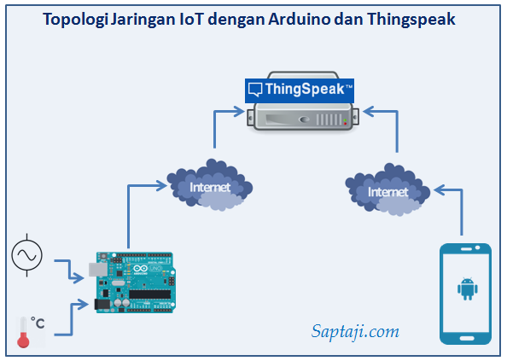](https://www.google.com/url?sa=i&rct=j&q=&esrc=s&source=images&cd=&cad=rja&uact=8&ved=2ahUKEwjM3qTdrebhAhVOi3AKHWmSAGEQjRx6BAgBEAU&url=/url?sa=i&rct=j&q=&esrc=s&source=images&cd=&ved=&url=http%3A%2F%2Fsaptaji.com%2F2016%2F11%2F21%2Fiot-dengan-arduino-dan-thingspeak%2F&psig=AOvVaw3CvNzzbsZr8k1mnT069RKS&ust=1556113758672413&psig=AOvVaw3CvNzzbsZr8k1mnT069RKS&ust=1556113758672413)