Introduction
The EnhancedLink module is a rewrite of the standard Link module provided with the core Rainbow.
The EnhancedLink module lets you build list of links, with optional image and link description. The links can be ordered by using a view order, and contains an option to expand all descriptions whent the page is loaded.

About this Document
Please let me know you find any errors, confusing parts, or serious omissions in this document: mochuelo@ya.com

Features
- Build list of links to external sites, internal sites, or files
- View lists in columnsl
- View list as a dropdown listbox
- Add an image to each link
- Auto expand all descriptions
- Use ViewOrder to order the links
- Use image separators for groups of links
- Localized module
- Specific CSS style for module

Install the EnhancedLink Module

- Copy EnhancedLink directory into DesktopModules  - Open Rainbow Visual Studio Solution and add EnhancedLink Directory to solution.  - Compile it | 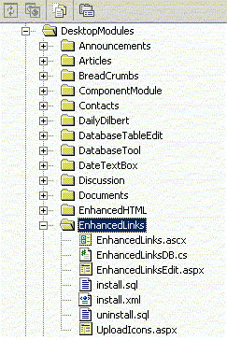

- Open your rainbow web, select ‘Admin all’ page and go to add new module
- Select DesktopModules/EnhancedLinks/install.xml and Apply Changes

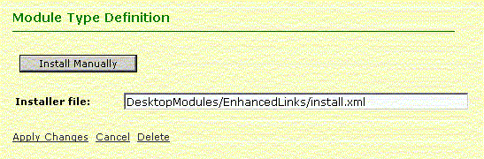

Use the module

- Select the desired tab and add the module

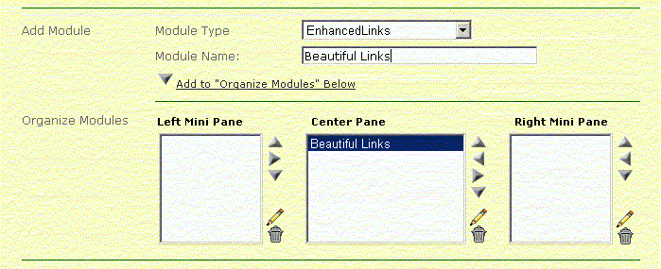

- Select the specific module settings

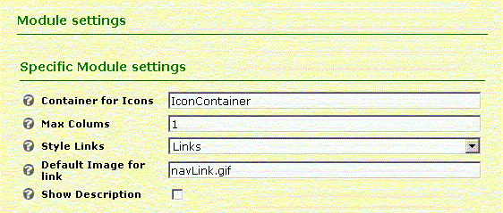
- Add links or Group Separator to module

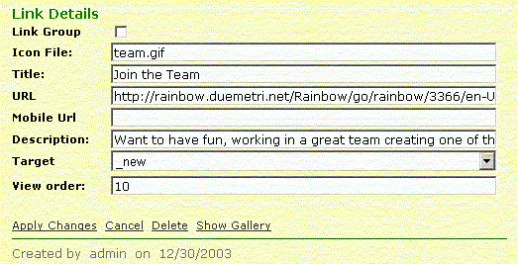

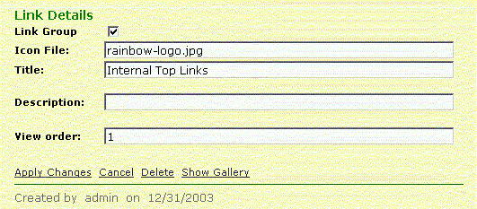

Sample results

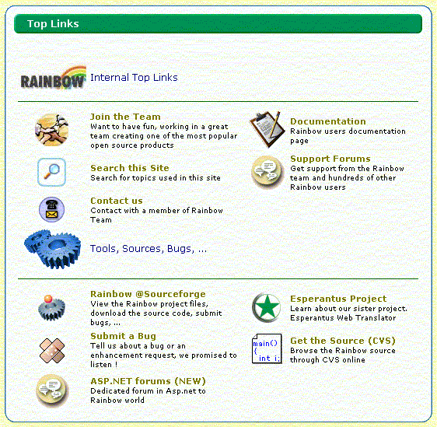
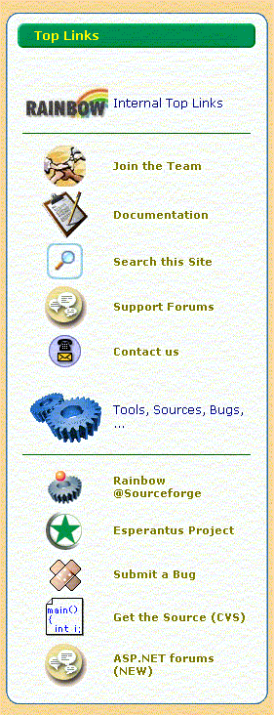
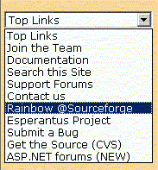

Specific CSS styles

For best performance of module is necessary add specific styles to your principal css page theme.
You can change the styles to your convenience.

/* ================================
EnhancedLinks Module
================================ */

.EnhancedTitle
{
font-family: Verdana, Helvetica, sans-serif;
font-size: 12px;
font-weight: normal;
color:darkblue;
}

.EnhancedLink
{
font-family: Verdana, Helvetica, sans-serif;
font-size: 11px;
font-weight: bold;
color: darkgray
}

A.EnhancedLink:link
{
text-decoration: none;
color: black;
}

A.EnhancedLink:visited
{
color: olive;
text-decoration: none;
}

A.EnhancedLink:active
{
text-decoration: none;
color: green;
}

A.EnhancedLink:hover
{
text-decoration: none;
color: red;
}

.EnhancedDescription
{
font-family: Verdana, Helvetica, sans-serif;
font-size: 9px;
font-weight: normal;
color: black;
}

Localized Module

The EnhancedLink module is localized. For additional languages is necessary add into corresponding resource file the keys for module and recompile the visual studio solution.

Rainbow.resx file

<data name="ENHANCEDLINKS_DROPDOWNLIST">
<value>DropDownList</value>
</data>
<data name="ENHANCEDLINKS_LINKS">
<value>Links</value>
</data>
<data name="ENHANCEDLINKS_ICONPATH_DESCRIPTION">
<value>Portal directory for upload used icons</value>
</data>
<data name="ENHANCEDLINKS_ICONPATH">
<value>Container for Icons</value>
</data>
<data name="ENHANCEDLINKS_GENERALIMAGE_DESCRIPTION">
<value>Select a image title for module. In blank for none</value>
</data>
<data name="ENHANCEDLINKS_GENERALIMAGE">
<value>General Image for module</value>
</data>
<data name="ENHANCEDLINKS_SWITCHERTYPES_DESCRIPTION">
<value>Select here how your module should look like</value>
</data>
<data name="ENHANCEDLINKS_SWITCHERTYPES">
<value>Style Links</value>
</data>
<data name="ENHANCEDLINKS_DEFAULTIMAGE">
<value>Default Image for link</value>
</data>
<data name="ENHANCEDLINKS_EXPANDALL">
<value>Show Description</value>
</data>
<data name="ENHANCEDLINKS_DEFAULTIMAGE_DESCRIPTION">
<value>Select here a image for links with no special setting image</value>
</data>
<data name="ENHANCEDLINKS_EXPANDALL_DESCRIPTION">
<value>Mark this if you like to see the description down the link</value>
</data>
<data name="ENHANCEDLINK_GALLERYTITLE">
<value>Icon Gallery</value>
</data>
<data name="ENHANCEDLINK_ICON">
<value>Upload Icon File</value>
</data>
<data name="ENHANCEDLINK_SELECT">
<value>1. Select the image</value>
</data>
<data name="ENHANCEDLINK_UPLOAD">
<value>2. Upload the File</value>
</data>
<data name="ENHANCEDLINKS_EDITLINK">
<value>Edit Link</value>
</data>

This is the translation for spanish

Rainbow.es.resx file

<data name="ENHANCEDLINKS_ICONPATH">
<value>Almacén de Iconos</value>
</data>
<data name="ENHANCEDLINKS_LINKS">
<value>Enlaces</value>
</data>
<data name="ENHANCEDLINKS_LINKSHORIZONTAL">
<value>Enlaces Horizontales</value>
</data>
<data name="ENHANCEDLINKS_DROPDOWNLIST">
<value>Lista Desplegable</value>
</data>
<data name="ENHANCEDLINKS_ICONPATH_DESCRIPTION">
<value>Directorio del Portal para descargar los iconos utilizados</value>
</data>
<data name="ENHANCEDLINKS_EXPANDALL">
<value>Mostrar Descripción</value>
</data>
<data name="ENHANCEDLINKS_GENERALIMAGE">
<value>Imágen General </value>
</data>
<data name="ENHANCEDLINKS_SWITCHERTYPES_DESCRIPTION">
<value>Seleccionar aquí como debe verse el resultado</value>
</data>
<data name="ENHANCEDLINKS_GENERALIMAGE_DESCRIPTION">
<value>Seleccionar una Imágen general_u112 ?ara todo el módulo</value>
</data>
<data name="ENHANCEDLINKS_SWITCHERTYPES">
<value>Estilo de Enlaces</value>
</data>
<data name="ENHANCEDLINKS_EXPANDALL_DESCRIPTION">
<value>Marcar para ver la descripción_u100 ?ebajo del enlace</value>
</data>
<data name="ENHANCEDLINKS_DEFAULTIMAGE">
<value>Imágen por defecto</value>
</data>
<data name="ENHANCEDLINKS_DEFAULTIMAGE_DESCRIPTION">
<value>
Selecciona la imágen que utilizarán todos los enlaces que no tengan una asignada.
</value>
</data>
<data name="ENHANCEDLINKS_EDITLINK">
<value>Editar Enlace</value>
</data>

