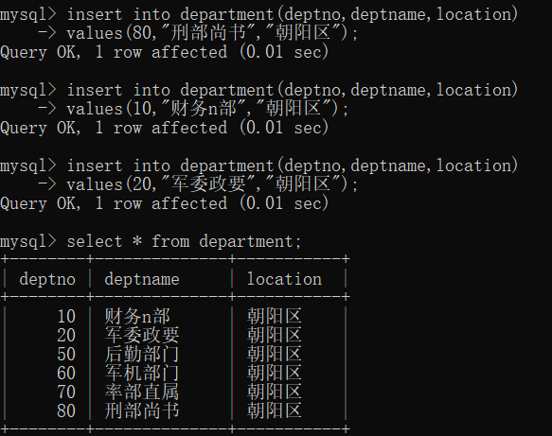

- 查询部门编号为20的人的名字、部门名字、工作岗位及薪水待遇
SQL语句：select e.empname,d.deptname,e.job,e.salary from employee as e,department as d where e.deptno=d.deptno and d.deptno=20;
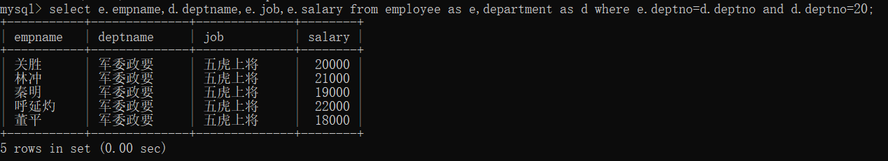

- 查询所有人的总工资、最高工资、最低工资和平均工资
SQL语句： select sum(salary) as 总工资,max(salary) as 最高工资,min(salary) as 最低工资,avg(salary) as 平均工资 from employee;
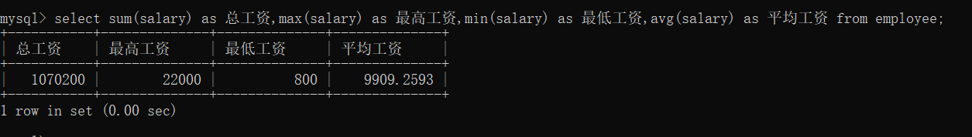
3、查看每个工作的人物名称、人数，且人数大于2、平均工资
SQL语句：select job,count(*),group_concat(empname),avg(salary) from employee group by job having count(*) >2;
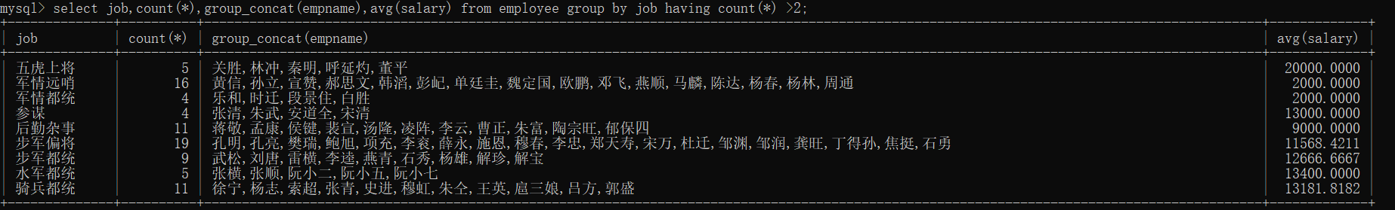

4、查询后勤部门、军委政要所有职员信息
SQL语句： SELECT * FROM employee WHERE deptno IN (SELECT deptno FROM department WHERE deptname IN ("后勤部门","军委政要"));
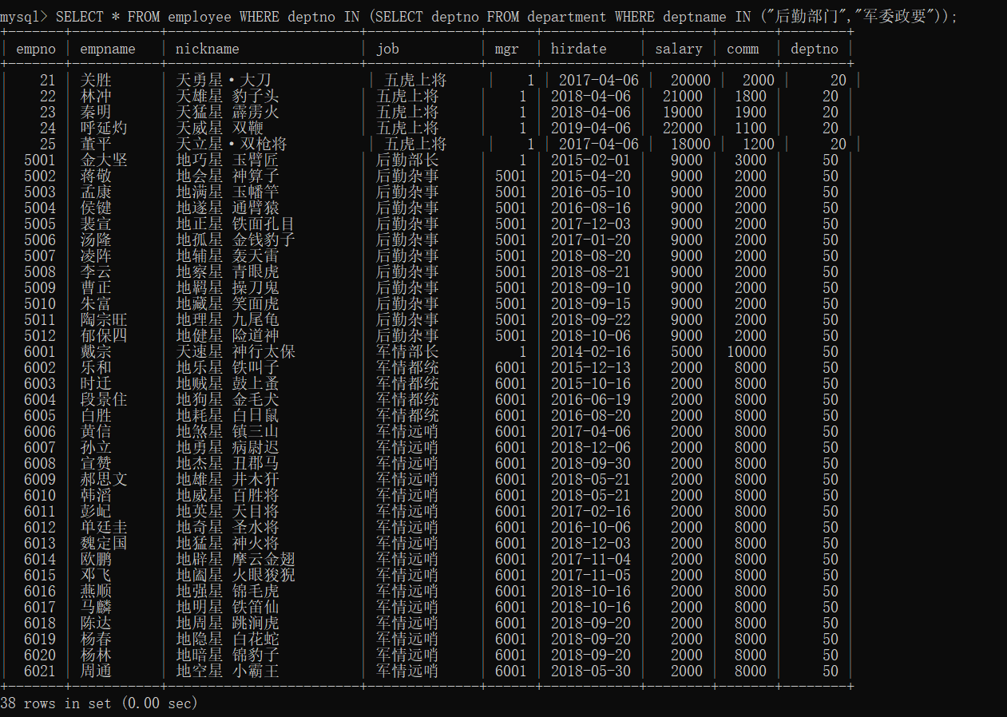

- 查询每个部门有哪些员工，并显示他们的姓名、工作、工资和部门名称
SQL语句：SELECT e.empname,e.job,e.salary,d.deptname FROM employee as e INNER JOIN department as d ON e.deptno = d.deptno;
