1. Introduction

Want to describe “mechanics” of atomic-scale things, like electrons in atoms and molecules.

Why? These ultimately determine the shape, the energy, and all the properties of matter.

When do we need *quantum mechanics*?

*de Broglie wavelength* (1924)



|  |  |
| --- | --- |
| **Car** | **Electron** |
| *m* = 1000 kg | 9.1 × 10−31 kg |
| *v* = 100 km/hr  Typical value on the highway | *v* = 0.01 *c*  Typical value in atom |
| *p* = 2.8 × 10−4 kg m/s | *p* = 2.7 × 10−24 kg m/s |
| λ = 2.4 × 10−38 m  Too small to detect. Classical object! | λ = 2.4 × 10−10 m  Comparable to size of atom. *Must* account for wave properties of an electron! |

How to describe wave properties of an electron? Schrödinger equation (1926?)

Kinetic energy + Potential energy = Total Energy

Expressed as differential equation (Single particle, non-relativistic):



: wavefunction

If the potential *V* is time-invariant, can use separation of variables to show that steady-state, time-independent solutions are characterized by an energy *E* and described by:



*E*: energy

1. Postulates of Non-relativistic Quantum Mechanics

Postulate I: **The physical state of a system is completely described by its wavefunction Ψ.** In general, Ψ is a complex function of the spatial coordinates and time. Ψ is required to be:

1. single-valued
2. continuous and twice-differentiable
3. square-integrable ( is defined over all finite domains)

For bound systems Ψ can always be normalized such that .

Postulate II: To every physically observable quantity *M* there corresponds a Hermitian quantum mechanical operator . **The only observable values of *M* are the eigenvalues of .**

|  |  |  |
| --- | --- | --- |
| **Physical quantity** | **Operator** | **Expression** |
| Position *x*, *y*, *z* |  |  |
| Linear momentum *px*, … | , … | , … |
| Angular momentum *l*x, … | , … | , … |
| Kinetic energy *T* |  |  |
| Potential energy *V* |  |  |
| Total energy *E* |  |  |

Postulate III: If a particular observable *M* is measured many times on many identical systems in a state Ψ, the average value of the result will be the expectation value of the operator **:**



Postulate IV: The energy-invariant states of a system are solutions of the equation



If the system is in a time-independent stationary state, this reduces to the Schrödinger equation:



Postulate V: (The **uncertainty principle***.*) Operators that do not commute  are called *conjugate*. Conjugate observables cannot be specified together to arbitrary accuracy. For example, the error (standard deviation) in the measured position and momentum of a particle must satisfy .

1. Note on constants and units

Resource on physical constants: <http://physics.nist.gov/cuu/Constants/>

Resource for unit conversions: <http://www.digitaldutch.com/unitconverter/>

Unit converter available in Calc for Gnu emacs

**Atomic units common for quantum mechanical calculations**

|  |  |  |  |
| --- | --- | --- | --- |
|  | Atomic unit | SI unit | Common unit |
| Charge | *e* = 1 | 1.6021×10−19 C |  |
| Length | *a*0 = 1 (bohr) | 5.29177×10−11 m | 0.529177 Å |
| Mass | *m*e = 1 | 9.10938×10−31 kg |  |
| Angular momentum | *ħ* = 1 | 1.054 572×10−34 J s |  |
| Energy | *E*h (hartree) | 4.359744×10−18 J | 27.2114 eV |
| Electrostatic force | 1/(4πε0) = 1 | 8.987552×109 C-2 N m2 |  |
| Boltzmann constant |  | 1.38065×10−23 J K−1 | 8.31447 J/mol K |

(see <http://en.wikipedia.org/wiki/Atomic_units>)

**Energy units**

1 eV = 1.60218×10−19 J = 96.485 kJ/mol = 8065.5 cm−1 = 11064 K *k*B

1. Example: Energy states of an electron in a box

3D box → 3 degrees of freedom



Schrødinger eq



Second-order linear partial differential equation

*Boundary value (eigenvalue) problem*

*Separable*





ftn x + ftn y + ftn z = constant → each term must be constant

 function that twice differentiated returns itself

Solutions called *eignefunctions/wavefunctions* and *eigenvalues*

Characterized by *quantum number*, one for each degree of freedom

*Normalization* – require that wavefunction square integrates to 1

 Dirac notation

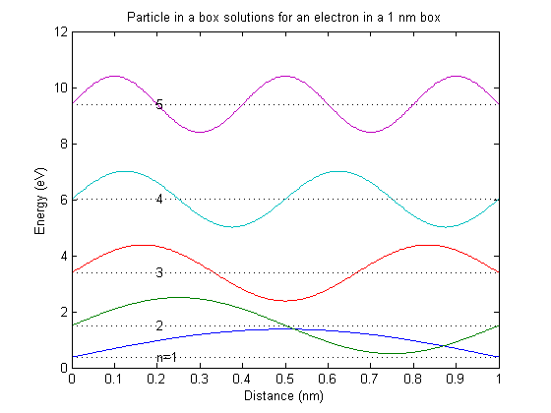

Note increasing *nodes* with increasing energy



See Ho, JPC B **2005**, *109*, 20657.3 dimensional solution



One quantum number for each dof

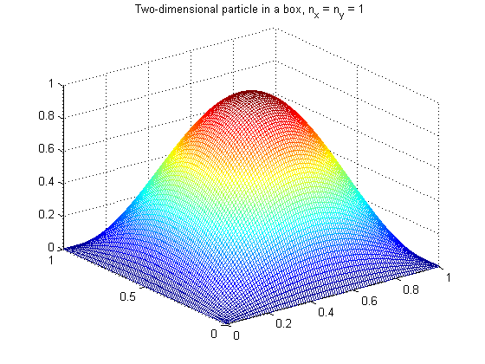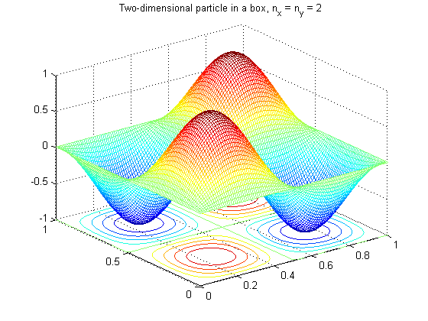



Degeneracy

Symmetry

Energy levels – depend on volume 🡪 pressure!!