1. Hydrogen atom

Simplest chemical “thing”

Represent in *spherical coordinates*, put massive nucleus at origin and follow motion of electron (really of c.o.m. and reduced mass)

H atom Schrödinger equation



Coulomb potential – our nemesis!!! Decays slowly with distance.

Separation of variables – *θ* and φ don’t appear anywhere other than the Laplacian

 three dof = three QN

*Angular component*

*Ylm* are so-called “spherical harmonic” functions, describe angular motion/angular momentum of electron

Angular quantum numbers:

azimuthal *l* = 0, 1, 2, … “shape” of angular distribution

magnetic *ml* = -*l*, -(*l*+1), …, *l* “orientation”

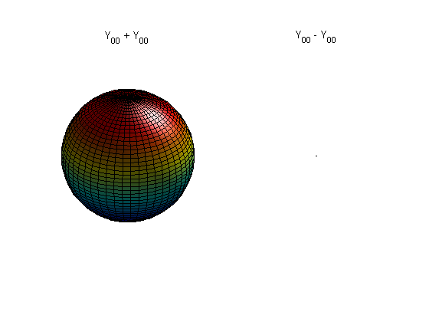 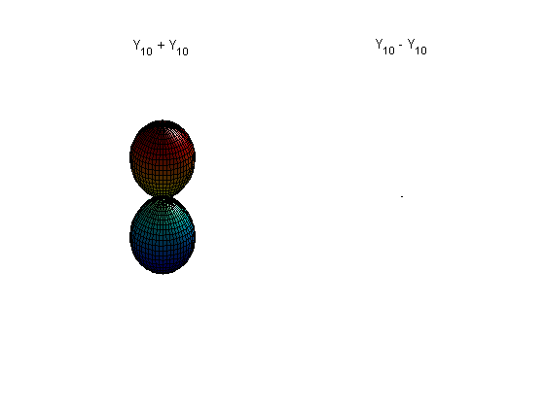 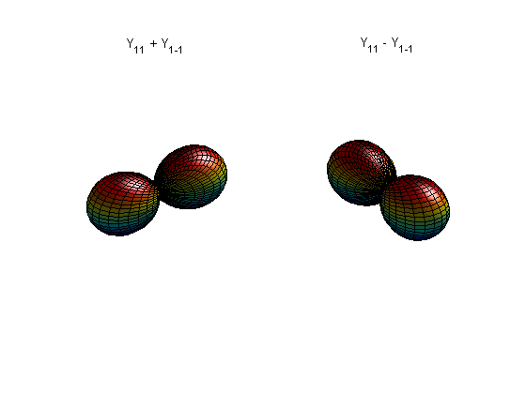

*l* = 0, *m* = 0, “s” function *l* = 1, *ml* = 0, ±1, “pz, px, py” functions

orbital angular momentum 

Note sign change on opposite lobes of p; nodal shape not that different from our 3-D box of Lecture 1

*Radial component*



Solve by … looking up (analytical) answer!

 *n* = 1, 2, 3, …

Gives us familiar H atom electronic spectrum *and* our first calculated ground-state energy of an element!

Ionization energy of an H atom? 1s 🡪 2s energy? Thermal population?



*, Rnl* = polynomial(*rn*−1) * exp(−*r*/*n*)

Polynomial part gives radial nodes.

Exponential decay form called a *Slater* function. The multiplier is called the exponent. Bigger the exponent faster the drop-off, and vice versa.

See that the electron doesn’t want to stay in its Coulomb box! The wavefunction extends beyond the classical region *r* < *rClasic*defined by *En* = *V*(*rClassic*). This leakage, or “tunneling,” is pervasive in chemistry. Same thing happens to an electron at the surface of a metal, for instance. Can you find the Classical and “forbidden” regions on the plot above?

1. Variational principle

What if we didn’t know where to look up the answers for *R*(*r*)?

*l* = 0 case, in atomic units



Guess something. Has to obey QM rules, , for instance, and normalized

How about a *Gaussian*, ?

First, normalize: 

(Note *r*2 integration factor)

Now evaluate energy. Choose 





Hmmm…doesn’t match very well, much higher in energy than true value of -0.5 Hartree.

Let’s try adding two Gaussians together with equal weight:

 again would have to normalize to determine *N*



Note appearance of “overlap” integral *S*, shows how similar or different *g*(r;1) and *g*(r;0.5) are.

Now evaluate energy: -0.306 Hartree, matches “truth” better, as does modified wavefunction.

Wouldn’t have to add with equal weight; maybe a little better to add more of the more spread out Gaussian:

, normalize, evaluate energy = -0.333 Hartree

Closer still!

Could continue to add Gaussians of various exponents, and could vary weights, or could even add in any other functions that we want that are “well-behaved”. Would find that no matter what we do, the “model” energy would be greater than the “true” value.

Basis of the *variational principle*:

For any system described by the Hamiltonian *H* and any satisfactory trial wavefunction Ψ,



where *E*0 is the true ground state energy of the system. (This comes from the fact that the solutions of *H* form a complete Hilbert space.)

Extremely important practically, because we can use the *calculus of variations* to seek optimal Ψ!

1. Basis functions

Recognize that what we are doing is approximating



*φi* are *basis functions* and *ci* are our variational parameters, or “coefficients”

If we can find *ci*such that , then we have an optimal approximation to *E*0 within our basis, and we are *sure* that our approximation is an upper bound.

Common trade-off:

want to choose *φi* that are good approximations to the “truth”

want to choose *φi* that are easy to calculate

For example,

|  |  |  |  |
| --- | --- | --- | --- |
| Slaters | Gaussians | Plane waves | Mixed basis |
| Accurate but expensive | Moderate accuracy but cheaper | Poor approximation but very cheap! |  |
| *ADF* | *Gaussian, Gamess, Molpro, NWChem, Crystal* | *Vasp,Dacapo, Castep, Abinit, PWSCF* | *FLAPW* |

Virtually *all* quantum chemical codes work on this principle, and the main differences are in the choices of basis functions.

There are exceptions. *GPAW*, for instance, solves the quantum chemical differential equations by finite difference on a numerical grid. This approach lends itself to modern computer architectures and may be the future…I don’t know!

1. Secular equations

Let’s try to apply the variational method to our two Gaussian basis for the H atom



Arrive at pair of linear *secular equations* described by the *secular matrix*. Can be solved by evaluating the *secular determinant*



Would give a quadratic equation in *E*. Solving would give two solutions, which would be our approximations to the 1*s* *and* 2*s* orbital energies of hydrogen. Back-substitution gives the *ci*.

1s: *E*1s > *E*1*s*,true , *c*1s,1 and *c*1s,2 2s: *E*2s > *E*2*s*,true, *c*2s,1 and *c*2s,2

What *are* solutions in this case…?

To get more orbitals (like the p’s, the d’s, …) , would have to include more basis functions…

Note that size of the secular matrix grows as the *square* of the number of basis functions. As number gets bigger, direct solution of secular determinant gets too inefficient.

By *orthogonalizing* basis, possible to eliminate the overlap terms:



This is in the form of a standard matrix eigenvalue problem. All the tricks of linear algebra can be used to finding the *eigenvalues* (orbital energies) and *eigenvectors* (orbital wavefunctions). Called *diagonalizing* the matrix. If matrix is really big, don’t even necessarily need to find all eigenvalues.

Same basic ideas will apply to bigger atoms, molecules, … Basis of extended Hückel, MNDO, tight binding, Hartree-Fock, configuration interaction (CI),…

1. Spin

Can’t leave the H atom without mentioning electron *spin*.

Have said that the electron has three dofs. A relativistic treatment shows that there really are *four* degrees of freedom, but one of which decouples from the others under “normal” circumstances. That one is the *spin*, which behaves like an intrinsic angular momentum of an electron with magnitude *s* = ½.

*ms* = +½ “spin-up” α

*ms* = −½ “spin-down” β

*ms* determines the z-component of the spin-angular momentum, *sz* = *msħ*.

Have to define all four quantities (*n*, *l*, *ml*, *ms*) to fully describe the state of a hydrogen electron.