CHAPTER 3

REQUIREMENT AND ANALYSIS

3.1: Requirements Analysis in general
Requirements Analysis is the process of determining the needs or conditions to meet for a new or altered product, taking account of the possibly conflicting requirements of the various stakeholders, analyzing, documenting, validating and managing software or system requirements. [1]

Requirements are description of how a system should behave or a description of system properties or attributes. It can alternatively be a statement of ‘what’ an application is expected to do. [1]

Requirements analysis includes three types of activities:
- Eliciting requirements: the task of identifying the various types of requirements from customers and users. This is sometimes also called requirements gathering.
- Analyzing requirements: determining whether the stated requirements are clear, complete, consistent and unambiguous, and resolving any apparent conflicts.
- Recording requirements: Requirements may be documented in various forms, usually including a summary list and may include natural-language documents, use cases, user stories, or process specifications. [1]

Requirements analysis can be a long and arduous process during which many delicate psychological skills are involved. New systems change the environment and relationships between people, so it is important to identify all the stakeholders, take into account all their needs and ensure they understand the implications of the new systems. Analysts can employ several techniques to elicit the requirements from the customer. These may include the development of scenarios (represented as user stories in agile methods), the identification of use cases, the use of workplace observation or ethnography, holding interviews, or focus groups (more aptly named in this context as requirements workshops, or requirements review sessions) and creating requirements lists. Prototyping may be used to develop an example system that can be demonstrated to stakeholders. Where necessary, the analyst will employ a combination of these methods to establish the exact requirements of the stakeholders, so that a system that meets the business needs is produced. [1]
In general, requirements are partitioned into functional requirements and non-functional requirements. Functional requirements are associated with specific functions, tasks or behaviors the system must support (e.g. the system must output the data in json format, or the system must provide the login function). While non-functional requirements are constraints on various attributes of these functions or tasks. The functional requirements address the quality characteristic of functionality while the other quality characteristics are concerned with various kinds of non-functional requirements (e.g. the system must be easily accessible, the quality must follow a particular standard). Because non-functional requirements tend to be stated in terms of constraints on the results of tasks which are given as functional requirements (e.g. constraints on the speed or efficiency of a given task).

Software prototyping are used to gather the functional and non-functional requirements.

3.1.1: Software prototyping
Software prototyping refers to the activity of creating prototypes of software applications, i.e., incomplete versions of the software program being developed. It is an activity that can occur in software development and is comparable to prototyping as known from other fields. A prototype typically simulates only a few aspects of, and may be completely different from the final product. The main purpose of a prototype is to allow users of the software to evaluate developers' proposals for the design of the eventual product by actually trying them out, rather than having to interpret and evaluate the design based on descriptions. Prototyping can also be used by end users to describe and prove requirements that developers have not considered. [2]

3.1.2: Outline of the prototyping process
The process of prototyping involves the following steps
- Identify basic requirements
Determine basic requirements including the input and output information desired. Details, such as security, can typically be ignored.
- Develop Initial Prototype
The initial prototype is developed that includes only user interfaces.
- Review
The customers, including end-users, examine the prototype and provide feedback on additions or changes.
- Revise and Enhance the Prototype
Using the feedback both the specifications and the prototype can be improved. Negotiation about what is within the scope of the contract/product may be necessary. If changes are introduced then a repeat of steps #3 and #4 may be needed. [2]

3.2: Software Requirements Specification
A Software requirements specification (SRS), a requirements specification for a software system, is a complete description of the behavior of a system to be developed and may include a set of use cases that describe interactions the users will have with the software. In addition it also contains non-functional requirements.

We will discuss the Use case diagram on the next page.

3.2.1: USE CASE Diagram
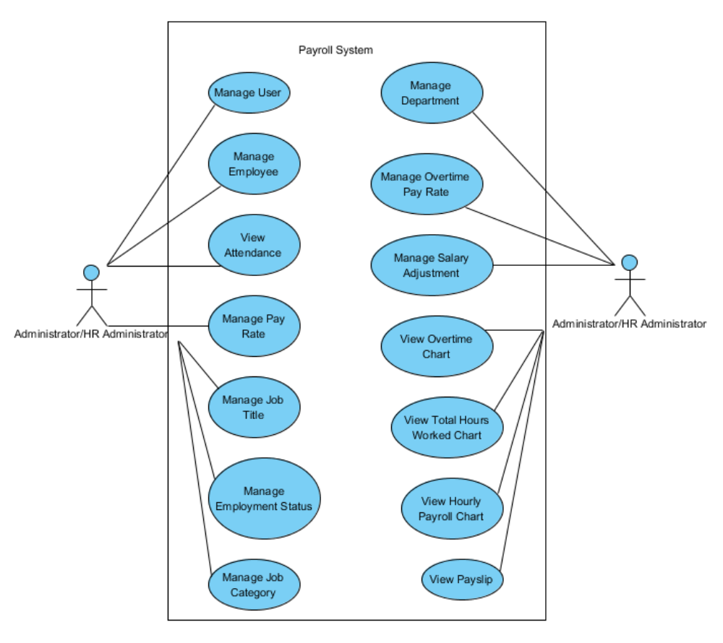
Figure x: Use Case Diagram – Administrator/HR Administrator

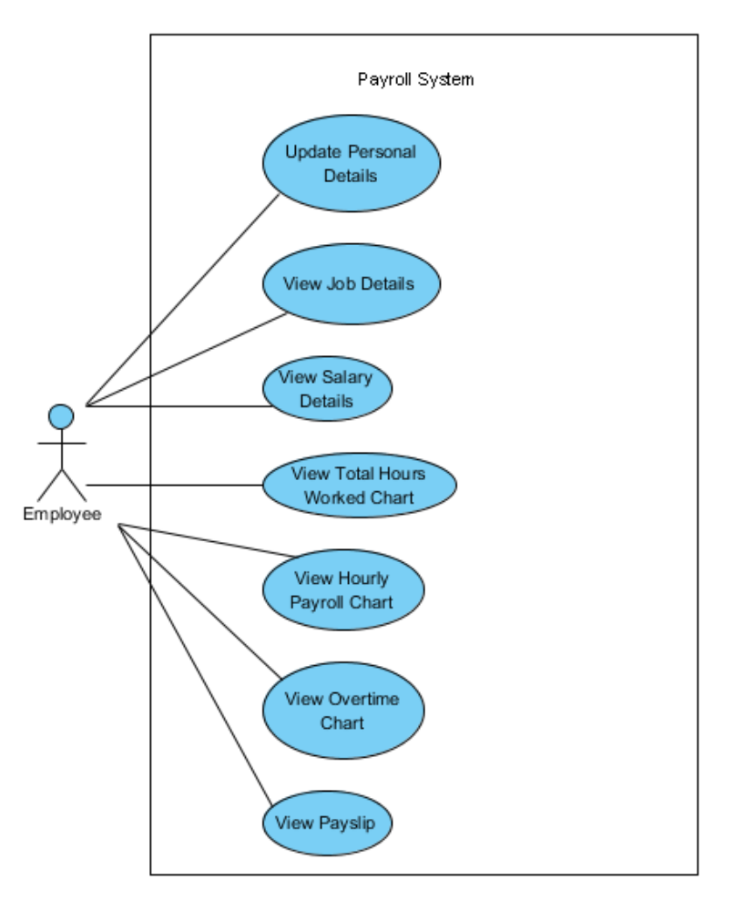
Figure y: Use Case Diagram - Employee

Table x: Actors Grid
ID | Name | Related use cases
1 | Administrator/HR Administrator | Manage User,  Manage Employee,  View Attendance,  Manage Pay Rate,  Manage Job Title,  Manage Employment Status,  Manage Job Category,  Manage Department,  Manage Overtime Pay Rate,  Manage Salary Adjustment,  View Overtime Chart,  View Total Work Hours Chart,  View Hourly Payroll Chart,  View Payslip
2 | Employee | Update Personal Details,  View Job Details,  View Salary Details,  View Total Work Hours Chart,  View Hourly Payroll Chart,  View Overtime Chart,  View Payslip

Table y: Use Cases Grid
ID | Name | Primary actors | Supporting actors
1 | Manage User | Administrator/HR Administrator
2 | Manage Employee | Administrator/HR Administrator
3 | View Attendance | Administrator/HR Administrator
4 | Manage Pay Rate | Administrator/HR Administrator
5 | Manage Job Title | Administrator/HR Administrator
6 | Manage Employment Status | Administrator/HR Administrator
7 | Manage Job Category | Administrator/HR Administrator
8 | Manage Department | Administrator/HR Administrator
9 | Manage Overtime Pay Rate | Administrator/HR Administrator
10 | View Overtime Chart | Administrator/HR Administrator,  Employee
11 | View Total Work Hours Chart | Administrator/HR Administrator,  Employee
12 | Manage Salary Adjustment | Administrator/HR Administrator
13 | View Hourly Payroll Chart | Administrator/HR Administrator,  Employee
14 | View Payslip | Administrator/HR Administrator,  Employee
15 | Update Personal Details | Employee
16 | View Job Details | Employee
17 | View Salary Details | Employee

Table z: Use Case Diagram Summary
Name | Documentation
Administrator/ HR Administrator | Manage employee details, manage salary structure for each employee, and generate employee payslip at end of month.
Manage User | Create, Update, and Delete user. A user is required in order to access the system.
Manage Employee | Create, Update, and Delete employee. Employee details include personal details, contact details, job details, salary details, and qualification details.
View Attendance | View employee’s attendance record.
Manage Pay Rate | Create, Update, and Delete pay rate.
Manage Job Title | Create, Update, and Delete job title.
Manage Employment Status | Create, Update, and Delete employment status.
Manage Job Category | Create, Update, and Delete job category.
Manage Department | Create, Update, and Delete department.
Manage Overtime Pay Rate | Create, Update, and Delete overtime pay rate.
Manage Salary Adjustment | Create, Update, and Delete salary adjustment.
View Overtime Chart | View monthly employee’s overtime chart.
View Total Hours Worked Chart | View hourly paid employee’s total hours worked chart.
View Hourly Payroll Chart | View employee’s payroll chart.
View Payslip | The home page of the user where all the friend's, group's, page's, activities appears.
Employee | The employee who can access system to update personal details, view salary details, view payroll charts, and generate payslip.
Update Personal Details | Allows authenticated employee to update his/her personal details.
View Job Details | Allows authenticated employee to view his/her job details.
View Salary Details | Allows authenticated employee to view his/her salary details.
View Total Hours Worked Chart | Allows authenticated hourly paid employee to view his/her total number of hours worked chart.
View Hourly Payroll Chart | Allows authenticated hourly paid employee to view his/her hourly payroll chart.
View Overtime Chart | Allows authenticated monthly paid employee to view his/her overtime chart.
View Payslip | Allows authenticated employee to view/print his/her payslip.
Payroll System | A system which allows Administrator to manage employee details, manage salary structure for each employee, and generate employee payslip at end of month, and allows employee to update personal details, view salary details, view payroll charts, and generate payslip.

3.2.2: Requirement Diagram
test

3.2.3: Operating Environment
In computing, an operating environment is the environment in which users run application software, whether by a command-line interface (such as in MS-DOS or the UNIX shell) or a graphical user interface (such as in the Macintosh operating system or a web browser). [3] Table X has briefly shows the operating environment of the Web based Payroll System.

Table X: Operating Environment
No | Requirement | Reason
1 | Google Chrome | Google Chrome web browser best work with the application
2 | Any Operating System with decent web browser | To access the system via local intranet or internet
3 | Ruby on Rails with jQuery UI as the client side user interface, and jQuery as the javascript library | To develop the system

3.2.4: Constraints and Dependencies

Facebook Aggregator is dependent on both, the Facebook open API and the Facebook Developer Toolkit library. [21] Facebook Aggregator extracts and posts the data to/from Facebook server through Facebook’s open API service using the Facebook Developer Toolkit library [22] and that is the main dependency of the system. However Facebook Aggregator is directly affected by the Facebook Developer Toolkit and indirectly by the Facebook APIs. How? We will see in the below section:

