Site-scoped record linkage and bounded disclosure

Hypothesis: Site-scoped linkage can preserve authorized record associations while restricting direct identifiers in structured research exports.

Abstract
Background: Endoscopy research benefits from longitudinal record linkage and controlled disclosure. Pseudonymization preserves useful associations that can also permit attribution using additional information.
Objective: To examine whether site-scoped linkage preserves authorized associations while restricting direct identifiers in structured research exports under the European Union General Data Protection Regulation (GDPR) [9].
Methods: We evaluated site-scoped UUID associations, HMAC-SHA-256 patient fingerprints and file-content hashes through recorded tests and bounded synthetic candidate scans. We formalized selected comparison and disclosure properties in Lean 4.19.0, treating the keyed function and payload encoder as abstract parameters.
Results: The evaluation includes 1,934 artifact observations and 47 focused passing tests. In a synthetic fixture with the source key and other attributes known, candidate verification recovered the matching date from a 366-date domain. The formal results distinguish tag equality, encoded-input equality and person identity, show that UUIDs require a separate binding, and establish that a correct disclosed match result reveals its membership information.
Conclusion: The evidence supports controlled linkage and structured-data minimization within the stated contracts. The formal analysis specifies functional guarantees and disclosure limits; it does not establish unconditional anonymity or the security of a deployed private-matching protocol.
Keywords: endoscopy; register studies; record linkage; pseudonymization; anonymization; data provenance; dataset publication

1. Study question and methods
Endoscopic videos and reports support research on findings, interventions and longitudinal outcomes. Resources such as HyperKvasir demonstrate the value of curated gastrointestinal media [1]. FAIR principles and “Datasheets for Datasets” motivate reusable data and transparent documentation [2,3].
Register research depends on associating records with the same person for correct case assignment. Evaluating datasets including follow-up examinations further complicates this because patients need to be matched after pseudonymization. Those associations can also permit attribution of clinical information to individuals through linkage. Anonymization therefore concerns the gathering of information and its sharing, rather than identifier removal alone [4].

2. Software evaluation

2.1. Software setting
LX-Annotate provides the site interface and orchestration; endoreg_db supplies domain models and processing services. LuxNix, an adaptation of NixOS, provisions the host [5]. The environment combines a Django backend, Vue frontend, a system based file encryption boundary and asynchronous workers for background processing. The finite-state approach provides a design analogy for the review gates and recovery transitions used in this project [6][20].
Implementation statements in this revision refer to the prototype branch at commit a965c67454013a92a95470e533a7f38a40ef4ddd, inspected on 20 October 2026 [12, R9]. We reviewed the canonical encoder, local input preparation, backend adapter and acceptance paths against the formal assumptions. The reported experimental executions retain their original scope and were not rerun for this code review.

2.2. Linkage analysis and assumptions
We map patient and examination identifiers, media digests, audit records and release identifiers to three settings: a clinical site holding source information; a research hub receiving approved processed resources; and a public recipient able to obtain released data and auxiliary information. For each representation, we assess its intended association, the information required for unintended matching, and the effect of retention or reuse across datasets.
The analysis separates record linkage, attribution to an identifiable person and inference of sensitive attributes. Matching two records establishes a relationship, but its identifying effect depends on context; identification need not involve recovery of a legal name [7,8]. We examine direct-identifier disclosure, demographic matching, repeated-media matching and longitudinal or cross-release association. These are analytical pathways, not measured attack outcomes.

2.3. Legal and assessment framework
GDPR Article 4(5) defines pseudonymization by separation from additional attribution information; Recital 26 assesses identifiability using means reasonably likely to be used [9]. We use the Article 29 Working Party’s Opinion 05/2014 (EU data-protection advisory guidance) and the EDPB Guidelines 02/2026 (consultation version) to structure the analysis of singling out, linkage and inference [7,8]. These interpretive sources inform, rather than replace, assessment of the actual dataset.
In EDPS v SRB, the Court interprets Regulation (EU) 2018/1725, whose personal-data definition it identifies as essentially identical to GDPR Article 4(1). Effective pseudonymization can prevent identification by recipients; the collecting controller’s information duties remain assessed at collection [10, paras. 52, 75–87, 102–115]. We therefore assess hub receipt separately from public dissemination, without treating missing access to the identity secret as sufficient evidence of anonymity.
Articles 25 and 32, with EDPB Guidelines 4/2019, frame the assessment of minimization, access separation and security [9,11]. Lawful processing and institutional authorization are governance requirements, not outcomes inferred from software tests.

2.4. Formal analysis
We specified the comparison rule and selected linkage and disclosure properties in Lean 4.19.0 [22, R8]. Its keyed function and encoder are abstract deterministic parameters; production HMAC-SHA-256 and Python JSON serialization are not verified by this model [21, R1]. The mathematical statements and complete checked source appear in Supplements S4–S5.

3. Results

3.1. Artifact identity
Seven recorded image-hash tests passed, with one pytest assertion-rewriting warning. Across six trajectories, all 960 forward modifications differed from both the baseline digest and preceding forward digests. All 960 reverse steps reproduced their corresponding earlier states. The six byte-identical copies retained their baseline digests. A metadata-only modification changed the digest while retaining identical pixels. These observations support byte-level artifact discrimination in the tested fixtures.
Reversing the controlled file modifications restored the corresponding earlier digests: digest equality followed restoration of the encoded file, rather than visual similarity. Metadata sensitivity is particularly relevant to research exports because equivalent pixels need not yield equal file digests. Conversely, unchanged artifacts permit equality-based linkage across releases. The observations neither estimate re-identification probability nor establish collision freedom.

3.2. Record association and identity boundaries
The inspected prototype provides local source/candidate preparation and revalidation helpers using enrolled source-key generations. Candidate demographics must be available and carry name and date-of-birth review flags. Its MP-SPDZ adapter checks pinned artifacts and certificates and expects aggregate output. Request registration applies a per-source-UUID limit. Acceptance checks two Ed25519 signatures, context and expiry, transactionally consumes the session, and creates a UUID relationship only for a single-match outcome. Hub transfer separately checks source ownership and rejects source identity-hash fields. These are source-level mechanisms; the tracker marks matching integration as in progress [12, R9].
The recorded evaluation reports 47 focused passing tests: 33 identity-input variations, 11 hash-security checks and three evaluation-contract checks. These cover outer-whitespace trimming, case and Unicode differences, date handling, bounded known-key candidate recovery and recognition of an enrolled weak historical key. That run completed in 57.25 seconds with one assertion-rewriting warning. These results are retained as historical execution evidence [R3–R5].

3.3. Formal linkage and disclosure boundaries
In a fixed source key and centre context, equal encoded inputs produce a match, provided that the target tag is bound to the claimed source input. Conversely, a match entails either equal encoded inputs or a collision of the keyed function for that pair. If distinct persons have identical demographic encodings, every deterministic fingerprint of those encodings is also identical. Changing a source or candidate UUID omitted from the comparison leaves the result unchanged. A correct, readable membership result necessarily distinguishes worlds with opposite results. These are proved properties of the abstract model, separate from the executed software tests (Supplements S4–S5).

3.4. Threat and risk interpretation
The threat boundary separates a source holding identifiable records and identity keys from a receiver holding authorized UUID associations and released artifacts. A hostile network, malicious participant, curious recipient and privileged endpoint administrator have different capabilities. Authentication can bind an assertion to its sender; demographic correctness and local authorization remain separate assumptions. Access to both private input sets defeats their intended separation.
Measured disclosure opportunities are representation specific. Identical copies matched in 6/6 controls; metadata modification prevented equality in 1/1 control despite identical pixels. These are conditional experimental frequencies, not attack-success probabilities. The known-key test’s 366-date domain illustrates how limited demographic uncertainty can make candidate enumeration practical. A three-key fingerprint fixture illustrates weak-key recognition. Neither fixture estimates compromise prevalence. Risk pathways and their evidential limits are appended in Supplement S2.

4. Interpretation
The evidence supports separating association utility from identity assurance. Stable UUIDs can preserve an authorized relationship, while rejecting local identity fingerprints limits a specific joining channel. The formal results show why equality of tags requires a collision qualification and why equality of encoded demographics cannot guarantee unique person identity. Multiple people can share those attributes, and changed names or spellings can split records belonging to one person. The fingerprint also cannot authenticate a UUID absent from its input. Consequently, an authenticated record relationship is a more defensible endpoint than verified human identity. Sharing the HMAC key expands who can test candidate demographics; centre identifiers provide input separation but are not an additional secret.
The artifact measurements show that byte restoration restores the digest, while pixel or metadata edits change it. The HMAC evaluation shows that candidate testing depends on access to the source key and correct centre context. These mechanisms serve distinct artifact-integrity and local identity-comparison roles.
Strengths include controlled perturbations, reversible trajectories, identical-copy controls and explicit negative test contracts. The pixel experiment uses two baseline images across three channels, plus a separate metadata fixture; its 1,934 observations are not independent images or patients. Synthetic inputs, deterministic trajectories and inspected rather than newly executed transfer assertions constrain inference. No clinical correlations or population linkage-error rates are estimated. The practical implication is to assess record association, structured-field restriction and content-based disclosure as separate properties of the released representation.
The formal proofs establish statements about abstract functions under explicit source-binding and output-correctness assumptions. They do not establish cryptographic hardness, truthful patient attributes, authenticated record binding or refinement of the deployed software to the specification. The disclosed-output result permits protection of other private inputs and privacy definitions that account for the authorized result. End-to-end backend execution, record-to-byte bindings and independent key administration require separate validation.

5. Conclusion
Site-scoped UUID associations and explicit identity-field boundaries provide a testable basis for the stated hypothesis. The recorded artifact experiment demonstrates reproducible equality behaviour under controlled changes. The evaluation supports these bounded software properties under the stated authorization, key-protection and recipient assumptions.
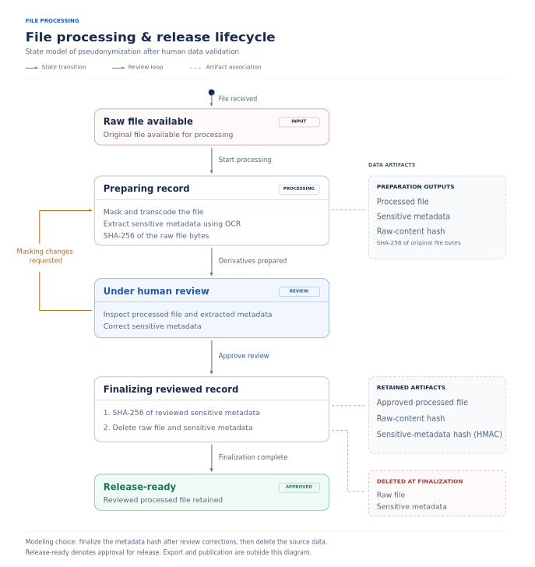Figure 1: Release data and lifecycle under human validation
The formal analysis qualifies these guarantees through explicit input-binding assumptions, demographic ambiguity and disclosure of the authorized result.

Evidence availability
Supplements S1–S3 describe the recorded experiments and their limits [R1–R7]. S4 provides the mathematical formulation; S5 contains the complete checked Lean source and checksum [R8]. The current implementation review is pinned separately [12, R9].

References
1. Borgli H, Thambawita V, Smedsrud PH, et al. HyperKvasir, a comprehensive multi-class image and video dataset for gastrointestinal endoscopy. Scientific Data. 2020;7:283. doi:10.1038/s41597-020-00622-y.
2. Wilkinson MD, Dumontier M, Aalbersberg IJJ, et al. The FAIR Guiding Principles for scientific data management and stewardship. Scientific Data. 2016;3:160018. doi:10.1038/sdata.2016.18.
3. Gebru T, Morgenstern J, Vecchione B, et al. Datasheets for datasets. Communications of the ACM. 2021;64(12):86–92. doi:10.1145/3458723.
4. Gadotti A, Rocher L, Houssiau F, Creţu AM, de Montjoye YA. Anonymization: The imperfect science of using data while preserving privacy. Science Advances. 2024;10(29):eadn7053. doi:10.1126/sciadv.adn7053.
5. Dolstra E, Löh A. NixOS: A purely functional Linux distribution. Proceedings of ICFP 2008. 2008. p. 367–378. doi:10.1145/1411204.1411255.
6. Bourguet ML. How finite state machines can be used to build error free multimodal interaction systems. Proceedings of HCI 2003. Vol. 2. 2003. p. 81–84. Author manuscript: HCI03-1.pdf.
7. Article 29 Data Protection Working Party. Opinion 05/2014 on Anonymisation Techniques. WP216. Adopted 10 April 2014. Interpretive guidance. Source.
8. European Data Protection Board. Guidelines 02/2026 on Anonymisation. Version 1.0, adopted 7 July 2026 for public consultation; sections 2–3. Consultation version, status checked 14 October 2026. Source.
9. European Parliament and Council of the European Union. Regulation (EU) 2016/679 (General Data Protection Regulation). Official Journal of the European Union. 2016;L119:1–88. Recitals 26, 28, 156 and 159; Articles 4–6, 9, 13–14, 24–26, 28, 30, 32, 35–36 and 89. Source.
10. Court of Justice of the European Union. EDPS v SRB (Concept of personal data). Judgment of 4 September 2025, C-413/23 P. ECLI:EU:C:2025:645. Paragraphs 52, 75–87 and 102–115. Source.
11. European Data Protection Board. Guidelines 4/2019 on Article 25 Data Protection by Design and by Default. Version 2.0, adopted 20 October 2020. Final version. Source.
12. endoreg-db contributors. endoreg-db source code. Prototype implementation snapshot a965c67454013a92a95470e533a7f38a40ef4ddd. Inspected 20 October 2026. Source.
13. lx-data-models contributors. AuditLedgerHashPayload and related contracts. Revision 7c1fe85a3f3c5515c5584a94faf0409fe7ce14d1; lx_dtypes/models/contracts/audit_ledger.py. Source.
14. Harron KL, Doidge JC, Knight HE, et al. A guide to evaluating linkage quality for the analysis of linked data. International Journal of Epidemiology. 2017;46(5):1699–1710. doi:10.1093/ije/dyx177.
15. Kapoor S, Narayanan A. Leakage and the reproducibility crisis in machine-learning-based science. Patterns. 2023;4(9):100804. doi:10.1016/j.patter.2023.100804.
16. Rocher L, Hendrickx JM, de Montjoye YA. Estimating the success of re-identifications in incomplete datasets using generative models. Nature Communications. 2019;10:3069. doi:10.1038/s41467-019-10933-3.
17. European Data Protection Board. Guidelines 1/2026 on processing of personal data for scientific research purposes. Adopted 15 April 2026; sections 3–5, 7–8. Consultation version, status checked 14 October 2026. Source.
18. European Data Protection Board. Guidelines 07/2020 on the concepts of controller and processor in the GDPR. Adopted 7 July 2021; version 2.1, corrected 20 September 2022. Final version. Source.
19. Wang H, Zhang Z, Wang T, et al. PrivTrace: Differentially Private Trajectory Synthesis by Adaptive Markov Models. arXiv:2210.00581v2. 2022. Source.
20. Wasserman, A: Extending State Transition Diagrams for the Specification of Human-Computer Interaction. III Transactions on Software Engineering. 1985; SE-11(8):699-713. doi:10.1109/TSE.1985.232519
21. Krawczyk H, Bellare M, Canetti R. HMAC: Keyed-Hashing for Message Authentication. RFC 2104. February 1997. doi:10.17487/RFC2104.
22. de Moura L, Ullrich S. The Lean 4 Theorem Prover and Programming Language. In: Automated Deduction – CADE 28. Lecture Notes in Computer Science, vol. 12699. Springer; 2021. p. 625–635. doi:10.1007/978-3-030-79876-5_37.

Supplement S1. Technical scope and observations
The current patient-identity encoding is a compact JSON array containing the scheme string patient-identity-v1, stripped first name, stripped last name, ISO birth date and stripped source-centre identifier. JSON preserves Unicode before UTF-8 encoding; separators are a comma and colon without added spaces. A datetime contributes its date. HMAC-SHA256 uses the configured secret’s actual UTF-8 bytes. This encoding separates fields unambiguously; the finite digest is not collision-free. Exact equality depends on the selected source key and centre context. A candidate centre’s unrelated fingerprint does not reconstruct the source comparison. [R1]
The image experiment uses RGB baselines with bytes cycling modulo 251 at 8 × 8 and 16 × 16 pixels. Each trajectory increments one channel by one intensity unit at successive pixels, then reverses those increments. Three channels at each size produce six trajectories. The first modified pixel represents 1.5625% or 0.390625% of pixels, respectively. File hashes concern encoded bytes, including metadata. [R2]
Observation class | Count | Recorded outcome
Forward changes: 3 × (64 + 256) | 960 | 0 baseline matches; no repeated forward digest within each trajectory
Reverse steps | 960 | 960 corresponding earlier-state matches
Identical-copy controls | 6 | 6 baseline matches
Metadata-only change | 1 | 0 baseline matches; pixels unchanged
Baselines | 7 | Reference observations
Total | 1,934 | Seven recorded tests passed
The original evaluation reported that its archived image-test source was byte-identical to the then-current test source. The recorded execution reports seven passes and one warning in 1.81 seconds. These measurements remain historical evidence rather than a rerun at the implementation snapshot reviewed here. The duration is that experiment’s execution time, not private-matching throughput. The warning concerns pytest assertion rewriting; no full-suite total is inferred.
The executed hash tests cover repetition, encoding ambiguity, date variation, weak retained-key recognition and known-key candidate recovery [R4–R5]. Transfer and response boundary assertions were inspected separately [R6–R7]. Eight source-centre/key/examination-date combinations require rejection of identity-hash payloads before receiver key access or patient creation. Valid UUID transfers can create receiver-side pseudonymous rows; the no-creation assertion applies to rejected payloads. Software tests establish fixture behaviour rather than verified clinical identity.

Supplement S2. Threat model and bounded risk characterization
Capability or pathway | Evidence or condition | Risk interpretation
Recipient compares artifact digests | 6/6 identical-copy controls match; 1/1 metadata edit differs | Equality can link unchanged artifacts; edited representations can evade exact matching.
Participant or attacker knows the identity key | Executed scans enumerate 366 dates with fixed names | Candidate testing depends on remaining input uncertainty and key access.
Attacker tests weak keys against a generation fingerprint | Passing test identifies one enrolled weak key among three candidates | A public fingerprint can verify guesses; it supplies no entropy guarantee.
Sender substitutes record ownership or identity fields | Current UUID-ownership and boundary-rejection assertions | Protection depends on authenticated principals and enforcement at each receiving boundary.
Administrator obtains keys, records or retained state | Endpoint privilege, backup and logging assumptions | Host or administrative compromise can expose inputs beyond protocol outputs.
Authorized recipient combines relationships and outside knowledge | Released UUID relationships and artifact equality | Purpose authorization does not remove attribution opportunities.
Repeated or adaptive queries | Each permitted result conveys information about selected inputs | Replay protection addresses duplicate requests, not cumulative inference from fresh queries.
The table reports conditional pathways rather than calibrated severity scores. The experiment measures artifact equality, not adversarial success. The 366-date and three-key quantities describe finite test domains. No numerical clinical risk, administrator-compromise probability or cross-release attribution rate is assigned.
Assumptions are explicit: local records are authorized for the operation; authenticated principals correspond to the asserted source; identity keys and retained computation state remain within their approved boundary; release-field controls execute on the actual export; recipients can observe permitted UUID relationships and artifact content. Protection against a hostile network depends on enforcement of the deployment’s required authenticated transport. Test assertions about application behaviour do not independently establish these operational assumptions.
For exact comparisons, source UUID, fingerprint, centre, scheme and key generation require a consistent binding; candidate tuples require authorization and binding to existing candidate UUIDs. If the target is bound to its claimed source input, successful comparison establishes recomputed-tag equality. Encoded-input equality additionally requires exclusion of a collision for that pair; person identity requires independent evidence (Supplement S4). Signed results authenticate an assertion and its session context when signature verification is sound. Failure, interruption, unavailable keys and ambiguous candidates require distinct treatment from a completed nonmatch. These are interpretation constraints; private cross-site matching has not been demonstrated by the recorded artifact experiment.

Supplement S3. Shared and local HMAC keys
All fingerprints in the recorded synthetic evaluation were computed by the production helper used for that run. The synthetic target was Synthetic Person, born 1980-07-14, under centre-a. The script enumerated every date in leap year 1980 in chronological order: 366 candidates per scan, ten scans per condition, five conditions. Shared-key and disclosed-local-key conditions intentionally used the same target key. The independent local key differed. Public synthetic 64-character keys were passed unchanged as UTF-8 strings; no key was hex-decoded. Existing UUIDs and stored identity hashes were untouched [R1, R3].
Both conditions supplying A’s key and context recovered exactly one candidate, at position 196, in every repetition. The other three conditions returned zero matches across the same complete date domain. A shared key with B’s centre identifier did not match A’s target, but switching to A’s identifier enabled recovery. Independent local keys prevented that reproduction in this experiment; disclosure of A’s key restored the same candidate-verification capability. These are conditional observations, not probabilities of key compromise or evidence of key recovery. A wrong-key digest match would be an accidental equality, not reliable date recognition; none occurred in these scans. Repetitions reuse the same candidates and keys, so they are not independent collision trials.
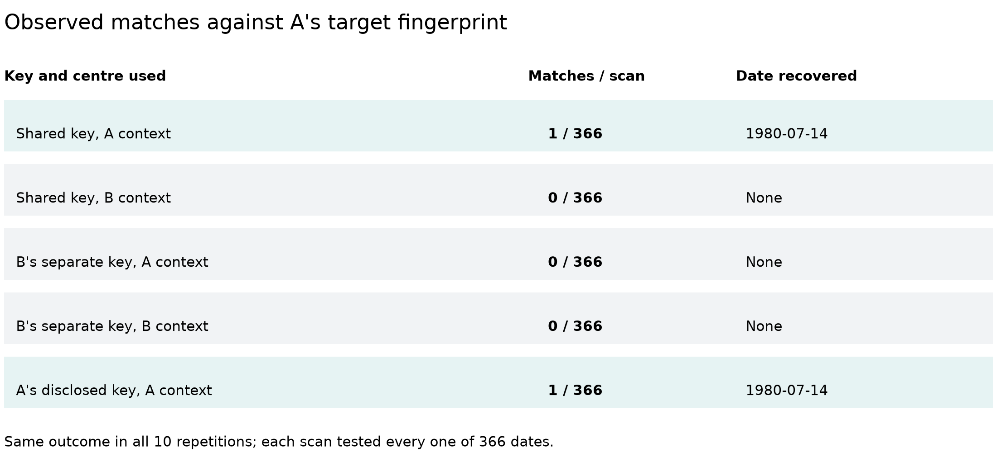
Figure S1. Match outcomes, separated from computation time. Each scan tested all 366 dates; all ten repetitions agreed. B’s separate key yielded zero matches and no recovered date. Known names, target fingerprint and source centre are assumed. HMAC candidate verification recomputes fingerprints; it does not decrypt them.
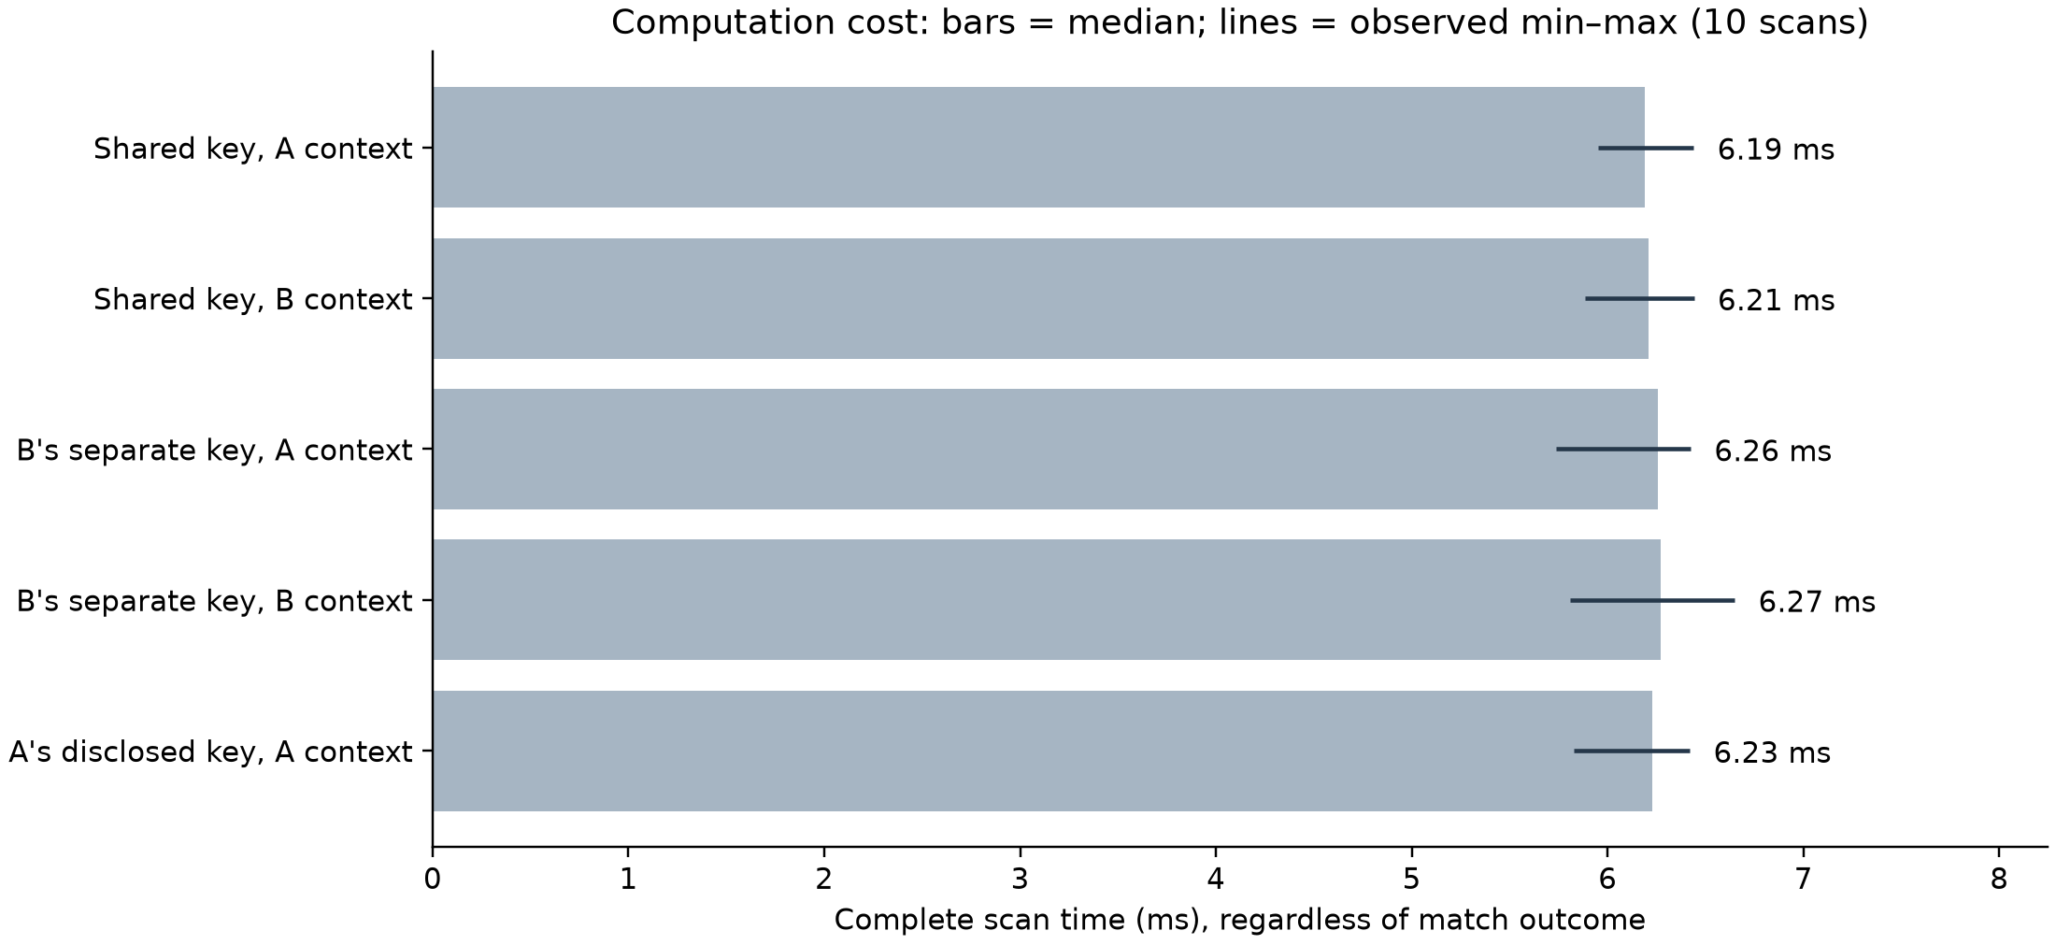
Figure S2. Cost of a complete scan, irrespective of match outcome. Bars show medians and lines the observed minimum–maximum across ten repetitions, not confidence intervals. The zero-based axis supports direct cost comparison. Timings include production encoding and key validation, excluding initialization and plotting.
In figure order, median scan times were 6.19, 6.21, 6.26, 6.27, 6.23 ms. Across all scans the measured range was 5.74–6.65 ms. Execution used an Intel Core i5-12450H (12 logical CPUs), Python 3.12.14 and Linux 6.12.112. These are local helper-loop measurements under uncontrolled concurrent workload, not two-party computation performance or population-scale attack estimates.
The passing weak-key test identifies an enrolled historical key from three guesses using the production generation-fingerprint helper. This demonstrates guess verification for that deliberately weak fixture; it does not recover a strong unknown key. Separate local keys limit the scope of one key’s disclosure, conditional on independent provisioning and access. Identical demographics can still describe different people, and signatures authenticate assertions rather than their clinical truth. [R4]

Supplement S4. Mathematical formulation and proofs
The propositions formalize the linkage and disclosure boundaries used in the main text. They are elementary consequences of deterministic comparison and the information available to a recipient. Each statement is proved in the standalone Lean listing in Supplement S5. Cryptographic security, patient-identity truth and production enforcement are outside these statements.

S4.1. Model and assumptions
Let X denote demographic tuples, C centre contexts, P encoded payloads, K keys, T tags and B complete artifact byte strings. Let E encode a demographic tuple in a centre context, M be a keyed deterministic function and H be a deterministic artifact digest. In the production helper, E has the JSON/UTF-8 form described in Supplement S1 and M is HMAC-SHA-256 [21, R1]. The formal model leaves both functions unspecified.
$$E : X × C → P, M : K × P → T, H : B → T (S1)$$
Write Mₖ(p) for M(k,p). A source record A contains a record label uA, centre cA, key kA and target tag tA. A candidate row contains a record label u and attributes x. Record labels model existing UUIDs; their concrete representation is immaterial. For an original source tuple xA, source binding is the explicit premise
$$t_{A} \text{=} M_{k_{A}}(E(x_{A}, c_{A})). (S2)$$
This premise states consistency of the tag and claimed payload. Define the source-context comparison, with brackets denoting a Boolean truth value, by
$${Match}_{A}(u, x) \text{=} [M_{k_{A}}(E(x, c_{A})) \text{=} t_{A}]. (S3)$$
Every candidate is evaluated in A’s key and centre context. This specification does not prescribe disclosing the key to another participant. An independently generated local tag under B’s own key and centre is not the same comparison operation. The generic model proves neither that different keys always give different tags nor that conversion between local tags or key recovery is computationally infeasible.

S4.2. Proposition 1 — Artifact equality and collision qualification
For any deterministic function F and two inputs p and q, define a collision for that pair as distinct inputs with equal outputs:
$${Coll}_{F}(p, q) ⇔ (p ≠ q ∧ F(p) \text{=} F(q)). (S4)$$
$$b \text{=} b′ ⇒ H(b) \text{=} H(b′), (S5)$$
$$H(b) \text{=} H(b′) ⇒ (b \text{=} b′ ∨ {Coll}_{H}(b, b′)). (S6)$$
Proof. Equality is preserved by application of a function. For the converse, split into the cases b = b′ and b ≠ b′; in the second case, the given digest equality satisfies the collision definition. Thus unchanged byte strings necessarily retain the same digest, whereas digest equality alone does not prove byte identity. The finite artifact experiment does not prove that all possible modifications change a digest. An observer with a candidate artifact can compute its public digest and test equality, subject to the same collision qualification.
Lean correspondence: identical_input_equal_digest; digest_equality_or_collision.

S4.3. Proposition 2 — Meaning of a patient-fingerprint match
Assume source binding (S2). Let p = E(x,cA) and pA = E(xA,cA). Then:
$$p \text{=} p_{A} ⇒ {Match}_{A}(u, x) \text{=} 1, (S7)$$
$${Match}_{A}(u, x) \text{=} 1 ⇒ (p \text{=} p_{A} ∨ {Coll}_{M_{k_{A}}}(p, p_{A})). (S8)$$
$${Match}_{A}(u, x) \text{=} 1 ∧ ¬{Coll}_{M_{k_{A}}}(p, p_{A}) ⇒ p \text{=} p_{A}. (S9)$$
Proof. Substitute (S2) into (S3). Equal payloads yield equal tags by determinism. If a match holds, the two recomputed tags are equal; applying Proposition 1 to the fixed-key function gives the two cases in (S8). Excluding the collision for this particular pair removes its second case. No global injectivity assumption or collision probability is supplied. Even the conclusion p = pA concerns encoded attributes and does not establish that the records refer to the same person.
Lean correspondence: equal_payload_matches; match_implies_equal_payload_or_collision; payload_equality_of_match_and_no_collision.

S4.4. Proposition 3 — UUIDs require an additional binding
Let A′ be A with only its source record label replaced. For any candidate labels u and v, while attributes and key context remain unchanged,
$${Match}_{A}(u, x) \text{=} {Match}_{A′}(v, x). (S10)$$
Proof. Neither source nor candidate record label occurs in (S3), so substitution leaves the defining expression unchanged. A demographic fingerprint therefore cannot authenticate the association between its payload and a UUID absent from that payload. The application must establish the source and candidate record bindings through an authenticated, authorized request and result. The prototype contains additional input and source-owner binding mechanisms [R9]. This proposition identifies the need for those mechanisms; it does not verify their implementation.
Lean correspondence: candidate_uuid_substitution; source_uuid_substitution.

S4.5. Proposition 4 — Demographic ambiguity precedes hashing
Let Q be the set of persons, d: Q → P their demographic encoding in a fixed context and F: P → T any deterministic fingerprint. If two distinct persons have the same encoding, then a matching fingerprint cannot be a universally sufficient condition for person identity:
$$(∃ a, b ∈ Q : a ≠ b ∧ d(a) \text{=} d(b)) (S11a)$$
$$⇒ ¬(∀ a, b ∈ Q : F(d(a)) \text{=} F(d(b)) ⇒ a \text{=} b). (S11b)$$
Proof. Choose distinct persons a and b with equal encodings. Applying F preserves equality. Any rule asserting that equal fingerprints imply a = b contradicts the chosen inequality. This ambiguity exists before hashing and is distinct from a cryptographic collision, which concerns different encoded payloads. The proposition is conditional on the stated existence premise; it does not estimate the frequency of demographic duplicates in a clinical population.
Lean correspondence: demographic_identifier_impossible.

S4.6. Proposition 5 — An exact disclosed result reveals membership
Let N > 0 and let R be uniform on the N execution choices {0,…,N−1}. For a world w and choice r, let V(w,r) be a recipient’s view, m(w) a membership bit and read a function extracting that bit from the view. Restrict attention to executions that return an exact readable result, with correctness for every considered world and choice:
$$∀ w, r : read(V(w, r)) \text{=} m(w). (S12)$$
For a Boolean distinguisher D, let CD(w) count choices r for which D(V(w,r)) = 1. Take worlds w1 and w0 with membership bits 1 and 0, respectively. Reading the result is itself a distinguisher, and its acceptance counts are:
$$C_{read}(w_{1}) \text{=} N, C_{read}(w_{0}) \text{=} 0. (S13)$$
$$Pr[read(V(w_{1}, R)) \text{=} 1] \text{=} \frac{N}{N} \text{=} 1, (S14a)$$
$$Pr[read(V(w_{0}, R)) \text{=} 1] \text{=} \frac{0}{N} \text{=} 0. (S14b)$$
Proof. Correctness fixes the extracted bit to 1 for every choice in w1 and to 0 for every choice in w0. Counting gives N and 0, so the views cannot have equal acceptance counts for every Boolean distinguisher when N > 0. The Lean listing proves these finite counts and their inequality. Dividing by the positive N gives the displayed probabilities under the stated uniform interpretation; a separate probability-measure construction is not part of the listing.
The result concerns information deliberately disclosed by a completed exact comparison. It does not model aborting or noisy protocols, imply that every recipient learns a person’s name, or rule out protection of other private inputs. A privacy definition for useful matching must account for the authorized output. The proposition alone supplies no simulator or security proof for a deployed private-comparison protocol.
Lean correspondence: exact_membership_distinguishes; exact_membership_cannot_be_perfectly_hidden; acceptanceCount_of_constant (supporting lemma).

Supplement S5. Lean formalization and verification
The complete listing below is also supplied as LinkageSupplement.lean. It imports only Std and can be checked with Lean 4.19.0 using the command shown below. The source and a separate theorem-dependency audit both completed with exit code 0 on 20 October 2026. There are 11 named theorems, including the finite-count helper. No custom axioms or admitted proofs are used. The dependency audit reports only Lean’s standard propext, Classical.choice and Quot.sound axioms [22, R8].
The listing specializes the relevant parts of the broader proof development to the five propositions in Supplement S4. Source-target consistency and exact output correctness remain explicit hypotheses. Natural numbers represent abstract UUID labels. Neither cryptographic hardness nor conformance of the Python implementation to the model is claimed.
lean --version
lean LinkageSupplement.lean
Source SHA-256:
ef47161c5946856adcdd3dae7b9912a864713b7a1002db470ca893858a8c6578
Listing S5. Complete standalone formalization. Logical blocks are kept together where space permits.
import Std

/-!
Supplement: functional linkage properties and disclosure limits.
Checked with Lean 4.19.0. Only `Std` is required.

`digest`, `mac`, and `encode` are arbitrary deterministic functions.
They are not verified implementations of SHA-256, HMAC, or Python JSON.
The source-binding and exact-output hypotheses are explicit premises.
No cryptographic hardness or deployed-protocol security is asserted.
-/

set_option autoImplicit false

namespace LinkageSupplement

variable {Data Key Payload Tag : Type}

def Collision (digest : Payload → Tag) (x y : Payload) : Prop :=
x ≠ y ∧ digest x = digest y

-- Identical encoded artifacts have equal deterministic digests.
theorem identical_input_equal_digest (digest : Payload → Tag)
(x y : Payload) (same : x = y) : digest x = digest y :=
congrArg digest same

-- Digest equality alone is qualified by a possible collision.
theorem digest_equality_or_collision (digest : Payload → Tag)
(x y : Payload) (equalTags : digest x = digest y) :
x = y ∨ Collision digest x y := by
classical
by_cases same : x = y
· exact Or.inl same
· exact Or.inr ⟨same, equalTags⟩

structure Candidate (Data : Type) where
uuid : Nat
data : Data

structure Source (Key Tag : Type) where
uuid : Nat
center : String
key : Key
target : Tag

-- Every candidate is reconstructed in the source's key/centre context.
def matchCandidate [DecidableEq Tag]
(mac : Key → Payload → Tag) (encode : Data → String → Payload)
(source : Source Key Tag) (row : Candidate Data) : Bool :=
decide (mac source.key (encode row.data source.center) = source.target)

theorem equal_payload_matches [DecidableEq Tag]
(mac : Key → Payload → Tag) (encode : Data → String → Payload)
(source : Source Key Tag) (row : Candidate Data) (original : Data)
(bound : source.target = mac source.key (encode original source.center))
(same : encode row.data source.center = encode original source.center) :
matchCandidate mac encode source row = true := by
simp [matchCandidate, same, bound]

theorem match_implies_equal_payload_or_collision [DecidableEq Tag]
(mac : Key → Payload → Tag) (encode : Data → String → Payload)
(source : Source Key Tag) (row : Candidate Data) (original : Data)
(bound : source.target = mac source.key (encode original source.center))
(matched : matchCandidate mac encode source row = true) :
encode row.data source.center = encode original source.center ∨
Collision (mac source.key) (encode row.data source.center)
(encode original source.center) := by
have tagEq :
mac source.key (encode row.data source.center) = source.target := by
simpa [matchCandidate] using matched
exact digest_equality_or_collision (mac source.key)
(encode row.data source.center) (encode original source.center)
(tagEq.trans bound)

theorem payload_equality_of_match_and_no_collision [DecidableEq Tag]
(mac : Key → Payload → Tag) (encode : Data → String → Payload)
(source : Source Key Tag) (row : Candidate Data) (original : Data)
(bound : source.target = mac source.key (encode original source.center))
(matched : matchCandidate mac encode source row = true)
(noCollision : ¬ Collision (mac source.key)
(encode row.data source.center) (encode original source.center)) :
encode row.data source.center = encode original source.center := by
rcases match_implies_equal_payload_or_collision
mac encode source row original bound matched with same | collision
· exact same
· exact False.elim (noCollision collision)

theorem candidate_uuid_substitution [DecidableEq Tag]
(mac : Key → Payload → Tag) (encode : Data → String → Payload)
(source : Source Key Tag) (row : Candidate Data) (replacement : Nat) :
matchCandidate mac encode source { row with uuid := replacement } =
matchCandidate mac encode source row := rfl

theorem source_uuid_substitution [DecidableEq Tag]
(mac : Key → Payload → Tag) (encode : Data → String → Payload)
(source : Source Key Tag) (row : Candidate Data) (replacement : Nat) :
matchCandidate mac encode { source with uuid := replacement } row =
matchCandidate mac encode source row := rfl

-- This ambiguity is in the encoded demographics, not a hash collision.
theorem demographic_identifier_impossible {Person : Type}
(encodePerson : Person → Payload) (fingerprint : Payload → Tag)
(homonyms : ∃ p q : Person, p ≠ q ∧ encodePerson p = encodePerson q) :
¬ (∀ p q : Person,
fingerprint (encodePerson p) = fingerprint (encodePerson q) →
p = q) := by
intro identifies
obtain ⟨p, q, different, sameEncoding⟩ := homonyms
exact different (identifies p q (congrArg fingerprint sameEncoding))

-- Fin N represents N equally likely random coins. Counts avoid rounding.
def acceptanceCount {View : Type} (readBit : View → Bool) :
(n : Nat) → (Fin n → View) → Nat
| 0, _ => 0
| n + 1, samples =>
(if readBit (samples 0) then 1 else 0) +
acceptanceCount readBit n (fun coin => samples coin.succ)

theorem acceptanceCount_of_constant {View : Type}
(readBit : View → Bool) (n : Nat) (samples : Fin n → View) (bit : Bool)
(constant : ∀ coin, readBit (samples coin) = bit) :
acceptanceCount readBit n samples = (if bit then n else 0) := by
induction n with
| zero => cases bit <;> rfl
| succ n ih =>
have tailConstant :
∀ coin : Fin n,
readBit ((fun i : Fin n => samples i.succ) coin) = bit :=
fun coin => constant coin.succ
have tailCount := ih (fun coin => samples coin.succ) tailConstant
simp only [acceptanceCount]
rw [constant 0, tailCount]
cases bit <;> simp [Nat.add_comm]

variable {World View : Type}

-- A disclosed bit is assumed correct for every world and every coin.
def ExactMembershipOutput (n : Nat)
(view : World → Fin n → View) (membership : World → Bool)
(readOutput : View → Bool) : Prop :=
∀ world coin, readOutput (view world coin) = membership world

theorem exact_membership_distinguishes (n : Nat)
(view : World → Fin n → View) (membership : World → Bool)
(readOutput : View → Bool)
(correct : ExactMembershipOutput n view membership readOutput)
(yesWorld noWorld : World)
(isYes : membership yesWorld = true)
(isNo : membership noWorld = false) :
acceptanceCount readOutput n (view yesWorld) = n ∧
acceptanceCount readOutput n (view noWorld) = 0 := by
constructor
· have constant : ∀ coin, readOutput (view yesWorld coin) = true := by
intro coin
rw [correct yesWorld coin, isYes]
simpa using acceptanceCount_of_constant readOutput n
(view yesWorld) true constant
· have constant : ∀ coin, readOutput (view noWorld coin) = false := by
intro coin
rw [correct noWorld coin, isNo]
simpa using acceptanceCount_of_constant readOutput n
(view noWorld) false constant

-- A readable, exact result cannot itself have perfect membership privacy.
-- This says nothing about whether other private inputs remain protected.
theorem exact_membership_cannot_be_perfectly_hidden
(n : Nat) (nonempty : 0 < n)
(view : World → Fin n → View) (membership : World → Bool)
(readOutput : View → Bool)
(correct : ExactMembershipOutput n view membership readOutput)
(yesWorld noWorld : World)
(isYes : membership yesWorld = true)
(isNo : membership noWorld = false) :
¬ (∀ distinguish : View → Bool,
acceptanceCount distinguish n (view yesWorld) =
acceptanceCount distinguish n (view noWorld)) := by
intro hidden
have counts := exact_membership_distinguishes n view membership
readOutput correct yesWorld noWorld isYes isNo
have equalCounts := hidden readOutput
omega

end LinkageSupplement

Supplementary evidence references
References R1–R7 identify software components and the previously reported experimental evidence for the 1.6.0 evaluation designation. The implementation snapshot reviewed in this revision is pinned separately in References 12 and R9; previous measurements are not relabelled as new executions. R8 identifies the formal supplement.
[R1] endoreg_db. Production patient-identity encoding, HMAC and key-generation fingerprints.
[R2] endoreg_db. Image content-hash experiment: current test definition and recorded observations.
[R3] endoreg_db. Synthetic shared/local-key HMAC evaluation: script, contract tests and recorded scans.
[R4] endoreg_db. Sensitive-metadata hash-security tests: candidate verification and retained-key recognition.
[R5] endoreg_db. Patient-identity input-variation tests: names, Unicode and date handling.
[R6] endoreg_db. Source patient-matching and transfer identity-boundary test contracts.
[R7] endoreg_db. Response identity-boundary test contracts.
[R8] LinkageSupplement.lean. Standalone formalization of the five propositions in Supplement S4, derived from the PatientMatching Lean development. Lean 4.19.0 (commit 6caaee842e94); 11 named theorems including one helper; source and dependency audit checked 20 October 2026. Complete source and SHA-256 appear in S5. The companion verification record lists the theorems, compilation status and standard axiom dependencies.
[R9] endoreg-db prototype implementation review, 20 October 2026, commit a965c67454013a92a95470e533a7f38a40ef4ddd. Inspected paths: utils/hashs.py; services/patient_identity/matching_inputs.py, matching_backend.py and matching_acceptance.py; schemas/patient_matching.py; models/hub/patient_matching.py; services/hub/transfers.py; related tests; feature-tracking/HubTransfer.yml. Paths are relative to endoreg_db unless prefixed by tests or feature-tracking. Code and test-source inspection only; no prototype tests rerun for this revision. Pinned source.

