Site-scoped record linkage with salt-bound hub pseudonyms
Hypothesis. Longitudinal record associations can be preserved for research while no site-local pseudonym, identity fingerprint or identity key reaches the central hub, so that relinking a hub record to a site record requires the site's local identity salt.
Revision of 22 October 2026. Development work, test evidence, proofs and open items are reported in Supplements S1–S7.

Abstract
Background: Longitudinal endoscopy research requires record linkage, yet every stable identifier that leaves a clinical site is itself a pseudonym. In the registry studied here, the hub no longer received identity fingerprints but still received each site's persisted local patient and examination UUIDs.
Objective: To keep follow-up linkage local, give the hub only pseudonyms bound to the site's local identity salt, and restrict relinking to the salt holder, interpreted under the European Union General Data Protection Regulation (GDPR).
Methods: Each site derives a hub pseudonym as a UUIDv8 of HMAC-SHA-256 under its local salt over record kind, local UUID and target-hub key; a shared typed contract rejects every other UUID version. We evaluated the boundary with tests in sender, contract and receiver, a synthetic key-exposure experiment and a Lean 4.19.0 formalization of 13 theorems.
Results: Local UUIDs were rejected in every tested transfer path. Under key exposure, independent local keys halved the attacker's new correct record–person mappings compared with a shared key (72 versus 144 over three synthetic trials). Formally, locally linked follow-ups keep one hub pseudonym, and under an explicit key-coverage premise no fixed rule recovers local UUIDs from the hub's view.
Conclusion: Salt-bound hub pseudonyms retain longitudinal association at the hub while confining fingerprints, local pseudonyms and keys to the site. Hub data remain pseudonymous, not anonymous.
Keywords: endoscopy; record linkage; pseudonymization; keyed hashing; data protection; formal verification

1. Introduction
Curated endoscopic media and reusable, documented datasets support research on findings, interventions and outcomes [1–3]. Register studies additionally require that follow-up examinations remain attributable to one patient after pseudonymization, and the same associations permit attribution through linkage with additional information [4,5].
Privacy-preserving record linkage compares encoded identifiers without revealing plaintext [6–8], but deterministic encodings of low-entropy demographics can be enumerated once their key is known [9], and even random identifiers become stable linkage keys once they cross an organizational boundary. Medical-research guidance therefore separates identifying and clinical data across roles [10].
We study a multi-site endoscopy registry in which each site holds a local identity salt and transfers processed media and structured metadata to a central hub. We contribute (i) an identifier inventory showing that a random local UUID acted as a hub-visible pseudonym; (ii) a salt-bound hub pseudonym that keeps follow-up linkage local and confines relinking to the salt holder; and (iii) an empirical and formal evaluation of this boundary.

2. Design

2.1. Identifier inventory
Table 1 classifies every patient-related identifier in the transfer path. Identity fingerprints and the salt already stayed at the site; the persisted local UUID, although random, reached the hub unchanged and let it accumulate a patient's transfers without any key.
Table 1. Patient-related identifiers in the site-to-hub transfer path.
Identifier | Derivation | Held by | Reaches hub (before → after)
Name, date of birth | Source data; deleted after review | Site | No → No
Patient / examination hash | HMAC-SHA-256 under local salt | Site | No → No
Identity salt | Local keyring | Site | No → No
Local patient / examination UUID | Random UUIDv4, persisted | Site | Yes → No
Hub pseudonym | Equation (1) | Hub | — → Yes
Media content hash | SHA-256 of bytes | Site, hub | Yes → Yes

2.2. Salt-bound hub pseudonyms
For a local record with UUID u of kind κ, target hub key h and local salt s, the site sends
ψ(s, κ, u, h) = UUIDv8( HMAC-SHA-256_s( J(σ, κ, u, h) ) ) (1)
where σ is a fixed scheme string, J a canonical JSON/UTF-8 encoding and UUIDv8 the RFC 9562 format of the first 128 digest bits [11,12]. Follow-ups are linked only at the site: a new examination resolves through the site's patient hash to the existing local UUID and hence to the same ψ. Including h makes pseudonyms for different hubs unlinkable without s. Because the input of ψ is a random UUID rather than demographics, even a party holding s cannot run demographic enumeration against hub pseudonyms without the site's UUID table. The shared contract accepts only UUIDv8 values, so a sender emitting local UUIDs fails closed (Figure 1; implementation in Supplement S1).
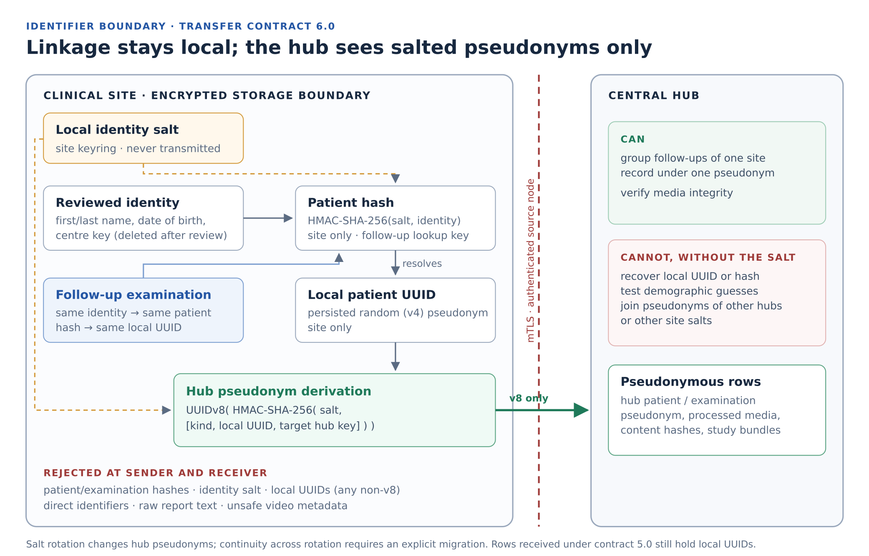
Figure 1. Identifier boundary. Fingerprints, salt and local UUIDs remain at the site; only salt-bound pseudonyms, processed media and content hashes cross the mutually authenticated channel.

3. Evaluation

3.1. Boundary enforcement
Contract, receiver and sender test suites passed (Supplement S1, Table S1). In every tested path, local UUIDs were absent from payloads and study bundles, pseudonyms were stable across retries and differed between hubs, and payloads or bundles carrying local UUIDs were rejected before persistence.

3.2. Effect of local keys under key exposure
A sandboxed attacker received an unlabelled dump of identity-hash rows from two synthetic centres (432 target rows per condition over three trials), an exposed key and an independent synthetic person corpus (Supplement S4). Table 2 shows that key scope bounded the exposed population.
Table 2. Additional identity gain after key exposure (sums over three synthetic trials; not population estimates).
Exposed key | Digest matches | New correct mappings | False mappings
Shared key of both centres | 192 | 144 | 12
Independent local key of one centre | 96 | 72 | 6
Wrong key | 0 | 0 | 0
Shared key, rows already labelled (control) | 192 | 0 | 0
These rows are identity hashes, which no longer leave the site; the experiment quantifies why the identity key must stay local.

3.3. Formal properties
In a Lean 4.19.0 model with abstract keyed functions [13], 13 theorems check using only Lean's standard axioms (Supplements S5–S6). Earlier results establish that a fingerprint match implies equal encodings or a collision, that equal demographics of distinct persons cannot be separated by any fingerprint, that fingerprints do not bind record UUIDs, and that an exact disclosed match reveals membership. Two new results concern ψ: locally linked follow-ups obtain one hub pseudonym (Proposition 6), and if every output is reachable from every local UUID under some salt, no fixed rule recovers local UUIDs from hub pseudonyms (Proposition 7).

4. Discussion
The design separates association utility (the hub follows one patient over time), identity confinement (fingerprints, local pseudonyms and keys stay at the site) and identity assurance (two records denote the same human). It retains the first, strengthens the second and claims nothing about the third. The key-exposure results support local rather than central keys: one compromised key exposes one site, and ψ extends this confinement to the last identifier that crossed the boundary.
At the hub, salt-bound pseudonyms and the associations they enable are pseudonymous data. Following EDPS v SRB, identifiability for the hub depends on the means reasonably likely to be available to it [14–16]; the design keeps the additional information out of its reach, but released content, artifact equality and auxiliary data may still permit attribution. Lawful basis, purpose limitation and access separation remain governance obligations [17–20].
Limitations. The receiver checks the UUID version but cannot verify that a value was derived by ψ. Proposition 7 idealizes a pseudorandom function and is not a computational security proof for HMAC-SHA-256 [21]. Salt rotation and hub rows received under the previous contract require migrations that are recorded but postponed. Populations are synthetic, so no clinical linkage-error or re-identification rate is estimated [22]. Open evidence obligations for individual claims are listed in Supplement S7 and tracked as feature criteria.

5. Conclusion
Salt-bound hub pseudonyms reconcile longitudinal research use with site-confined identity: follow-ups are linked locally, the hub receives only pseudonyms derived under the site's salt, and relinking requires that salt. The boundary is enforced fail-closed and supported by tests, a key-exposure experiment and machine-checked propositions; its guarantees are bounded to pseudonymization, not anonymization.

Data and code availability
Source code [23,24], the Lean supplement (SHA-256 bc38dc5e…6cfede) and the key-exposure archive (SHA-256 87e7c007…5790f2c) are identified in Supplement S7 and the evidence references R1–R11.

References
1. Borgli H, Thambawita V, Smedsrud PH, et al. HyperKvasir, a comprehensive multi-class image and video dataset for gastrointestinal endoscopy. Scientific Data. 2020;7:283. doi:10.1038/s41597-020-00622-y
2. Wilkinson MD, Dumontier M, Aalbersberg IJJ, et al. The FAIR Guiding Principles for scientific data management and stewardship. Scientific Data. 2016;3:160018. doi:10.1038/sdata.2016.18
3. Gebru T, Morgenstern J, Vecchione B, et al. Datasheets for datasets. Communications of the ACM. 2021;64(12):86–92. doi:10.1145/3458723
4. Gadotti A, Rocher L, Houssiau F, Creţu AM, de Montjoye YA. Anonymization: The imperfect science of using data while preserving privacy. Science Advances. 2024;10(29):eadn7053. doi:10.1126/sciadv.adn7053
5. Rocher L, Hendrickx JM, de Montjoye YA. Estimating the success of re-identifications in incomplete datasets using generative models. Nature Communications. 2019;10:3069. doi:10.1038/s41467-019-10933-3
6. Schnell R, Bachteler T, Reiher J. Privacy-preserving record linkage using Bloom filters. BMC Medical Informatics and Decision Making. 2009;9:41. doi:10.1186/1472-6947-9-41
7. Vatsalan D, Christen P, Verykios VS. A taxonomy of privacy-preserving record linkage techniques. Information Systems. 2013;38(6):946–969. doi:10.1016/j.is.2012.11.005
8. Christen P, Ranbaduge T, Schnell R. Linking Sensitive Data: Methods and Techniques for Practical Privacy-Preserving Information Sharing. Springer; 2020. doi:10.1007/978-3-030-59706-1
9. Kuzu M, Kantarcioglu M, Durham E, Malin B. A constraint satisfaction cryptanalysis of Bloom filters in private record linkage. In: Privacy Enhancing Technologies (PETS 2011). LNCS 6794. Springer; 2011. p. 226–245. doi:10.1007/978-3-642-22263-4_13
10. Pommerening K, Drepper J, Helbing K, Ganslandt T. Leitfaden zum Datenschutz in medizinischen Forschungsprojekten: Generische Lösungen der TMF 2.0. Berlin: MWV; 2014. ISBN 978-3-95466-123-8.
11. Krawczyk H, Bellare M, Canetti R. HMAC: Keyed-hashing for message authentication. RFC 2104. February 1997. doi:10.17487/RFC2104
12. Davis K, Peabody B, Leach P. Universally Unique IDentifiers (UUIDs). RFC 9562. May 2024. doi:10.17487/RFC9562
13. de Moura L, Ullrich S. The Lean 4 theorem prover and programming language. In: Automated Deduction – CADE 28. LNCS 12699. Springer; 2021. p. 625–635. doi:10.1007/978-3-030-79876-5_37
14. Court of Justice of the European Union. EDPS v SRB (Concept of personal data). Judgment of 4 September 2025, C-413/23 P. ECLI:EU:C:2025:645. Paragraphs 52, 75–87 and 102–115. Source.
15. Article 29 Data Protection Working Party. Opinion 05/2014 on Anonymisation Techniques. WP216. Adopted 10 April 2014. Source.
16. European Data Protection Board. Guidelines 02/2026 on Anonymisation. Version 1.0, adopted 7 July 2026 for public consultation; sections 2–3. Status checked 14 October 2026. Source.
17. European Parliament and Council of the European Union. Regulation (EU) 2016/679 (General Data Protection Regulation). Official Journal of the European Union. 2016;L119:1–88. Source.
18. European Data Protection Board. Guidelines 4/2019 on Article 25 Data Protection by Design and by Default. Version 2.0, adopted 20 October 2020. Source.
19. European Data Protection Board. Guidelines 1/2026 on processing of personal data for scientific research purposes. Adopted 15 April 2026; consultation version, status checked 14 October 2026. Source.
20. European Data Protection Board. Guidelines 07/2020 on the concepts of controller and processor in the GDPR. Version 2.1, corrected 20 September 2022. Source.
21. Bellare M. New proofs for NMAC and HMAC: Security without collision resistance. Journal of Cryptology. 2015;28(4):844–878. doi:10.1007/s00145-014-9185-x
22. Harron KL, Doidge JC, Knight HE, et al. A guide to evaluating linkage quality for the analysis of linked data. International Journal of Epidemiology. 2017;46(5):1699–1710. doi:10.1093/ije/dyx177
23. endoreg-db contributors. endoreg-db source code. Prototype implementation snapshot a965c67454013a92a95470e533a7f38a40ef4ddd. Inspected 20 and 22 October 2026. Source.
24. lx-data-models contributors. Hub transfer and study exchange contracts. lx_dtypes/models/contracts/hub_transfer.py. Source.
25. Dolstra E, Löh A. NixOS: A purely functional Linux distribution. Proceedings of ICFP 2008. 2008. p. 367–378. doi:10.1145/1411204.1411255
26. Bourguet ML. How finite state machines can be used to build error free multimodal interaction systems. Proceedings of HCI 2003. Vol. 2. 2003. p. 81–84.
27. Wasserman AI. Extending state transition diagrams for the specification of human–computer interaction. IEEE Transactions on Software Engineering. 1985;SE-11(8):699–713. doi:10.1109/TSE.1985.232519
28. Keller M. MP-SPDZ: A versatile framework for multi-party computation. In: Proceedings of ACM CCS 2020. p. 1575–1590. doi:10.1145/3372297.3417872
29. Davidson A, Faz-Hernandez A, Sullivan N, Wood CA. Oblivious pseudorandom functions (OPRFs) using prime-order groups. RFC 9497. December 2023. doi:10.17487/RFC9497

Supplement S1. Implementation of transfer contract 6.0

S1.1. Software setting
LX-Annotate provides the site interface and orchestration; endoreg-db supplies domain models and processing services; lx-data-models defines shared typed contracts. LuxNix, an adaptation of NixOS, provisions hosts [25]. Review gates and recovery transitions follow a finite-state design [26,27] (Figure S1).

S1.2. Production encoding
get_hub_record_pseudonym(record_uuid, kind, hub_node_key, salt) in endoreg_db/utils/hashs.py serializes ["hub-record-pseudonym-v1", kind, str(record_uuid), hub_node_key.strip()] as compact JSON with ensure_ascii=False, encodes it as UTF-8, computes HMAC-SHA-256 under the active (or an explicitly enrolled historical) identity salt, keeps the first 16 bytes and sets the version nibble to 8 and the variant bits to 10. Empty hub keys are rejected. endoreg_db/services/hub/hub_pseudonyms.py applies it to media identity rows and study bundles [R10].

S1.3. Fail-closed enforcement
Contract 6.0 keeps the field names patient_uuid and examination_uuid but requires UUIDv8 in HubTransferSensitiveMetaPayload and in every patient link of HubTransferStudyResourceRowsPayload. Local UUIDs are version 4, so legacy senders fail at their own pre-flight validation and again at the receiver before database access; versions 3.0–5.0 are rejected. Authenticated source-node ownership binds each pseudonym to its sending centre [R6, R10].

S1.4. Study bundles
The sender re-keys every patient and examination reference in study-exchange bundles with ψ before transfer, so hub-side study acceptance resolves to the pseudonymous rows created by media transfer. Version-pinned assessments are revalidated on the re-keyed bundle and remained unchanged in the tests.

S1.5. Operational consequences
- Salt rotation changes every hub pseudonym; continuity requires an explicit, site-computed migration (tracked as hub_pseudonym_lifecycle).
- Hub rows received under contract 5.0 still hold local UUIDs and require a separate fail-closed reconciliation (same criterion).
- Shared contract, sender and receiver must be deployed together; mixed versions fail closed.

S1.6. Verification
Table S1. Verification of contract 6.0 on 22 October 2026 (working tree on a965c674; sibling sources via explicit path overlays).
Suite | Scope | Outcome
lx-data-models contract | Identity rows, study links, legacy rejection | 63 passed
endoreg-db identity, study, transfer | ψ unit tests, study re-keying, receiver boundary, migration | 136 passed, 3 subtests
endoreg-db HTTP receiver, registration | Hub transfer endpoints with v8 payloads | 64 passed, 35 subtests
LX-Annotate tests/hub | Sender payloads, guards, recovery, worker, end-to-end, study | 259 passed
Static checks | Pyright (endoreg-db, lx-data-models), Ruff, 66 structure maps | 0 errors; passed

S1.7. Private matching status
The guarded private-matching implementation uses MP-SPDZ [28]. At the reviewed working tree its input, acceptance, backend-adapter and workflow suites passed with 56 tests; eight native MP-SPDZ tests were skipped without an installed v0.4.4 tree and are not counted as cryptographic validation. Matching on verified issuer-qualified identifiers, for example via oblivious pseudorandom functions [29], remains a separate tracked criterion.
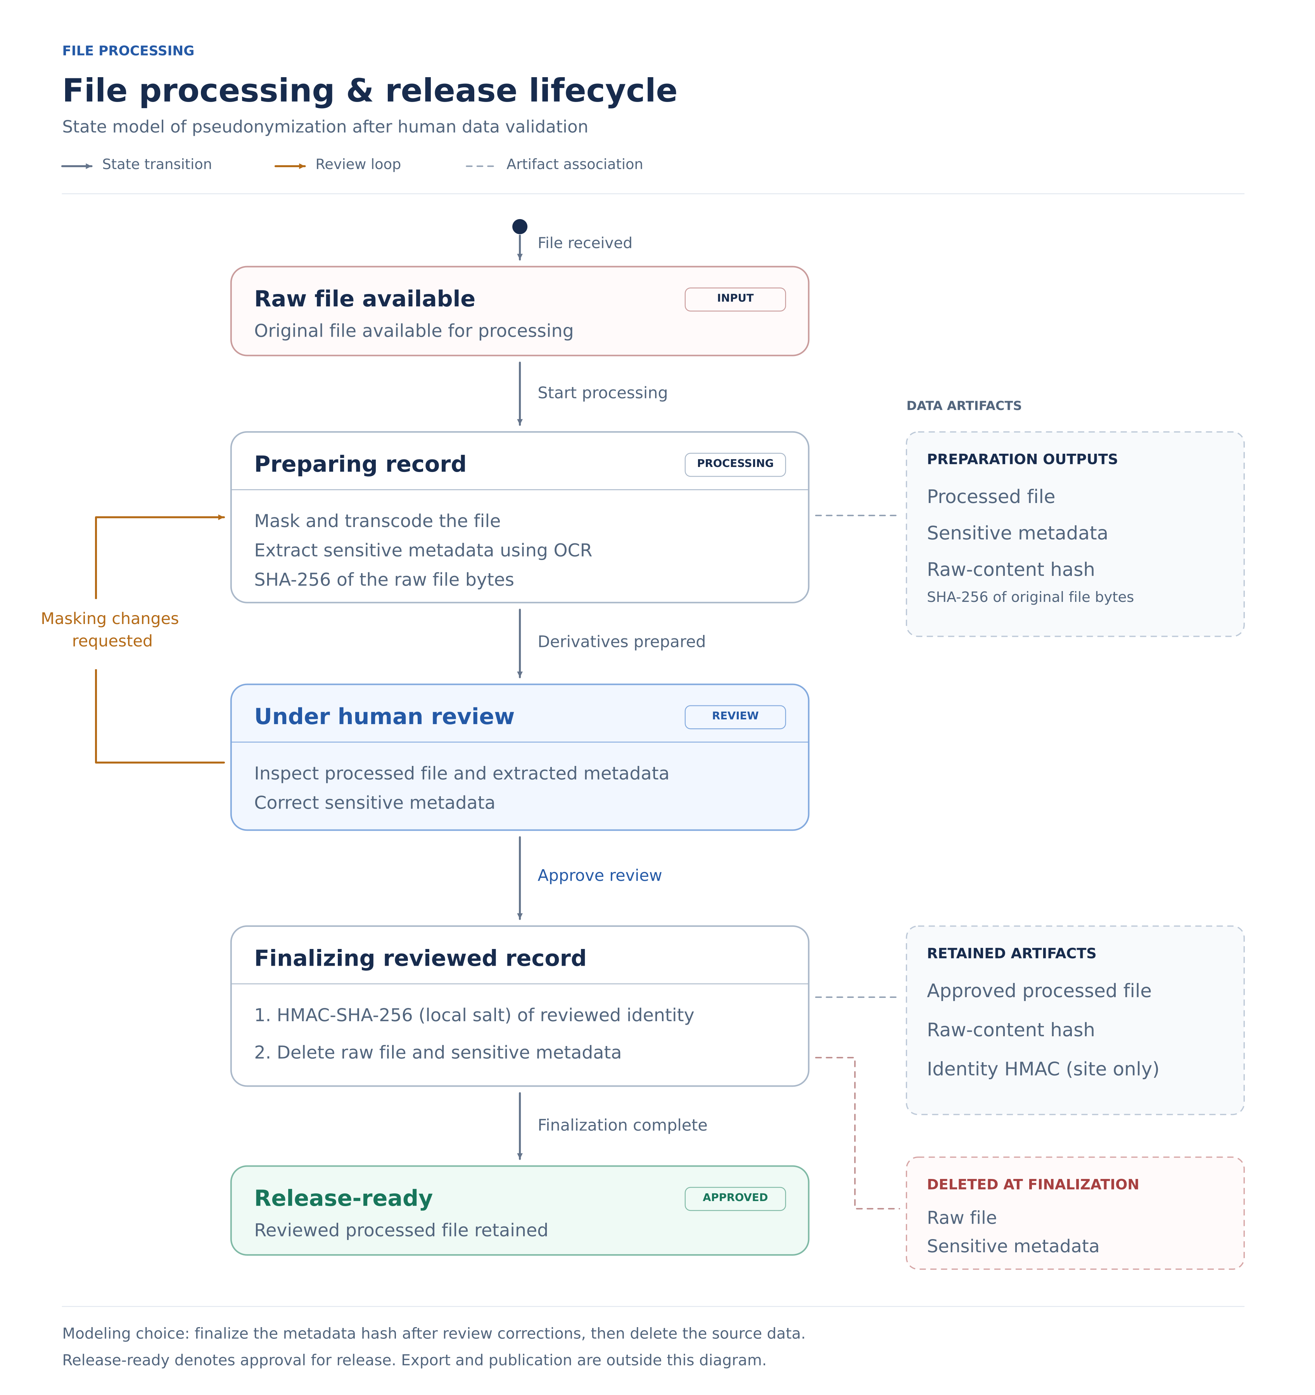
Figure S1. File processing and release lifecycle under human validation. The identity fingerprint is HMAC-SHA-256 under the local salt and is retained only at the site.

Supplement S2. Artifact identity experiment
RGB baselines with bytes cycling modulo 251 at 8 × 8 and 16 × 16 pixels were perturbed one channel intensity unit at a time and restored, giving six trajectories, identical-copy controls and a metadata-only change [R2]. Content hashes discriminate encoded bytes including metadata, not visual content; unchanged artifacts remain linkable by equality across releases, independently of patient pseudonyms.
Table S2. Artifact observations (historical execution; not rerun).
Observation class | Count | Outcome
Forward changes: 3 × (64 + 256) | 960 | 0 baseline matches; no repeated forward digest
Reverse steps | 960 | 960 earlier-state matches
Identical-copy controls | 6 | 6 baseline matches
Metadata-only change | 1 | 0 baseline matches; pixels unchanged
Baselines | 7 | Reference observations
Total | 1,934 | Seven recorded tests passed

Supplement S3. Threat model
Parties are a clinical site (records, salt, keyring), a central hub (approved processed resources over mutually authenticated TLS), a peer site in private matching and a public recipient with auxiliary information. A party holding both a site's salt and its local UUID table defeats the separation by construction; this is a governance boundary.
Table S3. Conditional pathways, not calibrated severity scores.
Pathway | Evidence or condition | Interpretation
Hub accumulates one patient's records | Contract 6.0 sends salt-bound pseudonyms | Association remains by design; relinking requires the salt.
Hub tries to recover local identifiers | Proposition 7; random-UUID input to ψ | No fixed recovery rule; enumeration inapplicable without UUID table.
Recipient compares artifact digests | 6/6 copies match; 1/1 metadata edit differs | Equality links unchanged artifacts.
Attacker holds key and hash dump | Table 2: 144 vs 72 new mappings | Key scope bounds exposure.
Sender substitutes ownership fields | Ownership checks; v8 requirement | Depends on authenticated principals.
Administrator obtains keys or state | Endpoint, backup, logging assumptions | Host compromise exceeds protocol outputs.
Adaptive matching queries | Each result conveys membership | Replay protection does not bound cumulative inference.

Supplement S4. Identity-key experiments

S4.1. Shared and local HMAC keys (historical)
The production helper fingerprinted Synthetic Person, born 1980-07-14, under centre-a; every date of leap year 1980 was enumerated (366 candidates, ten scans, five conditions). Conditions supplying A's key and context recovered exactly one candidate at position 196 in every repetition; the other three returned none. Median scan times were 6.19–6.27 ms on an Intel Core i5-12450H with Python 3.12.14 [R1, R3].
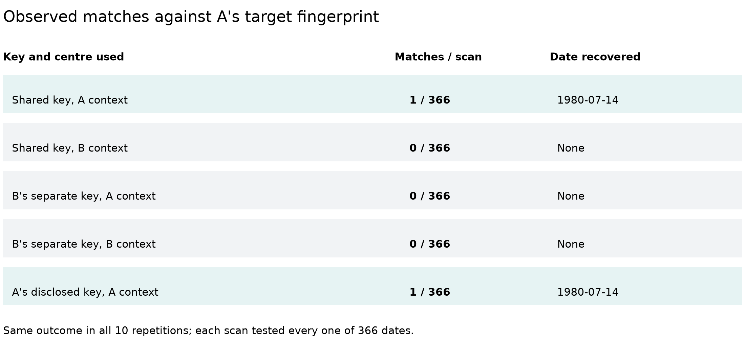
Figure S2. Match outcomes per condition; all ten repetitions agreed.
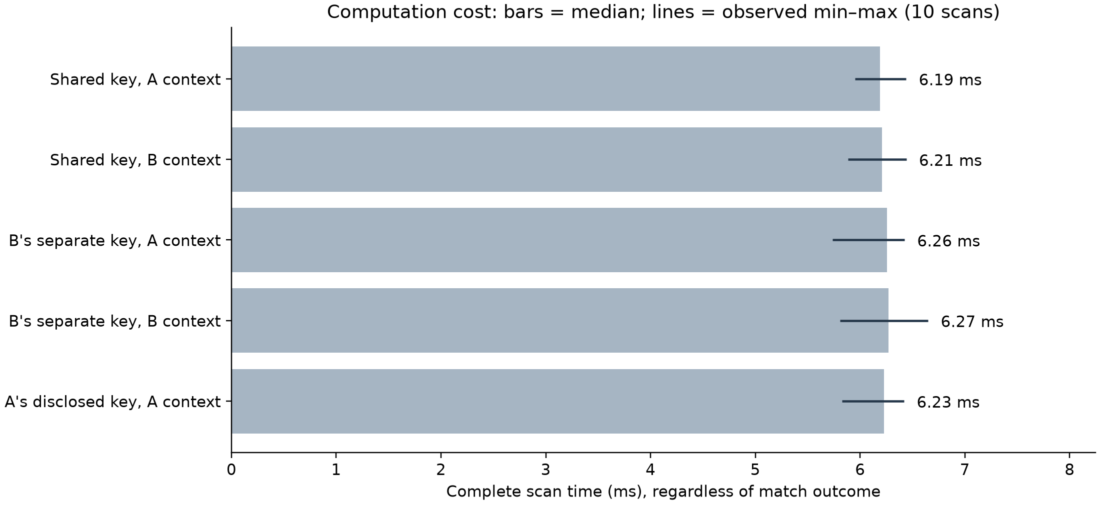
Figure S3. Cost of a complete scan; bars show medians, lines the observed range.

S4.2. Key-exposure experiment
Workers received only typed input bundles under Linux Landlock with file reads denied before processing; an independent rescorer reproduced all 48 case outcomes. Each trial contained 18 synthetic persons with two records per centre and key generation, including three persons sharing one encoded tuple and a hidden twin. Membership claims are conditional on corpus uniqueness [R11].
Table S4. All conditions of the key-exposure experiment (sums over three trials, 432 target rows each).
Condition | Digest matches | New correct | False | Membership correct / false
Shared key, independent person corpus | 192 | 144 | 12 | 36 / 3
Independent key of one centre | 96 | 72 | 6 | 36 / 3
Retained historical key | 192 | 144 | 12 | 36 / 3
Wrong key | 0 | 0 | 0 | 0 / 0
Central oracle, 32 queries | 92 | 44 | 12 | 11 / 3
Broad prior, no person corpus | 84 | 0 | 0 | n/a
Fully labelled control | 192 | 0 | 0 | 0 / 0

Supplement S5. Mathematical formulation
Each statement is proved in the Lean listing of Supplement S6. Cryptographic security, identity truth and production enforcement are outside these statements.

S5.1. Model
Let E : X × C → P encode a demographic tuple in a centre context, M : K × P → T be a keyed deterministic function and H : B → T an artifact digest. A source record A has label u_A, centre c_A, key k_A and target t_A with source binding t_A = M_{k_A}(E(x_A, c_A)); the comparison is Match_A(u, x) = [M_{k_A}(E(x, c_A)) = t_A]. For deterministic F, Coll_F(p, q) ⇔ p ≠ q ∧ F(p) = F(q).

S5.2. Propositions 1–5
P1. b = b′ ⇒ H(b) = H(b′), and H(b) = H(b′) ⇒ b = b′ ∨ Coll_H(b, b′). Lean: identical_input_equal_digest; digest_equality_or_collision.
P2. Under source binding, equal encodings match; a match implies equal encodings or a collision for that pair; without collision a match implies equal encodings, not the same person. Lean: equal_payload_matches; match_implies_equal_payload_or_collision; payload_equality_of_match_and_no_collision.
P3. Replacing source or candidate labels leaves Match_A unchanged; fingerprints cannot bind UUIDs absent from their input. Lean: candidate_uuid_substitution; source_uuid_substitution.
P4. If distinct persons share an encoding, no fingerprint satisfies F(d(a)) = F(d(b)) ⇒ a = b. Lean: demographic_identifier_impossible.
P5. If a readable result is correct for every world and each of N > 0 execution choices, the reading distinguisher accepts N choices in a member world and 0 in a non-member world, so membership cannot be perfectly hidden. Lean: exact_membership_distinguishes; exact_membership_cannot_be_perfectly_hidden; acceptanceCount_of_constant.

S5.3. Proposition 6 — Local follow-ups keep one hub pseudonym
For any deterministic ψ and site lookup ρ from patient hash to local UUID, t₁ = t₂ ⇒ ψ(s, κ, ρ(t₁), h) = ψ(s, κ, ρ(t₂), h). Follow-up linkage lies entirely in ρ, which the hub never receives; equal hashes need not denote the same person (P4). Lean: followup_keeps_hub_pseudonym.

S5.4. Proposition 7 — The hub view does not determine the local UUID
If ψ has key coverage for κ and h — for every u and output o some salt s gives ψ(s, κ, u, h) = o — then no rec satisfies rec(ψ(s, κ, u, h)) = u for all s and u. Proof. Take o = ψ(s₀, κ, 0, h); coverage gives s₁ with ψ(s₁, κ, 1, h) = o, so rec(o) would equal 0 and 1. Lean: hub_view_does_not_determine_local_uuid. Coverage idealizes a keyed function over a large key space; the statement does not bound a computationally limited adversary and does not address a party holding both salt and UUID table.

Supplement S6. Lean formalization
LinkageSupplement.lean imports only Std and was checked with Lean 4.19.0 (commit 6caaee842e94) on 22 October 2026 with warnings as errors. An axiom audit of all 13 theorems reported only propext, Classical.choice and Quot.sound; five theorems use no axioms.
lean -DwarningAsError=true LinkageSupplement.lean

Source SHA-256: bc38dc5e9f27997e9cb6bb5dcbd347204a95f0bb595129bc4561f4ef7d6cfede
Listing S1. Complete standalone formalization.
import Std

/-!
Supplement: functional linkage properties and disclosure limits.
Checked with Lean 4.19.0. Only `Std` is required.
`digest`, `mac`, `encode` and `pseudonym` are arbitrary deterministic functions.
They are not verified implementations of SHA-256, HMAC, Python JSON or UUIDv8.
The source-binding, exact-output and key-coverage hypotheses are explicit premises.
No cryptographic hardness or deployed-protocol security is asserted.
-/

set_option autoImplicit false

namespace LinkageSupplement

variable {Data Key Payload Tag : Type}

def Collision (digest : Payload → Tag) (x y : Payload) : Prop :=
x ≠ y ∧ digest x = digest y

-- Identical encoded artifacts have equal deterministic digests.
theorem identical_input_equal_digest (digest : Payload → Tag)
(x y : Payload) (same : x = y) : digest x = digest y :=
congrArg digest same

-- Digest equality alone is qualified by a possible collision.
theorem digest_equality_or_collision (digest : Payload → Tag)
(x y : Payload) (equalTags : digest x = digest y) :
x = y ∨ Collision digest x y := by
classical
by_cases same : x = y
· exact Or.inl same
· exact Or.inr ⟨same, equalTags⟩

structure Candidate (Data : Type) where
uuid : Nat
data : Data

structure Source (Key Tag : Type) where
uuid : Nat
center : String
key : Key
target : Tag

-- Every candidate is reconstructed in the source's key/centre context.
def matchCandidate [DecidableEq Tag]
(mac : Key → Payload → Tag) (encode : Data → String → Payload)
(source : Source Key Tag) (row : Candidate Data) : Bool :=
decide (mac source.key (encode row.data source.center) = source.target)

theorem equal_payload_matches [DecidableEq Tag]
(mac : Key → Payload → Tag) (encode : Data → String → Payload)
(source : Source Key Tag) (row : Candidate Data) (original : Data)
(bound : source.target = mac source.key (encode original source.center))
(same : encode row.data source.center = encode original source.center) :
matchCandidate mac encode source row = true := by
simp [matchCandidate, same, bound]

theorem match_implies_equal_payload_or_collision [DecidableEq Tag]
(mac : Key → Payload → Tag) (encode : Data → String → Payload)
(source : Source Key Tag) (row : Candidate Data) (original : Data)
(bound : source.target = mac source.key (encode original source.center))
(matched : matchCandidate mac encode source row = true) :
encode row.data source.center = encode original source.center ∨
Collision (mac source.key) (encode row.data source.center)
(encode original source.center) := by
have tagEq :
mac source.key (encode row.data source.center) = source.target := by
simpa [matchCandidate] using matched
exact digest_equality_or_collision (mac source.key)
(encode row.data source.center) (encode original source.center)
(tagEq.trans bound)

theorem payload_equality_of_match_and_no_collision [DecidableEq Tag]
(mac : Key → Payload → Tag) (encode : Data → String → Payload)
(source : Source Key Tag) (row : Candidate Data) (original : Data)
(bound : source.target = mac source.key (encode original source.center))
(matched : matchCandidate mac encode source row = true)
(noCollision : ¬ Collision (mac source.key)
(encode row.data source.center) (encode original source.center)) :
encode row.data source.center = encode original source.center := by
rcases match_implies_equal_payload_or_collision
mac encode source row original bound matched with same | collision
· exact same
· exact False.elim (noCollision collision)

theorem candidate_uuid_substitution [DecidableEq Tag]
(mac : Key → Payload → Tag) (encode : Data → String → Payload)
(source : Source Key Tag) (row : Candidate Data) (replacement : Nat) :
matchCandidate mac encode source { row with uuid := replacement } =
matchCandidate mac encode source row := rfl

theorem source_uuid_substitution [DecidableEq Tag]
(mac : Key → Payload → Tag) (encode : Data → String → Payload)
(source : Source Key Tag) (row : Candidate Data) (replacement : Nat) :
matchCandidate mac encode { source with uuid := replacement } row =
matchCandidate mac encode source row := rfl

-- This ambiguity is in the encoded demographics, not a hash collision.
theorem demographic_identifier_impossible {Person : Type}
(encodePerson : Person → Payload) (fingerprint : Payload → Tag)
(homonyms : ∃ p q : Person, p ≠ q ∧ encodePerson p = encodePerson q) :
¬ (∀ p q : Person,
fingerprint (encodePerson p) = fingerprint (encodePerson q) → p = q) := by
intro identifies
obtain ⟨p, q, different, sameEncoding⟩ := homonyms
exact different (identifies p q (congrArg fingerprint sameEncoding))

-- Fin N represents N equally likely random coins. Counts avoid rounding.
def acceptanceCount {View : Type} (readBit : View → Bool) :
(n : Nat) → (Fin n → View) → Nat
| 0, _ => 0
| n + 1, samples =>
(if readBit (samples 0) then 1 else 0) +
acceptanceCount readBit n (fun coin => samples coin.succ)

theorem acceptanceCount_of_constant {View : Type}
(readBit : View → Bool) (n : Nat) (samples : Fin n → View) (bit : Bool)
(constant : ∀ coin, readBit (samples coin) = bit) :
acceptanceCount readBit n samples = (if bit then n else 0) := by
induction n with
| zero => cases bit <;> rfl
| succ n ih =>
have tailConstant :
∀ coin : Fin n,
readBit ((fun i : Fin n => samples i.succ) coin) = bit :=
fun coin => constant coin.succ
have tailCount := ih (fun coin => samples coin.succ) tailConstant
simp only [acceptanceCount]
rw [constant 0, tailCount]
cases bit <;> simp [Nat.add_comm]

section Disclosure

variable {World View : Type}

-- A disclosed bit is assumed correct for every world and every coin.
def ExactMembershipOutput (n : Nat)
(view : World → Fin n → View) (membership : World → Bool)
(readOutput : View → Bool) : Prop :=
∀ world coin, readOutput (view world coin) = membership world

theorem exact_membership_distinguishes (n : Nat)
(view : World → Fin n → View) (membership : World → Bool)
(readOutput : View → Bool)
(correct : ExactMembershipOutput n view membership readOutput)
(yesWorld noWorld : World)
(isYes : membership yesWorld = true)
(isNo : membership noWorld = false) :
acceptanceCount readOutput n (view yesWorld) = n ∧
acceptanceCount readOutput n (view noWorld) = 0 := by
constructor
· have constant : ∀ coin, readOutput (view yesWorld coin) = true := by
intro coin
rw [correct yesWorld coin, isYes]
simpa using acceptanceCount_of_constant readOutput n
(view yesWorld) true constant
· have constant : ∀ coin, readOutput (view noWorld coin) = false := by
intro coin
rw [correct noWorld coin, isNo]
simpa using acceptanceCount_of_constant readOutput n
(view noWorld) false constant

-- A readable, exact result cannot itself have perfect membership privacy.
-- This says nothing about whether other private inputs remain protected.
theorem exact_membership_cannot_be_perfectly_hidden
(n : Nat) (nonempty : 0 < n)
(view : World → Fin n → View) (membership : World → Bool)
(readOutput : View → Bool)
(correct : ExactMembershipOutput n view membership readOutput)
(yesWorld noWorld : World)
(isYes : membership yesWorld = true)
(isNo : membership noWorld = false) :
¬ (∀ distinguish : View → Bool,
acceptanceCount distinguish n (view yesWorld) =
acceptanceCount distinguish n (view noWorld)) := by
intro hidden
have counts := exact_membership_distinguishes n view membership
readOutput correct yesWorld noWorld isYes isNo
have equalCounts := hidden readOutput
omega

end Disclosure

/-! Hub-scoped pseudonyms (contract 6.0).
`pseudonym salt kind localUuid hub` models the site-side keyed derivation;
`resolve` models the site's local patient-hash → local-UUID lookup. -/

section HubPseudonyms

variable {Salt Kind Hub Out Hash : Type}

-- Follow-ups resolved locally to the same patient keep one hub pseudonym.
theorem followup_keeps_hub_pseudonym
(pseudonym : Salt → Kind → Nat → Hub → Out) (resolve : Hash → Nat)
(salt : Salt) (kind : Kind) (hub : Hub) (first followUp : Hash)
(sameLocalHash : first = followUp) :
pseudonym salt kind (resolve first) hub =
pseudonym salt kind (resolve followUp) hub := by
rw [sameLocalHash]

/-- Key coverage: for this kind and hub, every output is reachable from every
local UUID under some salt. An ideal keyed function over a large key space
approximates this; HMAC-SHA-256 is not proved to satisfy it here. -/
def KeyCoverage (pseudonym : Salt → Kind → Nat → Hub → Out)
(kind : Kind) (hub : Hub) : Prop :=
∀ (uuid : Nat) (out : Out), ∃ salt, pseudonym salt kind uuid hub = out

-- Without the salt, no fixed rule recovers the local UUID from the hub view.
theorem hub_view_does_not_determine_local_uuid
(pseudonym : Salt → Kind → Nat → Hub → Out) (kind : Kind) (hub : Hub)
(coverage : KeyCoverage pseudonym kind hub) (someSalt : Salt) :
¬ ∃ recover : Out → Nat,
∀ salt uuid, recover (pseudonym salt kind uuid hub) = uuid := by
rintro ⟨recover, recovers⟩
obtain ⟨otherSalt, sameOut⟩ := coverage 1 (pseudonym someSalt kind 0 hub)
have viaZero := recovers someSalt 0
have viaOne := recovers otherSalt 1
rw [sameOut] at viaOne
omega

end HubPseudonyms

end LinkageSupplement

Supplement S7. Evidence provenance and open items
Table S5. Software version concerned by each result.
Evidence | Concerns | Executed
Artifact experiment (S2), HMAC scans (S4.1) | Evaluation designation 1.6.0 | Before 20 Oct 2026; not rerun
Key-exposure experiment (Table 2, S4.2) | a965c674 with recorded dirty state | 21 Oct 2026; replayed, rescored
Boundary tests (Table S1) | a965c674 + contract 6.0 working tree | 22 Oct 2026
Matching suites (S1.7) | a965c674 working tree | 22 Oct 2026
Lean supplement (S6) | Abstract model | 22 Oct 2026, Lean 4.19.0
Open review items behind claims of this paper are recorded in feature-tracking/HubTransfer.yml and postponed; they are not resolved by this revision.
Table S6. Implementation-review items and their tracking.
Item | Status | Tracker criterion
TODO-01 version reconciliation | Resolved (Table S5) | —
TODO-13 Figure S1 terminology | Resolved | —
TODO-08 UUID binding | Resolved for transfer; acceptance concurrency open | linkage_manuscript_evidence
TODO-02 historical archives | Open | linkage_manuscript_evidence
TODO-03 normalization report | Open | linkage_manuscript_evidence
TODO-04 Lean-to-code traceability | Open | linkage_manuscript_evidence
TODO-05 source-binding provenance | Open | linkage_manuscript_evidence
TODO-06/-07 end-to-end and native backend | Open (8 native tests skipped) | linkage_manuscript_evidence; guarded_patient_matching_resolver
TODO-09/-10 verification authority, key administration | Open | linkage_manuscript_evidence; cross_site_private_patient_matching
TODO-11 cumulative queries | Open | linkage_manuscript_evidence
TODO-12 disabled preparation test | Open | linkage_manuscript_evidence
Legacy 5.0 rows, salt rotation, pinned rollout | Open | hub_pseudonym_lifecycle

Evidence references
[R1] endoreg_db. Patient-identity encoding, HMAC and key-generation fingerprints (utils/hashs.py).
[R2] endoreg_db. Image content-hash experiment: test definition and recorded observations.
[R3] endoreg_db. Synthetic shared/local-key HMAC evaluation: script, contract tests and recorded scans.
[R4] endoreg_db. Sensitive-metadata hash-security tests.
[R5] endoreg_db. Patient-identity input-variation tests.
[R6] endoreg_db. Source patient-matching and transfer identity-boundary test contracts.
[R7] endoreg_db. Response identity-boundary test contracts.
[R8] LinkageSupplement.lean; 13 theorems; Lean 4.19.0; SHA-256 bc38dc5e9f27997e9cb6bb5dcbd347204a95f0bb595129bc4561f4ef7d6cfede.
[R9] endoreg-db implementation review, 20 October 2026, commit a965c67454013a92a95470e533a7f38a40ef4ddd.
[R10] Contract 6.0 working tree, 22 October 2026 (uncommitted): endoreg_db/utils/hashs.py; services/hub/hub_pseudonyms.py; services/hub/transfers.py; serializers/hub/transfer_job.py; tests/services/test_hub_pseudonyms.py; lx-data-models contracts/hub_transfer.py; LX-Annotate hub/hub_export_payloads.py and hub/study_transfer.py.
[R11] endoreg-db scripts/reidentification: REPORT.md, config.yml, worker, rescorer; evidence/public_bundle.tar.gz (SHA-256 87e7c007ee5496b8d542f9e64106b0bda684012464f9874805a34d9fe5790f2c); executed 21 October 2026.

