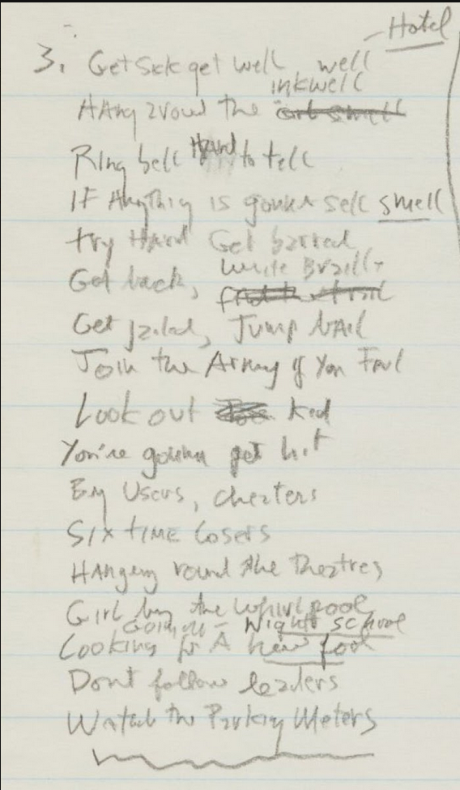

3. Get sick get well [↓inkwell] [↑well] [↑Hotel]
inkwell
Hang around the <oil smell>
Ring bell hard to tell
If anything is gonna sell [→smell]
Try hard get barred
Get back, [crossed out] [↑write braille)
Get jailed, Jump bail
Join the Army if you fail
Look out [crossed out] kid
You’re gonna get hit
By users, cheaters
Six time losers
Hanging round the theatres
Girl by the whirlpool
come in night school
Looking for a new fool [↑going at night shool]
Don’t follow leaders
Watch the parking meters
———

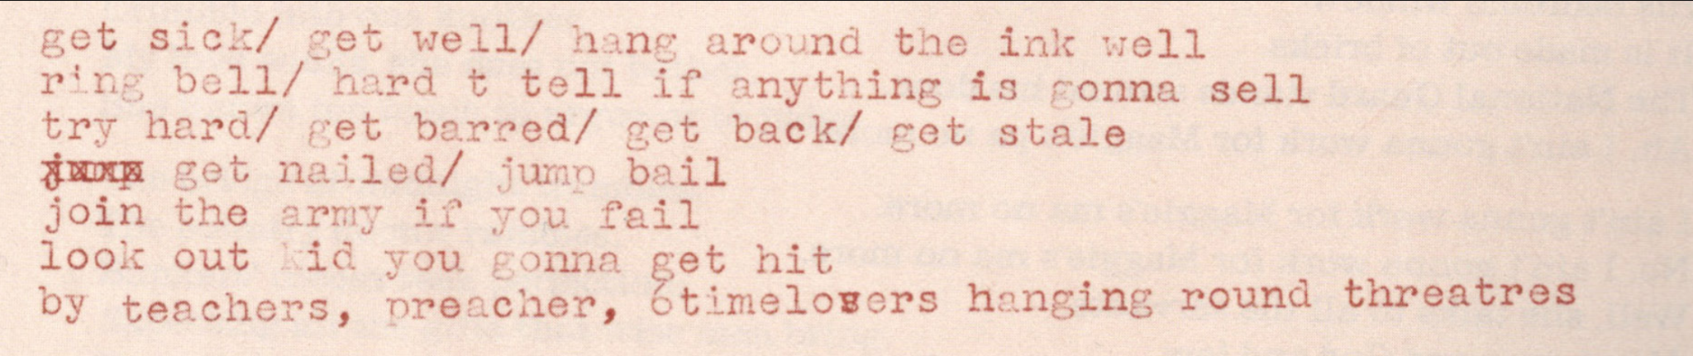

get sick / get well/ hang around the ink well
ring bell/ hard t tell if anything is gonna sell
try hard/ get barred/ get back/ get stale
<jump> get nailed/ jump bail
join the army if you fail
look out kid you gonna get hit
by teachers, preacher, 6time lo<v>/s\ers hanging round threatres

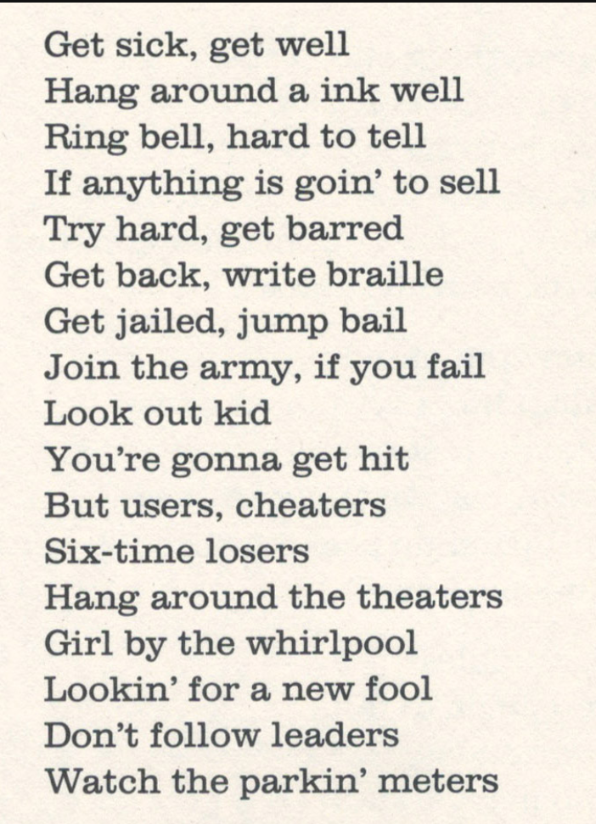
Get sick, get well
Hang around a ink well
Ring bell, hard to tell
If anything is goin' to sell
Try hard, get barred
Get back, write braille
Get jailed, jump bail
Join the army, if you fail
Look out kid
You're gonna get hit
But users, cheaters
Six-time losers
Hang around the theaters
Girl by the whirlpool
Lookin' for a new fool
Don't follow leaders
Watch the parkin' meters

