P&B MM Rail p4

W Greg Alvord, PhD

November 17, 2014

We begin with the first example discussed by Pinheiro and Bates (2000). Six rails were chosen at random; each rail was tested three times by measuring the time it took for a certain type of ultrasonic wave to travel the length of the rail. The engineers were interested in were: (1) the average travel time for a 'typical' rail (the *expected travel time*), (2) the *variation* in average travel time among the rials (*between-rail variability*), and (3) the *variation* in the observed in the observed travel times for a single rail (the *within-rail variability*). We see from Figure 1.1 that there is considerable variability in the mean travel times among the different rails.

plot(Rail)

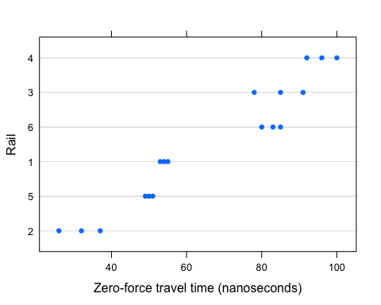

library(nlme)  
Rail

## Grouped Data: travel ~ 1 | Rail  
## Rail travel  
## 1 1 55  
## 2 1 53  
## 3 1 54  
## 4 2 26  
## 5 2 37  
## 6 2 32  
## 7 3 78  
## 8 3 91  
## 9 3 85  
## 10 4 92  
## 11 4 100  
## 12 4 96  
## 13 5 49  
## 14 5 51  
## 15 5 50  
## 16 6 80  
## 17 6 85  
## 18 6 83

lm1 <- lm(travel ~ as.factor(Rail), data = Rail)  
summary(lm1)

...  
## Coefficients:  
## Estimate Std. Error t value Pr(>|t|)   
## (Intercept) 66.5000 0.9477 70.169 < 2e-16 ***  
## as.factor(Rail).L 54.3032 2.3214 23.392 2.22e-11 ***  
## as.factor(Rail).Q -4.6917 2.3214 -2.021 0.066161 .   
## as.factor(Rail).C -2.6584 2.3214 -1.145 0.274458   
## as.factor(Rail)^4 -0.5669 2.3214 -0.244 0.811181   
## as.factor(Rail)^5 11.1919 2.3214 4.821 0.000418 ***  
...

This is equation 1.3, p. 7, in P&B.

$$y_{ij}=\overline{β}+β_{i}−\overline{β}+ε_{ij}$$

Now, I will try to enter the equation from LaTeX.

This is an R Markdown document. Markdown is a simple formatting syntax for authoring HTML, PDF, and MS Word documents. For more details on using R Markdown see <http://rmarkdown.rstudio.com>.

When you click the **Knit** button a document will be generated that includes both content as well as the output of any embedded R code chunks within the document. You can embed an R code chunk like this:

summary(cars)

## speed dist   
## Min. : 4.0 Min. : 2.00   
## 1st Qu.:12.0 1st Qu.: 26.00   
## Median :15.0 Median : 36.00   
## Mean :15.4 Mean : 42.98   
## 3rd Qu.:19.0 3rd Qu.: 56.00   
## Max. :25.0 Max. :120.00

You can also embed plots, for example:

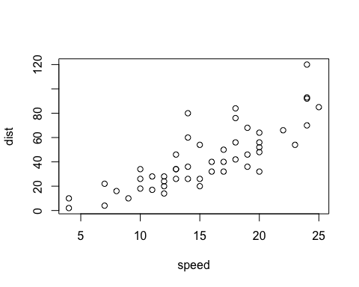

Note that the echo = FALSE parameter was added to the code chunk to prevent printing of the R code that generated the plot.