Inventory

William G. Foote

11/28/2018

## Data read

table_all <- read.csv("data/KP Direct_Raw.csv", stringsAsFactors = FALSE)  
table_all$Lead.Time <- as.numeric(table_all$Lead.Time)

## Warning: NAs introduced by coercion

table_all$Amount <- as.numeric(table_all$Amount)  
table_all$Quantity <- as.numeric(table_all$Quantity)  
str(table_all)

## 'data.frame': 30436 obs. of 16 variables:  
## $ Date : chr "4/27/2018" "4/27/2018" "5/21/2018" "5/21/2018" ...  
## $ Type : chr "Item Receipt" "Item Receipt" "Item Receipt" "Item Receipt" ...  
## $ Document.Number : int 366 366 565 565 594 594 607 607 666 666 ...  
## $ Name : chr "" "" "" "" ...  
## $ Account : chr "50000 Cost of Goods Sold - Purchases" "15000 Inventory Asset" "50000 Cost of Goods Sold - Purchases" "15000 Inventory Asset" ...  
## $ Memo : chr "Cost of Sales Adjustment" "Cost of Sales Adjustment" "Cost of Sales Adjustment" "Cost of Sales Adjustment" ...  
## $ Amount : num 21 -21 1739 -1739 -0.08 ...  
## $ Internal.ID : int 54313 54313 60957 60957 61963 61963 62889 62889 64914 64914 ...  
## $ Item : chr "833101" "833101" "62-746_" "62-746_" ...  
## $ Quantity : num NA NA NA NA NA NA NA NA NA NA ...  
## $ SO.PO.originating : chr "" "" "" "" ...  
## $ OD.Create.date : chr "" "" "" "" ...  
## $ Record.Type : chr "Not Specified" "Not Specified" "Not Specified" "Not Specified" ...  
## $ Lead.Time : num NA NA NA NA NA NA NA NA NA NA ...  
## $ Matching.PO.SO.Item: chr "No" "No" "No" "No" ...  
## $ Month : int 4 4 5 5 5 5 5 5 5 5 ...

head(table_all)

## Date Type Document.Number Name  
## 1 4/27/2018 Item Receipt 366   
## 2 4/27/2018 Item Receipt 366   
## 3 5/21/2018 Item Receipt 565   
## 4 5/21/2018 Item Receipt 565   
## 5 5/23/2018 Item Receipt 594   
## 6 5/23/2018 Item Receipt 594   
## Account Memo Amount  
## 1 50000 Cost of Goods Sold - Purchases Cost of Sales Adjustment 21.00  
## 2 15000 Inventory Asset Cost of Sales Adjustment -21.00  
## 3 50000 Cost of Goods Sold - Purchases Cost of Sales Adjustment 1739.00  
## 4 15000 Inventory Asset Cost of Sales Adjustment -1739.00  
## 5 50000 Cost of Goods Sold - Purchases Cost of Sales Adjustment -0.08  
## 6 15000 Inventory Asset Cost of Sales Adjustment 0.08  
## Internal.ID Item Quantity SO.PO.originating OD.Create.date  
## 1 54313 833101 NA   
## 2 54313 833101 NA   
## 3 60957 62-746_ NA   
## 4 60957 62-746_ NA   
## 5 61963 7925_ NA   
## 6 61963 7925_ NA   
## Record.Type Lead.Time Matching.PO.SO.Item Month  
## 1 Not Specified NA No 4  
## 2 Not Specified NA No 4  
## 3 Not Specified NA No 5  
## 4 Not Specified NA No 5  
## 5 Not Specified NA Yes 5  
## 6 Not Specified NA Yes 5

names(table_all)

## [1] "Date" "Type" "Document.Number"   
## [4] "Name" "Account" "Memo"   
## [7] "Amount" "Internal.ID" "Item"   
## [10] "Quantity" "SO.PO.originating" "OD.Create.date"   
## [13] "Record.Type" "Lead.Time" "Matching.PO.SO.Item"  
## [16] "Month"

table_10_Quantity <- table_all %>%  
 group_by(Account) %>%  
 top_n(n = 10, wt = Quantity)  
p <- table_10_Quantity %>%  
 ggplot(aes(x = Quantity, fill = Account)) + geom_histogram()  
p

## `stat_bin()` using `bins = 30`. Pick better value with `binwidth`.

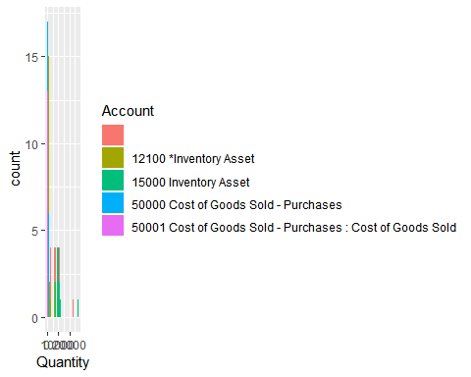

p <- table_10_Quantity %>%  
 ggplot(aes(x = Quantity, fill = Account)) + geom_histogram()  
p

## `stat_bin()` using `bins = 30`. Pick better value with `binwidth`.



p <- table_10_Quantity %>%  
 ggplot(aes(x = Lead.Time, fill = Account)) + geom_histogram()  
p

## `stat_bin()` using `bins = 30`. Pick better value with `binwidth`.

## Warning: Removed 23 rows containing non-finite values (stat_bin).

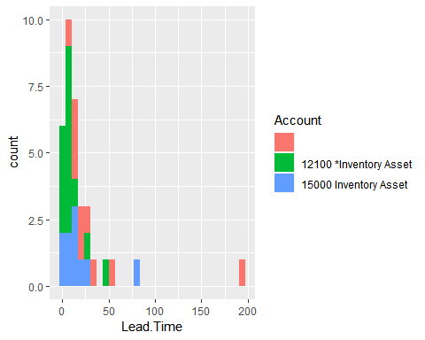

summary(na.omit(table_all$Lead.Time))

## Min. 1st Qu. Median Mean 3rd Qu. Max.   
## -15.00 3.00 6.00 12.61 14.00 215.00