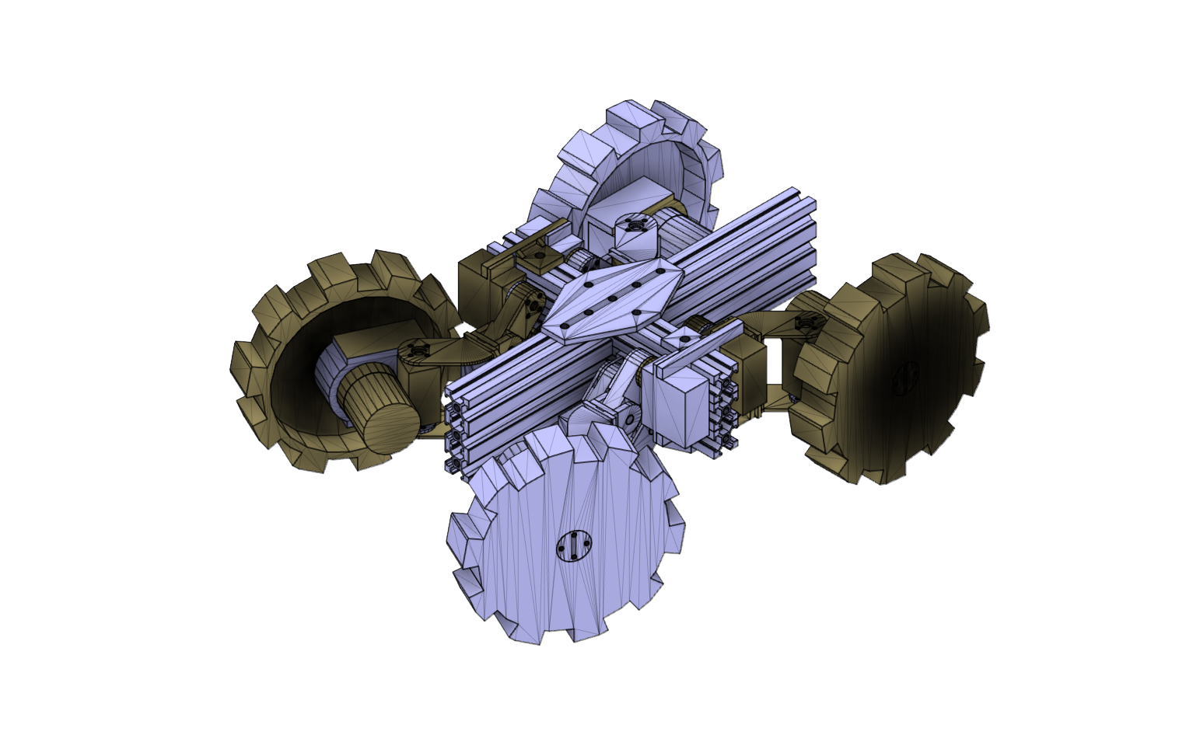

Billy

Unidad adaptable a distintos terrenos teleoperada

Gabriel Marzullo | Wvaldo Graell | Kelvin Kung

Asesor: Danilo Caceres

Laboratorio de Sistemas Inteligentes

|  |  |  |  |  |  |
| --- | --- | --- | --- | --- | --- |
| **Piezas requeridas para la construcción de la unidad Movil Billy** | | | | | |
| # | Descripción | Cant. | Precio Unitario | Sub. Total | Descripción Grafica |
| LOCOMOCIÓN | | | | | |
| [01](https://www.amazon.com/BangBang-Oblique-U-shaped-Bracket-Manipulator/dp/B072J8PKL5/ref=sr_1_17?ie=UTF8&qid=1548035324&sr=8-17&keywords=servo+bracket) | Oblique U-shaped Servo Bracket | 4 | 5.00 | 20.00 |  |
| https://www.amazon.com/BangBang-Oblique-U-shaped-Bracket-Manipulator/dp/B072J8PKL5/ref=sr_1_17?ie=UTF8&qid=1548035324&sr=8-17&keywords=servo+bracket | | | | | |
| [02](https://www.amazon.com/LewanSoul-LD-220MG-Digital-Bearing-Aluminium/dp/B07CMBMWZW/ref=sr_1_7?ie=UTF8&qid=1548035324&sr=8-7&keywords=servo+bracket) | LewanSoul LD-220MG 20kg High Torque Full Metal Gear Digital Servo Dual Ball Bearing | 4 | 22.00 | 88.00 |  |
| https://www.amazon.com/LewanSoul-LD-220MG-Digital-Bearing-Aluminium/dp/B07CMBMWZW/ref=sr_1_7?ie=UTF8&qid=1548035324&sr=8-7&keywords=servo+bracket | | | | | |
| [03](https://www.amazon.com/d/Rc-Servos/ANNIMOS-Digital-Waterproof-DS3218MG-Control/B076CNKQX4/ref=sr_1_3?ie=UTF8&qid=1548270718&sr=8-3&keywords=20kg+servo) | ANNIMOS 20KG Digital Servo High Torque Full Metal Gear | 4 | 18.00 | 72 |  |
| https://www.amazon.com/d/Rc-Servos/ANNIMOS-Digital-Waterproof-DS3218MG-Control/B076CNKQX4/ref=sr_1_3?ie=UTF8&qid=1548270718&sr=8-3&keywords=20kg+servo | | | | | |
| [04](https://www.amazon.com/Seamuing-Aluminum-Futaba-Mechanical-Helicopter/dp/B07D56FVK5/ref=sr_1_5?ie=UTF8&qid=1548270793&sr=8-5&keywords=25T+disc) | Seamuing 10Pcs Servo Horn Arm Aluminum 25T Futaba Servo Disc | 1 | 9.00 | 9.00 |  |
| https://www.amazon.com/Seamuing-Aluminum-Futaba-Mechanical-Helicopter/dp/B07D56FVK5/ref=sr_1_5?ie=UTF8&qid=1548270793&sr=8-5&keywords=25T+disc | | | | | |
| [05](https://www.amazon.com/Magic-Coupling-Hardness-Accessory-Connector/dp/B07FLWQMNW/ref=sr_1_2_sspa?ie=UTF8&qid=1548271049&sr=8-2-spons&keywords=6mm+shaft&psc=1) | Magic&shell 2-Pack 6mm Flange Shaft Coupling High Hardness Metal Axis Bearing | 2 | 12.00 | 24.00 |  |
| https://www.amazon.com/Magic-Coupling-Hardness-Accessory-Connector/dp/B07FLWQMNW/ref=sr_1_2_sspa?ie=UTF8&qid=1548271049&sr=8-2-spons&keywords=6mm+shaft&psc=1 | | | | | |
| [06](https://www.amazon.com/Joining-Bracket-Aluminum-Extrusion-Profile/dp/B01H6NPID2/ref=sr_1_16?ie=UTF8&qid=1548271256&sr=8-16&keywords=2020+profile+aluminum+joint+plate) | Boeray 1pcs 7 Hole Cross Joining Bracket Plate for Aluminum Extrusion Profile 2020 Series, 7 Hole Joint Plate | 2 | 7.00 | 14.00 |  |
| https://www.amazon.com/Joining-Bracket-Aluminum-Extrusion-Profile/dp/B01H6NPID2/ref=sr_1_16?ie=UTF8&qid=1548271256&sr=8-16&keywords=2020+profile+aluminum+joint+plate | | | | | |
| [07](https://www.amazon.com/IZTOSS-Die-Cast-Aluminum-Extrusion-Profile/dp/B078RH97L3/ref=sr_1_4?ie=UTF8&qid=1548271696&sr=8-4&keywords=2020+profile+aluminum+pivot) | IZTOSS 4PCS Die-Cast Zinc Alloy Pivot Joint for Aluminum Extrusion Profile 2020 Series | 3 | 21.00 | 63.00 |  |
| https://www.amazon.com/IZTOSS-Die-Cast-Aluminum-Extrusion-Profile/dp/B078RH97L3/ref=sr_1_4?ie=UTF8&qid=1548271696&sr=8-4&keywords=2020+profile+aluminum+pivot | | | | | |
| [08](https://www.amazon.com/Boeray-Aluminum-Extrusion-Profile-Sereis/dp/B01GCDG2QO/ref=sr_1_8?ie=UTF8&qid=1548271800&sr=8-8&keywords=2020+profile+aluminum) | Boeray 50pcs M5 Slide in T Nut Drop in Nut for Aluminum Extrusion with Profile 2020 Sereis Slot 6mm | 1 | 10.00 | 10.00 |  |
| https://www.amazon.com/Boeray-Aluminum-Extrusion-Profile-Sereis/dp/B01GCDG2QO/ref=sr_1_8?ie=UTF8&qid=1548271800&sr=8-8&keywords=2020+profile+aluminum | | | | | |
| [09](https://www.amazon.com/Greartisan-Electric-Reduction-Centric-Diameter/dp/B072R57C56/ref=sr_1_6?ie=UTF8&qid=1548271877&sr=8-6&keywords=dc%2Bgear%2Bmotor&th=1) | Greartisan DC 12V 100RPM Gear Motor High Torque Electric Micro Speed Reduction Geared Motor Centric Output Shaft 37mm Diameter Gearbox | 4 | 16.00 | 64.00 |  |
| https://www.amazon.com/Greartisan-Electric-Reduction-Centric-Diameter/dp/B072R57C56/ref=sr_1_6?ie=UTF8&qid=1548271877&sr=8-6&keywords=dc%2Bgear%2Bmotor&th=1 | | | | | |
| [10](https://www.amazon.com/Hilitchi-510pcs-Stainless-Socket-Assortment/dp/B073SVMX3T/ref=sr_1_5?ie=UTF8&qid=1548272606&sr=8-5&keywords=m3+m4+m5+flat+head) | Hilitchi 510pcs M3 M4 M5 Stainless Steel Flat Head Hex Socket Head Cap Bolts Screws Nuts Assortment Kit - 304 Stainless Steel | 1 | 15.00 | 15.00 |  |
| https://www.amazon.com/Hilitchi-510pcs-Stainless-Socket-Assortment/dp/B073SVMX3T/ref=sr_1_5?ie=UTF8&qid=1548272606&sr=8-5&keywords=m3+m4+m5+flat+head | | | | | |
| [11](https://www.amazon.com/Linear-Motion-Aluminum-Profiles-Extrusion/dp/B07MMX1QW9/ref=sr_1_1?ie=UTF8&qid=1548272841&sr=8-1&keywords=2060+t-slot+200mm) | Linear Motion Aluminum Profiles - 200mm Length 2060 T-Slot Aluminum Profiles Extrusion Frame for CNC | 3 | 15.00 | 45.00 |  |
| https://www.amazon.com/Linear-Motion-Aluminum-Profiles-Extrusion/dp/B07MMX1QW9/ref=sr_1_1?ie=UTF8&qid=1548272841&sr=8-1&keywords=2060+t-slot+200mm | | | | | |
| Hardware/Sensores | | | | | |
| [12](https://www.amazon.com/gp/product/B00FS83U42/ref=ox_sc_saved_title_1?smid=ATVPDKIKX0DER&psc=1) | ASUS Tinker Board Quad-Core | 1 | 85.25 | 85.25 | ASUS Tinker Board S Quad-Core 1.8GHz SoC 2GB RAM 16GB eMMC storage GB LAN Wi-Fi & GPIO connectivity Motherboards |
| https://www.amazon.com/gp/product/B00FS83U42/ref=ox_sc_saved_title_1?smid=ATVPDKIKX0DER&psc=1 | | | | | |
| [13](https://www.amazon.com/HiLetgo-Converter-Programmable-Amplifier-Development-x/dp/B01DLHKMO2/ref=sr_1_4?ie=UTF8&qid=1550794750&sr=8-4&keywords=analog+digital+converter+raspberry+pi) | ADC 16 BIT I2C HILETGO | 2 | 6.99 | 13.98 | HiLetgo ADS1115 16 Bit 16 Byte 4 Channel I2C IIC Analog-to-Digital ADC PGA Converter with Programmable Gain Amplifier High precision ADC Converter Development Board for Arduino Raspberry Pi |
| https://www.amazon.com/HiLetgo-Converter-Programmable-Amplifier-Development-x/dp/B01DLHKMO2/ref=sr_1_4?ie=UTF8&qid=1550794750&sr=8-4&keywords=analog+digital+converter+raspberry+pi | | | | | |
| [14](https://www.pololu.com/product/1354) | Mini Maestro 18-Channel USB Servo Controller | 1 | 39.95 | 39.95 | https://a.pololu-files.com/picture/0J9910.600x480.jpg?443e4859caeee6d6358887580fd12471 |
| https://www.pololu.com/product/1354 | | | | | |
| [15](https://www.pololu.com/product/2519/specs) | Dual MAX14870 Motor Driver Shield for Arduino | 2 | 12.75 | 25.50 | https://a.pololu-files.com/picture/0J8590.600x480.jpg?d4b1c4782f509d8e7eef19b6cff65023 |
| https://www.pololu.com/product/2519/specs | | | | | |
| [16](https://www.pololu.com/product/3132/resources) | Tic T834 USB Multi-interface Stepper Motor Controller | 2 | 31.95 | 63.90 | https://a.pololu-files.com/picture/0J8074.600x480.jpg?6ed19ff10e8dedc7e7720a9a89279f22 |
| https://www.pololu.com/product/3132/resources | | | | | |
| [17](https://www.amazon.com/ARDUINO-MEGA-2560-REV3-A000067/dp/B0046AMGW0/ref=sr_1_3?s=pc&ie=UTF8&qid=1550887800&sr=1-3&keywords=ARDUINO+MEGA) | Arduino Mega 2560 REV3 | 1 | 33.88 | 33.88 | https://images-na.ssl-images-amazon.com/images/I/61n4c0x7zIL._SL1000_.jpg |
| https://www.amazon.com/ARDUINO-MEGA-2560-REV3-A000067/dp/B0046AMGW0/ref=sr_1_3?s=pc&ie=UTF8&qid=1550887800&sr=1-3&keywords=ARDUINO+MEGA | | | | | |
| [18](https://www.amazon.com/Cylewet-3-3V-5V-Channels-Converter-Bi-Directional/dp/B074M8TM81/ref=sr_1_3?ie=UTF8&qid=1550887969&sr=8-3&keywords=logic+level+shifter+3.3v+to+5v) | Cylewet 10Pcs 3.3V-5V 4 Channels Logic level converter | 1 | 15.29 | 15.29 | https://images-na.ssl-images-amazon.com/images/I/618m8uNNGYL._SL1001_.jpg |
| https://www.amazon.com/Cylewet-3-3V-5V-Channels-Converter-Bi-Directional/dp/B074M8TM81/ref=sr_1_3?ie=UTF8&qid=1550887969&sr=8-3&keywords=logic+level+shifter+3.3v+to+5v | | | | | |
| [19](https://www.pololu.com/product/2849) | Pololu 3.3v, 2.5A Step-Down Voltage Regulator D24V25F | 1 | 10.95 | 10.95 | https://a.pololu-files.com/picture/0J6089.600x480.jpg?24c7e11eaa85d230f084060353226cac |
| https://www.pololu.com/product/2849 | | | | | |
| [20](https://www.pololu.com/product/2850) | Pololu 5v, 2.5A Step-Down Voltage Regulator D24V25F | 2 | 10.95 | 21.90 | https://a.pololu-files.com/picture/0J6089.600x480.jpg?24c7e11eaa85d230f084060353226cac |
| https://www.pololu.com/product/2850 | | | | | |
| [21](https://www.pololu.com/product/2469) | AltIMU-10 v3 Gyro, Accelerometer, Compass, and Altimeter | 1 | 13.95 | 13.95 | https://a.pololu-files.com/picture/0J5177.600x480.jpg?3b7df3d7d7ebfa6e96e78d6dcda8e85b |
| https://www.pololu.com/product/2469 | | | | | |
| [22](https://www.pololu.com/product/2474) | Pololu Carrier with Sharp GP2Y0A60SZLF Analog Distance Sensor 10-150cm,5v | 4 | 12.95 | 51.80 | https://a.pololu-files.com/picture/0J5782.600x480.jpg?d0dc29ca33bde495d7507411e2fa3a8d |
| https://www.pololu.com/product/2474 | | | | | |
| [23](https://www.pololu.com/product/3415/specs) | VL53L1X Time-of-Flight Distance Sensor Carrier with Voltage Regulator, 400cm Max | 4 | 11.95 | 47.80 | https://a.pololu-files.com/picture/0J8677.600x480.jpg?2ae2631a3cf1133a512eadb1d5501cea |
| https://www.pololu.com/product/3415/specs | | | | | |
| [24](https://www.amazon.com/Camera-Module-Tinker-Board-Adjustable/dp/B07916CXJX) | Camera Module for Tinker Board (Adjustable Focus) | 1 | 25.99 | 25.99 | Camera Module for Tinker Board (Adjustable Focus) |
| https://www.amazon.com/Camera-Module-Tinker-Board-Adjustable/dp/B07916CXJX | | | | | |
| [25](https://www.amazon.com/Pixy2-Smart-Vision-Sensor-BeagleBone/dp/B07D1CLYD2/ref=sr_1_1_sspa?s=electronics&ie=UTF8&qid=1550892586&sr=1-1-spons&keywords=PIXY+CAM&psc=1) | Pixy2 Smart Vision Sensor | 1 | 59.90 | 59.90 | Charmed Labs Pixy2 Smart Vision Sensor - Object Tracking Camera for Arduino, Raspberry Pi, BeagleBone Black |
| https://www.amazon.com/Pixy2-Smart-Vision-Sensor-BeagleBone/dp/B07D1CLYD2/ref=sr_1_1_sspa?s=electronics&ie=UTF8&qid=1550892586&sr=1-1-spons&keywords=PIXY+CAM&psc=1 | | | | | |
| [26](https://www.amazon.com/dp/B06XK9149L/ref=sspa_dk_detail_1?psc=1&pd_rd_i=B06XK9149L&pd_rd_w=6aPM0&pf_rd_p=733540df-430d-45cd-9525-21bc15b0e6cc&pd_rd_wg=tWoaI&pf_rd_r=NJ6KEVBX3CVN1KZ4D1AV&pd_rd_r=da2ea418-3974-11e9-adab-476bc8823d07) | HRB 3S 11.1V 6000mAh 50C RC LiPo Battery Pack with XT60 plug For RC Helicopter RC Airplane RC Hobby | 1 | 48.99 | 48.99 | https://images-na.ssl-images-amazon.com/images/I/61YTtxL-TyL._SL1000_.jpg |
| https://www.amazon.com/dp/B06XK9149L/ref=sspa_dk_detail_1?psc=1&pd_rd_i=B06XK9149L&pd_rd_w=6aPM0&pf_rd_p=733540df-430d-45cd-9525-21bc15b0e6cc&pd_rd_wg=tWoaI&pf_rd_r=NJ6KEVBX3CVN1KZ4D1AV&pd_rd_r=da2ea418-3974-11e9-adab-476bc8823d07 | | | | | |
| [27](https://www.amazon.com/dp/B07H3PS7DF/ref=sspa_dk_detail_2?psc=1&pd_rd_i=B07H3PS7DF&pd_rd_w=1FsPH&pf_rd_p=733540df-430d-45cd-9525-21bc15b0e6cc&pd_rd_wg=Ja7TE&pf_rd_r=WD6TTJW96075JZRG6HQ4&pd_rd_r=b155ae89-3975-11e9-8d5f-8b5d7e09eabc) | Lipo Battery Charger - Energy tech Balance Charger AC/DC 20W 2A 2-4Cells for LiPo/Life/LiHV Airsoft RC Car Battery Charging | 1 | 17.99 | 17.99 | https://images-na.ssl-images-amazon.com/images/I/7118YN0UmYL._SL1500_.jpg |
| https://www.amazon.com/dp/B07H3PS7DF/ref=sspa_dk_detail_2?psc=1&pd_rd_i=B07H3PS7DF&pd_rd_w=1FsPH&pf_rd_p=733540df-430d-45cd-9525-21bc15b0e6cc&pd_rd_wg=Ja7TE&pf_rd_r=WD6TTJW96075JZRG6HQ4&pd_rd_r=b155ae89-3975-11e9-8d5f-8b5d7e09eabc | | | | | |