# Excludable Public Good Minimum Delay:

N=3

distribution:

Two-peak-normal:

loc 0.2 scale 0.1

loc 0.6 scale 0.1

distribution:

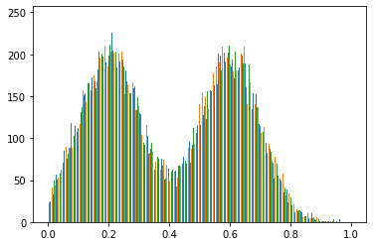

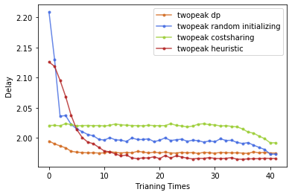

(CS: 2.0208, DP: 2.0107)

1.9660

N=3

distribution:

beta(0.1,0.1)

Use Kumaraswamy(0.1,0.354) approximate cdf.

kumaraswamy_a 0.1 kumaraswamy_b 0.354

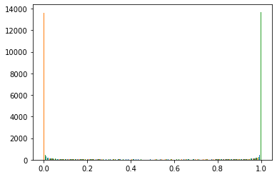

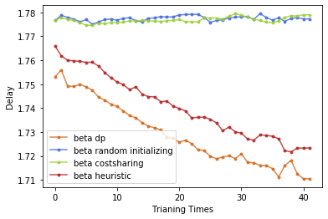

(CS: 1.77668, DP: 1.74812)

1.7104

N=3

distribution:

U-exponential

Exponential(15), Exponential(15)

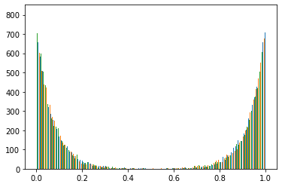

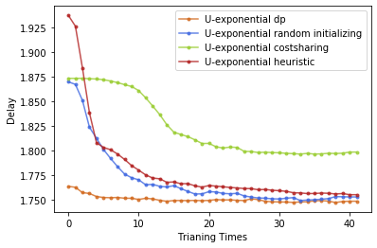

(CS: 1.87356, DP: 1.75084)

1.7490

N=3

distribution:

loc 0.4 scale 0.1

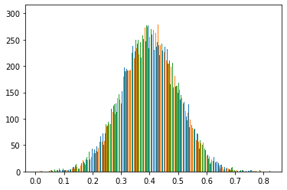

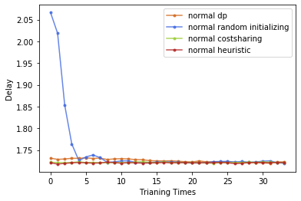

(CS: 1.722, DP: 1.74435)

1.7213

N=3

distribution:

uniformlow 0 uniformhigh 1.0

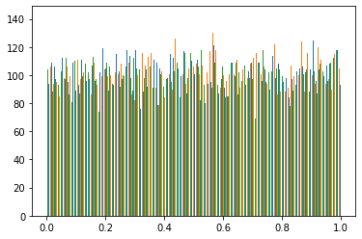

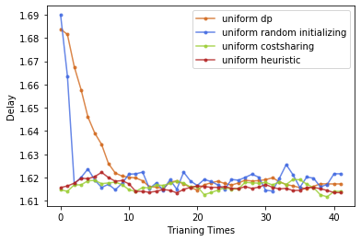

(CS: 1.61472, DP: 1.74272)

1.6141

N=3

distribution:

Two-peak-normal:

loc 0.15 scale 0.1

loc 0.85 scale 0.1

distribution:

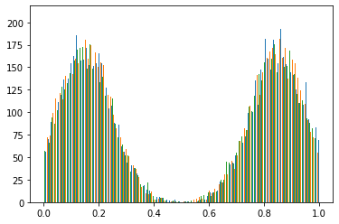

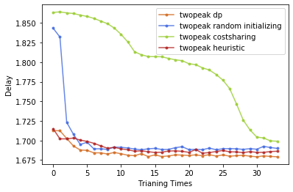

（CS: 1.8636，DP: 1.7527）

1.6793

N=5

distribution:

Two-peak-normal:

loc 0.15 scale 0.1

loc 0.85 scale 0.1

distribution:

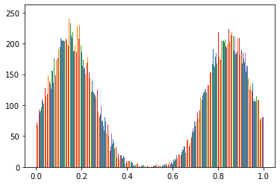

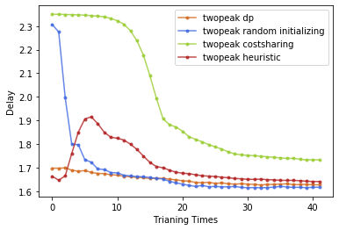

(CS: 2.34964, DP: 1.7516)

1.6171

N=10

distribution:

Two-peak-normal:

loc 0.15 scale 0.1

loc 0.85 scale 0.1

distribution:

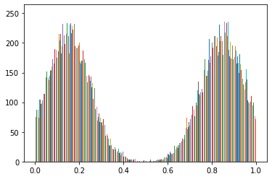

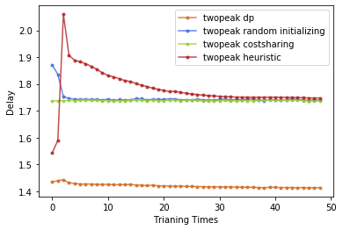

NN from dp

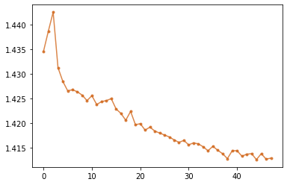

(CS: 1.7365, DP: 1.4480)

1.4129

# Excludable Public Good Maximum Welfare:

N=3;

distribution:

Two-peak-normal:

loc 0.2 scale 0.1

loc 0.6 scale 0.1

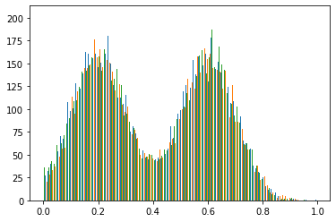

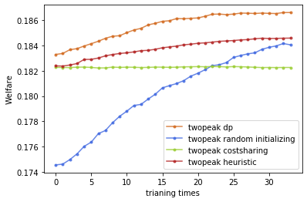

(CS: 0.1823, DP: 0.1793)

0.1866

N=3;

distribution:

Normal: loc 0.5 scale 0.1

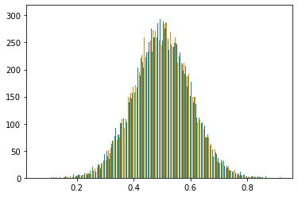

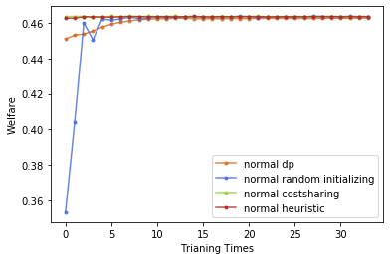

(CS: 0.4636, DP: 0.4505)

0.4627

# Nonexcludable Public Good Minimum Delay：

Two-peak:

Normal1(0.1,0.1), Normal2(0.9,0.1)

N=3:

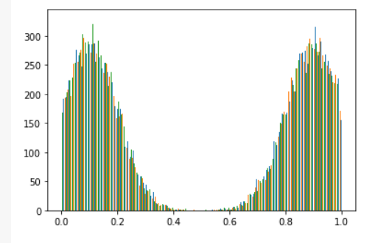

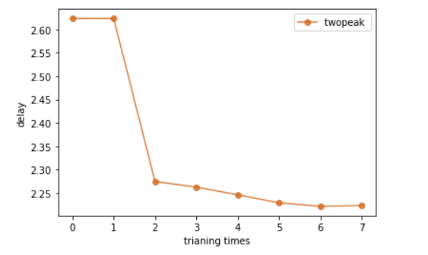

(CS: 2.6236, DP: 2.2342)

NN: 2.2228

Normal1(0.1,0.1), Normal2(0.9,0.1)

N=5:

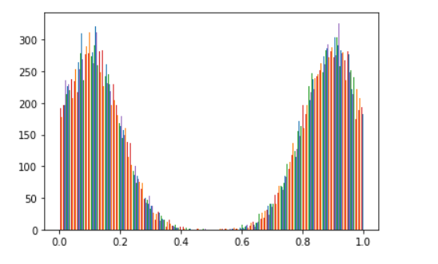

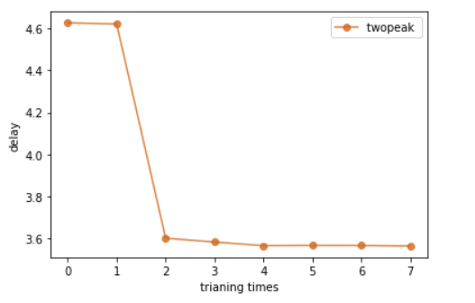

(CS: 4.6273 , DP: 3.574 )

NN: 3.5623

# Nonexcludable Public Good Maximum Welfare:

N=3:

Normal1(0.1,0.1), Normal2(0.9,0.1)

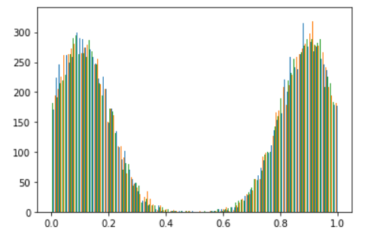

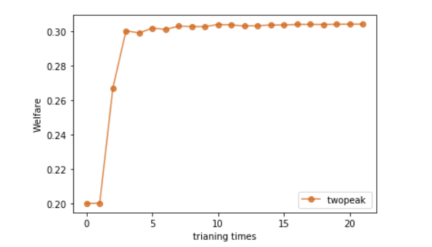

(CS: 0.20004, DP: 0.30619)

NN: 0.30429

N=5:

Normal1(0.1,0.1), Normal2(0.9,0.1)

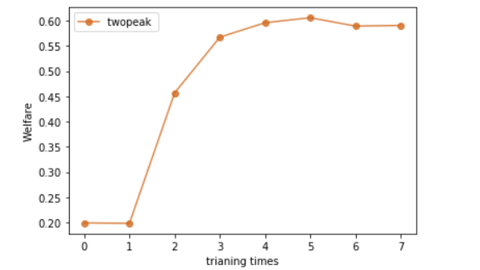

(CS: 0.1986, DP: 0.5908)

NN: 0.5909

# Redistribution:

n=3:

min value:1.9951419

max vaule:2.6215868

mean: 2.071576

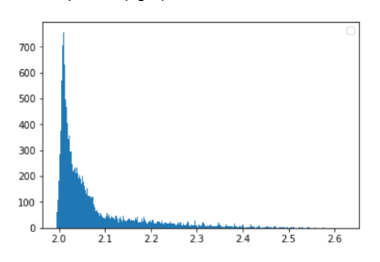

n=5:

min value:3.9614959

max vaule:4.966861

mean: 4.0610538

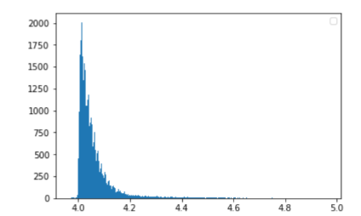

n=10:

min value:8.847169

max vaule:10.850268

mean: 9.018242

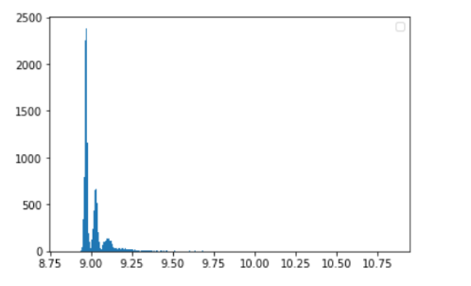

--

Other try:

N=3

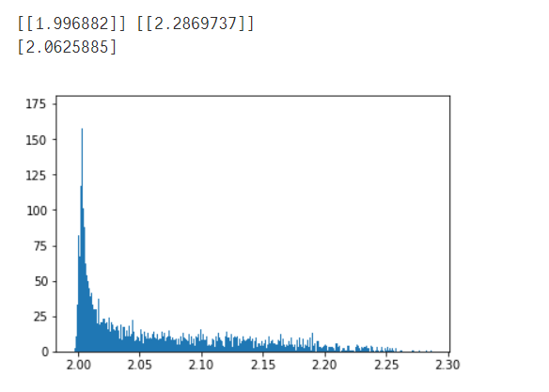

N=4

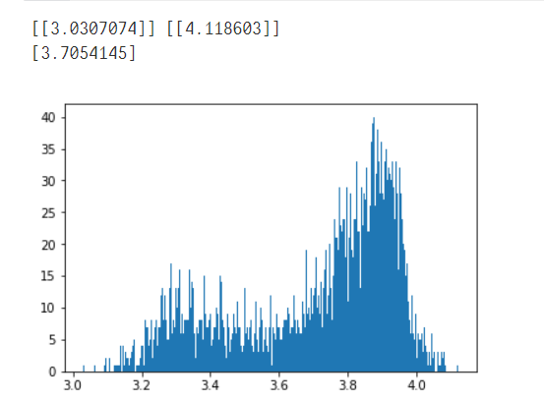

N=5

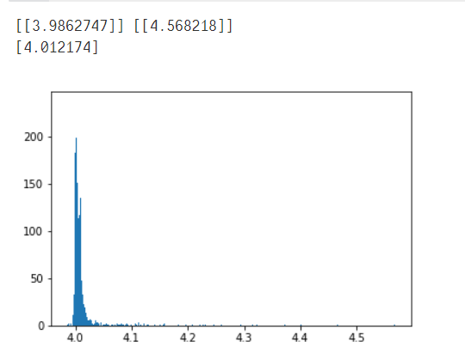

N=6

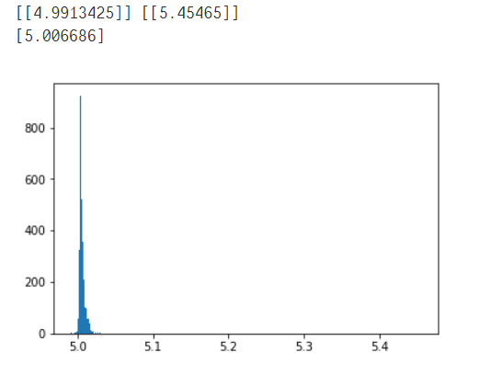

N=7

