CPU ：Inter(R) Core(TM) i5-8300H CPU @ 2.30GHz

RAM : 16GB

Windows 10 (x64)

# Excludable Public Good Minimum Delay:

N=3

distribution:

Two-peak-normal:

loc 0.2 scale 0.1

loc 0.6 scale 0.1

distribution:

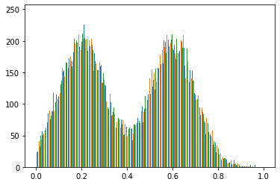

Learning rate = 0.0005

ADAM

log_interval = 5

trainSize = 50000

percentage_train_test= 0.5

penaltyLambda = 10

whichmeans：

25000 data for training and 25000 for testing each time.

Every training step training：5*128=640

Run time: about 15 mins.

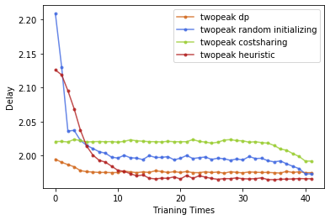

(CS: 2.0208, DP: 2.0107)

1.9660

N=3

distribution:

beta(0.1,0.1)

Use Kumaraswamy(0.1,0.354) approximate cdf.

kumaraswamy_a 0.1 kumaraswamy_b 0.354

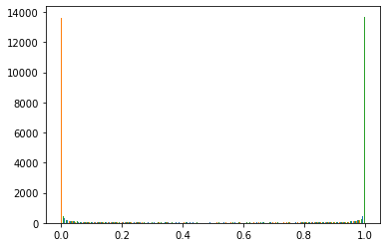

Learning rate = 0.0005

ADAM

log_interval = 5

trainSize = 50000

percentage_train_test= 0.5

penaltyLambda = 500

whichmeans：

25000 data for training and 25000 for testing each time.

Every training step training：5*128=640

Run time: about 15 mins.

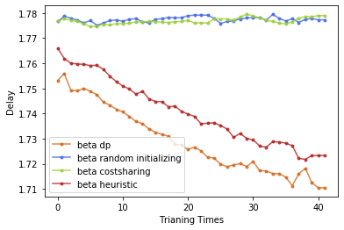

(CS: 1.77668, DP: 1.74812)

1.7104

N=3

distribution:

U-exponential

Exponential(15), Exponential(15)

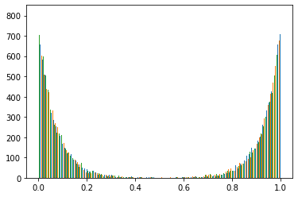

Learning rate = 0.0005

ADAM

log_interval = 5

trainSize = 40000

percentage_train_test= 0.5

penaltyLambda = 10

whichmeans：

25000 data for training and 25000 for testing each time.

Every training step training：5*128=640

Run time: about 15 mins.

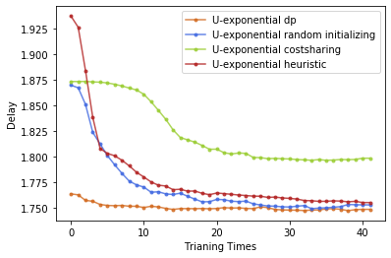

(CS: 1.87356, DP: 1.75084)

1.7490

N=3

distribution:

loc 0.4 scale 0.1

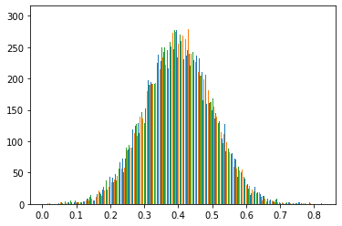

Learning rate = 0.0005

ADAM

log_interval = 5

trainSize = 50000

percentage_train_test= 0.5

penaltyLambda = 10

whichmeans：

25000 data for training and 25000 for testing each time.

Every training step training：5*128=640

Run time: about 15 mins.

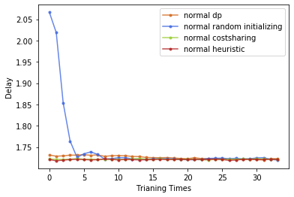

(CS: 1.722, DP: 1.74435)

1.7213

N=3

distribution:

uniformlow 0 uniformhigh 1.0

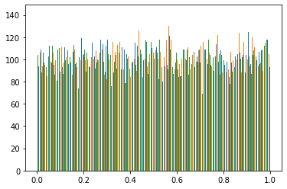

Learning rate = 0.0005

ADAM

log_interval = 5

trainSize = 50000

percentage_train_test= 0.5

penaltyLambda = 10

whichmeans：

25000 data for training and 25000 for testing each time.

Every training step training：5*128=640

Run time: about 15 mins.

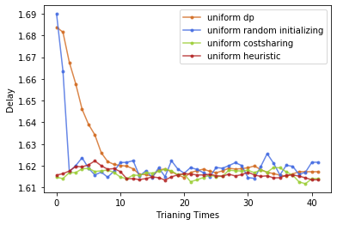

(CS: 1.61472, DP: 1.74272)

1.6141

N=3

distribution:

Two-peak-normal:

loc 0.15 scale 0.1

loc 0.85 scale 0.1

distribution:

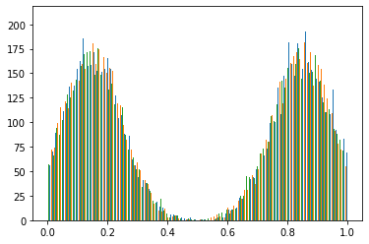

Learning rate = 0.0005

ADAM

log_interval = 5

trainSize = 40000

percentage_train_test= 0.5

penaltyLambda = 10

whichmeans：

20000 data for training and 20000 for testing each time.

Every training step training：5*128=640

Run time: about 15 mins.

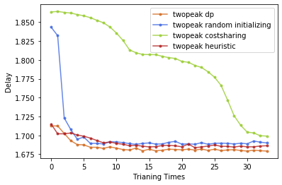

（CS: 1.8636，DP: 1.7527）

1.6793

N=5

distribution:

Two-peak-normal:

loc 0.15 scale 0.1

loc 0.85 scale 0.1

distribution:

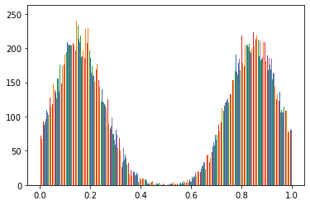

Learning rate = 0.0005

ADAM

log_interval = 5

trainSize = 50000

percentage_train_test= 0.5

penaltyLambda = 100

whichmeans：

25000 data for training and 25000 for testing each time.

Every training step training：5*128=640

Run time: about 30 mins.

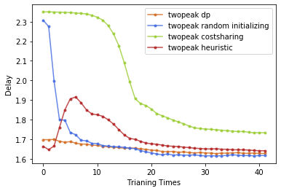

(CS: 2.34964, DP: 1.7516)

1.6171

N=10

distribution:

Two-peak-normal:

loc 0.15 scale 0.1

loc 0.85 scale 0.1

distribution:

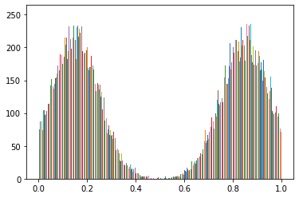

Learning rate = 0.001

ADAM

log_interval = 10

trainSize = 80000

percentage_train_test= 0.75

penaltyLambda = 100

whichmeans：

60000 data for training and 20000 for testing each time.

Every training step training：10*128=1280

Run time: about 3 hours.

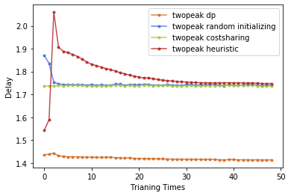

NN from dp

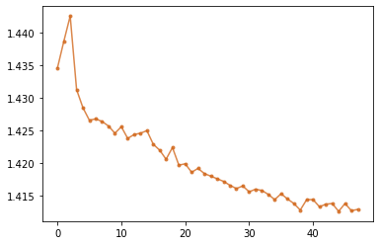

(CS: 1.7365, DP: 1.4480)

1.4129

# People Choice:

loc 0.1 scale 0.1

loc 0.9 scale 0.1

N=5:

lr = 0.0001

log_interval = 5

trainSize = 40000

percentage_train_test= 0.75

penaltyLambda = 10

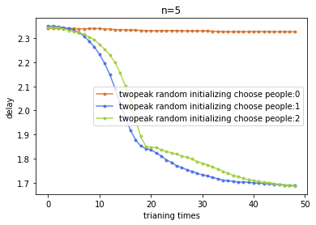

Other try:

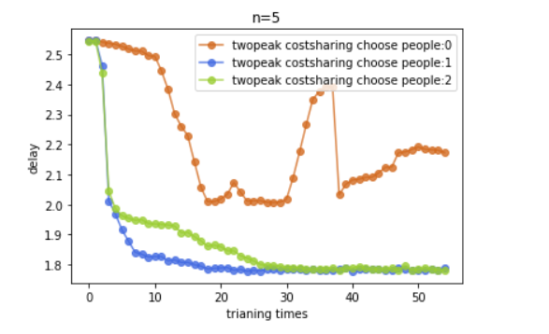

# Excludable Public Good Maximum Welfare:

N=3;

distribution:

Two-peak-normal:

loc 0.2 scale 0.1

loc 0.6 scale 0.1

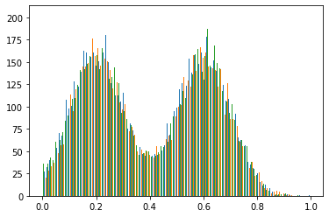

Learning rate = 0.0001

ADAM

log_interval = 5

trainSize = 40000

percentage_train_test= 0. 5

penaltyLambda = 10

whichmeans：

20000 data for training and 20000 for testing each time.

Every training step training：5*128=640

Run time: about 15 mins.

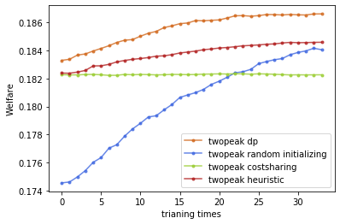

(CS: 0.1823, DP: 0.1793)

0.1866

N=3;

distribution:

Normal: loc 0.5 scale 0.1

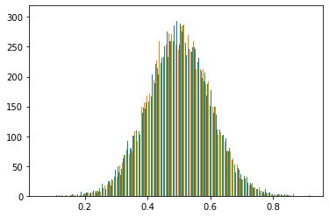

Learning rate = 0.0005

ADAM

log_interval = 5

trainSize = 40000

percentage_train_test= 0.5

penaltyLambda = 10

whichmeans：

20000 data for training and 20000 for testing each time.

Every training step training：5*128=640

Run time: about 15 mins.

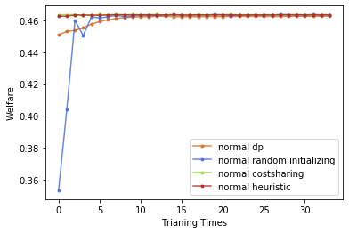

(CS: 0.4636, DP: 0.4505)

0.4627

N=5

distribution:

loc 0.2 scale 0.1

loc 0.6 scale 0.1

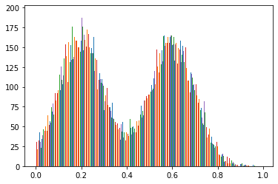

Learning rate = 0.00001

ADAM

log_interval = 5

trainSize = 40000

percentage_train_test= 0.5

penaltyLambda = 10

whichmeans：

20000 data for training and 20000 for testing each time.

Every training step training：5*128=640

Run time: about 30 mins.

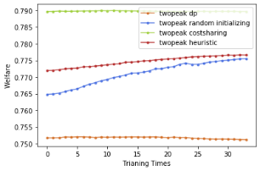

(CS: 0.4636, DP: 0.4505)

0.4627

# Nonexcludable Public Good Minimum Delay：

Two-peak:

Normal1(0.1,0.1), Normal2(0.9,0.1)

N=3:

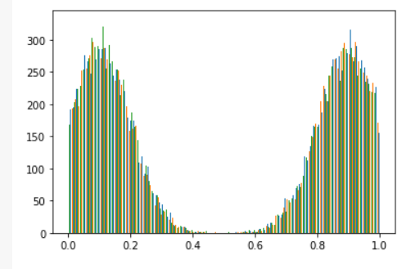

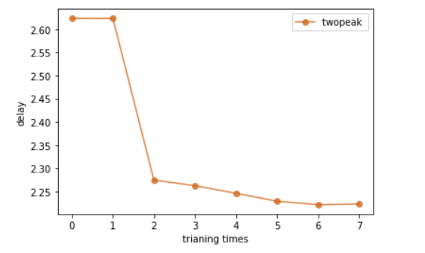

(CS: 2.6236, DP: 2.2342)

NN: 2.2228

Normal1(0.1,0.1), Normal2(0.9,0.1)

N=5:

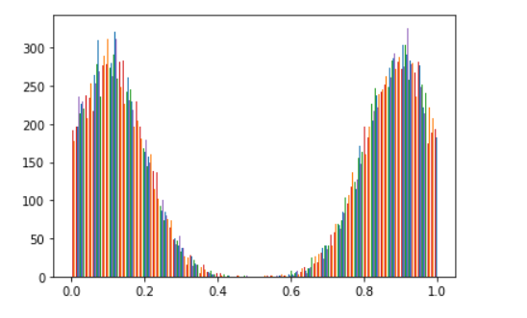

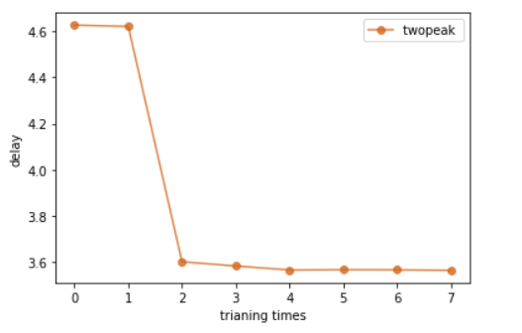

(CS: 4.6273 , DP: 3.574 )

NN: 3.5623

# Nonexcludable Public Good Maximum Welfare:

N=3:

Normal1(0.1,0.1), Normal2(0.9,0.1)

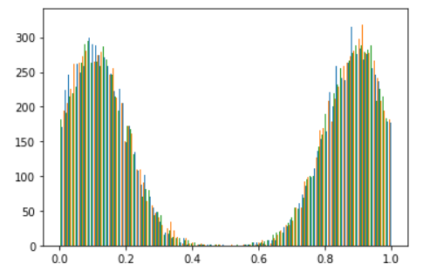

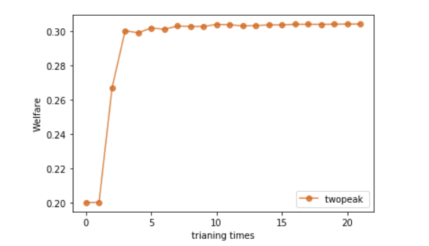

(CS: 0.20004, DP: 0.30619)

NN: 0.30429

N=5:

Normal1(0.1,0.1), Normal2(0.9,0.1)

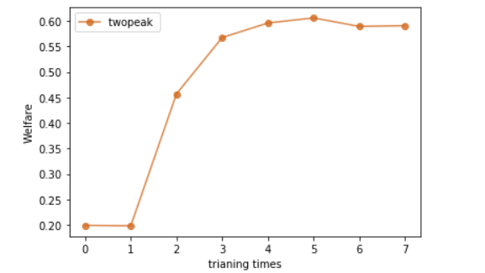

(CS: 0.1986, DP: 0.5908)

NN: 0.5909

# Redistribution:

TensorFlow

Adam

Sample precision 1/30.

n=3:

min value:1.9951419

max vaule:2.6215868

mean: 2.071576

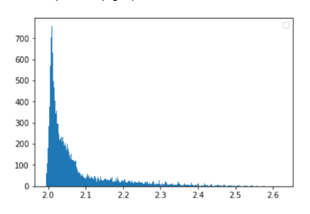

n=5:

min value:3.9614959

max vaule:4.966861

mean: 4.0610538

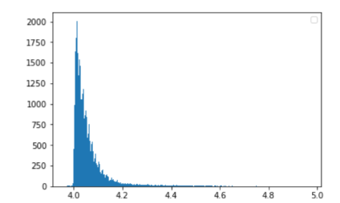

n=10:

min value:8.847169

max vaule:10.850268

mean: 9.018242

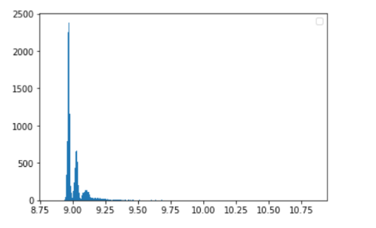

--

Other try:

N=3

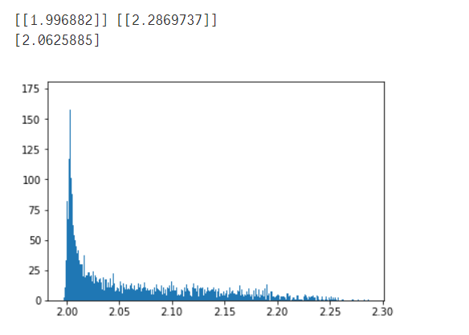

N=4

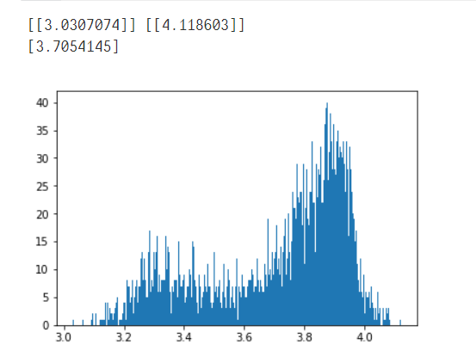

N=5

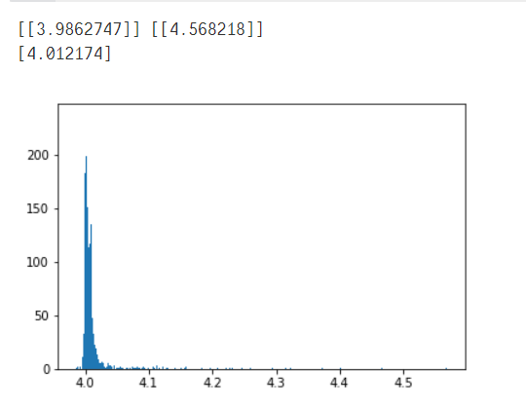

N=6

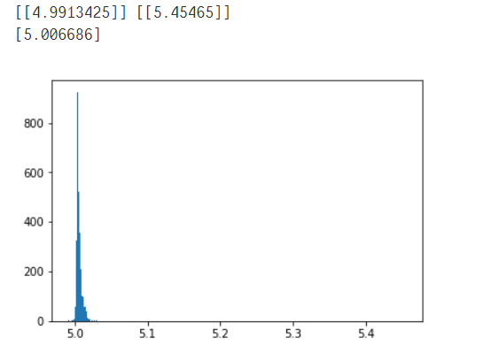

N=7

