CPU ：Inter(R) Core(TM) i5-8300H CPU @ 2.30GHz

RAM : 16GB

Windows 10 (x64)

N=3

distribution:

beta(0.1,0.1)

Use Kumaraswamy(0.1,0.354) approximate cdf.

kumaraswamy_a 0.1 kumaraswamy_b 0.354

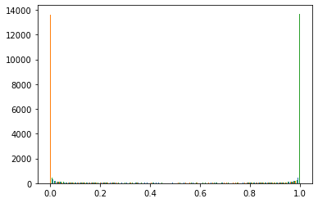

Learning rate = 0.0005

ADAM

log_interval = 5

trainSize = 50000

percentage_train_test= 0.5

penaltyLambda = 500

whichmeans：

25000 data for training and 25000 for testing each time.

Every training step training：5*128=640

Run time: about 15 mins.

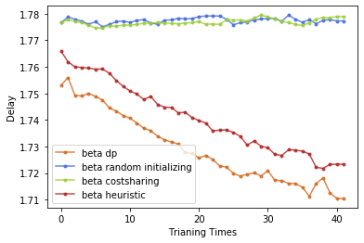

(CS: 1.77668, DP: 1.74812)

1.7104

N=3

distribution:

Two-peak-normal:

loc 0.15 scale 0.1

loc 0.85 scale 0.1

distribution:

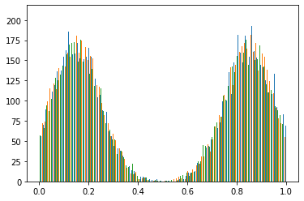

Learning rate = 0.0005

ADAM

log_interval = 5

trainSize = 40000

percentage_train_test= 0.5

penaltyLambda = 10

whichmeans：

20000 data for training and 20000 for testing each time.

Every training step training：5*128=640

Run time: about 15 mins.

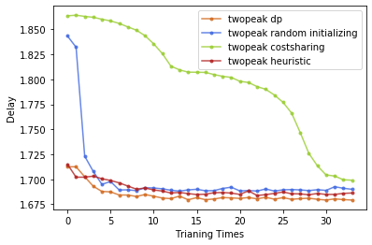

（CS: 1.8636，DP: 1.7527）

1.6793

N=5

distribution:

Two-peak-normal:

loc 0.15 scale 0.1

loc 0.85 scale 0.1

distribution:

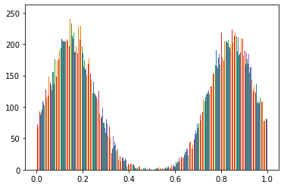

Learning rate = 0.0005

ADAM

log_interval = 5

trainSize = 50000

percentage_train_test= 0.5

penaltyLambda = 100

whichmeans：

25000 data for training and 25000 for testing each time.

Every training step training：5*128=640

Run time: about 30 mins.

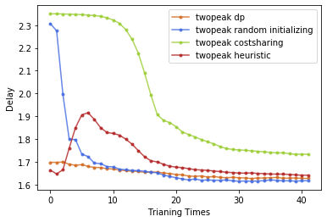

(CS: 2.34964, DP: 1.7516)

1.6171

N=10

distribution:

Two-peak-normal:

loc 0.15 scale 0.1

loc 0.85 scale 0.1

distribution:

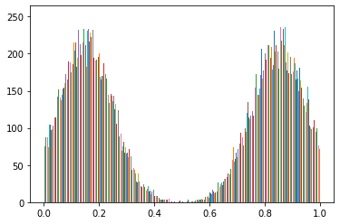

Learning rate = 0.001

ADAM

log_interval = 10

trainSize = 80000

percentage_train_test= 0.75

penaltyLambda = 100

whichmeans：

60000 data for training and 20000 for testing each time.

Every training step training：10*128=1280

Run time: about 3 hours.

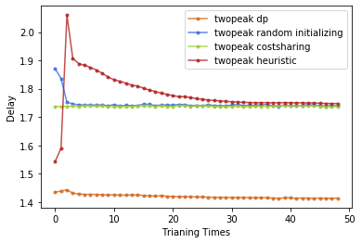

NN from dp

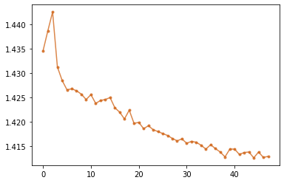

(CS: 1.7365, DP: 1.4480)

1.4129

# People Choice:

loc 0.15 scale 0.1

loc 0.85 scale 0.1

N=5:

lr = 0.0001

log_interval = 5

trainSize = 40000

percentage_train_test= 0.75

penaltyLambda = 10

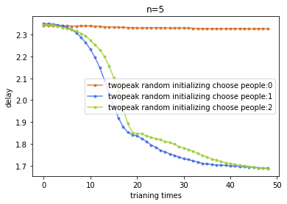

Other try:

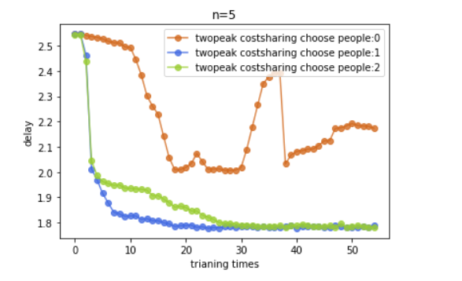

# Excludable Public Good Maximum Welfare:

N=3;

distribution:

Two-peak-normal:

loc 0.2 scale 0.1

loc 0.6 scale 0.1

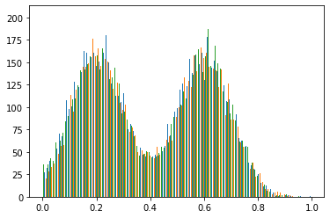

Learning rate = 0.0001

ADAM

log_interval = 5

trainSize = 40000

percentage_train_test= 0. 5

penaltyLambda = 10

whichmeans：

20000 data for training and 20000 for testing each time.

Every training step training：5*128=640

Run time: about 15 mins.

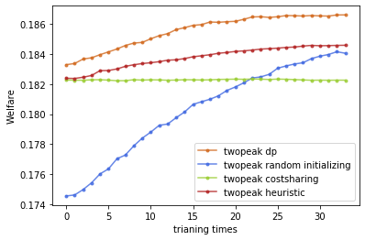

(CS: 0.1823, DP: 0.1793)

0.1866

N=5

distribution:

loc 0.2 scale 0.1

loc 0.6 scale 0.1

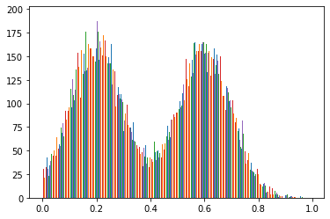

Learning rate = 0.00001

ADAM

log_interval = 5

trainSize = 40000

percentage_train_test= 0.5

penaltyLambda = 10

whichmeans：

20000 data for training and 20000 for testing each time.

Every training step training：5*128=640

Run time: about 30 mins.

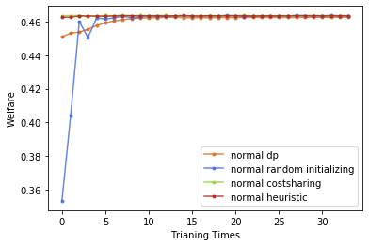

(CS: 0.4636, DP: 0.4505)

0.4627

Welfare

Nonconsumer

Two-Peak

DP

Random Initialization

SCS

Myopic