-------------------------------------------------------------------------------
Gradient Boosting 200

Fitting the model took 233 seconds
MSE : 10.5819453334
R2 : 0.919724418807
PM10_04143_1
Fitting the model took 223 seconds
MSE : 14.8106487619
R2 : 0.913733790952
O3_04143_1
Fitting the model took 231 seconds
MSE : 60.0218552782
R2 : 0.887014352859
NO2_04143_1
Fitting the model took 219 seconds
MSE : 46.0357859079
R2 : 0.878853970678
----------------------------------------------------------------------------
Gradient boosting 200 with new variables
PM2_5_04143_1
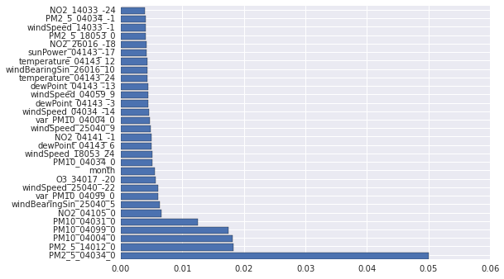
Fitting the model took 472 seconds
MSE : 9.97912987063
R2 : 0.924297430678
PM10_04143_1
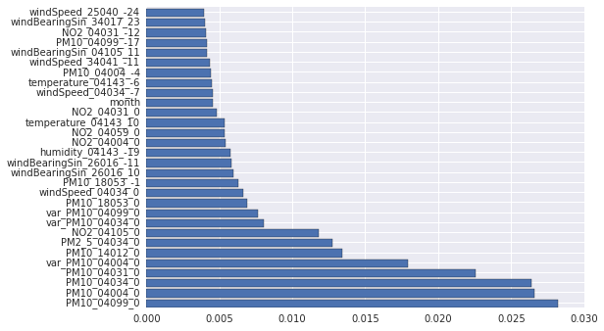
Fitting the model took 489 seconds
MSE : 14.1346813103
R2 : 0.91767103573
O3_04143_1
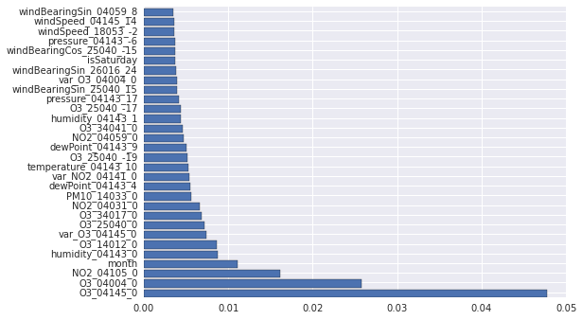
Fitting the model took 506 seconds
MSE : 60.901145474
R2 : 0.885359169571
NO2_04143_1
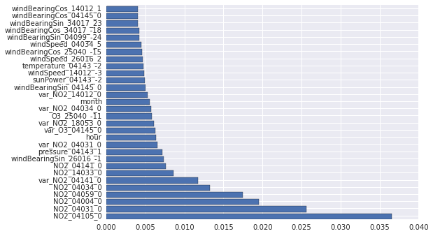
Fitting the model took 530 seconds
MSE : 43.6777435457
R2 : 0.885059305582

---------------------------------------------------------------
xgboost 200

PM2_5_04143_1
Fitting the model took 30 seconds
MSE : 10.8058322123
R2 : 0.918025992973
PM10_04143_1
Fitting the model took 28 seconds
MSE : 14.7756959084
R2 : 0.913937377588
O3_04143_1
Fitting the model took 31 seconds
MSE : 61.2506828174
R2 : 0.884701197524
NO2_04143_1
Fitting the model took 29 seconds
MSE : 43.345838817
R2 : 0.885932733486
---------------------------------------------------------------------------
GRID Search xgboost
PM2_5_04143_1
Fitting 3 folds for each of 12 candidates, totalling 36 fits
0.90955665859
{'n_estimators': 500, 'max_depth': 4}
Fitting the model took 3031 seconds
MSE :
[Parallel(n_jobs=1)]: Done 36 out of 36 | elapsed: 48.9min finished
[Parallel(n_jobs=1)]: Done 36 out of 36 | elapsed: 49.2min finished
9.35954894759
R2 : 0.928997626826
PM10_04143_1
Fitting 3 folds for each of 12 candidates, totalling 36 fits
0.932293490632
{'n_estimators': 500, 'max_depth': 6}
Fitting the model took 3112 seconds
MSE :

