Assignment Data Warehouse

Wedhar Gilang Prihandoko

wgilangp@gmail.com

1. **ERD (ENTITY-RELATIONSHIP DIAGRAM) STAR SCHEMA**

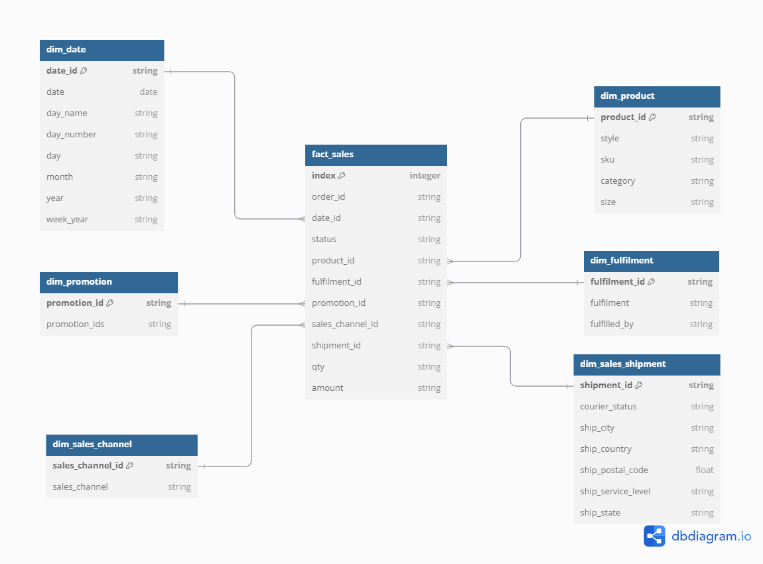

1. **BIGQUERY STAR SCHEMA**
   1. Table fact_sales

* 1. Table dim_product

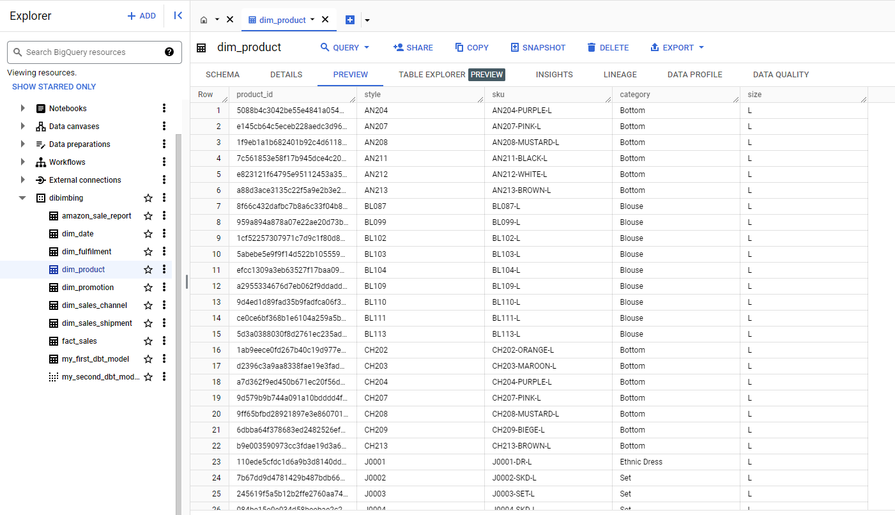

* 1. Table dim_date

* 1. Table dim_fulfilment

* 1. Table dim_promotion

* 1. Table dim_sales_channel

* 1. Table dim_sales_shipment

1. **ANALYSIS**
   1. **Top 10 Best Selling Product in Most Favorite Category**

Find the most favourite product category

-- Most Favorite Category

SELECT

  `category`,

  COUNT(`product_id`) AS count

FROM

  `dedibimbing.dibimbing.dim_product`

-- WHERE `category` = 'kurta'

GROUP BY `category`

ORDER BY count DESC;

We found Kurta is the most favourite product category, then we analyze deeper 10 best selling product in Category Kurta.

-- Top 10 Best Selling in Kurta

  dp.sku AS sku,

  SUM(fs.qty) AS sales_volume

FROM `dedibimbing.dibimbing.fact_sales` fs

LEFT JOIN `dedibimbing.dibimbing.dim_product` dp ON fs.product_id =  dp.product_id

WHERE `category` = 'kurta'

GROUP BY sku

ORDER BY sales_volume DESC

LIMIT 10

;

Those are Top 10 best selling products in Most Favourite Category, indeed those products contribute highest revenue

* 1. **Top 5 most interesting promo**

SELECT

    COALESCE(dp.promotion_ids, 'no promo') AS promo_id,

    SUM(fs.qty) AS sales_volume

FROM `dedibimbing.dibimbing.fact_sales` fs

LEFT JOIN `dedibimbing.dibimbing.dim_promotion` dp ON fs.promotion_id = dp.promotion_id

WHERE dp.promotion_ids IS NOT NULL

GROUP BY 1

ORDER BY 2 DESC

LIMIT 5;

There is high possibility that those 5 promos give high impact to sales

* 1. **Difference in Amount Sales between Weekday and Weekend**

WITH sales_by_day AS (

  SELECT

    dd.day_number AS day_number_no,  -- Ganti alias tanpa karakter khusus

    dd.day_name AS day,

    ROUND(SUM(fs.amount), 0) AS sales_amount

  FROM `dedibimbing.dibimbing.fact_sales` fs

  LEFT JOIN `dedibimbing.dibimbing.dim_date` dd ON fs.date_id = dd.date_id

  GROUP BY day_number_no, day  -- Sesuaikan dengan alias baru

  ORDER BY day_number_no ASC  -- Sesuaikan dengan alias baru

)

SELECT sbd.day, sbd.sales_amount FROM sales_by_day sbd;

We can conclude that Weekend has daily sales higher than Weekday, even though the amount is not significantly different.