1. **横向布局**

**新建view.vue，预览效果如下：**

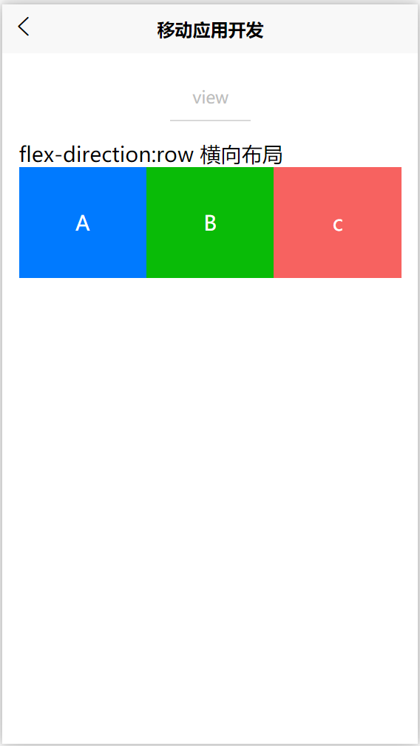

<template>

<view>

<!--顶部区域-->

<view class="smart-page-head">

<view class="smart-page-head-title">view</view>

</view>

**<!--主题部分-->**

**<view class="smart-padding-wrap">**

**<view>flex-direction:row 横向布局</view>**

**</view>**

**<view class="smart-flex smart-row">**

**<view class="flex-item smart-bg-blue">A</view>**

**<view class="flex-item smart-bg-green">B</view>**

**<view class="flex-item smart-bg-red">c</view>**

**</view>**

</view>

</template>

<script>

export default {

data() {

return {

}

},

methods: {

}

}

</script>

<style>

**.smart-flex{**

**display: flex;**

**}**

**.smart-row{**

**flex-direction: row;**

**}**

**.flex-item {**

**width: 33.3%;**

**height: 200rpx;**

**line-height: 200rpx;**

**text-align: center;**

**}**

**/*背景色*/**

**.smart-bg-red{**

**background: #F76260; color: #FFFFFF;**

**}**

**.smart-bg-green{**

**background: #09BB07; color: #FFFFFF;**

**}**

**.smart-bg-blue{**

**background: #007aff; color: #FFFFFF;**

**}**

</style>

**2、纵向布局**

在上一步基础上，添加如下代码

**<view>flex-direction:row 纵向布局</view>**

**<view class="smart-flex smart-column">**

**<view class="flex-item-100 smart-bg-blue">A</view>**

**<view class="flex-item-100 smart-bg-green">B</view>**

**<view class="flex-item-100 smart-bg-red">c</view>**

**</view>**

**.smart-column{**

**flex-direction: column;**

**}**

**.flex-item-100 {**

**width: 100%;**

**height: 200rpx;**

**line-height: 200rpx;**

**text-align: center;**

**}**

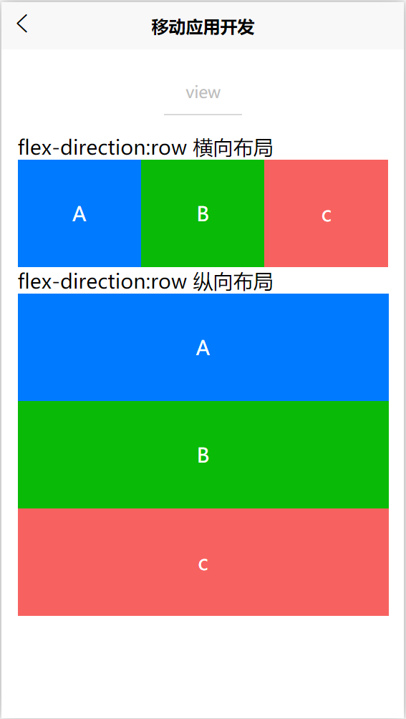

**3、其他布局**

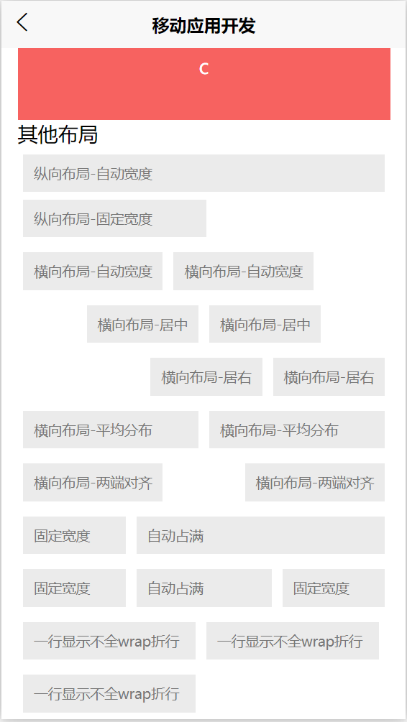

**<view>其他布局</view>**

**<view>**

**<view class="text">纵向布局-自动宽度</view>**

**<view class="text" style="width: 300rpx;">纵向布局-固定宽度</view>**

**<view class="smart-flex smart-row">**

**<view class="text">横向布局-自动宽度</view>**

**<view class="text">横向布局-自动宽度</view>**

**</view>**

**<view class="smart-flex smart-row" style="justify-content: center;-webkit-justify-content:center;">**

**<view class="text">横向布局-居中</view>**

**<view class="text">横向布局-居中</view>**

**</view>**

**<view class="smart-flex smart-row" style="justify-content: flex-end;-webkit-justify-content:flex-end;">**

**<view class="text">横向布局-居右</view>**

**<view class="text">横向布局-居右</view>**

**</view>**

**<view class="smart-flex smart-row">**

**<view class="text" style="-webkit-flex:1;flex:1;">横向布局-平均分布</view>**

**<view class="text" style="-webkit-flex:1;flex:1;">横向布局-平均分布</view>**

**</view>**

**<view class="smart-flex smart-row" style="justify-content: space-between;-webkit-justify-content:space-between;">**

**<view class="text" >横向布局-两端对齐</view>**

**<view class="text" >横向布局-两端对齐</view>**

**</view>**

**<view class="smart-flex smart-row">**

**<view class="text" style="width: 150rpx;">固定宽度</view>**

**<view class="text" style="-webkit-flex:1;flex:1;">自动占满</view>**

**</view>**

**<view class="smart-flex smart-row">**

**<view class="text" style="width: 150rpx;">固定宽度</view>**

**<view class="text" style="-webkit-flex:1;flex:1;">自动占满</view>**

**<view class="text" style="width: 150rpx;">固定宽度</view>**

**</view>**

**<view class="smart-flex smart-row" style="flex-wrap: wrap;-webkit-flex-wrap:wrap;">**

**<view class="text" style="width: 280rpx;">一行显示不全wrap折行</view>**

**<view class="text" style="width: 280rpx;">一行显示不全wrap折行</view>**

**<view class="text" style="width: 280rpx;">一行显示不全wrap折行</view>**

**</view>**

**</view>**