**一、效果演示**

**1、制作如下图所示的界面**

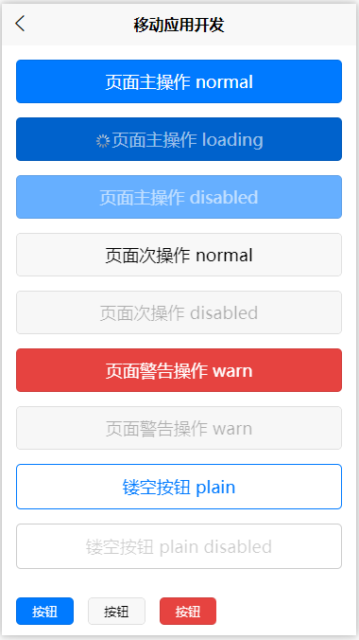

<template>

<view>

<page-head title="button,按钮"></page-head>

**<view class="smart-padding-wrap">**

**<button type="primary">页面主操作 normal</button>**

**<button type="primary" :loading="true">页面主操作 loading</button>**

**<button type="primary" disabled="false">页面主操作 disabled</button>**

**<button type="default">页面次操作 normal</button>**

**<button type="default" disabled="false">页面次操作 disabled</button>**

**<button type="warn">页面警告操作 warn</button>**

**<button type="default" disabled="false">页面警告操作 warn</button>**

**<button type="primary" plain="true">镂空按钮 plain</button>**

**<button type="primary" plain="true" disabled="false">镂空按钮 plain disabled</button>**

**<button type="primary" size="mini" class="mini-btn">按钮</button>**

**<button type="default" size="mini" class="mini-btn">按钮</button>**

**<button type="warn" size="mini" class="mini-btn">按钮</button>**

**</view>**

</view>

</template>

<script>

export default {

data() {

return {

};

},

methods: {}

};

</script>

<style>

button{

margin-top: 30rpx;

margin-bottom: 30rpx;

}

.mini-btn{

margin-right: 30rpx;

}

</style>

**2、增加按钮点击加载动作**

BtnSave(){

uni.showLoading({

Title:’加载….’;

});

SetInterval(()=>{

uni.hideLoading();

},3000)

}